Chapter 1

The Problem and its Background

Introduction

Computer is one of the most brilliant gifts of science. Most countries have developed fast because of the help of this technology. Writing a program, making projects and any form of task are done by using this. In just a short period of time we observe its evolution and improvements. Nowadays there are many kinds and subsidiaries of computer such as speed, accuracy, reliability and resourcefulness. Most daily routine/activities at home, schools and in business are done by the use of computers with ease. The computer has proved its integrity as a friend and a servant of science and technology. In industry, most offices, schools, shops, factories and corporations are using computers for daily work.

Background of the Study

The University of the East also known as U.E. is a private university located in [Manila](https://en.wikipedia.org/wiki/Manila), [Philippines](https://en.wikipedia.org/wiki/Philippines). It was founded in 1946. [Lucio Tan](https://en.wikipedia.org/wiki/Lucio_Tan" \o "Lucio Tan) acquired the university in 1990. UE was once labeled as the "largest university in Asia" once having an enrollment of over 60,000 students. UE offers degree programs in commerce and business administration, law, dentistry, engineering, arts and sciences, fine arts, education, computer technology, nursing, physical therapy, medicine, hospitality management and graduate studies. UE has two other campuses, one in [Caloocan](https://en.wikipedia.org/wiki/University_of_the_East_Caloocan) and its medical school, the [UE Ramon Magsaysay Memorial Medical Center](https://en.wikipedia.org/wiki/University_of_the_East_Ramon_Magsaysay_Memorial_Medical_Center) located in Quezon City. The four-storey Engineering Building was inaugurated in 1980. What used to be the technical shops were gradually converted into classrooms for the students of the College of Arts and Sciences and the College of Business Administration until November 2003. It is a four-story building that houses over 50 lecture rooms, 24 laboratories and lab rooms, tool rooms and stock rooms, two machine shops and the Campus's two Multipurpose Halls.

The CTAF (Computer Terminal Attendance Form) is a form that given to the students that going to use the computer laboratory rooms in College of Engineering of University of the East Caloocan. The student must sign the form by their name correspond to their terminal number, ID number, signature and check the parts of the terminal if complete or having problem.

The College of Engineering where the home-base of Computer Laboratory rooms and IT/CS department that will benefit the success of this study to enhance their learning skills according to their respective course.

Theoretical Framework of the Study

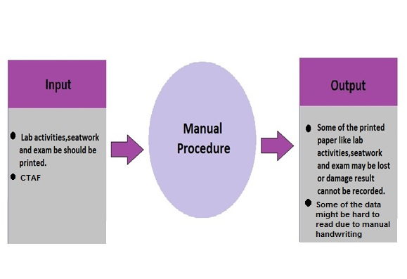

Existing System

Theoretical Framework

The paradigm shows that the manual/written procedure is not given consistency. Most of the laboratory activities, seatwork and exam are printed and obtain much time and papers that is not appropriate to a computer laboratory. Written attendance can make a ton of errors if the students are not mindful where to write their data manually. The problem is that the written system is not editable and may result to a disorganized situation.

Conceptual Framework of the study.

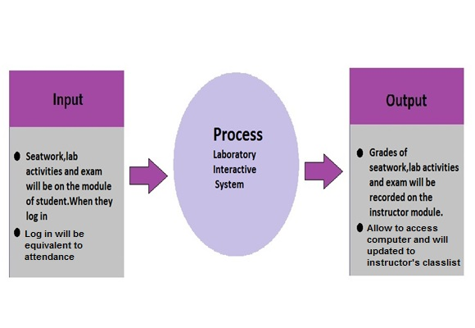Proposed System

The diagram shows that the proposed system answers what the needs for innovation and substitution for the existing system. Because this proposal is convenient and much more reliable than the existing system. When the student logged in they are allow to access computer, updated and mark as present to the instructor’s terminal class list. After that the learning phase specially seatwork, Lab activities, exams and file sharing and their results will be view online and add to the feature of this proposal. When it comes to programming class they are going to log in and after that they will proceed to desktop interface and they are now ready to open the programming language software that they are studying and enhance their programming techniques. This and any feature that will innovate this proposal is guaranteed as soon as possible.

Statement of the problem

Prior to our study we consider a bit security and learning. We simulate that how could we give both side at once. Because of that we enumerate different problems that may become hindrance to our research. In security although this is a minor priority to our study it is also important, it is clear those sit-in students are not allowed to enter any class without permission. This may cause any loss and damage for the terminals inside the laboratory and it is strictly prohibited by the College of Engineering administrators and authorities. aside from that, another problem is the unavailability of one or any computer terminals inside the laboratory rooms due to disordered flow of energy that result to class interruption and need to call a personnel from En. Bldg. Satellite repair center to troubleshoot the problem and its hassle and time consuming. In attendance, the CTAF a form that given by the instructor/s to students to indicate their attendance and is not editable if error occurs and sometimes it is leaved inside the room and become a waste and the use of papers for different kind of examinations that is not appropriate for a computer laboratory room.

Objectives of the study

Upon the course of this study, certain goals must be attained and these goals are listed below.

General Objectives

The objectives of this study is to develop Laboratory Interactive Learning System that would help the students for enhancement of their interactivity and learning using computerized features like online lessons, activities/seatwork, quiz and examinations that increase their learning capability and is suited for a computer laboratory.

Specific Objectives

* To create a system that will help the student for their studies and enhance their learning skills.
* To design a module that will have a remedial lesson through file sharing instead of viewing it from projector.
* To design a module that indicates all lab activities, seatwork, quiz and exam using the computer laboratory terminals.
* To design a log in to the student that will serve as attendance sheet instead of using CTAF.

1.7 Scopes and Limitations of the Study

The scope of study discusses the coverage of the study such as:

* Registration Module -the proponents will create a registration module for students in the first of the classes.
* Login Module - the proponents will create a login module for students and instructor and will serve as attendance.
* Student Form - the proponents will create a student module that will have lab activities, seatwork and exam.
* Faculty Form – in this module the proponents will create a faculty module where he/she give the lab activities, seatwork and exam. The instructor can monitor the class list.
* LAN-Based System – this covers the propose system is only use in school.
* Report- The proponents will create a module that student will make a report if the terminal encounter technical problem then student will send the report to faculty then the faculty will submit the report to the CLR Staff.

The limitation of study do not covers the following.

* The propose system will not upload any lecture, generating grades of prelim, midterm and finals.
* The propose system will not be use outside the school this is only exclusive for campus.
* The propose system will not be Web Based because this is only for study purposes only.

Significance of the study

To provide security and enhancement of utilities for better learning both side at once. In security measures the avoidance of sit-in students that is prohibited by the college authorities that is included in University’s law and firms. And if chances of problems and loss of the equipment the system will automatically shut down the computer and be detected by the instructor’s terminal. To give solutions for the time consumed due to the unavailability of one or any computer terminals inside the laboratory rooms just to call the troubleshooter instead of that, the instructor inside the computer room will alert the troubleshooter through simple mail transfer protocol for help. In attendance part the easement of CTAF paper form and substitute it to a log-in system that is well suited for a computer laboratory room. If chances that other student know the password of fellow student and logged it in to assume that he/she is present but is not the instructor will also roam around to make sure if that student is present or not and also the sitting arrangement is strictly implemented. And lastly the most important part the Learning phase which is online lessons, file sharing, laboratory seatwork/activities, quiz, and examinations that enhance the effectiveness of student interaction and learning inside the Computer Laboratory rooms. The benefactors of this proposal are listed here and their involvements are indicated:

* Students

The IT/CS students are the most beneficiaries for this proposal because they are going to use the proposed system.

* Professors or Instructors

The professor or instructor will guide the students how to use and understand the proposed system. They share files and lessons to all of computer terminals that students use.

* University of the East

The University of the East will have benefits and manipulate the proposed system.

* College of Engineering

Computer laboratory rooms are based here and IT/CS department and also the Engineering student will also benefit for this proposal.

Operational Definition of Terms

* Computer - is one of the most brilliant gifts of science. It make all works easier to people. Is a general-purpose device that can be programmed to carry out a set of arithmetic or logical operations automatically.
* Computer Laboratory Rooms (CLR) - a room equipped with computer terminals, projector and CCTV for security cause.
* Learning - a student have a proper education, discipline and responsible in their environment or school/University community.
* Computer Terminal Assignment Form (CTAF) – the form that Computer laboratory (CLR) is needed to determine the attendance and the functionality of the terminals. It is the present system in UE Caloocan
* Local area network (LAN)- is a group of computers and associated devices that share a common communications line or wireless link to a server.
* File sharing - is the practice of [distributing](https://en.wikipedia.org/wiki/Digital_distribution) or providing access to [digital media](https://en.wikipedia.org/wiki/Digital_media), such as [computer programs](https://en.wikipedia.org/wiki/Computer_program), [multimedia](https://en.wikipedia.org/wiki/Multimedia) (audio, images and video), documents or [electronic books](https://en.wikipedia.org/wiki/E-book)
* Simple Mail Transfer Protocol (SMTP) is an Internet standard for electronic mail (email) transmission.

Chapter 2

Review of related Literature and Studies

Introduction

This chapter is a compilation of all literatures and studies that are carefully cited to give justify and clear explanations/examples that are related to this research. All of the ideas, quotations and other references that included here are only guides in order to make this study productive. As researchers we respect the other people’s property and responsible for the following consequences that it may take and avoid violations like plagiarism. This study may help the future IT students for their research.

Local Literature

Prior that computer safety is substantial part of this research, the first thing that comes to our mind is the word “security”. security is protecting someone or something from danger. We are now going to computer security. According to Froilan Castelo (2015) “Cyber security is everyone’s responsibility, not just for the lawmakers, regulators, or the industry. We must all be mindful of the kind of information we send out online and be conscious about our own protection,”

Castelo, F. (2015). *Globe says security consciousness can help prevent cyber fraud*. Retrieved from: <http://www.mb.com.ph/globe-says-security-consciousness-can-help-prevent-cyber-fraud/>

That’s why the IT/CS professionals brainstorm and made a system that uses vital information in order to access that particular cite or something that needed to be protected. And the Log-in systems were made.

According to Wikipedia (n.d.) “In [computer security](https://en.wikipedia.org/wiki/Computer_security), Log- in refers to the credentials required to obtain access to a computer system or other restricted area”. “Logging in or signing on is the process by which individual [access](https://en.wikipedia.org/wiki/Access_control) to a [computer system](https://en.wikipedia.org/wiki/Computer_system) is controlled by [identifying](https://en.wikipedia.org/wiki/Proof_of_identity) and [authenticating](https://en.wikipedia.org/wiki/Authentication) the [user](https://en.wikipedia.org/wiki/User_%28computing%29) through the [credentials](https://en.wikipedia.org/wiki/Credential) presented by the user.”, “Once a user has logged in /signed in, they can then log out/sign off when access is no longer needed. To *log out* is to close off one's access to a computer system after having previously logged in.” The statements above are a sample procedure of a log-in system.

# Wikipedia(n.d*). Login*. Retrieved August 21, 2015,from <http://en.wikipedia.org/wiki/Login>

Later log-in system is not all about privacy it is widely use most specially in educational purposes like E- learning. Dela Pena-Bandalaria (2009) stated that “the term "e-learning" is used synonymously with online learning and concerns the online delivery of instructional content as well as associated support services to students.” She added “It showcases the development of e-learning in the country from just a supplement within once-a-month face-to-face (FTF) sessions in a university learning center to more extensive use of a learning management system (LMS) as avenue for academic discussions as well as learning assessments, sharing learning resources and content, and students submissions of course requirements.” And it will help the future employees to cope up on job with proper skills.

# Dela Pena-Bandalaria, M. M. (2009). *E-Learning in the Philippines: Trends, Directions, and Challenges* International Journal on E-Learning*,* 8(4), 495-510 Retrieved from <http://eric.ed.gov/?id=EJ851849/>

According to Manila Standard Today (2013) about E- Learning, The authority says the transition will“ provide sufficient time for mastery of concepts and skills, develop lifelong learners, and prepare graduates for tertiary education, middle-level skills development, employment, and entrepreneurship.”

# MST News. (2013, May 12). *E-Learning: The next paradigm shift in education. Manila standard today.* Retrieved from <http://manilastandardtoday.com/2013/05/12/e-learning-the-next-paradigm-shift-in-education/>

[Martinez-Castillo](http://opinion.inquirer.net/byline/tish-martinez-castillo) (2011)According to Jose Maria T. Policarpio, executive director of education publisher Diwa Learning Systems Inc. “The global outpouring of grief reflects Jobs’ impact on modern life. He blazed trails in education and understood that today’s learners grasp new technologies intuitively,” he means that grabbing this opportunity is crucial for guiding students to execute better academically to become more competitive and successful in life with such skills.

# Martinez-Castillo, T. (2011, October 30*). Investing in e-learning, future.* [*Philippine Daily Inquirer*](http://opinion.inquirer.net/source/philippine-daily-inquirer). Retrieved from <http://opinion.inquirer.net/16263/investing-in-e-learning-future/>

Aside from that, the security of a particular establishment is also innovate they are now having a computer-based security system like card-swiped entry system that you are allow to enter if you have your ID and swipe it to the sensor-like panel after that you can see on the screen your all identity details. But before that trends there are two equipments that use during old days this two are logbook and punch card. The logbook is a notebook used by security firm to list down the name, time and other details of the person who enter the building, while punch card is used specially in old office there they have a card and they indicate the card to the machine to be punched for their attendance. Although this two are rarely seen they are used thoroughly. The old system are now replaced by new technological trends.

Instead of logbook they replace it to computer - based database which is more relevant, concise and editable. When they swipe the ID or card to the sensor the data that the system collect from card/ID is being processed then Inside the database list all of the entities who enter the establishments and what time they arrive and other activities. And all of the data that will collected are accepted by admin and now allow that person to enter anytime if they have their ID/card. Now we see the difference between those system and their time.

Foreign Literature

According to [University of Central Lancashire](https://www.uclan.ac.uk/students/study/attendance_monitoring.php) (n.d), they monitor attendance as research has shown that regular attendance and academic achievement are closely linked; it is therefore important that we know you are attending regularly. By monitoring student attendance we hope to be able to identify students who need support at an early stage and put in place measures to help them continue their studies.

### Uclan Student Support (n.d). *Attendance monitoring system.* September 10, 2015, Retrieved from : [https: // www .uclan .ac. uk/ students/ study/ attendance _ monitoring.php](http://https:%20//%20www.uclan.ac.uk/students/study/attendance_monitoring.php)

According to Clock in systems (n.d) remove the inherent inaccuracies associated with manual registers and the students/ employee signatures, which are clearly open to abuse and demand time-consuming administration.

Retrieve from <https://clockinginsystems.wordpress.com/student-attendance> monitoringsystem/para.1

According to Chron (n.d.) Most likely your company maintains a selection of office supplies for employee use, which means you need to maintain a consistently updated list of inventory purchased and used within a specific accounting period. An accurate inventory serves a two-fold purpose: it helps ensure your business does not run out of necessary office supplies, and it allows you to properly account for office supply purchases as assets or liabilities under an accrual system of accounting.

Retrieve from <http://smallbusiness.chron.com/inventory-office-supplies->18351.html. para. 1

According to M. Wahab et al. (2010) There RFID (Radio Frequency Identification) Benefits of the system include enhancement of the safety of University asset and reduce losses of assets and enhancement of the laboratory inventory control of equipment Web-based laboratory equipment monitoring system using RFID.

Retrievefromhttp://www.researchgate.net/publication/224219864_Web- based_laboratory_equipment_monitoring_system_using_RFID. para. 1

According to Henri Van Bost (2015) Always keep track of who last had equipment. This saves you valuable time once an item is missing. Avoid having to contact everyone on your team just to establish who last used a missing piece of equipment.

Retrieve from [http://www.cheqroom.com/how-to-report-missing-stolen-equipment. para. 3](http://www.cheqroom.com/how-to-report-missing-stolen-equipment.%20para.%203))

Local Studies

In a study conducted by Cayabyab (2007) many problems and difficulties were identified in the exisiting system of Dagupan City National High School (DCNHS). These major concerns are affecting the efficient enrollment system of students. Security of the students records were found to be at high risk. The current system may fail to protect some important documents. It has also untimely and inefficient report generation. A computerized system for DCNHS shall result to a significant increase in the number of enrollees.

Retrieved from : <http://www.slideshare.net/EzhrihmCradan>

According to Aquino (2005). importance of computer application is increasing day by day. In the latest decades of the Millennium winning organization are those which are willing to integrate business strategy and computer information technology in playing their respective trades. The use of computer information technology results for them to be able to develop products fast and make decisions fast, ability to have fluid organization structures, able to cope with the demanding work force and external environment by the rapid development of innovative approaches and lastly using information system confirms the company's mission vision.

# Retrieved from : <http://www.slideshare.net/EzhrihmCradan>

# During the recent conference of Computer Manufacturers, Distributors and Dealers Association of the Philippines (COMDDAP) last October 2006, they have estimated that there are over 1.53 million personal computers (PCs) in the country (i.e. about 1 computer for every 57 Filipinos), and roughly 7.82 million people can readily access the internet, which puts the internet penetration at about 9.0 percent. Users access the internet through their own personal computers, corporate facilities, schools and the growing Internet Café business. It is estimated that internet dial-up still predominates (80 percent of the total internet users) up to the moment. The big telecommunication companies PLDT, Digitel, Smart and Globe put enormous marketing campaign for DSL and broadband shift though. Internet penetration and infrastructure is superior in urban centers like Metro Manila. Between 2000 and 2006, the number of internet users increased by about 291 percent, fueled by affordable pre-paid cards (preferred by Filipinos), increased access and interest, but most of all since users are dominated by Filipino youth, on-line gaming. Added to this is the desire of the corporate sector to identify more cost-efficient and productivity-enhancing training methods and the academic sector’s drive to improve learning techniques to cope withthe rest of the wired world. Computer Manufacturers, Distributors and Dealers Association of the Philippines (COMDDAP), Manila

# Retrieve from: http// [www.comddap.org](http://www.comddap.org)

# Security is the degree of protection against danger, damage, loss and criminal activity. Securities as a form of protection are structures and processes that provide or improvement security as a condition. It is indeed a great demand and can somehow be a great loss if it’s prevented. Security with the human responsibility and interference are now at risk of loss because of the technology that certain machines can do. One of this is the swipe card technology. Faculty Attendance Monitoring and Announcement information system with SMS alert is known as essential part of the school security in terms of attendance checking and performance of certain faculty combines with swipe card technology. The Proponents aim to come up with the solution for a secured, fast, and accurate system that will answer the parents, faculty concerns for the faculties.

# Retrieve form: <http://prezi.com/qzwxx61xasrg/attendance-monitoring-system/>

# According to Evangelista (2008) the university's Student Information System (SIS) of Nueva Vizcaya State University is a secure, web accessible interactive computer system that allows user access to grade reports, transcripts, schedule of classes, and remaining balance for the semester and register for classes online.Through the system, students would be assigned a unique identification number All data to and from the university would use that unique identifier. The use of individual student records would: 1) Increase the admissions capacity to follow a student’s progress over time; 2) provide better quality data to drive more enlightened policy decisions resulting in enhanced educational opportunities for all students; 3) reduce data collection burden through a web enabled SIS; and 4) as a tool of parents in monitoring the academic performance of their children.

# Retrieve form: http://www.academia.edu/8222610/

Foreign Studies

With constant advances in technology, the world becomes a smaller community each day. In line with its reputation as a cultural melting pot, children of immigrants are the fastest growing student population in the United States today. It’s clear that the U.S. needs a strong approach in language education; one that can keep pace with our potential and our lives. Technology can be used to foster student collaboration and shared learning experiences, thereby increasing learner interest, motivation and learning outcomes. ForWord aims to use interaction design in foreign language education to meet this need. ForWord has four main goals: Provide a user-friendly online learning environment Promote teacher-student interaction and collaboration Promote student-student interaction and collaboration Increase learner interest and motivation. This project takes the form of a proof-of-concept web application. The outcome relies heavily on research, design principles, user experience and human-computer interaction theory, and the use of technology to demonstrate the overarching concepts.

Curtis, Christina A., "*ForWord: A Study on an Interactive Learning Environment in Foreign Language"* (2014).

In the computer world, networks are the primary means of inter-computer communications. The building and maintenance of a network is the responsibility of the network manager. The network manager must have the expertise to design and implement an appropriate network for his client. The proper design of a network is based on more than a few principles. However, the job of the network manager encompasses more than simply building a useable network, although that is the end result.

According to Sheth Sonal, Kotak Mahindra Bank is one of the best organization where they can study about networking and clear their concepts. They selected this particular network, so that the impact of networking on a corporate world can be studied closely. Mr .Prasad Mehta, a network engineer, helped them to clear all queries and concepts of networking. In this case study, they have mainly focused on the concepts of technological development in networking field, along with the network design. In this centre, a star topology is used. Because, it is less expensive, requires less cabling and easy to install and reconfigure.

*Computer Network Case Study*, Sheth Sonal, V.G.VAZE COLLEGE OF ARTS SCIENCE AND COMMERCE, 2009

Online courses play an increasing role in professional development of environmental educators, yet little information is available on the interactive processes involved in online learning. We examined the relationship of three types of interactions in an urban environmental education online course – participant–participant, participant–instructor, and participant–content – to four course outcomes: participants’ motivation to learn, intent to adapt ideas and information learned through the course in their practice, actual adaptation of ideas in their practice, and development of professional networks. Content analysis was used to characterize participants’ and instructors’ weekly online posts and comments, and generalized estimation equation modeling was used to explore the relationships between interactions and outcomes. The results showed that participant–content interaction had significant positive relationships with participants’ motivation to learn, intent to adapt ideas, and adaptation of ideas. Participant–participant interaction had significant positive relationships with participants’ motivation to learn, and development of professional networks with each other. Finally, participant–instructor interaction had a significant positive relationship with participants’ development of professional networks. The results of this study can be used to improve professional development online courses for environmental educators.

Li, Y, ME Krasny, and A Russ. 2014. *Interactive learning in an online urban environmental education course.*Environmental Education Retrieve from*.*<http://dx.doi.org/10.1080/13504622.2014.989961>

Information Technology skills are becoming important skills in life. They are vital during communication. While promoting economic and scientific progress, IT skills are fundamental factors. This is not only through the communication role they play but also in enhancing and promoting better production methods (VanDame, 2001). In Vilnius, schools play a role of providing students from poor families with the opportunity of learning and acquiring IT skills. However, in Vilnius universities, there is a shortage of Information Technology (IT). On the other hand, IT plays a significant role in teaching students with special needs. IT skills are important in promoting efficient learning in schools and as well helping they overcome social exclusion. Therefore, they are indispensable for every communication in every society. Therefore, due to the role played by IT skills in communication, it is important providing schools with IT (Peleckis, 2013). Poor computer technologies and internet access supply in schools limits the schools in fulfilling their social roles of reducing the gap lying between different people in the society. International students in Vilnius universities face a challenge in communication arising from the poor supply of IT skills. This limits results from their limitation to computers technologies and as well internet thus rare interactions with others in the universities. International students’ communication highly depends on the level of IT skills. In addition, it depends on IT accessibility and reliability to the students.

Peleckis, K. (September 2013). *Theoretical And Practical Problems of Negotiating Competencies Development for International Journal of Business and Social Science.*

VanDame, D., 2001. *Quality issues in the internationalisation of higher education*. Belgium: University of Ghent. Available Retrieve from:<http://www.springerlink.com/content/h1655n7084776473/fulltext.pdf?MUD=MP> (accessed on 3 November, 2012).

A virtual learning environment (VLE) is a system that creates an environment designed to facilitate teachers' management of educational courses for their students, especially a system using computer hardware and software, which involves distance learning. In North America, a virtual learning environment is often referred to as a "learning management system" (LMS). In 1987, NKI Distance Education in Norway starts its first online distance education courses. The courses were provided through EKKO, NKI's self-developed Learning Management System (LMS). The experiences are described in the article NKI Fjernundervisning: Two Decades of Online Sustainability in Morten Flate Paulsen's book Online Education and Learning Management Systems which is available from the author via Campus NooA1987, Glenn Jones of Jones Intercable in Denver, Colorado believed he saw a potential goldmine when he created a new system, called Mind Extension University in 1987. Jones created a system where telecourses could be provided across a network to various colleges and at the same time, students could interact with the instructors and each other, by using email, sent over the internet. Jones then began to beam the courses by satellite, so anyone with a satellite dish could watch the classes and if they had a computer and a phone line they could interact with the class. A group of companies in Alberta, working with Alberta Government Telephones, create a pre-internet "whiteboard-like" audiographic teleconferencing system. Using PCs, specialized NAPLPS-based software, and audioconferencing bridges, the system shares graphics, text, and voice, for synchronous multipoint instructor/student student/student communication. The system was used by the Commonwealth of Learning in several locations around the globe, and was also used by Arctic College in Alaska for distance education. In some implementations, the students uploaded assignments to instructors for marking.

Wikipedia (n.d). *Virtual Learning Environments.* Retrieved August 27, 2015 from <https://en.wikipedia.org/wiki/History_of_virtual_learning_environments>

Columbia State Community (2006) uses computer identification account (Log in Name and Password) for access to the institutions computer usage logs occurs electrically through the individual users log in/out process. Users are also informed that they are responsible for any computer file’s, database and/or internet sites that are accessed through their computer identification account, not withstanding their failure to adhere to the log in/out process, on their voluntary publication of their account information to others.

My TimeForce (2006), It is a software-based time and attendance system that allows the user to collect and organize employee time data simply and accurately. You can use TimeForce to easily and efficiently track your employee time, manage your time & attendance data and employee profiles, eliminate buddy punching, make employee scheduling a breeze and reduce the headaches and time associated with payroll. Best of all, TimeForce can quickly pay for itself in time savings, reduction of time theft and elimination of payroll errors. TimeForce is the manifestation of 10years of experience, customer feedback, and research and development in the time and attendance market. Over 35,000 businesses use TimeForce.

Retrieve from <http://www.scribd.com/doc/45262822>

Attendance monitoring – important information for schools The University takes its responsibilities towards monitoring students’ attendance very seriously. Many schools already have processes in place to record and follow up persistent absence as an integral part of their duty of care. However, practice is variable and the additional legal requirement from the UK Border Authority (UKBA) on all Higher Education Institutions in respect of international students, has prompted the University to ensure a more robust attendance monitoring system for implementation in September. In response to school feedback, the project team has produced guidance on attendance monitoring and is developing a University-wide system to support the process. There are still a number of outstanding issues in relation to UKBA's sponsor management system, to which the University will be expected to report, so the first phase of development has taken longer than anticipated. This has resulted in a challenging timescale to trial the central system, but demonstrations are underway with schools for the taught student system. Further information about the research student system will be shared with schools later in July. User acceptance testing is planned for week commencing August 10, with road shows on how to use the system provided during late August and early September. Help and support will be provided to schools on an ongoing basis as the system and approach is refined.

Retrievefrom<http://www.leeds.ac.uk/forstaff/news/article/1086/Attendance_monitoring_%E2%80%93_important_information_for_schools>

Chapter 3

Research methodology

Introduction

This chapter presents the research methodology like agile approach and extreme programming used for the development of this proposed system. It contains the discussion of software implementations, references, time frame and other source utilize for developing the system.

Research Method

The method that we use for this study is developmental research because of the systematic studying, designing and development of proposed system in order to meet the criteria of consistency and effectiveness and also with the help of other study resources the outcome is successful.

Project Design

This research is not complete without a project design. The concept of

proposed system Laboratory Interactive Learning (LIL) is a LAN – based structure that purpose is to track/monitor the laboratories, attendances, utility conditions, file sharing and other features. This proposal is important to implement because we must avail the upgrade and improvement of Information Technology field inside the University of the East Caloocan so that we can proudly compete with other universities IT firms.

The diagrams below demonstrate how the proposed system must conduct and how the activities of its entities/users implement the operation of the system which is clearly indicated here.

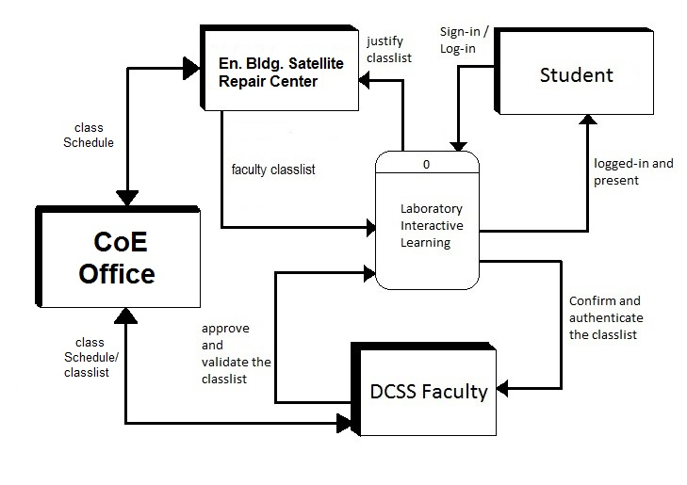

Fig 3.2.1. The context diagram of the proposed system.

The diagram below is the expanded or exploded form of the proposed System. Compare to context diagram above, the diagram below is more detailed and clear that we can understand the sequence and flow of the system.

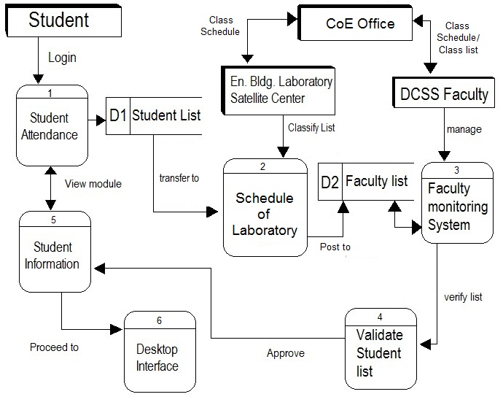

Fig 3.2.2. The diagram 0 of the proposed system.

Project Development

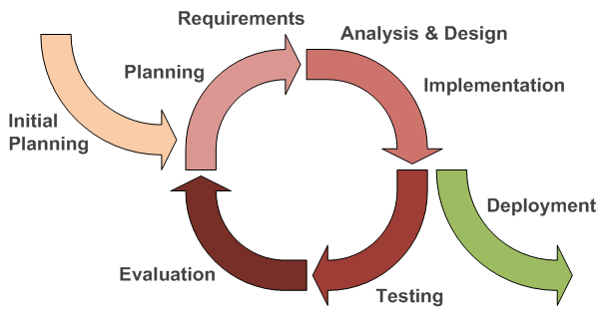

The Agile Model: Iterative Development Model

Figure 3.3.1 System Development Life Cycle Model

Figure 3.3.1 shows the SDLC model used by the proponents for the development of the system. We used prototyping model because it is more effective compare to other models and it is easiest and commonly used by other system developers.

The Agile Model: Iterative Development Model

Initial Planning

During this phase, the proponent conducted an interview to the chosen company regarding the system. Also meetings, discussions and other means of interaction falls under this phase.

Requirements Planning

The Requirements Planning phase shows how the researchers conceptualize the different works to be assigned for each member of the group. The proponents. Divided the tasks among themselves according to their mastery. This phase shows how the time management and plan on what are necessities of the system.

Analysis and Design Implementation

Under the Analysis and Design Implementation phase, the proponents arranged the data gathered and figure out a solution for the problem. They set out a plan to construct a system that would benefit of the owner of the business as well as its customers.

Construction

In this phase, the proponents do the coding process. They combined all of their different ideas to formulate a specific output of code that comprises the whole system

Testing and Evaluation

In this phase, the proponents had their assessment of the system if there are any bugs and errors that may occur and evaluate the System if it's acceptable enough. Hence, the proponents test the system to verify if the program works correctly.

Testing and Evaluation Procedures

Planning

During this phase, the proponents think carefully about the task they need to do for the development of the study and performed brainstorming about the ideas and matters for successful accomplishment of the study.

Data Gathering

After planning phase data gathering phase follows. In this phase the proponents gather all relevant data that will be used to develop the proposed system. The proponents conduct an interview to the University of the East Caloocan staffs to learn the existing process of the company and to gather information and necessary documents that will help for the development of the proposed system.

Data Analysis

After gathering all important information of the Campus, the proponents now analyzed the date they gathered. The proponents figure out how gathered information will be connected to each other to be able to use in the development of the system and the proponents provide a necessary action to accomplish and achieve their objectives. To achieve and develop a successful system. The proponents carefully analyzed what type of programming language they will use to develop the proposed system. Added features for the system are also analyzed in order the system will be more functional.

Designing the System

Next on Data Analysis phase is Designing the System phase. In the phase, the actual coding in the system was made. The system coding was performed by the proponents; they will create all useful functionalities and will added features to the proposed system.

System Testing

In System Testing phase, the proponents perform continuous testing to their system to find some bugs and errors and to lessen the possibility that created system will malfunction in the near future.

Debugging

After performed the System Testing phase, the Debugging phase comes next. In this phase the all bugs and errors found-out on system testing phase will try to have a solution. The proponents perform again the data analysis phase to find-out what functions or features they need to add to the system. the proponents will must perform again the designing phase because they need to manipulate again the codes to assure the error or bugs will not occur again. And after that, they need to perform the testing again to ensure that the system is error/bug free.

Implementing the System

This time the proponents will implement the system to the company; they will orient the users of the proposed system and let them try/handle the system.

Project Planning and Management

In this section demonstrate how the system is planed, organize and Manage gathered resources to create a successful and meaningful documentation to fulfill the goals and objectives. The proponents used Gantt chart to determine the time frame used to complete the necessity of this research.

Gantt Chart

We use Gantt chart to display time duration that occurs during the making of the research and also present the allocation of time spent in order to acquire the essential part of the research. The chart below Illustrate how the process of data gathering occurs during the period of time.

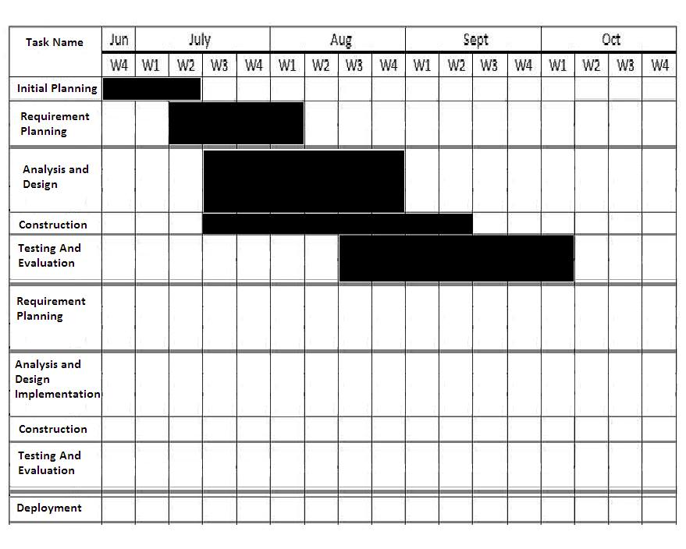

Fig. 3.4.1.1 the Gantt chart of the time spent for research

Work breakdown structure per proponent

|  |  |
| --- | --- |
| Introduction | R. Malapitan |
| Background of the study | R. Malapitan |
| Theoretical Framework | J. Andutan |
| Conceptual Framework | J.Andutan |
| Statement of the Problem | K.Andoy |
| Objectives of the study | K.Andoy |
| Scopes and Limitations of the Study | J.Andutan |
| Significance of the Study | N.Vergara |
| Operational Definition of Terms | K.Andoy |
| Local Literature | J.Andutan |
| Foreign Literature | R.Malapitan |
| Local Studies | K.Andoy |
| Foreign Studies | N.Vergara |
| Synthesis of the Reviewed Literature and Studies | M.Chua |
| Research Method | K.Andoy |
| Project Development | J.Andutan |
| Project Planning and Management | K.Andoy |
| Description of Respondents | N.Vergara |
| Population, Sample Size, and Sampling Technique | R.Malapitan |
| Data-Gathering Procedure | K.Andoy |
| Statistical Treatment of Data | J.Andutan |
| Testing and Evaluation Procedures | M.Chua |

Fig. 3.4.2.1 Work breakdown structure per proponent

The diagram above shows the assigned task and activities of each proponent to achieve their goals by sharing their knowledge and ideas

Description of Respondents

* Students

The main respondents for this study are students because they are going to use and the most beneficiary for this proposed system.

* Professors/Instructors

Respondents that also use the proposed system to monitor and determine the attendance and maintain the discipline of the IT/CS students of the University of the East Caloocan

* College of Engineering

As the home base of IT/CS department is also the respondent

of the proposed system prior to the maintenance of the laboratories and its terminals not only for the IT/CS students but also for the benefit of the Engineering Students.

Population and Sample Size

In this segment the survey only depends and rely to the students of College of Engineering itself because they are the most benefactor of this research and all of the data gathered are use to complete the survey

Population

The population that will test the system are 80 students and 10 professors.

Sample size

The system itself will be occupying at least 2 CLR laboratories which will consist of 40 pcs. each laboratory.

Data-Gathering Procedure

In this method, the proponents gathered all the data and information that can be used to develop the system. This study used internet and library as a source in developing this proposal. This method assists to give solution to the necessity and the problem of the school/university.

Library research method: Gathering the information, references and other previous research work. That is carefully cited to gain more knowledge for the achievement of this study

Internet research method: the Internet as an electronic source of studies is also use to gather ideas, approach, and other online references to complete this study.

Interview: Is another method used by the proponents. We Talk and discuss to the

beneficiaries all about the proposed system. The proponents prepare a set of questions and give to the benefactors to evaluate the system.

Statistical Treatment of Data

Statistical Methods will be used in analyzing the evaluation process. The method that will be used to assess the system is the calculation of the mean

***Mean = x/n***

***Where:***

*Mean = Average*

*x = Summation of Results*

*a = Number of Respondents*

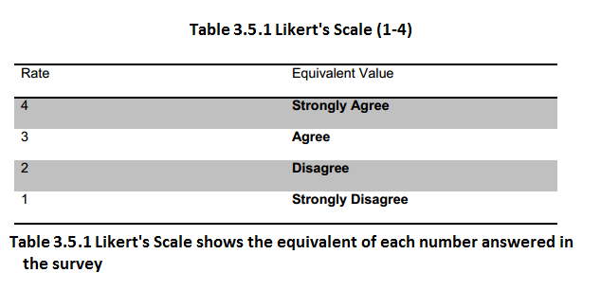

Testing and Evaluation Procedures

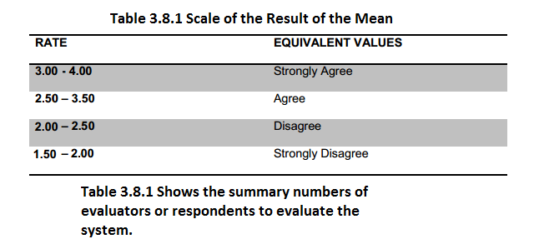

This section is an evaluation area where the students of College of Engineering are going to test the system and be given justification. All of the result and suggestions for this given test is subject to the system improvement.