MANGT510 Midterm

Naomi Kriner
Kyle Brown
Benjamin Foringer
Jeff Krystek

“Bathroom Renovation Project Plan”

Dr. Peerasit Patanakul

3 July 2023

Scenario:
Your team is contacted to renovate a bathroom in a residence of a university professor. You know that the other teams will be contacted as well. The client will make a decision to hire the team that provides the proposal that is reasonable in terms of time, cost, and quality perspectives.
The bathroom is on the second floor of the house and the client would like to optimize the natural light in this 13’ X 13’ bathroom. With this totally renovated bathroom, the client would like to have a whirlpool hydrotherapy system and a separated shower stall. The client would like your team to lay tiles up to the 9’ ceiling. He would also like to have two sinks for him and her with mirrors, cabinets, and plenty of storage spaces. The ventilation, lighting, and plumbing systems must be redone. The client also prefers to have a toilet bowl and a urinal.
From these initial requirements, your team will do as best as you can to propose a project proposal, which includes a project plan, to the client. He does not have much time to meet and discuss so your team may have to make some assumptions if need be. Your team worked with this client before to renovate his kitchen. You know that he is very detail-oriented and focuses on quality. He does not mind paying a little extra as long as he sees the value of the product. He wants the project to start at the beginning of March.

The project plan attached to the proposal should include:
- Executive summary
  - See submission attachment (01_Executive_Summary) for full Executive Summary

- Project Scope Statement
  - See submission attachment (02_Project_Scope_Statement ) for full Project Scope Statement
  - We are also assuming that we (Task Masters) are project managers with background in residential remodeling. We are responsible for project management, designing blueprints, budgeting, installing materials, and any other tasks not covered by contractors. We are paid at a rate of $40/hr, according to the average hourly wage of project managers from ZipRecruiter. Only one PM is assigned each task in the WBS, which allows us to each work to our strengths on a part time basis. When budgeting labor costs, we assume an 8-hour work day. Projects are planned 7 days per week as to fit the client’s timeline as best as possible.

- Deliverable-oriented Work Breakdown Structure (at least the total of 20 items at the bottom most level from all branches). In addition, briefly explain your Work Breakdown Structure (WBS) and discuss the benefits and drawbacks of deliverable-oriented Work Breakdown Structure

Breakdown | Description | WBS | Code
Bathroom Renovation |  |  | 1.0
Deliverable 1 | Blueprints and safety assessment |  | 1.1
WP1 | Make blueprints for redesign of bathroom to optimize natural lighting | 1.1.1
WP2 | Assess safety concerns | 1.1.2
WP3 | Finalize budget | 1.1.3
WP4 | Confirm plans with client | 1.1.4
Deliverable 2 | Preparation and procurement |  | 1.2
WP1 | Hire contractors | 1.2.1
WP2 | Obtain work permits | 1.2.2
WP3 | Consult with client to choose brands/styles of materials | 1.2.3
WP4 | Schedule procurement of materials | 1.2.4
Deliverable 3 | Demolition |  | 1.3
WP1 | Set up safety measures | 1.3.1
WP2 | Demolish bathroom | 1.3.2
Deliverable 4 | Ventilation |  | 1.4
WP1 | Contractor installs HVAC | 1.4.1
Deliverable 5 | Plumbing |  | 1.5
WP1 | Contractor installs plumbing | 1.5.1
Deliverable 6 | Tiles up to 9ft ceiling |  | 1.6
WP1 | Transport materials and staff to site | 1.6.1
WP2 | Install tiles | 1.6.2
Deliverable 7 | Cabinets and storage space |  | 1.7
WP1 | Transport materials and staff to site | 1.7.1
WP2 | Install cabinets | 1.7.2
Deliverable 8 | Sink with his and her mirrors |  | 1.8
WP1 | Transport materials and staff to site | 1.8.1
WP2 | Install sink and mirrors | 1.8.2
Deliverable 9 | Whirlpool Hydrotherapy System |  | 1.9
WP1 | Transport materials and staff to site | 1.9.1
WP2 | Install system | 1.9.2
Deliverable 10 | Separated Shower Stall |  | 1.10
WP1 | Transport materials and staff to site | 1.10.1
WP2 | Install shower stall | 1.10.2
Deliverable 11 | Toilet and Urinal set |  | 1.11
WP1 | Transport materials and staff to site | 1.11.1
WP2 | Install set | 1.11.2
Deliverable 12 | Project Termination |  | 1.12
WP1 | Quality Control and necessary touch ups | 1.12.1
WP2 | Clean up | 1.12.2
WP3 | Double checking accounts, bills, and documentation records | 1.12.3

Benefits of a WBS | Drawbacks of a WBS
- Clear designation of tasks  - Insight to potential risks  - Keeps everyone on the same page  - Great communication with Accounting | - Disrupts existing management strategy  - Not flexible enough for project evolution  - Oversimplifies the project
Our WBS considers the client’s requests and the steps required to successfully complete this project. Deliverables 6-11 covers the former, while Deliverables 1-5 and 12 cover the latter. To sum it up, using a WBS can be a great asset if utilized properly. One must approach the situation with the mindset of creating a project that works with and adapts to the existing management and operations. Asking departments to change too much will result in poor relations, tense conflict, and rough project progression.

- A table indicates tasks, task dependencies, task duration and task cost (focus on labor cost). In addition, discuss or justify the methods you use to estimate task duration and cost (labor).
  - See submission attachment (04_Project_Plan_Master_Chart) for full cost table.

- Human resources required for this project, listed in corresponding to the tasks. Make sure to write a summary regarding the resources needed for this project.

There are physical constraints for this restoration project that prevent us from completing the project any quicker. For instance, we stacked deliverables 6 through 11 so that only allow one person at a time works on the bathroom each day. The area of the bathroom and the nature of the work that needs to be completed for each deliverable only allows for one person to work effectively and efficiently at a time. There are not many resource constraints in terms of human resources for this project other than the bureaucracy and waiting for the permitting process before restoration can be completed. Each person is assigned work that they are experienced and specialized in so that can quickly complete their work assignment. Finally, there are no technical constraints that we can see affecting this project once demolition, ventilation, and plumbing are completed. The remaining six deliverables can be completed in any order, which provides Task Masters flexibility in case one of the workers needs to adjust their schedule (I.e. illness).

The human resources that will be required for this project are as follows:
- Blueprints and safety assessment – 1 Task Master, 5 working days (40 hours) over the course of a week
- Preparation and procurement – 3 Task Masters working separately for a total of 17 days (136 hours) over 4 weeks
- Demolition – Jeff, 2 working days (16 hours)
- Ventilation – 1 subcontractor, 3 working days (24 hours)
- Plumbing - 1 subcontractor, 3 working days (24 hours)
- Tiling – Kyle, 1 working day (8 hours)
- Cabinetry – Naomi, 1 working day (8 hours)
- Vanity Installation – 1 Task Master, 1 working day (8 hours)
- Whirlpool Installation – Ben, 1 working day (8 hours)
- Shower Installation – Ben, 1 working day (8 hours)
- Toilet and Urinal - 1 Task Master, 1 working day (8 hours)
- Project Termination – 3 Task Masters working separately for a total of 40 hours over 3 days

- A list of materials needed for this project and the cost associated with them.
Cost of Materials
Material | Cost | Justification
Tiles | $1988 | 13’x9’ = 117*4 = 468 sqft = $1988, Midrange price to balance cost and quality
Him&Her vanity | $1037 | Midrange price to balance cost and quality, includes storage
Full Cabinet  Over-the-toilet storage | $238  $219 | Full size, some décor  Extra storage without taking up floor space
Whirlpool hydrotherapy | $2937 | Midrange price to balance cost and quality, corner tub to mirror stall
Shower stall | $431 | Midrange price to balance cost and quality, corner stall to mirror tub
Toilet | $718 | Lowest price toilet with a bidet
Urinal | $170 | Lower price with simple design

- Project network diagram based on the items in your WBS and Gantt chart (either draw them by hand or using software). Use items from the bottom most level for the network diagram (and Gantt chart) and make sure that it represents the entirety of your projects. With that your network diagram should have at least 20 nodes that represent the project activities (if you use A-O-N) or at least 20 arrows that represent the project activities (if you use A-O-A).
  - See submission attachment (07_Gantt) for full Gantt Chart
  - See submission attachment (07_Network_Diagram) for full Network Diagram
  - See submission attachment (07_BathroomReno) for reference .mpp file used to create Gantt Chart and Network Diagram

- The identification of project critical path, project duration, and project cost (labor, materials, etc.). Show calculations of forward and backward passes, total cost, etc. In addition, discuss your critical path and justify the project duration and project total cost. Make sure to maintain consistency throughout.
  - See submission attachment (08_CriticalPath) for critical path diagram with calculations.
  - The project’s critical path for this renovation follows the black arrows through the attached project flow PDF. The total cost of the labor for this project is $12,143 and the total cost of materials is $8,378. This brings the total estimated cost of the project to $20,881. The critical path diverges two times in the renovation project flow chart. The first time is during the second deliverable where three activities can be simultaneously completed: hiring, permitting, and consulting. Commercial permitting typically takes a total of 4 weeks to be completed even if it only takes 7 days of work of actual work due to much of the process being in the hands of local bureaucracy. Therefore, we follow this task for the critical path because it takes much longer than the consulting (5 days) and the hiring (5 days) tasks. The second divergence is at the end where quality control, disposal, and record keeping tasks can all be completed simultaneously. However, the record keeping job takes three days, and the other two only take one day, and therefore the critical path follows the record keeping task to reach an estimated project completion time of 50 days.

- Project risks (5 risks), their assessment (probability, impact, risk score, and priority – show calculations), and response plan associated with each risk. Make sure to write a short description of each risk and discuss the result.
  - See submission attachment (09_Risks) for information shown below which also includes calculations used to create values.

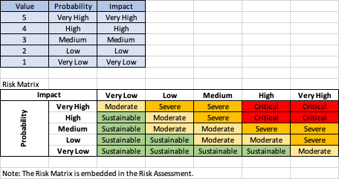
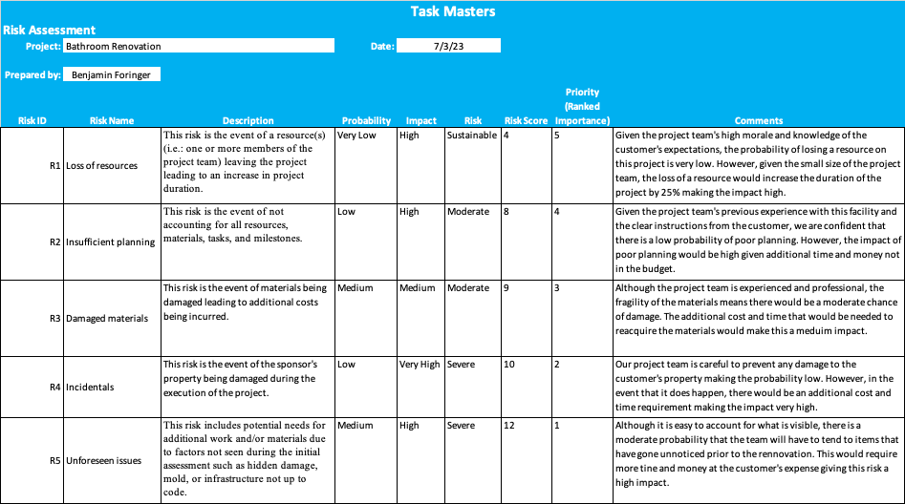

- Conclusion: Summarize your project plan and highlight key issues that you want to draw attention from the client.

The bathroom renovation will include new tiling, a vanity, a cabinet, over-the-toilet storage, hydrotherapy, a shower stall, a toilet with a bidet, and a urinal. On-site renovation time is scheduled for 16 consecutive days in order to minimize the only time the bathroom will not be available for use. The material costs ($8,378) and our estimated labor cost ($12,143) make our overall project estimate $20,881 with an estimated duration of 50 days. There may be variations in the cost and project duration depending on the HVAC contractor hired, the potential variation in time to acquire the necessary permits, and the project risks including a loss of resources, insufficient planning, damaged material, incidental property damage, and unforeseen issue. The customer will have to cover the additional costs incurred by unforeseen issues including but not limited to mold, additional plumbing issues, and hidden infrastructure damage. The Task Masters will cover all other additional costs resulting from the other stated risks that are directly related to their staff and quality of work.

