Data Collection :

**Win Rate against AlwaysRaisedPlayer**

Results for 1000e games against an alwaysRaisedPlayer :

* 1000e : {"AlwaysRaisedPlayer" : 981, "Group19Player" : 19}
* 2000e : {"AlwaysRaisedPlayer" : 930, "Group19Player" : 70}
* 3000e : {"AlwaysRaisedPlayer" : 1000}
* 4000e : {"AlwaysRaisedPlayer" : 1000}
* 5000e : {"AlwaysRaisedPlayer" : 930, "Group19Player" : 70}
* 6000e : {"AlwaysRaisedPlayer" : 922, "Group19Player" : 78}
* 7000e : {"AlwaysRaisedPlayer" : 89, "Group19Player" : 11} // Ran only for 100 games
* 8000e : {"AlwaysRaisedPlayer" : 92, "Group19Player" : 8}
* 9000e :
* 10000e : {"AlwaysRaisedPlayer" : 981, "Group19Player" : 19}

**Win Rate against AlwaysRandomPlayer**

Results for 100 games against an alwaysRandomPlayer

* 1000e : {"Group19Player" : 100}
* 2000e : {"Group19Player" : 100}
* 3000e : {"AlwaysRandomPlayer" : 92, "Group19Player" : 8}
* 4000e : {"AlwaysRandomPlayer" : 93, "Group19Player" : 7}
* 5000e : {"Group19Player" : 100}
* 6000e : {"Group19Player" : 100}
* 7000e : {"Group19Player" : 100}
* 8000e : {"Group19Player" : 100}
* 9000e : {"Group19Player" : 100}
* 10000e : {"Group19Player" : 100}

**Win Rate against AlwaysHonestPlayer**

Results for 100 games against an alwaysHonestPlayer

* 1000e : {"Group19Player" : 100}
* 2000e : {"Group19Player" : 100}
* 3000e : {"Group19Player" : 100}
* 4000e : {"Group19Player" : 100}
* 5000e : {"Group19Player" : 100}
* 6000e : {"Group19Player" : 100}
* 7000e : {"Group19Player" : 100}
* 8000e : {"Group19Player" : 100}
* 9000e : {"Group19Player" : 100}
* 10000e : {"Group19Player" : 100}

**Non-multiprocessing :**

* Total completion time 100 iterations : 1226.4115364551544
* Total build time 100 iterations : 218.0676474571228

**Multiprocessing : (Not completed)**

* Total completion time 100 iterations
* Total build time 100 iterations

**Number of times hand evaluation function was called in training for one iteration :**

* 1048 per iteration

**Deuces Vs PyPokerEngine :**

* Deuces : 0.011290853673761541
* PyPokerEngine : 0.19035700234499844

**AlwaysRaised against AlwaysHonest :**

* {"AlwaysRaisedPlayer": 65.5, "AlwaysHonestPlayer": 34.5}

**AlwaysRaised against AlwaysRandom :**

* {"AlwaysRaisedPlayer": 100}

**AlwaysHonest against AlwaysRandom :**

* {"AlwaysRandomPlayer": 87.5, "AlwaysHonestPlayer": 12.5}

**Five buckets :**

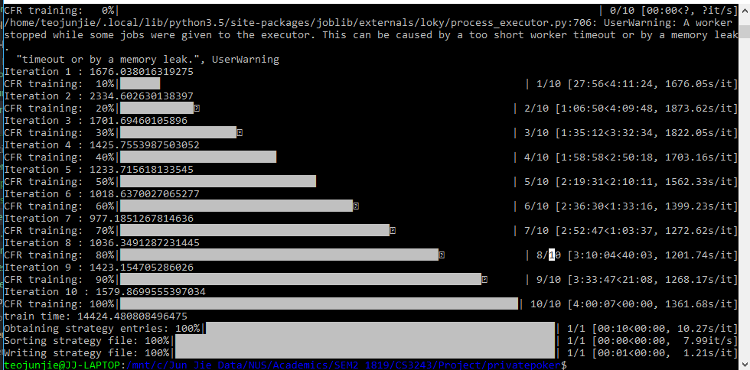

**Ten buckets : (Not Completed)**