Analysis

Analysis

Background Information
The main aim of my project is to design a computerize system that helps to do the stock control of clothes selling for “D-store”. “D-store” is a clothes selling business started in Hong Kong this year. Recently, “D-store” doesn’t have their shop yet. However, their plan is to sell clothes in their shop as well as taking in local orders. They buy in products of other brands and resell them to customers, mainly aim for men market. “D-store” will take in orders from local buyers by phone call and as soon as there are stock and they receive the payment from buyers they ship out the ordered products. Recently they plan to record all data such as sales, orders and members’ details under different folders all in hand-written form. They will also run a discount system which when members buy clothes they will collect member points and when certain amount of member points are collected, they can be used to discount a single item for up to 50%.

Analysis of existing systems
Under the hand-written system, it will be inconvenient when members change their details and the stock controls are done by hand-written paper form. When details are changed, the old details will be crossed out and new details are written on next to the old details or write in a completely new member detail form with the old and newly changed details. When clothes are sold, the amount of stock will be crossed out on their stock book, receipts are created in hand-written form and when discount sales, the price of the items will have to be recalculated again. Besides, member points will always have to be calculated and write manually. Other than inconveniency, human errors are also quite likely to occur in these cases.

Problem Identification
The problem is that there isn’t any computer system available to support their work at the moment. By using a computer system, papers and time can be saved and human errors are less likely to occur. This enables the business to become more environmentally friendly as well as reducing the cost on paper usage and chance of human errors occurring and increase the efficiency. I’m going to design a user-friendly interface system that does stock control, records accurately, as well as calculating the discount for items and produces statistical data such as sales details.

Identification of prospective user(s)
The main user is the owner himself. However, the owner is not always in shop and, therefore shopkeepers or shop-assistants may also be the potential users. However, it also mean that data are not kept safely if it’s an ‘open system’ which everyone can have access to the system and therefore, security would be a problem I have to consider when designing the system.

Limitations
The main limitation is that there is only one computer available in their shop recently. Therefore there won’t be a local area network since only one workstation is available which also means that different users are accessing the same computer. However, there is a printer and therefore I can create print out such as receipts.

Hardware and Software requirements for the system
The new computer system requires software Microsoft Office (minimum requirement is MS Office 2000, XP is recommended) and the operation system Microsoft Windows (minimum requirement is MS Windows 2k, XP is also highly recommended). The computer must match the base requirement of running Microsoft Office so that the new computer system can work properly. Here is the minimum requirement for hardware:

Pentium® 4 800 MHz
128MB RAM
500MB free HDD space

Identification of user needs
After interviewing the owner of “D-store”, Dickson Pang in Hong Kong on summer 2006, I’ve found out what Dickson needs are and so when I design the computer system, I will have to consider his needs. Below are the main requirements of my computer system must meet according to Dickson’s needs:
- Record stock correctly, able to edit the details of stock
- Every sales must be recorded correctly and receipts are printed to customers
- Records must be able to identify for the month of sales made
- Must be able to create or delete members, and able to edit their details
- Member points automatically recalculated when sales made
- Create bills when orders are made and when orders are confirmed remove from record and record in sales
- Produce statistical data such as monthly cost of sales and monthly total sales
- Can backup records on an USB drive that he has
- Keep data safely

Data sources and destinations
Input
-Details of stock such as stockid, sizes, colours…etc, will be recorded into the database via the computer system. (See the entity STOCK)
-Details of members will be recorded into the database when they are created via the computer system. (See the entity MEMBERS)
-Items sold must be input into the system and when sales are made, the quantity of items sold to customers will be reduced.
-Discount percentage must be input when discount sales are on so that the selling price of chosen items will be recalculated.
-When orders are made, the order details will temporarily be stored in the entity ORDERS and when money are received and products are shipped out, the records of ordered items should be transferred to the data table SALES.
-When members purchased products, member points are collected and points can be used to reduce the price of a normal price product.
Output
-When sales are made, receipts of sales details are then printed out to the customers.
-When orders are made, bills will be printed out.
-At the end of the month statistics such as sales figure will be calculated by the system and allow users to print them out.
-Sales records are printed out as a list at the end of the month.
-Lists of stock left are printed out at the end of the month.

Data flow diagram

Data flow diagram Level 0

User/Admin
MEMBERS

Stock Control
SALES
Monthly statistics
Orders print out

STOCK
Bills

ORDERS

Data Flow diagram Level 1

User/Admin
MEMBERS

Make sales
Bills
STOCK

SALES

Calculating statistics

Monthly statistics

Data Flow diagram Level 1

MEMBERS
User/Admin

Make orders
Orders print out
STOCK

Confirmed orders
ORDERS
SALES

Edit orders
Cancel orders

Analysis Data Dictionary
-STOCK (stockID, brand, size, descriptions, pprice, price, quantity)

-ORDERS(ordernumber, memberID, stockID, pprice, price, quantity, time, date, Staff)

-SALES (salenumber, saleID, stockID, pprice, price, quantity, time, date, member, memberID, Fromorders, Staff)

-MEMBERS(memberID, title, surname, forename, contact number, email, address1, address2, address3, Date of register, points)

Other than these 4 entities in the database, I’ve also got a separate text file called USERS that records user details such as username, userID and password. Below is a screenshot of the text file:
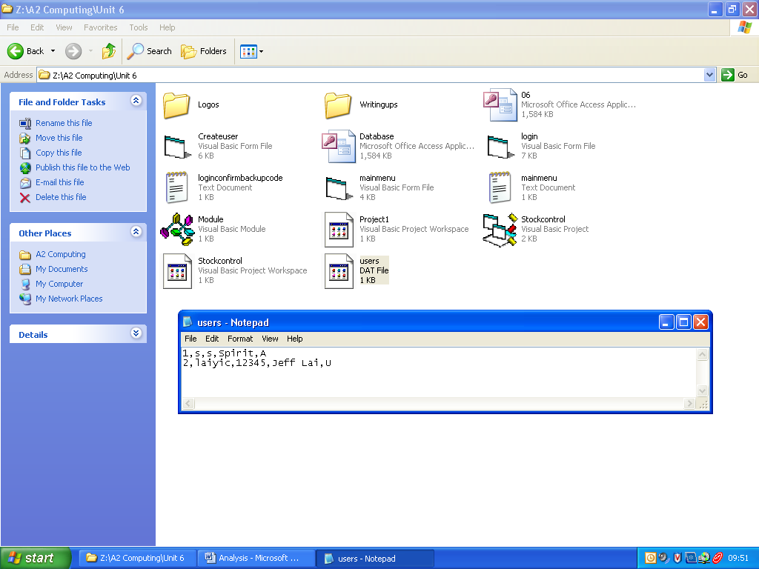

The table contains 5 fields:
-USERS (userID, username, password, name of user, user status)

Table Structures and planned validation
Table name: STOCK
Key field: StockID
Field name | Type, Size | Comment/Purpose | Validation
StockID | Text, 11 | Use to identify stock uniquely | UC170380JP, created by the users themselves but will be checked with the database and therefore it will be unique.
Brand | Text, 30 | To identify which brand the product is | Levi’s, Supreme
Size | Text, 2 | To identify the size of this stock | S, M, L, XL only
Descriptions | Text, 35 | To identify the color of this stock | Blue, Jeans  Black, Jacket
Pprice | Currency, 8 | Price bought in | $500
Price | Currency, 8 | Current price of selling | $1000
Quantity | Integer, 2 | To show how many stock was left | 5

Table name: ORDERS
Key field: ordernumber
Related to MEMBERS on memberID (As a Foreign key of MEMBERS)
Related to STOCK on stockID (As a Foreign key of STOCK)
Field name | Type, Size | Comment/Purpose | Validation
ordernumber | Long Integer, 4
memberID | Long Integer, 4 | Member’s ID | Automatically filled by the computer system when sales are made and buyers are members
stockID | Text, 20 | To identify the item ordered | Must be filled
pprice | Currency, 8 | To record the price of purchase for monthly profit calculation use | Must be filled
price | Currency, 8 | To record the price of sold for monthly profit calculation use | Must be filled
quantity | Integer, 2 | To record the number of stock ordered | Must be filled
time | Date/Time, 8 | To record the time of orders made | Automatically generated by the computer system when orders are made. HH:MM:SS
date | Date/Time, 8 | To record the date of orders made | Automatically generated by the computer system when orders are made. DD/MM/YY
Staff | Text, 20 | To identify which staff made this order | The current user’s name

Table name: SALES
Key field: Salenumber
Related to STOCK on stockID (As a Foreign key of STOCK)
Related to MEMBERS on memberID(As a Foreign key of MEMBERS)
Field name | Type, Size | Comment/Purpose | Validation
salenumber | Autonumber, 4 | Autonumber to identify the items of sold | Automatically unique number
saleID | Long Integer, 4 | Identification of stock sold at one time | Automatically generated by the computer system when sales are made
stockID | Text, 20 | To identify the item sold | Must be filled
pprice | Currency, 8 | To record the price of purchase for monthly profit calculation use | Must be filled
price | Currency, 8 | To record the price of sold for monthly profit calculation use | Must be filled
quantity | Integer, 2 | To record the number of stock sold | Must be filled
time | Date/Time, 8 | To record the time of sales made | Automatically generated by the computer system when sales are made  HH:MM:SS
date | Date/Time, 8 | To record the date of sales made | Automatically generated by the computer system when sales are made  DD/MM/YY
member | Boolean, 1 | To identify whether is a member or not | Yes/No
memberID | Long Integer, 4 | Member’s ID | Automatically filled by the computer system when sales are made and buyers are members
Fromorders | Boolean, 1 | To identify whether is transferred from orders | Yes/No
Staff | Text, 20 | To identify which staff made this sale | The current user’s name

Table name: MEMBERS
Key field: MemberID
Field name | Type, Size | Comment/Purpose | Validation
MemberID | Autonumber, 4 | Unique key of identifying members | Automatically unique number
Title | Text, 4 | Title of customer | Mr, Mrs, Miss, Ms, must be filled
Surname | Text, 15 | Member’s surname | Must be filled
Forename | Text, 20 | Member’s forename | Must be filled
contact number | Text, 8 | Contact number of members | 8 digits, start with 2, 3, 6 or 9 , must be filled
email | Text, 30 | Email of members | Must be valid format like: user@email.com
address1 | Text, 30 | Address of members | Must be filled
address2 | Text, 30 | Address of members | Must be filled
address3 | Text, 20 | Address of members | The districts of Hong Kong (18 different districts)
Date of register | Date/Time, 8 | The date of register of member | DD/MM/YY
points | Long Integer, 4 | Point collected | 700

Entity-Relationship Model diagram

STOCK

SALES

ORDERS

MEMBERS

USERS

This is the ERM diagram of my database design. This shows the relationship between all entities within my database. The entities ORDERS and SALES both relate to the entity STOCK on stockID. The reason I relate them this way is because one specific stock can have many quantity and so one stock can be used to made many different orders or sales where as orders or sales must point to a specific item, which simply means that STOCK to ORDERS or SALES is one to many. Under the policy of “D-store”, ordering requires customers to be a member. The entity ORDERS relates to the entity MEMBERS on memberID. This is then a one to many relation for MEMBERS to ORDERS. The reason it is related this way is because ORDERS requires a memberID to identify which member made the order. USERS is an independent DAT format table out side of the database that records users’ details such as username, password and user status which is used to identify the user is a admin or a user. The entity USERS is not related to any other entities in the database.
Objectives for the proposed system
After analysing the user’s needs, I’ve outlined some objectives that the computer system must be able to achieve below:

- Allows different users to have access to the program
I was asked to keep the system and data safely and so I’m going to enable a login check for users. Therefore I will make the system able to create, delete or edit users
- Print out receipts for customers
Reports will be used in the new system to allow users to print receipts.
- Records monthly sales
Date and time will be recorded when sales are made and therefore when a month’s sales records is requested the system will search only that month’s record.
- Recalculates stock quantity when sales, order made, cancelled or confirmed
Stock quantity will be reduced when sales or orders are made. However, when orders are cancelled the stock quantity will be recalculated for the certain items.
- Print out bill of orders
Report will be printed when orders are made.
- Print out list of stock left
When this function is requested a list of all stock left will be printed out.
- Calculate and print out statistical data such as total sales
When this function is requested statistical data will be calculated and printed out.
- Records store in yearly database basis
The system will manage the database automatically. It will create new database for this year and will backup the old databases. It also allows users to read the database as well as old databases.
- Need security on data
Different users of the system will have different access to the data. Besides, the folder of holding databases will be set to hidden attribute.
- Able to backup or archive records onto USB flash memory
The system will also include a function that helps the users to backup the database to the USB flash memory drive that they have when the user have the certain access permission.
- Automatically calculate and update member points of members in database when sales are made
When sales are made, the member points will be recalculated and updated.
- Managing members details on database
The details of members will be able to edit or add when needed.
Members’ details will be kept and move to the new database when new Year started which new database is created and used.
- Managing stock/items details on database
The details of stock/items will be able to delete, edit or add when needed. Stock left last year will be input to the next year’s database automatically.
- Able to manage orders from program side, such as transfer completed orders to sales records and/or delete cancelled orders
When orders are marked as finished the record will be transferred to the sales records.
When orders are cancelled the records in orders related to the cancelled order will be deleted and the stock/items ordered will be recalculated and updated.

Realistic appraisal of the feasibility of potential solutions
Database based system
Economical feasibility
The shop owner himself has both Microsoft Office and Microsoft Visual Basic and a computer that fits the minimum requirement of the system. Since I’m not charging them for creating the new system, economical feasibility won’t be a problem.

Social feasibility
I will create a very user-friendly interface for the system and I will create a user manual to guide the users, it won’t be a problem for users to learn and understand how to use the system.

Technical feasibility
I’m going to provide technical support to the users if they have any problem on using the system. If bugs are found in the system, I will debug the program for them, which hopefully won’t happen because I will test the system for using all the functions of the system.

Spreadsheet based system
Economical feasibility
The shop owner has Microsoft Office and a computer that meets the minimum requirement of the Microsoft Office, and therefore he is able to use the spreadsheet “Microsoft Excel”. Again, I’m not charging them so it doesn’t cost them anything.

Social feasibility
The spreadsheet based system is not as user-friendly as database based system is, however has the advantage of auto-recalculating the figures when some of the numbers are changed.

Technical feasibility
I’m going to provide technical support to the users when the face any problems on using the spreadsheet system.

Summary
I’ve chosen the database based system. The reason for my choice of solution is that database based system has more advantages over spreadsheet based system. It’s more flexible and has more features, as well as it is bespoke program, it’s specifically written for user’s needs. Another point is that it’s also quite hard and inefficient to record the stock and sales records in the spreadsheet based system.

Justification of chosen solution
With a database based system, human errors are reduced and time is saved for the staff to perform various tasks for the shop such as sales, orders and calculating statistics easily. By simplifying the way to carry out these actions by typing using computer, this improves the efficiency of the working environment by saving time as well as reducing the chance of human errors occur. For example the stock needs to be counted at the end of the month or year without using the system, whereas the system also calculates the stock when sales or orders are made and therefore a list of stock left will be showed in the system. By operating these appropriate actions, time can be saved for the staff to do more other works.

