Design

Design

Overall System Design
The system will be set up for a password request from the users when access to restrict their actions. Different users have different access right to the system and the database. For example, the some salesmen may only check stock details, check customer details and make sales and orders, while people stockmen who are in charge of recording information of newly purchased stocks can add new items and edit information about them and the administrators, who can do everything from above as well as creating users, changing details and all other functions that are not available to the other users. The only person who will have the administrator account is the shop owner, Dickson Pang.
The system will produce reports whenever required by the users that have the right to do so. For example, when sales or orders are made, bills will be printed out, or when required by administrators, the system will produce a statistical report for the month, providing information such as total sales, gross profit, sales : orders ratio…etc.

Identification of Appropriate Storage Media and Format
The storage method I will use for my program will be a CD-ROM. This will include all files of the program as well as the empty database that will be used to create database for the year.

Database Size Estimate
Table name | Record size and Reserve number of records | Total size
Members | 1 Record = 173 bytes  1500 Members | 259.5kb
Orders | 1 Record = 82 bytes  3500 Orders | 287 kb
Sales | 1 Record = 88 bytes  8000 Sales | 704 kb
Stock | 1 Record = 96 bytes  1500 Items | 144 kb
Total size: 1394.5 kb(1.4MB)

Backup and Archiving
The databases can be backed up whenever the user required. After a certain period of time the database may potentially gets enormously big and storing unnecessary data such as old sales records of previous years that are not used by the system therefore storage spaces are wasted. Not only storage spaces but also slows down the speed of the system like searching for fields. The databases can then be archived by the users instead of keeping them on the storage as well as not using them. The system will also recommend user to archive databases that are 3 years or older. Databases are backing up or archiving directly to the user’s USB flash memory drive.

Structure Diagram
Stock Control

Orders
Reports
Sales
Customers
Stocks

Calculates statistical calculations
Discount calculation
Make/Confirm/ Edit/Cancel Orders
Add/Delete/Edit items
Add/Delete/Edit Customer details

Stock recalculation and store in the sales table

Print out reports
Print out order bills
Users

Print out the sales receipt
Add/Delete/Edit Users

Description of measures planned for security and integrity of data
For the reason of data protecting, I will use a login form which requires username and password from the user, which will then be used to check and identify the user’s name and access rights against the database of users. If it does match then the login form will allow the user to have access to the main menu of the program. If the username and password does not match to the database or even not found, then it will show a message box of telling incorrect password or username and will not allow the user to have access to the main menu. In order to prevent users from accessing the database directly, I will hide both the user database and the shop’s database from the users. All the databases will be saved in the folder “databases”. The folder will exist under the same folder as the program. I will use the hidden attribute for the folder and the databases and tell the user to choose not showing hidden folders and files as the window’s option, and therefore users will not be able to find the files. As to data integrity I will have various forms of validation throughout the program in order to make sure no erroneous data can be inputted into the system.

Description of measures planned for system security
There will be 3 main types of access: salesman, stockman and the admin. To consider that some salesmen may also be stockman, which means that they may need two accounts that have different access rights. However, it will cause inconvenience by having two accounts for some staff and therefore I decide to add a status “B” representing “Both” the salesman and stockman. The admin will always have full access to the system. Another words, there will be 4 status, “U”,”S”,”B” and “A” for which “U” represents salesman and “S” stands for stockman.

Data validation
Validation is ensuring that data comes between certain expected parameters. In the system I will apply the validation rules to check for data entered matches the validation rules of the certain fields that the data will be write into the database. For examples, the contact number of customers in the MEMBERS table must be 8 digit numbers (Hong Kong) starting with 2, 3, 6 or 9. However, there are also some data that doesn’t have strict rules for validation. For example, email address the domain name could be varying from everyone and therefore it would be hard to set a rule for validation and therefore when validating it the system will only check does the “@” symbol exist. There are also some data that has only limited choices of options and for those data I will provide a combo box to allow user to choose the options and set limitations to the box in order to limit the data entered are in the acceptable range.

Description of Modular Structure of System

Login Form
The login form has two text boxes which are used to let users to type in their username and password in order to check against the database to confirm themselves in order to obtain permission of access to the system. The user will have to click on the enter button to check their username and password against the database. It also has a button of exit/cancel depending on users typed in their details in or not. The exit button will exit from the program and the cancel button will clear the username and password users typed in. In order to prevent unauthorised access to the system, the number of attempts to login will be limited. The program will not allow anyone to login if run out of attempts allowed.

Mainmenu Form
The mainmenu form contains buttons of opening other forms such as sales and orders on the left hand side of the form. For the different status that users have, which will be checked when they type in their username and password in the login form, different buttons will be shown in this form to limit their access to the system. For example, all the buttons will be available to the admin while only sales, orders, stocks and logout will be available to a salesman. All the forms open in mainmenu will be shown on the right hand side of the form and the fore colour of the buttons will become red when the forms are open, as will be white when the forms are closed.

Users Form
This is the form that will only be visible to the admin and it allows the admin to add user, edit their details or delete users. It contains 4 text boxes and a combo box on the right hand side of the form which are for the username, password and confirm of password, their name and the access status. Depending on the user is accessing add user or changing details, the boxes will be empty or show details of the chosen user. There is also a confirm button which will save the new user or the changed details. However, users are not allowed to edit their own account in this form.

Stock Form
The stock form contains 5 option buttons, adding, editing, deleting, search and show all items on the top of the form. This form is visible to all type of user status but salesman can only access the search stock button and show all items which is at the bottom of the form and show items in this form. Similar to the user form, there will be 5 text boxes and 2 combo boxes and a confirm button on the right hand side of the form which allows users that have permit right to add/edit details of items. By selecting an item on the list follow by clicking the delete button, the selected item will be deleted from the database. Search function will allow user to search items that matches certain criteria from the database

Sales Form
This form will contain a text box that allow user to enter stock ID to search and fill in quantity in the quantity combo box. There will also be discount box that allow user to discount items. Add item button will add the item onto the sales list. The right hand side will be the member details section. By choosing a member, his/her member points will be load from the database and can be used for discount non-discounted items. The total price will be calculated for all items on the list. There will also be a cancel discount button that allows user to get the original price of the item. Confirm sales button will records all the items on the item list into the database and print out a sale invoice of this sale.

Order Form
When initial the form will contain 3 main buttons on the top of the form, make orders, confirm orders and cancel orders. There will also be two lists on the centre of the form. After pressing make orders, the make orders button will turn into “Add order”, text and combo boxes will become visible to let user to fill in information such as stock ID in order to add onto the order list and the member ID to make the order. Total price will be calculated for each order and for pressing “add order” the order will be added into the database and an order invoice will be printed out and the list on left hand side will show the order details and clicking on it the right hand side list will show the items in that order.

Members Form
The member form has 4 main buttons on the top, new member, change details, search member and show all member. The list on the middle of the form will show all member details when started. By clicking the new member item and filling in the boxes on the right hand side and pressing the confirm button, the details for this member will be saved into the database. By clicking on a member on the list after pressing the change details button, all the details will be filled into the boxes on the right hand side and if users match the validation for the boxes, the details will be saved into the database. Search member will allow user to search members that match certain criteria. Show all members will simply show all the members on the list.

Reports Form
When the form start it will automatically calculates the statistics for the recent month. The form contains 2 combo boxes and a calculate button on the top. The will allow user to calculate statistics for specific month. The statistic will be shown in the middle on the form and by pressing print it will print the statistics out. There is also a stock list button and by pressing it list of stock left will be printed out.
Backup and Archive Form
This form has 2 combo boxes on the top of the form. First one is year which allows user to choose a certain year’s database to backup or archive. Second one is the drive to save the database to. The system will automatically search for the USB drive when it is plug in, while it’s not it the system won’t allow to either backup or archive the database. There will also be two options, backup and archive. The confirm button on the bottom will then backup or archive the database.

Change Password Form
This form has 3 text boxes, old password, new password, confirm new password and a confirm button. This form allows the user to change his/her own password.

Identification of Processes & Suitable Algorithms for Data Transformation

Make sale
OPEN SALES
GET SaleID + 1
CLOSE SALES
FOR 1 to NumberofItemsInTheSaleList
GET STOCKID
OPEN STOCK find stock quantity of that STOCKID
IF stock quantity < quantity in list for this item THEN
OUTPUT “Error”
EXIT process
CLOSE STOCK
ELSE
OPEN SALES
GET all fields required in SALES
FILLIN sales details of this tem INTO SALES
CLOSE SALES
END IF
CLOSE STOCK
NEXT item
IF is member THEN
OPEN MEMBERS
FILLIN New Member Points INTO MEMBERS
CLOSE MEMBERS
END IF
OUTPUT “Sale Made”
UPDATE the stock list in the stock form
RESET the sale form
CALL function to print out receipt

Add Order
CHECK the text box MemberID
IF MemberID is filled THEN
FOR 1 to number of item in the order list
GET item price, quantity
OPEN STOCK find stock quantity of that STOCKID
IF stock quantity < quantity in list for this item THEN
OUTPUT “Error”
EXIT process
CLOSE STOCK
ELSE
OPEN ORDERS
GET all fields required in ORDERS
FILLIN sales details of this item INTO ORDERS
CLOSE ORDERS
END IF
NEXT item
UPDATE the stock list in the stock form
OUTPUT “Order Made”
CALL function to print out receipt
ELSE
OUTPUT “Order not completed because MemberID is missing”
Exit process
END IF

Confirm Order
GET order number
OPEN SALES
GET SaleID + 1
CLOSE SALES
OPEN ORDERS find records that match the order number
FOR 1 to record(s) found
OPEN SALES
GET all filed requiredin SALES
FILLIN order detals of this item INTO SALES
CLOSE SALES
NEXT record
CLOSE ORDERS
CALL function to print out receipt

Definition of data requirements
Table name: STOCK
Key field: StockID
Field name | Type, Size | Comment/Purpose | Validation
StockID | Text, 11 | Use to identify stock uniquely | UC170380JP, created by the users themselves but will be checked with the database and therefore it will be unique.
Brand | Text, 30 | To identify which brand the product is | Levi’s, Supreme
Size | Text, 2 | To identify the size of this stock | S, M, L, XL only
Descriptions | Text, 35 | To identify the color of this stock | Blue, Jeans  Black, Jacket
Pprice | Currency, 8 | Price bought in | $500
Price | Currency, 8 | Current price of selling | $1000
Quantity | Integer, 2 | To show how many stock was left | 5

Table name: ORDERS
Key field: ordernumber
Related to MEMBERS on memberID (As a Foreign key of MEMBERS)
Related to STOCK on stockID (As a Foreign key of STOCK)
Field name | Type, Size | Comment/Purpose | Validation
ordernumber | Long Integer, 4
memberID | Long Integer, 4 | Member’s ID | Automatically filled by the computer system when sales are made and buyers are members
stockID | Text, 20 | To identify the item ordered | Must be filled
pprice | Currency, 8 | To record the price of purchase for monthly profit calculation use | Must be filled
price | Currency, 8 | To record the price of sold for monthly profit calculation use | Must be filled
quantity | Integer, 2 | To record the number of stock ordered | Must be filled
time | Date/Time, 8 | To record the time of orders made | Automatically generated by the computer system when orders are made. HH:MM:SS
date | Date/Time, 8 | To record the date of orders made | Automatically generated by the computer system when orders are made. DD/MM/YY
Staff | Text, 20 | To identify which staff made this order | The current user’s name

Table name: SALES
Key field: Salenumber
Related to STOCK on stockID (As a Foreign key of STOCK)
Related to MEMBERS on memberID(As a Foreign key of MEMBERS)
Field name | Type, Size | Comment/Purpose | Validation
Salenumber | Autonumber, 4 | Autonumber to identify the items of sold | Automatically unique number
saleID | Long Integer, 4 | Identification of stock sold at one time | Automatically generated by the computer system when sales are made
stockID | Text, 20 | To identify the item sold | Must be filled
pprice | Currency, 8 | To record the price of purchase for monthly profit calculation use | Must be filled
price | Currency, 8 | To record the price of sold for monthly profit calculation use | Must be filled
quantity | Integer, 2 | To record the number of stock sold | Must be filled
time | Date/Time, 8 | To record the time of sales made | Automatically generated by the computer system when sales are made  HH:MM:SS
date | Date/Time, 8 | To record the date of sales made | Automatically generated by the computer system when sales are made  DD/MM/YY
member | Boolean, 1 | To identify whether is a member or not | Yes/No
memberID | Long Integer, 4 | Member’s ID | Automatically filled by the computer system when sales are made and buyers are members
Fromorders | Boolean, 1 | To identify whether is transferred from orders | Yes/No
Staff | Text, 20 | To identify which staff made this sale | The current user’s name

Table name: MEMBERS
Key field: MemberID
Field name | Type, Size | Comment/Purpose | Validation
MemberID | Autonumber, 4 | Unique key of identifying members | Automatically unique number
Title | Text, 4 | Title of customer | Mr, Mrs, Miss, Ms, must be filled
Surname | Text, 15 | Member’s surname | Must be filled
Forename | Text, 20 | Member’s forename | Must be filled
contact number | Text, 8 | Contact number of members | 8 digits, start with 2, 3, 6 or 9 , must be filled
email | Text, 30 | Email of members | Must be valid format like: user@email.com
address1 | Text, 30 | Address of members | Must be filled
address2 | Text, 30 | Address of members | Must be filled
address3 | Text, 20 | Address of members | The districts of Hong Kong (18 different districts)
Date of register | Date/Time, 8 | The date of register of member | DD/MM/YY
points | Long Integer, 4 | Point collected | 700

Sample of planned data capture and entry designs
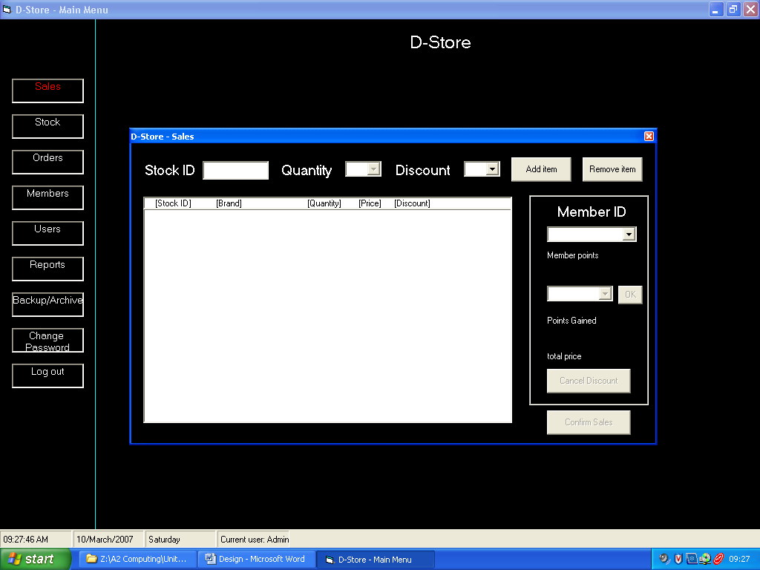

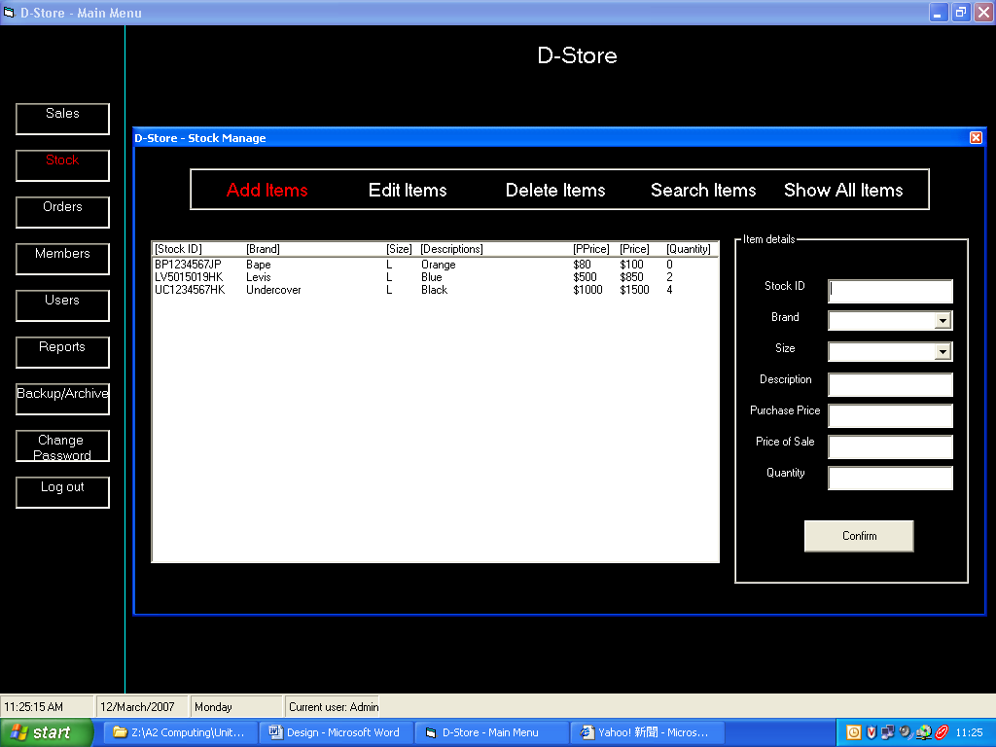

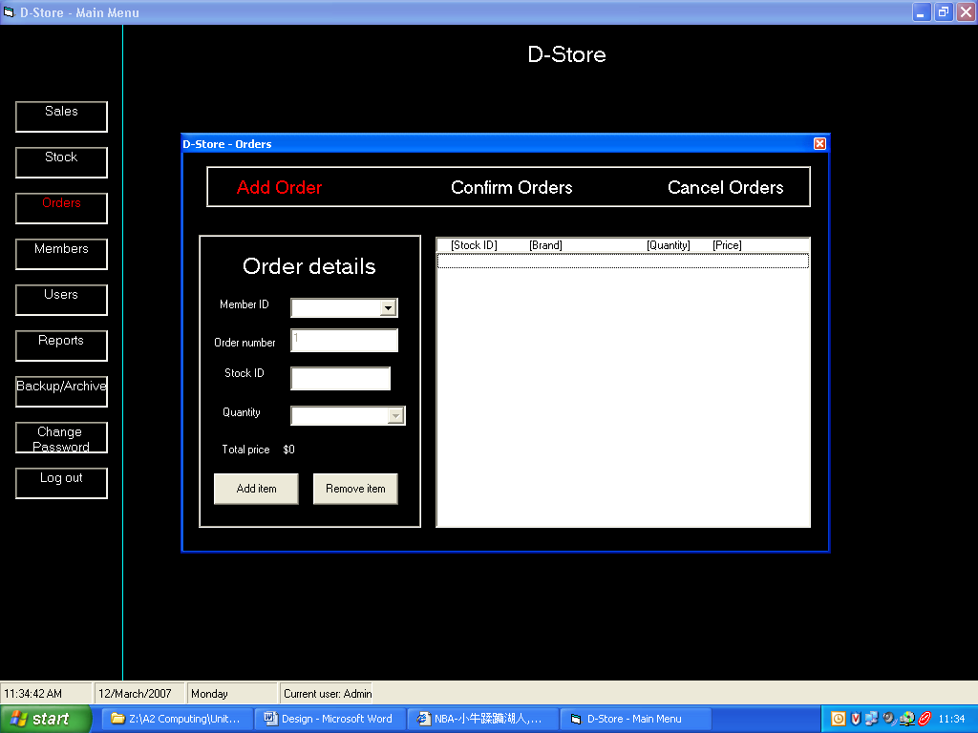

Overall test strategy

I will test every part of my system to ensure that the system is performing the specification required and is robustness to any potential errors on extreme data that I could think of. However, I will only show part of all the tests for each of the forms, for the reason of not repeating same/similar tests. For example, there are many buttons on the mainmenu form to show other form, but I will only include one test for those buttons in this section, although I will make sure that each of they are working properly.

Login Form
Test number | Test Purpose | Expect Result
1 | Attempt to open the program for more than once at a time | The secondly opened one will be closed automatically
2 | Login with correct username and password as a “Admin” | Unloads the login form, shows the mainmenu form
3 | Login with incorrect username and/or incorrect password | Message of “Incorrect username or password”, and clears the username box and password box
4 | Login as a “User” | Shows only the “sales”, “stock”, “orders”, “members”, “change password” and “logout” buttons

Mainmenu Form
5 | Click on the Sales button on the mainmenu form | Shows the sales form within the frame of the mainmenu on the left hand side
6 | Click on the Log out button on the mainmenu form | Unloads the mainmenu form and shows the login form

Sales Form
7 | Type in a valid Stock ID that has stock | The quantity combo box enables and allows user to pick a number up to the maximum stock
8 | Type in an invalid Stock ID | Message of “Invalid Stock ID” shows
9 | Type in a valid Stock ID that has no stock | Message of “No Stock” shows
10 | Attempt to type in more characters of stock ID for more than 11 word length | The text box will become empty
11 | The discount rate combo box | Allows user to pick a discount rate range from 65% to 95%
12 | Attempt to change the quantity combo box | Clears and disables the combo box and the discount rate combo box
13 | Add item button with filled Stock ID and quantity (discount rate is optional) | Adds details of the item into the sales list, recalculates the price if discount rate was chose, calculates the points gain and total price, reduce the maximum allow in quantity combo box
14 | Chose a item on the sales list and click delete item | Removes the details of the chosen item from the list
15 | Choosing a member from the members combo box | Disables the member combo box, shows the member points of that member
16 | Clicking on an item after chose a member | Enables the member points based discount rate combo box
17 | Click on the “OK” button after chose a discount rate | Apply discount to an chosen non-discounted item, calculates points gain after sale and recalculated the total price. Discounted items are not allowed to discount again.
18 | Click on the “OK” button after chose a discount rate and attempt to discount a discounted item | The system will not discount the discounted item and displays error message
19 | “Cancel Discount” button after chose an item | Recalculates the price of an discounted item to it’s original sale price
20 | Confirm Sale | Adds all items on the list to the database, recalculates the member points, update the stock list in the stock form and prints out receipts

Stock Form
21 | Attempt to type in Stock ID that is longer than allowed length, 11 | When click on confirm the system will not add the stock and displays error message
22 | Attempt to include characters in price | When click on confirm the system will not add the stock and displays error message
23 | Put number “1” as price | The system should accept the data
24 | Attempt to put number below 1 or over 50000 as price | When click on confirm the system will not add the stock and will display message "Invalid price"
25 | Pressing the “Confirm” button in “Add item” mode with invalid or empty field(s) | From up to down order, the empty or invalid field’s text will become red and Message of either invalid or empty field
26 | Pressing the “Confirm” button in “Add item “ mode with all filled and valid fields | Adds the item details into the database, clears all fields, and updates the stock list
27 | In “Edit item” mode, choose stock on the list | Shows all details of that stock, allows users to edit them and save by pressing the “Confirm” button
28 | In “Edit item” mode, choose stock on the list and press “Delete items” | A confirmation message shows up and if confirm the item will be removed from the database as well as the list
29 | In “Search item” mode, fill in wanted search criteria (could be empty) for the fields and press confirm | Searches for items in the database that matches the criteria and shows on the list
30 | Search for item with no match criteria | Show the search result as in nothing if no items of criteria match is found

Orders Form
31 | Press the “Make Orders” button | The order list become invisible and a frame that allows users to choose/fill in information such as stock ID, quantity and member ID and add item to the item list will become visible, the font of the button will become “Add Order”
32 | Choose “Create member” in member ID combo box | Shows the Members Form
33 | Attempt to change member ID | Cleans the combo box
34 | Press the “Add Order” button | With at least one item in the item list and chose a member, confirmation message shows up and if confirm all items with details will be added into the order table, and receipt print out
35 | Choose an order from the order list and press “Confirm Order” | Confirmation message shows up and if confirm, all records of that order will transfer to the sales table, update the list and prints out receipt
36 | Choose an order from the order list and press “Cancel Orders” | Confirmation message shows up and if confirm, all records of that order will be removed, quantity of for the stock ID will be added back to stock table and updates the list

Members Form
37 | In “New Member” mode, Type in all valid fields but use same contact number as an existing member | Message of “Contact number already used by another user” and highlights the field’s text as font colour red
38 | In “New Member” mode, Type in all valid fields but use same contact email as an existing member | Message of “Email address already used by another user” and highlights the field’s text as font colour red

Users Form
39 | In “Edit user” mode, attempt to change any details of the currently using account | Message of “Change of current account’s details is not allowed in this mode”

Report Form
40 | Combo box “cbyear” | Shows only databases within the “Databases” folder that are named of years (excluding the user database and default database)
41 | Combo box “cbmonth” | Shows options of months only up to the current month for the recent year and all months for previous years
42 | Command button “Calculate” | Searches for records in the chosen month in the chosen database and calculates the statistics. Message of “No records found in this month” shows if no records exist for that month.
43 | Command button “Print” | Prints out a report having statistics calculated on the form along with all the items sold over the chosen month.
44 | Command button “Stock List” | Prints out a list of stock left (quantity larger than 0)

Backup/Archive Form
45 | Combo box “dselect” | Shows “Drive not found” when the USB drive is not connected to the computer
46 | Combo box “dselect” | Shows the drive’s name if the USB drive is found
47 | Option button “Backup” | When this button is chose and dselect is not empty, cdbyear is not empty and button “confirm” was pressed then the chosen database will be backup onto the USB drive, within the root folder “Databases”, will be created if not exist
48 | Attempt to Archive this year’s record | Not allow to archive this year’s record
49 | Option button “Archive” | When this button is chose and dselect is not empty, cdbyear is not empty and button “confirm” was pressed then the chosen database will be archived onto the USB drive, within the root folder “Databases”, will be created if not exist

Change Password Form
50 | “New password” textbox not same as “Confirm new” textbox | Message of “New passwords not match!”, not allow to change password
51 | “Old password” textbox same as “New password” and “Confirm new” textboxes | Message of “The new password can’t be the same as old one”, not allow to change password

Test Date

Test number | Test data
2 | Username : “s”, password : “s”
3 | Username : “s”, password : “d”  Username : “d”, password : “s”
4 | Username : “d”, password : “d”
7 | Stock ID : “UC1234567HK”
8 | Stock ID : “UC1234567UK”
9 | Stock ID : “BP1234567HK”
12 | 99
13 | Stock ID : “UC1234567HK”, Quantity : 1
14 | Stock ID : “UC1234567HK”, Quantity : 1
15 | Member ID : 1, Mr Lai
17 | Stock ID : “UC1234567HK”, Quantity : 1
18 | Stock ID : “UC1234567HK”, Quantity : 1
19 | Stock ID : “UC1234567HK”, Quantity : 1
20 | Stock ID : “UC1234567HK”, Quantity : 1
21 | Stock ID : “ABC98546252232”
22 | Price : as1324dvhgfd
23 | Price : 1
24 | Price : 0 AND Price : 50001
25 | Size : “J”, Description : empty
26 | Stock ID : “MF1234567UK”, Brand : “Millfield”, Size : “L”, Description : “T-Shirt”, Purchase Price : “$300”, Price of Sale : “$400”, Quantity : “5”
27 | Item Stock ID : “MF1234567UK”, edit field “Size”, from “L” to “XL”
28 | Stock ID : “MF1234567UK”, Brand : “Millfield”, Size : “L”, Description : “T-Shirt”, Purchase Price : “$300”, Price of Sale : “$400”, Quantity : “5”
29 | Stock ID : “MF1234567UK”, Size : “XL”
30 | Stock ID : “MF1234567UK”, Size : “L”
33 | Member ID “gfjddgfg32142”
34 | Member ID : “1) Mr Lai”  Order number : 1  Stock ID : UC1234567HK  Quantity : 1  Price : $1500
35 | Order ID : 1  Member ID : 1  Member Name : Mr Lai  Price : 1500
36 | Order ID : 2  Member ID : 2  Member Name : Mr safdasd  Price : 400
37 | 60238102
38 | Laiyic@millfieldschool.com
39 | Current user’s username : s  Status : Admin  Attempt to change to : User
41 | 07 in Combo box “cbyear”
 | 06 in combo box “cbyear”
50 | New password : w  Confirm new : g
51 | Old password : s  New password : s  Confirm new : s

