Testing

Testing

Test No. | Actual Result
1 | Only one program window is shown
2 | Successfully log in as an “Admin”  See fig 1
3 | Unsuccessful to log in the program, shows message of “Incorrect username or password”  See fig 2
Unsuccessful to log in the program, shows message of “Incorrect username or password”
See fig 2
4 | Successfully log in as an “User”  See fig 3
5 | Shows the form sales within the mainmenu form  See fig 4
6 | Unloads the mainmenu form and shows the login form
7 | See fig 5 & fig 6
8 | See fig 7 & fig 9
9 | See fig 8 & fig 9
10 | The text box becomes empty
11 | See fig 10
12 | The quantity and discount rate combo box becomes empty
13 | See fig 11
14 | Removes the item from the list  See fig 12
15 | See fig 13 & fig 14
16 | See fig 15
17 | See fig 16
18 | See fig 17
19 | Recalculates the original price of the discounted item and update the list
20 | Update the table “Sales” and “Members”, prints out receipt  See fig 18 & fig 19
21 | Will not add the item to the database
22 | Display error message “Characters not allowed in this field” and not adding the item to the database  See fig 20 & 21
23 | Accepting 1 as a price
24 | Display error message "Invalid price" and not adding the item to the database  See fig 23
Display error message "Invalid price" and not adding the item to the database
See fig 24
25 | The label for the field “Size” will be highlight as red
26 | Item is added to the table Stock  See fig 25
27 | Table Stock is updated  See fig 25 & fig 26
28 | Table Stock is updated
29 | Shows all matched results  See fig 28 & fig 29
30 | Shows no results  See fig 30 & fig 29
31 | See fig 30
32 | Shows the Members Form
33 | Cleans the combo box
34 | See fig 32, fig 33 & fig 34
35 | See fig 36, fig 37, fig 38 & fig 39
36 | See fig 35 & fig 36
37 | Not adding the record to the member table  See fig 40
38 | Not adding the record to the member table  See fig 41
39 | Nothing changed
40 | See fig 42 & fig 43
41 | 07 only allows options of month choice up to March
 | 06 allows options of month choice of whole year
42 | Calculates the statistics for the month chosen  See fig 44
43 | Prints out the statistics of that month
44 | Prints out all the stock that has quantity (larger than 0)
45 | See fig 45 & fig 46
46 | See fig 47 & fig 48
47 | See fig 49, fig 50, fig 51 & fig 52
48 | See fig 53
49 | See fig 54, fig 55, fig 56 & fig 57
50 | Message of “New passwords not match!”, not updating password
51 | Message of “The new password can’t be the same as old one”, not updating password

Fig 1 Fig 2
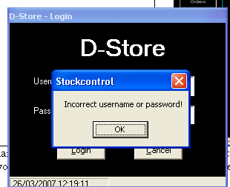
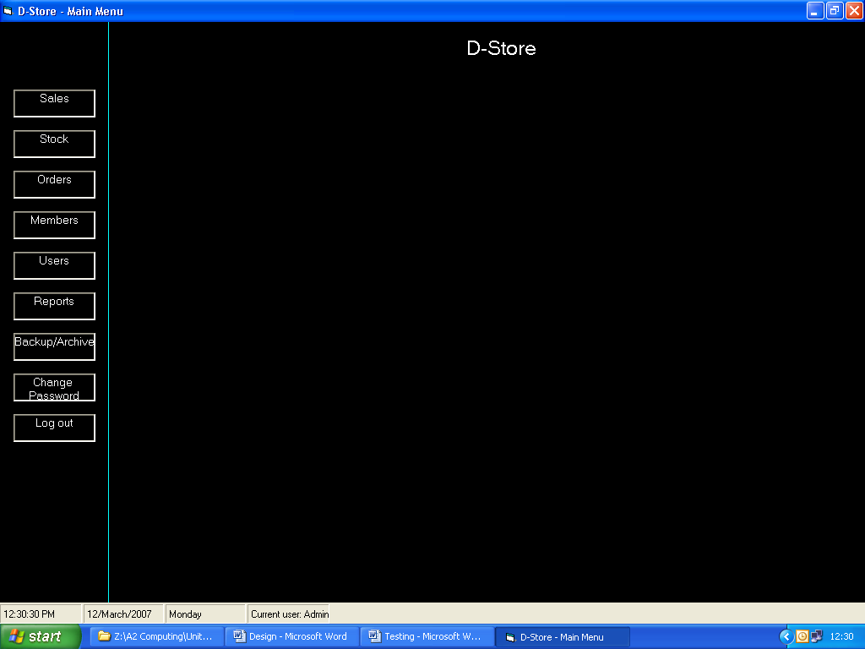

Fig 3 Fig 4
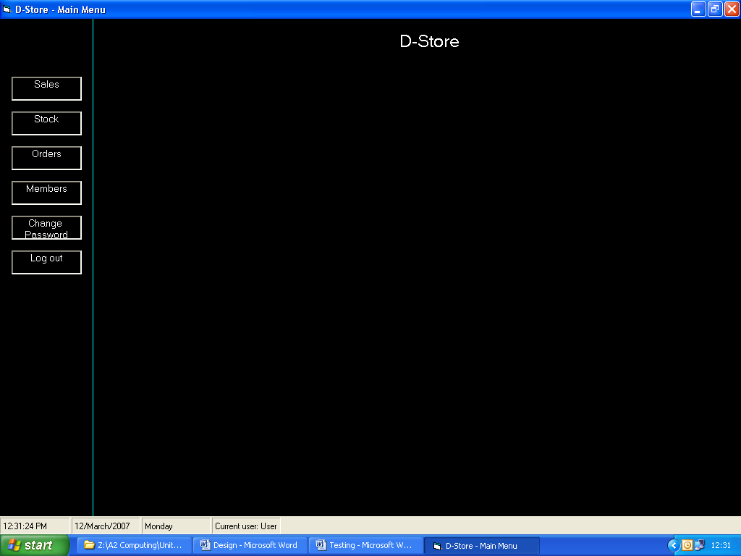
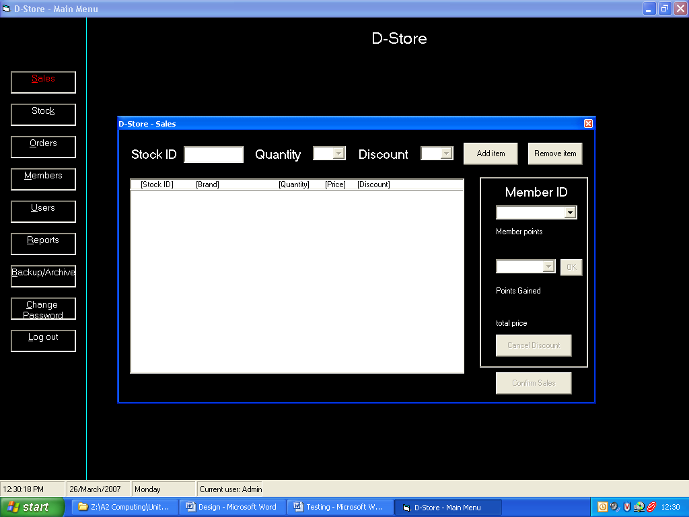

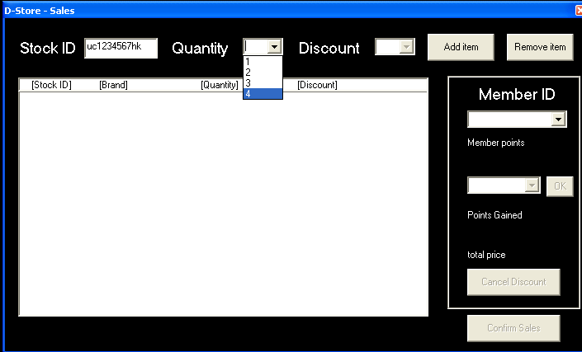
Fig 5

Fig 6 Fig 7
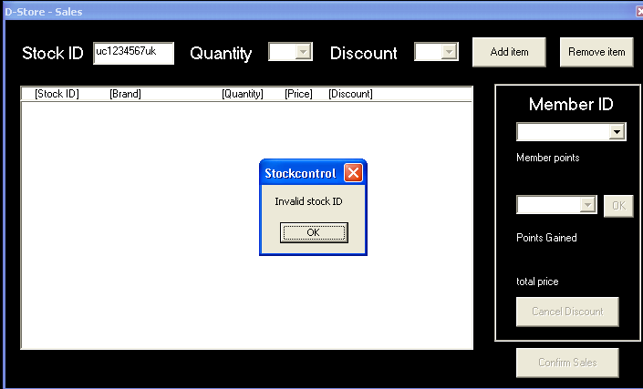
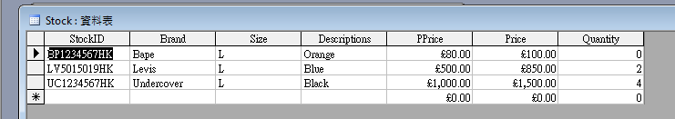

Fig 8
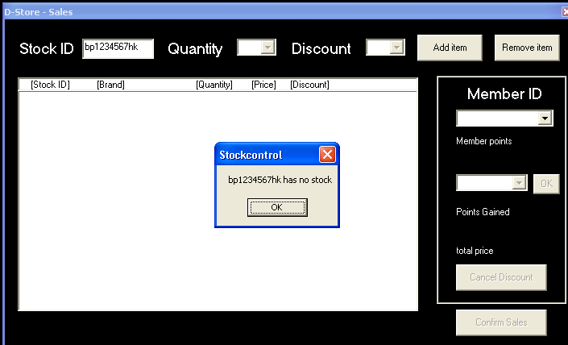

Fig 9
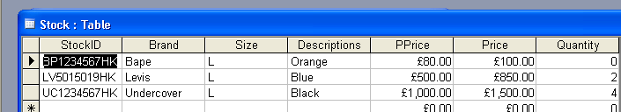

Fig 10
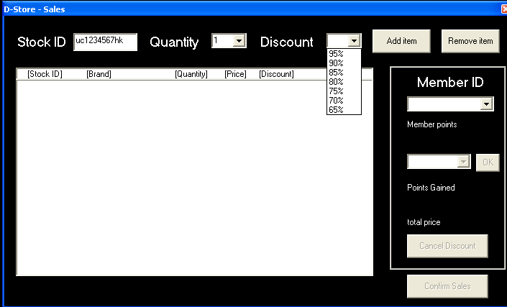

Fig 11
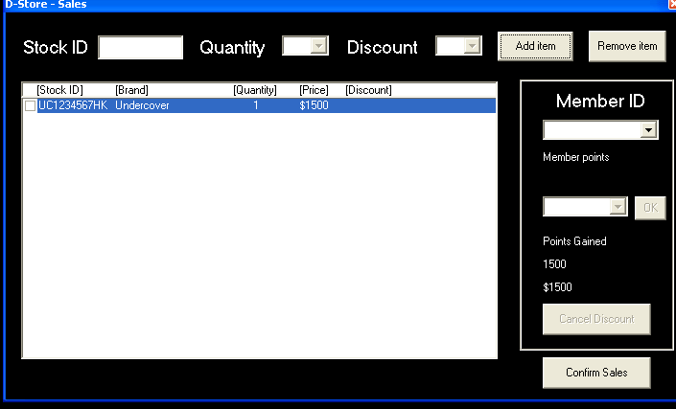

Fig 12
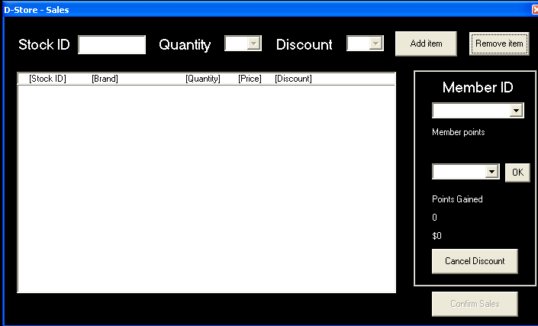

Fig 13
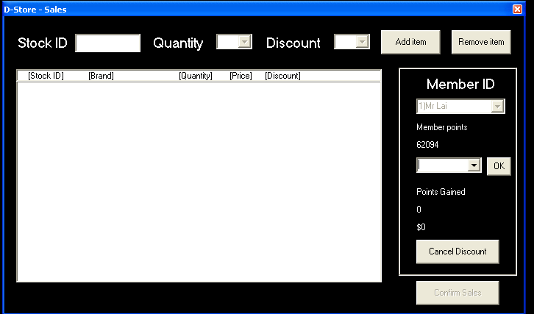

Fig 14
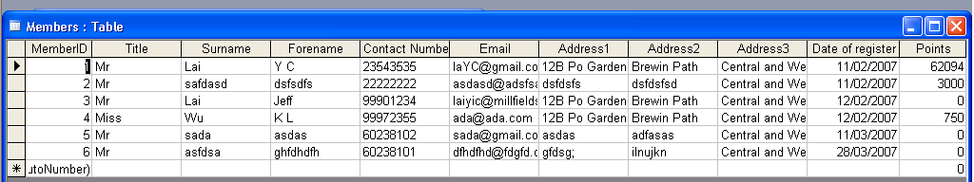
Fig 15
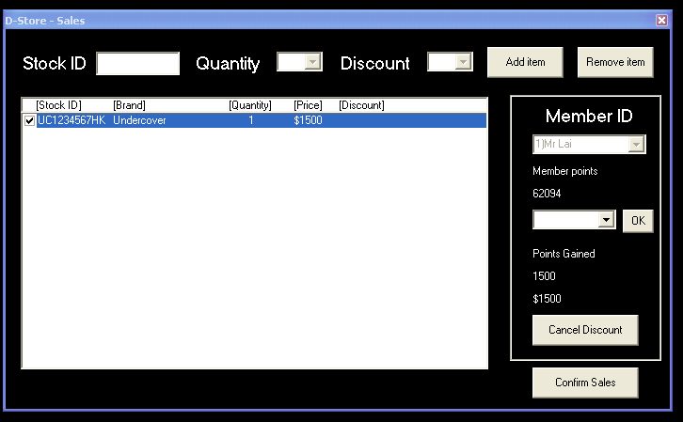

Fig 16
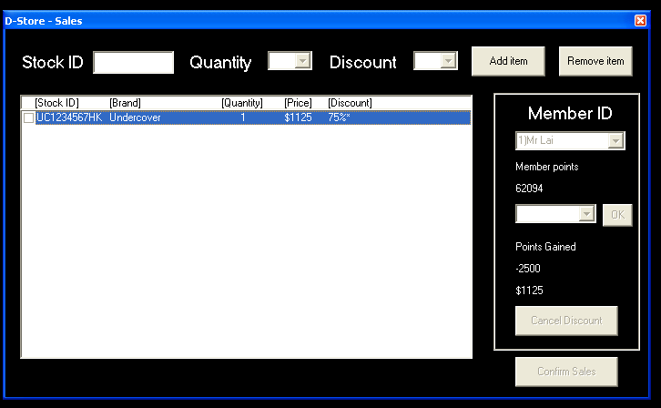

Fig 17
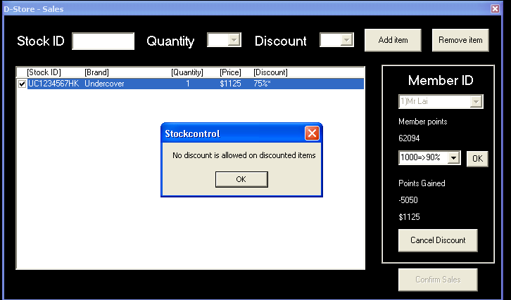

Fig 18
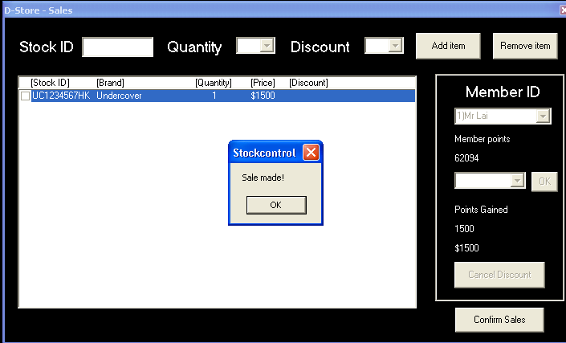

Fig 19
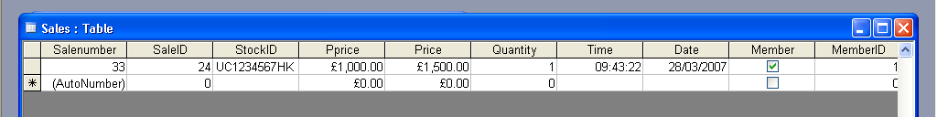

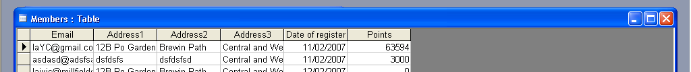
Fig 20

Fig 21
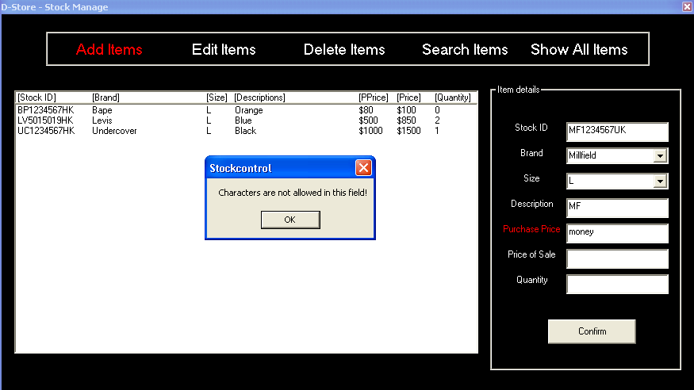

Fig 22
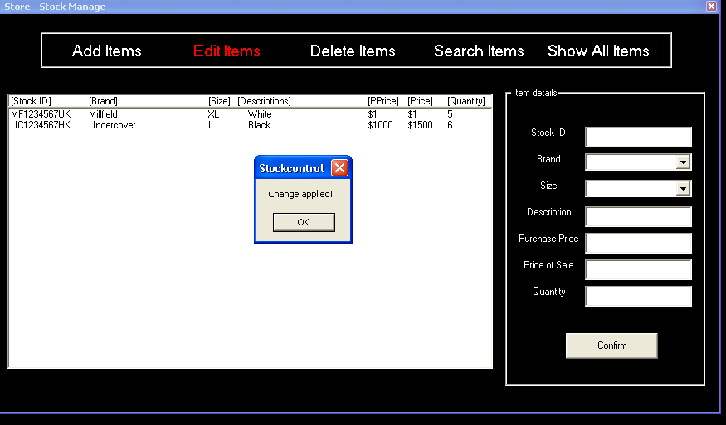

Fig 23
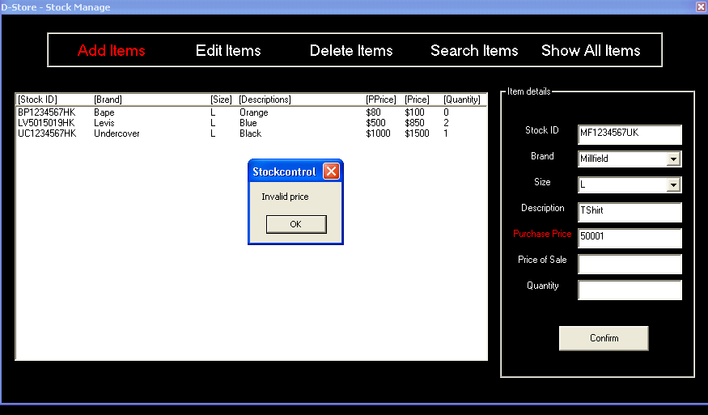

Fig 24
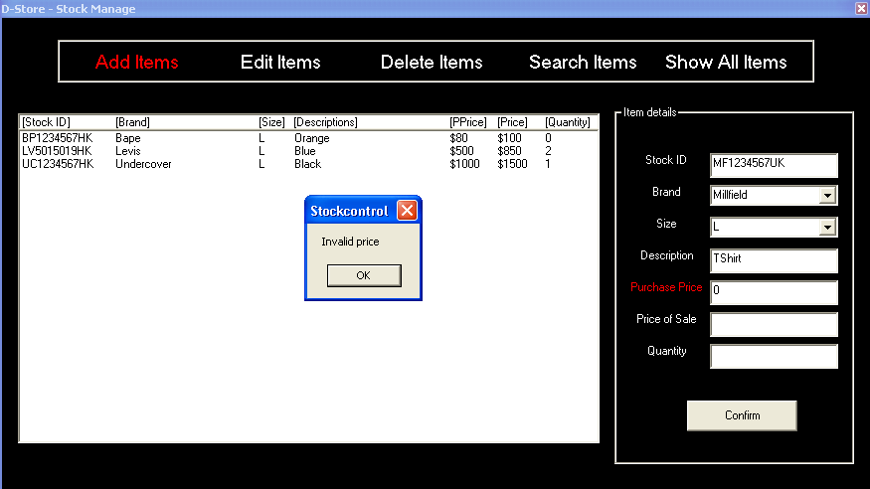

Fig 25
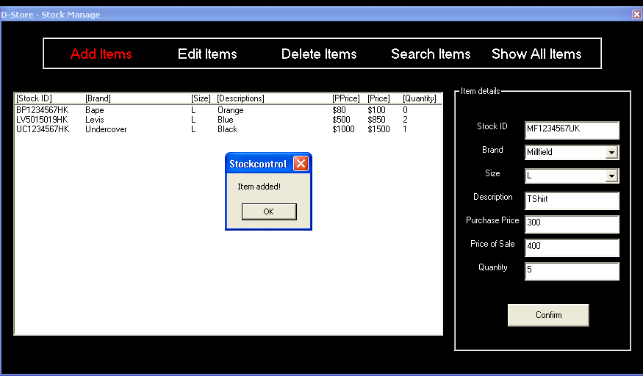

Fig 26
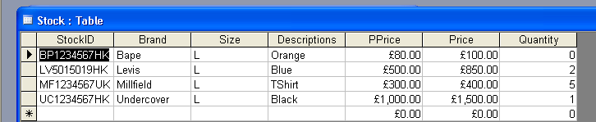

Fig 27
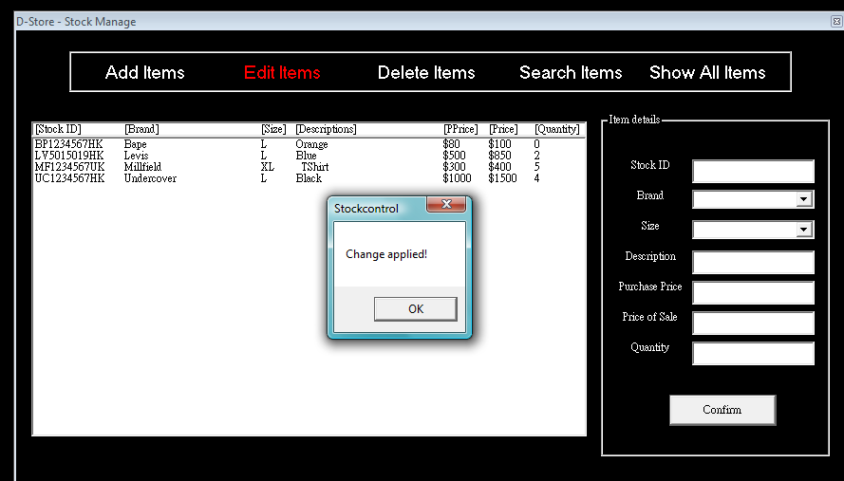

Fig 28
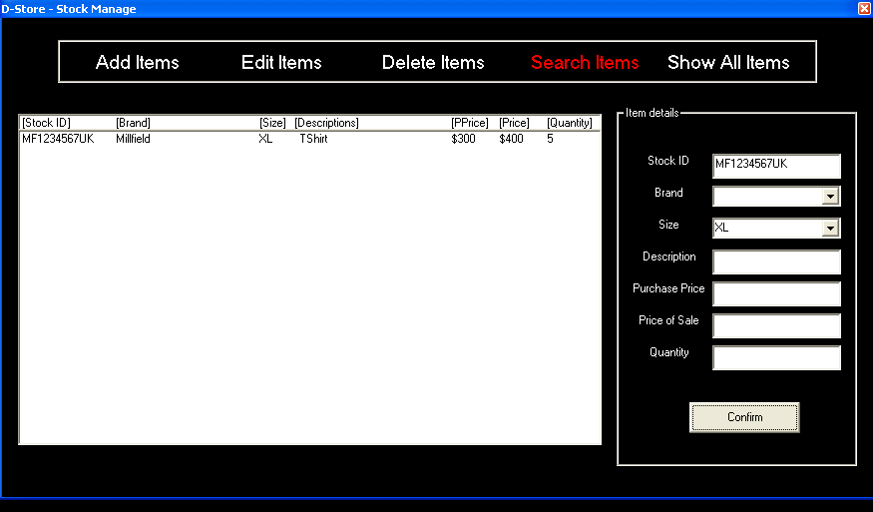

Fig 29
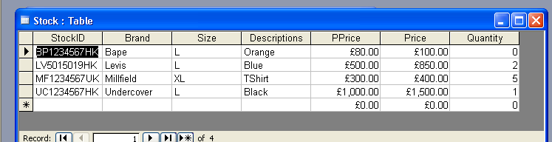

Fig 30
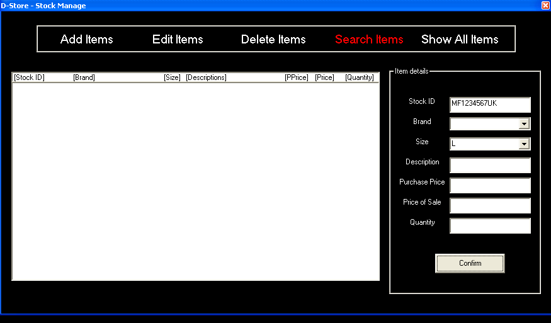

Fig 31
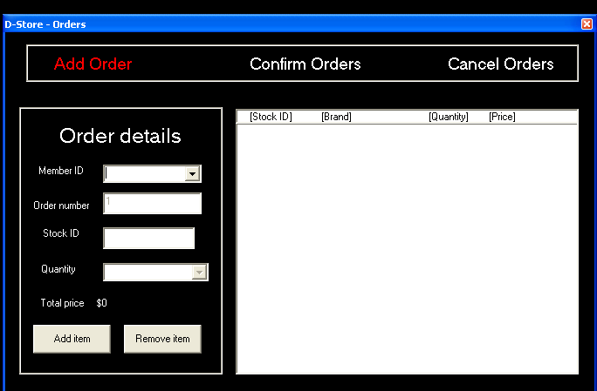

Fig 32 Fig 33
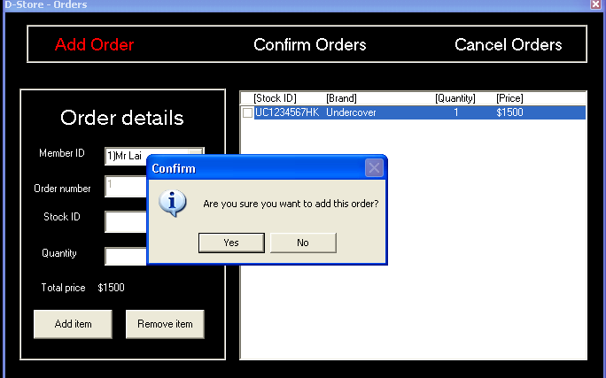
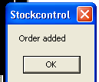

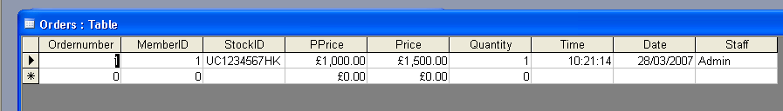
Fig 34

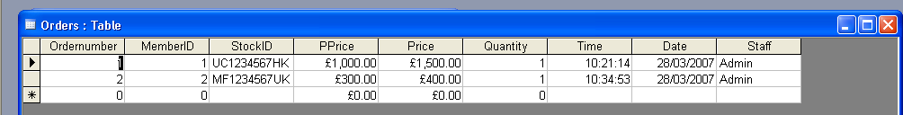
Fig 35

Fig 36
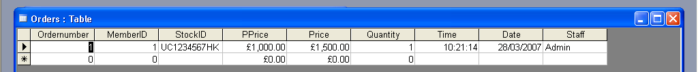
Fig 37 Fig 38
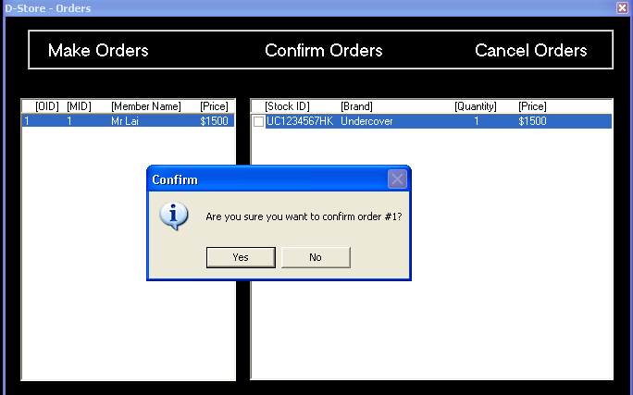
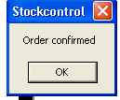

Fig 39
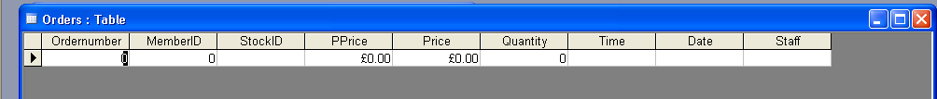

Fig 40
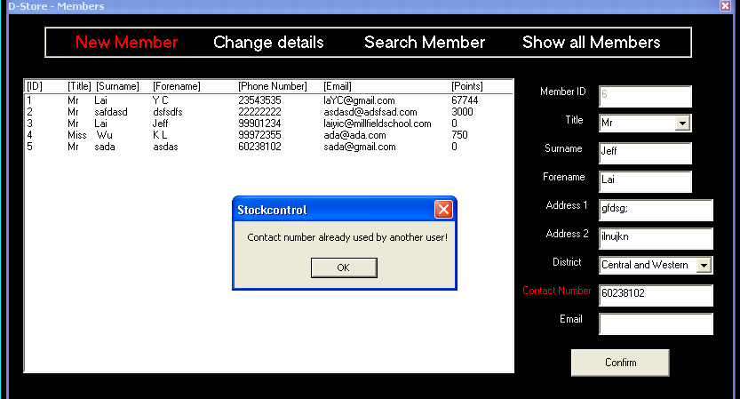

Fig 41
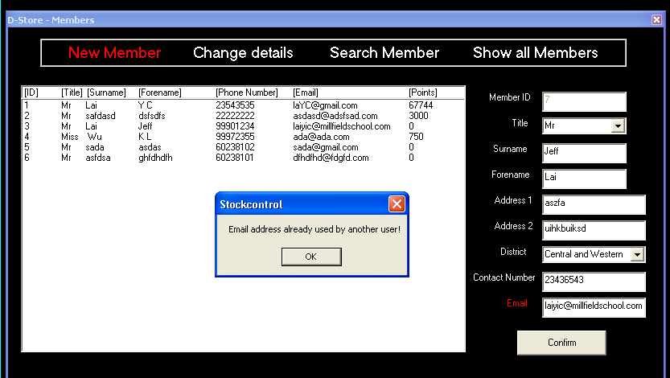

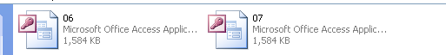
Fig 42

Fig 43 Fig 44
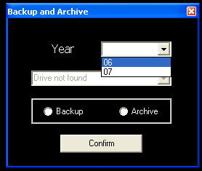
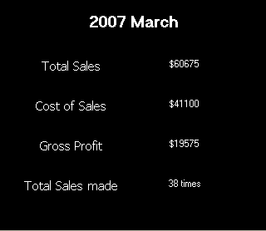

Fig 45
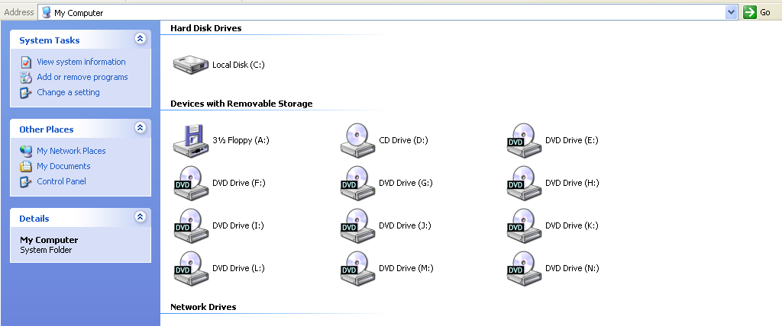
Fig 46 Fig 47
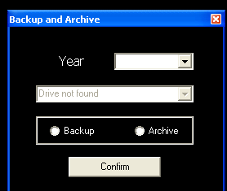
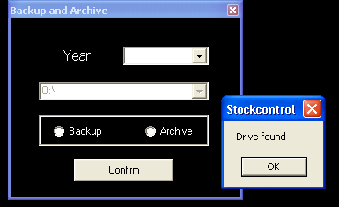

Fig 48
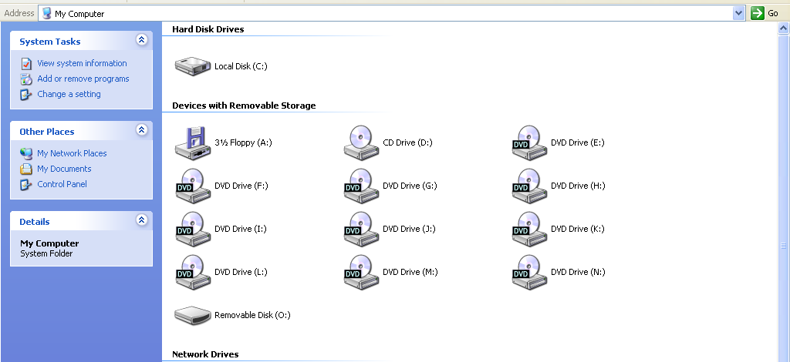

Fig 49 Fig 50
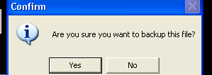
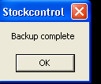

Fig 51
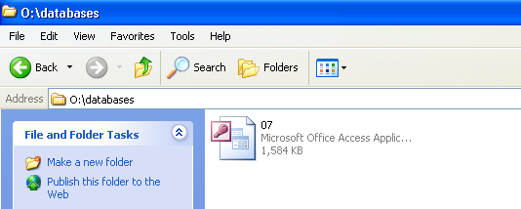

Fig 52
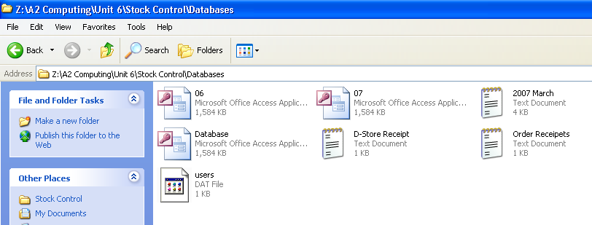

Fig 53 Fig 54 Fig 55
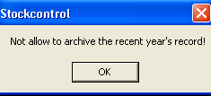
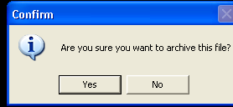
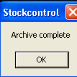

Fig 56
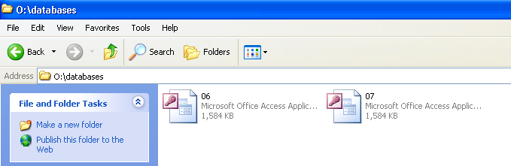

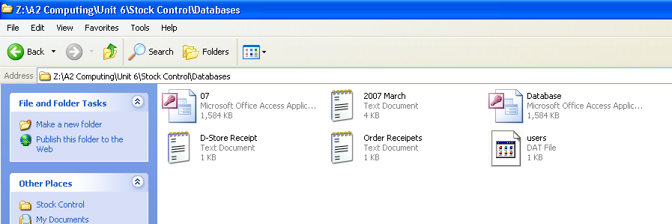
Fig 57

