**ADMINISTRATIVE USER GUIDE**

[**www.jcnfinancial.com**](http://www.jcnfinancial.com)

**Log into the administrative portal**

Go to [www.jcnfinancial.com](http://www.jcnfinancial.com) and click *Admin Login* at the bottom of the page

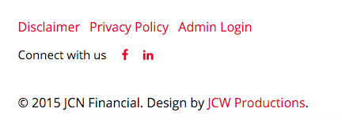

**Creating blog posts**

After signing in, click *Manage Blog* at the bottom of the page

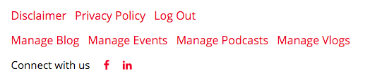

Click *New Post* to create a new blog post (you may also edit or delete existing posts)

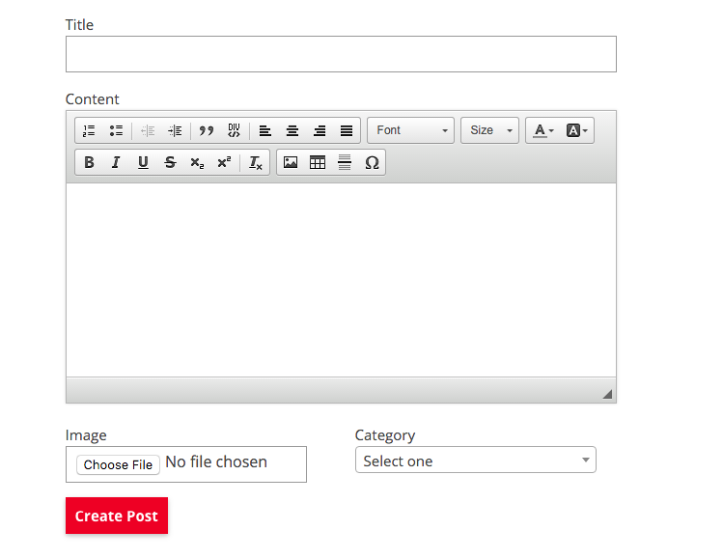

When using the image upload field above the submit button, the chosen image will be set as the banner for the page that displays the blog posts (*recommended minimum size*: *1400x450)*

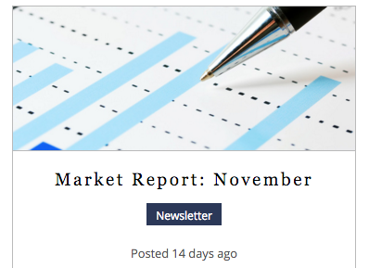

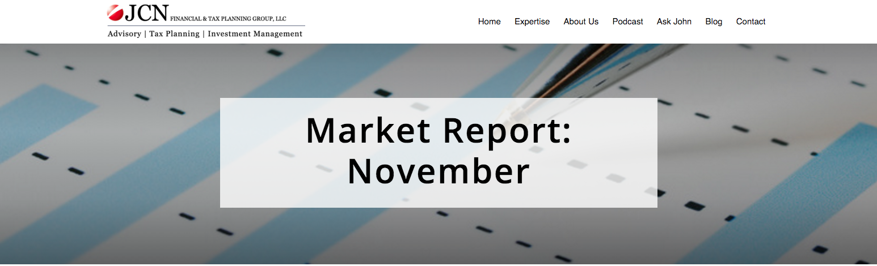

Images may be added to the post’s content by clicking the  icon and clicking *Browse Server*

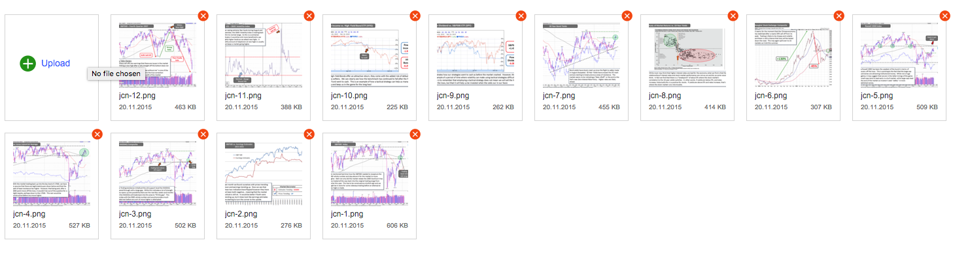

**Create Events**

After signing in, click *Manage Events* at the bottom of the page



Click *New Event* to create a new event (you may also edit or delete existing events)

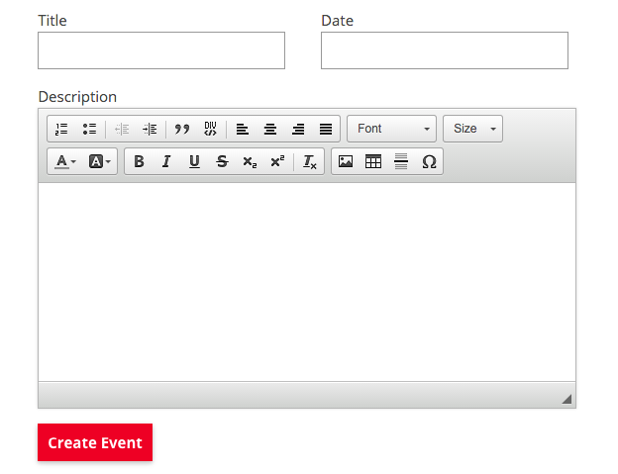

**Create Ask John Post**

After signing in, click *Manage Vlogs* at the bottom of the page



Click *New Vlog* to create a new vlog (you may also edit or delete existing vlog)

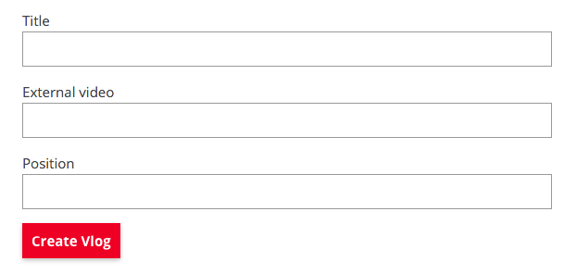

The *External Video* text can be obtained from YouTube

Example:

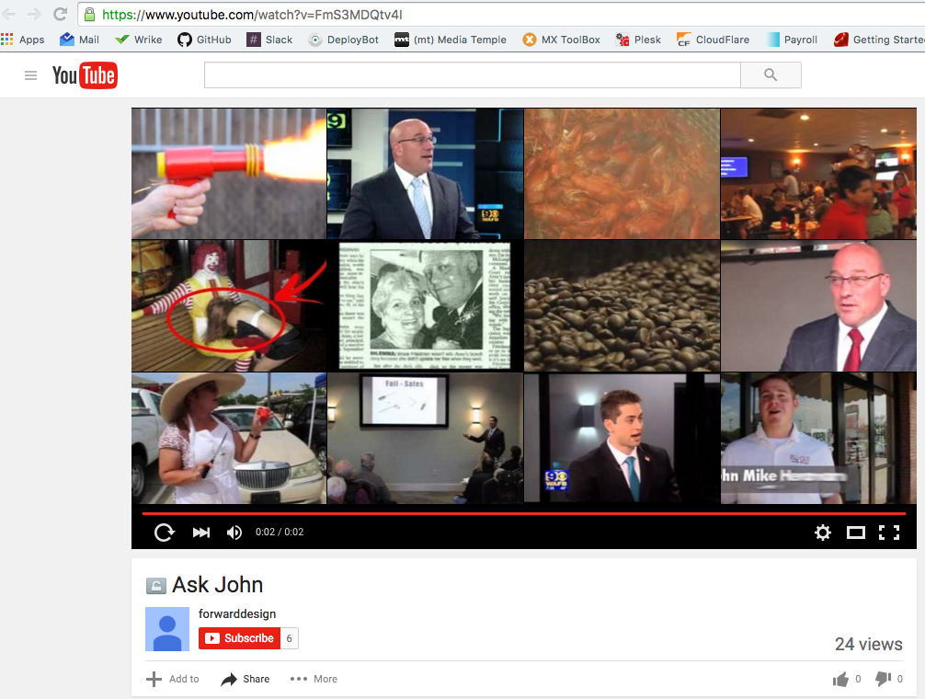



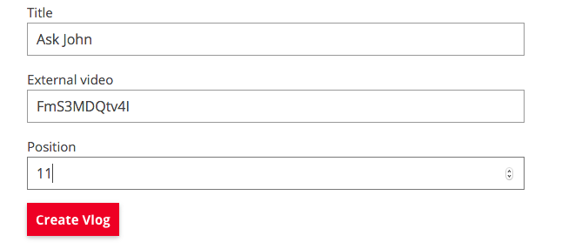

The position indicates which order the videos will be placed in (1 is first and so on…)

**Creating Podcasts**

After signing in, click *Manage Podcasts* at the bottom of the page



Click *New Podcast* to create a new podcast (you may also edit or delete existing podcast)

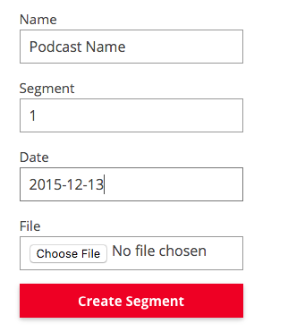

Each audio segment would have to be uploaded individually

Example:

Podcast name: Rollover Mistakes, What To Avoid

Segment: 1

Date: 2015-11-15

Podcast name: Rollover Mistakes, What To Avoid

Segment: 2

Date: 2015-11-15

Podcast name: Rollover Mistakes, What To Avoid

Segment: 3

Date: 2015-11-15