DSC 106 – HW1

Z-Ting Jeff Liao

**Google G Suite**

Pros:

* Easy table creation
* Similar to excel

Cons:

* Hard to customize

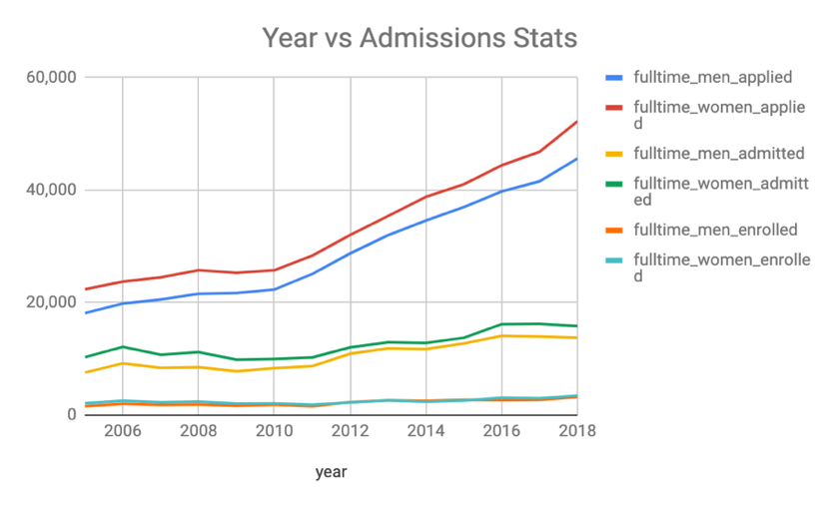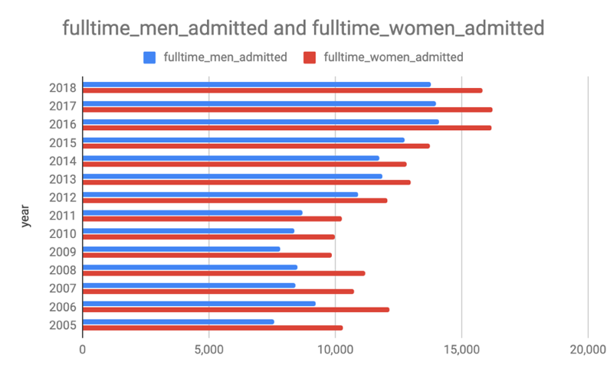

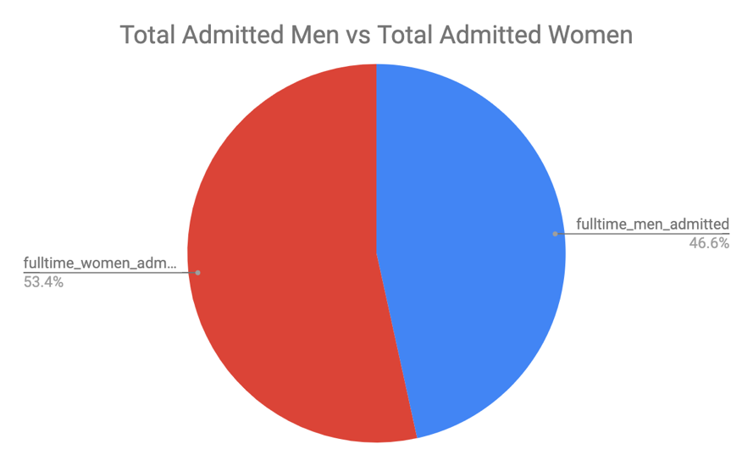

**Infographic**

Pros:

* Easy to use / intuitive
* Interactive UI built for visualization

Cons:

* Limited customization

**Tableau**

Pros:

* Highly customizable
* Great learning community
* Complete toolkit built out and ready to use

Cons:

* Complicated ways to do things
* A close up of a map

  Description automatically generatedA screenshot of a cell phone

  Description automatically generatedA picture containing screenshot

  Description automatically generated

**D3**

Pros:

* Highly customizable
* Is able to create complex and interactive charts

Cons:

* High learning curve
* Need to know coding and JavaScript
* Syntax is a pain if you are not familiar with JavaScript
* Documentation is all over the place
* Each version released has a different syntax

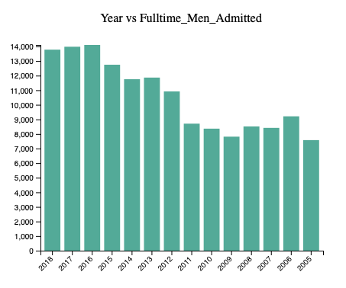

Highcharts

Pros:

* Highly customizable, like d3
* Better documentation than d3
* Has a Highcharts Cloud to help edit online with simpler tools

Cons:

* Has a learning curve
* Needs to have familiarity with coding for max capability

