McDonald’s Burger Sales Report

Link to website:

**Purpose**

Burger King has introduced a new line of burgers called the Impossible burger. We want to know how the market is responding to such action and the degree in which McDonald’s burgers’ are impacted.

**Sales by Region**

We will start out with a number of line graphs that show burger sales from the 2016 to 2019.

All of the graphs have a vertical reference line that indicates when Burger King released their Impossible Burger.

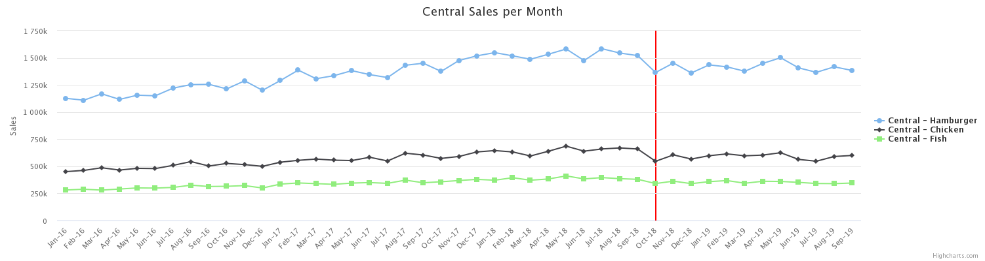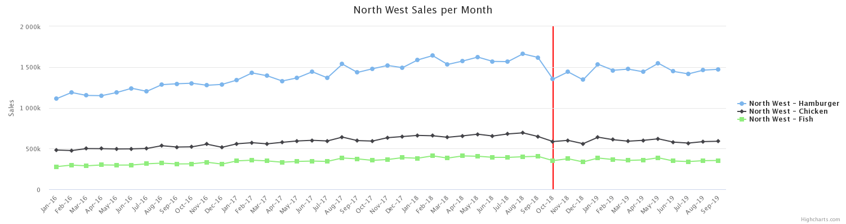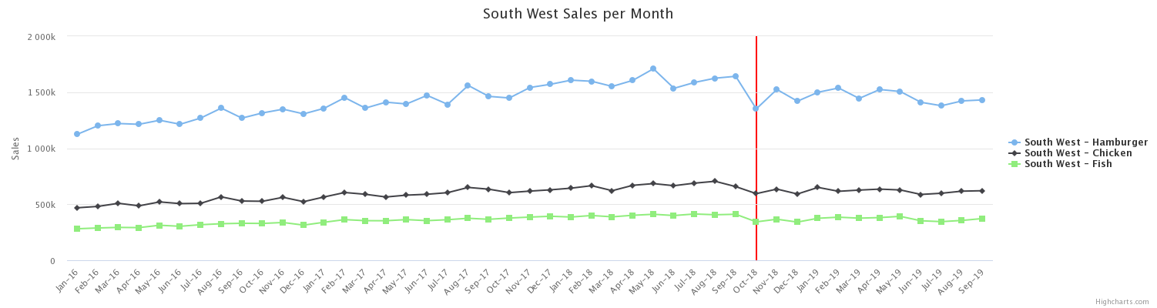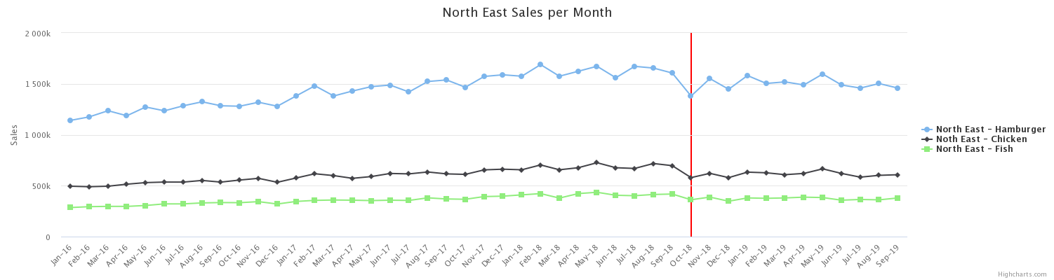

It seems like burger sales for the past 4 years have been steady and has been increasing until Burger King introduced its Impossible burger. When the Impossible burger was first introduced, our burger sales have taken a hit in its sales number. This happened across all regions and to our hamburgers, chicken fillet, and fish fillet. However, there is no need to panic. Our burger sales have risen immediately the next month, which shows that customers are still inclined to buy our burgers no matter the competition.

**Sales by Days of Week**

The following 3 charts are graphed by total sale of each type of burger on a day of the week in January 2016. The last chart is total sale of all the burgers combined by a day of week in January 2016. These sales figures have no close connection with the impact done from Burger King's Impossible burger, but they may provide insight on how we devise strategic promotion events.

Out of the chicken fillet, fish fillet, and the hamburger, both the chicken fillet and the hamburger have high sales on Friday, Saturday, and Sunday. From the chart that aggregates all the burger sales, it still seems like Friday, Saturday, and Sunday have high sale figures. Therefore, we should make a strategy to boost burger sales on Monday, Tuesday, Wednesday, and Thursday. We could try to push promotions on those other burgers. Furthermore, the fish fillet seems to be lagging in sales. We should also try to increase sales for the fish fillet, since it is one of our legacy menu items.

**Verdict**

Our burgers are among the best in the world. Our customers choose McDonald's for a reason. We have created a culture. Although our competitor, Burger King, tried to form a new line of burgers to ramp up the competition, our burger sales figure has only been impacted for a month. The following month our burger sales recouped. Therefore, we do not have to feel anxious about their Impossible burgers. Furthermore, I recommend that we try to increase burger sales on Monday, Tuesday, Wednesday, adn Thursday by push promotions through commercials or our mobile app. Overall, we are doing great.