|  |
| --- |
| 40Gbps CRC32 256bit |
|  |
|  |

[Pick the date]

1. Overview

CRC23 is used widely in digital communication for packet validation. This core implements parallel CRC32 engine with 256-bit input data-path. This core can reach 40Gbps at 156.25MHz clock

1. Interfaces

CRC32 Engine

www.fpga-ipcores.com

**256**

i256_Din

**5**

i5_SoPEmpty

**5**

i5_EoPEmpty

**1**

i_SoP

**1**

i_EoP

**1**

i_Dv

**1**

i_Clr

**1**

i_Clk

**32**

o32_CRC

**1**

o_CrcV

|  |  |
| --- | --- |
| Port name | Description |
| i256_Din | Packet data input  256 bit wide, 32 byte |
| i5_SoPEmpty | Number of empty bytes in the start of packet line |
| i5_EoPEmpty | Number of empty bytes in the end of packet line |
| i_SoP | Start of Packet, should be 1 cycle long |
| i_EoP | End of Packet, should be 1 cycle long |
| i_Dv | Data valid |
| i_Clr | Synchronous clear to clear internal registers |
| i_Clk | Clock input, 156.25MHz to achieve 40Gbps throughput |
| o32_CRC | 32bit CRC Output |
| o_CrcV | CRC valid flag |

|  |  |  |  |  |
| --- | --- | --- | --- | --- |
| Clk |  | Bit 255 Bit0  Byte 0 Byte31 | | |
| 1 | Start of Packet | Empty Bytes | Valid packet Data | |
| 2 | Packet Data | Valid packet Data | | |
|  | …. | Valid packet Data | | |
| n | End of Packet | Valid packet Data | | Empty Bytes |

1. Performance

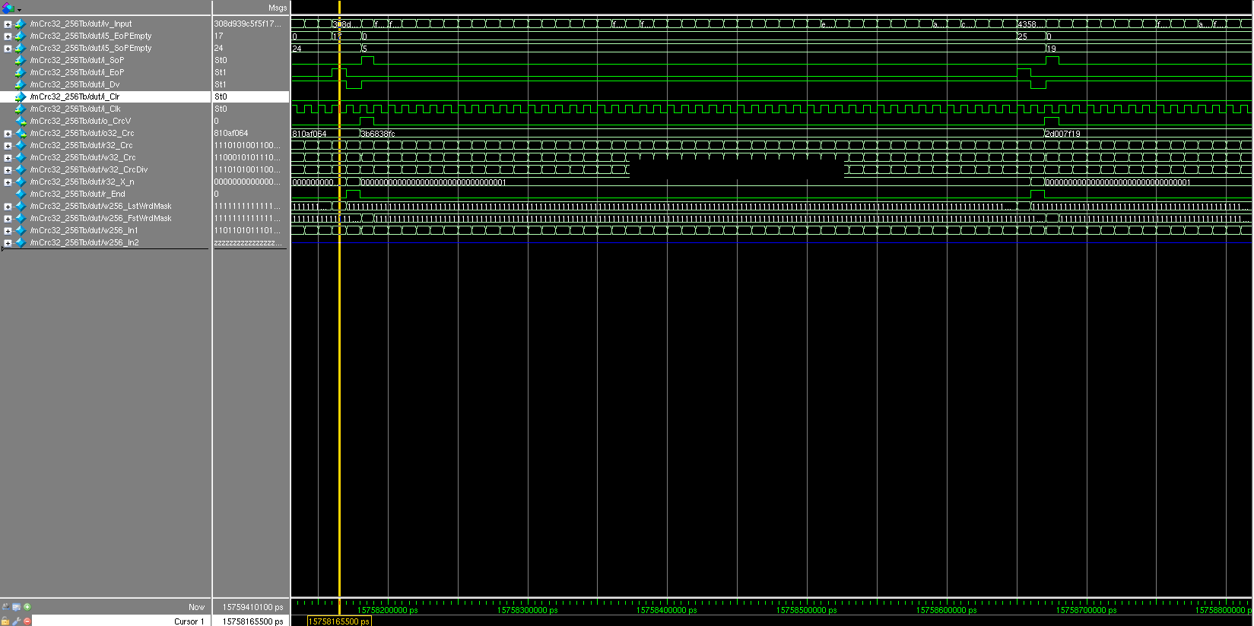

The engine requires an additional cycle after end of packet to compute the CRC value. The next packet should only start 1 cycle after end of previous packet.

|  |  |  |  |
| --- | --- | --- | --- |
| Parameters | ArriaVGXC5ES |  |  |
| Registers | 199 |  |  |
| ALM | 1380 |  |  |
| Max Speed  Slow 1100mV 85oC | 176MHz |  |  |
|  |  |  |  |

1. VERIFICATION

The CRC results are verified against traditional serial method of CRC calculation for 1 million packets with random sizes.

The algorithm to generate referenced CRC is shown below

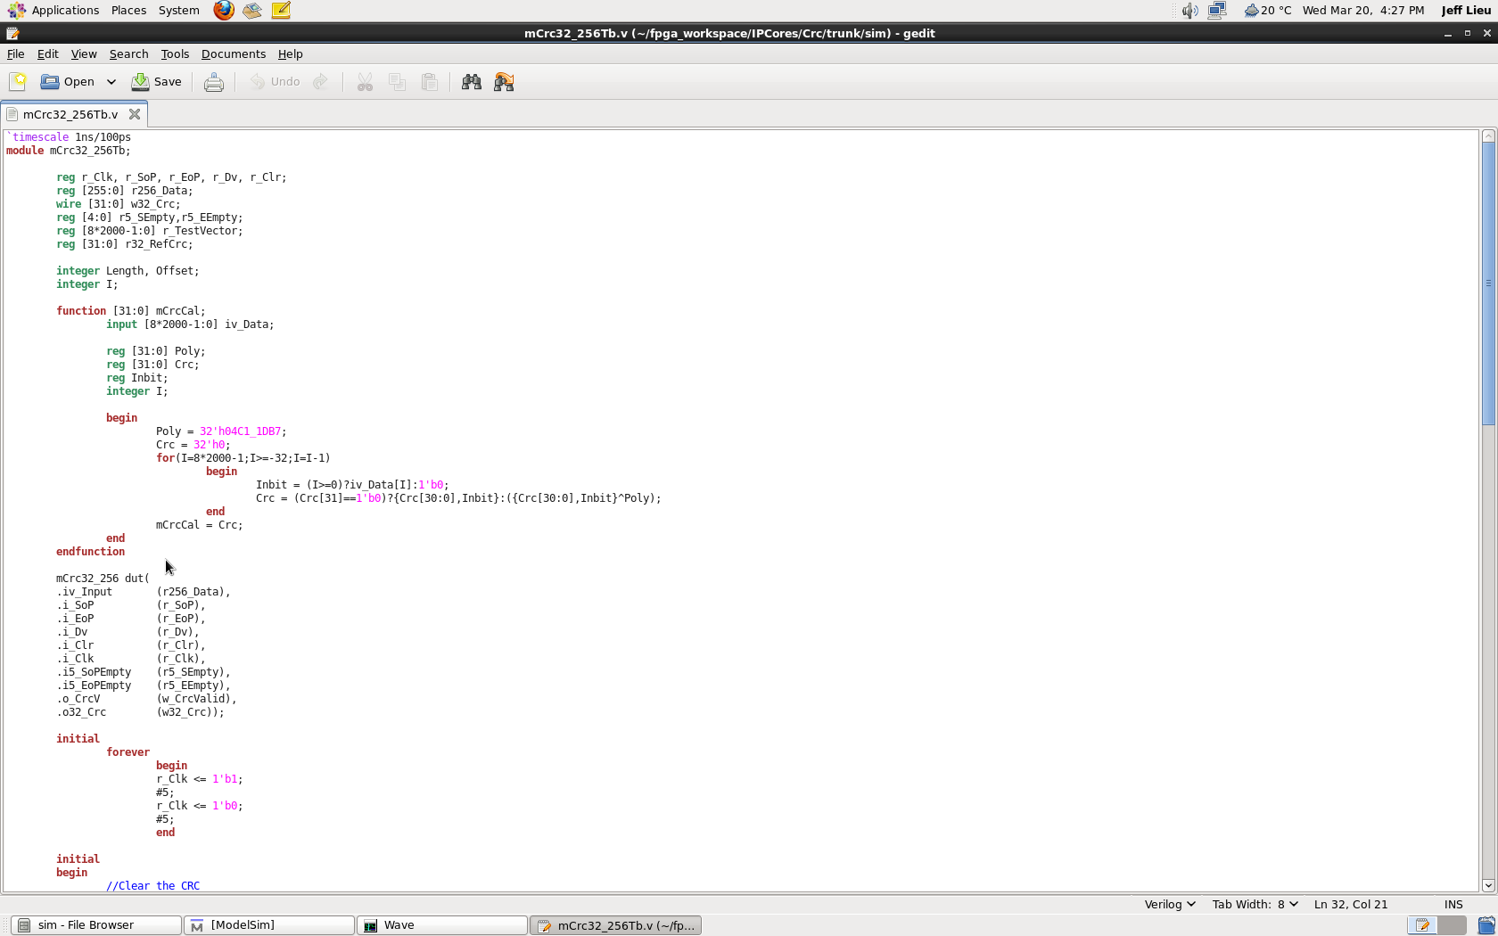

1. Revision History

|  |  |  |  |
| --- | --- | --- | --- |
| Date | Author | Core’s Revision | Description |
| 30Mar13 | JL | 1.0 | Initial Release |