A 16-Bit Eight-Register Register File

1. Enabled-controlled 3-to-8 noninverting output decoder

X en Y

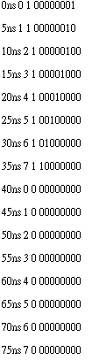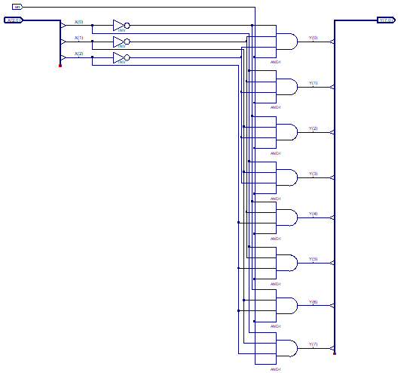

1. 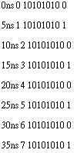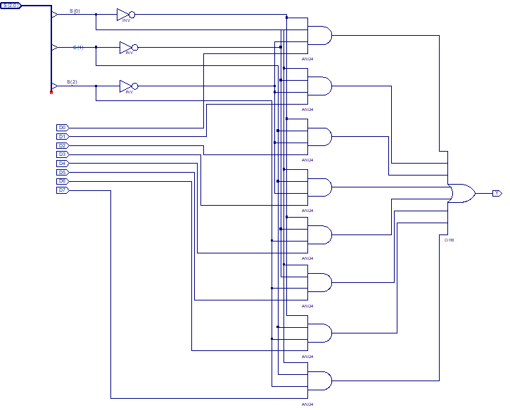8-to-1 multiplexer

S D Y

1. 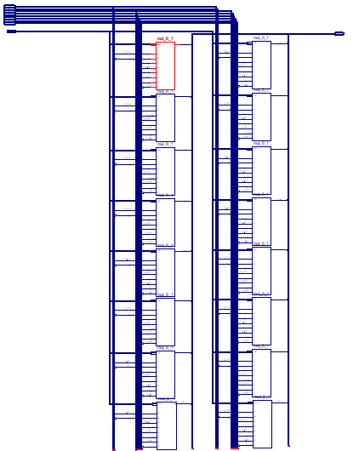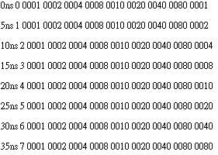16-bit 8-to-1 multiplexer

S D0 D1 D2 D3 D4 D5 D6 D7 Y

1. 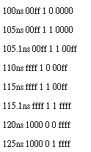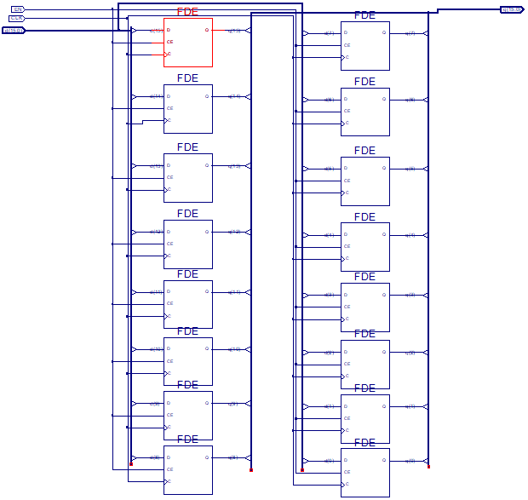16-bit D-flip-flop register

Din EN CLK Qout

1. 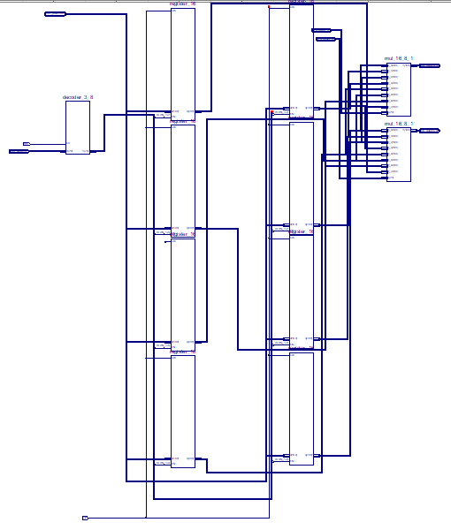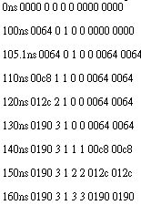A 16-Bit Eight-Register Register File

WDATA WADDR WE RAADDR RBADDR RBDATA RADATA

A 16-Bit ALU

1. 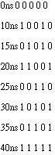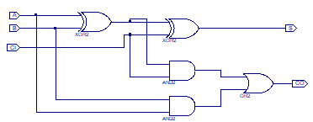full adder

A B CI S CO

1. 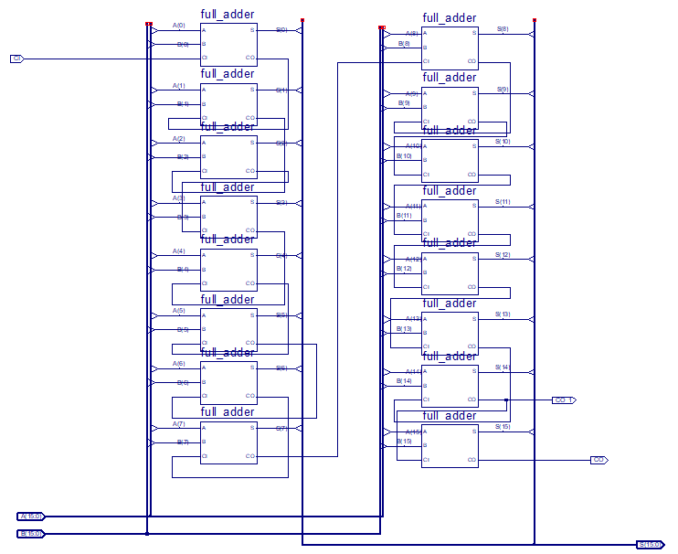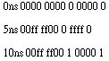16-bit adder

A B CI CON Y C V Z N

1. 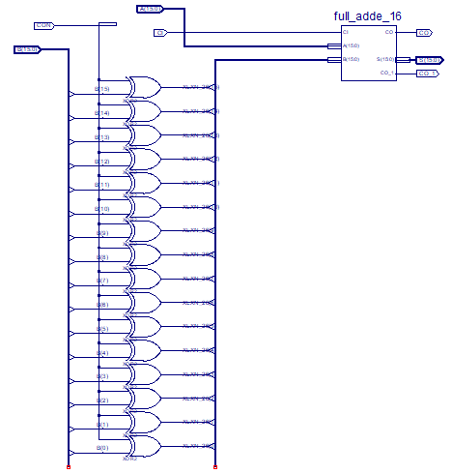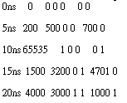a 16-bit two’s complement adder

A B CON CI S CO

1. 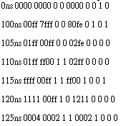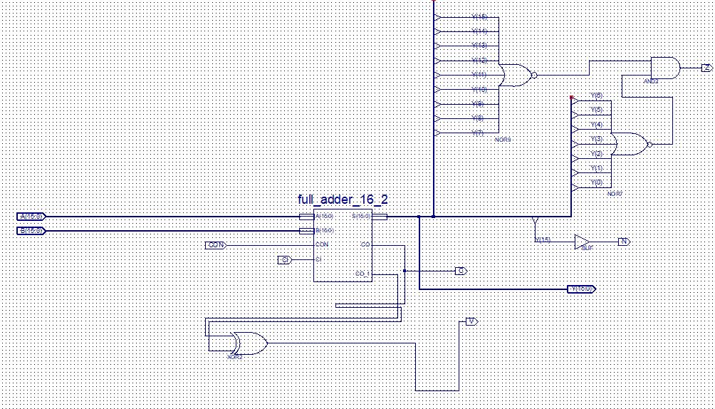16-bit alu

A B CON CI S CO

A 256×16 Memory Module

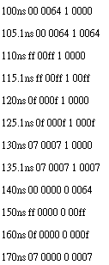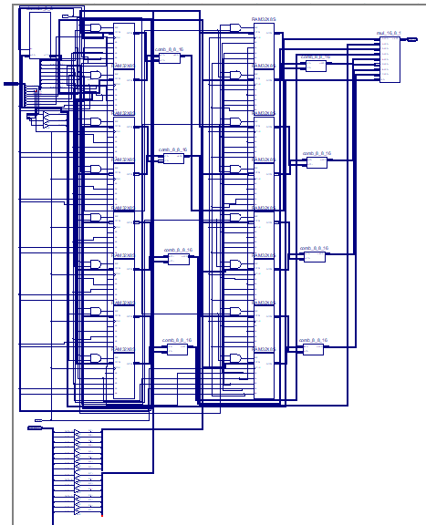

ADDR DATA WE Y

PC Circuitry

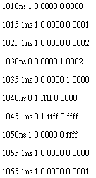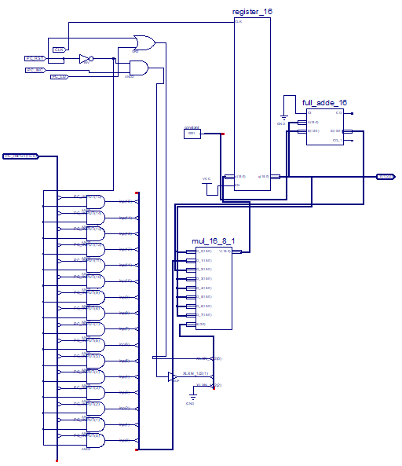

PC_INC PC_LD PC_INPUT PC_RST Y

Instruction Decoder

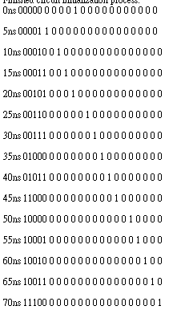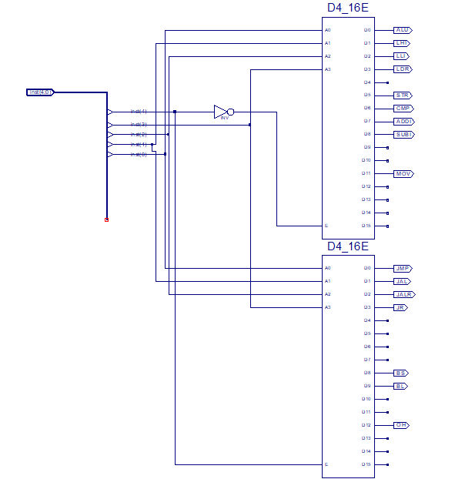

inst,LHI,LLI,LDR,STR,ALU,CMP,ADDI,SUBI,MOV,BS,BL,JMP,JAL,JALR,JR,OH

Complete computer

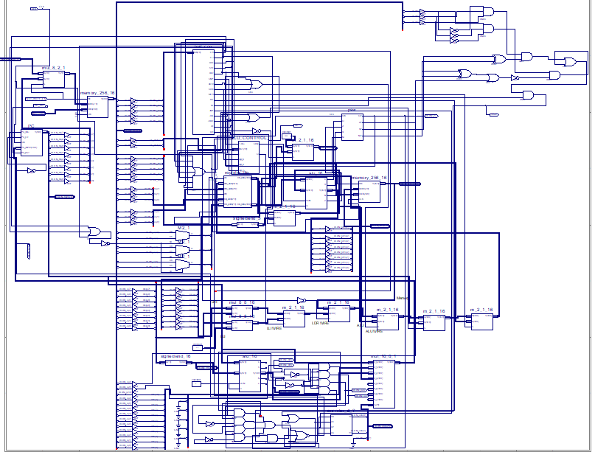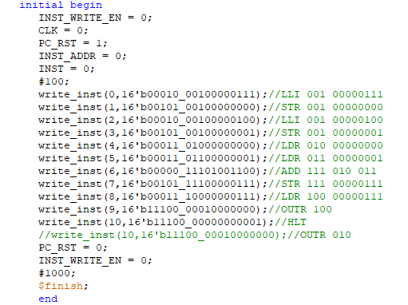

Write 7 and 4 to 00000000 and 00000001. Load data of address 00000000 and 00000001 to RF address 010 and 011. Add this to number and save this result in 111.

Store data in 00000111. Load data from 00000111 and print it.

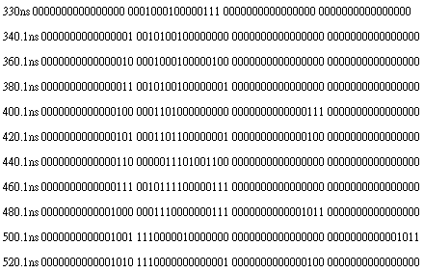

Load from memory and result is 7+4=11

PC_counter Instruction MEM_OUT OUTR