# Number of measurements

## all trt groups

| **Num_ID** | **Frequency** | **Percent** | **Cumulative Frequency** | **Cumulative Percent** |
| --- | --- | --- | --- | --- |
| **1** | 63 | 3.87 | 63 | 3.87 |
| **2** | 209 | 12.82 | 272 | 16.69 |
| **3** | 230 | 14.11 | 502 | 30.80 |
| **4** | 194 | 11.90 | 696 | 42.70 |
| **5** | 244 | 14.97 | 940 | 57.67 |
| **6** | 98 | 6.01 | 1038 | 63.68 |
| **7** | 94 | 5.77 | 1132 | 69.45 |
| **8** | 92 | 5.64 | 1224 | 75.09 |
| **9** | 70 | 4.29 | 1294 | 79.39 |
| **10** | 66 | 4.05 | 1360 | 83.44 |
| **11** | 63 | 3.87 | 1423 | 87.30 |
| **12** | 60 | 3.68 | 1483 | 90.98 |
| **13** | 56 | 3.44 | 1539 | 94.42 |
| **14** | 32 | 1.96 | 1571 | 96.38 |
| **15** | 36 | 2.21 | 1607 | 98.59 |
| **16** | 22 | 1.35 | 1629 | 99.94 |
| **17** | 1 | 0.06 | 1630 | 100.00 |

## plc only

| **Num_ID** | **Frequency** | **Percent** | **Cumulative Frequency** | **Cumulative Percent** |
| --- | --- | --- | --- | --- |
| **1** | 42 | 7.08 | 42 | 7.08 |
| **2** | 97 | 16.36 | 139 | 23.44 |
| **3** | 103 | 17.37 | 242 | 40.81 |
| **4** | 67 | 11.30 | 309 | 52.11 |
| **5** | 77 | 12.98 | 386 | 65.09 |
| **6** | 19 | 3.20 | 405 | 68.30 |
| **7** | 31 | 5.23 | 436 | 73.52 |
| **8** | 31 | 5.23 | 467 | 78.75 |
| **9** | 27 | 4.55 | 494 | 83.31 |
| **10** | 20 | 3.37 | 514 | 86.68 |
| **11** | 20 | 3.37 | 534 | 90.05 |
| **12** | 16 | 2.70 | 550 | 92.75 |
| **13** | 13 | 2.19 | 563 | 94.94 |
| **14** | 10 | 1.69 | 573 | 96.63 |
| **15** | 11 | 1.85 | 584 | 98.48 |
| **16** | 8 | 1.35 | 592 | 99.83 |
| **17** | 1 | 0.17 | 593 | 100.00 |

# Plots (plc only)

## HBA1

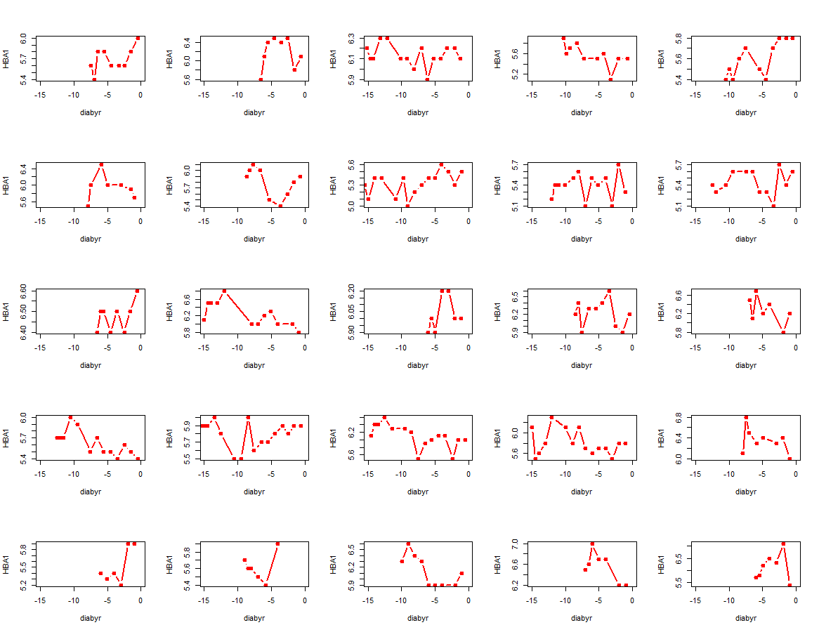

## G000

