AD-HOC NETWORK MANAGEMENT:
USING THE SIMPLE NETWORK MANAGEMENT PROTOCOL
IN AN AD-HOC ENVIRONMENT
_______________________

A Thesis
Presented to the Faculty of
the Department of Computer Science
Kutztown University of Pennsylvania
Kutztown, Pennsylvania

_______________________

In Partial Fulfillment
of the Requirements for the Degree
Master of Science

_______________________

By
Kyle M. Fox
April, 2010

Abstract

The desire to share information in any place at any time has demonstrated an urgent need for ad-hoc networking. While once thought to be futuristic, ad-hoc networking is now an important discipline. From cellular telephones to traffic predicting cars, ad-hoc networks are used in many mainstream applications today.
With ad-hoc networking comes a need for ad-hoc network management. Although ad-hoc networks are on the rise, ad-hoc network management has fallen behind. Protocols developed for managing ad-hoc networks have either failed or been lost in time. Ad-hoc network management has not been extensively studied, though it is clearly a topic that is worthy of attention
This thesis explores the use of the Simple Network Management Protocol (SNMP) on ad-hoc networks. After explaining the basics of the SNMP protocol and the concept of a Management Information Base (MIB), the theoretical problems of ad-hoc network management are discussed. Finally, an ad-hoc subagent and ad-hoc MIB are proposed for use in ad-hoc networks. The subagent and MIB enable remote power management of nodes, which is crucial to ad-hoc network management.

Acknowledgements
Without all of the help I received from faculty, family, and friends, this thesis would never have been possible.
I am grateful for all of the time and effort my thesis advisor, Professor Lisa Frye, has put into my work and into this paper. Her optimism and expertise have helped craft this thesis considerably. I also wish to thank Dr. Dale Parson, my second thesis reader, for the corrections he has made and suggestions he has offered throughout the course of my thesis writing.
Aside from faculty, I also owe my deepest gratitude to my aunt Monica for the countless hours she has spent proofreading my thesis without understanding a word of it. This thesis is as much hers as it is mine. Without her, I’m certain I would not be writing these acknowledgements today. The constant support from both my aunt Monica and my mother, Vanessa, is all that has kept me vibrant during the past year.
Lastly, I also want to thank my family and friends for being so supportive. From the plans I’ve cancelled to the important events I’ve missed, I’m thankful to everyone that has been so understanding. With sincerity, I promise that I will soon return to the energetic and attentive person I have always been. Thank you to all who have interacted with me while I have been working on this thesis.
Table of Contents
Chapter Page
1. INTRODUCTION 1
Problem Statement 2
2. NETWORK MANAGEMENT 3
Five Areas of Network Management 4
Software Network Managers 7
Ad-hoc Network Management 8
Effectiveness of SNMP for Ad-hoc Networks 11
3. SIMPLE NETWORK MANAGEMENT PROTOCOL 13
Protocol Basics 14
Protocol Data Units and Classification 16
Security Mechanisms 20
4. AGENTS AND MANAGED INFORMATION 24
Object Identifiers 24
Management Information Bases 26
MIB File Syntax 32
5. AD-HOC MIB DESIGN 35
Managed Ad-hoc Information 35
Exclusion of Routing Information 38
Kutztown Ad-hoc MIB Variables 41

6. AD-HOC AGENT DESIGN 50
Agent Extensibility Protocol 51
Power Monitoring 54
Agent Implementation 55
7. SUMMARY AND CONCLUSION 57
Summary 57
Conclusion 58
REFERENCES 59
APPENDIX A 61
List of Figures
Figure Page
2.1 Areas of Network Management 5
2.2 Infrastructure vs. Ad-hoc Networks 10
3.1 PDU Classes 17
4.1 MIB Tree 25
4.2 Depiction of Agent and MIB 27
4.3 The sysName Object 28
4.4 The PrinterV2 Alert Notification 29
4.5 SNMP System Utilizing MIB Files 30
4.6 Begin Clause 33
4.7 Module Identity Statement 34
5.1 Internet Architecture Stack 39
5.2 Routing Protocol and Agent Interactions 41
5.3 Battery Notification for Small Thresholds 44
5.4 Battery Notification for Large Thresholds 45
5.5 Rearming for Small Rearm Values 47
5.6 Rearming for Large Rearm Values 48
6.1 Communication Without Using the Agent Extensibility Protocol 52
6.2 Communication Using the Agent Extensibility Protocol 53
6.3 Power Package Class Diagram 55

Chapter 1
Introduction

Imagine a world where autonomous wireless networked devices interact cooperatively, setting out to accomplish a common task. In this alternate reality, standard electronics break boundaries and solve seemingly impossible problems, working together via on the fly networks. A cell phone deep within a mountain tunnel contacts other cell phones, forming a chain of communication capable of reaching the service towers outside. Tiny wireless nodes deployed on wildlife collars track migration, nesting and interaction habits, building an understanding where none previously existed. Vehicles exchange information to lessen the chances of accidents and inform drivers of traffic delays. Underprivileged children use laptops that communicate independent of any user interaction, forming on-demand networks for file and internet access sharing. Such are the ambitions of universities and businesses around the globe. Although these scenarios may seem science fiction to the average person, they are reality.
All of these capabilities are made possible through ad-hoc, on-demand, infrastructure-less networking. TerraNet employees have created an ad-hoc phone system, allowing cell phones to form a network, independent of cell phone service towers (TerraNet, 2010). Students and faculty of Princeton University have deployed ZebraNet, an ad-hoc zebra tracking system, in regions of Kenya (Martonosi, 2004). Massachusetts Institute of Technology (MIT) students and faculty are in the process of creating CarNet, an ad-hoc traffic congestion monitoring service (Decouto, Jannotti, Kaashoek, Li, & Morris, 2000). Lastly, the One Laptop per Child (OLPC) program, started by Nicholas Negroponte, delivers low-cost laptops fitted with wireless cards to needy children around the globe (Buchele, S., 2009). The laptops grant internet connectivity and file sharing through ad-hoc networking (Buchele, S., 2009).
Problem Statement
Ad-hoc wireless networking is positioned at the forefront of computer science. It is a cutting-edge technology that enables innovative design and promotes the creation of new software and hardware. Ad-hoc network management is one area that desperately needs attention. Computer science and engineering professionals understand that perfecting wireless communication is impossible. Nodes fail, interference is inevitable, and attenuation (signal strength decreasing with distance) occurs. For these reasons, management of ad-hoc networks is far more difficult than management of wired networks. Yet, tools for wireless ad-hoc network management are almost non-existent. Proposed protocols have failed and have been lost in time, and few scholarly papers venture into ad-hoc network management. It is the objective of this thesis to explore ad-hoc network management via the Simple Network Management Protocol (SNMP), and to develop an SNMP agent that is able to satisfy the need for remote power management.

Chapter 2
Network Management

Computer networks are dynamic in nature. Much like a New York City street at 7:00 A.M. on a weekday, a network is a source of constant movement. Packets of information bounce between routers and filter in and out of end systems. Firewalls stationed at various locations intercept unacceptable packets before they reach their final destinations. Clients and servers radiate data intra and inter-network. All of these things occur within milliseconds. It is extremely clear why network management is immensely important. Every time a networked system goes down, information and revenue are lost, and communication becomes impossible. It is the job of a network administrator to ensure that a network runs smoothly, with as few interruptions as possible. The tasks and tools associated with such a job are considered network management.
According to Clemm (2007, p. 8), “Network management refers to the activities, methods, procedures, and tools that pertain to the operation, administration, maintenance, and provisioning of networked systems.” The activities, methods, and procedures allude to the general problem-prevention and problem-resolution techniques a system administrator must employ. These tasks must be well planned in order to provide the best service. Tools are a requirement for network management and administration. It would be impossible for a network administrator to operate and administer a network without an array of hardware and software tools. Lastly, maintenance and network provisioning are undoubtedly as important as any other management job. Network usage generally expands with time, making hardware and software updates and expansions crucial to network management.
Five Areas of Network Management
Although the term network management conveys a distinct meaning to most, the boundaries are not as definite as one may be led to believe. A CEO of an organization will visualize network management differently than an employee working in information technology. A CEO sees figures and dollar amounts, a network administrator sees time and maintenance costs, and an end user sees speed and ease of use. In order to elucidate the concept of network management, the International Organization for Standardization (ISO) divides network management into five separate fields. These five areas, depicted in Fig. 2.1, include fault management, configuration management, performance management, security management, and accounting management (Cisco, 2004). All true network management tasks fall into one or more of these categories; however, some daily tasks may fall outside of the bounds established by the ISO.
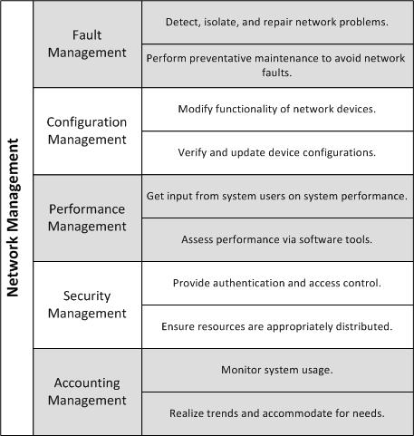
Figure 2.1. Areas of Network Management
The first component of network management, fault management, attempts to tackle problems as they occur. Problems happen regardless of the number of precautions taken. Links will go down, servers will fail, and damaged network interfaces will flood the network with irrelevant packets. Network faults are inevitable, and need to be treated as regular occurrences, not as exceptional events. Fault management involves solving these complications in as timely a manner as possible. From a software point of view, fault management can include detecting, isolating, and possibly repairing faults automatically. Preventative maintenance to prevent network faults also falls under fault management. Network managers must regularly update equipment and software in an attempt to prevent downtime.
The second functional area of network management is configuration management. Almost all electronic devices require some configuration. From customizing a ring tone on a cell phone to setting up a web server, configurations enable modification of functionality. In relation to network management, configuration is a daunting task. With the multitude of networked devices an average network contains, there are bound to be a high number of different configurations. These configurations may need to be updated periodically, verified in the event of a network fault, or changed altogether. Configuration management does not necessarily mean configuration of software on a device. It can refer to the hardware and software platforms, along with version information for hardware and software (Cisco, 2004). Configuration management itself can keep a network administrator working all day.
Performance management, the third conceptual area of network management, assumes both the position of a system user and the position of a network manager. Users of computer networks continuously evaluate performance of the system they are using. As soon as something does not perform quickly and correctly, that negative performance evaluation becomes very apparent. Despite the seemingly obvious nature of performance flaw recognition, recognizing system performance issues can become quite tedious. How does one know if all areas of a system are performing well? There is no simple solution without the ability to be in multiple locations at once. While some system users undoubtedly will complain as soon as they get the feeling something is not right, others may attempt to deal with the problem, assuming it is normal. To provide performance management, properties like throughput, bandwidth utilization, and response times are assessed (Cisco, 2004). An important role of the network manager is to continually monitor these properties in hopes of identifying possible performance issues before the end user recognizes a problem exists.
The last two areas of network management are security management and accounting management. Security management involves controlling access to resources and making sure only authorized entities can retrieve and modify data. Along with security management, accounting management tracks usage of the resources security management aims to protect. Accounting management may occur at the user level, keeping track of system usage by specific users. However, more often than not, it simply tracks resource usage independent of a specific user. The goal of accounting management is to realize usage trends and attempt to accommodate for them by performing some capacity planning. Security management collaborates with accounting management in that it must restrict resource usage to only authorized entities. From a network manager’s point of view, these network management fields address prevention and detection of access control problems, and help monitor the use of system resources.
Software Network Managers
Network management is a broad field, and can be accomplished through many different approaches. Historically, network management, as a discipline, began in the 1980s when companies with large heterogeneous networks came to the realization that these networks would require full time management (Cisco, 2004). In its infancy, network management consisted of a single network manager doing his or her best to keep all systems running. As time progressed, these network administrators developed software tools to aid them in their work. Today, software managers play an important role in network management. An important distinction to make is the difference between software and human network managers.
Initially, human network managers used software network managers for problem detection, diagnosis, and repair. Software managers were never intended to replace human network managers. A software network manager simply aids a human network manager with his or her daily tasks. While both human and software network managers cannot detect all network problems instantaneously, software network managers come closer to it. They enable network managers to see potential and current problems, and facilitate repairs before system users realize something has changed. Software network managers empower network administrators. They can be utilized in all five areas of network management; however, their use is limited in some of the areas.
Ad-hoc Network Management
The topic of this paper involves the usage of the Simple Network Management Protocol for the management of ad-hoc networks. This central idea illustrates an important point: network management styles vary depending on the type of network being managed. Wired network management differs slightly from wireless network management, while ad-hoc network management falls into its own category. For wired networks, network management is deeply understood. There exists a wide range of software managers and tools capable of aiding wired network administrators. Many network device manufacturers include software to enable remote management of their devices. The same can be said of standard infrastructure-based wireless networks. Generally, wireless networks consist of an underlying wired network with wireless access points. Aside from the wireless connection between the wireless node and the underlying infrastructure, the differences are minimal.
In an ad-hoc environment, added difficulties exist. Ad-hoc networks sacrifice organization in favor of mobility. Infrastructure based wireless networks require all wireless nodes to relay information through a central access point even if communicating directly with another peer on that same access point. From a top down perspective, all infrastructure-based wireless networks appear the same. Like a child’s drawing of the sun, infrastructure-based wireless networks have a central point and “rays” that emerge from that point in all directions. In contrast, ad-hoc networks form a mesh-like topology. Any node in range of any other node has a direct connection to it. In a mesh topology, true direct peer to peer communication is possible. Figure 2.2 exemplifies the structure of infrastructure versus ad-hoc networks. The mesh-like topology of an ad-hoc network is more complex, but provides much more flexibility in relation to infrastructure-based networks. This added flexibility, although it comes at a cost, appeals to many network applications. As a result, complex routing protocols and innovative network management tools need to be developed for ad-hoc networks.
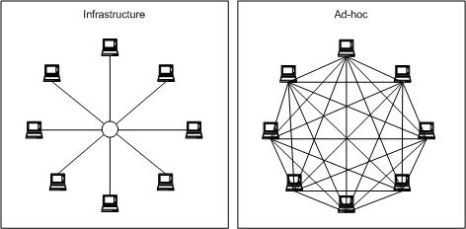
Figure 2.2. Infrastructure Versus Ad-hoc Networks
In a paper proposing an ad-hoc network management protocol, Cheng, Jain, and Singh (1999) outline the difficulties ad-hoc networks introduce to network management. In addition to the difficulties of wired network management, ad-hoc network management must accommodate for the capability differences and power constraints of nodes, the frequent link state changes, and the possibly hostile environments inherent with ad-hoc networks. The first new issue introduce to ad-hoc network management is the range in complexity of nodes. In an ad-hoc network, nodes may vary from simple sensors to high power servers (Chen, Jain, & Singh, 1999). In addition to varying node capability, battery constraints are another difficulty of ad-hoc network management. Software managers must be designed in such a way as to minimize battery usage, especially in small, sensor style nodes. The ever-changing topology of an ad-hoc network adds a third complexity for management. Ad-hoc nodes, more often than not, are mobile, causing frequent link state changes. From a software network manager’s standpoint, these link state changes may or may not be important. Lastly, ad-hoc nodes may be deployed in hostile environments, meaning software management systems must keep information as secure as possible.
Effectiveness of SNMP for Ad-hoc Networks
The Simple Network Management Protocol (SNMP), for all practical purposes, is a software network manager. Examination of the protocol reveals that it can function on ad-hoc networks and wired networks in much the same fashion. The question that arises is whether or not the protocol can be used to efficiently monitor an ad-hoc network. In order to maximize the efficiency of SNMP on an ad-hoc network, the creators of ANMP (Ad-hoc Network Management Protocol) combined SNMP with a routing protocol (Chen, Jain, & Singh, 1999). ANMP uses a cluster-based routing scheme, which groups nodes into clusters. Each cluster selects a cluster head to maintain cluster membership and perform inter-cluster routing (Liu & Kaiser, 2005). The ANMP protocol aimed to maximize efficiency by electing cluster heads based on power availability, processor capabilities, and resource constraints. By selectively choosing cluster heads, network traffic would be reduced due to collection and concentration of data. Also, weak nodes would be relieved of strenuous jobs, which would save their battery power (Chen, Jain, & Singh, 1999). The intent of the ANMP protocol was to address conservation issues; yet, it created much overhead. The overall effectiveness of the protocol is debatable and cannot be proven since no implementations of the ANMP protocol currently exist (S. Singh, personal communication, October 12, 2009).
Another possible methodology of ad-hoc network management is to allow the SNMP protocol to operate at the application layer, where it was designed to function. With such an implementation, SNMP performs exactly as it would on a wired network. In order to satisfy the problem of varying complexity of nodes, SNMP implementations exist for many platforms available today. As its name implies, SNMP is simple. New implementations can be created for virtually any platform. Frequent topology changes are another cause for concern. The SNMP protocol will have to decide which topology changes are critically important, and which ones are not. Though making these decisions may be difficult, SNMP can be configured in such a way as to accommodate for topology changes. The underlying routing protocol will take care of the actual link state changes, meaning the SNMP protocol needs no change to work correctly. The battery power constraint will apply to any network management protocol. Software network managers, inevitably, will contribute to battery loss. This is not a flaw in the protocols, but rather, a loss the system administrator will have to weigh against the increased efficiency. If a network management protocol does not contribute enough to make it worth its overhead, then there is no reason to install network manager software in the first place. The last problem proposed by Chen, Jain, and Singh, has to do with hostile environments and security. As will be explained later, the newest version of SNMP is capable of encrypting data, thereby providing the needed security (Chen, Jain, & Singh, 1999).
As a bottom line: SNMP is fully capable of running on an ad-hoc network without any modifications to the protocol. The rest of this paper aims to utilize the SNMP protocol to assist with ad-hoc network management.

Chapter 3
Simple Network Management Protocol

In 1987, the network working group of the Internet Engineering Task Force (IETF) submitted a specification for a Simple Gateway Monitoring Protocol (SGMP). The IETF published the SGMP memorandum as a Request for Comments (RFC) in November of the same year. An RFC is a document published for the purpose of being reviewed by IETF members. Some RFCs are complete internet standards, while others may only be introductory proposals. The network working group submitted the SGMP RFC as a proposal for a standard method of gateway management. A gateway is a device that acts as an intermediary between two networks. The capabilities of SGMP included monitoring gateway status and updating gateway configurations remotely (Davin, Case, Fedor, & Schoffstall, 1987). The SGMP protocol was the first step towards a standardized management protocol.
At an Industrial Advisory Board meeting on March 21, 1988, the need for a standard network management protocol was recognized. “The scaling of the size and scope of the Internet and increased use of its technology in commercial applications has underscored for researchers, developers and vendors the need for a common network management framework within which TCP/IP products can be made to work” (Cerf, 1988, p. 4). After comparing candidate protocols, the members at the board meeting decided on SGMP as the best option for a potential network management protocol standard. Recognizing the need to adapt the protocol to suit their needs, the Industrial Advisory Board submitted an RFC to the IETF recommending creation of two new working groups for this purpose. The purpose of the first working group would be to develop formal specifications for information management, while the purpose of the second group would be to ready SGMP for standardization. As part of the process, SGMP was to be renamed the Simple Network Management Protocol (SNMP) (Cerf, 1988).
Protocol Basics
Since its adoption by the IETF, SNMP has undergone three version changes. Each version added functionality and fixed minor issues. Throughout all versions, the goal of SNMP has remained the same: to present useful information to a network manager in order to facilitate his or her job. SNMP enables remote management of network nodes via a well defined set of messages. Realistically, SNMP is just a software tool used to aid network managers. SNMP is not a replacement for a human network manager. The scope of SNMP is limited to information verification, configuration updates, and problem diagnosis. While there are certainly situations in which SNMP may handle small problems without intervention, expecting the protocol to handle network problems on its own will not produce desired results.
When used within its intended scope, SNMP proves itself to be an invaluable asset to personnel involved in network management. SNMP is able to help solve many network problems before they are otherwise noticeable. The protocol provides a foundation that allows the development of a wide variety of network management tools. Its modular design makes it highly flexible and extendable, which is crucial in the rapidly advancing field of computer science. Implementations of the protocol are available for the majority of platforms in use today, including but not limited to Windows, Macintosh, Linux, and UNIX. The SNMP protocol, as its name implies, is simple to learn. Its high understandability makes implementation on new platforms possible. Overall, it is a robust protocol which serves its primary purpose very satisfactorily.
The key to understanding SNMP is recognizing how SNMP entities interact at the highest level of abstraction. At this level, there are two types of interacting nodes communicating via SNMP defined messages. All SNMP enabled nodes can be classified as managers, agents, or a combination of the two. Manager nodes provide an interface for the network administrator, while agent nodes are the nodes that are managed by the manager nodes. SNMP managers send request messages to agents, which perform some action and respond with messages containing the needed information. Agent nodes are also capable of sending unsolicited messages called traps or notifications to manager nodes. Traps are sent when some internal event necessitating immediate attention occurs. The messages passed between agents and managers are known as SNMP protocol data units (PDUs). They contain necessary network information as well as the needed message in the form of a structured packet.
Before looking at the PDU classes, a quick introduction to managed information is needed. As previously explained, SNMP is capable of retrieving information from managed nodes. These managed nodes contain pieces of software known as agents, which respond to requests and generate traps based on the information they possess. The information an agent stores is kept in its Management Information Base (MIB). This managed information can be thought of as a group of managed objects. Each object has a type, such as integer or character string, and an identifier, which is capable of distinguishing that specific managed object. These identifiers are known as object identifiers (OIDs), and they will play an important role in SNMP PDUs. While an in-depth understanding of the structure of managed information on a node is un-needed for a discussion on PDU classes, it is important to understand how that information can be accessed.
Protocol Data Units and Classification
All SNMP PDUs can be classified, as depicted in figure 3.1, based on the functions they perform and whether or not they require confirmation of receipt. The SNMP version three (SNMPv3) RFC defines five separate classes of PDU functionality: the read class, the write class, the response class, the notification class, and the internal class. The RFC also defines two classes of response expectation: confirmed and unconfirmed (Harrington, Presuhn, & Wijnen, 1999). Although the actual PDUs differ between SNMP versions, these functional classes apply to all SNMP versions. This is not to say that all SNMP versions utilize all classes, but rather, all PDUs of all versions can be fit into these classes. Where SNMP version one (SNMPv1) had only five PDUs, SNMP version two community (SNMPv2c) and SNMP version three (SNMPv3) have nine PDUs. The SNMPv1 PDUs can all be fit into four of the five PDU classes, while the SNMPv2c and SNMPv3 PDUs occupy all five classes. Because SNMPv2c and SNMPv3 PDUs obsolete the original SNMPv1 PDUs, only SNMPv2c and SNMPv3 PDUs will be discussed.
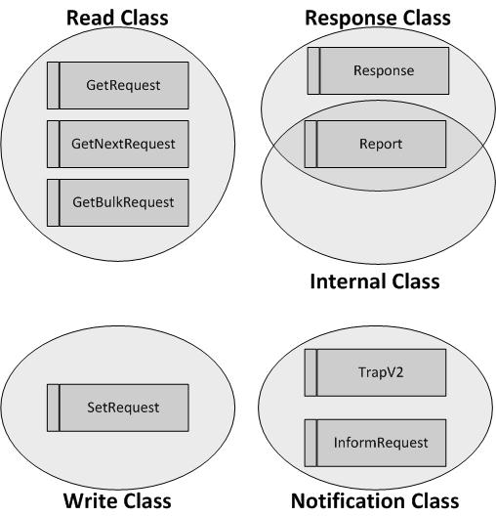
Figure 3.1. PDU Classes
The first class of PDU, the read class, encapsulates the SNMP PDUs that are designed to acquire information from an agent node. More often than not, a manager will send read class PDUs to an agent in order to retrieve or verify information the agent has in its possession. Read class PDUs include the GetRequest, GetNextRequest, and GetBulkRequest PDUs. The GetRequest PDU is the simplest. It is used for retrieving one or more managed objects possessed by the agent (Mauro & Schmidt, 2005). Because a manager may want to “walk” through the managed objects in a MIB, the creators of SNMP designed the GetNextRequest PDU. The GetNextRequest retrieves the next MIB object in the MIB, or an end of MIB failure if no more objects are available. The GetBulkRequest fixes a fundamental flaw within the GetRequest. If the size of a response to a GetRequest exceeds a limitation, then the entire GetRequest fails and returns an error. In a GetBulkRequest, as much information as can fit in a packet is sent, along with information that allows subsequent GetBulkRequest messages to retrieve the rest of the needed information (Walsh, 2008).
The PDUs in the write class accomplish exactly what their class name implies. They are capable of writing managed object values to managed objects on an agent. The SetRequest PDU is the only PDU available in the write class. A SetRequest PDU contains a variable binding, which consists of an object identifier and an associated data value. Provided the variable binding contains a valid object identifier and an accompanying data value which is of the correct type, the SetRequest PDU will change the value of the managed object to the value specified by the given variable binding. Clearly some form of authentication will be needed, as anyone could formulate a write class PDU and modify the contents of any managed object. The permission mechanisms for SNMP will be discussed shortly after PDU classes.
The response class of PDUs is used when a received PDU requires a confirmation or a response containing information. The two PDUs within the response class are the Response and Report PDUs. An agent or manager will generate a Response PDU upon receipt of a read class PDU, a write class PDU, or upon receipt of certain notification class PDUs. The Report PDU is also considered to be part of the response class because it can act in response to certain events. The protocol operations for SNMPv2c explain that “usage and precise semantics of Report-PDU are not presently defined. Any SNMP administrative framework making use of this PDU must define its usage and semantics” (Case, McCloghrie, Rose, & Waldbusser, 1996a, p. 6). In the context of the response class, the Report PDU can respond to network failures (Walsh, 2008).
The class of unsolicited PDUs, known as notification PDUs, encompasses all PDUs sent from agent to manager without any request. These PDUs are used to notify managers of some unforeseen event which may need immediate attention. The notification class includes the TrapV2 and InformRequest PDUs. The TrapV2 notification is an unsolicited message sent from an agent to a manager with details of an event that occurred. Inform-Request PDUs attempt to solve a flaw with TrapV2 PDUs. No response from the manager is required with a TrapV2 PDU, while InformRequest PDUs require a response. If the agent may have the ability to fix network problems preventing traps from arriving at the manager, InformRequest PDUs can help the agent recognize that a problem exists. Otherwise, TrapV2 notifications suffice.
The last functional class of PDUs is the internal class. Internal class PDUs are utilized between SNMP entities for exchanging protocol specific information. The RFC for SNMPv3 explains that “the Internal Class contains protocol operations which are exchanged internally between SNMP engines” (Harrington, Presuhn, & Wijnen, 1999, p. 13). The only PDU that is considered part of the internal class is the Report PDU. As noted above, the report PDU can be defined for many different purposes. A common usage of the Report PDU is synchronization of messages passed between SNMP entities (Walsh, 2008).
In summary, the read and write classes allow reading from and writing to managed objects, the notification class allows sending of unsolicited messages, the response class allows responses to the former three, and the internal class allows internal SNMP information to be transmitted. All of the PDUs which can fit in the five functional classes can also fit into the two classes of responsiveness. Simply put, some PDUs require a response, while others do not. The PDUs that do require a response are considered part of the confirmed class, and consist of the GetRequest, GetNextRequest, GetBulkRequest, SetRequest, and InformRequest PDUs. It is easy to tell which PDUs are part of the confirmed class because they all end in “Request”. The Unconfirmed class of PDUs includes the Report and TrapV2 PDUs.
All of these PDU classes and their respective PDUs come together to form the heart of the SNMP protocol. The message passing system of SNMP is what makes it usable. The information exchanged cross-network allows remote management of nodes, which is the primary goal of the Simple Network Management Protocol. With the pieces of SNMP that have been explained to this point, a fully functional protocol was built. Agent and manager nodes at various locations in a network communicate via the SNMP protocol data units. The manager can send requests to agents to retrieve or make changes to the managed objects residing on an agent. The agent can send notifications to the manager when important events occur. Overall, the architecture allows a network administrator to accomplish all that SNMP promises.
Security Mechanisms
Even with this seemingly complete protocol, there is more to add. So far, the security mechanisms of SNMP have been overlooked. This lack of security at the start reflects the way in which SNMP was built: low to high security. The security mechanisms available in SNMPv1 and SNMPv2 are minimal. SNMPv1 introduced the idea of community strings. Community strings are passwords with associated access levels. SNMPv1 and SNMPv2 allow for three different community string access levels: read-only, read-write, and trap. A correct read-only community string grants a requesting SNMP entity the ability to view the managed information on an agent. A correct read-write community string allows an SNMP entity to make changes to the managed information on an agent. Lastly, the trap community string, which is sent with trap messages, helps a manager decide if it wants to listen to incoming traps.
The community string system of SNMPv1 and SNMPv2c seems appropriate at first glance. Passwords are a very reasonable method of providing security. The problem with the community string implementation of SNMP is not in the community strings themselves, but rather, the transmission of these passwords across the network. The strings are sent within the SNMP PDUs in plaintext form. This means that any network interface receiving SNMP PDUs with the correct community string can potentially steal that community string. With a simple packet capture utility, anyone can read community strings from SNMP packets. An adversary could potentially use the string to read information from a remote SNMP entity using a read-only string, or modify information on a remote SNMP entity using a read-write string. Because of this extreme weakness, the Internet Engineering Task Force (IETF) developed a new security mechanism for SNMPv3.
The completely overhauled security system available in SNMPv3 features authentication mechanisms, access control mechanisms, and privacy mechanisms. For authentication and access control, user and password combinations are used. A hash algorithm, such as MD5 or SHA-1, calculates a hash value of a PDU using the supplied password before it is sent. On the other side of the network, the hash is recomputed using the password the authenticating entity knows to be correct, and is compared to the original hash. Provided the two hash values match, the system will authenticate the user. Access control is taken care of on the authoritative entity, which is the SNMP entity acting as the agent. SNMPv3 introduced the View-Based Access Control Model, which allows specific users to be granted different permissions to specific areas of information within the agent. Privacy is provided via the Data Encryption Standard algorithm (DES). If privacy of information within the PDU is required, the contents are encrypted with the DES algorithm before transmission. The password used for authentication and access control may be the same or different from the password used for privacy (Mauro & Schmidt, 2005).
Other than the new security features, SNMPv3 does not differ much from older versions of SNMP. It keeps the same PDU formats and the same structure as SNMPv2c. It does eliminate the idea of managers and agents to some degree. Instead, the standard proposes new terminology: managers are authoritative entities and agents are non-authoritative entities (Mauro, & Schmidt, 2005). Functionally, no change has been made. The new naming conventions aim to blur the lines between agents and managers for good reason: they may very well be one in the same. An entity may serve the role of an agent, a manager, or both. As an agent, it will send responses and notifications to a manager. As a manager, it will receive notifications from and query another entity. In the first scenario, the entity acts authoritatively, while in the second, the entity acts non-authoritatively. There is also a possibility that multiple agents could run on a single node. The point is that SNMP entities are not constrained in the way they interact; therefore, the terminology should reflect that flexibility.
Since the start of SNMP, when it was still labeled the Simple Gateway Monitoring Protocol (SGMP), the protocol has adapted well to the changes that have occurred. With each successive version, new message types and improved security have enhanced the already exceptional performance of SNMP. The flexibility and extensibility of the protocol has lead to its wide acceptance in the computer science industry. The ability to use SNMP is vital to network administration and management. Furthermore, competency in SNMP systems programming is a supporting skill that can help anyone working in a computer networking environment. An SNMP deployment on a network can save considerable time in network problem diagnosis and repair.

Chapter 4
Agents and Managed Information

In March of 1988, when the Internet Engineering Task Force (IETF) began adaptation of the Simple Gateway Monitoring Protocol (SGMP), the organization created two working groups. The IETF delegated renovating SGMP and creating a new version, renamed SNMP, to the first working group, and developing specifications for information management and storage to the second working group. These specifications for information management have come to be known as the Structure of Management Information (SMI). Since the creation of the SNMP and SMI working groups, the working group members have kept the SNMP and SMI development cycles as separate as possible, arguably for modularity. Through the use of the SNMP protocol, the SMI, and a few other tools, robust and secure SNMP entities can be and have been programmed. The combination of well designed agents and SNMP managers has lead to the widespread adoption of the overall SNMP architecture. A large part of the success of SNMP can be attributed to the information management system.
Object Identifiers
The first important topic relevant to the structure of managed information is the concept of an object identifier (OID). The SNMP protocol requires a method of identifying specific managed objects. When an entity sends a request, it must include some information that the receiving entity can use to select the correct object. The SMI accomplishes this by using a hierarchical tree of managed object identifiers. Every managed object available on the Internet has a globally unique identifier within the hierarchy. In written form, an object identifier (OID) is a hierarchical order of period separated numbers. Each number represents a specific node in the overall OID tree, as can be seen in Figure 4.1. The node may be a data object, a trap object, or simply a container for data and trap objects. Container nodes exist within the OID tree only to provide structure.
The root of the OID tree, as displayed in Figure 4.1, is directly above the International Organization for Standardization (ISO) node. The root does have other child nodes, but they are out of the scope of this paper.
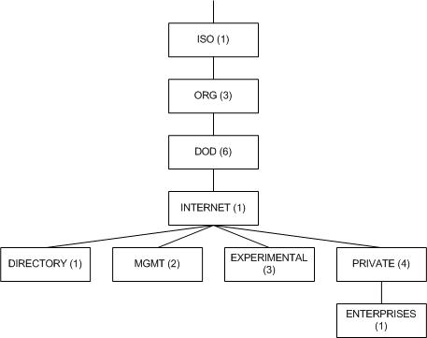
Figure 4.1. MIB Tree
The prefix 1.3.6.1 is almost always the prefix to a given OID, and is the numeric form of the following hierarchy: International Organization for Standardization (1), International Organizations (3), Department of Defense (6), Internet (1). This can be abbreviated as iso.org.dod.internet or 1.3.6.1 (McCloghrie & Rose, 1988). Each node in the dotted list is a node in the universal OID tree. Nodes can be represented by their name or their respective number (iso or 1). As an example, the IETF represents the system name object as 1.3.6.1.2.1.1.5.0 where 1.3.6.1 is the standard prefix. The remaining portion is Management (2), MIB-II (1), System (1), System Name (5), Instance (0) (McCloghrie & Rose, 1991). As pointed out, this number is hierarchical, where each number represents a node in the overall OID tree. The very last zero, labeled “Instance”, is really not a node. It stems from the fact that any OID can have more than one instance. Since there is only one instance of the sysName object, its OID must end with a zero (Walsh, 2008).
Management Information Bases
A fundamental concept of agent programming involves understanding the boundary between agents and managed information. When learning how agents and managed information fit together, many will envision agents as software programs that access a collection of information in order to respond to requests and generate notifications. Similarly, those new to the SNMP protocol will often understand a Management Information Base (MIB) to be a database of information available to an agent. Figure 4.2A is diagram of such a conceptual agent and MIB combination. This model of an agent is not entirely correct. While an agent could potentially be programmed to store the information it maintains in a database, it is not a requirement. A database backend may be appropriate in situations where agents need to store large amounts of persistent data, but agents which manage only small amounts of information may not need the added functionality a database provides. Some information may also be dynamic, making database storage un-needed overhead. It all comes down to the managed information and its accessibility. Figure 4.2B. provides a correct depiction which will be made clearer later in this paper.
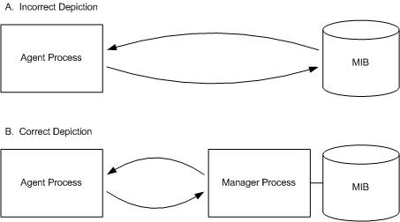
Figure 4.2. Depiction of Agent and MIB
The concept of a MIB is difficult to understand at first, but only because it is used in multiple different ways. Some authors will speak of “the agent’s MIB”, indicating the aggregation of all managed information for which an agent is capable of handling requests and generating traps. At other times, writers will talk about a specific MIB within an agent or manager. Not all information managed by an agent is related. For instance, information about an agent’s display may be logically separate from information about an agent’s network interfaces. Therefore, it would make sense to think of these as separate MIBs. Lastly, in the context of managers, MIBs are loaded into managers to allow them to map object names to OIDs. Larry Walsh explains that the term MIB “describes data objects and trap objects to be managed by an agent within a device. MIBs are files containing parsable syntax, and shared knowledge of specific MIBs is the basis of meaningful communications between managers and agents” (Walsh, 2008, p. 29).
To alleviate confusion, it may be best to use a low level explanation of MIBs. MIBs are files that describe a hierarchy of data objects and trap objects. Every data object in a MIB is given an object identifier (OID), a name, and a data type. As an example, figure 4.3 shows the sysName object from the SMIv2 MIB (Case, McCloghrie, Rose, & Waldbusser, 1996b). The name of the object is sysName, and the type is DisplayString. In order to specify the OID, MIB syntax uses a node name and an additional number to append to that node’s OID. In the case of the sysName object, system 5 is representative of 1.3.6.1.2.1.1.5
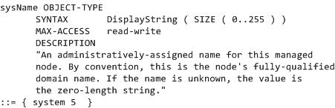
Figure 4.3. The sysName Object
Every notification object in a MIB is given an OID, a name, and a list of data objects it will contain. Notification objects define a specific area within the OID tree containing related data and trap objects. Figure 4.4 shows a printer notification from the IETF’s printer MIB. The notifications name is printerV2Alert, and its objects are listed after the OBJECTS keyword. The statement printerV2AlertPrefix 1 specifies the OID of the notification to be the number 1 appended to the OID of the printerV2AlertPrefix node.
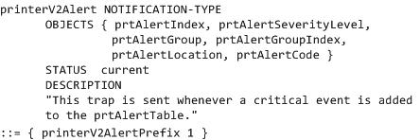
Figure 4.4. The printerV2Alert Notification
MIB files are used to tell manager nodes needed information about those objects. Contrary to the way the term MIB has been used with agents, MIB files are truly only used by managers. Agents must be programmed to perform actions and generate responses and notifications based on the information in a MIB file, but agents never utilize a MIB file themselves. A MIB is not a database of information accessed by an agent.
To emphasize this point, a MIB is a file describing data and trap objects. It allows a manager to map object names to identifiers to data types, so that the manager can make requests and receive notifications that it understands. Agents never use MIB files, but are programmed based on the information contained in them. Agents are, effectively, implementations of MIBs. Where a MIB file defines managed objects, agents contain programming code and variables used to implement those objects. They are responsible for doing the work that a MIB describes.
A diagram of a true SNMP system including an agent, a manager, and MIB files is included in Figure 4.5. In the figure, the authoritative entity has a manager process which uses MIB files to retrieve information about MIB objects. The manager process sends requests to and receives responses and notifications from the agent process running on the non-authoritative entity.
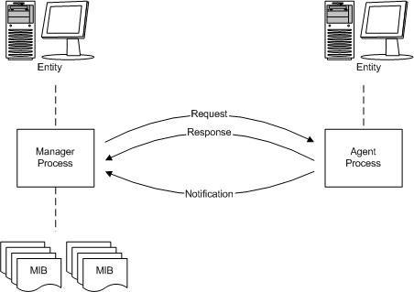
Figure 4.5. SNMP System Utilizing MIB Files.
Think about an enterprise creating a new device which will need to be managed by an SNMP manager. The enterprise will first decide what information to make accessible via SNMP, whether that information is read-only or writeable, and when to send traps to the manager or managers. After making these decisions, the company will create a MIB file, which defines these data and trap objects. The company will then write an agent program which will provide the functionality described by the MIB, and load this program on the device they have created. When a network administrator purchases the device, he or she can now load the accompanying MIB file into his or her own manager. Now the manager knows the data and notification objects by name, and can formulate queries on behalf of the administrator. These queries will be sent to the device, where the agent will respond appropriately.
Pretend this fictitious battery powered device has an internal thermometer that the network administrator wants to query for current temperature. The administrator may specify that he or she wants to get sysTemp from a node with a given network address. The manager software running in the form of a process on the node the administrator is using will first search through the MIB files it has available. When it finds the MIB containing the definitions for sysTemp, it can use the information in the MIB file to translate sysTemp into an OID. The manager process will then build a GetRequest PDU with the OID it found in the fictitious device’s MIB, and send it to the node with the address specified by the administrator. If the network administrator forgot to load the enterprise MIB created for his or her new device, the manager process will return an error explaining that it does not know what sysTemp is, and that it cannot translate it to an OID. As a second example, the process will work exactly the same if the administrator wants to query the node for battery power. The manager will translate the battery power object name into an OID and send a request to the agent, just as it did with the sysTemp object.
When the GetRequest PDU arrives at the managed device, it will be forwarded to the correct agent process. The agent will be programmed to perform some action when it receives a request for the OID. In this case, the agent will either read the current internal temperature from the thermal sensor or retrieve the battery power remaining from the battery. Once it has the correct information, it will formulate a Response PDU, and add a variable binding consisting of the corresponding OID and the value returned by the temperature sensor or battery. Next, it will send this information back to the network address it received the request from (the manager). The manager can retrieve the needed information from the Response PDU, and present it to the network administrator.
MIB File Syntax
In order for this process to work appropriately, the agent must be designed from a syntactically and semantically correct MIB. The SMI defines a common language and an acceptable structure for MIB files so that all managers can parse them. The syntax of a MIB file is a derivation of the Abstract Syntax Notation One (ASN.1) language (McCloghrie & Rose, 1988). The ASN.1 language provides a means of representing data in a platform independent fashion (Mauro & Schmidt, 2005). There are two forms of MIB syntax: SMI version one and SMI version two. Both have slightly different syntax and data types. Although the technical differences between the two versions are not important in the context of this paper, it is important to note that well-written SMI version two syntax can be translated into SMI version one syntax if needed. This provides a semi backwards compatibility in order to accommodate for old manager software (Walsh, 2008).
All SMI data types are derivations of one of the two main types: OctetString or Integer. An OctetString is a hexadecimal value that can be any length, while an Integer is a simple number. Other data types exist only to convey functionality. A Gauge is understood to be a range between a minimum and maximum value. A Counter is generally incremented continuously. Both types can be represented as an Integer, but semantically both data types are different. Therefore, both data types exist as valid data types. The base types for SMIv2 include Integer, Integer32, Unsigned32, Gauge32, Counter32, Counter64, TimeTicks, OctetString, ObjectIdentifier, IPAddress, Opaque, and Bits (Walsh, 2008). Most of these data types do not require an explanation. One thing to note is that character strings are considered to be of type OctetString. Characters are generally represented in a byte of data, which is equivalent to one octet of an OctetString.
The syntax of a MIB file is not too complex, but one could spend ages learning the subtle differences between SMI versions and the many statements not used in an average MIB. For this reason, a detailed description of MIB syntax will be left out of this paper. Details aside, an understanding of the structural basics of MIB syntax is necessary. An important distinction to make from the start is the difference between a MIB filename, a MIB name, and the name of the topmost node. A MIB file can contain multiple MIB definitions. For this reason, managers do not use filenames. A manager will not care about a filename provided it ends in the correct file extension. Managers care about MIB names. In order to load a given MIB into a manager, one can use the name of the MIB. Managers must parse all MIBs accessible to them in order to know where specific MIBs are defined. Lastly, the name of the topmost node in the MIB is the name that can be used in an OID to access the data objects in the MIB. For instance, a topmost node located directly under the internet node, named “important”, with node number eight, could be written as “iso.org.dod.internet.important” or “1.3.6.1.8”.
All MIB modules start out with a special clause, the begin clause, used to define the name of the MIB. Figure 4.6 provides an example begin clause.
KU-ADHOC-MIB DEFINITIONS ::= BEGIN
Figure 4.6. Begin Clause
Following the MIB name definition, pieces of other MIBS that need to be included in the given MIB can be loaded using an import statement. This is useful for retrieving derived data types and other MIB objects that need to be part of the MIB. Directly after the import statement comes the most important part of an entire MIB file: the module identity statement. The module identity statement identifies where in the MIB tree the MIB will be located. It defines the node number and the name of the top-most node. It contains the OID up to the point of the topmost node in the MIB, along with the name and number assigned to the node. Figure 4.7 provides an example module identity statement.
kutztownAdhocMIB MODULE-IDENTITY
LAST-UPDATED "201001280000Z"
ORGANIZATION "Kutztown University, Department of Computer Science"
CONTACT-INFO "Kyle Fox (kfox112@live.kutztown.edu)"
DESCRIPTION "This MIB defines objects and notifications useful for
management of wireless adhoc networks. The bulk of
data objects defined in this MIB support query of
power information from a node, such as battery life
and current power source. This MIB also defines
notifications to be sent when low and critical battery
power levels are reached. All notifications and
objects are grouped to conform with SMIv2"
REVISION "201001280000Z"
DESCRIPTION "Initial version of this MIB module."
::= {kutztownCSDExperimental 1}

Figure 4.7. Module Identity Statement

All other nodes in the MIB can be defined with their respective names, data types, and OIDs after the module identity statement. This includes data objects, trap objects, and organizational nodes. Once all nodes in the MIB have been defined, the MIB file concludes with the end keyword. The ad-hoc MIB included in appendix A demonstrates MIB syntax.

Chapter 5
Ad-hoc MIB Design

Designing a management information base (MIB) is like playing a game of chess. During any state of the game, the options available to a player are endless. Every time a player makes a move, the outcome of the game may change. A wise chess player will think ahead and make moves strategically by evaluating all possible outcomes. Designing a MIB requires an equal amount of forethought. Understanding how all elements of a MIB will interact is crucial to the design process. A MIB should be predictable and intuitive. Following the chess paradigm, a good player must understand all possible repercussions of making a move. Similarly, a MIB designer must evaluate all possible outcomes of changing a MIB variable in order to prevent a flawed design. Often, the variables in a MIB are tightly coupled. Modification of one variable may cause drastic changes within the MIB. Therefore, it is important to understand the outcome of interleaving operations on a MIB during its design. A MIB is like a blueprint to an agent implementation, and a flawed MIB design can make implementation impossible.
Managed Ad-hoc Information
The purpose of this thesis was to design and develop an ad-hoc MIB and an accompanying ad-hoc agent. An ad-hoc MIB serves the same purpose as any other standard MIB: to make specific information accessible to a manager. Similar to how a printer MIB makes printer information available to a manager, an ad-hoc MIB makes ad-hoc information available to a manager. A fundamental problem with ad-hoc MIB development is deciding what information should be part of an ad-hoc MIB. All networks serve the same purpose regardless of their underlying architecture: to provide connectivity between end systems. Because of the common goal ad-hoc and wired networks share, the boundary between wired network management and ad-hoc network management blurs. Arguably, there are two key differences between ad-hoc network management and wired network management.
The first key difference between ad-hoc and wired network management is the complexity added by battery power. Because ad-hoc nodes are often mobile, they will run on battery power. Maintaining power information about remote nodes can help prevent unnecessary faults. As an example, consider the zebra tracking network described in the introduction. Zebras are inherently mobile; therefore, zebra tracking devices must run on battery power. If the battery in one zebra’s collar loses power, the impact is minor. Losing track of a single zebra will not have a substantial effect on the overall biological study. The loss of multiple zebra collars, however, may begin to impact the network as a whole. The lessened number of ad-hoc collars will decrease the density of the network, eventually leading to unacceptable partitioning.
With the use of an ad-hoc MIB and an ad-hoc agent, the zebra collars could notify the manager and each other in the event of low battery. After receiving a low battery notification, a ZebraNet administrator could locate the zebra with the dying collar and re-place the battery before the collar fails. This simple solution would allow the network to maintain strength over time and the zebras would not end up with useless collars. The collars could either be replenished or removed after the death of the internal battery. While one would hope that the ZebraNet system employs some sort of power management, any system utilized in this project was not been published. The MIB and agent developed as a supplement to this thesis are designed to be standard, extendable, and open-source. Such a system can function in virtually any ad-hoc environment, such as ZebraNet.
The second key difference between ad-hoc network management and wired network management stems from the underlying routing protocol. In comparison to wired network routing protocols, ad-hoc network routing protocols have many more issues to solve. Node movement and route changes are unusual events in a wired network making wired network routes generally static. Usually, a network administrator will be aware of any route changes or node movement in a wired network. In contrast, wireless ad-hoc network nodes move continuously. Route changes occur frequently, meaning route table updates must be performed dynamically. From a network management standpoint, the ability to retrieve routing information remotely from an ad-hoc routing protocol is important. A remotely located manager node could potentially make route changes to improve performance.
Looking at the ZebraNet tracking system, routes between collars will change often. Remote routing information retrieval can help zebra collar managers learn which zebras stay close to each other, and how often the zebras come into contact. The real benefit comes from a combination of routing information with power information. Some zebras may prefer shady areas, while others may enjoy sunshine. Because the zebra collars utilize miniature solar panels for power regeneration, the collars on zebras that tend to stay in the sun will regenerate quickly in comparison to the zebras that stay in the shade. From a routing standpoint, it would make the most sense to use the quickly regenerating collars as relays. Also, collars that predict a loss of power can request to be used sparingly as routing intermediaries. As a last example, in a clustering routing algorithm, cluster head elections could take into account the regeneration statistics of a given collar.
Exclusion of Routing Information
Although routing protocol information can help considerably with ad-hoc network management, the provided MIB and agent do not include routing. The architecture of the Internet relies on layers of abstraction to provide modularity. Routing protocols, in effect, work at the network layer of the Internet architecture stack, depicted in Figure 5.1. The Simple Network Management Protocol (SNMP) operates at the application layer, which is at the top of the stack. The relative positions of the network and application layers in the Internet architecture stack illustrate dependencies between layers. Any given layer relies recursively on the layers below it. In other words, a given layer N needs layer N-1 to function correctly. Coupling of a routing protocol with SNMP violates the modularity of the layered architecture of the Internet. One reason no routing protocol is included with the ad-hoc MIB and agent proposed by this paper is that SNMP should depend on a routing protocol rather than provide it.
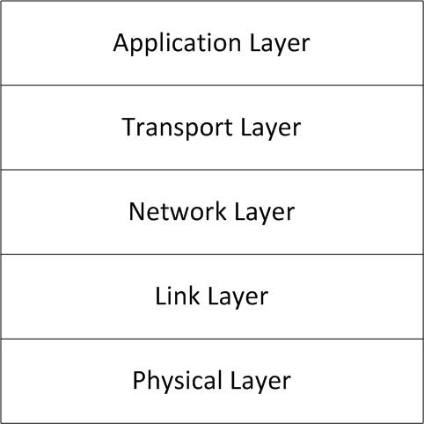
Figure 5.1. Internet Architecture Stack
Additionally, combining a routing protocol with SNMP requires a forced relationship between a network management protocol and a specific routing protocol. There are many routing protocols available, and the SNMP protocol should be able to work on top of any of them. Because routing protocols are still evolving, creating a dependency on a single routing protocol would make an ad-hoc network management MIB and agent un-sustainable. The added value in using a hybrid protocol does not outweigh the losses mandated by selecting a single routing protocol for network management. Aside from the ever-changing routing protocols and new implementations, some routing protocols may be better adapted for one situation than for another. It would not be practical to disallow utilization of different routing protocols in different situations.
Although joining a routing protocol and a network management protocol is a poor choice, there are many ways to allow routing protocols and network management protocols to interact without combining them. For instance, a routing protocol can provide its own agent and MIB. Rather than have the routing protocol and the network management protocol interact directly, a manager can read and modify information in both accompanying agents based on the data in its possession. As an example, a manager could receive a notification from an agent explaining that its battery power is low. In response, the manager could modify a read-write variable in the routing protocol’s agent in order to tell the routing protocol to attempt to route away from the dying node. This approach avoids needing to program either agent to know of the other’s existence, and also allows managers to customize exactly how power and routing information interact.
A second option is to make the ad-hoc agent directly aware of the routing protocol. The problem with this approach is that routing protocols all define their own way of interaction. Without a standard interface, it is almost impossible to enable this approach. Although not currently an option, future routing protocols could be programmed to ad-here to a standard, allowing direct awareness. As an alternative, the routing protocol could provide its own agent similar to the option discussed previously. Instead of requiring the manager to make route changes, the ad-hoc agent could directly contact the routing protocol agent to perform necessary changes. Once again, this would require additional programming. Routing protocol agents would need to be implemented for any routing protocols to be used with the ad-hoc agent. The design of routing protocol agents is out of the scope of this paper, and therefore, the ad-hoc agent will require a manager intermediary. Figure 5.2 illustrates the difference between the combined agent and routing protocol approach, and the separation of the two.
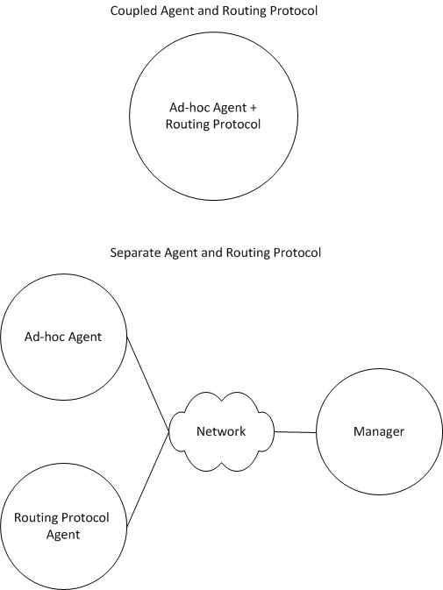
Figure 5.2. Routing Protocol and Agent Interactions
Kutztown Ad-hoc MIB Variables
Because of the problems associated with combining a routing protocol with a management protocol, the proposed ad-hoc MIB focuses on power state and power management information. In general, the ad-hoc MIB defines power information values able to be remotely queried and specifies notifications to be sent to a manager in the event of low battery levels. Its purpose is to allow remote power management of ad-hoc network nodes. In addition, the ad-hoc MIB also functions as a scheme for development of an ad-hoc agent. The design of the MIB assumes that an underlying, functional routing protocol exists. Routing protocol information is excluded from the MIB in order to support the layered Internet architecture and to allow for routing protocol independence. The full kutztownAdhocMIB is available in appendix A.
There are three core sets of objects available in the ad-hoc MIB: read-only power state objects, read-only power state notification objects, and read-write agent configuration objects. As previously explained, there are many dependencies between object sets. The power state information objects depend on the underlying system to report power information correctly. The MIB requires use of the configuration objects and the power state objects when formulating notifications. Lastly, the notification objects depend on both the power information objects and the configuration variables. Object sets must interact considerably in order to provide the best service to a manager station. The majority of these dependencies pertain mostly to agent design, but some dependency issues manifest themselves at the MIB design level.
The first core set of ad-hoc MIB objects is the set of power state objects. The most obvious and critical information about a node’s power state is its current power source. Some nodes may be plugged into an AC power outlet, while others will have to rely on a DC power battery. The first object included in the ad-hoc MIB is named adhocPowerStatus, with possible values of AC, DC, and unknown. Another important component of a node’s power state is whether or not it contains a battery. Without a battery, a node can only function while AC power is available. The second ad-hoc MIB object is adhocBatteryPresent, which can contain the values YES, NO, and unknown. The last important component of power state exists only if a node has a battery. Especially in mobile ad-hoc networks, remaining battery power is crucial. The remaining battery power of a node can be measured in either percent, or seconds. The ad-hoc MIB provides access to both measurements via adhocBatteryLifePercent and adhocBatteryLifeSeconds.
The power state notification objects for the ad-hoc MIB are the second core set of objects. There are two types of notifications which can be sent to a manager. The first notification in the ad-hoc MIB is the adhocLowBattery notification. The purpose of the low battery notification is to alert a manager when the agent’s node has low battery power. The unsolicited message contains the four power status objects; some configuration objects; and the system name, location, and description. The second and last notification defined in the ad-hoc MIB is the adhocCriticalBattery notification. A critical battery notification is sent when an agent recognizes that its corresponding node has a critical battery level. Generally, a critical battery level is less than a low battery level.
Clearly, some determination of when a battery has reached low and critical levels is necessary. The entire purpose of the third and final set of objects in the ad-hoc MIB is to configure the notification objects appropriately. The configuration objects modify the notification objects in order to make them useful for a specific deployment of the ad-hoc MIB and agent combination. Four configuration objects satisfy the need for specific low and critical battery levels: adhocBattLowPercentThresh, adhocBattCritPercentThresh, adhocBattLowSecondsThresh, and adhocBattCritSecondsThresh. Each of these read-writable objects specifies thresholds for low and critical battery levels. Because the ad-hoc MIB specifies notifications based on both percentage and seconds of battery life remaining, thresholds must be defined for both groups. A notification is sent for low battery when a node’s battery power drops below its low battery threshold. Similarly, a notification is sent for critical battery when a node’s battery power falls below its critical battery threshold.
The following two figures illustrate the interactions between battery thresholds and current battery levels for percentage based notification generation. Figure 5.3 demonstrates the ability to disable battery notifications by setting the threshold value to zero. Because the current percentage of battery life cannot fall below zero, a notification will never be sent if the threshold is set to zero. To reiterate, notifications are only sent when the corresponding value goes below the threshold, not when the value reaches the threshold. As an example, a notification for a percentage threshold value of 87 will be sent when the actual battery percentage remaining reaches 86.
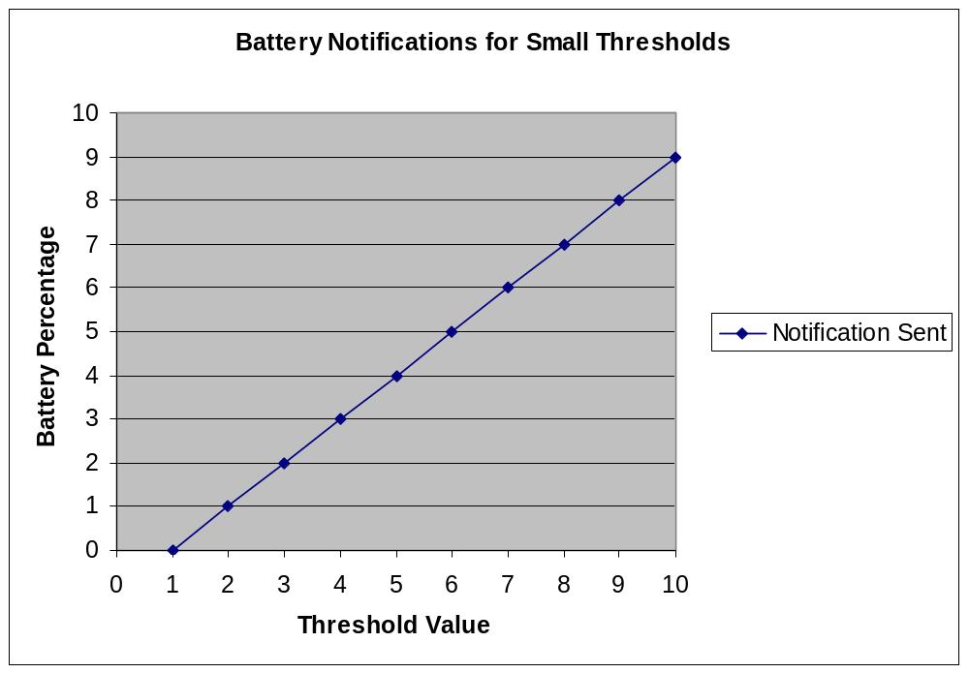
Figure 5.3. Battery Notifications for Small Thresholds
To further demonstrate, Figure 5.4 displays the notification chart for high threshold values. There are no special cases with high threshold values as there are with low thresholds. Even with the highest possible value of a percent threshold, 100, a notification will simply be sent when the percentage battery remaining reaches 99.
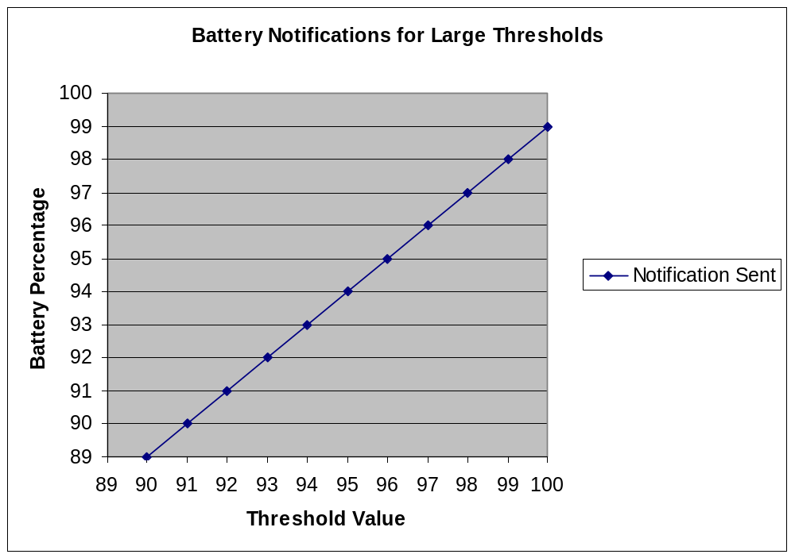
Figure 5.4. Battery Notifications for Large Thresholds
In order to handle measurements in both percentages and seconds, a configuration object for battery threshold units is included. The adhocBattThreshUnits object has two available options, percent and seconds. If the battery threshold units object is set to percent, battery notifications are based on the percentage of battery life remaining and the percentage thresholds. Otherwise, if the battery threshold units object is set to seconds, notifications are generated based on the seconds of battery life remaining and the seconds thresholds. Usage of seconds as a unit for notification generation is discouraged due to the inherent problem in seconds remaining calculation. Many batteries and platforms do not support retrieval of seconds remaining. In addition, when both a battery and platform calculate seconds remaining, the values are seldom accurate. If a timeframe on battery life is needed, it would be better to implement timeframe generation in the software manager by keeping track of percentage loss over time.
Battery notifications bring up an important problem: the frequency of sending notifications and the termination point. Without any other configuration objects, a manager will receive constant notifications from an agent for the duration of time that its remaining battery power falls under a given battery level. To prevent this problem, an additional configuration object, known as a rearm object, is necessary. Additional notifications are prevented by disarming a notification after it is sent. Rearm values allow calculation of a new threshold. A notification is rearmed once it reaches the calculated rearming threshold. For the ad-hoc MIB, notifications are rearmed once a battery level reaches the low or critical battery threshold value added to the rearm value. As an example, with a battery low threshold of 20 percent and a rearm value of 10, a disarmed battery low notification will only be rearmed after the battery level reaches 30 percent. It is important to note the difference between a rearm value and a rearm threshold. Rearm values are objects within the ad-hoc MIB, and rearm thresholds are calculated based on rearm values. Subsequent notifications will not be sent until battery life reaches a rearm threshold.
Figure 5.5 displays the relationship between rearm values and battery critical or battery low threshold values for low rearm values. Rearming takes place when the battery low or critical threshold added to the rearm value is equal to the remaining battery, or wherever there is a point on a line in the figure. For a battery threshold value of zero, rearming will never take place, as it is impossible for a battery to reach less than zero percent or zero seconds remaining. Because notifications are not generated when a battery threshold value is zero, rearming is unnecessary as well.
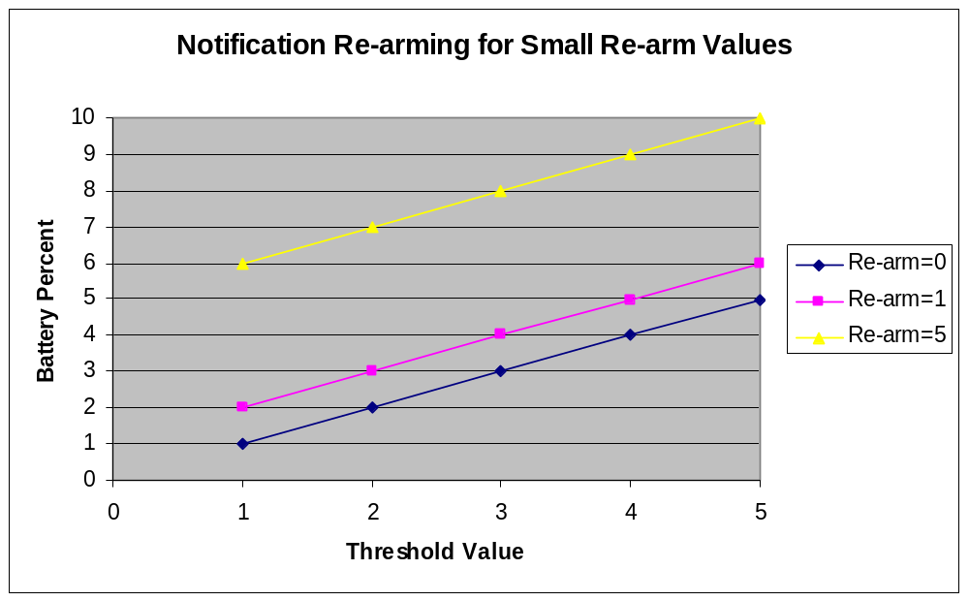
Figure 5.5. Rearming for Small Rearm Values
Although rearm values, as they are implemented in the ad-hoc MIB, are an obvious solution, there is still one small issue. An erroneous rearm value could place the rearming threshold above 100 percent battery life. For this reason, regardless of where a percent or seconds rearm value places the re-arm threshold, rearming will always take place when 100 percent battery life is reached. At first glance, it may seem appropriate to allow an exuberantly high rearm value to disable notifications. However, a high rearm value will never prevent the first notification from being sent. Therefore, disablement of notifications needs to be accomplished via setting battery threshold values to zero and not by choosing high rearm values. Figure 5.6 displays the relationship between threshold values and high rearm values. When a rearm threshold (rearm value + battery threshold value) is equal to or above 100 percent, rearming always happens at 100 percent battery life, irrelevant of units.
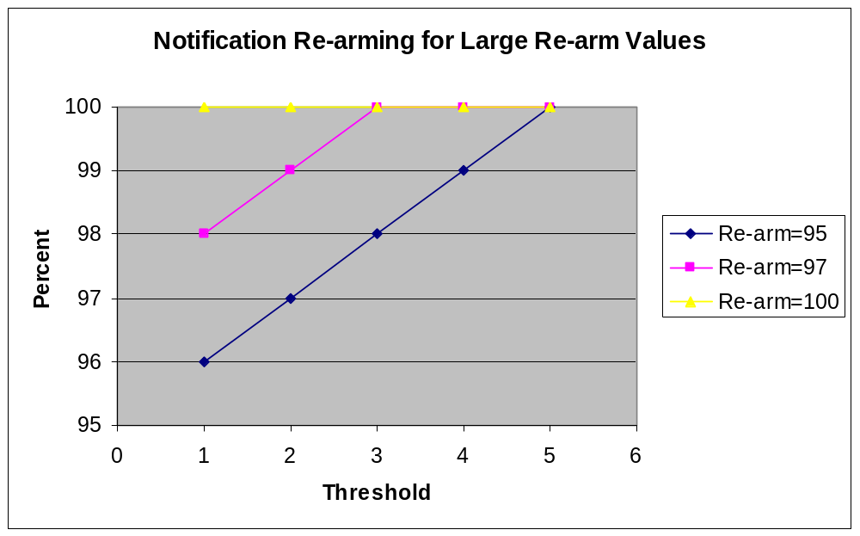
Figure 5.6. Rearming for Large Rearm Values
The last configuration variable in the ad-hoc MIB is the adhocBattPollInterval. Because an agent must poll for battery information from the operating system, a polling interval is an important configuration option. The longer the polling interval, the more battery life is conserved. At the same time, a longer polling interval will mean much more latency when reporting that the battery is at a low or critical level. In some situations, batteries may be designed to last for a long time period. The battery in a zebra collar will last much longer than the battery in an average laptop. Therefore, the poll interval would be set much lower in a collar in order to conserve energy. Since zebra collar batteries decrease at a very slow rate comparably to laptops, the notification latency will not matter as much.
The ad-hoc MIB aims to define power information objects useful in ad-hoc networking. The MIB promises access to power state information, as well as unsolicited trap messages when battery levels fall below a user defined threshold. The kutztownAdhocMIB can be loaded into an SNMP manager so that the manager can interpret the ad-hoc MIB’s object identifiers (OIDs) correctly. Loading the ad-hoc MIB into a manager also ensures that the manager will understand any notifications it may receive from a MIB implementing agent.

Chapter 6
Ad-hoc Agent Design

The agent development process is straightforward provided a well designed MIB is available to use as a model. Conformance to a MIB is the basis of agent creation. As stated previously, a MIB is like a blueprint to an agent. A good analogy to use is that of a building construction project. When a corporation decides that a new high-rise is needed, that corporation will first hire an architect. The job of an architect is to design the layout of the building. From the basement to the penthouse, an architect will develop structurally stable and easy to navigate floor plans. All building infrastructure will be laid out on paper before any construction takes place. MIB design is the job of the architect. A MIB designer makes all infrastructure decisions, and generates a specification for all manageable information.
The process of agent development is the job of the contractor. When an architect completes a building plan, general contractors make bids on the construction job. After selection of a general contractor, construction can begin. The construction workers follow the design of the original building plan created by the architect to the best of their ability. Some parts of the building plan will require strict adherence, while other parts of the plan may allow for some minor modification. The same is true of agent design. The designer of a MIB and the designer of an agent are not always the same person. Often, a MIB design group will develop a MIB and leave the job of agent implementation to another group. An agent implements the functionality a MIB describes. Similar to how contractors make small changes to building plans, agent implementers have some leeway based on the MIB. A MIB file contains statements specifying which components are mandatory and which are optional. Agent designers may choose which optional components of a MIB they wish to support, and which they do not.
Agent Extensibility Protocol
An extreme flaw exists in the overall manager/agent architecture. Because agents are programmed as supplements to single MIB files, many agents may be necessary in order to serve all information available on a node. For instance, a node may have a battery and an internal thermometer. Because batteries and thermometers are logically separate, they will have separate MIB files. Having separate MIB files usually means having separate agent implementations. Using this design model, SNMP nodes serving multiple MIBs require multiple agent processes. Each agent will have to register with the master agent independently, using its respective port. This may not seem like a problem until additional agents and MIBs are introduced. The manager may also need to query the node for its system name, thereby necessitating a third MIB and agent. Therefore, for N MIBs, a system would need to have N ports available, and a manager would need to keep N agents registered for one single node. Such a situation is not practical. Figure 6.1 provides a diagram of multiple agents running on a single node. Each agent must use its own port to connect to the manager independently.
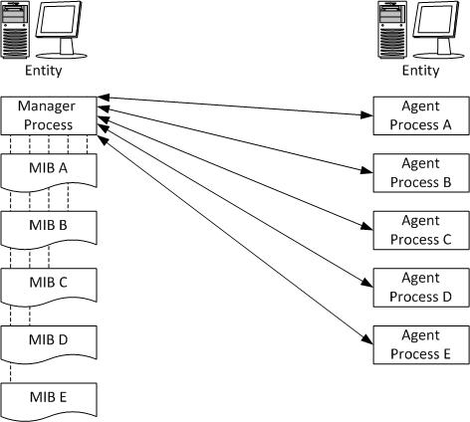
Figure 6.1. Communication Without Using the Agent Extensibility Protocol
To alleviate the problem, the Internet Engineering Task Force (IETF) developed the Agent Extensibility (AgentX) protocol. The AgentX protocol defines two types of agents: master agents and subagents. An AgentX master agent “sends and receives SNMP protocol messages in an agent role … but typically has little or no direct access to management information” (Daniele, Ellison, Francisco, & Wijnen, 2000). In contrast, AgentX subagents are processes which “are ‘shielded’ from the SNMP protocol messages processed by the master agent, but which have access to management information” (Daniele et al., 2000). AgentX allows one line of communication between two nodes, which runs from the manager process on one node, to the master agent process on another. Instead of having multiple agent processes running on different ports, there is one single master agent running on a single port, which communicates with subagents via the AgentX protocol. Figure 6.2 illustrates the new model of communication.
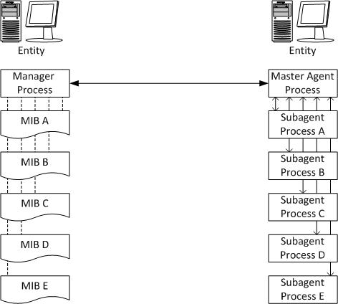
Figure 6.2. Communication Using the Agent Extensibility Protocol
The ad-hoc agent created as part of this research is an AgentX subagent that uses the AgentX protocol to communicate with a master agent. Since the AgentX protocol provides a standard means of communicating between master agents and subagents, the ad-hoc subagent can be used with any master agent that adheres to the AgentX protocol. The ad-hoc subagent uses the SNMP4J Java Application Programming Interface (API) authored by Frank Fock (Fock, 2010). Through the use of the AgentX protocol, the ad-hoc subagent does not need to worry about SNMP administrative tasks such as choosing an SNMP version, or registering with the manager. Instead, the ad-hoc subagent communicates with a master agent, which takes care of SNMP protocol specifics. The abstraction added by the AgentX protocol allows the ad-hoc agent to inherit the functionality of the master agent. As an example, if a master agent supports both the SNMPv3 View-Based Access Control Model (VACM) and User-Based Security Model (USM), the subagent will inherit these abilities.
Power Monitoring
The goal of the ad-hoc subagent is to enable remote power management of nodes. The power package created for the ad-hoc subagent allows the subagent to retrieve power information. Written in Java, the PowerInfo class is capable of running on both Windows and Linux platforms. On a Linux platform, power information is retrieved from the Advanced Configuration and Power Interface (ACPI) via system files. Through the use of the Java Native Interface (JNI), the ad-hoc agent uses C code compiled into a dynamically linked library to retrieve power information on a Windows platform. When a PowerInfo object is instantiated, it will check the operating system version for compatibility and generate an exception if it does not support the underlying operating system.
For extensibility purposes, any platform specific class used by the PowerInfo class must implement the PowerInfoInterface interface. The PowerInfoInterface contains four methods: getPowerStatus, getBatteryPresence, getBatteryLifePercent, and getBatteryLifeSeconds. If the ad-hoc subagent needs to be adapted to support a new platform, a new class must be created that implements PowerInfoInterface and provides the functionality described by it. For example, to allow the PowerInfo class to function on a Macintosh platform, one would need to create a class that implements PowerInfoInterface and retrieves the needed information from the operating system. Lastly, one would need to update the PowerInfo class to accept the newly created platform specific class.
The PowerInfo class delivers all of the needed power state information to the ad-hoc subagent. Figure 6.3 is a domain class diagram of the power package.
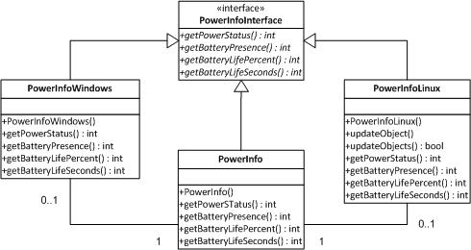
Figure 6.3. Power Package Class Diagram
Agent Implementation
The ad-hoc subagent uses the abstraction provided by the PowerInfo class to offer quasi platform independence among supported operating systems. In other words, the agent can run on any platform, but can only retrieve power information from platforms supported by the PowerInfo class. Currently, the PowerInfo class provides support for Windows and ACPI enabled Linux. Support for other platforms can be added by implementing the PowerInfoInterface interface, and providing platform specific code for retrieving the needed information. Through the included power package, the agent is able to efficiently retrieve power status from the system.
To provide the battery notification described by the ad-hoc MIB, the agent must poll the PowerInfo object for state information. The ad-hoc MIB provides a read-write object known as adhocBattPollInterval. The value of the object specifies exactly how long to wait in between polling of power state. As previously explained, the polling interval can be used to reach a balance between notification latency and power consumption. When a new poll interval is set, the ad-hoc subagent will automatically execute an introductory poll. Because a new poll value may be lower than an old poll value, the agent must poll immediately to move into the new polling interval. As an example, if a previous poll interval had a value of five minutes, and a new poll interval of 30 seconds is introduced, the battery polling thread cannot know how long to wait before executing a subsequent poll. There is a possibility that an agent could wait 29 seconds before polling due to the old 30 second interval. To alleviate the problem, the ad-hoc subagent will generate a poll as soon as the adhocBattPollInterval object changes.

Chapter 7
Summary and Conclusion

From business gatherings at urban cafés to groups of African zebras, ad-hoc networks are the most efficient method of communication where no infrastructure is available. The information age has introduced a variety of new communication methods. Electronic devices have made it possible to stay connected from all locations at all times. The need for information sharing will undoubtedly push ad-hoc networking into the mainstream. Computer science professionals around the globe have already recognized the importance of ad-hoc wireless networking. “Ad hoc networks are a key factor in the evo-
lution of wireless communications” (Stojmenovic & Wu, 2004). The desire for infrastructure-less communication will surely impact wireless communication in the near future. As Bill Gates once said, "Any tool that enhances communication has profound effects in terms of how people can learn from each other, and how they can achieve the kind of freedoms that they're interested in" (Coley, 2009).
Summary
With the rise of ad-hoc networking, ad-hoc network management is also an important topic. The Simple Network Management Protocol (SNMP) is, by far, the best tool for standard network management. Through the use of an underlying routing protocol, SNMP is capable of functioning in an ad-hoc environment. Although SNMP functions on ad-hoc networks, few have proposed its usage in ad-hoc environments. To utilize SNMP in an ad-hoc network, an ad-hoc MIB and ad-hoc agent are necessary. A small number of protocols for ad-hoc network management have been created, but all of them have been lost in time.
The ad-hoc subagent developed pushes into unexplored areas of ad-hoc network management. Because power management is of utmost importance to ad-hoc network management, the sub-agent can help in virtually any ad-hoc network. Its modular design and ease of extendibility will allow it to expand and grow as ad-hoc networking increases in prevalence. Since the subagent implementation uses the AgentX protocol, it can pair with virtually any AgentX enabled master agent. The use of standardized protocols gives the subagent the ability to adapt to future changes. The power management classes developed for the ad-hoc subagent’s use are easily expandable to include new platforms. Lastly, the agent and source code are freely available, and can be modified to accommodate for any situation.
Conclusion
The ad-hoc subagent is a great asset to ad-hoc network management. While it clearly cannot solve all problems inherent with ad-hoc networking, it facilitates remote power management and enables new innovation in the use of SNMP on ad-hoc networks. The ad-hoc MIB and agent are a step towards recognition of a need for better ad-hoc network management practices. Ad-hoc networking will only gain strength in time, and the ad-hoc MIB and subagent will ease the transition into managing ad-hoc networks.

References

Buchele, S. F. (2009). Using OLPC laptop technology as a computer science case study teaching tool. Journal of Computing Sciences in Colleges, 24(4), 130-136.

Case, J., McCloghrie, K., Rose, M., & Waldbusser, S. (1996a). Protocol Operations for Version 2 of the Simple Network Management Protocol (SNMPv2). Internet Engineering Task Force, RFC 1905. Retrieved from http://www.ietf.org/rfc/rfc1905.txt

Case, J., McCloghrie, K., Rose, M., & Waldbusser, S. (1996b). Management Information Base for Version 2 of the Simple Network Management Protocol(SNMPv2). Internet Engineering Task Force, RFC 1907. Retrieved from http://www.ietf.org/rfc/rfc1907.txt

Cerf, V. (1988). IAB Recommendations for the Development of Internet Network Management Standards. Internet Engineering Task Force, RFC 1052. Retrieved from http://www.ietf.org/rfc/rfc1052.txt?number=1052

Chen, W., Jain, N., & Singh, S. (1999). ANMP: Ad hoc network Network Management Protocol, IEEE Journal on Selected Areas in Communications, 17. Retrieved from http://citeseerx.ist.psu.edu/viewdoc/summary?doi=10.1.1.31.4459

Cisco. (2007). Network Management System: Best Practices
Retrieved November 8, 2009 from Cisco White Paper Database
http://www.cisco.com/application/pdf/paws/15114/NMS_bestpractice.pdf

Cisco Systems, Inc. (2004). Internetworking Technologies Handbook. (4th Ed.). Indianapolis, IN: Cisco Press

Clemm, A. (2007). Network Management Fundamentals. Indianapolis, IN: Cisco Press.

Coley, A. (2009). Historical Examples of Courage. Associated Content. Retrieved from http://www.associatedcontent.com/article/1354311/historical_examples_of_courage_no13.html

Daniele, M., Ellison, M., Francisco, D., & Wijnen, B. (2000). Agent Extensibility (AgentX) Protocol Version 1. Internet Engineering Task Force, RFC 2741. Retrieved from http://www.ietf.org/rfc/rfc2741.txt

Davin, J., Case, J., Fedor, M., & Schoffstall, M. (1987). A Simple Gateway Monitoring Protocol. Internet Engineering Task Force, RFC 1028. Retrieved from http://www.ietf.org/rfc/rfc1028.txt?number=1028

Decouto, D., Jannotti, J., Kaashoek, F., Li, J., & Morris, R. (2000). CarNet: a scalable ad hoc wireless network system. Proceedings of the 9th workshop on ACM SIGOPS European workshop: beyond the PC: new challenges for the operating system. doi: 10.1145/566726.566741

Fock, F. (2010). SNMP4J: The SNMP API for Java. Retrieved from http://www.snmp4j.org/

Harrington, D., Presuhn, R., & Wijnen, B. (1999). An Architecture for Describing SNMP Management Frameworks. Internet Engineering Task Force, RFC 2571. Retrieved from http://www.ietf.org/rfc/rfc2571.txt

Kaiser, J., & Liu, C. (2005). A Survey of Mobile Ad Hoc Network Routing Protocols. Retrieved from http://citeseerx.ist.psu.edu/viewdoc/download?doi=10.1.1.105.7768
&rep=rep1&type=pdf

Martonosi, Margaret. (2004). The ZebraNet Wildlife Tracker. Retrieved from http://www.princeton.edu/~mrm/zebranet.html

Mauro, D. R., & Schmidt, K. J. (2005). Essential SNMP: Help for System and Network Administrators (2nd ed.). Sebastopol, CA: O’Reilly Media, Inc.

McCloghrie, K., & Rose, M. (1988). Structure and Identification of Management Information for TCP/IP-based internets. Internet Engineering Task force, RFC 1065. Retrieved from http://www.ietf.org/rfc/rfc1065.txt

McCloghrie, K., & Rose, M. (1991). Management Information Base for Network Management of TCP/IP-based internets: MIB-II. Internet Engineering Task Force, RFC 1213. Retrieved from http://www.ietf.org/rfc/rfc1213.txt

Stojmenovic, I., & Wu, J. (2004). Adhoc Networks. IEEE Computer Society. Retrieved from http://citeseerx.ist.psu.edu/viewdoc/download?doi=10.1.1.103.8923&rep=rep1&type=pdf

TerraNet. (2010). TerraNetAB: Mobile communications without a regular network. Retrieved from http://www.terranet.se/index.php

Walsh, L., (2008). SNMP MIB Handbook: Essential Guide to MIB Development, Use, and Diagnosis. Stanwood, WA: Wyndham Press.

Appendix A

Kutztown Ad-hoc MIB

KU-ADHOC-MIB DEFINITIONS ::= BEGIN
--
-- iso(1).org(3).dod(6).internet(1).private(4).enterprises(1)
-- |
-- kutztownuniversity(35318)
-- |
-- kutztownComputerScience(1)
-- |
-- kutztownCSDExperimental(1)
-- |
-- kutztownAdhocMIB(1)
-- |
-- _________________________________________________
-- | | | |
-- adhocNotifications(0) | adhocGroups(2) |
-- | |
-- adhocObjects(1) adhocConformanceGroups(3)

IMPORTS
kutztownCSDExperimental
FROM KUTZTOWN-UNIVERSITY-MIB
MODULE-IDENTITY, OBJECT-IDENTITY, OBJECT-TYPE, NOTIFICATION-TYPE,
Integer32, Gauge32, Unsigned32
FROM SNMPv2-SMI
sysName, sysLocation, sysDescr
FROM SNMPv2-MIB
OBJECT-GROUP, NOTIFICATION-GROUP, MODULE-COMPLIANCE
FROM SNMPv2-CONF;

kutztownAdhocMIB MODULE-IDENTITY
LAST-UPDATED "201001280000Z"
ORGANIZATION "Kutztown University, Department of Computer Science"
CONTACT-INFO "Kyle Fox (kfox112@live.kutztown.edu)"
DESCRIPTION "This MIB defines objects and notifications useful for
management of wireless adhoc networks. The bulk of
data objects defined in this MIB support query of
power information from a node, such as battery life
and current power source. This MIB also defines
notifications to be sent when low and critical battery
power levels are reached. All notifications and
objects are grouped to conform with SMIv2"
REVISION "201001280000Z"
DESCRIPTION "Initial version of this MIB module."
::= {kutztownCSDExperimental 1}

adhocNotifications OBJECT-IDENTITY
STATUS current
DESCRIPTION "The parent node to all ad-hoc Notification-Type objects."
::= {kutztownAdhocMIB 0}

adhocObjects OBJECT-IDENTITY
STATUS current
DESCRIPTION "The parent node to all ad-hoc Object-Type objects."
::= {kutztownAdhocMIB 1}

adhocGroups OBJECT-IDENTITY
STATUS current
DESCRIPTION "The parent node to all object groups."
::= {kutztownAdhocMIB 2}

adhocConformanceGroups OBJECT-IDENTITY
STATUS current
DESCRIPTION "The parent node to all conformance groups."
::= {kutztownAdhocMIB 3}

adhocPowerStatus OBJECT-TYPE
SYNTAX INTEGER { acpower(1), dcpower(2), unknown(3) }
MAX-ACCESS read-only
STATUS current
DESCRIPTION "The current power mode of the ad-hoc node. Enumeration
1 - acpower is set if the node is plugged in.
Enumeration 2 - dcpower is set if the node is running
on battery. Enumeration 3 - unknown is set if the power
status of the node cannot be determined."
::= {adhocObjects 1}

adhocBatteryPresent OBJECT-TYPE
SYNTAX INTEGER { yes(1), no(2), unknown(3) }
MAX-ACCESS read-only
STATUS current
DESCRIPTION "If there is a battery present in the node, this value will
be set to 1 - yes. If no battery is present, this value
will be set to 2 - no. If battery presence cannot be
determined, this value will be set to 3 - unknown."
::= {adhocObjects 2}

adhocBatteryLifePercent OBJECT-TYPE
SYNTAX Gauge32 (0..100)
MAX-ACCESS read-only
STATUS current
DESCRIPTION "The current battery life of the node, expressed as a
percentage. The low battery notification will be sent
when this value reaches the low battery threshold. The
critical battery notification will be sent when this
value reaches the critical battery threshold. If this value
cannot be determined, it will be set to zero."
::= {adhocObjects 3}

adhocBatteryLifeSeconds OBJECT-TYPE
SYNTAX Unsigned32
MAX-ACCESS read-only
STATUS current
DESCRIPTION "The current battery life of the node, expressed in
number of seconds of battery life left. If the number
of seconds left cannot be determined, the value will
be set to zero."
::= {adhocObjects 4}

adhocBattThreshUnits OBJECT-TYPE
SYNTAX INTEGER { percent(1), seconds(2) }
MAX-ACCESS read-write
STATUS current
DESCRIPTION "When sending notifications due to low and critical battery
life, these notifications will be based on the low and
critical battery threshold values for percentages if 1 -
percent is set, or seconds if 2 - seconds is set."
DEFVAL {1}
::= {adhocObjects 5}

adhocBattLowPercentThresh OBJECT-TYPE
SYNTAX Integer32 (0..100)
MAX-ACCESS read-write
STATUS current
DESCRIPTION "The percentage battery life threshold for a low battery
notification. A low battery notification will be sent
when the percentage battery life goes below this level."
DEFVAL {20}
::= {adhocObjects 6}

adhocBattCritPercentThresh OBJECT-TYPE
SYNTAX Integer32 (0..100)
MAX-ACCESS read-write
STATUS current
DESCRIPTION "The percentage battery life threshold for a critical
battery notification. A critical battery notification
will be sent when the percentage battery life goes
below this level."
DEFVAL {10}
::= {adhocObjects 7}

adhocBattPercentRearm OBJECT-TYPE
SYNTAX Integer32 (0..100)
MAX-ACCESS read-write
STATUS current
DESCRIPTION "After a battery percentage notification is sent, additional
notifications will be prohibited until the percentage battery
life remaining reaches this re-arm value percent above the
notification threshold. If the re-arm value places the
re-arm percent above 100, the notification will be re-armed
at 100 percent battery life."
DEFVAL {10}
::= {adhocObjects 8}

adhocBattLowSecondsThresh OBJECT-TYPE
SYNTAX Unsigned32
MAX-ACCESS read-write
STATUS current
DESCRIPTION "The seconds battery life threshold for a low battery
notification. A low battery notification will be sent when
the seconds battery life remaining goes below this level."
DEFVAL {1200}
::= {adhocObjects 9}

adhocBattCritSecondsThresh OBJECT-TYPE
SYNTAX Unsigned32
MAX-ACCESS read-write
STATUS current
DESCRIPTION "The seconds battery life threshold for a critical battery
notification. A critical battery notification will be sent
when the seconds battery life remaining goes below this
level."
DEFVAL {600}
::= {adhocObjects 10}

adhocBattSecondsRearm OBJECT-TYPE
SYNTAX Unsigned32
MAX-ACCESS read-write
STATUS current
DESCRIPTION "After a battery seconds notification is sent, additional
notifications will be prohibited until the seconds battery
life remaining reaches this re-arm value seconds above the
notification threshold. If the percentage battery life
remaining reaches 100 percent before the seconds re-arm
occurs, the notification re-arm will occur then."
DEFVAL {600}
::= {adhocObjects 11}

adhocBattPollInterval OBJECT-TYPE
SYNTAX Unsigned32
MAX-ACCESS read-write
STATUS current
DESCRIPTION "In order to provide up to date notifications, an agent must
poll current battery life. The adhocBattPollInterval is the
number of seconds between polls for system battery life."
DEFVAL {10}
::= {adhocObjects 12}

adhocLowBattery NOTIFICATION-TYPE
OBJECTS
{
adhocPowerStatus,
adhocBatteryLifePercent,
adhocBatteryLifeSeconds,
adhocBattThreshUnits,
adhocBattLowPercentThresh,
adhocBattLowSecondsThresh,
sysName,
sysLocation,
sysDescr
}
STATUS current
DESCRIPTION "Notification sent when the battery level reaches
adhocBattLowThres - 1. Therefore, if low battery thresholds
are set to zero, no notifications will be generated."
::= {adhocNotifications 1}

adhocCriticalBattery NOTIFICATION-TYPE
OBJECTS
{
adhocPowerStatus,
adhocBatteryLifePercent,
adhocBatteryLifeSeconds,
adhocBattThreshUnits,
adhocBattCritPercentThresh,
adhocBattCritSecondsThresh,
sysName,
sysLocation,
sysDescr
}
STATUS current
DESCRIPTION "Notification sent when the battery level reaches
adhocBattCritThresh - 1. Therefore, if low battery
thresholds are set to zero, no notifications will be
generated."
::= {adhocNotifications 2}

requiredObjects OBJECT-GROUP
OBJECTS
{
adhocPowerStatus,
adhocBatteryPresent,
adhocBatteryLifePercent,
adhocBattLowPercentThresh,
adhocBattCritPercentThresh,
adhocBattPercentRearm,
adhocBattPollInterval
}
STATUS current
DESCRIPTION "MIB objects which must be implemented by agents."
::= {adhocGroups 1}

optionalObjects OBJECT-GROUP
OBJECTS
{
adhocBatteryLifeSeconds,
adhocBattThreshUnits,
adhocBattLowSecondsThresh,
adhocBattCritSecondsThresh,
adhocBattSecondsRearm
}
STATUS current
DESCRIPTION "MIB objects which are optionally implemented by agents."
::= {adhocGroups 2}

requiredNotifications NOTIFICATION-GROUP
NOTIFICATIONS
{
adhocLowBattery,
adhocCriticalBattery
}
STATUS current
DESCRIPTION "Notifications which must be implemented by agents."
::= {adhocGroups 3}

adhocCompliance MODULE-COMPLIANCE
STATUS current
DESCRIPTION "Specifies object groups which are and are not mandatory."
MODULE --This Module
MANDATORY-GROUPS --Must be implemented
{
requiredObjects,
requiredNotifications
}
GROUP optionalObjects --Optional implementation
DESCRIPTION "This group is optional."
::={adhocConformanceGroups 1}
END

