VISUAL DATA MINING: USING PARALLEL COORDINATE PLOTS
WITH K-MEANS CLUSTERING AND COLOR
TO FIND CORRELATIONS IN A
MULTIDIMENSIONAL DATASET
___________________________
A Thesis
Presented to the Faculty of
the Department of Computer Science
Kutztown University of Pennsylvania
Kutztown, Pennsylvania
____________________________
In Partial Fulfillment
of the Requirements for the Degree
Master of Science
____________________________
by
Angela R. Peterson
April, 2009

Abstract

This thesis examines the use of parallel coordinate (PC) plots for visual data mining. It concentrates on graphs using PC plots with multidimensional data sets. The concept of the “polyline” and parallel axis are defined. These are the basic building blocks for graphing a parallel coordinate plot. Visualization problems with parallel coordinate plots typically involve ambiguity and clutter. These two issues are addressed by using the technique of “clustering and color”. The use of color in a parallel coordinate plot reduces the problem of ambiguity. Separating the data set into natural groups, or clusters, reduces clutter. A methodology is outlined that describes how to cluster and color a multidimensional data set. The K-means clustering algorithm will be introduced. Application of K-means to produce clusters of polylines in a PC plot is shown. The ‘K’ from K-means is defined as the number of clusters. The value for K is user defined. In the spirit of graphical visualization, to select the “best” number for K, the “distortion plot” is introduced. Once the methodology of graphing a meaningful parallel coordinate plot is outlined, it is illustrated with an analysis of a real multidimensional data set. The thesis finishes with a summary of the effectiveness and applications of visual data mining using a series of PC plots with clustering and color.

Acknowledgments

I wish to express my appreciation to all who have made this thesis possible. This includes the professors who encouraged me in my studies and research. Particularly I would like to thank the following persons:
Joanne Bucks, Electronic Resource and Periodicals Technician of Rohrbach Library, who assisted me in accessing research papers.
My graduate advisor Dr. Daniel Spiegel who performed as the reader for my thesis. His encouragement gave me the confidence to pursue this work.
My thesis advisor Dr. Randy Kaplan, who guided my work. He evaluated this work with honesty and pushed me for excellence.
My husband John, who provided tremendous strength and support, throughout the time of the research and writing of this thesis. His unfailing encouragement have made this work possible.
Table of Contents

LIST OF EQUATIONS, TABLES AND FIGURES…………………………………….vi
Chapter Page
1. Introduction………………………………………………………………...1
Problem Statement………………………………………………………...1
Visual Data Mining………………………………………………………..1
Multidimensional Data Sets……………………………………………...2
Parallel Coordinates……………………………………………………….3
2. Parallel Coordinates……………………………………………………6
Parallel Coordinate Axes and Polylines……………………………….......7
PC Plots and Correlation…………………………………………………..8
Clutter and Ambiguity…………………………………………………….9
3. Clustering…………………………………………………………………...16
K-means Algorithm……………………………………………………...17
K-means and R programming language…………………………………19
Distortion Plot ……………………………………………………………22
Maximum K……………………………………………………………...24
Hartigan’s Index………………………………………………………….28
4. Analysis of Fisher’s Iris Data……….………………………………..30
- Summary and Conclusion……………………………………………..36
Summary…………………………………………………………………36
Conclusion……………………………………………………………….38

Appendix A, R Programming Language……………………………………...39
Bibliography………………………………………………………………..50

List of Equations, Tables and Figures

Equation Page
3.1 Euclidean distance.................................................................................................17
3.2 Within group sum of squares.................................................................................17
3.3 Hartigan index ........................................................................................................25
Table
3.1 Example data set....................................................................................................18
3.2 Mean of each cluster..............................................................................................18
3.3 Mean of each cluster after reassignment................................................................19
3.4 kmeans()object’s components...........................................................................21
3.5 Distortion,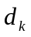…………………………………………………………………….24
3.6 Sum of within group sum of squares,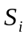, for 10 iterations of K=3.......................26
3.7 Sum of within group sum of squares,, for 10 iterations of K+1=4 ...................27
Figure
1.1 Scatter plot of number of air passengers..................................................................5
1.2 Parallel coordinate plot of number of air passengers……………………………...5
2.1a A Cartesian coordinate graph…………………………………………………….11
2.1b A PC graph……………………………………………………………………….11
2.1c Point on a Cartesian coordinate plot……………………………………………..11
2.1d Point as a polyline in PC…………………………………………………………11
2.2a Three dimensional data point (2,1,3)…………………………………………….11
2.2b Three dimension data point, (2,1,3) as a polyline in PC…………………………12
2.3 Car data set plotted using a PC graph. Graph is drawn by XmdvTool………….12
2.4a A line with a negative correlation………………………………………………..13
2.4b A line with a positive correlation………………………………………………...13
2.4c Vertical line showing zero correlation…………………………………………...14
2.4d Horizontal line showing zero correlation………………………………………...14
2.5a A PC plot with ambiguity………………………………………………………..14
2.5b A PC plot with color uniquely identifies the data set……………………………15
2.6 Wine data set plotted using a PC graph………………………………………….15
3.1 Distortion plot for Fisher’s Iris data set………………………………………….29
4.1 Setosa iris flower………………………………………………………………...33
4.2 PC plot of observations of Iris Data Set………………………………………….33
4.3 Distortion Plot for Fisher’s iris data set………………………………………….34
4.4 PC Graph – Cluster for Iris Data Set…………………………………………….34
4.5 PC Graph - means or centers of clusters for Iris Data Set……………………….35
4.6 Lattice plot – Each cluster for Iris Data Set……………………………………...36
Program
Appendix.r……………………………………………………………………….42

Chapter 1
Introduction

In 1854 a cholera epidemic was raging in London. Dr. J. Snow placed dots on a map of the neighborhood at the locations of the recorded deaths. He also noted the location of the water pumps. He saw there was a concentration of dots in the area of just one pump. He had the pump disabled by removing its handle and the epidemic stopped. This true story is considered one of the first uses of visual data mining (The puzzle was a maddening one, n.d.; Inselberg, 2002).
Problem Statement
What is the visual correlation in a multidimensional data set, using a series of parallel coordinate plots with clusters marked by color?
Visual Data Mining
The formal definition of data mining is the extraction of interesting and potentially useful information or patterns in large databases. Visual data mining is finding patterns with your eyes. The human mind acts as the visual data mining tool (Soukup & Davidson, 2002, p. xxii).
To perform visual data mining with your eyes, graphic tools are needed, such as scatter plots, xy coordinate plots, grids, and other graphs to picture and demonstrate the variety and complexity of datasets. Using these graphs, visual data mining is used to find correlations, associations, clusters, anomalies and other structures of datasets.
Visual data mining is not intended to replace the statistical analysis of a data set. Its intention is to explore the possible correlations within the data, possible associations between variables, and to assist in data analysis. Statistical analysis refers to statistical inference. Statistical inference means the use of probability theory to draw conclusions from data, based upon how the data was sampled. Visual data mining uses exploratory methods of descriptive statistics. Descriptive statistics uses diagrams or calculates numbers which are used to summarize data in tables or charts (Freedman, Pisani, & Purves, 1978, p.407).
Multidimensional Data Sets
There are a plethora of different graphic plots to be used for visual data mining. Many of them have a shortcoming: how to display data having more than two variables? Most graphs are plotted in two dimensions. Some graphs, such as the Cartesian graph can be plotted in three dimensions. But most traditional plots can not go beyond three dimensions. For example if a data set has 13 variables, how can that data be graphed?
An example of a multidimensional data set would be the Air Passenger data set from the data library of the R programming language (R Development Core Team, 2008). The number of variables in this data set is 13. This data set is a collection of values about the number of air passengers who fly each month. The data was collected from the years1949 to 1960.
One simple graph that could be used to visualize the data is the scatter plot. One scatter plot is created for every combination of two variables. See Figure 1.1. One hundred and fifty-six scatter plots were formed. (The scatter plots are symmetric, therefore only the lower or upper triangular grid of 78 plots is sufficient). This is a large amount of information for the eye to see. How does a researcher who is studying the relationship of airline passengers from month to month and year to year use these small graphs? There is a relationship within every plot. Every scatter plot has a positive linear correlation, (as defined in Chapter 2). But beyond that the researcher would have difficulty seeing any other relationship without statistical analysis. As stated earlier, visual data mining is not intended to replace statistical analysis. However there is more that can be visually gleaned about the data using a different style of plot. Another type of plot that will prove useful in such a situation is the parallel coordinate plot.
Parallel Coordinates
Parallel coordinate plots, developed by Inselberg and Dimsdale (1990), are one of the most general techniques to use to visualize multidimensional data. The parallel coordinate plot for the air passenger data set brought all the variables together onto a single graph. See Figure 1.2. The eye can read that almost every year the number of air passengers increased. This relationship was not obvious to the eye using the scatter plots in Figure 1.1.
Chapter 2 defines what a parallel coordinate plot is and how it is graphed. This chapter defines the term “polyline”, a fundamental concept used in plotting a parallel coordinate graph. Chapter 2 speaks about the concept of correlation and its use in the analysis of a data set. Chapter 2 also describes two of the weaknesses of using a parallel coordinate plot: clutter and ambiguity. Examples are shown to explain the concepts of polyline, correlation, and clutter and ambiguity in a parallel coordinate plot.
Two methods are introduced to address the problems of clutter and ambiguity. The first method to be presented to improve visualization in a parallel coordinate plot is color. Color, correctly used on a parallel coordinate plot, will reduce data ambiguity.
Clustering reduces clutter and ambiguity when it is used in conjunction with color. Chapter 3 outlines in detail the definition, algorithm, and methodology of clustering used in this thesis. The clustering procedure used in this paper is the K-means algorithm. Its mathematical equation and algorithm are outlined in a separate section within Chapter 3.
Once a parallel coordinate plot is defined, and the method for producing and using the plots are described, a multidimensional data set will be analyzed in Chapter 4. The data set will be the “Fisher Iris Data Set” (Fisher, 1936). The analysis of the data set will follow the methodology outlined in Chapters 2 and 3.
Chapter 5 summarizes the methodology of producing an uncluttered and unambiguous parallel coordinate plot. The conclusion will cover the uses and benefits of the graphing a parallel coordinate plot for multidimensional data sets. It will point out the possible short comings of using a parallel coordinate plot. The chapter reviews the ease and the complications of the methodology using clusters and color to creating an effective parallel coordinate plot.

Figures for Chapter 1.
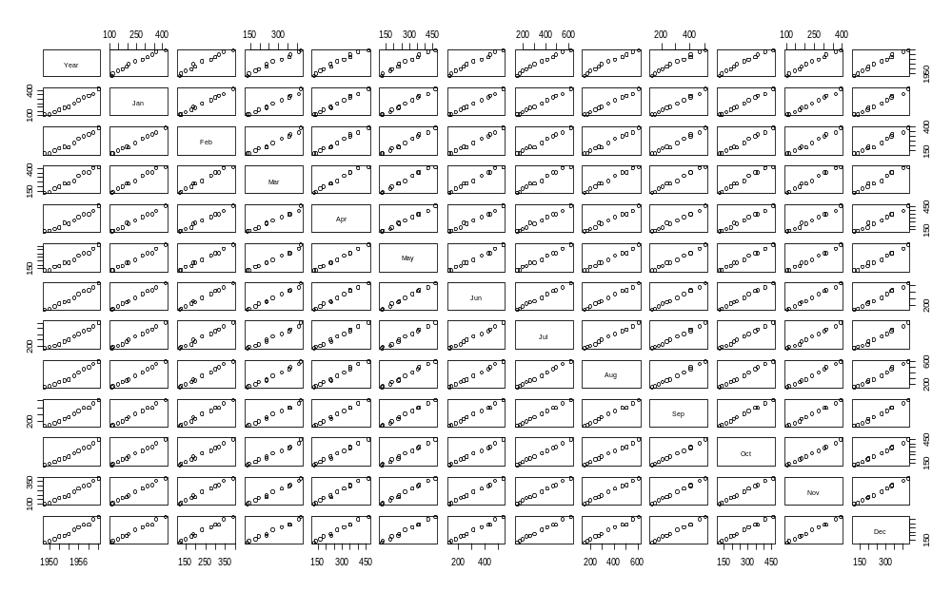

Figure 1.1: Scatter plot of number of air passengers.
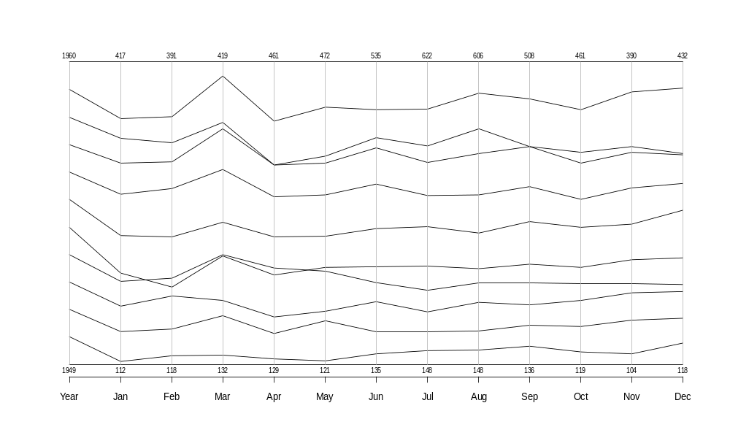
Figure 1.2: Parallel coordinate plot of number of air passengers.

Chapter 2
Parallel Coordinates

In the introduction it was stated that many visual data mining tools have a special challenge: how to display data that is multidimensional. A data set is considered multidimensional if it has more than five variables. This type of data set is very common, (Siirtola & Raiha, 2006). Inselberg and Hibbard stated, “It is widely agreed that the visualization of multidimensional data is a challenging problem.” (as cited in Siirtola & Raiha, 2006).
Alfred Inselberg began the work on parallel coordinates in 1981 while working at the IBM research laboratory (Siirtola & Raiha, 2006). Inselberg and Dimsdale stated that scientists and others who were studying multi-variant relations had an underlying need to understand the geometry of the problem. He claims parallel coordinates “differs from all other visualization methodologies in a fundamental way.” Then he added, “Parallel coordinates yield graphical representations of Multi-Dimensional relations rather than just finite point sets.” (Inselberg & Dimsdale, 1990).
Visual data mining is usually thought of as scatter plots, histograms, bar charts, etc. They are all based on Cartesian coordinate plots of two dimensions. To add more visual perspective they can be drawn as three dimensional. But if a data set has more than three dimensions, how can it be represented visually?

Parallel Coordinate Axes and Polylines
Parallel coordinates, (PC) takes the axes and places them vertically and parallel to each other. (The axes may also be drawn horizontally and parallel to each other.) See Figures 2.1a and 2.1b. A single point or record in a data set becomes a polyline in the parallel coordinate plot (Siirtola & Raiha, 2006). Figures 2.1c and 2.1d show how a point on a Cartesian coordinate plot becomes a polyline on a PC plot. Figure 2.1c is a point on a Cartesian coordinate plot. The polyline in Figure 2.1d is the point in the Figure 2.1c.
If a record (or observation) has three variables it can be represented in a series of scatter plots with three permutations. Then the plots are compared with each other for analysis. See Figure 2.2a for an example of the three permutation of scatter plots. With a PC graph, the three variables can be represented in a single plot with a single polyline. See Figure 2.2b.
Additional polylines and variables can be added to the PC plot. The number of polylines and variables that can be added is only limited by the size of the computer screen and the limitation of the visualization by the human eye. PC plots are also able to visualize non-numerical data. Each axis can each have its own scale and data range. This makes the PC plot into a powerful tool with which to visualize multidimensional data, (Siirtola & Raiha, 2006). Figure 2.3 is an example of a multidimensional data set represented as a PC plot. It has seven variables (or axes) and more than 100 data points. The data points are mapped as polylines onto each axis of the PC plot. The PC plot in Figure 2.3 is of the car data set used by Ramos and Donoho (1983) in their research. The data is from the 1983 American Statistical Association Data Exposition (as cited by Siirtola and Raiha, 2006). Figure 2.3’s PC plot was drawn using the computer program XmdvTool, (Ward, et.al, n.d.).

PC Plots and Correlation
The goal of PC plots is to make clear the correlations within the data for multidimensional data. Correlation is the (approximately linear) relationship (or association) between two or more variables. There are three classes of correlation: positive, negative, and none (or zero), (Kushner and De Maio, 1980, p.188).
Figure 2.4a is a Cartesian plot with a line that has the class of negative correlation. The line plots to a PC plot with the polylines intersecting between the axes. If Figure 2.3 is reviewed, as the variable MPG increases, the variable Cylinders decreases. This is a negative correlation between the variables MPG and Cylinders. The PC in Figure 2.3 shows the polylines intersect between the two axes MPG and Cylinders.
Figure 2.4b is a Cartesian plot with a line that has the class of positive correlation. The points plot to a PC plot with parallel polylines. In Figure 2.3 the variable Horsepower increases as the variable Cylinders increases. The polylines between the variables Cylinders and Horsepower, in Figure 2.3, intersect very little. A car with eight cylinders has a higher amount of horsepower. A car with two cylinders has a lower amount of horsepower. This would define the variables Cylinders and Horsepower as positively correlated.
Figure 2.4c and 2.4d are two plots showing the class of none or zero correlation. In Figure 2.4c the value of Y is the same regardless of the value of X. The PC plot shows the value of Y is constant as the value of X varies. In Figure 2.4d the value of X is the same regardless of the value of Y. The PC plot show the value of X is constant as the value of Y varies. For each plot the variables X and Y show no, or zero, correlation.
These three classes of correlation will be referred to in the analysis of data using PC plots in Chapter 4.
Clutter and Ambiguity
Sometimes visual data mining and PC plots are applied to massive data sets. This creates an issue of “computational complexity and data transfer as well as visual complexity.” (Wegman, 2003). Computation complexity means complex algorithms with the order-of-magnitude of the size of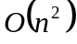 (using Big O Notation) (Carrano, 2006). Data transfer over standard Ethernet can create an issue. The data transfer can take an unfeasibly long amount of time when the data sets are very large. A very large data set is somewhere between 10⁶ to 10⁷ bytes (Wegman, 2003). The data sets used in this paper (less than 200 observations) will be small enough to avoid the issues of computational complexity and data transfer. But the data sets are large enough to bring forth the problem of visual complexity. Two visual complexity problems will be addressed: ambiguity and clutter.
Ambiguity can even be a problem in a PC plot with only two data points or polylines. Figure 2.5a shows ambiguity of a PC graph with two data points. This figure is a PC plot representing two possible sets of data points: (1,2,3) and (2,2,3) or (1,2,1) and (2,2,3). Using a different color for each polyline will uniquely identify the two data points eliminating ambiguity. Figure 2.5b is the same PC plot as Figure 2.5a with color added. In this figure the points are clearly identified by the colors used. Here the point (1,2,1) is represented by the red line, while the point (2,2,3) is represented by the blue line.
As the data set grows in observations and variables another problem arises – clutter. Peng, Ward and Rundensteiner state, “A good visualization clearly reveals structure within the data and thus can help the viewer to better identify patterns and detect outliers. Clutter, on the other hand, is characterized by crowded and disordered visual entities that obscure the structure.” (Peng, Ward, & Rundensteiner, n.d.).
Figure 2.6 is an example of a larger data set with clutter and ambiguity. It has 14 variables and 178 observations from three wine cultivars and the chemical makeup of the wine they produce, (Hurley, 2004). (A cultivar is a variety of plant that may grow only under cultivation, (Random House College Dictionary)). The number of observations creates clutter. The number of variables or vertical axes creates ambiguity. This visually complexity makes it difficult to visually evaluate the correlations between variables. With distance between the axes on the left and the axes on the right, it is difficult to determine correlations between some of the variables.
The technique to reduce clutter and ambiguity in a data set is to divide the data set into clusters. The clusters must be separated or grouped in a meaningful manner. Once the clusters are separated meaningfully they will be each drawn in a PC plot with its own color.
To create groups of clusters the K-means algorithm will be used. The next chapter explains how to determine the number of clusters for K-means and how the K-means algorithm calculates clusters in a meaningful manner.

Figures for Chapter 2.
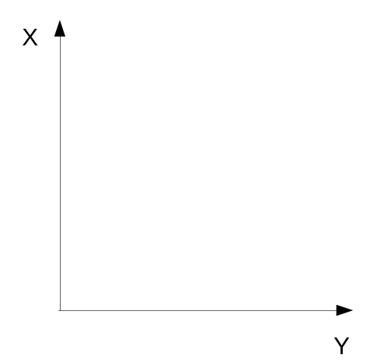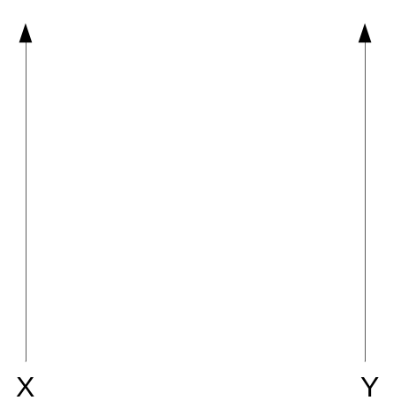
Figure 2.1: (a) A Cartesian coordinate graph. (b) A PC graph.

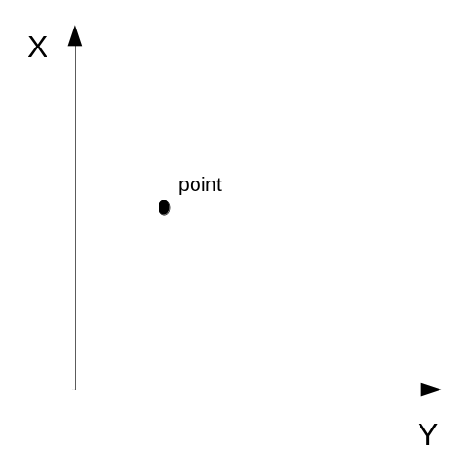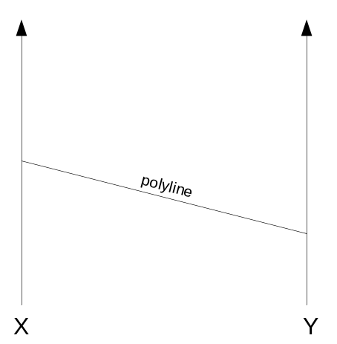
Figure 2.1: (c) Point on a Cartesian coordinate plot. (d) Point as a polyline in PC.

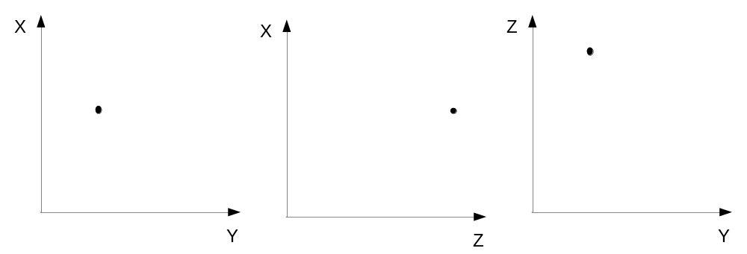
Figure 2.2a: Three dimensional data point (2,1,3). Different permutations of the axes are compared.

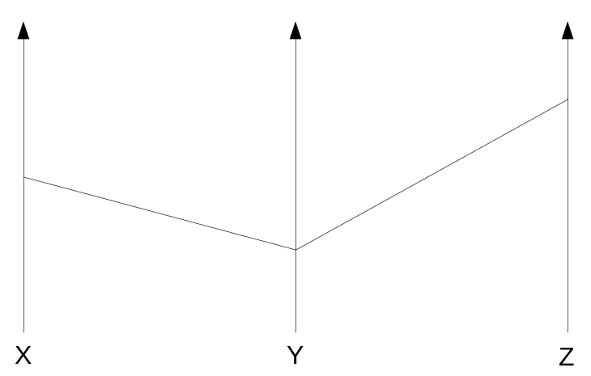
Figure 2.2b: Three dimension data point, (2,1,3) as a polyline in PC.

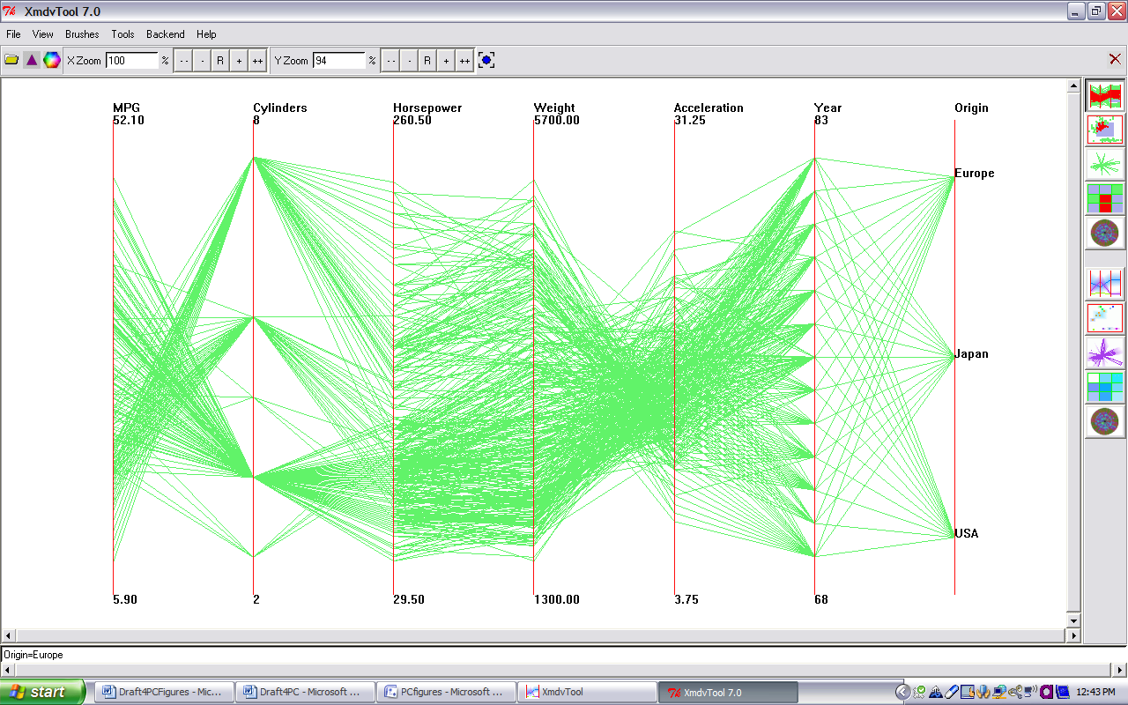

Figure 2.3: Car data set plotted using a PC graph. Graph is drawn by XmdvTool.

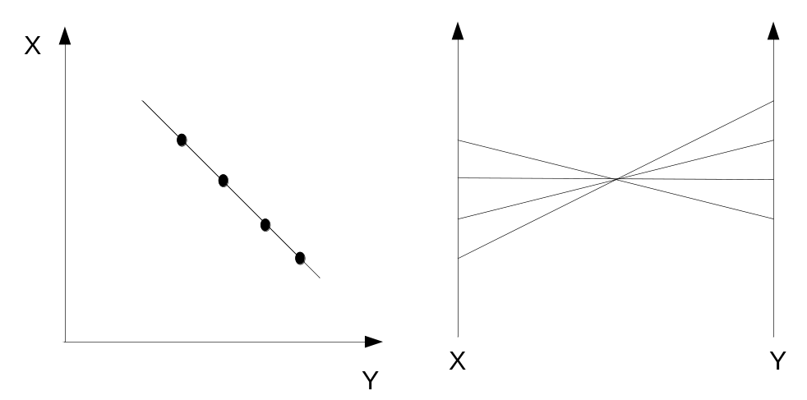
Figure 2.4a: A line with a negative correlation plots to a PC plot with the polylines intersecting between the two axes.

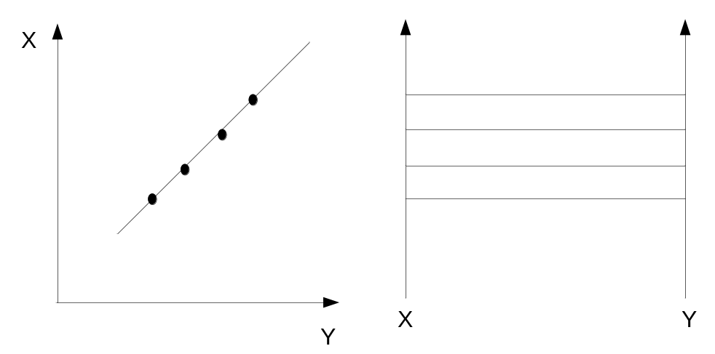

Figure 2.4b: A line with a positive correlation plots to a PC plot with the polylines laying parallel to each other between the two axes.
.

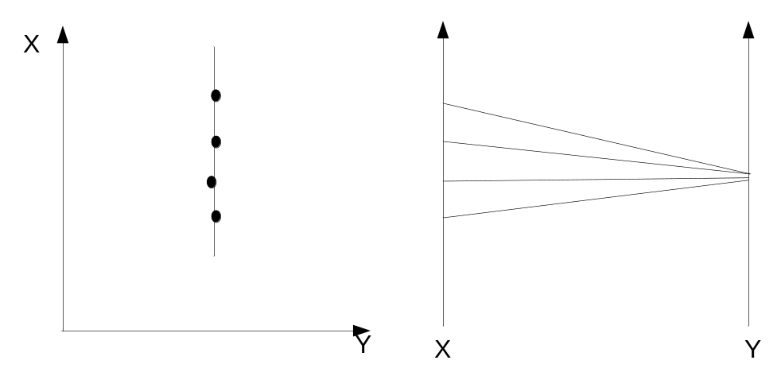
Figure 2.4c: Vertical line showing zero correlation. The polylines intersect on the right axes.

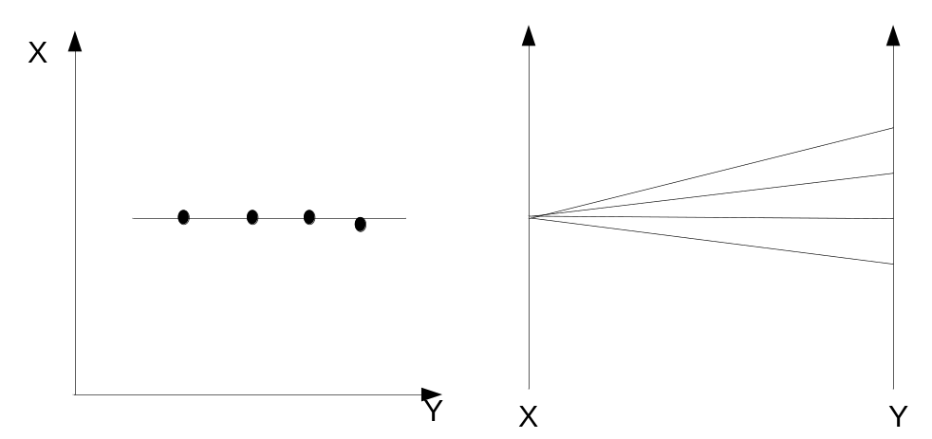
Figure 2.4d: Horizontal line showing zero correlation. The polylines intersect on the left axes.

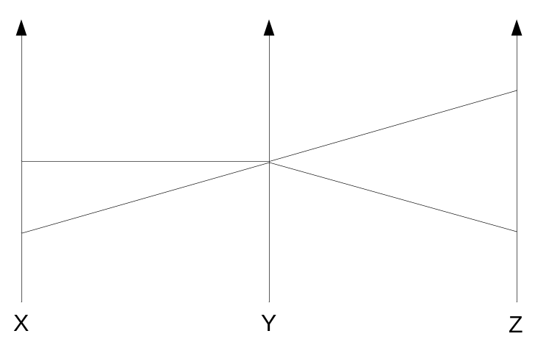

Figure 2.5a: A PC plot with ambiguity. The possible data sets are: (1,2,3)(2,2,1) or (1,2,1)(2,2,3)

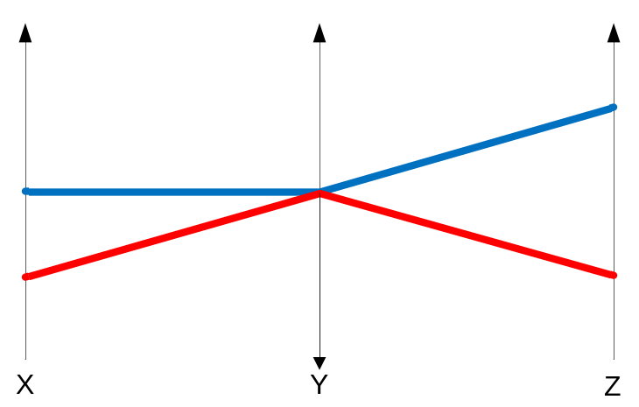
Figure 2.5b: A PC plot with color uniquely identifies the data set. The red polyline is (1,2,1), and the blue polyline is (2,2,3).

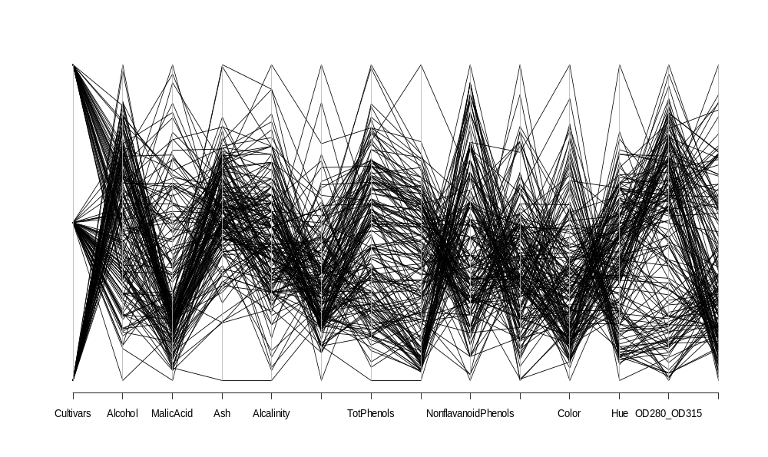
Figure 2.6: Wine data set plotted using a PC graph. This PC graph has ambiguity and clutter.

Chapter 3
Clustering

Clustering is a method to explore and understand the nature of a multivariate data set. Clustering looks for the structure of “natural” groupings within the data set. The natural grouping is done on the base of similarities or distances between the objects (Johnson & Wichern, 1988, p. 543). The similarities or distances are often measured using a mathematical algorithm. Even without mathematical measures, an individual can usually group points visually, using a two or three dimensional scatter plot (Johnson & Wichern, 1988, p. 545).
Large data sets require a formal mathematical algorithm to calculate the distances between data points. The distance is a measure of “closeness,” or “similarity.” (Johnson & Wichern, 1988, p. 545).
K-means is the mathematical algorithm chosen for this project. K is defined as the number of clusters or groups. A statistical variance (within group sum of squares or within cluster sum of squares) is the method K-means uses to measure distance or similarity within the groups or clusters. (In some texts the within group sum of squares is called the within cluster sum of squares.) It partitions the points into a number of clusters or groups such that the sum of squared distances from the points to the assigned cluster centers (usually mean) is minimized (R Documentation). The within group sum of squares is the total amount of deviation within each group from all points in the group to the group’s mean (Kushner & DeMaio, 1980, p. 172).
K-means Algorithm
K-means is the term suggested by MacQueen for describing his clustering algorithm (Johnson & Wichern, 1988, p. 566). To find the statistical variance within group sum of squares, K-means uses the square of the Euclidean distance. Euclidean distance between two points is the shortest distance between those two points in Euclidean space (Rosenlicht, 1968, p. 34). Equation 3.1 is the definition of the Euclidean distance.
Equation 3.1: Euclidean distance.
Where p and q are observations or points of n coordinates or variables,
p = (, . . .,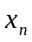), and q = (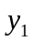, . . .,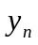).
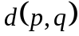 = 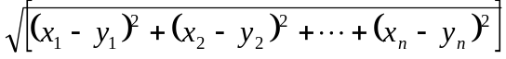
The Euclidean distances are squared to find the within group sum of squares.
Equation 3.2 is the within group sum of squares for one point.
Equation 3.2: Within group sum of squares for one point.
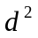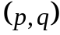= 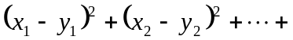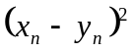
The following are the steps of the K-means algorithm outlined by Johnson and Wichern (1988, p. 566).
1. Arbitrarily partition the data points into K initial clusters.
2. Calculate the mean of each cluster.
3. Choose a random data point to start.
4. Proceed through the list of items or points, assigning an item to the cluster whose mean is the nearest, using Euclidean distance.
5. Recalculate the mean for the cluster receiving the new point and for the cluster losing the point.
6. Repeat Steps 3, 4 and 5 until no more reassignments take place.
The following example is from Johnson and Wechern (1988, p. 567). It has three variables: Item, , and . There are four observations or data points. Table 3.1 is the data set.
Table 3.1: Example data set.

Item
A | 5 | 3
B | -1 | 1
C | 1 | -2
D | -3 | -2

For Step 1 the data set is divided into two clusters. Here, the clusters are arbitrarily selected as AB and CD. For Step 2 the means coordinates of and , (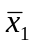 and 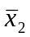), are calculated using an arithmetic mean (Kushner & DeMaio, 1980, p.64). The calculation is shown in Table 3.2.
Table 3.2: Mean of each cluster.
Cluster
(AB) | 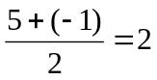 | 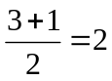
(CD) | 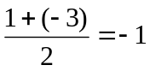 | 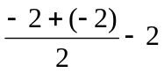

For Step 3, point A is randomly chosen as the first point. In Step 4 the within group sum of squares is computed between point A and the mean of each group (i.e. each initial cluster). The following is the computation of the within group sum of squares for the point A.
d²(A, (AB)) = (5 – 2) ² + (3 – 2)² = 10
d²(A, (CD)) = (5 + 1)² + (3 + 2)² = 61
Point A is closer to the mean of the cluster (AB). Therefore point A is not reassigned to another cluster. Because there is no reassignment Step 5 will be skipped for this iteration.
The next point to be randomly selected is B. The within group sum of squares is calculated as follows.
d²(B, (CD)) = (-1 – 2)² + (1 – 2)² = 10
d²(B, (CD)) = (-1 +1)² + (1 + 2)² = 9
Point B is closer to the mean of the cluster (CD). It is reassigned to that cluster. The algorithm would recalculate the means in Step 5. Table 3.3 shows the mean for the new clusters.
Table 3.3: Mean of each cluster after reassignment of point B.
Cluster
(A) | 5 | 3
(BCD) | -1 | -1

The algorithm would continue to check each point using Steps 3, 4, and 5, until there are no more reassignments in which case the algorithm terminates. The final clusters for the above example are: (A) and (BCD) (Johnson & Wichern, 1988, p. 568).
K-means and R programming language
The K-mean algorithm is a well researched and accepted clustering algorithm. K-means was chosen for this project, because of the components that it generates. An “object” is produced by the kmeans() package (R Documentation). The “object” holds four components. If a different clustering algorithm was used, the problem of plotting each cluster would have increased in magnitude. Plotting PC graphs requires the use of the kmeans()object’s components.
From the R programming documentation, 2008, kmeans() components are:
- cluster – A vector of integers indicating the cluster to which each point is allocated.
- centers – A matrix of cluster centers.
- withinss – The within cluster sum of squares.
- size – The number of points or observations in each cluster.
Table 3.4 list the object’s components for a data set called “Fisher’s Iris data set” (Fisher, 1936). The K-means algorithm with a K of three for the Iris data set produces the following values for the four components.
The first component is the size of each cluster. The first cluster has 51 observations. The second cluster has 49 observations. And the third cluster has 50 observations. If these values are summed the total number of observations is 150. The second component centers are denoted in Table 3.4 as “Cluster means”. The mean values are laid out in table form to show the coordinates for the mean of each cluster. The first cluster’s mean has the coordinates of (5.915686, 2.764706, 4.264706, 1.333333, 2.019608).
The second cluster has a mean with coordinates of (6.622449, 2.983673, 5.573469, 2.032653, 3.000000). The third cluster’s mean has the coordinates of (5.006000, 3.428000, 1.462000, 0.246000, 1.000000). These values will be used to create a PC plot of the cluster means for the analysis of the data set in Chapter 4.

Table 3.4: kmeans()object’s components for Iris data set.

K-means clustering with 3 clusters of sizes 51, 49, 50

Cluster means:
SepalLength SepalWidth PetalLength PetalWidth Species
1 5.915686 2.764706 4.264706 1.333333 2.019608
2 6.622449 2.983673 5.573469 2.032653 3.000000
3 5.006000 3.428000 1.462000 0.246000 1.000000

Clustering vector:
1 2 3 4 5 6 7 8 9 10 11 12 13 14 15 16 17 18 19 20
3 3 3 3 3 3 3 3 3 3 3 3 3 3 3 3 3 3 3 3

21 22 23 24 25 26 27 28 29 30 31 32 33 34 35 36 37 38 39 40
3 3 3 3 3 3 3 3 3 3 3 3 3 3 3 3 3 3 3 3

41 42 43 44 45 46 47 48 49 50 51 52 53 54 55 56 57 58 59 60
3 3 3 3 3 3 3 3 3 3 1 1 1 1 1 1 1 1 1 1

61 62 63 64 65 66 67 68 69 70 71 72 73 74 75 76 77 78 79 80
1 1 1 1 1 1 1 1 1 1 1 1 1 1 1 1 1 1 1 1

81 82 83 84 85 86 87 88 89 90 91 92 93 94 95 96 97 98 99 100
1 1 1 1 1 1 1 1 1 1 1 1 1 1 1 1 1 1 1 1

101 102 103 104 105 106 107 108 109 110 111 112 113 114 115 116 117 118 119 120
2 2 2 2 2 2 1 2 2 2 2 2 2 2 2 2 2 2 2 2

121 122 123 124 125 126 127 128 129 130 131 132 133 134 135 136 137 138 139 140
2 2 2 2 2 2 2 2 2 2 2 2 2 2 2 2 2 2 2 2

141 142 143 144 145 146 147 148 149 150
2 2 2 2 2 2 2 2 2 2

Within cluster sum of squares by cluster:
[1] 32.91412 39.15551 15.15100

The third component is cluster denoted as “clustering vector” in the table. The vector gives the number of the cluster to which each observation is assigned. The cluster is marked below each observation. Observations 1 to 50 are assigned to the third cluster. Observations 51 to 100 are assigned to the first cluster. And observations 101 to 106 and 108 to 150 are assigned to the second cluster. The observation numbered 107 is assigned to the first cluster. This component is very useful when it comes time to create a PC plot for each cluster.
The final component is withinss denoted as “within cluster sum of squares by cluster”. (Note: The term “within cluster” is defined as “within group”.) The first cluster’s within cluster sum of squares is 32.91412. The second cluster’s within cluster sum of squares is 39.15551. And the third cluster’s within cluster sum of squares is 15.15100. This component will be useful when it is time to determine the best value for the number of clusters or K for K-means.
Distortion Plot
K-means algorithm has a fundamental problem. The number of clusters or K must be user specified. How does one determine the number of clusters for a data set? There is no actual “true” number of clusters in some cases. However a representative of the “true” number of clusters can be found. That representative will be defined as the “best” number of clusters.
In Step two of the K-means algorithm, the mean is calculated for each cluster. The mean represents the cluster. This representation introduces a “distortion” of the dispersion of the points within the clusters. The definition of “distortion” for a value of K is the total sum of within cluster sum of squares. From Table 3.2 the within cluster sum of squares for K of three are the values: 32.91412, 39.15551, and 15.15100. These three values are summed to find for the K of three. The distortion or for three clusters is 87.22022.
A natural approach to choosing the number of clusters is to plot the distortion, versus K in a Cartesian plot, (Sugar & James, 2003). As K increases the distortion decreases.
The distortion plot is represented by a curve. The curve is always monotone decreasing, i.e. if K₂ is greater than K₁ then the distortion for K₂ is less than the distortion for K₁. The point on the curve where the curve drops off is called the “elbow”. K at the “elbow” indicates the “best” number of clusters for K. Past this point any additional clusters tends to simply partition within a natural group rather than partition between groups, (Sugar & James, 2003).
The “distortion” for each K number of clusters was calculated by the following steps:
- Choose the initial K value of two.
- Calculate the K-means for K to find the within group sum of squares.
- Sum the within group sum of squares, to find the “distortion” for K.
- Increment K by one.
- Repeat steps 2, 3, and 4 until K reaches its maximum value. (The maximum value of K will be defined in the next section.)
Table 3.5 lists an example distortion for each cluster of the Iris data set. It should be noted, the distortions of a data set may vary from execution to execution. The variation is due to the random selection of points and initial clusters. Table 3.3 is just one possible result.
For Step 1 the initial K is 2. Step 2 and 3 results are in the Distortion column. For Step 4, K is incremented to 3. Steps 2, 3, and 4 are repeated to the maximum K of 7. Figure 3.1 is the Distortion plot for Table 3.5.

Table 3.5: Distortion,, for each cluster of the Iris data set.
Number of clusters, K | Distortion,
2 | 179.05358
3 | 87.22063
4 | 66.81859
5 | 50.27764
6 | 42.87144
7 | 35.48114

The “elbow” is clearly at the value of three for K. The user will insert the value of three for K number of clusters. The K-means algorithm will group the data into three clusters. The results will be plotted as a PC plot with each cluster highlighted by a different color. (See Chapter 4 for the analysis of the data set “Fisher’s Iris Data Set”.)
The distortion plot will plot K from two to a maximum value for K. How is the maximum value determined?
Maximum K
In the above steps for developing the distortion plot, to find the “true” K, the initial K is defined as two. The maximum value of K varies in relation to the characteristics of the data set. The characteristics of a data set include the number of variables, the number of observations and the correlation among the data. K-means’ random selection of initial clusters and points also effect the outcome of the maximum number of K.
Hartigan’s index uses an internal index for scoring the number of clusters (Chiang & Mirkin, 2007) and is a variance based approach. It uses the statistical variance within cluster sum of squares. The following are the steps to finding the Hartigan’s index’s for K.
- Initialize K to one.
- Increment K.
- Repeat Steps a, b, and c for i = 1 to 10.
a. Calculate K-means for K clusters.
b. Sum the within group sum of squares. The sum is denoted as .
(The within group sum of squares may be different for each iteration of K-means with the same K. The difference is due to the random selection of points by the K-means algorithm when assigning a point to a cluster.)
c. Increment i by one.
4. Select the minimum for K. The minimum is denoted as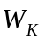.
5. Calculate the Hartigan index, (HK). See Equation 3.3.
Equation 3.3: Hartigan index.
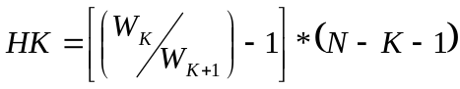, where N is the number of observations (Chiang & Mirkin, 2007.)
6. Check if HK is less than the threshold of the value of 10. (The value of the threshold is a “crude rule of thumb” suggested by Hartigan (Chiang & Mirkin, 2007)).
7. Repeat Steps 2, 3, 4, 5, and 6 until the threshold condition is met.
The Iris data set will be used as an example for computing the Hartigan’s index. For Step 2 in this example K is incremented to three. In Step 3 the K-means is computed and the within sum of squares are summed 10 times. Table 3.6 lists the within cluster sum of square values for the 10 iterations.
Table 3.6: Sum of within group sum of squares,, for 10 iterations of K=3.
i
1 | 169.94995
2 | 87.22063
3 | 87.22063
4 | 87.22063
5 | 87.22063
6 | 87.22063
7 | 87.22063
8 | 87.22063
9 | 87.22063
10 | 87.22063

Only one value is different. As the number of clusters, K, increases the iterations will produce more a varied result. In Step 4, the minimum value for, notated as , is selected. is 87.22063.
To be able to calculate the Hartigan’s index, Equation 3.1, 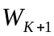 must also be found. The number of clusters for K+1 is four. Table 3.7 shows S_{i} for 10 iterations.
The minimum, is 66.81859.
Table 3.7: Sum of within group sum of squares,, for 10 iterations of K+1=4.
i
1 | 79.81443
2 | 66.81859
3 | 79.81443
4 | 66.81859
5 | 79.81443
6 | 66.81859
7 | 67.66292
8 | 67.66292
9 | 79.81443
10 | 79.81443

Step 5’s calculation follows.
HK =
In Step 6, HK is checked to the threshold of 10. HK is greater than 10. The condition fails for K= 3. The next step is Step 7. Steps 2, 3, 4, 5, and 6 are repeated. For this example of the Iris data set, the threshold condition is met at K=7 when HK is 9.148634.
When the HK meets the threshold condition the computation stops. The value of K that is used by HK to meet the condition becomes the maximum value of K for the distortion plot. In Figure 3.1 the maximum value of seven is marked by a red point.
The Hartigan Index
The K found by the Hartigan index usually ensures the distortion plot will include all the necessary number of clusters to find the “best” K of a data set. It also usually ensures the distortion plot does not include an excess of clusters.
Some researchers utilize the Hartigan’s index itself as the means to find the “best” number of clusters. The K found by the index is used for their cluster analysis instead of using a distortion plot to find K. For a small data set of 150 observations and five variables, as used in this paper in Chapter 4, it appears that the Hartigan’s index over partitions the clusters. The distortion plot is a better representation of the “best” value of K for the data sets used in this thesis.
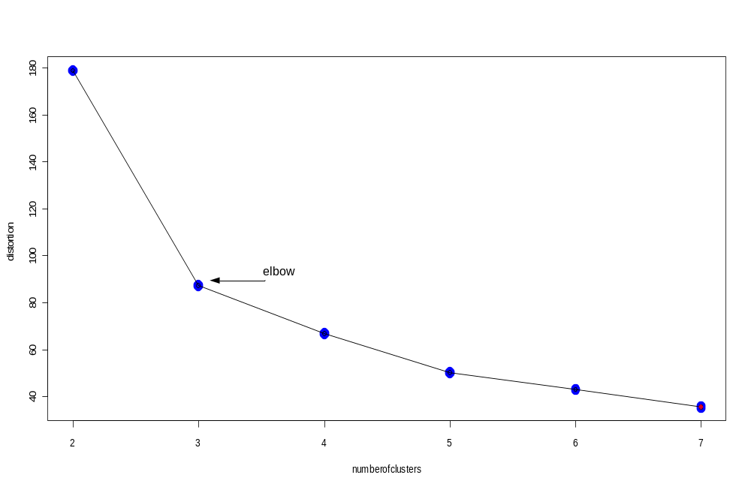Figure 3.1: Distortion plot for Fisher’s Iris data set.
Chapter 4
Data Analysis of Fisher’s Iris Data

In Chapter 3, Fisher’s iris data set was used to demonstrate the use of the K-means algorithm. In this chapter, the Fisher’s iris data set will receive a full visual exploratory analysis. It was a result of the work of Dr. Edgar Anderson, who measured the flowers of fifty plants found growing together in the same colony. (Fisher, 1936) This famous iris data set gives the measurements of three iris species (in centimeters) of their four variables sepal length & width and petal length & width, respectively, for 50 flowers from each of three species of iris. The species are iris setosa, versicolor, and virginica (R Documentation). The total number of observations is 150. The five variables used in the analysis are sepal length & width, petal length & width and species.
Sepals are the outermost organs of a flower. They are sterile and leaf-like and protect the flower in bud (Ingrowille, 2001). Sepals are often green but sometimes are the color of the petal. Figure 4.1 is a picture of the iris setosa (Celebrating Wildflowers, n.d.). This flower’s sepals have the color of the petals and are larger than the petals.
A PC plot of all the observations for the iris data set is shown in Figure 4.2. A correlation is visible. See Chapter 2 for more information defining correlation. The many black polylines create ambiguity and clutter making any correlation difficult to evaluate. See Chapter 2 for the definition of ambiguity and clutter. To bring out the possible correlations between the variables, a cluster analysis will follow.
The goal of the analysis is to visualize the correlation (if any) between variables by using a series of PC graphs. The graphs plot the clusters, each with its own color, of the iris data set.
To find the “best” number of clusters for the iris data set, a distortion plot (as explained in Chapter 3) is drawn: see Figure 4.3. A distortion value is calculated from two clusters up to seven clusters. Seven was determined as the maximum number of clusters for the iris data set by calculating the Hartigan index for the data set. See Chapter 3 for more details about the Hartigan index.
In Figure 4.3 of the distortion plot, the curve‘s elbow is at three clusters. After this point, adding more clusters simply partitions within groups or clusters instead of between groups or clusters (Sugar and James, 2003). Three clusters are chosen as the “best” number of clusters for the iris data set.
Three, as the number of clusters or “K”, is input to the K-means clustering algorithm. Figure 4.4 is the PC graph of the collective clusters determined by the K-means algorithm. Each cluster is a different color. The colors indicate the clusters are grouped by iris species. Each species has its own characteristics in relation to the sepal length & width and the petal length & width. In addition, setosa’s relation between sepal and petal size is inversely correlated to viginica and versicolor’s relation to sepal and petal size.
Figure 4.5 is the PC plot of the means or centers of the clusters. This plot clearly shows that the relation of sepal, petals and species is the same as the result from viewing the PC plot with the full data set in Figure 4.4. The color of each polyline, for each mean, corresponds to the clusters in Figure 4.4.
A PC lattice plot is drawn of each individual cluster. The lattice plot decouples the cluster element of the data set in the PC display (Sarkar, 2008). One panel shows the PC plot for one cluster. Figure 4.6 verifies the findings from the previous Figures 4.4 and 4.5. Each species has its own relation to its petal length & width and sepal length & width. The setoso species relationship among its variables petal length & width to sepal length & width is inverse to viginica and versicolor’s relationship. The color used for each panel and its cluster corresponds to the cluster colors in Figure 4.2.
One item to note is an outlier. In Figure 4.4 the PC plot of the full data set, cluster one, the black cluster, has an anomaly. All the points in the cluster are from the species vericolor, except one. In Figure 4.6 the panel for cluster one shows the same outlier.
Scientists interested in analyzing the iris data set would be able to use PC plots to visually examine the data. The PC plots are effective visual aids in finding correlations as well as outliers.
Looking at Figure 4.4 again correlations are visible. In Figure 4.4, it can be seen from the three different clusters, that two of the plots for the clusters are visually similar. Those two plots are 1 and 2 in the lattice plot Figure 4.6. Seeing this, the scientist might return to examining the characteristics of the flowers that make up these two clusters. Doing this may give scientists more information about how the relationship among the iris flower species. It is interesting to note that the species of the two similar clusters, viginica and versicolor, have been combined to develop a hybrid iris flower named IrisXrobusta (Shear, 2002).

Figures for Chapter 4.
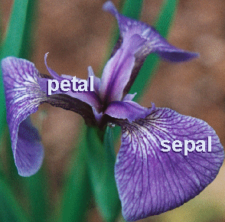

Figure 4.1: Setosa iris flower.

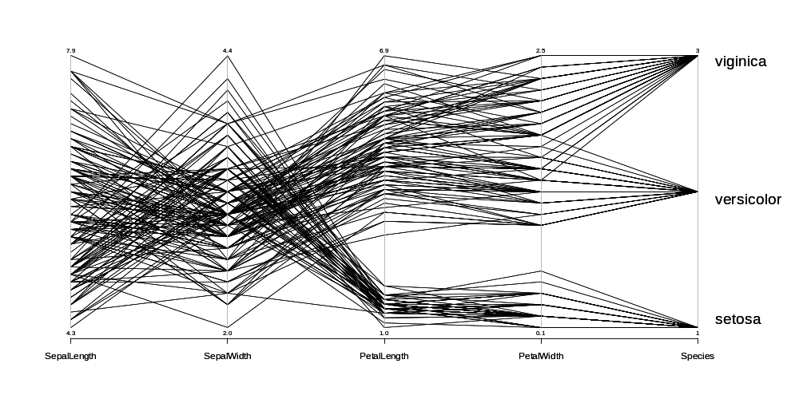

Figure 4.2: PC plot of observations of Iris Data Set.

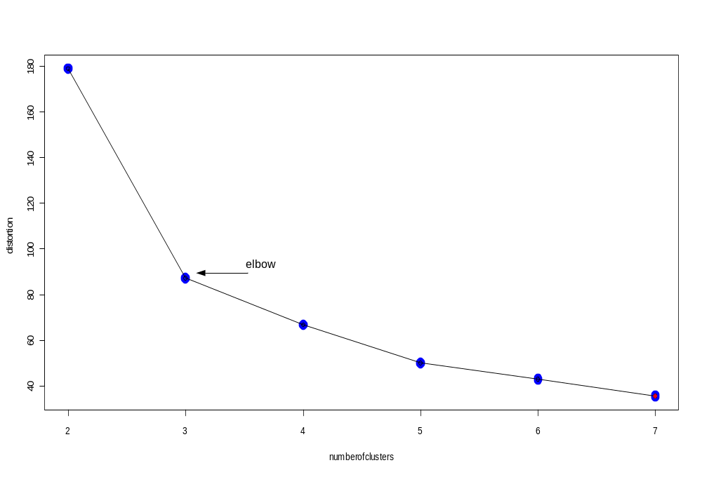
Figure 4.3: Distortion Plot for Fisher’s iris data set.

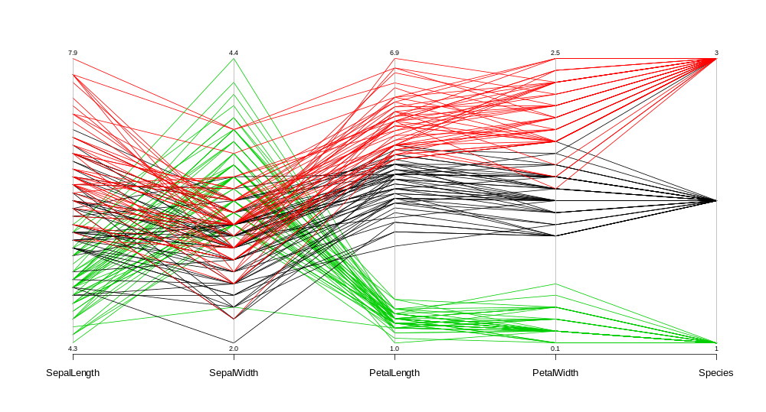
viginica
vericolor
setosa

Figure 4.4: PC Graph – Cluster for Iris Data Set.

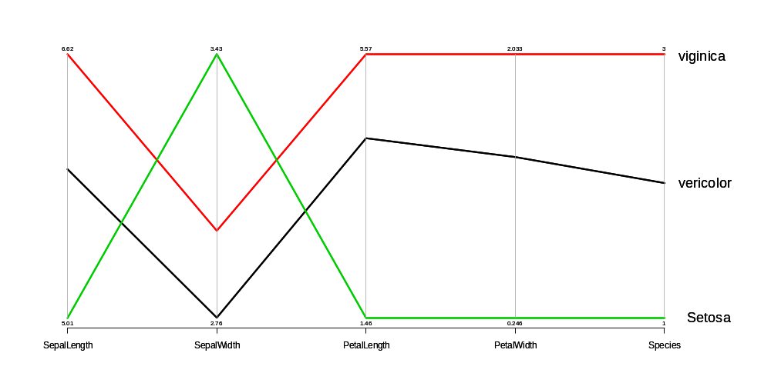

Figure 4.5: PC Graph - means or centers of clusters for Iris Data Set

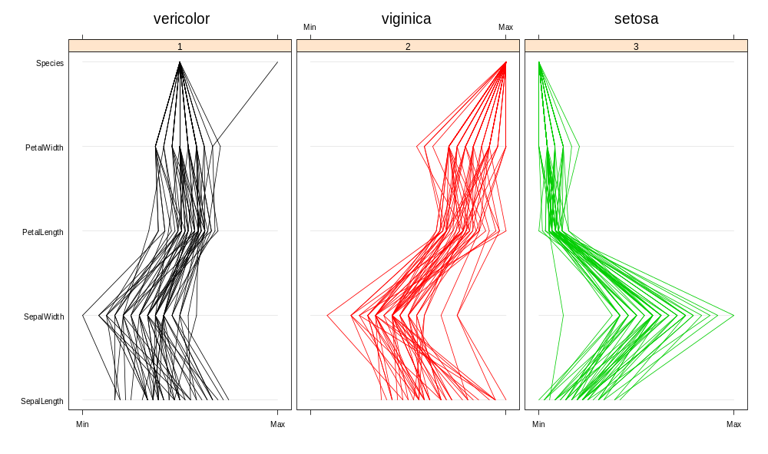
Figure 4.6: Lattice plot – Each cluster for Iris Data Set.

Chapter 5
Summary and Conclusion

Summary
Data mining is the extracting of data that exhibit a pattern or correlation in its group. Visual data mining is finding the patterns in the data using the human eye.
Many graphing tools are available for this task. Most graphing tools are limited in that they are two dimensional. Most data analyzed by researchers have more than three variables or are multidimensional. The PC plot was introduced to address the problem of the multidimensional data set.
The concept of parallel axes and the “polyline” were explained. These concepts are used to graph a PC plot. The graph allows any number of variables to be drawn. The only limitations on the size of a PC plot are the size of the computer screen and the capacity of the human eye.
To be able to interpret what a user sees in the PC plot, the user must be able to interpret the polylines. The interpretation method defined used the concept of correlation and its three classes: positive, negative, and zero (or none).
The PC plot approach to visual data mining has a few shortcomings. Two were covered in this paper: ambiguity and clutter. Ambiguity was explained as the problem of not being able to distinguish one polyline from another polyline. Clutter can cause ambiguity. When the data set is large, there are so many polylines that they overlap each other. Clutter makes it difficult to visually follow a single polyline or a group of polylines. If the polylines are too cluttered, no correlation can be determined.
Two methods to address the issues of clutter and ambiguity were introduced. They were color and clustering. Clustering separates a data set into its natural groupings reducing clutter. By introducing a different color for each cluster, ambiguity was reduced.
The clustering algorithm K-means was used in the analysis described in this paper. Chapter 3 described in detail, the concept of clustering and the methodology of using the K-means algorithm to finding clusters in a data set. The K-means algorithm used the statistical variance “within cluster sum of squares” as the measurement for distance from a point within a cluster to the cluster’s mean. This variance was used to measure the similarly of points within a cluster by K-means.
K was defined as the number of clusters. It must be defined by the user. To find the “best” K a “distortion” plot was drawn. The methodology of creating the distortion plot was described in Chapter 3. Once the plot was drawn, the “elbow” was determined. The elbow was the position at which the distortion curve began to flatten out. The elbow indicated the “best” value for K.
The Hartigan index was also introduced. This index was used to find the maximum K to be used to create the distortion plot. The methodology to calculating the maximum K was outlined in Chapter 3. The Hartigan index’s K ensured the distortion plot was large enough to encompass the best K at the elbow. It also ensured the distortion plot did not include unnecessary values of K.
To demonstrate visual data analysis as a PC plot, Fisher’s Iris data set was clustered and drawn on a PC plot. The PC plot was analyzed for correlations among the variables measured. The analyst could see the ambiguity and clutter in the PC plot when the clustering and the color were not employed, the data set needed to be separated into clusters. A distortion plot was drawn with its maximum K set to seven by the Hartigan index. The elbow was visually defined as K=3. The K-means algorithm was executed for the data set with K=3. A PC plot was drawn with each cluster marked by its own color. The visual analysis of the PC plot determined there were two different correlations patterns. One of the species’ correlations was inverse or negative to the other two correlations. It was noted that there were three iris species in the data set. The two species which had the same correlation pattern were used to create a hybrid iris flower.
Conclusion
PC plots can be an effective tool to visually analyze a multidimensional data set. The multidimensional data set is a type of data set difficult to display using two dimensional plotting techniques. The problems of clutter and ambiguity can be overcome with the correct tools. Clustering with color is very effective tool to visually bring out the correlation in a data set. The K-means algorithm used here is the most commonly used algorithm to create clusters in a data set. It is a well researched and well developed method to determining clusters. It was easy to compute and did an accurate job of grouping the clusters.
Graphs of any sort will not replace statistical analysis of a data set. The PC plot is able to visually display multidimensional data sets in an effective manner; it can give insight and direction to the analysis of a data set. In exploratory statistics, PC plots have a useful place in supplementing the statistical inference and analysis of data sets by researchers from many different disciplines.

Appendix A
R Programming Language and Source Code for Thesis

The R programming language is a tool useful for the visual exploration of data. With the advent of high performance personal computing, data analysis using visual exploration of data has become more available, (Wegman, 2003).
The R programming language is an open source, interactive programming language. R is developed by the R Foundation for Statistical Computing, (R Development Core Team, 2008) and distributed by CRAN (Comprehensive R Archive Network, 2008). It offers:
- an effective way of handling data,
- a suite of operators for matrix calculations,
- a large collection of intermediate tools for data analysis,
- graphical facilities for data analysis and display, either on the computer screen or on a hardcopy, and
- a well defined and simple programming language, which allows conditions, loops, recursion, and user defined functions, (Venables, et al., 2002).
The program following is the source code written for this thesis. The program is used in the analysis of the Fisher’s iris data set by Chapter 4. The program is partitioned into five parts.
PART I contains nine user defined functions. Among the functions are: getdata, getKmeans, getPC, etc. PART II starts at the beginning of the main function of the program. This section accesses the data file from a text file (created in Excel) and puts it into a dataframe. A data frame is similar to a matrix. But the data frame can contain characters and missing values. It is comprised of rows and columns. The columns are the variables. The rows are the observations (Venables, et al., 2004, p.42).
Once the dataframe is created and the initial values are assigned to their variables, PART III begins the calculations for the analysis of the Fisher’s iris data set. The calculations begin with using the package kmeans() to find the distortion for different values of K or number of clusters. The Hartigan index is calculated to determine the maximum K.
In PART IV the distortion plot is drawn on the computer screen to visually determine the best K to be used by the K-means clustering algorithm. The best K is visually selected by the user and entered into the prompt on the screen.
In PART V, three PC plots are drawn on the computer screen. Each plot aids the user in the analysis of the data set. The first PC plot is graphed using parcoord()(R Documentation, n.d.). It is the polyline of each mean for each cluster. See Figure 4.5. Each mean is marked by a different color. The second PC plot is also graphed using parcoord(). This plot contains all the observations. See Figure 4.4. The observations are grouped by cluster using different colors. The color for each cluster’s mean corresponds to the color for each cluster on the PC plot for all the observations. The final PC plot is a lattice plot graphed by using parallel() (R Documentation, n.d.). Each panel of the lattice plot is a single cluster with all its observations. See Figure 4.6. The color for each cluster’s panel corresponds with the colors for each cluster from the other two PC plots.
With the three PC plots, the exploratory statistical analysis for the Fisher’s iris data set was able to be effectively evaluated.
################################
#File Name: Appendix.r
#Author: Angela Peterson
#Description: Input a Fisher's Iris data set (Fisher, 1936) into R.
# Find the number of clusters for the data set using:
# distortion plot. (Sugar & James, 2003)
# and Hartigan's index. (Chiang & Mirkin, 2007)
# With number of clusters, K, use K-mean algorithm to group data.
# Parallel Coordinate plot of means.
# Parallel Coordinate plot of all observations.
# Lattice plot.
#To call file from R: source("Appendix.r")
#Working Directory:
#setwd("c:/Documents and Settings/Angela/My Documents/Thesis/NumofClusters")
#Date: Wednesday, January 28, 2009
#Book: All page numbers reference this book, unless otherwise noted.
# The R Book, Michael J. Crawley, Wiley
# ISBN 978-0-470-51024-7 (Crawley, 2007)
#Data: Fisher's (or Edgar Angerson) Iris Data Set, (R documentation).
################################

#///////////////////////////////
# PART I: Functions.
#///////////////////////////////
#***************************
# Function name: getdata
# Description: Gets the data from a data file in Excel.
# Parameters: dataname - object name of the file with the data.
# Return: Dataframe of the file with the data set with NA values removed.
#***************************
getdata<-function(dataname){
#Clean up all the objects and dataframes by removing them. p. 8
rm(list=ls())
#Read in the data in R.
#read.table produces a dataframe. p. 98.
tstfunct <- read.table(dataname)
#Omit all rows with missing values, NA, p. 119.
na.omit(tstfunct) #kmeans will not function with NA.
}
#************* end function getdata ********************

#***************************
# Function name: getKmeans
# Description: Calculates the natural groups or clusters for a data set.
# Function is used to create PC plot.
# Parameters: tstdata-dataframe of data set.
# numclusters-number of clusters or K.
# Return: Object with the components from K-means.
#***************************
getKmeans <- function(tstdata, numclusters){
# Partition Clusters. page 738
kmeans(tstdata,numclusters)
}
#***************** end function getKmeans ****************

#***************************
# Function name: getsumwith
# Description: Sums the within group sum of squares.
# Function is used to find the distortion.
# Parameters: modeldata-object with components from K-means.
# Return: The sum of the within group sum of squares.
#***************************
getsumwith <- function(modeldata){
sum(modeldata$withinss)
}
#***************** end function getsumwith ****************

#***************************
# Function name: getminwith
# Description: Extracts the minimum value from a vecter holding the values
# of within group sum of squares.
# Function use to find the Hartigan's index.
# Parameters: modeldata-vecter of within group sum of squares
# from 10 iterations.
# Return: The minimum value for within group sum of squares.
#***************************
getminwith <- function(modeldata){
min(modeldata$withinss)
}
#***************** end function getminwithss ****************

#***************************
# Function name: getsumobs
# Description: Sums the number of observations used from a data set.
# Function uses to calculate the Hartigan's index.
# Parameters: modeldata-object containing the components from K-means.
# Return: The sum of the number of observations used from the data set.
#***************************
getsumobs <- function(modeldata){
sum(modeldata$size)
}
#***************** end function getsumobs ****************

#***************************
# Function name: getHart
# Description: Calculates the Hartigan's index.
# Hartigan's index: HK = [(Wk/Wk1)-1]*(N-K-1).
# Function use to find the maximum K value to plot the
# distortion plot.
# Parameters: minwithin-vector of the minimum values for
# within group sum of squares.
# sumobser-the sum of the observations from the data set.
# numclust-the number of clusters.
# ind-index for the vector minwithin.
# Return: The Hartigan's index.
#***************************
getHart <- function(minwithin, sumobser, numclust, ind){
#multleft is: (Wk/Wk1)-1.
multleft <- (minwithin[ind-1] / minwithin[ind]) -1
#multright is: N-K-1.
multright <- sumobser - (numclust-1) - 1

#Hartigan index for scoring the number of clusters.
multleft * multright
}
#***************** end function getHart ****************

#***************************
# Function name: getThreshold
# Description: Determines the condition if the
# Hartigan's index < threshold value.
# Function used to determine maximum K for distortion plot.
# Parameters: HartIdex-value of the Hartigan's index.
# threshold-value of the threshold.
# Return: TRUE or FALSE.
#***************************
getThreshold <- function(HartIdex, threshold){
HartIdex < threshold
}
#***************** end function getThreshold ****************

#***************************
# Function name: getPC
# Description: Plot the parallel coordinate plot.
# Parameters: plottst-dataframe with data set to be plotted by PC.
# modellf-object with components calculated by K-means.
# Return: PC plot of data set shown on the screen.
#***************************
getPC <- function(plottst, modelf){
library(MASS)
parcoord(plottst, col=modelf$cluster, pch=16, var.label=TRUE)
}
#***************** end function getPC ****************

#***************************
# Function name: getPlotDis
# Description: Plot the distortion plot.
# Function used to determine the best K for K-means.
# Parameters: number of clusters-vector of the values for initial K to
# maximum K.
# distortion-vector of distortion values.
# Return: Distortion plot is shown on the screen.
#***************************
getPlotDis <- function(numberofclusters, distortion){
#Plot the points.
plot(numberofclusters, distortion, type = "p", lwd =10, col = "blue")
#Overlay the lines on plot.
lines(numberofclusters, distortion, type = "o")
#The maximum value for K.
last <- numberofclusters[length(numberofclusters)]
#Mark the maximum value for K as a red point.
points(last, distortion[last-1], type = "o", col="red", pch=16, lwd = 10)
#make Hartigan index red.
#Murrell,pg 69.
}
#***************** end function getPlotDis ****************

#====================================
# MAIN FUNCTION.
#====================================
#////////////////////////////////////
# PART II: Create the initial variables.
#////////////////////////////////////
#---------------------------
# Create a dataframe of the data set.
#---------------------------
# File name of data set in Excel.
dataname <- "IrisDataTest.txt"
# Extract the file and put into dataframe.
tst <- getdata(dataname)

#---------------------------
# PC plot of all the observations.
#---------------------------
# library with the parallel coordinate package.
library(MASS)
# PC plot of all the data in the dataframe with black color.
parcoord(tst, col=1, pch=16, var.label=TRUE)

#---------------------------
# Adjust the look of the screen.
#---------------------------
#To stop multiple graphs whizzing by: page 7
par(ask=TRUE) #wait until press Enter.

#---------------------------
# Initialize variables and vectors.
#---------------------------
# Initialize variables.
numofclust <- 2 #number of clusters must start at 2.
thres <- 10 #threshold for the Hartigan index, Chiang & Mirkin, 2007.
lessthan <- FALSE #initial condition for loop.
indx <- 1 #index for vector.

# Initialize vectors. Note: The initializes values will be throw away values.
sumwith <- 1.1 #vector sum of within group sum of squares.
W <- 1.1 #vector sum of within group sum of squares
# for 10 different initializations.
HK <- 10.1 #vector Hartigan index.

#---------------------------
# Calculate the initial K-means for K of 2.
#---------------------------
# K-means components put into an object.
model <- getKmeans(tst,numofclust) #vector of kmeans components.
# Get the sum of the within group sum of squares.
sumwith[indx] <- getsumwith(model)
# Get the sum of the number of observations.
sumobs <- getsumobs(model)

#---------------------------
# Print results of Hartigan's index calculation.
# Used for trouble shooting and debugging propose.
#---------------------------
# Print results to R console window.
print("number of K+1 clusters: ")
print(numofclust)
print("W for 10 initiations. ")
print(W)
print("sumwith Wk+1 ")
print(sumwith)
print("HK for k ")
print(" not calculated for a k+1 of 2 ")
print(" ============== ")

#///////////////////////////
# PART III: Calculate the distortion values using K-means & Hartigan's index.
#///////////////////////////
#---------------------------
# Loop: Find distortion of each value of K until maximum K.
# When threshold condition satisfied loop stops and maximum K found.
#---------------------------
while(lessthan == FALSE) {
# Next K-means with one more cluster for W k+1.
numofclust <- numofclust + 1 #increment number of clusters.
indx <- indx + 1 #increment index.

#--------------------------------------
# Loop to get sum of within group sum of squares for
# different initializations.
#---------------------------
for(initial in 1:10){
# Get next clusters using K-means algorithmn.
model <- getKmeans(tst, numofclust)
W[initial] <- getsumwith(model) #put the sum into vector W.
}
#------------- end of for loop ------------------

# Get mininum within group sum of squares from the 10
# different initializations.
Wk <- min(W)
# Put mininim sum within group sum of squares from 10 iterations into vector.
sumwith[indx] <- Wk
# Calculate the Hartigan's index for the number of clusters.
HK[indx] <- getHart(sumwith, sumobs, numofclust, indx)
# Check if the index HK less than threshold of 10.
lessthan <- getThreshold(HK[indx], thres)

# Print results of Hartigan's index and distortion.
# Used for trouble shooting and debugging proposes.
print("number of K+1 clusters: ")
print(numofclust)
print("W for 10 initiations. ")
print(W)
print("sumwith Wk+1 ")
print(sumwith)
print("HK for k ")
print(HK)
print(" ============== ")
}
#************* end of while loop ********************

#///////////////////////////
# PART IV: Plot the distortion plot.
#///////////////////////////
#---------------------------
# Correct the number of clusters for maximum K.
#---------------------------
# Go back one K with one less cluster.
numofclust <- numofclust - 1 #numofclust is for K+1. Adjust numofclust to K.
# Calculate clusters using K-means algorithmn.
model <- getKmeans(tst, numofclust) #maximum number of clusters.

#---------------------------
# Plot the distortion curve.
#---------------------------
# Find the lenght of the distortion curve.
l <- length(sumwith)
# Adjust the distortion to K by removing K+1.
distortion <- sumwith[-l] #remove the last k+1 distortion.
# Create vector of K=2 to maximum lenght for K.
numclust <- c(2:l)
# Plot the distortion plot.
getPlotDis(numclust, distortion)

#---------------------------
# User choses best K from distortion plot.
#---------------------------
# Print on console prompt for best value for K.
print(" From distortion plot, input number if clusters. ")
print(" Input number then enter twice. ")
# Scan user input for the best value of K.
k <- scan()

#---------------------------
# K-means with "best" value for K.
#---------------------------
#Set the seed for the randon generator of R to be used by kmeans.
set.seed(42) #42 is a random number kmeans will start with.
modelscank <- getKmeans(tst,k) #vector of kmeans components.

#///////////////////////////
# PART V: PC plots of data set using "best" K for K-means clustering.
#///////////////////////////
#---------------------------
# PC plot of means.
#---------------------------
# Vector of the K-means component; center of each cluster.
partcentk<-modelscank$centers
#Plot centers (means) of each cluster in parallel coordinates, p. 854.
# Note: lwd-line witdth, p. 865.
parcoord(partcentk,col=c(1:10), pch=16, var.label=TRUE,lwd=3)

#---------------------------
# PC plot of full data set.
#---------------------------
#Plot the clusters in parallel coordinates with each clusters colored.
parcoord(tst, col=modelscank$cluster, pch=16, var.label=TRUE)

#---------------------------
# PC Lattice plot.
#---------------------------
# Create a data frame with the cluster number as a column. R book page 128.
# Set up a new dataframe to be used by PC lattice plot.
newdf <- tst
# Variable to hold K-means component cluster number.
NumClustscan<-modelscank$cluster
# Append a column to the newdf with the each point's cluster number, p. 126.
newdf<- cbind(newdf,NumClustscan)

#---------------------------
# Plot the lattice plot.
#---------------------------
# Call library that holds lattice R package.
library(lattice)
# Find the number of variables in the dataframe or data set.
v <- length(tst) #number of variables in dataframe.
# Create the PC lattice plot, Sarkar, 2008, p.87.
# groups- p. 838 and http://lmdvr.r-forge.r-project.org/figures/figures.html.
pcgraphscan<-parallel(~newdf[c(1:v)]|factor(NumClustscan), data=newdf,
groups=modelscank$cluster, col= c(1:k))
# Plot the lattice plot.
plot(pcgraphscan)

################################
# End of Appendix.r program.
################################

Bibliography

Carrano, F. M. (2006). Data abstraction and problem solving with C++: Walls and Mirrors (5th ed.). Boston, MA: Pearson Education, Inc
Celebrating Wildflowers (n.d.). U.S. forest service rangeland management botany program. Retrieved November 11, 2008 from: http://www.fs.fed.us/wildflowers/beauty/iris/flowers.shtml
Chiang, M.M., & Mirkin, B. (2007). Experiments for the number of clusters in K-means. Springer-Verlay Berlin Heidelberg.
Comprehensive R Archive Network (2008). Retrieved November 10, 2008 from: http://cran.stat.ucla.edu/
Crawley, M. J. (2007). The R book . Chichester, England: John Wiley & Sons Ltd.
Fisher, R. A. (1936). The use of multiple measurements in taxonomic problems. Annals of Eugenics, 7, 179-188.
Freedman, D., Pisani, R., & Purves R. (1978). Statistics. New York, NY: W. W. Norton & Company.
Hurley, C. B. (2004). Clustering visualizations of multidimensional data. Journal of Computational and Graphical Statistics, 13(4), 788-806.
Ingrouille, M., (2001). Sepals. In Encyclopedia of life sciences (Vol. 10, p. 1038) Wiley InterScience. New York, NY: John Wiley & Sons, Inc.
Inselberg, A, & Dimsdale, B. (1990). Parallel coordinates: A tool for visualizing multi-, dimensional geometry. IEEE Computer Society, 1990.
Inselberg, A. (2002). Visualization and data mining of high-dimensional data. Chemometrics and intelligent laboratory systems, 60, 147-159.
Johnson, R. A., & Wichern, D. W. (1988). Applied multivariate statistical analysis (2nd ed). Englewood Cliffs, NJ: Prentice-Hall, Inc.
Kushner, H.W., & De Maio, G. (1980). Understanding basic statistics. San Francisco, CA: Holden-Day, Inc.
Peng, W., Ward, M. O., & Rundensteiner, E. A. (n.d.). Cluster reduction in multi-dimensional data visualization using dimension reordering.
The puzzle was a maddening one (n.d.). Retrieved March 29, 2009 from: http://www.ph.ucla.edu/epi/snow/uab_snow.htm.
Random House College Dictionary (Unabridged edition). (1973). New York, NY: Random House, Inc.
R Documentation (n.d.). Edgar Anderson’s Iris Data. Retrieved September 2, 2008 from: mk:@MSITStore:C:\PROGRA~1\R\R-27~1.1\library\datasets\chtml\datasets.chm::/iris.html
R Documentation (n.d.). K-Means clustering. Retrieved August 27, 2008 from: mk:@MSITStore:C:\PROGRA~1\R\R-27~1.1\library\stats\chtml\stats.chm::/kmeans.html
R Documentation (n.d.). Parallel coordinates plot. Retrieved August 19, 2008 from: mk:@MSITStore:C:\PROGRA~1\R\R-27~1.1\library\stats\chtml\stats.chm::/parcoord.html
R Development Core Team (2008). R: A language and environment for statistical computing. Vienna, Austria: R Foundation for statistical computing.
Rosenlicht, M. (1968). Introduction to analysis. Glenview, IL: Scott, Foresman and Company.
Sarkar, D. (2008). Lattice: Multivariate data visualization with R. New York, N.Y.: Springer Science+Business Media.
Shear, W. (2002). The gardener’s iris book. Newtown, CT: The Taunton Press, Inc.
Siirtola, H., & Raiha, K. (2006). Interacting with parallel coordinates. Interacting with Computers, 18, 1278-1309.
Soukup, T. & Davidson, I. (2002). Introduction. Visual data mining (pp. v, xxiii). New York, NY: John Wiley & Sons, Inc.
Sugar, C. A., & James, G. M. (2003). Finding the number of clusters in a dataset: An information-theoretic approach. Journal of the American Statistical Association, 98, 463, 750-762.
Venalbes, W. N., Smith, D. M. et al. (2005). An introduction to R, notes on R: A programming environment for data analysis and graphics (Version 1.9.1). Bristol, United Kingdom: Network Theory Limited.
Ward, M. O., Rundensteiner, E. A., Yang, J., Doshi, P. R., & Rosario, G. (n.d.). Interactive poster: XmdvTool: Interactive visual data exploration system for high-dimensional data sets.
Wegman, E. J. (2003). Visual data mining. Statistics in medicine, 22, 1383-1397.

