Image Processing
The phrase “a picture is worth a thousand words” actually contains quite a bit of truth to it. People can look at an image and very thoroughly perceive what is in a scene. Quite a bit of work has been done in order to allow computers to use images to gather information about a scene or an environment. This is easier said than done. Significant amounts of processing must be performed in order for the data stored in images to become useful to a computer.
Computer Vision
Computer vision describes a collection of ideas that express the ways in which programmers are attempting to imbue computers with an ability to “see” things in their environment. Computer vision is not by any means a new concept.
Images in computers
When a person sees a ball in the middle of the floor, they know immediately many facts about the ball. They can see what color it is, judge the size of the ball which gives them an idea as to whether or not they could pick it up with one hand, and they can judge the distance between them and the ball. Most importantly, they know for what is essentially a fact that it is indeed a ball. This knowledge comes from years of learning about what objects are and how to interact with them. When a computer that has a camera captures an image of a room with a ball in it all that is seen is a collection of numbers. Images in computers are simply collections of values that define the colors of the pixels in an image. This means that without further processing, there is know way for a computer to understand what is in an image or what that image may represent. This is the biggest problem that computer vision aims to tackle.
Colors
There are many ways that the color of a pixel in a image can be represented. The most common method is to use the RGB color space. According to the CIE, a color space is a geometric representation of colors in space, usually of three dimensions [CIE]. In the RGB space, each pixel has three values associated with it. These values represent the intensity of red, green and blue light the values can range from 0 which means no intensity to 255 meaning full intensity. Intensities can be and are often represented in a string of hexadecimal digits 0x0054FF, the first two values represent red intensity, the middle is green and the last group is blue. This color space can be seen in use in many computer programs such as Adobe Power-point and in computer programming such as defining the colors of various elements in HTML documents.
OpenCV
The first image processing package that was approached in the course of this research was the Open CV package of image processing tools. OpenCV [xx] (Open Source Computer Vision) is “a library of computer vision routines from Intel. First released in 2000, OpenCV code is used in applications such as object, face, and gesture recognition, lip reading and motion tracking.”[xx] OpenCV showed very good potential early on in the research, specifically in the first iteration of the project. However, due to the limitations of the camera that were discovered, further development and development using OpenCV halted and the camera in the first iteration was largely abandoned.
MATLAB
When work first started on the second iteration of the robot, a need arose to find a way to control the platform that had been developed on the Create. Initially the robot was controlled using a Python library built by [xxx]. Python initially seemed to be a good choice as there already exist bindings that let python use OpenCV natively. The issue that arose with this implementation was that Python is an interpreted language, with inefficient memory access. This cause image processing operations to take much longer then they had when using OpenCV in C++. At this point a switch could have been made to return to using C++ for the programming. Instead xxx John Spletzer a professor at Lehigh University who has done a large amount of work into robotics and computer vision was contacted. At his recommendation, MATLAB was chosen to control the robot and process images. MATLAB is a high-level language and interactive environment that enables you to perform computationally intensive tasks faster than with traditional programming languages such as C, C++, and Fortran [matlab website]. MATLAB can be nearly unlimitedly expanded through the addition of what are called toolboxes. MATLAB toolboxes are functions or collections of functions that help a developer to perform certain tasks. MATLAB's Image Processing Toolbox offers a user the ability to perform operations on images that rival the operations that OpenCV can perform. MATLAB's Image Acquisition Toolbox allowed for the capturing of images from a connected web-cam. In addition to these MATLAB developed toolboxes, a toolbox developed by the robotics students at Lehigh University was used that is designed to control the iRobot Create. The fact still remained that like Python, MATLAB is also an interpreted language. The advantage lies in the purpose behind MATLAB which is the processing of data stored in matrices. This gives MATLAB a significant edge over Python as images in computers are nothing more than matrices in which each cell contains the color values for a particular pixel.
Object Recognition
An image itself is useless to a computer. The image is stored in the computers memory as simply a collection of numbers that defines the color values of each pixel in an image. In the earlier example of a person seeing a ball in a room, the person can see that ball and recognize what it is even though there are countless other objects in the image. A computer however can't initially distinguish the difference between the pixels that make up the ball from any other pixels in the image. The computer must determine what discrete pixels make up the ball and which pixels can be ignored.
Blob Extraction
Blob extraction is an process by which an image is separated into groups of pixels that share some common features. This is also called connected component extraction because blobs not only are the blobs composed of similar objects but all objects in a blob are connected to the rest of the blob somehow.

function BLOB_IMG(img, threshold) returns regions2pix:
inputs: img – the image to blob, a 2 dimmensional matrix. Top left (0, 0), bottom right (total height, total width)
threshold – threshold value for use in determining if pixels belong in the same blob
returns: regions2pix – 2 dimensional array, one row for each segment that is found in the image, each row contains the coordinates of all pixels in that segment in the from of a string

uf ← union/find data structure of strings representing pixel coordinates
west ← [-1, 0] /*used to find pixel to the north of current pixel of interest*/
north ← [0, -1] /*used to find pixel to the west of current pixel of interest*/
width ← WIDTH(img) /*get total number of pixels in x direction*/
height ← HEIGHT(img) /*get total number of pixels in y direction*/

for i = 0 to width do:

The process involves examining each pixel one at a time in order from left to right and top to bottom. Grouping for blobs is done by setting some threshold value where the difference in value between two pixels does not exceed this threshold. Two separate passes along the pixels in the image are required to obtain discreet connected blobs. In the first pass, each pixel is assigned to a group based on the groups that the pixels to the top and left belong to. If the current pixel and the one to the west (left) are within the threshold then the current pixel is assigned the same label as the west pixel. If then the north (top) pixel is within the threshold value also and it has a different label then the west pixel then the list that higher of the two labels belongs to is joined with the list the lower label is in. If the west pixel isn't a match and the north is then the current pixel is given the label of the north pixel. If the current pixel doesn't match west or north it is given a new unused label. This is continued for every pixel of the image. During the second pass each pixel is reassigned the label that represents the whole of the label list the pixel belongs to. This results in a image in which each different label represents a distinct blob in the image.
The major key to blob extraction is the union/find or disjoint-set data structure that is used to store the pixel labels. Each list of levels is uniquely identified by the lowest value label in the set. This structure contains three functions. The “find” function gives the set identifier for the set a given label belongs to. The “makeset” function creates a new list containing the label given to the function. Lastly the “union” or “join” function combines two given sets into one, the resulting sets identifier will be the lower of the two initial set identifiers.
Initially blobbing seemed as though it would be a valid method for detecting objects in image. Images were blobbed by setting a threshold value for the red, blue and green values for each each pixel. As long as those values weren't to greatly different from the adjacent pixels, the pixel was added to its group. The first problem discovered with the blobbing approach was in the shapes of the blob regions. This method relied heavily on the premise that an object would be fairly uniform in color. This is not the case. Even a ball that is red has many different shades across its surface due to the way light interacts with it. Since the threshold was simply a number, there was no way to represent this complexity. If the value was set higher so that an entire object would be detected, the detection area would invariably encompass areas around the object as well, distorting the objects shape and the objects average color values. If the value was set low, only portions of the object was detected and although this allowed for better average color calculation, it still distorted the complete shape of the object. When thinking of ways to allow a robot to recognize an object it was deemed necessary to have the shape and average color across the object in order to identify it and store its signature for later recognition.
Clustering
Clustering is quite similar to blobbing. Using a processing algorithm, a set of data can be split into some number of clusters. Unlike blobbing, clustering is derived from statistical analysis of any kind of data.
K-Means
In searching the MATLAB knowledge base for reliable ways to segment images and recognize objects, a method was found that uses a statistical method known as K-Means clustering to split images into sets of related pixels. The K-Means algorithm splits a set of data into K clusters.
function KMEANS(data_vecs, segments) returns data_idxs, centroids:
inputs: data_vecs – a one or two dimmensional vector of data to be segmented, see figure 1.3
segments – the number of segments the data stored in data_vecs should be separated into

centroids ← segments evenly spaced values inclusivly between min of data_vecs and max of data_vecs, see figure 1.4
prev_centroids ← centroids offset by 1 rem guarantess that prev_centroids and centroids are not equal at start of first pass over data_vecs

data_idxs ← empty one dimensional vector of length LENGTH(data_vecs)
while prev_centroids ≠ centroids do:
prev_centroids ← centroids
dists ← empty two dimensional vector of length of first dimension LENGTH(data_vecs) and length second dimension segments
for j = 1 to segments do:
for k = 1 to LENGTH(data_vecs) do:
temp ← data_vecs[k] – centroids[j]
dists[j, k] ← SUM_OF_SQUARES(temp)
for j = 1 to LENGTH(data_idxs) do:
data_idxs[j] ← IDX_OF_MIN(dists[j])
for j = 1 to segments do:
new_centroid[j] ←
MEAN(data_vecs[x such that data_idxs[x] = j])
centroids ← new_centroid

return data_idxs, centroids

function SUM_OF_SQUARES(vals) returns sum_sq:
inputs: vals – collection of values to get sum of squares for

for j = 1 to LENGTH(vals) do:
sq ← vals[j] ^ 2
sum_sq ← sum_sq + sq

return sum_sq

Figure 1.1. Pseudo-code for K-Means algorithm

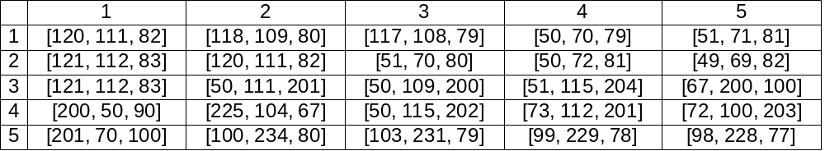
Figure 1.2. Five by five matrix representing an image, each cell contains the color information in the form [red, green, blue] for a given pixel in the image

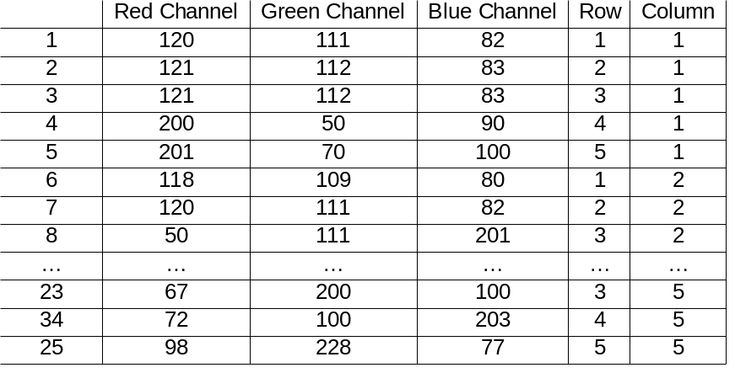
Figure 1.3. Two dimensional matrix obtained by transforming the five by five matrix in figure 1.2. Each row in the matrix represents one pixel. The data included for each pixel is the value of its red, green and blue color channels as well as its location in the original image

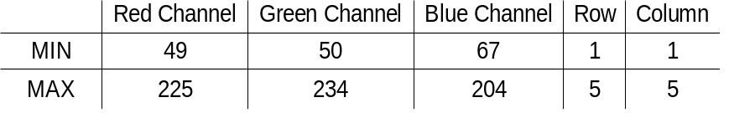
Figure 1.4. The minimum and maximum values of each column from the data in the matrix in figure 1.3, used to create initial centroids

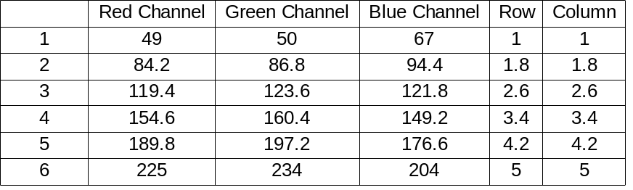
Figure 1.4. The initial centroids for K clusters, K being six in this case. Uses min and max from figure 1.4 as first an last respectively. Determines other values by choosing equally spaced values between min and max

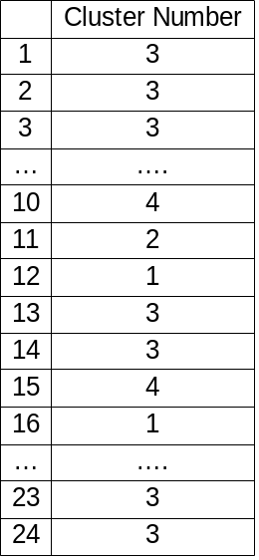
Figure 1.5. Cluster index matrix created after one pass over data. Each row represents the cluster that the pixel in the corresponding row in figure 1.3 belongs to.

K-Means and Images
The first test of using the k-means algorithm showed exceptional results, beyond anything earlier blobbing techniques had shown. The initial blob extraction techniques only cared if adjacent pixels where similar to each other, this often allowed for large gradients in the colors of pixels recognized as being a connected blob, or on portions of an object that were very similar in color would be extracted. The k-means on the other hand considers the similarity between a pixel and the mean of an entire cluster. Through experimentation with using different values for k and using different color spaces for the image that would be segmented, It was shown that applying k-means to the data in an image could reliably return sets of data containing only a specific object in an image.

