The start of it all!

#0

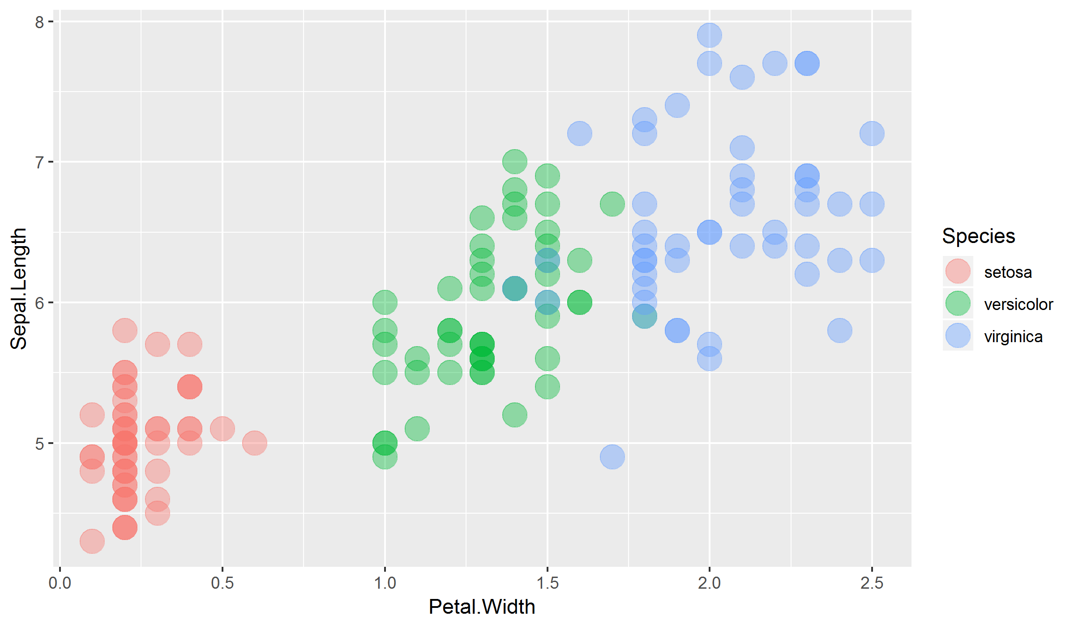

#1



#2

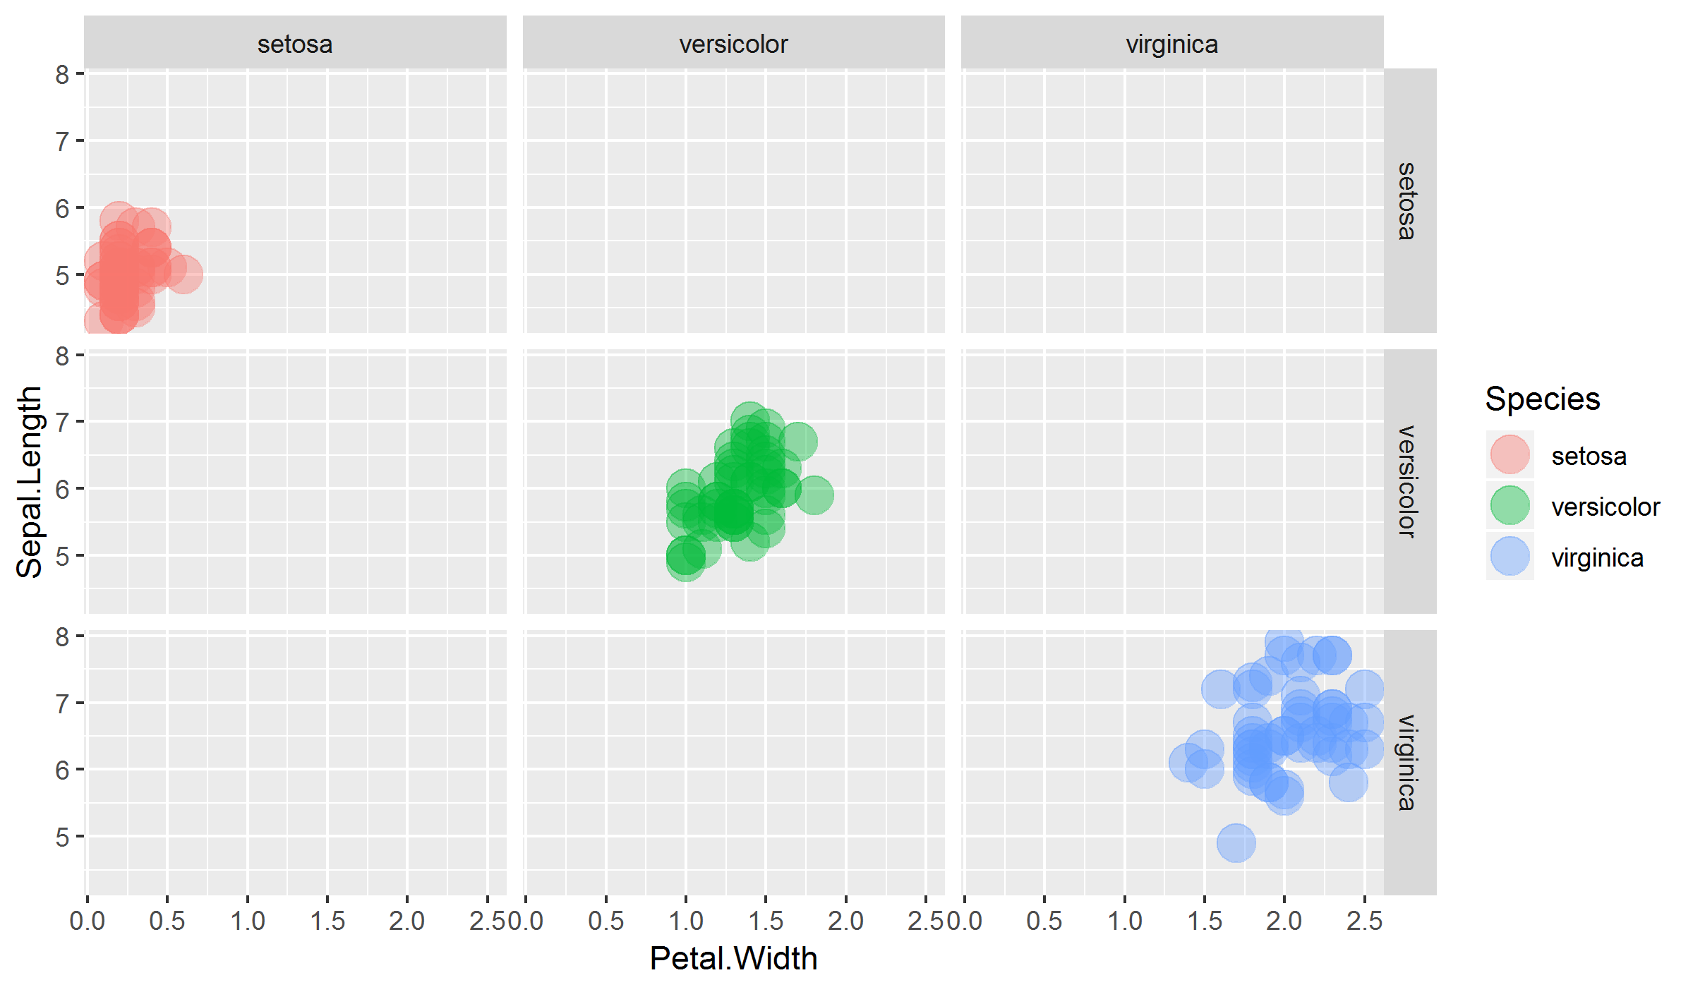

#3



#4

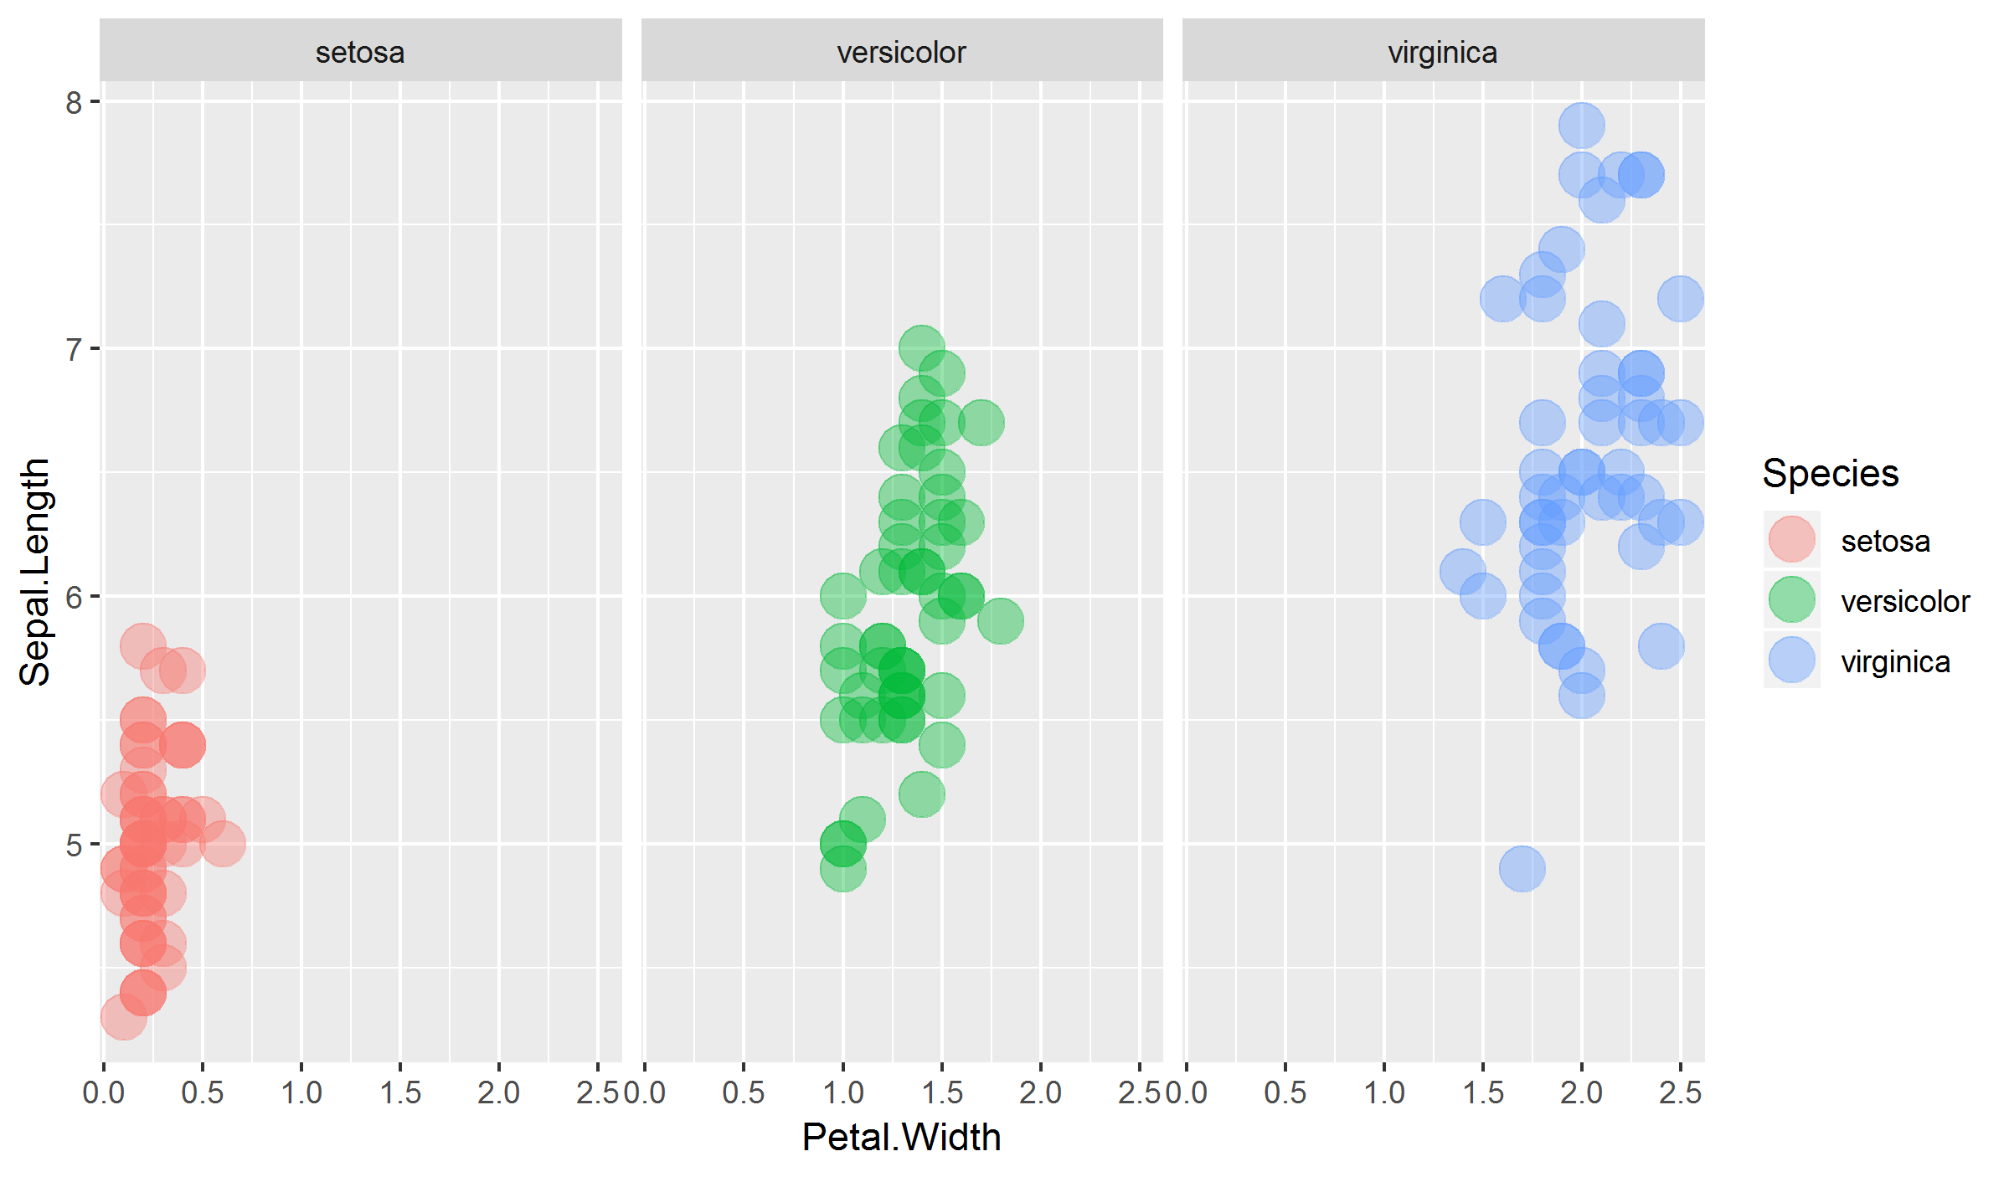

#5

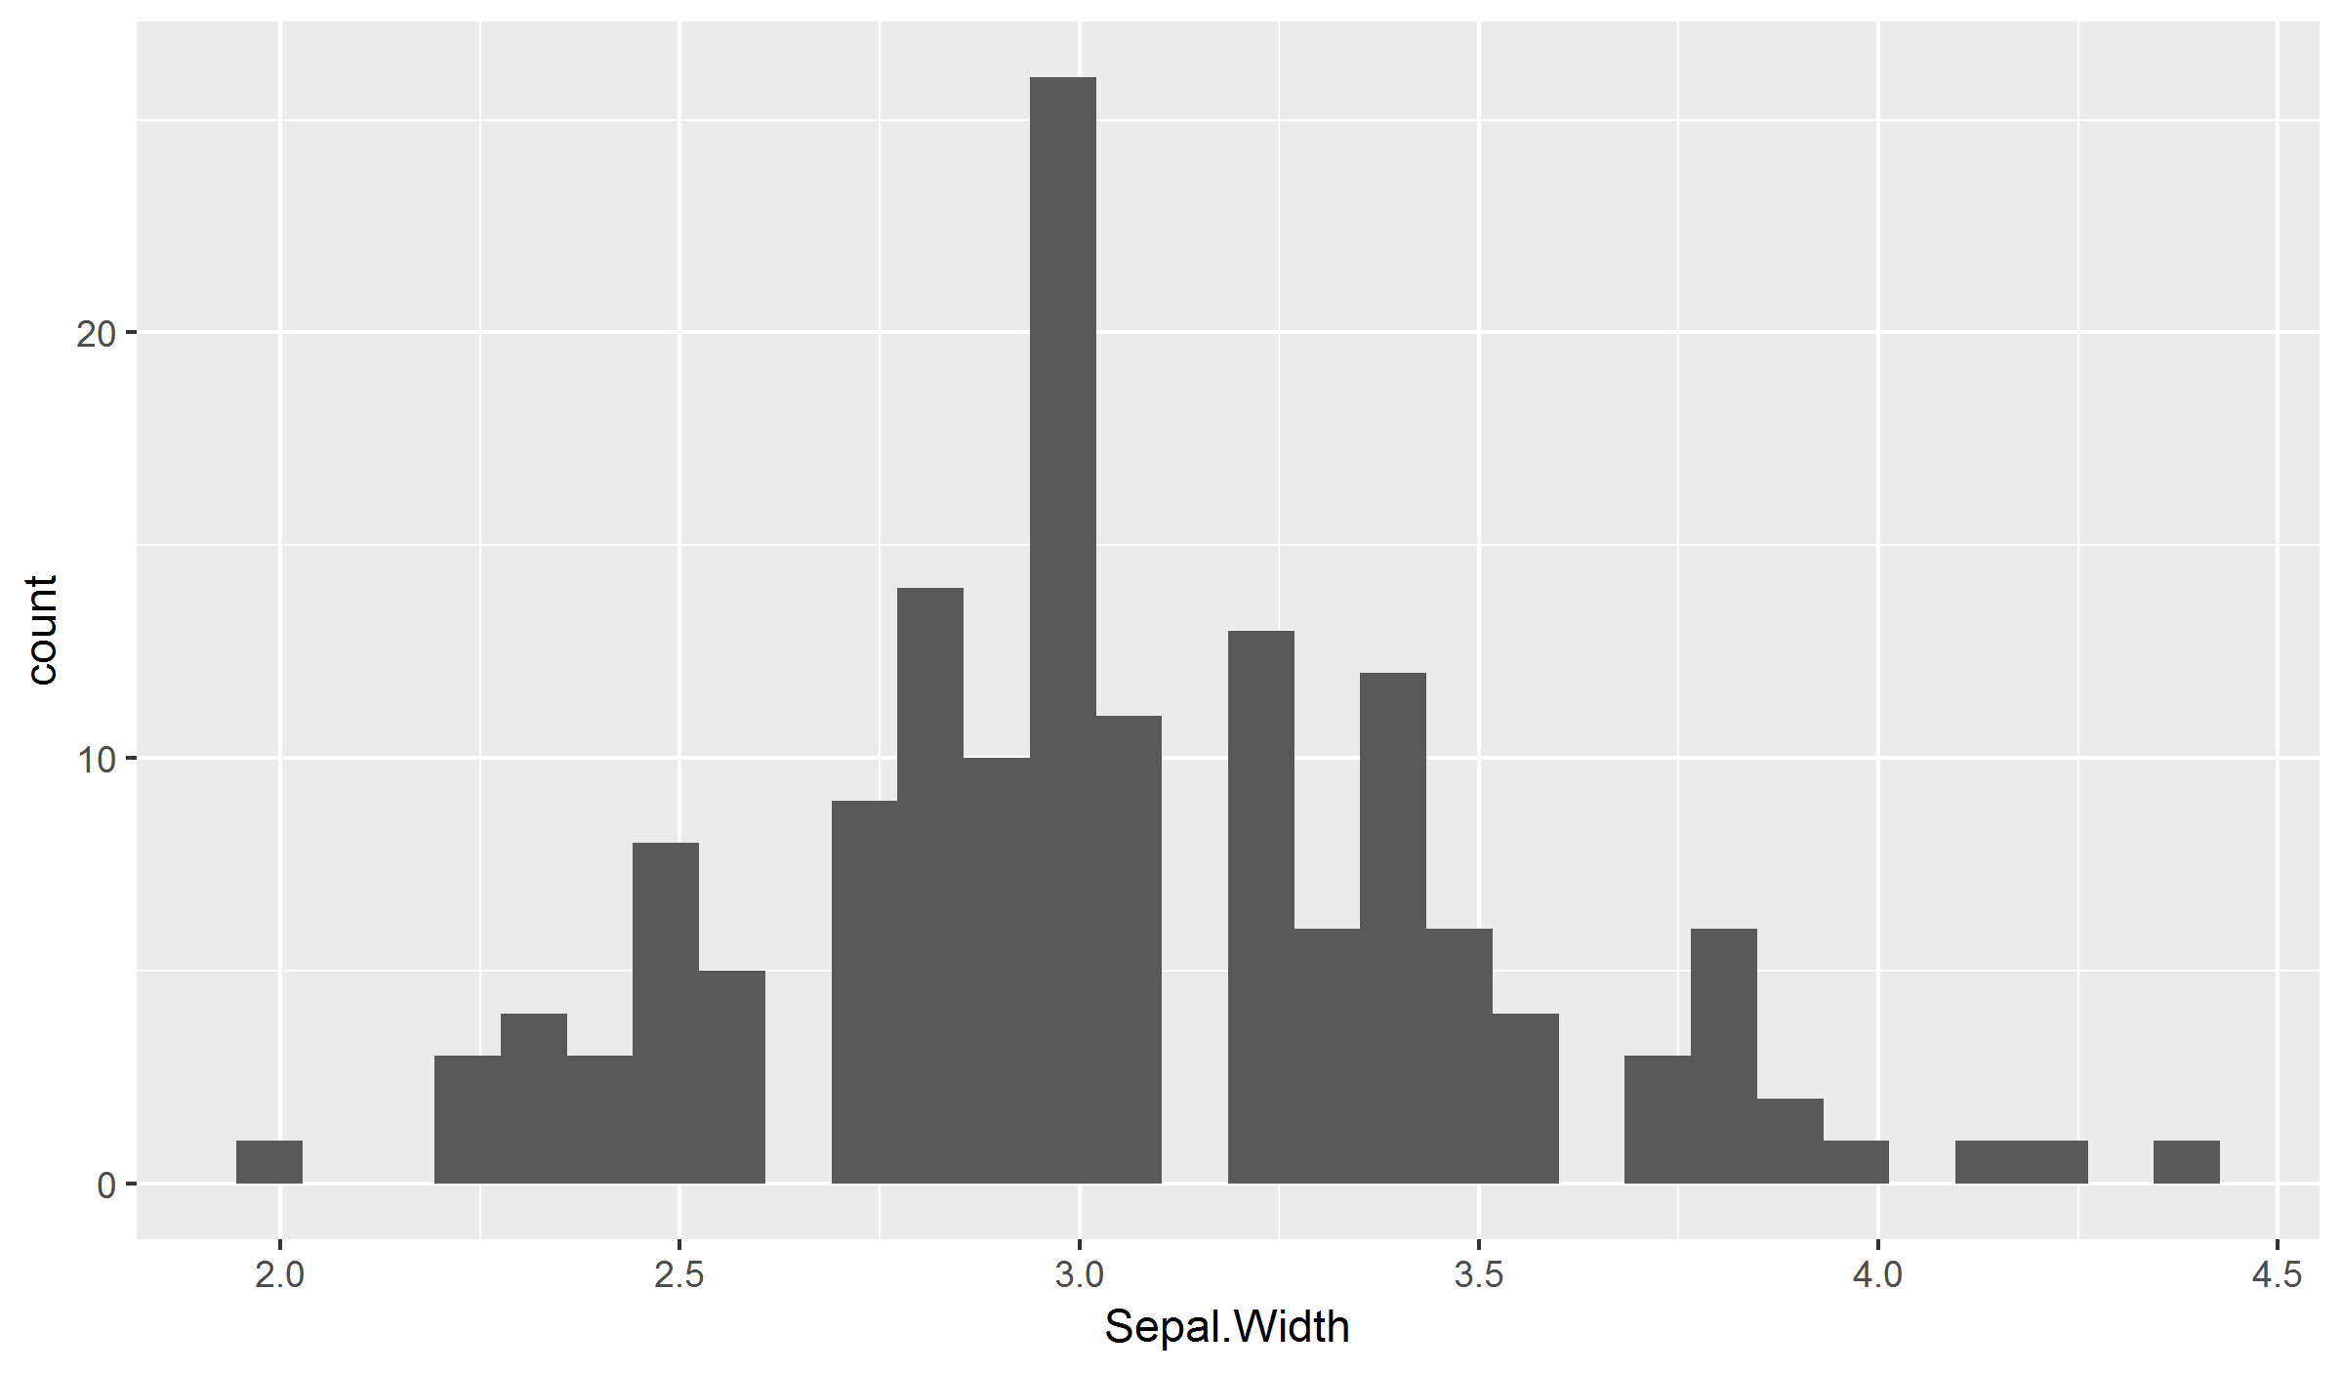

**Tables#0**

**PK1_Proj_5169_Data_20181116_1548_jeffmun_TN1.html**

|  |  |
| --- | --- |
| **My Title** | |
|  | |
|  | *Dependent variable:* |
|  |  |
|  | Sepal.Width |
|  | |
| Speciesversicolor | -0.658*** |
|  | (0.068) |
| Speciesvirginica | -0.454*** |
|  | (0.068) |
| Constant | 3.428*** |
|  | (0.048) |
|  | |
| Observations | 150 |
| R2 | 0.401 |
| Adjusted R2 | 0.393 |
| Residual Std. Error | 0.340 (df = 147) |
| F Statistic | 49.160*** (df = 2; 147) |
|  | |
| *Note:* | *p<0.1; **p<0.05; ***p<0.01 |

#1

**PK1_Proj_5169_Data_20181116_1548_jeffmun_TN2.html**

|  |  |
| --- | --- |
| **My Title** | |
|  | |
|  | *Dependent variable:* |
|  |  |
|  | Sepal.Width |
|  | |
| Speciesversicolor | -0.658*** |
|  | (0.068) |
| Speciesvirginica | -0.454*** |
|  | (0.068) |
| Constant | 3.428*** |
|  | (0.048) |
|  | |
| Observations | 150 |
| R2 | 0.401 |
| Adjusted R2 | 0.393 |
| Residual Std. Error | 0.340 (df = 147) |
| F Statistic | 49.160*** (df = 2; 147) |
|  | |
| *Note:* | *p<0.1; **p<0.05; ***p<0.01 |

#2

**PK1_Proj_5169_Data_20181116_1548_jeffmun_TN3.html**

|  |  |
| --- | --- |
| **My Title** | |
|  | |
|  | *Dependent variable:* |
|  |  |
|  | Sepal.Width |
|  | |
| Petal.Length | 0.388 |
|  | (0.260) |
| Speciesversicolor | -1.685*** |
|  | (0.563) |
| Speciesvirginica | -1.188** |
|  | (0.596) |
| Petal.Length:Speciesversicolor | -0.014 |
|  | (0.277) |
| Petal.Length:Speciesvirginica | -0.154 |
|  | (0.273) |
| Constant | 2.861*** |
|  | (0.383) |
|  | |
| Observations | 150 |
| R2 | 0.491 |
| Adjusted R2 | 0.473 |
| Residual Std. Error | 0.316 (df = 144) |
| F Statistic | 27.798*** (df = 5; 144) |
|  | |
| *Note:* | *p<0.1; **p<0.05; ***p<0.01 |

#3

**PK1_Proj_5169_Data_20181116_1548_jeffmun_TN4.html**

|  |
| --- |
| **My Title** |
|  |
| } |
|  |

#4

**PK1_Proj_5169_Data_20181116_1548_jeffmun_TN6.txt**

|  |  |  |  |
| --- | --- | --- | --- |
|  | **Sepal.Length** | **Sepal.Width** | **Petal.Length** |
| Sepal.Length |  |  |  |
| Sepal.Width | -0.12 |  |  |
| Petal.Length | 0.87**** | -0.43**** |  |
| Petal.Width | 0.82**** | -0.37**** | 0.96**** |