

NetPass Administrator’s Guide
Version 2.0

Copyright © 2005 University at Buffalo.
Permission is granted to copy, distribute and/or modify this document
under the terms of the GNU Free Documentation License, Version 1.2
or any later version published by the Free Software Foundation;
with no Invariant Sections, no Front-Cover Texts, and no Back-Cover
Texts. A copy of the license is included in the section entitled "GNU
Free Documentation License".

This manual applies to Version 2.0 of the NetPass product.

NetPass is built upon many other software packages. All trademarks and registered trademarks appearing in this manual are the property of their respective owners.

Chapter 1 : Overview 1
Inside the Quarantine 1
Outside the Quarantine 2
Chapter 2 : Installation 3
Prerequisites 3
DHCP Server 3
Switches 3
Server Hardware 4
Network Architecture 6
System Architecture 8
Single Server 8
High-Availability 10
Installation Procedure 11
High-Availability Installation 11
Overview 11
OS Installation 11
Building the Kernel 12
Packages not included with NetPass (Nessus and MySQL) 13
(Optional) Configure Snort to work with Endace cards 17
(Optional) Install NetPass::Snort Integration Module 18
Packages included with NetPass 20
Configuring the Servers 21
Configuring the network interfaces on the servers. 22
Making the network interface configuration persist across reboots. 23
Configuring DHCP Relay 23
Tuning Your Server’s Kernel 23
Configuring the Redirectors 24
Installing the NetPass software onto the redirectors 24
Configuring the interfaces on the redirectors. 24
Tuning Your Redirector’s Kernel 25
Chapter 3 : Configuration 27
Managing Authentication Methods 27
RADIUS (NetPass::Auth::RADIUS) 27
LDAP (NetPass::Auth::LDAP) 28
Local Database (NetPass::Auth::DB) 28
Unix (NetPass::Auth::Unix) 29
Managing Users 29
Managing Netgroups 31
Managing Networks 32
Managing Switches 36
Managing Global Settings 37
General Settings 37
Nessus Settings 42
Snort Settings 43
NetPass API (npapid) Settings 44
Database Connection Settings 44
Managed Snort IDSes 45
Tight Integration (“RW” Mode) 46
Loose Integration (“RO” Mode) 46
API-Only Integration (Roll Your Own) 47
Chapter 4 : Using NetPass 48
Defining Walk-Thru Pages 48
Defining Remediation Pages 50
Defining Client Baseline Security Requirements (“Scan Config”) 51
Managing Clients 51
Reset Their Strikes 52
Quarantine Them 52
Un-quarantine Them 53
Add To Their Incident History 53
Adjust When the Client Will Be Un-quarantined 53
Manual Registration 54
API Control of NetPass 55
Appendix A : ISC DHCP Daemon Patch 56
Appendix B : SquidGuard Patch 58
Appendix C : LVS (High-Availability) Patch 59
Appendix D : Using custom gateway MACs instead of Gratuitous ARPing 61
Appendix E : API Reference 61
Appendix F : Rebuilding Perl from Source 61
Appendix G : Rebuilding Apache from Source 61
Appendix H : Rebuilding SquidGuard from Source 61
Appendix I : GNU Free Documentation License 62

Figure 1 - Typical Switch Fanout 3
Figure 2 - Resource Utilization Example 4
Figure 3 - Single Subnet Deployment 6
Figure 4 - Multi-Subnet Deployment 7
Figure 5 - Packet Flow For Approved URL 9
Figure 6 - Packet Flow for Blocked URL 9
Figure 7 - Authentication Methods Panel 26
Figure 8 - User Editor Panel 28
Figure 9 - Netgroup Panel 30
Figure 10 - Add/Edit Network Panel 32
Figure 11 - Possible BSW Locations 34
Figure 12 - Example of DHCP failure due to asymmetric routing of reply. 57
Figure 13 - Packet flow through redirector 60

: Overview

Identify. Quarantine. Remediate.

NetPass is a system that implements a VLAN (802.1q) based network quarantine environment with a built-in self-remediation mechanism, administrative web interface and API for auto-quarantining of clients by external systems.

NetPass works by managing the edge ports and controlling the VLAN membership of those ports. Each edge port can belong to one of two VLANs – the quarantine and un-quarantine VLAN.

When the port is in the quarantine VLAN, any traffic sent into the port by an end-user machine is examined by the NetPass server. The majority of the traffic in this VLAN is discarded with the exception of DHCP, DNS, HTTP and HTTPS traffic.

When the port is in the un-quarantine VLAN, all traffic is permitted according to the filters on your routing infrastructure. No traffic from this VLAN is sent to the NetPass server.

Inside the Quarantine

When inside the quarantine, all traffic from client ports is sent to the NetPass server. Initially, that traffic is most likely DHCP related. This traffic arrives at the NetPass server and is proxied (relayed) to your DHCP server by using the “dhcprelay” application.

The DHCP server responds with a lease offer which is relayed back to the client. The client eventually acquires a lease and all of it’s “normal” network settings (gateway, subnet mask, DNS servers, etc). See the “DHCP Server Prerequisites” section for important information about stipulations about how the DHCP server must behave.

Once the client acquires its IP configuration, it can then boot. If it makes any DNS queries during or after booting, those are NAT’d and sent to your “normal” DNS servers, as specified in the DHCP lease. All replies that come back are sent directly back to the client, unaltered.

If the client attempts any web traffic, it is intercepted by the IPTables configuration on the NetPass server (unless the traffic is specifically directed to the NetPass server’s web server) and redirected to Squid. Squid hands the web request to SquidGuard which examines the URL and decides whether to permit it or to send a redirect back to the client.

If the URL is on a configurable whitelist of permitted URLs, then Squid proxies the request on behalf of the client. Otherwise, a HTTP redirect is returned to the client machine, instructing it to go to the NetPass web server’s home page.

Once at the NetPass home page, the client is presented with a per-network configurable welcome page, AUP and login prompt. Once the client logs in, they are scanned using Nessus.

If the scan detects any vulnerabilities, they are given instructions on how to fix their PC so that it passes the scan. The remediation messages, by default, come from Nessus. However, they can be over-ridden with per-network customized messages.

If the client passes the scan, the client’s information (IP, MAC Address, username, switch, port) is recorded and the port is moved from the quarantine VLAN to the un-quarantine VLAN.

On subsequent boots, the MAC on the client port is evaluated to see if it’s registered and tagged as being un-quarantined. If it is, the port is either immediately moved to the un-quarantined state or is moved once the client visits the NetPass website to read a “message of the day” page based on a configuration setting.

Outside the Quarantine

Clients that are outside of the quarantine are free to use the network without any interaction with NetPass. All traffic from those clients is handled by your normal network infrastructure.

NetPass includes an option to periodically check ports for unregistered hosts and move those ports automatically back into quarantine so the unregistered hosts have the opportunity to register.

: Installation

Prerequisites

DHCP Server

If you are using ISC DHCP on the network you plan to deploy NetPass on, it’s important to apply a patch to the server so that clients can boot. The reason for the patch is discussed in Appendix A of this document.

As of this writing (July 2005) the only DHCP test and verified to work with NetPass is ISC’s. Other DHCP servers may work. If you are using static addressing, there are no special considerations.

Also as of this writing, the patch is only available for 3.0.1 and 3.0.2 versions of ISC DHCP.

Switches

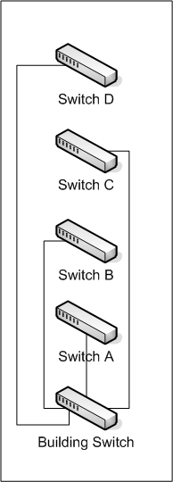
For NetPass to work, all of the switches that will be managed by NetPass must support 802.1q VLAN tagging as well as trunking (the ability to propagate tagged packets off of the switch).

In addition, the networking infrastructure between the edge port and the NetPass server must support trunking.

The switches must be able to support manipulation of VLAN membership via SNMP version 2c. The switches must also support the standard MIB-II tree for gathering configured ports (interface tree) and address translation (atTable) information. In all cases, SNMP version 2c is used for bulk operations (efficiency).

For client port discovery, a tree search is used to avoid querying every port on the network. If the switches on the network don’t support some sort of topology discovery (CDP, AutoTopology, etc) NetPass will fall back to the less efficient linear search. For optimal operation, all switches should support topology discovery. Due to the lack of an industry standard, this usually implies that all of the switches are from a single vendor.
Figure 1 - Typical Switch Fanout

When your switches are aware of the layer-2 topology that they are a part of, NetPass is able to start at the base/building switch and search for a client (MAC address) efficiently by first determining which port the client is on, and then determining which switch is connected to that port. NetPass will then search that switch for the client, and so on, until the exact port that the client is on is determined.

With the linear search (which NetPass always falls back to as a last resort) each switch must be queried in turn until the client is found. If the client is on the last switch on the list, the first 4 switches are needlessly sent queries. In a large layer-2 network, these excessive queries cause a measurable drop in overall performance of NetPass and result in slower movement from quarantine to unquarantine and vice versa.

Server Hardware

Presently NetPass runs on Intel based hardware. Each server must have two physical network interfaces. One interface terminates all of the trunks and masquerades as the gateway address of each NetPass-enabled network, and the other interface is the ‘public’ side of the server. For every 2000 clients on the network, 2 gigabytes of RAM and one 2.8 GHz or higher CPU is needed.

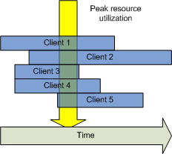
Practically speaking, each concurrent client hit on the web server consumes approximately 30 MB of RAM. With 2 GB of RAM, you can generally handle around 100 concurrent NetPass clients. While this seems low, in practice this limit isn’t usually reached. While the use of virtual memory (swap space) can increase this ceiling for a low-cost, in practice once the machine starts swapping, performance drops precipitously. The recommended configuration is to always purchase enough physical RAM to handle the projected peak load.

The highest client load occurs during startup or after a mass-quarantining. During these times, many clients attempt to access the NetPass server to be scanned and unquarantined. During the scanning process, which occurs synchronously, a client will consume 30 MB of RAM for possibly many minutes at a time. The actual duration is determined by the presence of a personal firewall on the client and the number and type of Nessus scans you have enabled. Using a small set of scans (20) minimum scan times are around 10-15 seconds (no personal firewall) and maximum is around 5 minutes (personal firewall).
Figure 2 - Resource Utilization Example

Experience has shown that 2 load-balanced servers, equipped with 3 GB RAM and dual 2.8 GHz CPUs can comfortably handle 7000-8000 clients, even during high utilization times (semester startup). NetPass can be clustered to N servers using the High Availability option.

In the resource utilization example about, five concurrent clients are being scanned. Some are taking a long time, and some are not. At the time denoted by the yellow arrow, the concurrent memory utilization is approximately 150 MB.

A NetPass installation on an 8000 client network will generate about 5-10 GB of data per semester (per 6 month period) to the database. In addition, NetPass generates a good deal of back-end diagnostic logging to the filesystem. A minimum of two SCSI disks are needed in a RAID 0+1 configuration (for performance).

If you are planning on using the High Availability option with LVS (Linux based) Load Balancers (redirectors) then those machines (two are recommended) should have one CPU of at least 2.0 GHz, a minimum of 1 GB of RAM and two network interfaces. The disks are less critical in the redirectors since they perform minimal disk I/O. Since you are deploying redirectors, redundancy must be important to you, so some sort of RAID is recommended.

Network Architecture

NetPass relies on 802.1q VLAN tagging and trunking to implement the quarantine environment. Each subnet has two VLANs assigned to it – the quarantine and unquarantine VLAN. This allows for a smaller quarantine network with less clients residing in the shared quarantine at any time. This also allows for client segregation so that a client from one unit or department is never in quarantine with a client from another unit or department (unless they both share the same address space).

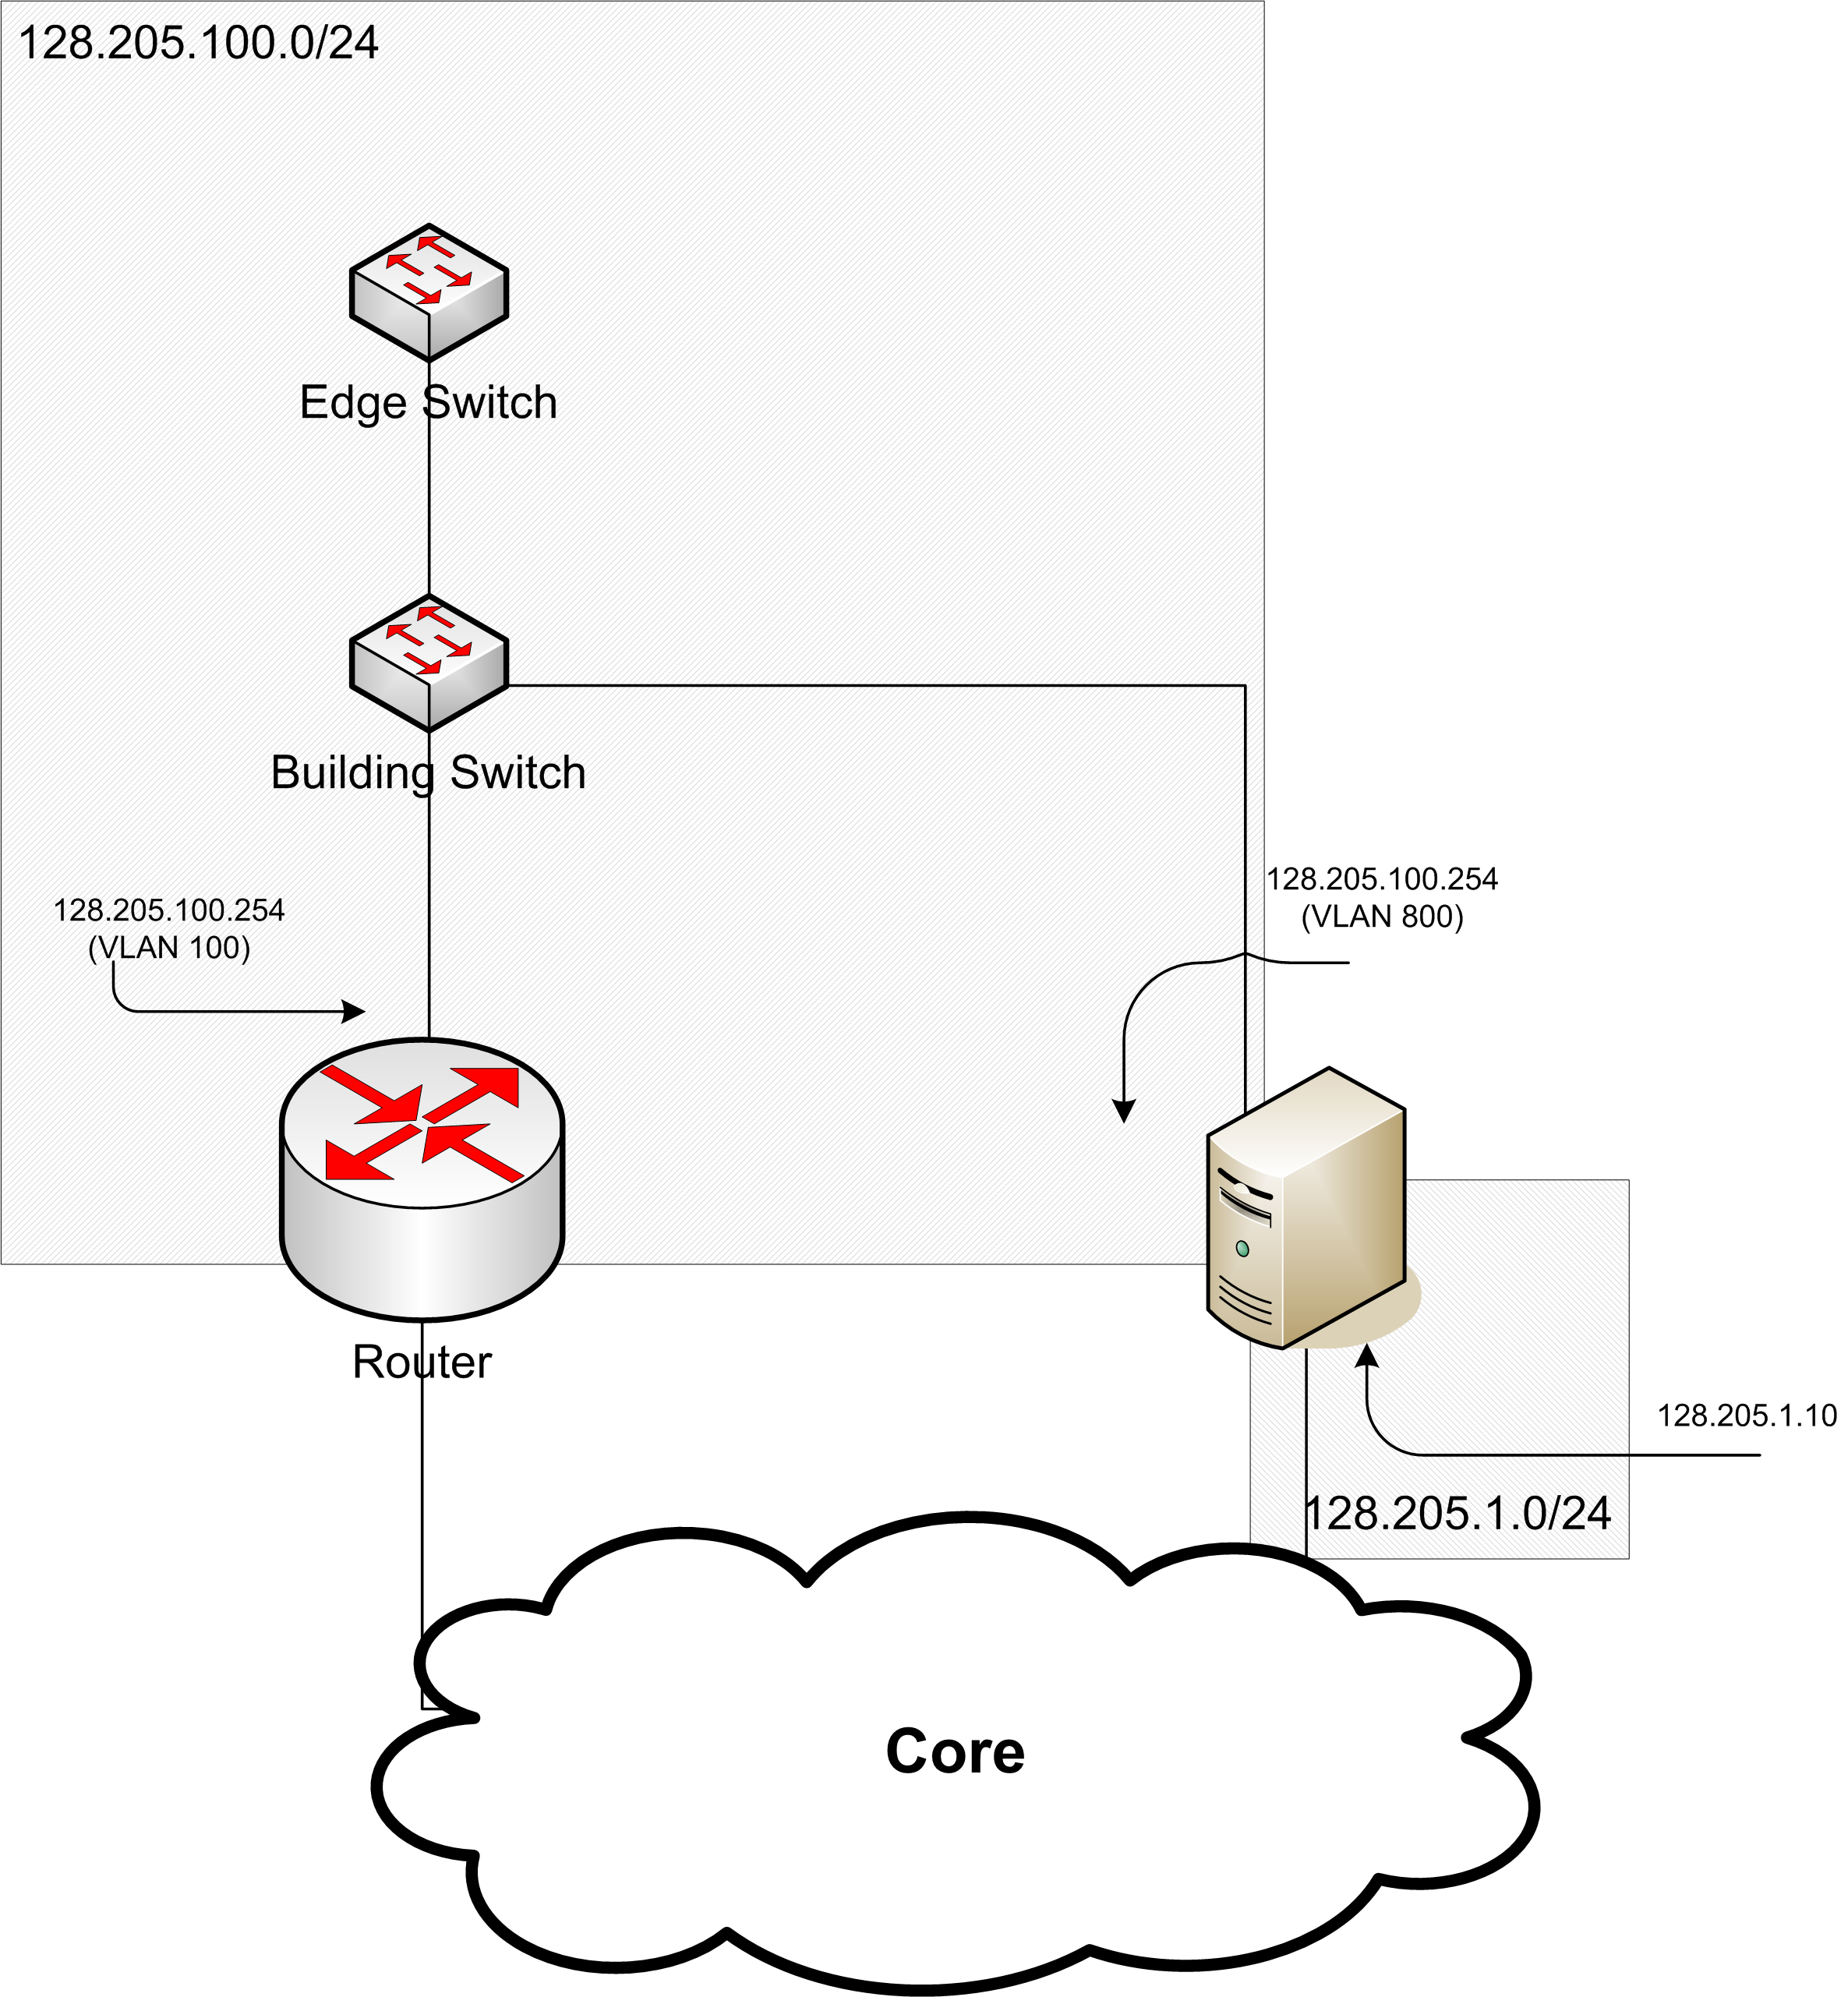
Clients keep their “normal” IP address and network parameters at all times. NetPass does not use private (RFC 1918) addressing, DNS spoofing or any other tricks to implement the quarantine.

The following discussion assumes that your network architecture has a router, an aggregation switch and then multiple edge switches. The network being managed is 128.205.100.0/24. The quarantine VLAN is 800 and the unquarantine VLAN is 100. The public side of the NetPass server resides on the 128.205.1.0/24 network. The gateway address for the network is 128.205.100.254 and it exists in two places: on the router which is the gateway for the unquarantine VLAN and on the NetPass server which is the gateway for the quarantine VLAN.
Figure 3 - Single Subnet Deployment

Once the two VLANs are determined they are configured on the aggregation switch and all edge switches connecting to the aggregation point. All of the connections between the edge switches and the aggregation switch are designated as trunked/tagged links and all packets are passed with tags over those links.

Off of the aggregation switch is an uplink to your core routing infrastructure. That link need only be tagged into the un-quarantine VLAN. However, depending upon your specific network architecture this may not always be the case.

A separate tagged link off of the aggregation switch is connected to the NetPass server. Both the quarantine and un-quarantine VLANs are configured on this link. This is depicted in the “Single Subnet Deployment” diagram. Since NetPass is only managing that single subnet, the server can be plugged directly into the aggregation switch.

When a client is switched from Quarantine to Un-quarantine, the gateway’s MAC address changes, but the IP address remains the same. In order to make the transition quickly, the NetPass server produces gratuitous ARP packets which cause the client to learn the new MAC-to-IP mapping for the gateway address. Some routing platforms (for example, Cisco 65xx) allow you to specify the MAC address on the router’s interface. In those cases, the gratuitous ARP feature can be turned off after you configure the router and NetPass server with the appropriate MAC addresses. See Appendix D for a discussion on how custom MAC address assignment works.
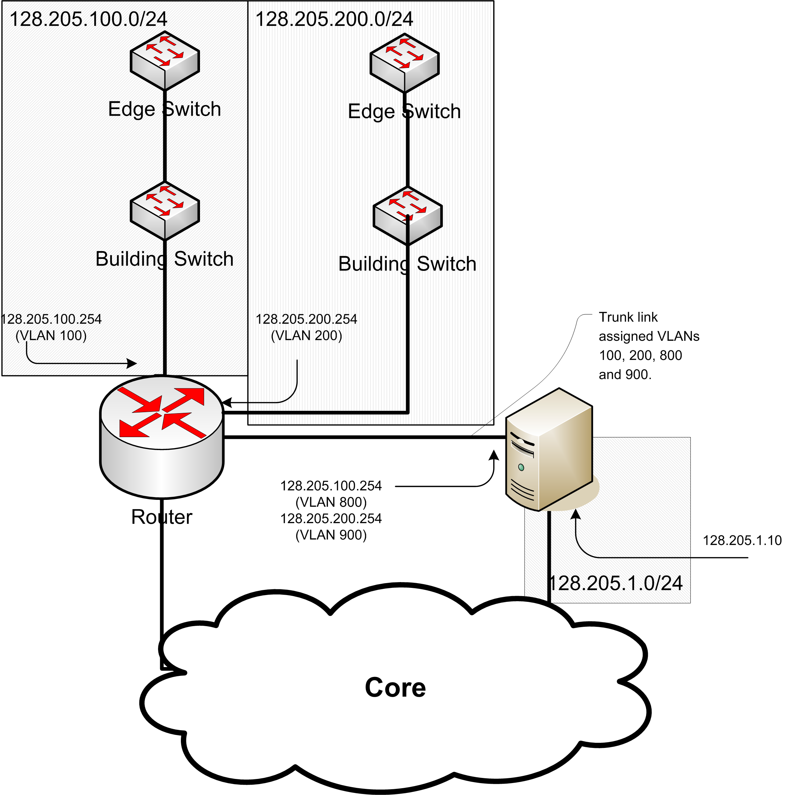
In the Multi-Subnet Deployment diagram, the server’s quarantine interface has moved to the router.

It should be noted that the management address for the switches should always be in a separate address space. In the above examples, the switches are not in the 128.205.100.0/24 space nor are they are in the 128.205.200.0/24 space.

Figure 4 - Multi-Subnet Deployment

To summarize the how to configure the network (for multiple subnets):

- Place all of the switches management interface in a separate VLAN and separate IP subnet space.
- Select a VLAN for the quarantine and un-quarantine networks.
- Configure the uplink port on each edge switch so that it is a trunked port with both of the NetPass VLANs on it as well as the VLAN assigned to switch management.
- Configure the uplink port from the aggregation switch to the router with both NetPass VLANs as well as the VLAN assigned to switch management.
- Place all edge ports in the un-quarantine VLAN.
- Configure the router so that the un-quarantine VLAN has a gateway (is routed) and a bootp-relay (if you are using DHCP).

At this point your network should function as it normally does. Connectivity for end-users should be established and work. Switch management should work.

- Configure the router with a port to attach the NetPass server(s) to. Add all of the NetPass VLANs for all of the NetPass-enabled subnets to that port.

You are now ready to attach the NetPass server(s). Note that the quarantine VLANs do not have a gateway specified on the router.

System Architecture

Single Server

A single NetPass server consists of a DHCP relay, a webserver (Apache), a database (MySQL), Squid and SquidGuard (for URL filtering) and IPTables to make traffic routing decisions.

When a packet comes in, if it’s a DHCP packet, it’s relayed to your DHCP server.

If the packet is a DNS packet, it’s NAT’d to your DNS servers.

If the packet is HTTPs it is permitted through because Squid can not proxy or filter encrypted Web transactions. While it is possible to limit HTTPs to specific destination addresses, many vendors (e.g. Microsoft) use extensive caching networks that make this impractical.

If the packet is for HTTP, then it is redirected, via IPTables, to the port that Squid is running on. Squid picks up the request and, by using SquidGuard, determines whether or not the URL is to a permitted web site. If it is, Squid performs the web request on the client’s behalf. If the URL is not approved, Squid returns an HTTP redirect instructing the client to go to the NetPass web site.

Once the client arrives at the NetPass website, Apache and Mason handle processing the client. This includes logging them in, scanning them, displaying appropriate messages and finally changing the VLAN membership of their port.

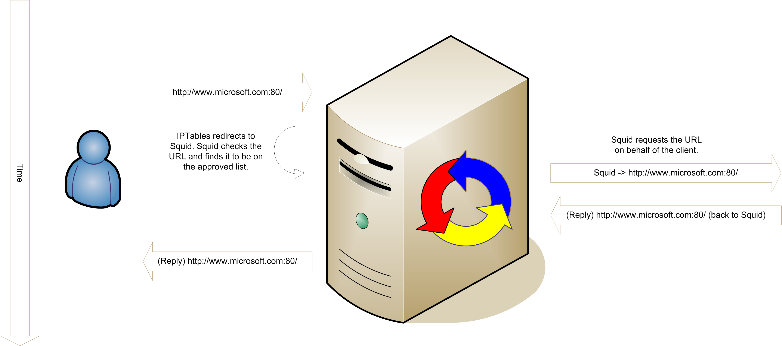
Figure 5 - Packet Flow For Approved URL

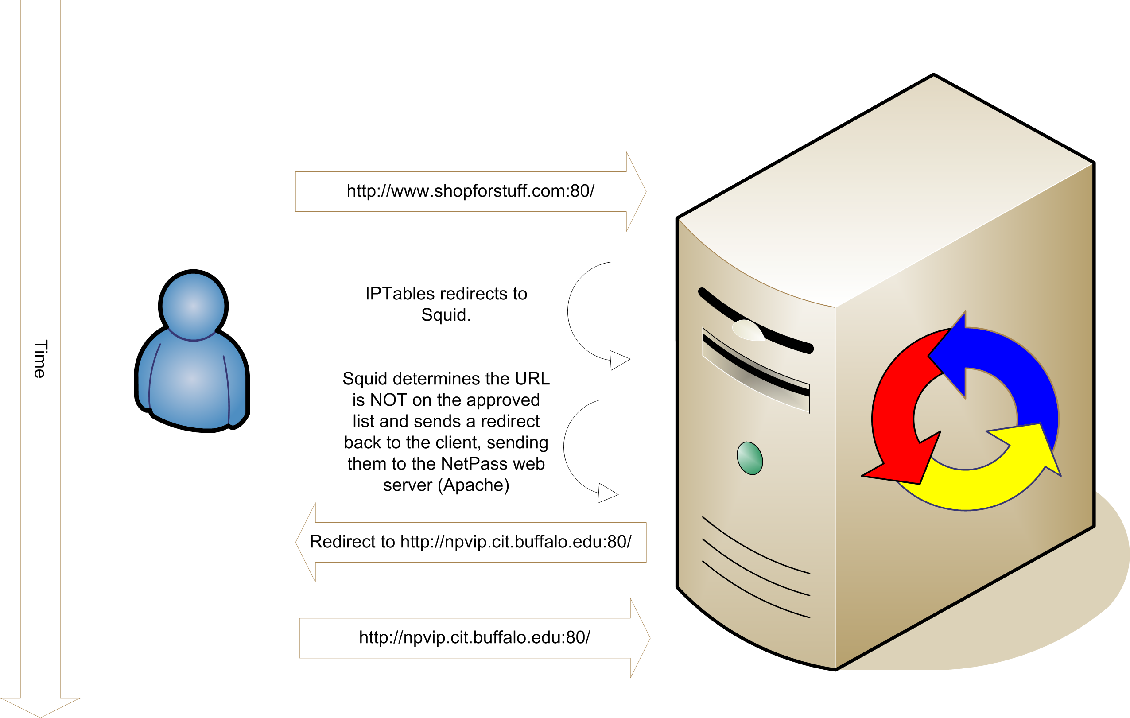
Figure 6 - Packet Flow for Blocked URL

High-Availability

NetPass can scale beyond a single server and provide high-availability by deploying it behind a redirector. While appliance-type redirectors should work (provided they understand VLAN trunking) none have been tested.

Instead LVS has been tested and deployed. LVS turns a PC running Linux into a redirector. Connections coming into that redirector are load-balanced across multiple back-end NetPass servers.

Installation Procedure

High-Availability Installation

To complete this procedure you will need a minimum of three machines. Two of those will be the NetPass servers and one will be the redirector. For maximum redundancy a second redirector is recommended. The machines should be sized according to the recommendations in the Hardware Architecture section.

Overview
- OS Installation
- Kernel Build and Installation
- Installation and Configuration of Packages not included with NetPass
- Installation and Configuration of Packages included with NetPass
- Configuring NetPass
- Configuring Redirectors
- Staying up to date (because this is a Beta release).
The following instructions use some example machine names and addresses. They are:

Purpose | Name | Address
Redirector #1 | npr1-d.cit.buffalo.edu | 128.205.10.40
Redirector #2 | npr2-d.cit.buffalo.edu | 128.205.10.62
NetPass Server #1 | npw1-d.cit.buffalo.edu | 128.205.10.27
NetPass Server #2 | npw2-d.cit.buffalo.edu | 128.205.10.37

OS Installation
RedHat Enterprise Linux 4 or Fedora Core 3 is the recommended OS. While other distributions will work, those are the only two we've tested on. A basic OS installation is all that's needed. When doing the installation, configure the disks with at least 2G of swap space. Leave the remainder of the disk as the root filesystem. When the installer asks if you want to enable SELinux, say “no”.

The NetPass installer will pull in any packages that are missing, so you don’t need to customize the package list.

Since this is a high-availability installation, you will need to apply the "hidden" patch to your NetPass server(s). You will also need to apply the NetPass LVS patch to the redirector(s). Both patches can be downloaded from
www.sf.net/projects/netpass
You should use the kernel source supplied with your distribution. Do not use the generic kernel (http://www.kernel.org/).

Do the following to acquire and build your kernel on each machine in your NetPass Cluster:

Building the Kernel
- mkdir –p /usr/src/redhat/SOURCES
- cd /usr/src/redhat/SOURCES
- up2date --get-source kernel
- rpm -iv /var/spool/up2date/kernel*.src.rpm
- up2date --nox –i rpm-build gcc redhat-rpm-config
- rpmbuild -bp --target=i686 ../SPECS/kernel.spec
- cd ../BUILD/kernel-2.6.9/linux-2.6.9
- patch -p1 < hidden.patch (NetPass server)
OR
patch -p1 < lvs.patch (redirector)
- cp configs/kernel-2.6.9-i686-hugemem.config .config
- vi .config
- set CONFIG_REISERFS_FS=m (you can skip this on the redirectors)
- vi Makefile
- set EXTRAVERSION = -netpass
- make bzImage and answer (if you skipped step 11 this step does not apply):
Reiserfs support (REISERFS_FS) [M/n/y/?] m
Enable reiserfs debug mode (REISERFS_CHECK) [N/y/?] (NEW) n
Stats in /proc/fs/reiserfs (REISERFS_PROC_INFO) [N/y/?] (NEW) y
ReiserFS extended attributes (REISERFS_FS_XATTR) [N/y/?] (NEW) n
- make modules
- make modules_install
- make install
- Reboot and select the "netpass" kernel. Once tested, make it the default by editing /boot/grub/grub.conf and adjusting the DEFAULT setting.

Packages not included with NetPass (Nessus and MySQL)
- Nessus
  - Download Nessus from http://www.nessus.org/download/index.php
  - You should also register for the plugin feed while you are at the website (the download page will contain instructions for you). A registration code will be emailed to you. You will need to enter this code into the installer. You will need a distinct code for each NetPass server.
  - Save the package to /tmp
  - As "root" do the following:
up2date --nox -i openssl-devel bison flex gcc sharutils
or (depending upon your OS)
yum install openssl-devel bison flex gcc sharutils
and then
sh /tmp/nessus
  - Install Nessus into /usr/local (the default). The installer may complain about “gtk-config” and not building the GUI. That’s OK.
  - Create a nessusd certificate using /usr/local/sbin/nessus-mkcert
You will be asked for a number of days for the CA and Server certificates. Enter a large number. Only the local machine will attach to this instance so 10 years should be fine. Enter all the other information it asks for.
  - Add a nessusd user by using /usr/local/sbin/nessus-adduser
Login : netpass
Authentication (pass/cert) [pass] : pass
Login password : netpass
Login password (again) : netpass
User rules… just hit “Control-D” and leave the rules empty.
  - Edit /usr/local/etc/nessus/nessusd.conf and set max_hosts = 1000 or however many clients you think you’ll need to handle concurrently. “1000” is more than enough. You can set this higher, since Apache will stop handling clients before this number is actually reached. You can leave max_checks as 10.
  - Start the Nessus daemon (nessusd) by typing:
/usr/local/sbin/nessusd –D
The NetPass installation script will install a system startup script for you.
  - Run the command
nessus -q -p 127.0.0.1 1241 netpass netpass
and for “SSL paranoia” choose “2”. Wait. Nessus will think for 10-20 seconds. Nessus should print out all of the available plugs. You can ignore the output, it’s just there to confirm that Nessus is installed properly.
- MySQL
Rather than a Master/Master replicated instance of MySQL, this version of NetPass uses MySQL Cluster. This allows you to add more than two machines to the NetPass cluster. The NetPass servers will run the MySQL database engine software and the redirectors will run the MySQL management agent software.
Do the following on the NetPass Redirectors to install the MySQL Management Daemon.
  - On the MySQL download page (http://dev.mysql.com/downloads/mysql/4.1.html) download the “MySQL NDB Cluster (x86) - Storage engine management” RPM as well. It’s about half way down the page.
  - Log into the redirector that will run the MySQL Management daemon and install that piece.
rpm -iv MySQL-ndb-management-4.1.13-0.i386.rpm
  - create config.ini (ONLY on servers with management daemon - the redirectors. This example uses "npr2-d.cit.buffalo.edu") but you should do it on both of your redirectors (if you have two of them).
[NDBD DEFAULT]
NoOfReplicas=2
[MYSQLD DEFAULT]
[NDB_MGMD DEFAULT]
[TCP DEFAULT]
[NDB_MGMD]
ID=10
HostName=npr2-d.cit.buffalo.edu
[NDBD]
ID=1
HostName= npw2-d.cit.buffalo.edu
DataDir= /var/lib/mysql-cluster
[NDBD]
ID=2
HostName= npw1-d.cit.buffalo.edu
DataDir= /var/lib/mysql-cluster
[MYSQLD]
[MYSQLD]
[MYSQLD]
  - run /usr/sbin/ndb_mgmd (ONLY on server with management daemon which should be your redirectors)
  - Make sure IPTables is configured to permit connects from all of the NetPass servers.
  - cp NetPass/install.d/init.d/ndbdmgmd /etc/init.d
  - chkconfig --add ndbdmgmd
  - chkconfig --level 2345 ndbmgmd on
Do the following on the NetPass Server to install the MySQL Database engine.
- rpm -qa | grep mysql
and remove any MySQL packages (using “rpm –e”) that are installed to avoid confusion. On RedHat, you need to remove the cyrus-sasl-sql dependency too.
- Download the latest stable “Max” version of MySQL 4.1 from http://dev.mysql.com/downloads/mysql/4.1.html These instructions assume you downloaded the tar file and not the RPM. Either should work however.
- groupadd mysql
- useradd -g mysql mysql
- cd /usr/local
- tar -zxvpf /PATH/TO/MYSQL-VERSION-OS.tar.gz
- ln -s FULL-PATH-TO-MYSQL-VERSION-OS mysql
- cd bin
- ln –s ../mysql/bin/mysql
- ln –s ../mysql/bin/mysqladmin
- cd ../mysql
- chown -R root .
- chown -R mysql data
- chgrp -R mysql .
- mkdir -p /var/lib/mysql-cluster /var/lib/mysql /var/run/mysqld
- touch /var/log/mysqld.log
- chown mysql:mysql /var/run/mysqld /var/lib/mysql
- Make sure that IPTables is configured to permit connections from the other NetPass server(s) as well as the redirector(s).
- edit my.cnf so that it looks like this (note: 128.205.10.40 = npr1-d.cit.buffalo.edu, 128.205.10.62 = npr2-d.cit.buffalo.edu). If you only have on redirector (and therefore only one MySQL Management daemon running) then you will only list that single server on the ndb-connectstring line)
[mysqld]
datadir=/var/lib/mysql
socket=/var/lib/mysql/mysql.sock
[mysql.server]
user=mysql
basedir=/var/lib
[mysqld_safe]
err-log=/var/log/mysqld.log
pid-file=/var/run/mysqld/mysqld.pid
[mysqld]
ndbcluster
[mysql_cluster]
ndb-connectstring=128.205.10.40;128.205.10.62
- run /usr/local/mysql/bin/ndbd --initial
- pkill ndbd
- cd /usr/local/mysql
- scripts/mysql_install_db ignore the instructions that this command prints out.
- Install a startup script (available in NetPass/install.d/init.d/mysqld) and type /etc/init.d/mysqld start
- chkconfig –add mysqld
- chkconfig --level 2345 mysqld on
- Test cluster by connecting to one member:
npw1-d% mysql -u root test
mysql> create table foo (a integer) type=ndbcluster;
mysql> insert into foo values(1);
and ensure that table is replicated onto the other member(s):
npw2-d% mysql -u root test
mysql> select * from foo;
(should return a single row)
mysql> drop table foo;

(Optional) Configure Snort to work with Endace cards

Specific version numbers might have changed when you go to download the drivers (for example, as of this writing DAG 2.5 is out). You may substitute the latest version for the ones cited below – the overall build procedure should be the same or very similar.

  - Download the libpcap (v0.8.3) source from www.tcpdump.org
  - Unpack libpcap to /opt/src/libpcap-0.8.3
  - Unpack dag-2.4.14 to /opt/src/dag-2.4.14
  - cd dag-2.4.14
  - mkdir /opt/dag-2.4.14; ln -s /opt/dag-2.4.14 dag
  - ./configure –prefix=/opt/dag-2.4.14
  - make; make install
In this version and possibly others of dag you may need to run dag/drv/dagload by hand to install the kernel modules and create the devices in /dev. If this is the case don’t forget to run modprobe on dagmem and dag to load the modules. We also recommend passing DAGMEM=128M to dagmem when you load the module.
  - mkdir /opt/libpcap-0.8.3; ln -s /opt/libpcap-0.8.3 libpcap
  - cd /opt/src/libpcap-0.8.3
  - ./configure –prefix=/opt/libpcap-0.8.3 –with-dag=/opt/src/dag-2.4.14
  - make; make install
  - Download latest snort source from http://www.snort.org and unpack in /opt/snort/snort-2.3.3
  - mkdir /opt/snort-2.3.3; ln -s /opt/snort-2.3.3 /opt/snort
  - cd /opt/src/snort-2.3.3
  - ./configure --prefix=/opt/snort-2.3.3 –with-libpcap-includes=/opt/libpcap-0.8.3/include –with-libpcap-libraries=/opt/libpcap-0.8.3/lib
  - make; make install
  - cd /opt/snort-2.3.3
  - mkdir logs; mkdir etc
  - cp classification.config and reference.config from an updated ruleset at snort.org and place in /opt/snort/etc

(Optional) Install NetPass::Snort Integration Module

NetPass includes a Snort integration option which will tightly bind a Snort sensor to NetPass. When tightly bound, NetPass can control the sensor and report status information. You may also loosely bind it where NetPass can not control the sensor directly, but can still report status information. In either case, the Snort sensor can be used to automatically trigger quarantining of hosts based on Snort rule hits. This is done via the NetPass::Snort API Application.

  - Download and untar NetPass-Snort-0.01.tar.gz (or whatever is the most current version) from http://www.sf.net/projects/netpass
  - cp etc/snort.conf from NetPass-Snort-0.01.tar.gz to /opt/snort/etc
  - cp install.d/init.d/snortd from NetPass CVS tree to /etc/init.d/snortd
  - cd install.d/sysconfig.snort /etc/sysconfig/snort
  - perl -MCPAN -e shell and then
cpan> install File::Tail
cpan> install SOAP::Lite
cpan> install Sys::HostIP
  - cd into the directory you untarred NetPass-Snort-0.01.tar.gz into
  - perl Makefile.PL
  - make; make install
This will install the NetPass::Snort Perl module and the npsnortd.pl daemon. To modify parameters passed to npsnortd edit /etc/sysconfig/npsnortd
  - start npsnortd by /etc/init.d/npsnortd start

Packages included with NetPass
This version of NetPass includes pre-built versions of Perl, SquidGuard and Apache. These versions have been tested and are known to work and are built with all of the necessary options. Use of these is optional, but encouraged. This document doesn't discuss how to set up any of these by hand. The source distribution includes various scripts to assist in, for example, building a new copy of Perl with all of the required modules.
This version of NetPass is a pre-release (beta) version of 2.0. As such, it is not available as a packaged distribution. This document instructs you to extract the source from CVS. Doing so allows you do more easily stay in sync with changes as features are implemented and bugs fixed in the beta code. Instructions for getting the latest updates and installing them are given below.
Installing NetPass

- Select a location where the source code will reside. The recommended location is /opt/netpass-src
- sudo mkdir /opt/netpass-src
- cd /opt/netpass-src
- sudo chown you:yourgroup .
- cvs -d:pserver:anonymous@cvs.sourceforge.net:/cvsroot/netpass login
- cvs -z3 -d:pserver:anonymous@cvs.sourceforge.net:/cvsroot/netpass co -P NetPass
- cd NetPass
- sudo ./install /opt/netpass
The installation procedure is a bit ugly, but will walk you through downloading the pre-built binaries, installing them, and configuring them.
NetPass Installation Procedure
This section discusses what the installation script actually does. You may skip this section if you like.
The NetPass installation script can both install and uninstall NetPass. It will add (and remove) patches to various system configuration files as needed.
It will do the following (confirmation is prompted for often and a log file is kept in /tmp/netpass-install.txt):
- Create a netpass user and a netpass group.
- Create /var/run/netpass and chown it to netpass:netpass
- Download and unpack pre-built binaries for Perl, Apache and SquidGuard. These will be installed into /opt
- Copy the NetPass source into /opt/netpass
- Download and install HTMLArea into /opt/netpass/www
- Make a /cookies mount point, a /var/cookies file. A ReiserFS filesystem will be written to the /var/cookies file and /etc/fstab will be modified as needed.
- Configure Apache. You will be prompted for all of the options. If you answer "Y" to enabling SSL, you must already have your certificate files. The Installer will not help you create them. It will ask for their location.
- Configure Swatch for log watching
- Configure Squid. You will be prompted for some address ranges to which access will be limited.
- Install system startup scripts.
- Patch system configuration files (services and syslog.conf).
- Install /etc/iptables.sh. You will be prompted for address ranges. The file has an area for placing customizations. If you make any, place them in the specified area (see comments in that file) then use the commands:
sudo /etc/iptables.sh
sudo /etc/init.d/iptables save
to have the changes take effect.
- Load the NetPass database into MySQL
- Create the ‘netpass’ WebUI user
- Import the initial NetPass configuration into the database
- Install crontab files
- chown netpass:netpass /opt/netpass
- startup Apache and NetPass

Configuring the Servers

Once the NetPass software is installed, you’ll be instructed to log into the NetPass Administrative Web UI and configure the system. To do a basic configuration and get the system running, login as netpass/netpass and use the User Editor to either add another Admin user or change the default password.

Once that’s done, use the Network configuration panel to add your NetPass Cluster public network. This is the shared network that the NetPass servers and redirectors are on.

- Fill in Interface field (probably with “eth0”)
- Set HA to Enabled
- Enter your primary and secondary redirector names (or IPs)
- Enter your NetPass server names (or IPs)
- Enter the Virtual IP you will be using
- Leave GARP disabled on the public network
- Leave the switches empty
- Leave all of the Network Settings as the defaults

You are now ready to configure DHCP Relay and bring networking online.

Configuring the network interfaces on the servers.

Once you’ve configured your networks (via the Web UI on your NetPass server) you’ll want to do the following on each of the servers:

bin/interfacecfg.pl –c ‘dbi:mysql:database=netpass;host=yournpserver’ -r 1 | sudo sh -x
Note that the “ticks” (single quotes) in the above line are both “forward ticks” regardless of how they are rendered in this manual.

The “1” in the above line denotes “real server #1”. If you have two, you’ll do the same command on the 2nd one, but you will use “2” on that line.

The reason that you tell this script which server it is configuring is because each server has an IP address on the client networks. The IP addresses must be unique. The script currently calculates the IP address as an offset from the all-ones broadcast address. Real server #1 is assigned allones-4 (usually 251) and real server #2 is assigned allones-5 (usually 250).

In a non-HA deployment, the real server would use normal gateway address. Some places use allones-1 as the gateway while others use allzeros+1

The reason why each server still needs a distinct IP address within the client subnets is so that dhcprelay will work. The relay agent software uses the IP address to determine which network to broadcast DHCP replies (from the DHCP server) onto.

For now, if you add or remove a network, you would use
‘service netpassha restart’ to have the change take effect on the server(s). This will be automated in the future.

Making the network interface configuration persist across reboots.
- cp /opt/netpass/install.d/init.d/netpassha /etc/init.d/
- chkconfig --add netpassha
- chkconfig --level 2345 netpassha on
- vi /etc/init.d/netpassha
Set NPSERVER to the name of the local server. This will be used to connect to the local database and retrieve the network settings.
Set MYTYPE to “-r 1” on your first NetPass server and “-r 2” on your second one. If you have other NetPass servers in the cluster, keep increasing the “-r #” value.

Configuring DHCP Relay

To configure the DHCP Relay agent, you’ll need to edit /etc/sysconfig/dhcprelay and specify all of your quarantine interfaces (only!) for the INTERFACES value and all of your DHCP servers (if you have multiple) for DHCPSERVERS.

For example:

INTERFACES="eth0 eth1.800 eth1.808 eth1.816 eth1.818 eth1.820 eth1.822 eth1.824 eth1.826 eth1.828 eth1.830 eth1.846 eth1.859 eth1.860 eth1.862 eth1.866 eth1.870 eth1.873 eth1.874 eth1.876 eth1.880 eth1.881 eth1.886 eth1.888 eth1.892"
DHCPSERVERS="128.205.1.32 128.205.1.33"

Note that all of the 8xx VLANs are the quarantine VLANs. Note the inclusion of “eth0”. In the above example, two DHCP servers are used. They are configured as an HA pair using DHCP Failover. If you don’t use failover, you’ll probably only list one DHCP server.

For now, if you add or remove a network, you would use edit the dhcprelay file and add or remove the appropriate virtual interface. This may be automated in the future.

Tuning Your Server’s Kernel

There are a few kernel parameters that should be tuned (in /etc/sysctl.conf) for proper operation. These parameters are related to the size of the ARP table and the amount of time that the kernel keeps TCP connections recorded. The NetPass installation script should set these for you with reasonable values.

The default values that NetPass uses are:

net.ipv4.neigh.default.gc_thresh3 = 16384 # cant exceed this
net.ipv4.neigh.default.gc_thresh2 = 8192 # gc will run 5
# secs after
# exceeded
net.ipv4.neigh.default.gc_thresh1 = 4096 # gc wont run
# below this thresh
net.ipv4.tcp_tw_recycle = 1
net.ipv4.tcp_fin_timeout = 3

Configuring the Redirectors

Installing the NetPass software onto the redirectors

- Install the OS (RH4)
- Patch (lvs.patch) and install the kernel (see Building the Kernel, above)
- Copy the NetPass source tree to each redirector
- cd /opt/netpass-src/NetPass
- sudo install.d/install-lvs.sh
that will install required packages onto the system
- sudo install.d/lvs
that will configure ha.cf and ldirectord.cf
- cp install.d/iptables-lvs.sh /etc/iptables.sh
- vi /etc/iptables.sh and adjust local system rules (change 128.205's to something appropriate so you can SSH into the redirectors).
- sudo /etc/iptables.sh ; sudo /etc/init.d/iptables save
- Copy the NetPass source code to the redirector
- Install the source using “install /opt/netpass”
- Answer “N” when the installer asks if it should install SquidGuard and Apache.
- Answer “Y” when the installer asks if it should install Perl.
- On each MySQL server (each NetPass server) grant the redirectors permission to connect
npw1-d% mysql mysql
mysql> insert into user values (‘npr1-d.cit.buffalo.edu’, ‘root’, ‘’, ‘y’,…);
repeat on the other NetPass server. The “…” mean just specify “Y” for all of the remaining columns.
- Execute “mysqladmin reload” on both NetPass servers to have the permissions take effect.

Configuring the interfaces on the redirectors.

Once you've configured your networks (via the WEB UI on your NetPass server) you'll want to do the following on each of your redirectors:

bin/interfacecfg.pl –c ‘dbi:mysql:database=netpass;host=yournpserver’ -d 1 | sudo sh -x
Note that the “ticks” (single quotes) in the above line are both “forward ticks” regardless of how they are rendered in this manual.

The “1” in the above line denotes “redirector #1”. If you have two, you’ll do the same command on the 2nd one, but you will use “2” on that line.
Making the redirector interface configuration persist across reboots.
- Install the NetPass source code into /opt/netpass
- Install the pre-built Perl binary into /opt
- Make a symbolic link called /opt/perl and point it to the pre-built binary (which will be in a directory called /opt/perl-VERSION)
- cp /opt/netpass/install.d/init.d/netpassha /etc/init.d/
- chkconfig --add netpassha
- chkconfig --level 2345 on netpassha
- vi /etc/init.d/netpassha
Set the NPSERVER line to one of your NetPass Servers. The redirector will connect to the database on that server to retrieve the network interface configuration. At this time, the script is not smart enough to try another server if that one is down. So you should specify a different server on each redirector.
Set the MYTYPE line to “-d 1” on your primary redirector and “-d 2” on your secondary.
- service netpassha start
For now, if you add or remove a network, you would use
‘service netpassha restart’ to have the change take effect on the redirector(s). Note that adding a network requires a restart of heartbeat (because “haresources” changes), so existing networks will see a 1-2 minute outage.

Tuning Your Redirector’s Kernel

The NetPass LVS installation script will make some adjustments to /etc/modprobe.conf for performance tuning. You may want to further adjust those settings as needed. Those settings control how many buckets/nodes IPTables allocates for connection tracking. This relates to how many active connections can be handled by the redirector. The installation script (install-lvs.sh) assumes you have 512MB ram. Once you execute that script, edit /etc/modprobe.conf and adjust the hashsize according to how much memory is installed in your redirector. Refer to the table below if you have more memory installed in your redirectors.

The installation script will configure the hashsize, which must be done via modprobe.conf.
Total Memory | Reserved for  Applications | Hashsize  Setting
512 MB | 128 MB | 1048576
1024 MB | 256 MB | 2097152
2048 MB | 512 MB | 4194304
There’s no need to adjust the “gc_thresh” settings as we do on the NetPass servers because the redirectors will not enter the client’s MAC addresses into their local ARP cache.

Refer to http://www.wallfire.org/misc/netfilter_conntrack_perf.txt for a detailed discussion on how to tune these variables.

Staying up to date.
Periodically as bugs are fixed and features are finished, you'll be asked to update since this is a Beta release. To do so:
- cd /opt/netpass-src/NetPass
- cvs update
- sudo make install
The “make install” step will only copy the files and restart apache. It will not redo any of the other steps.

: Configuration

After installing the NetPass software, you’ll be using a web browser to configure it. Point your web browser at the NetPass server’s “/Admin” directory.

http://yournetpassserver.somewhere.edu/Admin/

Login using a username of “netpass” and a password of “netpass”. You can (and should) change the password and possibly add additional Administrator accounts by using the User Editor and Authentication Methods panels.

Managing Authentication Methods

Click on the “Auth Methods” side-link to access the Authentication Methods panel. In this panel you can specify how NetPass authenticates Administrative and Client users.

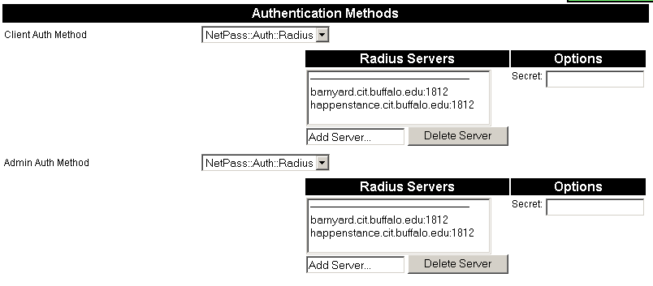
“Client Authentication” is used to authenticate end-users as they log into the NetPass “Welcome” page, just before being scanned.
Figure 7 - Authentication Methods Panel

“Administrative Authentication” is used to authenticate users who want to use the Administrative Web interface.

The following authentication methods are available: RADIUS, LDAP, Local Database (DB) and Unix (passwd/shadow file). NetPass uses these systems as username and password storage. Group membership information and access level is managed by NetPass.

RADIUS (NetPass::Auth::RADIUS)

The RADIUS module has the following configuration parameters:

- RADIUS Server
- Secret

The panel shows a list of configured servers. They will be tried in order until one of them answers. You may add a server by typing the server name (optionally followed with “:port”) into the “Add Server…” input box. Removing focus from the box (by pressing TAB or clicking anywhere outside of that box) will add the server to the list.

The newly added server should be highlighted in the server list. If it is not highlighted, click on it.

You may now edit the “Secret”. RADIUS uses a shared secret mechanism to authenticate RADIUS clients (the NetPass Server in this case) to the RADIUS server. You will need to configure the same secret, along with the name and/or IP address of the NetPass server into your RADIUS server.

Click “Commit Changes” to save the newly added RADIUS server.

Note that the RADIUS server list is shared by the Client and Administrator authentication method settings. It is not possible, at this time, to specify a RADIUS server for Client authentication that is distinct from the one used for Administrative authentication. This should not present a problem. A client user won’t have any permissions to the NetPass administrative areas (groups). So even though the RADIUS server will authenticate the user, if they attempt to log into the Administrative interface, they will not have any permissions to do or see anything.

LDAP (NetPass::Auth::LDAP)

The LDAP authentication module has the following parameters:

- LDAP Server
- Base (e.g. ou=People,dc=cit,dc=buffalo,dc=edu)
- Filter (e.g. uid=%s)
- Password Field (e.g. passwordField)

The LDAP server list allows you to specify multiple LDAP servers. They will be tried in order until one of them answers.

Local Database (NetPass::Auth::DB)

The DB authentication module stores all usernames and passwords in the NetPass backend database. When you select this module, a link will appear on the User Editor panel which allows you to specify the password associated with the username. The link appears below the User list.

Unix (NetPass::Auth::Unix)

This module tells NetPass to authenticate users against the local “passwd” database on the Unix server that NetPass is running on.

Managing Users

Click on the “User Editor” side-link to access the User Editor panel. Once there, you will see the list of configured users, the list of available groups (networks) that they may manage and the list of access levels that they may have in each group. You can use the Netgroup panel to add a group.

The “default” group is a global group. If a user has permissions in that group then they implicitly have the same permissions in all groups. To create a new user, click in the “Add user…” input box (below the user list). Enter a username and remove focus from the box (press TAB or click anywhere outside of the box).

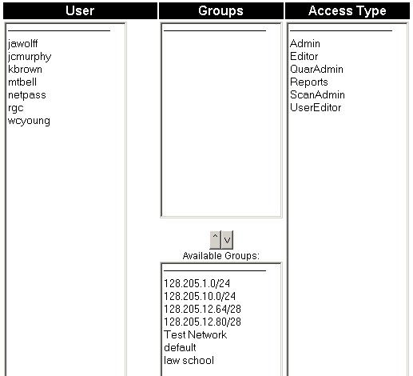
The user will be added to the User list and the entry will be highlighted.
Figure 8 - User Editor Panel

Add a group to the user (optionally) by selected the appropriate group from the “Available Groups” list and click the “^” button to move the group up to the user’s Group list.

You can remove a group from the user by clicking on the group, in their Group list and then click the “v” button. Removing all of a user’s groups will cause the user to be deleted from the User list.

In both cases you may select multiple groups.

Once you’ve added a group to the user (keeping in mind that the “default” group means “all groups”) you can grant the user specific permissions for those groups by click on the permission levels in the “Access Type” list and then click “Commit Changes”.

You may perform operations on multiple users and then click “Commit Changes” to commit all of the changes. You don’t necessarily have to commit changes immediately.

The following Access Types are defined within NetPass:

Admin
Full access to all functions and pages for the selected group.
ScanAdmin
Read/write access to the Scan (Nessus) configuration page and the IDS (Snort) configuration page.
Editor
Read/write access to the Message Editor page.
Reports
Read only access to:
- Message Editor
- ScanAdmin
- Audit Logs
- Statistics
User
Read/write access to the User page (this page) with the exception that you can not change or add Admin users. Only another Admin user can change/add an Admin user.
QuarAdmin
Read/write access to the Quarantine Control page.

By segmenting access to the system, you are able to hand out control to your Help Desk, etc, so that they can directly access end-user information and control the state of each end-user. The “Admin” user has access to network configuration screens, and should generally be reserved for the person or group who manages the network and system configuration of NetPass.

Managing Netgroups

A Netgroup is simply a collection of subnets. For example, your Law School might have multiple, non-contiguous blocks of address space. You will likely want to treat all of that address space as a single entity (the Law School) and apply customizations to that entity instead of to each individual network. Customizations include specific features within NetPass, Administrator permissions and client walk-thru and remediation pages.

You do that by creating a group called “Law School” (to continue the example) by:
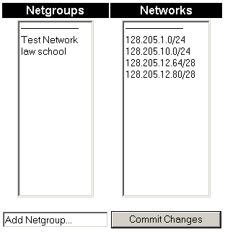
- Click inside the "Add Netgroup.." box.
Figure 9 - Netgroup Panel
- Type in a netgroup name ("default", "clientAccess" and network-names are not permitted).
- Click a network (or networks) to add to the netgroup.
- Click 'Commit Changes'
Once the group is added, you can over-ride global settings (those found under the “General” configuration panel) with settings specific to the entire group of networks that comprise the “Law School”. The group-specific settings are found directly below the Netgroups list. You must select the Netgroup you wish to edit in order to see the settings list.

To specify group-specific parameters (and over-ride the Global settings):
- Select the Netgroup you wish to edit. Currently only Admin/default can edit these parameters. A future enhancement might be to allow Administrators for the specific group to edit the parameters.
- Uncheck the "Use Default" box for the parameter you wish to over-ride.
- Select or enter a new value.
- Click 'Commit Changes'
See the “Global” settings section for a discussion on all of the configurable parameters.

Managing Networks

In order for NetPass to operate, it must be told what networks it manages, as well as what switches and ports are assigned to each network. You can use the “Networks” and “Switches” panels to configure these things.
- To add a new network:
  - Click inside the "Add Network.." box.
  - Type in a network name (CIDR notation only)
  - Click 'Commit Changes'
- To edit a network (once it's been added):
  - Select the network from the drop-down menu.
  - Edit its parameters.
  - Click 'Commit Changes'

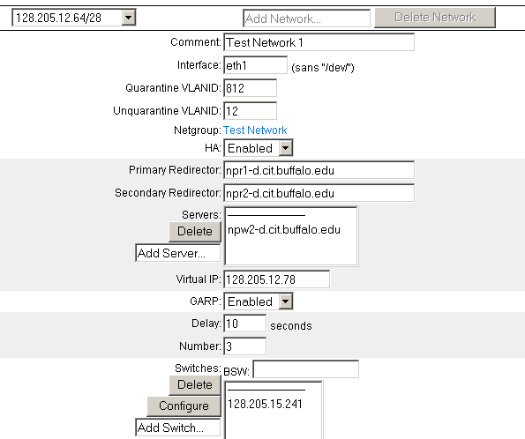
You will need to define the public network side of NetPass (typically “eth0”) if you are running in High Availability mode. See the section on HA for details.
Figure 10 - Add/Edit Network Panel

To add a network, enter its range in the “Add Network…” box. The range should be specified in CIDR notation. For example “128.205.100.0/24”. Change focus away from the input box to add the network to the drop-down list.

Once added, the configuration options will appear.

The following options are available for configuration:

Comment
This is a free-form text field. You can place anything in it that you like. The contents of this field will appear on reports that cite the network.

Interface
This is the physical interface that this network is attached to on the NetPass server. Since NetPass servers (typically) have two interfaces, this will generally be either “eth0” or “eth1”.

Quarantine VLANID

This is the VLAN ID (number) assigned to the quarantine VLAN for this network.

Unquarantine VLANID

This is the VLAN ID (number) assigned to the un-quarantined VLAN for this network.

Netgroup

This is the netgroup, if any, that this network is a member of. A network can only be a member of a single netgroup. Use the Netgroups panel to manage netgroup membership. See the section on Managing Netgroups for details.

HA

This is a toggle indicating whether or not HA (High Availability) is enabled for this network. See the section on High Availability for details. If you set HA to “enabled” four additional options appear. Those options are Primary Redirector, Secondary Redirector, Servers and Virtual IP. Those options are discussed in the High Availability section.

GARP

This option determines whether or not the Gratuitous ARP daemon is running for this particular network. In almost all cases, this should be “enabled”. If you have Cisco 65xx routers, you may disable this provided you read Appendix D and follow the instructions listed there. See Appendix E “Gratuitous ARP Usage” for a discussion of how and why NetPass uses this.

Delay

When you set GARP to “enabled” this option appears. It specifies the number of seconds between GARP packets. Setting it to longer durations means that clients will “hang” for that amount of time when switching between the two VLANs. The clients rely on the GARPs to inform them that the gateway has changed and they will be unable to realize full network connectivity until the GARPs have trigger a re-cache of their local ARP tables. Recommended setting is less than five seconds.

Number

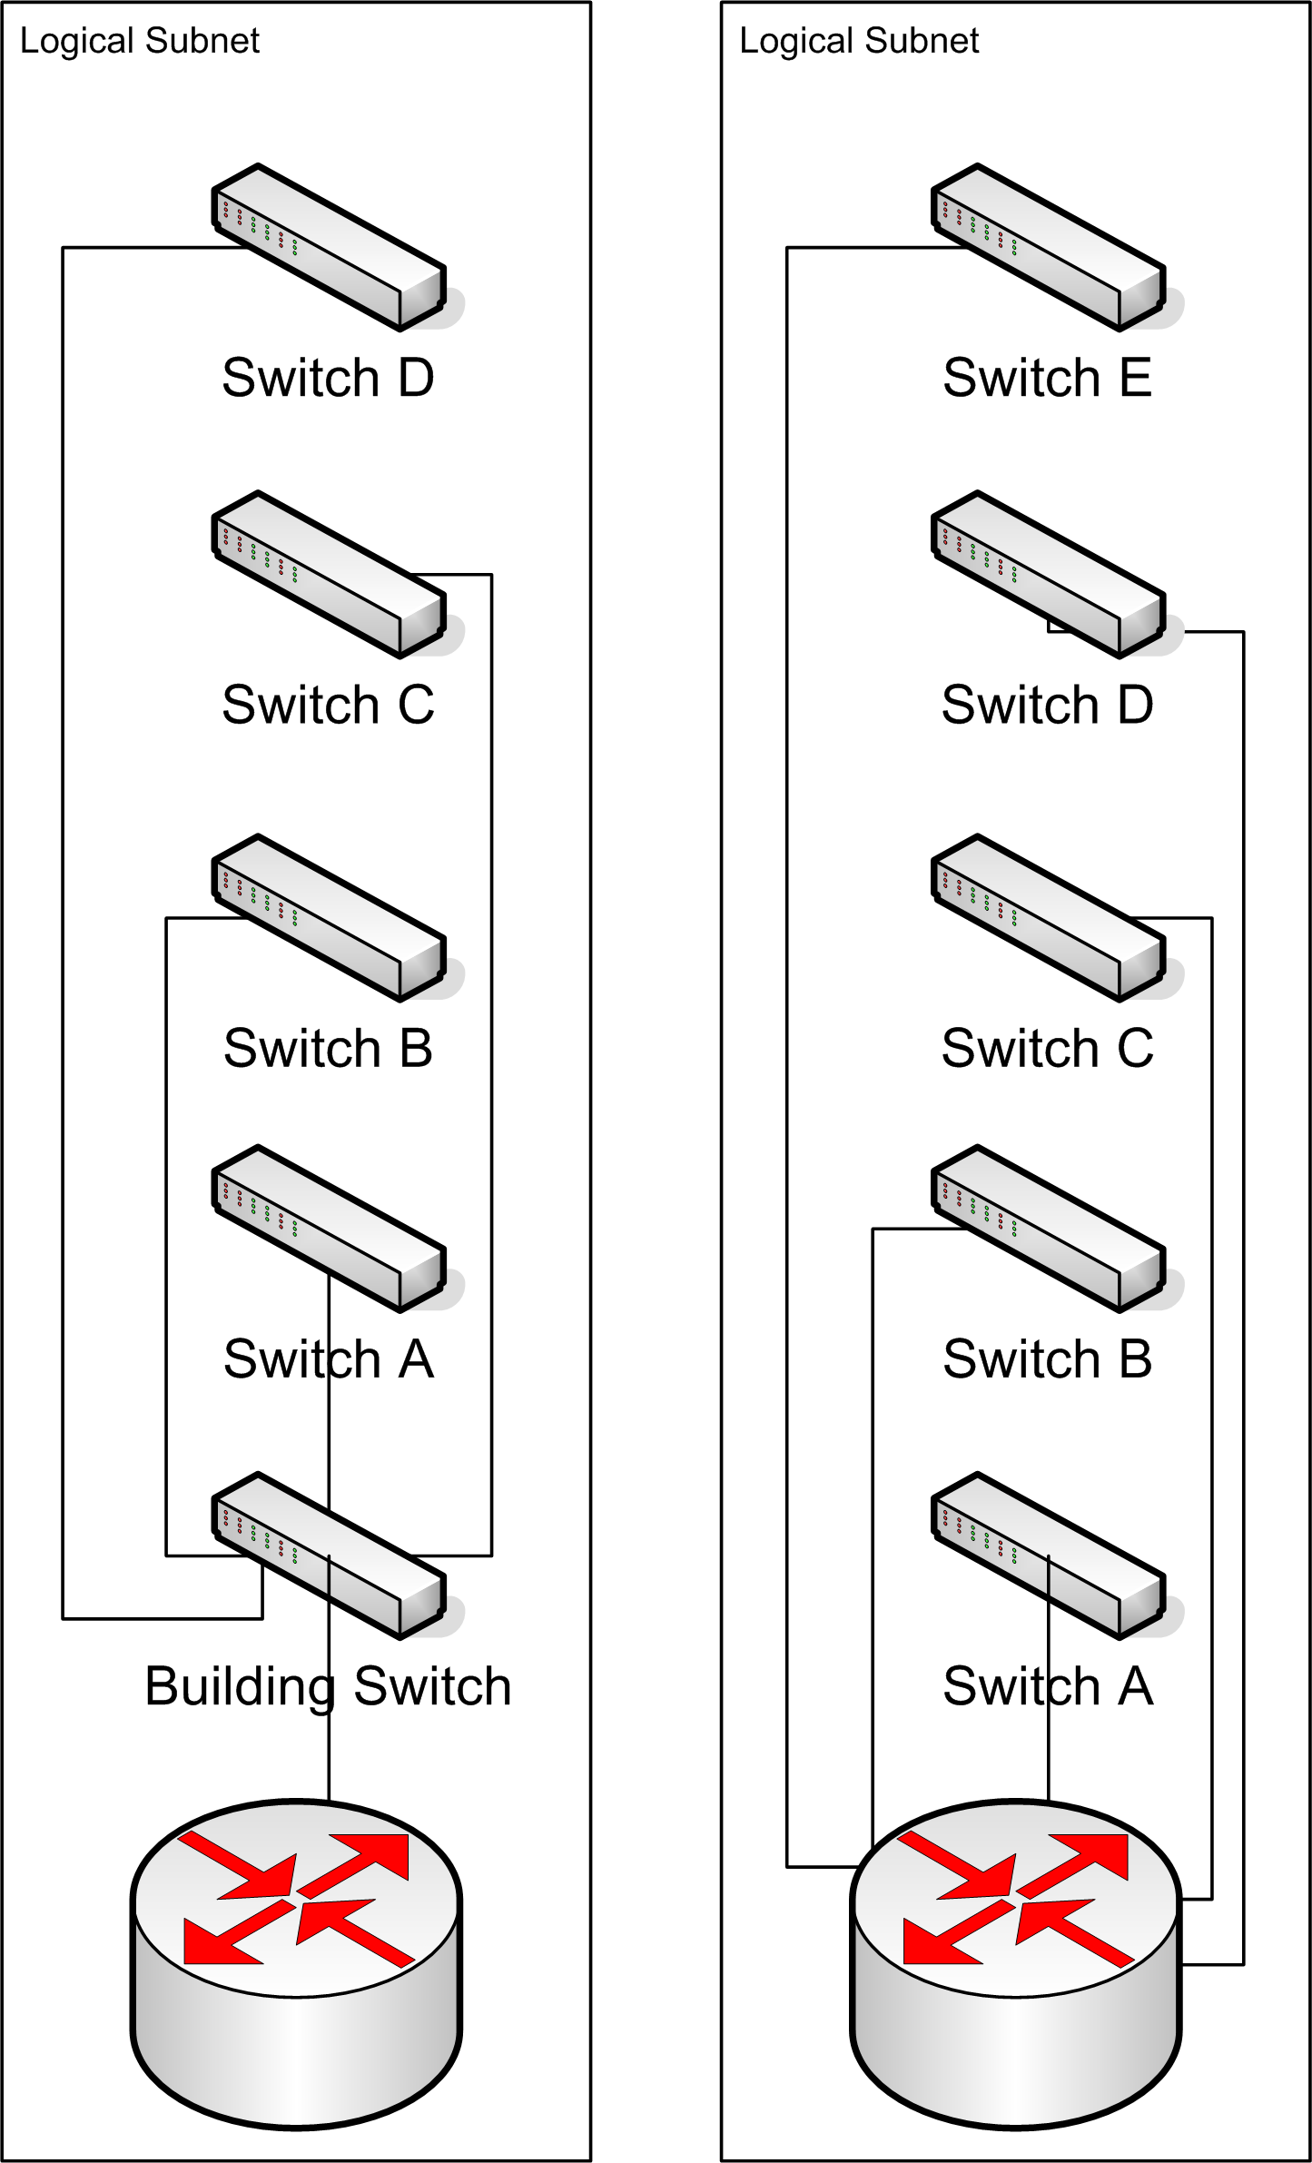
When you set GARP to “enabled” this option appears. It specifies the number of GARP packets to issue at the end of each time interval (the time interval is specified as the “Delay” setting). Recommended setting is 2-3.
Figure 11 - Possible BSW Locations

BSW

This is the “building switch” or “aggregation switch”. Some network architectures have these while others do not. While it’s not absolutely necessary to specify something for this field, doing so will greatly improve NetPass’ performance. If you have an aggregation switch, you should specify it here (even if it’s on the list of switches in the next option). If your aggregation switch is one of your core routers, then specify the router’s IP here. As long as the router and the switches can share topology information, NetPass can use it for efficient client port discovery. In the example, at right, the first diagram (left side) shows a typical fan-out network with an aggregation switch. The right side diagram shows all of the switches (which are still servicing the same logical subnet) being brought back to one of the core routers. The ports on that router are bridged together (those ports on the router are, in essence, acting like a small 5 port switch). On the left, you’d specify the “Building Switch” from that diagram in the BSW field. On the right, you’d specify the router’s address. NetPass will use these devices as the root of the tree when it performs client port discovery.

Switches

This is the list of switches that service this particular network. It’s not a requirement that an entire switch be dedicated to an entire network. Sometimes your network architecture might dictate that a switch be split between multiple networks/VLANs. This is OK and NetPass can deal with it. You specify the VLAN-to-Port mapping on the “Switches” panel. See the “Managing Switches” section for details. Add switches by entering them into the “Add switch..” input box and removing focus from that box (press TAB or click outside of the box with the mouse).

At the bottom of the “Networks” panel are the same options you see in the “General” panel. You may over-ride any of the global settings here, on a per-network case. If you have many networks that you’d like to give the same options to, either specify the options globally or place all of those networks into a single group and specify the options for the group. See the section on “Managing Global Settings” and “Managing Netgroups” for details.

Managing Switches

The Switches Panel is used to configure what switches are managed by NetPass and which VLAN each port is a member of. It is also where you can enter the read and write SNMP community names.

To use this panel you will first add a new switch by clicking in the “Add Switch…” input box. Enter the IP address of the switch. Remove focus from the input box (press TAB or click somewhere outside of the input box) to add the switch.

It should appear in the list of switches (drop-down menu) and it should be selected. You can then click in “Add Vlan Map…” to add your VLAN-to-Port mappings for the switch.

Note that a “port” corresponds to the SNMP ifIndex for the interface and not necessarily to the actual port number on the unit. Also be careful not to enter in your uplink port in this list or NetPass will changes its VLAN membership, which will result in a loss of connectivity to the switch. If this occurs, you will need to access the switch’s console port (typically via a serial connection) to reset the uplink port’s VLAN membership settings.

Ports can be entered individual, separated by commas, or as a range. The port list is followed by a colon and the two VLANs that the port should be a member of. The first VLAN is the un-quarantine VLAN and the second is the quarantine.

For example, if you have a 24 port switch and are using port #1 (the physical port) as the uplink, you would first perform an “snmpwalk” on the ifDescr portion of the MIB to see what ifIndex is assigned to port #1.

EXAMPLE SNMP OUTPUT HERE

In the above example, the ifIndex numbers map directly to the port numbers. This will not always be the case.

Now, if you want to use all of the remaining ports (2-24) as edge ports and want to assign VLAN 100 as the quarantine and VLAN 800 as the un-quarantine, you would enter

2-24:100/800

Into the “Add Vlan Map…” field and then hit TAB. For a more complicated example, you could write

2-8,10,12,14-18,24:100/800

To only use the ports listed. Finally, if you have the switch partitioned such that it is being used by two (or more) separate NetPass managed networks, you could write:

2-12:100/800
13-24:101/801

In that example, the first 11 ports would be on one network and the second 12 ports would be on another.

Managing Global Settings

NetPass has many configurable options and parameters. These can generally be found in the Global Settings panel. Each of these options can be over-ridden on a per-netgroup or per-network basis.

When NetPass looks up a particular setting, it often starts with the clients IP address or the switch/port that the client is connected to. It will then look in the specific network that the client is a part of (or that the switch port is assigned to) to see if the setting is specified there.

If it is not, it next checks the netgroup (if any) that the network is a member of.

Finally, it will check the global setting.

In the following tables, “Setting” is the name of the setting or the phrase used to identify the setting. “Value” is the possible values that the setting can take. “Description” is a description of the setting, where it’s used and what the values mean. “Can be over-ridden” indicates if the setting can be over-ridden on a per-network/per-netgoup basis.

General Settings

Setting | Value | Description | Can be over-ridden?
MULTI_MAC |  | Determines how NetPass handles the presence of multiple MAC addresses on a port. | Yes
 | ALL_OK | All of the MACs present on the port must be registered and tagged as un-quarantined in order for the port to be moved out of the quarantine.
 | ONE_OK | At least one of the MACs must be registered and un-quarantined. This is not currently implemented.
 | DISALLOWED | Only one MAC per port is permitted. If multiple are present, the port is quarantined. This is currently not implemented.
Strikes | An integer >= 0 | This determines the number of times that a client can indicate that they’ve fixed the same problem. Some processes, like Snort, can auto-quarantine a client. NetPass has no way to actively determine that the client has “fixed” what Snort, for example, has found to be wrong. We trust the end-user when they say they’ve fixed it and we un-quarantine them. If we see them quarantined for the same violation more than “strikes” times, they can no longer get out of quarantine without contacting someone to have the strikes reset. Setting strikes to zero disables this feature (i.e. gives the client an infinite number of strikes) | Yes
Disable Strikes for manual quarantine? | Yes or No | This indicates whether or not the strikes system applies to “manual” quarantine events. The default is “yes”. | Yes
Disable Strikes for Snort quarantine? | Yes or No | This indicates whether or not the strikes system applies to “snort” quarantine events. The default is “yes”. | Yes
Disable Strikes for Nessus quarantine? | Yes or No | This indicates whether or not the strikes system applies to “nessus” quarantine events. The default is “no” because Nessus can actively determine whether or not the client has really fixed the problem. So they should be given as many tries as needed to fix it. | Yes
Results Display |  | How to present the results of scans, etc, to the client. | Yes
 | INLINE | The results should be disable inline as a single web page.
 | POPUP | The results should popup in a separate window when the user clicks on one of the results.
Results Expand | Integer >= 0 | When there are less than this number of results to be shown to the user, auto-expand them (if Results Display is “inline”) rather than forcing the user to click on each one. Many times there is only one or two results to be shown so we minimize the required number of clicks by immediately expanding them. Default is “5”. | Yes
Auto Redirect |  | When the client is redirected to the NetPass website, we capture the URL that they were originally trying to get to. At the end of the NetPass process, we can automatically redirect them to that URL or we can present them with a “welcome to the network” page. | Yes
 | Yes | Redirect them to the original URL they were trying to get to.
 | No | Show them the “welcome to the network” page.
Redirect URL Default | A URL | If we couldn’t determine what URL the client was trying to get to, redirect them to this one (if “Auto Redirect” is enabled). | Yes
Cookie Detect |  | NetPass relies on cookies to track client sessions. If we detect that cookies are disabled, we can instruct the client to enable them. If cookies are disabled, NetPass will not work. | Yes
 | Yes | Check to see that cookies are enabled.
 | No | Don’t check.
Cookie Name | A string | Use this as the name of the cookie we set on the client. Choose something unique. | Yes
Survey Enabled | Yes or No | NetPass can present a client with a short survey after they’ve registered but before they’re moved out of quarantine (in other words, the survey is mandatory). The survey results are sent via email. | Yes
 | Yes | Show the client the survey.
 | No | Don’t show the survey.
Survey Email | An email address | The address to which survey results are sent. | Yes
PID_DIR | A directory | Where NetPass subsystems store their “pid” files. Don’t change this unless you know what you are doing. | N/A
BASE_DIR | A directory | Where some components (like “Nessus”) are installed. Don’t change this once NetPass is installed unless you’ve re-installed Nessus into a new location. | N/A
Port Search Algo |  | NetPass tries to be efficient when searching for which port the client is connected to. The default is “TREE” and should be left that way. If the tree-search fails, NetPass will fall back to the linear search. | Yes
 | TREE | Use a tree search when looking for the client’s port.
 | LINEAR | Search all of the switches linearly.
Enable resetport? | Yes or No | The “resetport” application listens for incoming linkup and linkdown traps and (un)quarantines the client’s port as appropriate. | Yes
Unquar On Linkup | Yes | As soon as link come up on a port, try to determine what MACs are on the port and validate them. If they checkout OK (according to the “MULTI_MAC” setting) un-quarantine the port. | Yes
 | No | Don’t try to un-quarantine the port when link comes up. Let the client go to the website and view the “message of the day” and then un-quarantine them. | Yes
Linkflap Tolerance | Integer >= 0 (seconds) | When a port experiences linkflap (rapid linkdown/linkup events) due to, possibly, electrical instability, NetPass will quarantine the port, then un-quarantine it, etc, in rapid succession. This is disruptive to the client. Setting this value to something greater than zero causes NetPass to wait for link to settle for that number of seconds. At the end of the tolerance period, NetPass will either leave the port alone (if link is up) or it will quarantine it (if link is down). This assumes that ‘resetport’ is enabled. | Yes
Enable macscan? | Yes or No | NetPass can periodically sweep every managed switch looking for unregistered MACs. If found, the switch port that they are on will be quarantined. | Yes
Port Cache | On or off | Port cache is currently not implemented. | Yes
Require Nessus to register? | Yes or No | If set to yes, the client must be scanned as part of the registration process. Setting to ‘no’ disables the scan and takes the client directly to the successful registration page. | Yes
LDAP Query URL | A URL | Some screens on the Admin UI report the username associated with a client. If you set this value, the username will be a hyperlink to your LDAP (or anything, really) query CGI script. The first “%s” in this string will be replaced with the username. This is convenient if the Admin wants to resolve a username to a person’s contact record. | N/A
LDAP Popup Width | Integer >= 0 | Default is 573. When you click on the LDAP Query hyperlink, the resulting URL is opened in a pop-up window. This is the width of that window. | N/A
LDAP Popup Height | Integer >= 0 | Default is 734. This is the height of the popup window. | N/A
Username Prompt | A string | This is the text that prefixes the username input box on the NetPass login page. | Yes
Password Prompt | A string | This is the text that prefixes the password input box on the NetPass login page. | Yes
Company Name | A string | This is placed at the top of web pages. | Yes
Company Abbreviation | A string | Not sure where this is used anymore. | Yes
Organization Name | A string | This is placed at the top of web pages. | Yes
Example IP Address | A string | This is used on Admin pages that request that you enter an IP address. Default is “128.205.x.x”. | N/A

Nessus Settings

Setting | Value | Description | Can be over-ridden?
BASE_DIR | A string | This is the directory where Nessus is installed. The default is /usr/local | No
Host | A string | This is the hostname or IP address of the Nessus server. This should always be set to 127.0.0.1 | No
Username | A string | The username to use when logging into Nessus. This username was created as part of the Nessus installation procedure. See the Installation section, above. The default is “netpass”. | No
Password | A string | The password to use when logging into Nessus. The default is “netpass”. | No
Port | Integer > 0 | The port number that the Nessus daemon is running on. The default is 1241. | No
WHEN_DOWN | OK or FAIL | What to do if we can’t log into Nessus. OK means assume that the client passed all of the scans. FAIL means assume that the client wouldn’t pass the scans, give them an error and don’t allow them to complete the registration. | No

Snort Settings

Setting | Value | Description | Can be over-ridden?
Mode |  | This what mode of operation the NP Snort Daemon is running in. It can be in one of three different modes. | Yes
 | Disabled | Snort integration is disabled. The NP Snort Daemon will take no action if snort detects any hits on configured rules.
 | Enabled | Snort integration is fully enabled. If Snort gets a hit on a configure rule, the NP Snort Daemon will take the IP address and the Rule ID from the hit and attempt to quarantine the corresponding host. The remediation page that the host gets will be determined by the Rule ID.
 | Not Really | Snort integration partially enabled. In this mode the NP Snort Daemon will log the fact that it would have quarantined a particular host, but it won’t actually quarantine the host.
Sensor | A hostname or IP address | This is a list of one or more sensors that the NP Snort Daemon is running on. | No
Port | Integer > 0 | This is the port that the NP Snort Daemon is listening on. | No
Sensor Mode | RO or RW | This determines whether or not the NetPass Web UI can control the sensor – causing it to stop, start, reload rules, etc (if it’s in RW mode). “RO” mode means the Web UI can check the status of the sensor, but can not affect it in any way. | No

NetPass API (npapid) Settings

Setting | Value | Description | Can be over-ridden?
Port | Integer > 0 | The port that the npapi daemon is running on. | N/A
Secret | A string | The shared secret that the npapi daemon is using to authenticate API calls placed by remote clients. | N/A

Database Connection Settings

Setting | Value | Description | Can be over-ridden?
Source | A string | This is the DBI source identifier that NetPass will use to connect to the database. It must be a legal DBI identifier. See “perldoc DBI” for details. The default causes NetPass to connect to a database on the localhost. Other settings are not supported. | N/A
Username | A string | The username to use when connecting to the database. The default is “root”. This is not the same as the unix “root”. | N/A
Password | A string | The password to use when connecting to the database. The default is no password. Only the local machine can connect to the database. | N/A

Managed Snort IDSes

NetPass comes with either tight or loose Snort integration. You can also access the API directly to drive NetPass via your own integration points. In the two former cases, a package is installed on the sensor to facilitate communication between the sensor and the NetPass server. Snort is configured to only watch NetPass managed networks. Since the objective is to identify hosts on those networks who are compromised and automatically quarantine them, we configure Snort to ignore traffic sourced from other networks.

To determine that Snort’s gotten a hit on a particular rule, the NetPass::Snort software watches a specific snort.log file. Snort is configured to write hits to that file in a specific format consisting of the source IP address that triggered the rule, the Rule ID and the time that the rule was triggered.

The NetPass::Snort daemon will periodically read (“tail”) that file, looking for new entries. When it finds them, it rolls up (“uniq”s) entries that have the same source IP and Rule ID. It can then, optionally, ask the NetPass server to quarantine that IP and, using the Rule ID, give the client a specific remediation message.

Whether or not a particular host is quarantined is based upon the “Snort Mode” setting (see General Settings, above).

The mode can be over-ridden. This means that it can be tailored to a specific network or netgroup, allowing you to, for example, enable Snort integration on one network, but disable it on another.

If the mode is “enabled” then the Snort sensor will automatically quarantine hosts based upon hits it receives for configured rules. It will also make an entry in the NetPass audit log indicating that an auto-quarantine event has occurred.

On the NetPass server side, the incoming API call supplies an IP address (often, due to sensor placement, the MAC address is available). The NetPass code correlates that to the last-known MAC address that was associated with that IP address. In most cases this should be accurate, but is not guaranteed to always be accurate.

It’s possible, for example, for a host to register and then, due to the “unquar on linkup” feature, never again have to visit the NetPass website. When a hosts visits the website, we can grab its IP and MAC and store them in the database. If the host doesn’t visit the website, it’s possible for the host to get a different IP address, via DHCP, that NetPass will not know about.

At this time, there’s no plan to correct this limitation. One way to do so would be to query the DHCP server and ask it which MAC address currently holds the lease for the given IP address. This feature may be added in the future.

If the mode is “disabled” then the NetPass::Snort software will do nothing when it sees a hit for a particular host. As mentioned above, it’s possible to disable/enable Snort integration on a per-network/per-netgroup basis.

If the mode is “not really” then the NetPass::Snort software will make an audit entry indicating that, had the mode been “enabled”, it would have quarantined the particular host. However, it will not quarantine the host. This mode is provided to help build confidence that you will not mass-quarantine an inordinate number of hosts due to your Snort rules being too liberal.

The NetPass::Snort package is available as a separate download.

Refer to the installation section for instructions on how to install this optional package.

Tight Integration (“RW” Mode)

With this option, the Snort sensor is completely controlled via the NetPass Admin UI. You are able to control which rules are pushed out the sensor as well as the operation (running, not running) of the sensor.

You can control which rules get pushed to the sensor via the Scan Config panel. When you enable or disable Snort rules, you need to go back to the NetPass Admin Home Panel and restart the sensor(s).

With the tight integration mode, the NetPass::Snort software will fetch the Snort rules from the NetPass database and push them into Snort each time the Snort daemon is started. This is why it’s necessary to restart the Snort daemon when you modify the Snort rules in the “Scan Config” panel.

Loose Integration (“RO” Mode)

With this option, the NetPass::Snort software is still installed on the sensor, but control communication is only one-way: from the sensor to NetPass. The sensor obeys the “Snort Mode” settings and the NetPass server can query the state of the sensor but can not stop and start the snort daemon. The NetPass::Snort daemon also will not attempt to fetch the Snort rules from the NetPass server and push them into the Snort server.

This type of integration is appropriate for occasions where you want your helpdesk to be able to see that the sensor is operational, but you want to control the rules database and daemon operational state from another piece of software (i.e. a Snort control panel).

API-Only Integration (Roll Your Own)

This type of integration is best suited for Snort (and other) IDS installations that are completely managed by another piece of software. You can use the API to write your own daemon that will watch your Snort logs or somehow receive information about hits. When your software determines that an IP address should be quarantined, it can place the API call to the NetPass server. No “Snort” configuration parameters are necessary on the NetPass side, since the NetPass server has no control over the IDS.

This type of integration can be applied to anything, not just Snort. See the section on API Control of NetPass for details.

Managing Custome Side-Links

NetPass allows you to add custom side-links at the bottom left of the Administrative Web UI. To do so, click on “User Links” and enter a URL and description into the User Links panel. Click “<<” to add the new link to the list. It is saved automatically.

To remove a link, select it from the list and click “>>”. You don’t have to clear the Name and URL fields.

To edit a link, select it from the list and click “>>”. Now edit the Name and/or URL fields and click “<<”.

: Using NetPass

Defining Walk-Thru Pages

All of the web pages that are presented to the client are fully configurable without requiring any HTML editing. NetPass includes a number of pre-defined “walk-thru” pages that help guide the user through the registration process. Each of these pages can be defined on a per-network or per-netgroup basis. If no page exists for the network that the client is on, NetPass will check to see if the network is a member of a netgroup. If no page is defined for the netgroup (assuming the network was a member of one) then NetPass will use the ‘default’ message.

The following reserved (pre-defined) message names are used by NetPass. You may not use any of these names for remediation pages.

Message Name | Use
msg:welcome | Initial web page that an unregistered client sees. The contents of this page appear below the top banner and above the AUP text box and login dialog.
msg:eula | End-User License Agreement. This is typically used to present the user with a copy of your organization’s Acceptable Use Policy. This appears on the initial web page presented to unregistered clients, immediately below the msg:welcome text and above the login dialog.
msg:being_scanned | This is the second page that a client sees after they’ve entered their login credentials and clicked the “I understand, begin the scan” button. The text of this page appears below the banner and above the progress meter.
msg:scan_completed | This message is displayed when the scan is finished. It is shown below the progress meter after it’s reach 100%. The client is prompted to click to proceed to the next screen.
msg:you_passed | This message is shown after the scan is completed and only of the scan resulted in no problems being detected.
msg:remediate_directions | This message is shown if there are problems that the client needs to address. This might result from the scan detecting problem or, after the client has registered, another system or manual process quarantining the client.
msg:remediate_finished | This message is shown once the client has acknowledged all of the pending problems.
msg:final | This is the last message the client sees. When they see this message their port is scheduled to be moved to the un-quarantine VLAN. The move typically takes 10-15 seconds from the time the page is displayed.
msg:daily_message | This is a MOTD type page that is shown to registered and OK clients that just booted or brought up link (and are therefore temporarily in the quarantine). This page is generally not seen if you have the ‘unquar on linkup’ feature turned on.
msg:authentication_failed | This message is displayed if the credentials that the client entered on the msg:welcome page failed the authentication check.
msg:no_cookies | This page is displayed if the client failed the cookies-enabled check and if you have the check-for-cookies feature enabled.
msg:multi_mac | Clients will see this message if they are registered and OK but have other clients on the same port that are either not registered or are not OK. In order to see this message the ‘multi-mac’ feature must be set to ‘ALL_OK’
msg:feedback_form | If you have the survey feature enabled, this form is displayed just prior to msg:final.
msg:remote_welcome | This message is shown if the client is not on a NetPass managed network. The client can not register, but is still able to go through the scan and walk-thru process.
msg:remote_you_passed | The client sees this if they are on a non-NetPass managed network and have successfully completed the scan. They will not be registered.

To edit any of these pages, you use the Message Editor panel. Once at that panel, you can search for a particular message. While you can search for and see any message in any netgroup (or network) you can only edit the messages that you have permissions to.

For example, if you have Editor privileges on the “Law School” netgroup, you can search for and access the “msg:welcome” page for the “default” netgroup or any other netgroup. The editor will appear and you can edit the page, but upon saving it you will receive a permission-denied error. NetPass allows you to open the message in the editor so you can use it as a starting point. If you change the netgroup (at the top of the Editor) to a netgroup that you have Editor permissions on, you can then save the message.

This allows you to make a copy of, for example, the “msg:welcome” for the “default” group and then use that as a basis for developing a customized message for the “Law School” network.

Defining Remediation Pages

The primary objective of NetPass is to provide the end-user with helpful information on why they are in quarantine and how to get out. While NetPass will fall back on the canned messages that accompany Snort and Nessus, it’s best if you write your own messages that contain detailed information and hyperlinks to help the client get their computer working properly.

To do develop custom remediation pages, you will once again use the Message Editor panel. Once on that panel, you will create a new message. This will open the Editor GUI. At the top of the Editor GUI panel you can fill in a new page name and a network or netgroup to limit the page to. Specify the ‘default’ netgroup to make this message available to all networks/netgroups.

Enter your message into the Editor and save it. Your message is now added to the database.

You can now go to the Scan Config panel and associated your newly created page with a particular Snort or Nessus scan. If the client becomes quarantined for failing a particular scan, they are shown your custom message.

An example of how NetPass decides which message to present to the client follows:

- Assume client X is quarantined for reason Y and is attached to the “Law School” network
- If reason Y has a custom message associated with it for the “Law School” netgroup, show that
- Otherwise, if reason Y has a custom message associated with it for the particular network that the client is on, show that
- Otherwise, if reason Y has a custom message associated with it for the ‘default’ netgroup, show that
- Finally, if there is no custom message for reason Y, then show the client the ‘canned’ message that is associate with reason Y (for example, the canned message for Nessus Plugin Y)

Defining Client Baseline Security Requirements (“Scan Config”)

You can use the Scan Config panel to define what the client’s baseline security profile. This profile describes what NetPass checks for when evaluating each client. If a client fails any of the checks, they are placed in quarantine and given instructions on how to bring their PC into baseline compliance.

To use the Scan Config panel, select either a Nessus or Snort type of scan and enter some search conditions (or leave the search qualification empty to see all configured Nessus or Snort scans).

Once you’ve gotten a list of available scans, you can check the “enable” box to enable it. For Nessus scans, committing your changes causes the scan to be immediately enabled. For Snort scans, you must restart any managed sensors by using the IDS control panel on the NetPass Admin Home page.

When you enable a scan, regardless of whether it’s a Nessus or Snort scan, you should always associate the scan with a custom message explaining how to correct the problem that the scan has detected. You do that by first creating a custom message in the Message Editor Panel and then using the Scan Config Panel to associate that message with a specific scan.

If the client fails the scan, they will be given that custom message. The canned messages that come with Nessus and Snort are often cryptic and unhelpful to end-users. Try to make your custom message as easy to follow as possible so that you can avoid calls to your helpdesk. If the client can fix it on their own, they generally will and save you the call!

Managing Clients

At times it will be necessary to directly manage the client’s registration data. This is true if the client has exhausted their Strikes (and that feature is enabled) and you must reset the strikes. It is also true if you receive a complaint and want to manually quarantine the client and deliver a custom message to them (for example a “DMCA Violation” type of message).

To manage a client, you will use the Quarantine Control (“QuarControl”) Panel. Clicking on QuarControl gives you a search box to help you find the particular client you want to manage. Enter the search qualification to find the particular client.

If the end user is calling you for help, you can enter their username or MAC address to find their record. If you’ve received a complaint from an off-site entity (for example, a complaint sent to your “abuse” email address) then you most likely only have an IP address to work with.

Once you’ve located the client’s registration record, you can perform one of the following tasks:

Reset Their Strikes

To reset their strikes, click on the Results column entry. It will expand the table to show all of the results that the client has in the “pending” or “user-fixed” state. The strikes system works by counting up the number of “user-fixed” entries for a particular scan type and checking to see if that number has exceeded the strikes setting. If it has, the user can not get out of quarantine without contacting an Administrator to have the “user-fixed” records (at least one of them) changed to “fixed”. Each record converted to “fixed” will lower their strike count by one. The client can then go to the NetPass website and be un-quarantined when they acknowledge any “pending” results. To save the client the trip to the remediation page, you can optionally set all the “pending” results to “fixed” (if you feel they really are fixed!) and then set the client’s Status to “UNQUAR”. This will cause NetPass to un-quarantine the port without requiring that the client visit the website.

Quarantine Them

If you want to manually quarantine the host, first add a result to their record by selecting one from the “Results” drop-down menu. The result is immediately added to their record and the “Pending” count in the “Results” column will increase by one. Next, quarantine the client by changing their Status to “QUAR”. This will cause their port to be set to quarantine (if they are currently on the network). They will then see the NetPass remediation page and the custom message you gave them. If you want to force the client to call someone, set their Status to “PQUAR”. If the client is only “QUAR” they can click a “Fixed” button to indicate that they acknowledge the custom message. They will then be un-quarantined. Sometimes this is not what you want, and instead you want the client to contact you (or someone) to discuss the specific problem. If they are “PQUAR” then they are Permanently quarantined and they will not see the “Fixed” button. They can only read the custom message (which should contain contact information!) and then contact someone to get un-quarantined. Once the issue has been resolved, you can click on the “Results” entry, set the result to “fixed” and then set the client’s status to “UNQUAR” to return them to the un-quarantined VLAN.

Un-quarantine Them

If the client is quarantined and you wish to un-quarantine them, you should first identify why they’ve been quarantined. Click on the “Results” column entry to review the reason(s) why they are in quarantine. Once you’ve determined that, you next want to make sure the reason for the quarantining has been addressed. If it has, you may change the status of the particular result (or all of the results) from “pending” to “fixed” (the user will never see results that are “fixed” or “user-fixed” so you need only be concerning with “pending” results). Once that’s done you can change their status to “UNQUAR” and, if they are currently on the network, their port will be move to the un-quarantine VLAN. The “multi-mac” feature setting, along with the presence of additional unregistered or “QUAR” MACs on the same port might cause the port to be left in the quarantine VLAN. The client would receive the “msg:multi_mac” notice in that case.

Add To Their Incident History

NetPass includes a rudimentary client incident history tracking mechanism. If you click on the “[view]” link under the “History” column, you can add some information about the client. This maybe helpful if the client has been manually quarantined for something sent to the “abuse” email address. You can paste in the original email that triggered the manual quarantining of the client, and then that message will be available to anyone reviewing the status of the client.

Adjust When the Client Will Be Un-quarantined

The “Unquar When?” column determines when NetPass will attempt to un-quarantine the client. If the “unquar on linkup” setting (see Global Configuration) is not specified globally or for the network or netgroup that the client is booting on, then the client will need to visit the NetPass website to be un-quarantined. You can over-ride this default by setting the “Unquar When?” option in the client’s record to “LinkUp”. In that case, that specific client will be un-quarantined as close to the linkup event as possible. This is useful for game consoles (see the Manual Registration section).

Manual Registration

If a client does not have a web browser (e.g. game consoles) it will be necessary to manually register the client. This is generally accomplished by having the end-user contact your Helpdesk. The user will need to minimally provide the MAC address of the game console (for example). The Helpdesk employee, assuming they have QuarAdmin privileges on the appropriate network, netgroup or ‘default’ netgroup, can then fill in the form on the Manual Register panel. The QuarAdmin will need to determine the IP address of the console and the username of the user who is requesting that it be manually registered.

When the QuarAdmin clicks ‘Register’ the client will be registered and set to “QUAR”. The QuarAdmin should then go to the QuarControl panel, retrieve the record they just created and set the Status to “UNQUAR”. Additionally, if the “unquar on linkup” feature is not enabled for the network (or globally) that the game console is on, the “Unquar When?” column should be set to “LinkUp” and not “Web Visit”.

Now, when link comes up on the port that the game console is attached to, NetPass will un-quarantine the client. Since the client does not have browser capabilities, this is the only time that NetPass can un-quarantine the client.

API Control of NetPass

NetPass includes an API, based on SOAP, that will allow you to access certain parts of NetPass. Currently the following API operations are available:

- Quarantine By IP Address
- Retrieve Client Registration Record

See Appendix E for details on what calls are available and how to use each call.

- : ISC DHCP Daemon Patch

When using NetPass on a network serviced by an ISC DHCP server, it’s important to apply a patch to that DHCP server. Without the patch, clients that are in quarantine will not be able to acquire or renew their DHCP lease. Since clients initially boot in the quarantine, this effectively breaks the client – they can’t get an address, so they can’t register!

The reason that the clients can not access DHCP while in quarantine is due to a route asymmetry introduced by the client’s subnet appearing in two different logic locations. Their subnet appears behind two gateways. When not in quarantine, their gateway is located on some router on your network. While in quarantine, their gateway is the NetPass server.

The problem lies in that the ISC DHCP server will construct the reply packet, to be sent back to the DHCP relay (the NetPass server) by copying the contents of the “giaddr” field into the destination IP address field of the IP packet. This causes the reply packet to be routed to the un-quarantined gateway. Since the client is quarantined, the reply packet never reaches the client. Instead of copying the contents of the “giaddr” field, if the DHCP server simply replied back to the source IP address in the relayed packet, then the reply would go back to the NetPass server. This is what the patch does.

This “problem” was discussed on the dhcp-server mailing list in May 2004. After running the patch for a year on a couple of moderately busy (8000+ clients a piece) DHCP servers, it was submitted to ISC in May 2005. There’s no definitely time frame for when we can expect the patch to become part of the official ISC DHCP source tree.

The patch adds an option to the DHCP configuration file. The option is called “relay-to-giaddr” and is available in the global and network scopes. The option can be set to “on” or “off”. The default behavior is for the option to be “on” (the server relays to the “giaddr” in the relayed packet). This is how the unpatched DHCP behaves.

In order for NetPass to work, apply the patch and either issue the directive “relay-to-giaddr off;” in the global scope or in each network clause for each network that NetPass is enabled on.

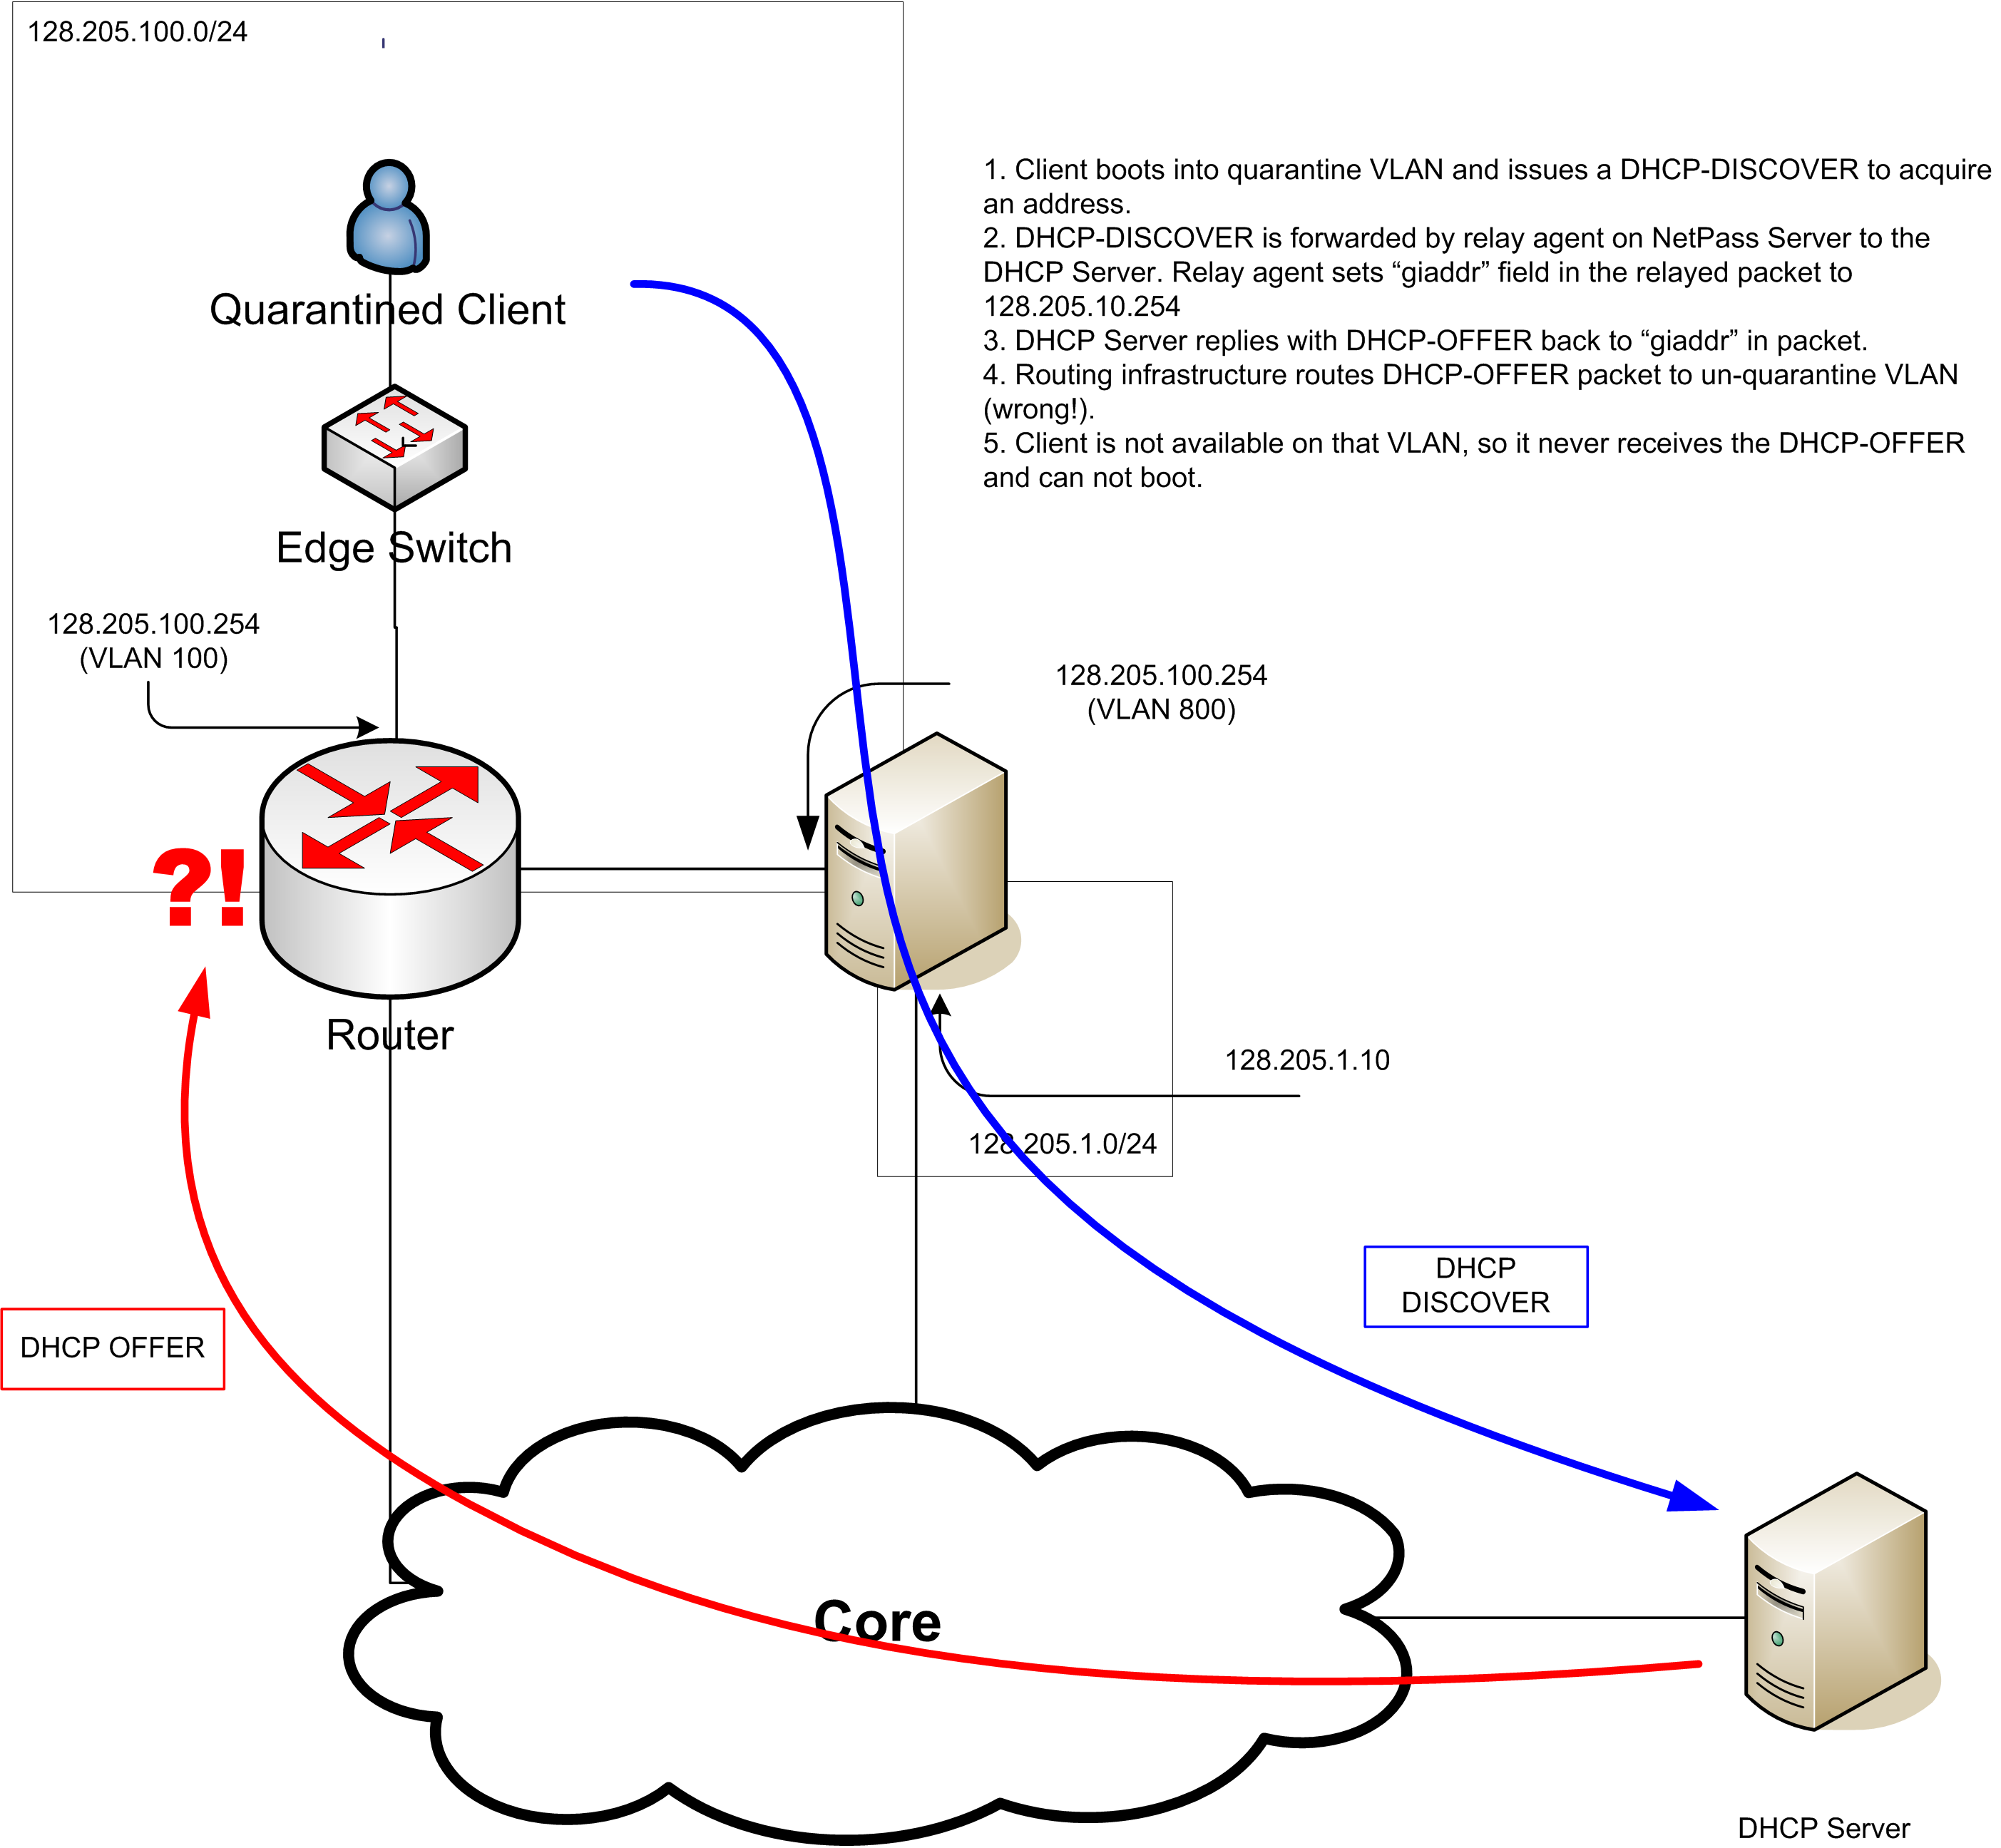
Figure 12 - Example of DHCP failure due to asymmetric routing of reply.
- : SquidGuard Patch

SquidGuard, which is used to determine which URLs are allowed to pass through the NetPass server and which are captured, has a bug in it that occasionally makes it go into “safe mode”. In this mode, all traffic passes through. A patch was available on the Internet, but was not added to the SquidGuard source code.

The patch is archived as part of the NetPass project to make it more easily accessible.
- : LVS (High-Availability) Patch

The LVS patch is a one-line kernel patch that changes the IPVS’ module binding from the INPUT chain to the PREROUTING chain.

The IPVS module, in the default Linux kernel, only sees traffic destined to addresses considered to be “local”. This is because LVS is intended to be used to load balance traffic destined to server farms.

NetPass wants LVS to be a firewall load balancer. Instead of load-balancing inbound connections destined to a server farm, it’s used to balance connects passing through the NetPass servers, which are NAT’ing routers. In order to route all packets and distribute them across the NetPass servers, the module was moved up into the stream of routed packets. Now, when the user tries to go to some external website, it’s load-balanced.

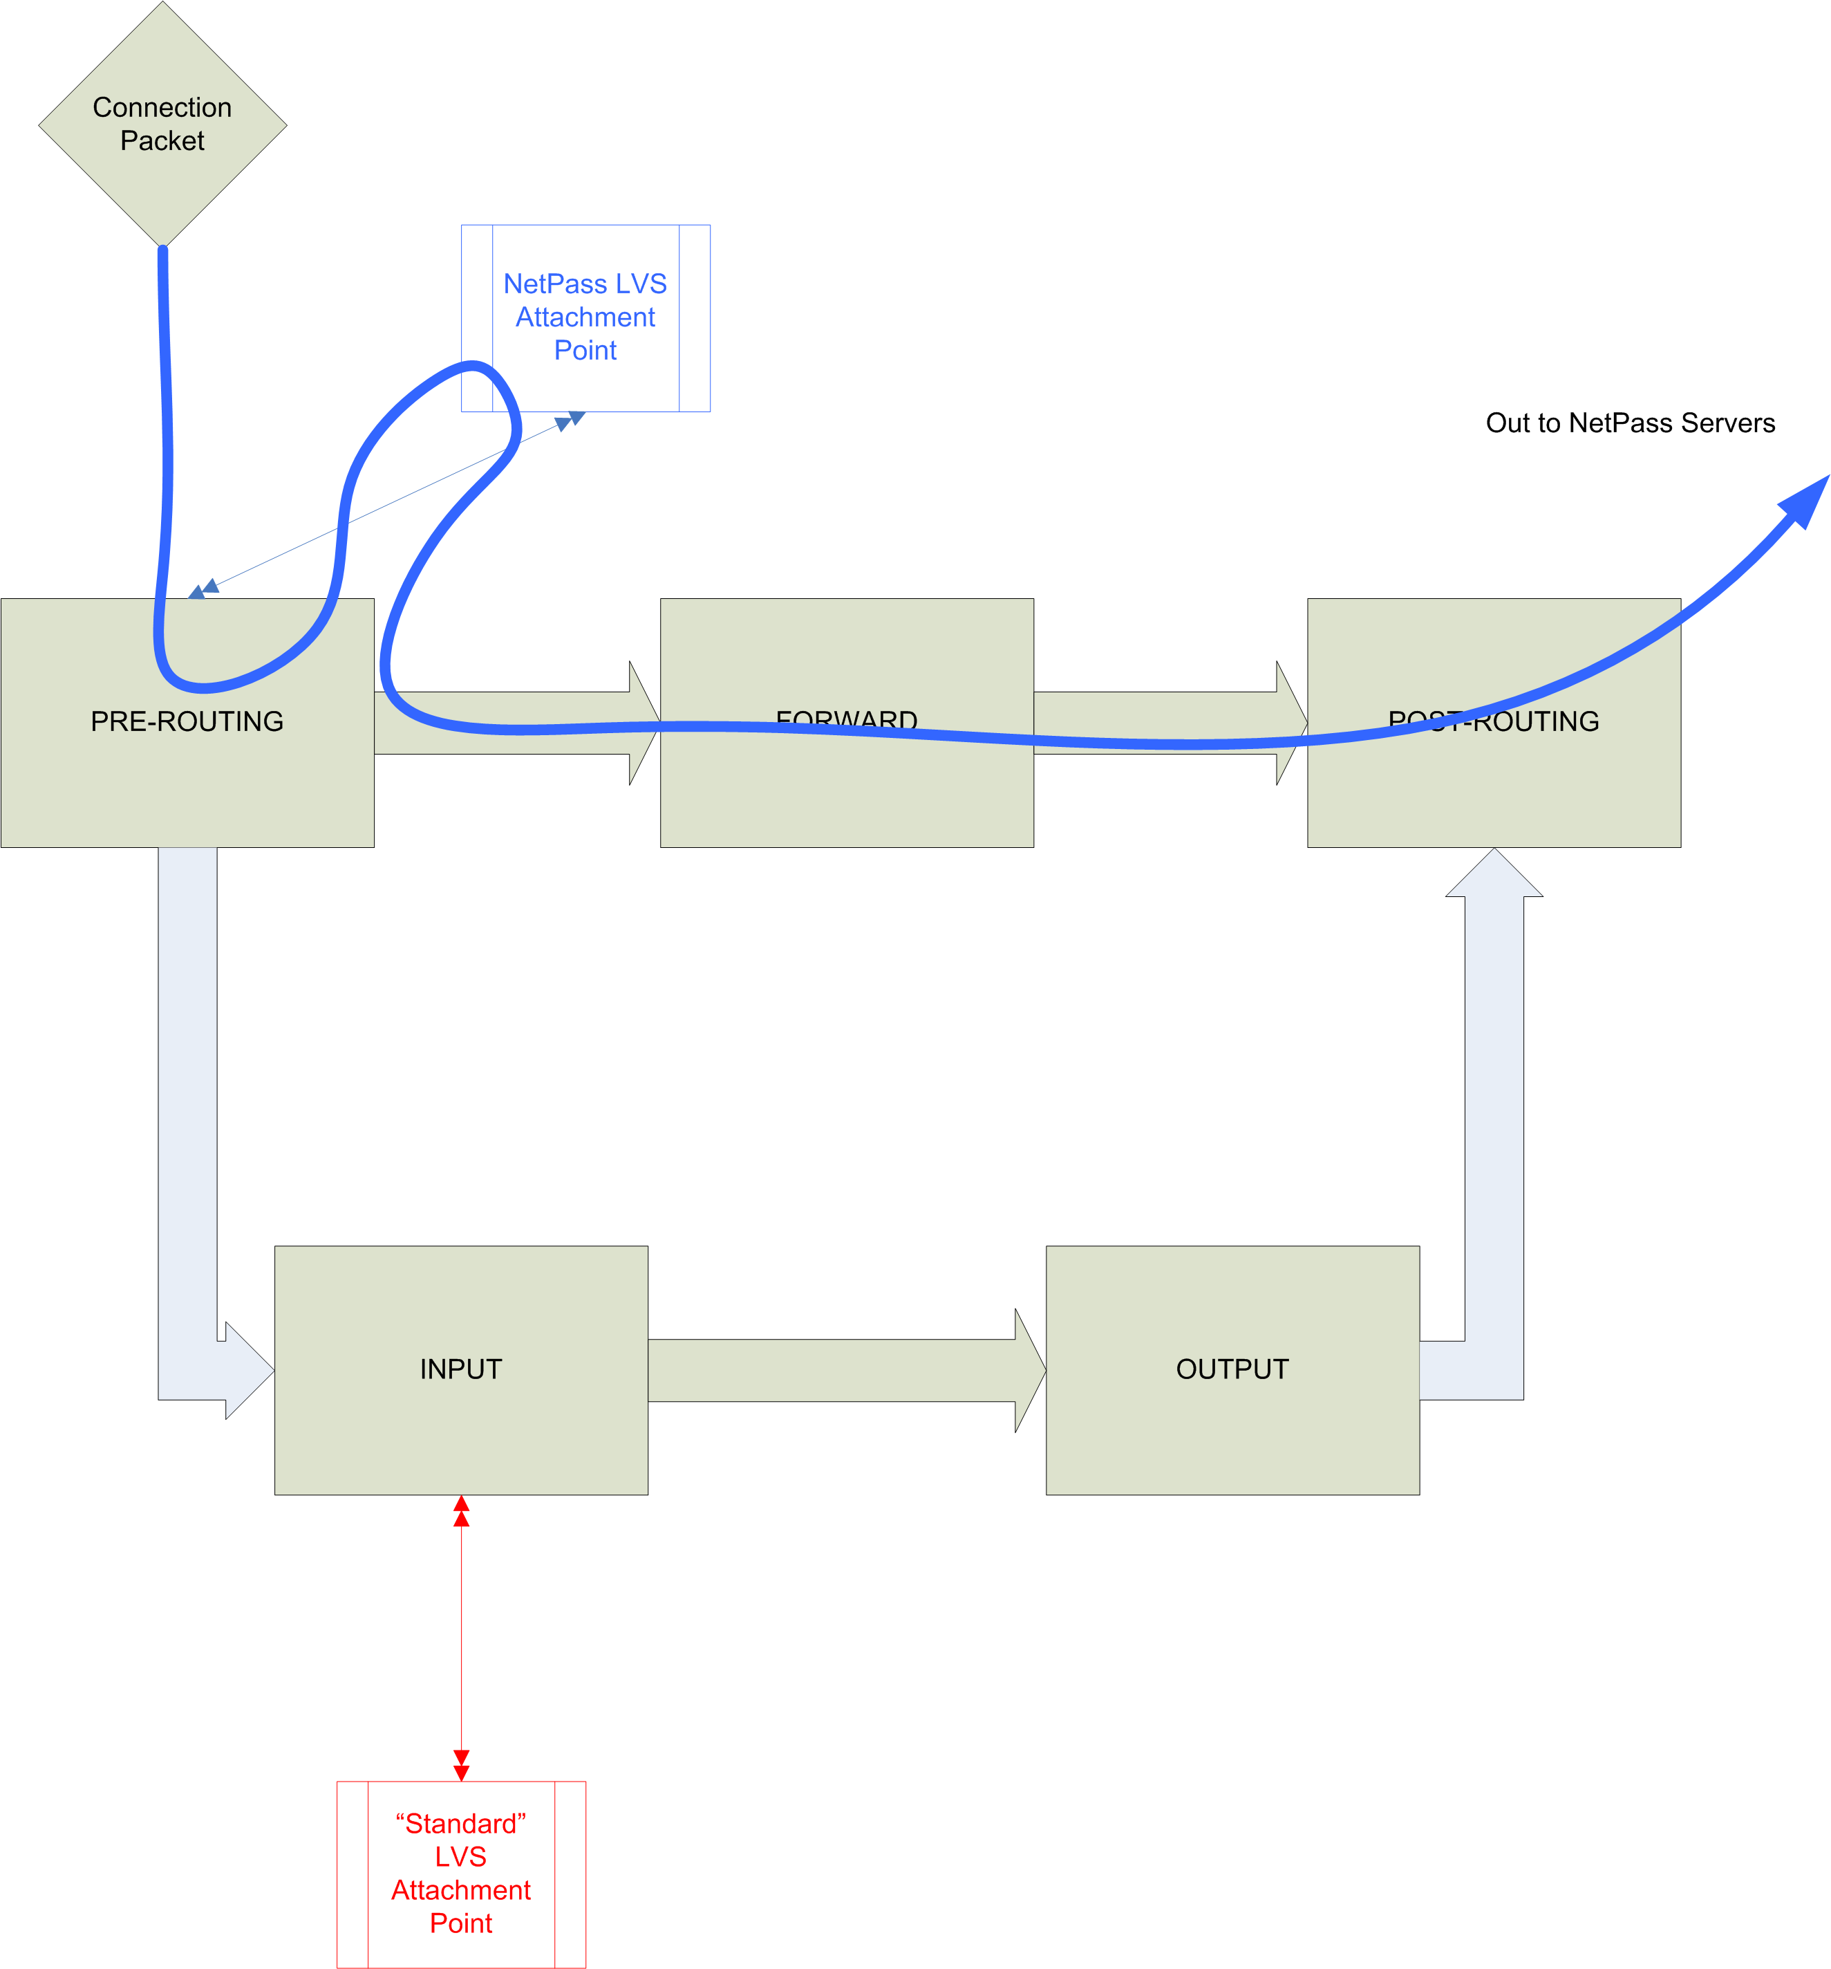
Figure 13 - Packet flow through redirector

- : Using custom gateway MACs instead of Gratuitous ARPing

- : API Reference

- : Rebuilding Perl from Source

- : Rebuilding Apache from Source

- : Rebuilding SquidGuard from Source
- : GNU Free Documentation License
Version 1.2, November 2002
Copyright (C) 2000,2001,2002 Free Software Foundation, Inc.
51 Franklin Street, Fifth Floor, Boston, MA 02110-1301, USA
Everyone is permitted to copy and distribute verbatim copies
of this license document, but changing it is not allowed.

0. PREAMBLE
The purpose of this License is to make a manual, textbook, or other functional and useful document "free" in the sense of freedom: to assure everyone the effective freedom to copy and redistribute it, with or without modifying it, either commercially or noncommercially. Secondarily, this License preserves for the author and publisher a way to get credit for their work, while not being considered responsible for modifications made by others.
This License is a kind of "copyleft", which means that derivative works of the document must themselves be free in the same sense. It complements the GNU General Public License, which is a copyleft license designed for free software.
We have designed this License in order to use it for manuals for free software, because free software needs free documentation: a free program should come with manuals providing the same freedoms that the software does. But this License is not limited to software manuals; it can be used for any textual work, regardless of subject matter or whether it is published as a printed book. We recommend this License principally for works whose purpose is instruction or reference.
1. APPLICABILITY AND DEFINITIONS
This License applies to any manual or other work, in any medium, that contains a notice placed by the copyright holder saying it can be distributed under the terms of this License. Such a notice grants a world-wide, royalty-free license, unlimited in duration, to use that work under the conditions stated herein. The "Document", below, refers to any such manual or work. Any member of the public is a licensee, and is addressed as "you". You accept the license if you copy, modify or distribute the work in a way requiring permission under copyright law.
A "Modified Version" of the Document means any work containing the Document or a portion of it, either copied verbatim, or with modifications and/or translated into another language.
A "Secondary Section" is a named appendix or a front-matter section of the Document that deals exclusively with the relationship of the publishers or authors of the Document to the Document's overall subject (or to related matters) and contains nothing that could fall directly within that overall subject. (Thus, if the Document is in part a textbook of mathematics, a Secondary Section may not explain any mathematics.) The relationship could be a matter of historical connection with the subject or with related matters, or of legal, commercial, philosophical, ethical or political position regarding them.
The "Invariant Sections" are certain Secondary Sections whose titles are designated, as being those of Invariant Sections, in the notice that says that the Document is released under this License. If a section does not fit the above definition of Secondary then it is not allowed to be designated as Invariant. The Document may contain zero Invariant Sections. If the Document does not identify any Invariant Sections then there are none.
The "Cover Texts" are certain short passages of text that are listed, as Front-Cover Texts or Back-Cover Texts, in the notice that says that the Document is released under this License. A Front-Cover Text may be at most 5 words, and a Back-Cover Text may be at most 25 words.
A "Transparent" copy of the Document means a machine-readable copy, represented in a format whose specification is available to the general public, that is suitable for revising the document straightforwardly with generic text editors or (for images composed of pixels) generic paint programs or (for drawings) some widely available drawing editor, and that is suitable for input to text formatters or for automatic translation to a variety of formats suitable for input to text formatters. A copy made in an otherwise Transparent file format whose markup, or absence of markup, has been arranged to thwart or discourage subsequent modification by readers is not Transparent. An image format is not Transparent if used for any substantial amount of text. A copy that is not "Transparent" is called "Opaque".
Examples of suitable formats for Transparent copies include plain ASCII without markup, Texinfo input format, LaTeX input format, SGML or XML using a publicly available DTD, and standard-conforming simple HTML, PostScript or PDF designed for human modification. Examples of transparent image formats include PNG, XCF and JPG. Opaque formats include proprietary formats that can be read and edited only by proprietary word processors, SGML or XML for which the DTD and/or processing tools are not generally available, and the machine-generated HTML, PostScript or PDF produced by some word processors for output purposes only.
The "Title Page" means, for a printed book, the title page itself, plus such following pages as are needed to hold, legibly, the material this License requires to appear in the title page. For works in formats which do not have any title page as such, "Title Page" means the text near the most prominent appearance of the work's title, preceding the beginning of the body of the text.
A section "Entitled XYZ" means a named subunit of the Document whose title either is precisely XYZ or contains XYZ in parentheses following text that translates XYZ in another language. (Here XYZ stands for a specific section name mentioned below, such as "Acknowledgements", "Dedications", "Endorsements", or "History".) To "Preserve the Title" of such a section when you modify the Document means that it remains a section "Entitled XYZ" according to this definition.
The Document may include Warranty Disclaimers next to the notice which states that this License applies to the Document. These Warranty Disclaimers are considered to be included by reference in this License, but only as regards disclaiming warranties: any other implication that these Warranty Disclaimers may have is void and has no effect on the meaning of this License.
2. VERBATIM COPYING
You may copy and distribute the Document in any medium, either commercially or noncommercially, provided that this License, the copyright notices, and the license notice saying this License applies to the Document are reproduced in all copies, and that you add no other conditions whatsoever to those of this License. You may not use technical measures to obstruct or control the reading or further copying of the copies you make or distribute. However, you may accept compensation in exchange for copies. If you distribute a large enough number of copies you must also follow the conditions in section 3.
You may also lend copies, under the same conditions stated above, and you may publicly display copies.
3. COPYING IN QUANTITY
If you publish printed copies (or copies in media that commonly have printed covers) of the Document, numbering more than 100, and the Document's license notice requires Cover Texts, you must enclose the copies in covers that carry, clearly and legibly, all these Cover Texts: Front-Cover Texts on the front cover, and Back-Cover Texts on the back cover. Both covers must also clearly and legibly identify you as the publisher of these copies. The front cover must present the full title with all words of the title equally prominent and visible. You may add other material on the covers in addition. Copying with changes limited to the covers, as long as they preserve the title of the Document and satisfy these conditions, can be treated as verbatim copying in other respects.
If the required texts for either cover are too voluminous to fit legibly, you should put the first ones listed (as many as fit reasonably) on the actual cover, and continue the rest onto adjacent pages.
If you publish or distribute Opaque copies of the Document numbering more than 100, you must either include a machine-readable Transparent copy along with each Opaque copy, or state in or with each Opaque copy a computer-network location from which the general network-using public has access to download using public-standard network protocols a complete Transparent copy of the Document, free of added material. If you use the latter option, you must take reasonably prudent steps, when you begin distribution of Opaque copies in quantity, to ensure that this Transparent copy will remain thus accessible at the stated location until at least one year after the last time you distribute an Opaque copy (directly or through your agents or retailers) of that edition to the public.
It is requested, but not required, that you contact the authors of the Document well before redistributing any large number of copies, to give them a chance to provide you with an updated version of the Document.
4. MODIFICATIONS
You may copy and distribute a Modified Version of the Document under the conditions of sections 2 and 3 above, provided that you release the Modified Version under precisely this License, with the Modified Version filling the role of the Document, thus licensing distribution and modification of the Modified Version to whoever possesses a copy of it. In addition, you must do these things in the Modified Version:
- Use in the Title Page (and on the covers, if any) a title distinct from that of the Document, and from those of previous versions (which should, if there were any, be listed in the History section of the Document). You may use the same title as a previous version if the original publisher of that version gives permission.
- List on the Title Page, as authors, one or more persons or entities responsible for authorship of the modifications in the Modified Version, together with at least five of the principal authors of the Document (all of its principal authors, if it has fewer than five), unless they release you from this requirement.
- State on the Title page the name of the publisher of the Modified Version, as the publisher.
- Preserve all the copyright notices of the Document.
- Add an appropriate copyright notice for your modifications adjacent to the other copyright notices.
- Include, immediately after the copyright notices, a license notice giving the public permission to use the Modified Version under the terms of this License, in the form shown in the Addendum below.
- Preserve in that license notice the full lists of Invariant Sections and required Cover Texts given in the Document's license notice.
- Include an unaltered copy of this License.
- Preserve the section Entitled "History", Preserve its Title, and add to it an item stating at least the title, year, new authors, and publisher of the Modified Version as given on the Title Page. If there is no section Entitled "History" in the Document, create one stating the title, year, authors, and publisher of the Document as given on its Title Page, then add an item describing the Modified Version as stated in the previous sentence.
- Preserve the network location, if any, given in the Document for public access to a Transparent copy of the Document, and likewise the network locations given in the Document for previous versions it was based on. These may be placed in the "History" section. You may omit a network location for a work that was published at least four years before the Document itself, or if the original publisher of the version it refers to gives permission.
- For any section Entitled "Acknowledgements" or "Dedications", Preserve the Title of the section, and preserve in the section all the substance and tone of each of the contributor acknowledgements and/or dedications given therein.
- Preserve all the Invariant Sections of the Document, unaltered in their text and in their titles. Section numbers or the equivalent are not considered part of the section titles.
- Delete any section Entitled "Endorsements". Such a section may not be included in the Modified Version.
- Do not retitle any existing section to be Entitled "Endorsements" or to conflict in title with any Invariant Section.
- Preserve any Warranty Disclaimers.
If the Modified Version includes new front-matter sections or appendices that qualify as Secondary Sections and contain no material copied from the Document, you may at your option designate some or all of these sections as invariant. To do this, add their titles to the list of Invariant Sections in the Modified Version's license notice. These titles must be distinct from any other section titles.
You may add a section Entitled "Endorsements", provided it contains nothing but endorsements of your Modified Version by various parties--for example, statements of peer review or that the text has been approved by an organization as the authoritative definition of a standard.
You may add a passage of up to five words as a Front-Cover Text, and a passage of up to 25 words as a Back-Cover Text, to the end of the list of Cover Texts in the Modified Version. Only one passage of Front-Cover Text and one of Back-Cover Text may be added by (or through arrangements made by) any one entity. If the Document already includes a cover text for the same cover, previously added by you or by arrangement made by the same entity you are acting on behalf of, you may not add another; but you may replace the old one, on explicit permission from the previous publisher that added the old one.
The author(s) and publisher(s) of the Document do not by this License give permission to use their names for publicity for or to assert or imply endorsement of any Modified Version.
5. COMBINING DOCUMENTS
You may combine the Document with other documents released under this License, under the terms defined in section 4 above for modified versions, provided that you include in the combination all of the Invariant Sections of all of the original documents, unmodified, and list them all as Invariant Sections of your combined work in its license notice, and that you preserve all their Warranty Disclaimers.
The combined work need only contain one copy of this License, and multiple identical Invariant Sections may be replaced with a single copy. If there are multiple Invariant Sections with the same name but different contents, make the title of each such section unique by adding at the end of it, in parentheses, the name of the original author or publisher of that section if known, or else a unique number. Make the same adjustment to the section titles in the list of Invariant Sections in the license notice of the combined work.
In the combination, you must combine any sections Entitled "History" in the various original documents, forming one section Entitled "History"; likewise combine any sections Entitled "Acknowledgements", and any sections Entitled "Dedications". You must delete all sections Entitled "Endorsements."
6. COLLECTIONS OF DOCUMENTS
You may make a collection consisting of the Document and other documents released under this License, and replace the individual copies of this License in the various documents with a single copy that is included in the collection, provided that you follow the rules of this License for verbatim copying of each of the documents in all other respects.
You may extract a single document from such a collection, and distribute it individually under this License, provided you insert a copy of this License into the extracted document, and follow this License in all other respects regarding verbatim copying of that document.
7. AGGREGATION WITH INDEPENDENT WORKS
A compilation of the Document or its derivatives with other separate and independent documents or works, in or on a volume of a storage or distribution medium, is called an "aggregate" if the copyright resulting from the compilation is not used to limit the legal rights of the compilation's users beyond what the individual works permit. When the Document is included in an aggregate, this License does not apply to the other works in the aggregate which are not themselves derivative works of the Document.
If the Cover Text requirement of section 3 is applicable to these copies of the Document, then if the Document is less than one half of the entire aggregate, the Document's Cover Texts may be placed on covers that bracket the Document within the aggregate, or the electronic equivalent of covers if the Document is in electronic form. Otherwise they must appear on printed covers that bracket the whole aggregate.
8. TRANSLATION
Translation is considered a kind of modification, so you may distribute translations of the Document under the terms of section 4. Replacing Invariant Sections with translations requires special permission from their copyright holders, but you may include translations of some or all Invariant Sections in addition to the original versions of these Invariant Sections. You may include a translation of this License, and all the license notices in the Document, and any Warranty Disclaimers, provided that you also include the original English version of this License and the original versions of those notices and disclaimers. In case of a disagreement between the translation and the original version of this License or a notice or disclaimer, the original version will prevail.
If a section in the Document is Entitled "Acknowledgements", "Dedications", or "History", the requirement (section 4) to Preserve its Title (section 1) will typically require changing the actual title.
9. TERMINATION
You may not copy, modify, sublicense, or distribute the Document except as expressly provided for under this License. Any other attempt to copy, modify, sublicense or distribute the Document is void, and will automatically terminate your rights under this License. However, parties who have received copies, or rights, from you under this License will not have their licenses terminated so long as such parties remain in full compliance.
10. FUTURE REVISIONS OF THIS LICENSE
The Free Software Foundation may publish new, revised versions of the GNU Free Documentation License from time to time. Such new versions will be similar in spirit to the present version, but may differ in detail to address new problems or concerns. See http://www.gnu.org/copyleft/.
Each version of the License is given a distinguishing version number. If the Document specifies that a particular numbered version of this License "or any later version" applies to it, you have the option of following the terms and conditions either of that specified version or of any later version that has been published (not as a draft) by the Free Software Foundation. If the Document does not specify a version number of this License, you may choose any version ever published (not as a draft) by the Free Software Foundation.

Acceptable Use Policy
http://www.nessus.org/
See MULTI_MAC option
See “Macscan” option
Linux Virtual Server http://www.linuxvirtualserver.org
Instead of manually repeating the above several times, a short-cut is to apply the LVS and Hidden patches to a single kernel, configure that kernel for a NetPass server (i.e. with ReiserFS) and then copy that kernel onto each machine.
ReiserFS is used for the cookie-store filesystem. NetPass uses cookies to track client sessions. This filesystem can occasionally grow to many thousands (even hundreds of thousands) of files and ReiserFS offers better performance under those circumstances. If you opt not to use ReiserFS, then the install script will fail when it tries to make the filesystem and mount it.
http://www.endace.com produces high-speed network capture cards. If you don’t use or need these cards, you may skip this section. The cards are optional and may be purchased if traffic load warrants.
For example: 128.205.1.0/24
RFC 1531
http://marc.theaimsgroup.com/?l=dhcp-server&m=108558416803846&w=2

