部署配置工具需求

DTools

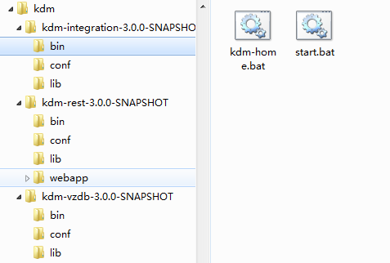

|  |  |  |  |
| --- | --- | --- | --- |
| 序号 | 功能 |  |  |
| 1 | 启停 |  |  |
| 2 | 校验 |  |  |
| 3 | 跟踪 |  |  |
| 4 | 更新 |  |  |
| 5 | 分布式部署 |  |  |