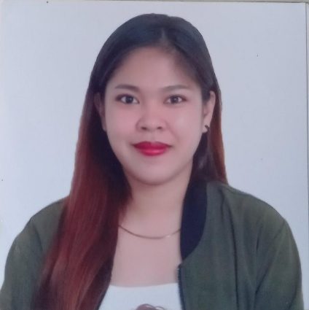**BEVERLY D. CASTILLO**

**Contact #: 09129328210**

**Email acct.: [b](mailto:babycastillo143@yahoo.com)ebeytot08@gmail.com**

**Personal Information**

Birthday: August 03, 1997

Gender: female

Civil Status: Single

Religion: Roman Catholic

Citizenship: Filipino

Father: Ronald Castillo

Mother: Norie Castillo

**Objective**

To be able to apply in your good office as a **Sales Staff** that will commensurate with my past experience that is related to the position I desire in your good company.

**Skills and Abilities**

I am a Hardworking person, friendly, work efficiently, flexible and truthful.

Good oral and written communications skills both English and Filipino languages.

Computer literate

**Experience**

**SALES STAFF**

**ROYQUEEN INT’L CORP.**

May 2015 – February 2017

**SERVICE CREW (Senior Cashier)**

**JOLLIBEE ROBINSONS PLACE BUTUAN**

June 2017 – January 2018

**SERVICE CREW (Counter Crew)**

**MANG INASAL BUTUAN HIGHWAY**

May 18 – October 19 2018

**SERVICE CREW (On-Site Supervisor)**

**JOLLIBEE SM BUTUAN**

Nov. 19,2020 - Present

**Educational Attainment**

**GABRIEL ELEMENTARY SCHOOL**

Gabriel Village Libertad Butuan City

**(2009 – 2010)**

**BUTUAN CITY SCHOOL OF ARTS AND TRADES**

J.P Rosales Ave. Butuan City

**(2010 – 2013)**

**PHILIPPINE ELECTRONICS COMMUNICATION INSTITUTE OF TECHNOLOGY**

Imadejas Subd. PECBC Corner Bonbon Road Butuan City

**(2013 – 2015)**

**Character References**

**Mrs. Imelda C. Bongabong**

Head of Exam Division CSC (Caraga)

**Mr. Rudy Robles**

Department Head of Information Communication Technology (PECIT)

**Ms. Merlina Coral**

Product Quality Manager of Jollibee Robinsons Place Butuan

This is to certify that the above information is true and correct with the best of my abilities.

**BEVERLY D. CASTILLO**

Applicant