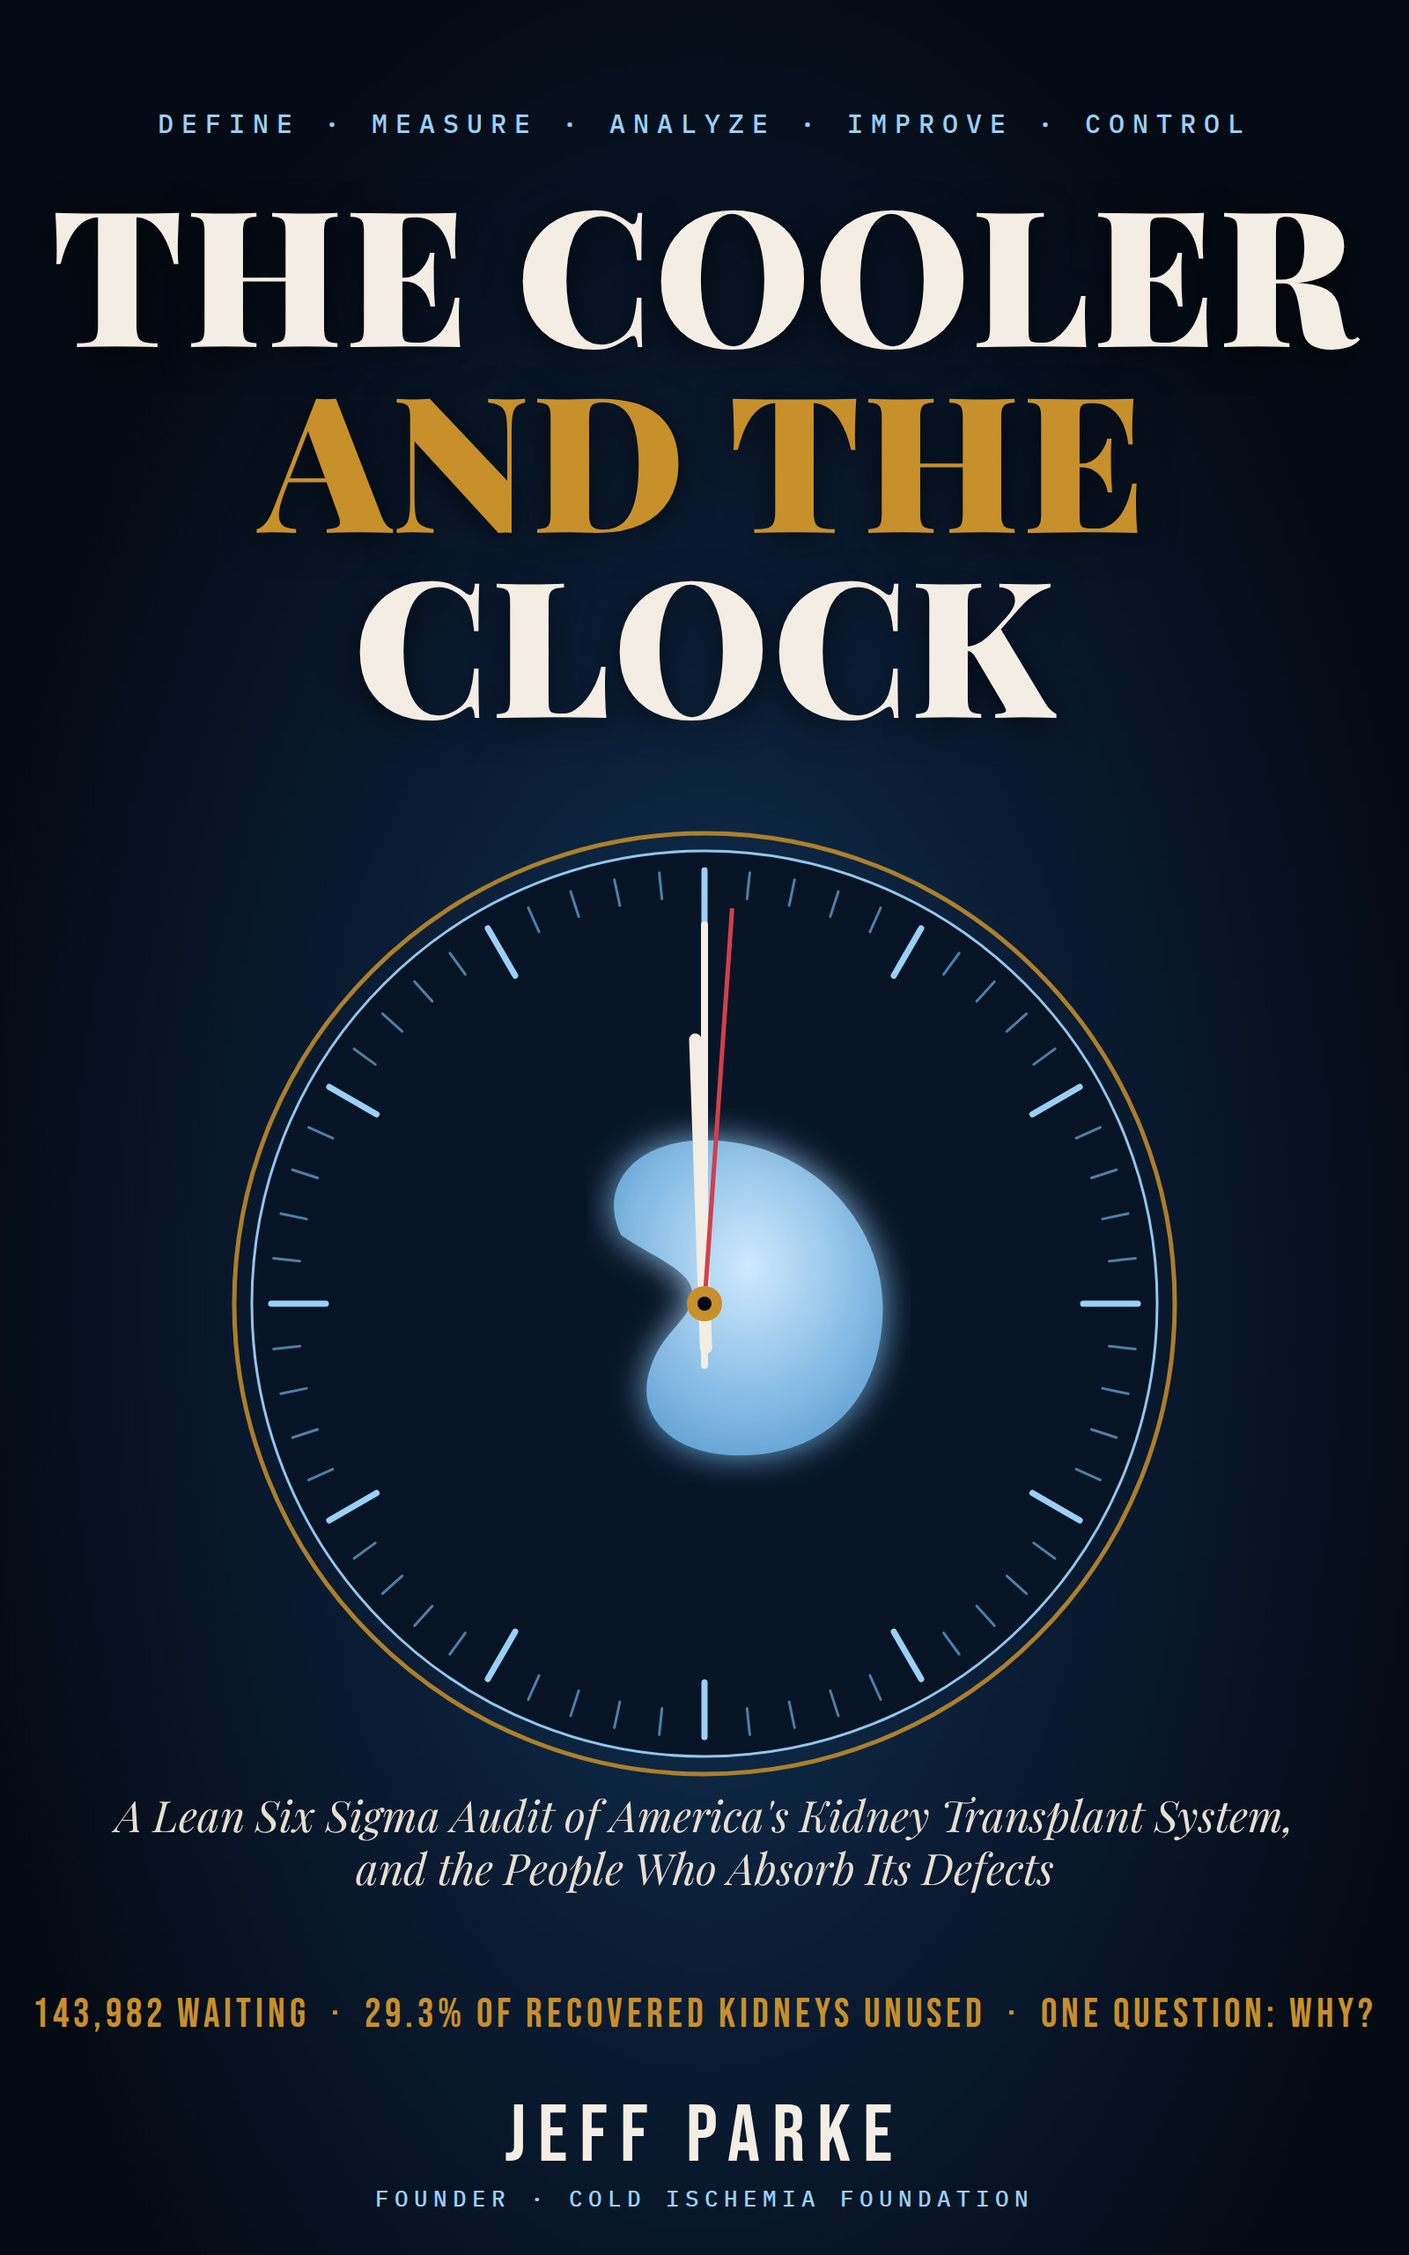

THE COOLER AND THE CLOCK
A Lean Six Sigma Audit of America’s Kidney Transplant System, and the People Who Absorb Its Defects

JEFF PARKE
Cold Ischemia Foundation

The Cooler and the Clock
A Lean Six Sigma Audit of America’s Kidney Transplant System, and the People Who Absorb Its Defects
Copyright © 2026 Jeff Parke. All rights reserved.
Published by the Cold Ischemia Foundation, Ellenton, Florida. coldischemia.foundation
First edition, October 2026.
No part of this book may be reproduced, stored in a retrieval system, or transmitted in any form or by any means without the prior written permission of the publisher, except for brief quotations used in reviews or scholarly work with full attribution.
Educational purpose. This book analyzes systems and policy. It is not medical, legal, or financial advice and does not replace the counsel of your own clinicians. In a medical emergency call 911. If you or someone you love is in emotional crisis, call or text 988.
On accuracy. Statements about organizations, investigations, and legal matters describe the sources cited and are labeled in the text as facts, findings, allegations, or rumors. An allegation is not proof of wrongdoing. Sources marked with a dagger (†) have bibliographic details that should be completed from the original before any future edition. Corrections are welcome through the Foundation’s contact page.
Quotations. The epigraphs are drawn from works in the public domain.

For the ones still counting the hours, and for the ones who count them beside the bed.

“I often say that when you can measure what you are speaking about, and express it in numbers, you know something about it; but when you cannot measure it, when you cannot express it in numbers, your knowledge is of a meagre and unsatisfactory kind.”
— Lord Kelvin, lecture to the Institution of Civil Engineers, 1883

Contents
Prologue: The Hum of the Corridor
Author’s Note: How This Book Was Checked
PART ONE: DEFINE
Chapter 1: The Customer Nobody Surveyed
Chapter 2: A Map Nobody Holds
Chapter 3: A Field Guide to Reading Transplant Numbers
PART TWO: MEASURE
Chapter 4: The Number That Should Embarrass Us
Chapter 5: The Gate Before the Gate
Chapter 6: The Clock
PART THREE: ANALYZE
Chapter 7: A Fishbone for a Wasted Kidney
Chapter 8: Who Is Paid for What
Chapter 9: The Interregnum
Chapter 10: Trust Is a Process Variable
Chapter 11: The Living Donor Paradox
PART FOUR: IMPROVE
Chapter 12: The Innovation Deficit
Chapter 13: What the Method Has Already Done
Chapter 14: Awareness Without Evidence
Chapter 15: The Patient Who Cannot Afford to Be Saved
Chapter 16: A Conservative Case for Reform
PART FIVE: CONTROL
Chapter 17: A Control Plan for a Nation
Epilogue: The Readiness Is All
Appendix A: Evidence Ledger
Appendix B: A Short Glossary
Appendix C: References
About the Author

Prologue: The Hum of the Corridor
“Depend upon it, sir, when a man knows he is to be hanged in a fortnight, it concentrates his mind wonderfully.”
Samuel Johnson, as recorded by James Boswell (1791)
Every institution has a sound, and the sound of a transplant system is a hum. It lives in the fluorescent tubes above a corridor that smells of citrus disinfectant. It lives in the refrigerator compressor of a pharmacy, in the monitor that keeps its patient count of seconds, in a telephone that is expected to ring and does not. Anyone who has spent real time inside this world learns the hum the way sailors learn weather. You learn it without choosing to, and afterward you cannot stop hearing it.
I have lived long enough in these corridors, in more than one role and through more than one season, to be fluent in their dialect. I can tell you what a nurse’s pause means before the sentence arrives. I know the arithmetic that families perform on the backs of envelopes: mileage, missed shifts, copayments, the cost of a motel near the hospital. I know that a waiting list is not a list at all. It is a held breath, stretched across a nation, divided into zip codes.
This book is not a memoir, and it will not behave like one. My own story belongs to me and to the few people who carried me through it. What I owe the reader is something harder to write and, I hope, more useful: an audit. I intend to look at the American kidney transplant system the way an engineer looks at a bridge that people are crossing at this very moment. I want to know where the load is carried, where the metal is fatigued, and which warning lights were wired to nothing.
Consider the shape of the problem. In 2024 the national registry counted 143,982 adults listed for a kidney, a number the official annual report described as approaching the peak recorded before the pandemic (Scientific Registry of Transplant Recipients [SRTR] & Organ Procurement and Transplantation Network [OPTN], 2026a). In that same year, 29.3% of the kidneys that surgeons and coordinators had managed to recover were never transplanted (SRTR & OPTN, 2026b). Read those two facts together and let them settle. A country that cannot find enough kidneys is declining nearly three in every ten that it finds.
Here is the unsettling part. Nobody involved is a villain in the cartoon sense. The surgeons I have met are exhausted and exacting. The coordinators drive through the night. The regulators, whatever else may be said about them, are reading the same tables that you and I can read. Yet the aggregate behavior of this well-meaning crowd produces waste on an industrial scale, and it does so reliably, year after year, with the unglamorous consistency of a machine. That consistency is the clue. Systems that fail by accident fail randomly. Systems that fail by design fail the same way every time.
Design is the operative word, because design is where accountability lives. A defect that is random can be mourned. A defect that is built in can be fixed, and the people who refuse to fix it can be named. This is why I have chosen, for the scaffolding of this book, a discipline that was born on factory floors and that has since traveled into hospitals: Lean Six Sigma. It is a method for people who are tired of anecdotes. It asks four unglamorous questions. What does the customer actually need? How are we really performing against that need? Why is the gap what it is? And what, specifically, will keep it closed once it has been closed?
Some readers will bristle at the vocabulary of manufacturing applied to the most intimate act in medicine. I understand the instinct and I share its reverence. But reverence has a poor record as a management technique. A kidney does not care how tenderly we speak of it. It cares about the hours it spends in a cooler, the number of phone calls that precede an acceptance, and whether someone on a Saturday night had the authority to say yes. Lean Six Sigma insists that these hours and calls and authorities be counted. Counting, I have come to believe, is a form of love that has been disciplined into usefulness.
You will find in these pages arguments that conservative readers will recognize and arguments that progressive readers will recognize, and I make no apology for borrowing from both. I believe in transparency as a public good and in accountability as an engine. I believe that institutions should be measured by outcomes and not intentions, that incentives should be aligned before they are lamented, and that any organization granted a monopoly over a human organ supply has accepted an obligation to be examined without flattery. I also believe that the people whom this system serves are owed plain language. Where a claim is a finding, I will call it a finding. Where it is an allegation, an anecdote, or a rumor, I will say so, and I will show my reasoning when I decline to repeat it.
Some of what follows will be uncomfortable for persons and organizations I respect. I would ask them to read the footnotes before the headlines, because the footnotes are where the evidence is. I would ask patients and care partners to read the headlines before the footnotes, because the headlines are where your lives are. And I would ask everyone to hold in mind a simple fact that no policy memo can soften: while we deliberate, the clock keeps running, and somewhere tonight a cooler is being carried down a hallway toward a decision.
Let us go and look at the cooler.

Author’s Note: How This Book Was Checked
“Felix qui potuit rerum cognoscere causas.”
Virgil, Georgics, II.490 (“Fortunate is the one who has been able to learn the causes of things.”)
A book that accuses systems of failure must first accuse itself of the same possibility. Here, in plain terms, is how this manuscript was built and where its limits lie.
The six-month standard. I set a rule for myself: the developments that carry this book’s argument should be no more than about six months old as of the date of writing, 9 October 2026. Where the newest reliable account of a subject is older, I say so in the text. A handful of landmark studies, such as the classic comparison of mortality among patients on dialysis and those who receive transplants (Wolfe et al., 1999), are older than that by decades. They appear only as background, they are labeled as foundational, and nothing in my argument rests on them alone.
What counts as evidence. Every factual claim carries an inline citation in the style of the American Psychological Association. I graded each source on a three-step ladder. Grade A means a primary document or registry, such as a federal rule, an agency report, a registry data report, or a peer-reviewed paper, whose key figures I could confirm. Grade B means a credible secondary account, such as a law-firm analysis or trade press report, of a primary document. Grade C means a single-source figure, or one that originates with an organization that has a stake in the result, such as a device manufacturer or an advocacy campaign. Grade C material is used sparingly and is always marked as preliminary in the text. The complete ladder, source by source, appears in Appendix A.
How the book is organized. The five parts follow the five phases of the Lean Six Sigma method: define the customer and the process, measure the defects, analyze their causes, improve, and control. Each chapter separates the record, which is what the sources document, from the reading, which is my interpretation of it. Where I argue for a policy, I say so, and I say what evidence would change my mind.
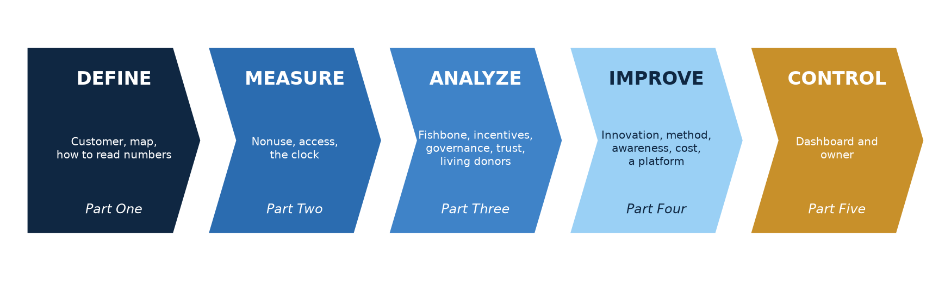
Figure 0.1. The five phases of the method and how the five parts of this book follow them.
Fact, finding, allegation, rumor. These four words are not synonyms, and the book uses them with discipline. A fact is a measurement that anyone can reproduce. A finding is a conclusion reached by a body with authority and a method, such as a federal investigation. An allegation is a claim made by a party in a dispute and not yet adjudicated. A rumor is a claim with no traceable source. You will meet all four in Chapter 10, and you will see how easily the first three can be mistaken for one another.
What I could not verify. The research tools used for this manuscript returned summaries and the bibliographic details of many journal articles, but not the complete text of every paper or agency page. For that reason, a few citations are marked with a dagger (†). A dagger means that the central figures were confirmed against more than one summary, but that some bibliographic detail, such as a full author list or a final volume number, should be completed from the original before any edition is published. I would rather show you the gap than hide it. A foundation that conceals its own gaps has no business asking federal agencies to close theirs.
Where the evidence is thin. Several subjects in this book are not yet supported by strong evidence. The first year of the Increasing Organ Transplant Access model has not been reported. The recertification outcomes for organ procurement organizations have not been announced. No outcome data from the first clinical trial of pig kidney transplantation have been published. In those places, I analyze the design and the incentives, and I decline to pretend that results exist.
Disclosure. The Cold Ischemia Foundation accepts no donations, grants, or sponsorships, and it charges posted fees only for services that individuals request. The Foundation publishes educational material about oxygen-carrier technology for organ preservation, including the work of a company called BHOC Therapeutics. The author reports no financial interest in that company or in any other organization discussed in this book. The Foundation’s own published position is that this technology remains a research concept whose benefits are unproven, and this book repeats that position without softening it.
A word on the numbers. Registry counts differ from one source to another because populations and definitions differ. A candidate who is listed at two centers may be counted twice in one table and once in another. When two figures from different sources appear in the same chapter, I explain why they differ. Where I have calculated a figure myself, such as an extrapolation of a published hazard ratio or an estimated sigma level, the text and the figure caption say so.
Not medical or legal advice. This book analyzes systems and policy. It is not clinical guidance and does not replace the counsel of your own medical team. If you are in a medical emergency, call 911. If you or someone you love is in emotional crisis, call or text 988.

PART ONE: DEFINE
“That which is not good for the swarm, neither is it good for the bee.”
Marcus Aurelius, Meditations, VI.54 (Long translation, 1862)
Every quality discipline begins in the same place, which is with a definition. Before one measures a process, one must say what the process is for and who it is for. Part One does that work. It describes the customer who was never surveyed, and it draws the map of a process that most participants experience only as a fragment.

Chapter 1: The Customer Nobody Surveyed
“Would you tell me, please, which way I ought to go from here?” “That depends a good deal on where you want to get to,” said the Cat.
Lewis Carroll, Alice’s Adventures in Wonderland (1865)

The customer is a person, and the person has a clock
In the vocabulary of Lean Six Sigma, the customer is whoever receives the output of a process and decides, by their experience of it, whether the process has done its job. A factory has a buyer. A restaurant has a diner. A transplant system has a customer who cannot shop elsewhere, who did not choose the product, and who may be too ill to complain about the service. That customer is a person whose kidneys have failed, together with the small circle of family and friends who organize their lives around the failure.
The transplant system has other stakeholders too. Donor families are customers of a different kind, because they are asked for consent in the worst hour of their lives and they are owed an honest process in return. Living donors are customers who volunteer an organ and a stretch of their own livelihood. Taxpayers purchase a good deal of this care. Transplant surgeons, coordinators, dialysis nurses, and registry analysts are employees of the process, and their burnout is a data point whether or not anybody records it. For the purposes of an audit, however, the primary customer is the patient, and the question that governs everything else is simple. What does that person need from the process, and does the process deliver it?

The record: how large is the demand?
The national registry reports that 143,982 adults were listed for a kidney transplant during 2024, a figure the annual data report characterizes as approaching the peak recorded just before the pandemic (SRTR & OPTN, 2026a). The report’s overview, which counts a candidate once for every center at which that candidate is listed, tallies 147,091 listings (SRTR & OPTN, 2026b). The gap between 143,982 and 147,091 is not an error. It is a reminder that a registry is a model of reality and not reality itself, and that every number in this book should be read with its definition attached.
New demand arrives faster than supply. A record 49,249 adults joined the kidney list in 2024, and 50,481 patients of all ages were added in total (SRTR & OPTN, 2026a). The previous year’s report counted 47,838 additions against 28,142 kidney transplants, the highest number of transplants ever performed in a single year (SRTR & OPTN, 2025). Set those two figures beside each other. Even in a record year for surgery, the system added roughly 19,700 more names than it removed through transplantation. Whatever one thinks of any individual reform, the arithmetic of the inflow does not close.
Removals from the list tell a second story. According to the national registry’s removal table for kidney candidates, deaths on the list ran 4,891 in 2020, 5,032 in 2021, 4,448 in 2022 and 3,803 in 2023, while removals because a candidate had become too sick for transplant ran 3,814, 3,920, 4,396 and 4,672 over the same years (Organ Procurement and Transplantation Network [OPTN], n.d.). The latest annual report shows the same crossing pattern: removals for death fell to 3,743 in 2024, and removals for being too sick rose to 4,901 (SRTR & OPTN, 2026a). Note that different publications count these categories slightly differently, which is why the figures in the annual report and the registry table do not match exactly.
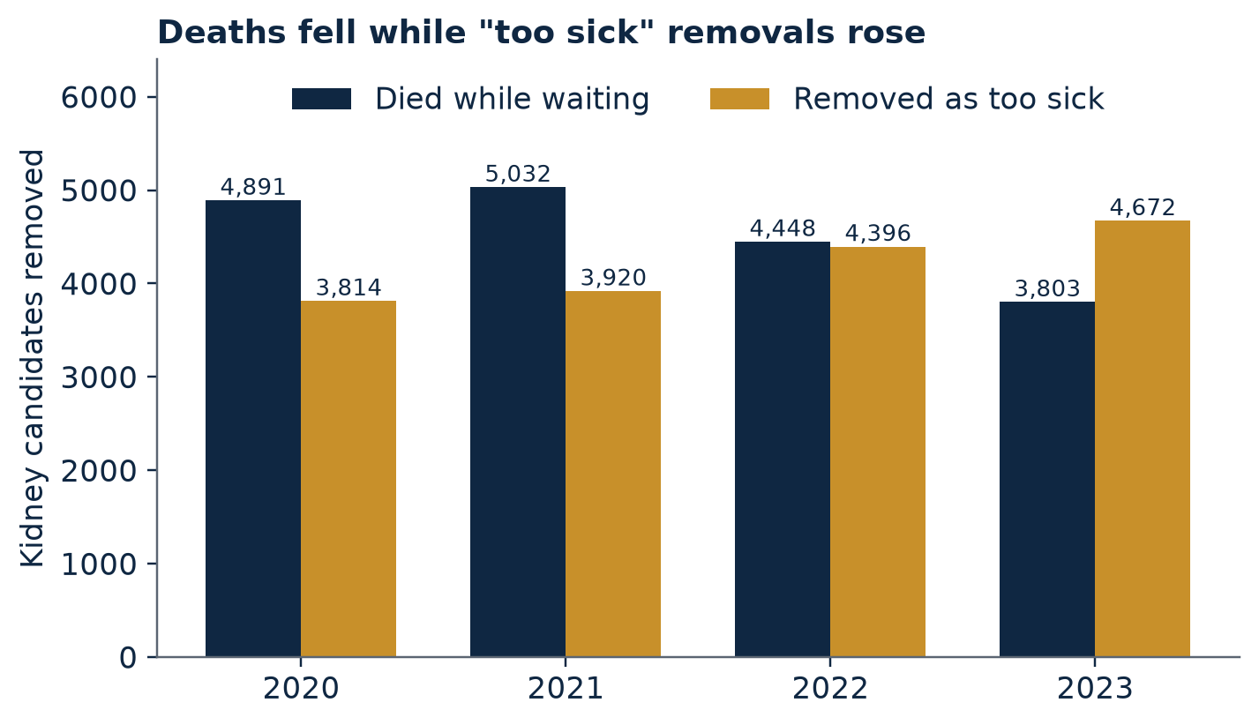
Figure 1.1. Kidney candidates removed from the waiting list, by reason, 2020–2023. Source: OPTN removal table (n.d.). Annual data report counts differ slightly because of population and definition.

The reading: a falling death count is not necessarily good news
It would be comforting to read the declining number of deaths as proof that waiting has become safer. I want to resist that reading, and the reason is a lesson from quality engineering about the danger of a metric that can be moved without moving the thing it stands for. A candidate who is removed for being too sick is, in the registry’s accounting, not a death on the list. Yet that candidate has been withdrawn from the only path that could have saved them. When deaths decline while too-sick removals climb, at least two explanations compete. One is that care is improving and fewer people are dying. The other is that the system is increasingly reclassifying decline, so that the same attrition flows through a different door. The registry figures alone cannot adjudicate between these explanations, and the honest course is to say that the question is open. What can be said is that a single headline metric, deaths while waiting, is an incomplete instrument. A proper dashboard would report deaths and too-sick removals together, and would follow delisted candidates for a fixed period afterward.

The record: what a transplant is worth to the customer
Why does the customer wait so intently? Because the difference between the waiting room and the operating room is, statistically, enormous. In a landmark cohort study of 228,552 patients on long-term dialysis, the death rate was 16.1 per 100 patient-years among all dialysis patients, 6.3 among those on the transplant waiting list, and 3.8 among recipients of a first deceased-donor kidney (Wolfe et al., 1999). The authors also documented the cost of the first weeks, since mortality was higher right after surgery before it fell below the waiting-list rate. This study is a quarter-century old and the methods of the field have improved, so I cite it only as a foundational benchmark. The more recent national summaries, though they describe older cohorts, point in the same direction: among patients who started treatment in 2007, adjusted five-year survival was about 40.4% on dialysis, 73.7% after a deceased-donor transplant, and 87.0% after a living-donor transplant (United States Renal Data System [USRDS], 2014).
An honest reader must attach a caveat to every number in that paragraph. People who receive transplants are selected, in part, because they are healthier, so part of the survival gap reflects who is chosen rather than what the operation does. The best studies attempt to correct for this, as Wolfe and colleagues did by comparing transplant recipients against others who were also on the waiting list. Even so, the direction of the finding is not seriously disputed, and the magnitude is large enough to make access and timeliness the central quality characteristics of the whole enterprise.

Translating the voice of the customer into measurable requirements
Lean Six Sigma translates what customers say they want into what the process must deliver, using a device called a critical-to-quality tree. One starts with a broad need, such as “I want to live,” and decomposes it into requirements specific enough to measure. When I apply that device to the kidney patient, six branches emerge.
Access. The patient must be told that transplantation is an option, referred to a center, evaluated, and placed on the list. Chapter 5 shows that this gate leaks.
Timeliness. The patient must receive an offer before health declines past the point of eligibility. The measures here are time to listing, time to offer, and the rate of removal for deterioration.
Quality of the organ. The kidney that arrives must function and endure. Cold ischemia time, delayed graft function, and long-term graft survival are the instruments, and Chapter 6 examines them.
Affordability. The patient must be able to obtain the surgery and, crucially, to keep taking the immunosuppressive drugs afterward. Chapter 15 turns to this branch.
Trust. The patient and the donor family must believe that the process is clean and fair, because belief is the fuel that keeps donors registering. Chapter 10 treats trust as a process variable and not as a public-relations afterthought.
Understanding. The patient must be able to comprehend the options in plain language. Chapter 14 takes up the awareness problem.
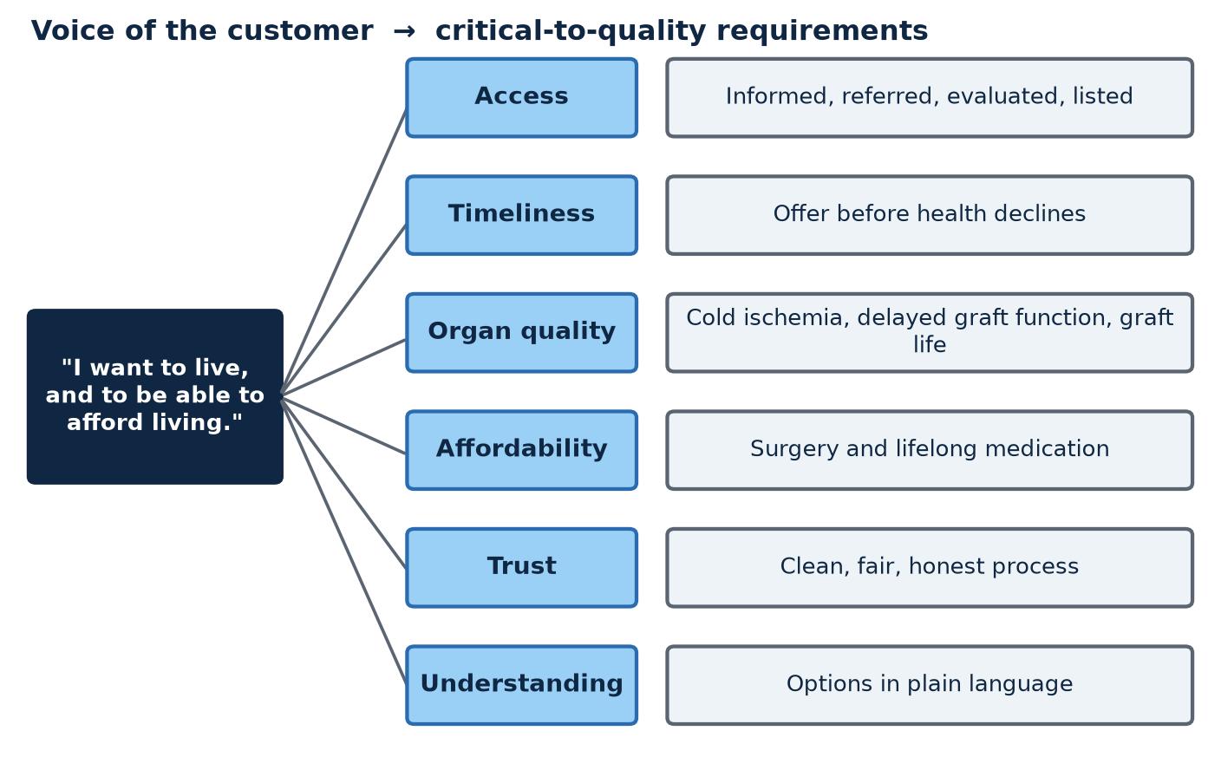
Figure 1.2. Voice-of-the-customer to critical-to-quality tree for the kidney patient. Author’s analytic framework.

A project charter for a national problem
Six Sigma projects begin with a charter, a short document that states the problem, the scope, and the goal in terms that can be checked later. I offer one here, in the spirit of an exercise and not a regulation.
Project charter
Problem statement. In 2024, the national registry listed 143,982 adults for a kidney transplant while 29.3% of recovered kidneys went unused. Candidates continue to be removed for death or deterioration in numbers that the registry reports as between 3,700 and 4,900 each per year.
Scope. From the moment a patient with advanced kidney disease first meets a nephrologist to the first year after transplant, including the donor pathway and the payment pathway.
Goal. Reduce the share of recovered kidneys that go unused, reduce unexplained variation in referral, listing, and offer acceptance, and make the whole journey measurable in public.
Out of scope. Clinical decisions about any individual patient.

The charter is deliberately modest. It claims no cure. It claims only that a country able to name the problem in numbers has already taken the first step toward solving it, and that a country unwilling to publish the numbers has not yet begun.

Chapter 2: A Map Nobody Holds
“I returned, and saw under the sun, that the race is not to the swift, nor the battle to the strong... but time and chance happeneth to them all.”
Ecclesiastes 9:11 (King James Version, 1611)

SIPOC: the process on one page
Before improving a process, a Six Sigma team draws it, and the preferred drawing is a deliberately crude one known by its acronym, SIPOC. The letters stand for suppliers, inputs, process, outputs, and customers. The exercise forces a team to agree on where the process begins and ends and on who hands what to whom. I have drawn one for the kidney transplant system, and the first thing it reveals is how many hands are involved.
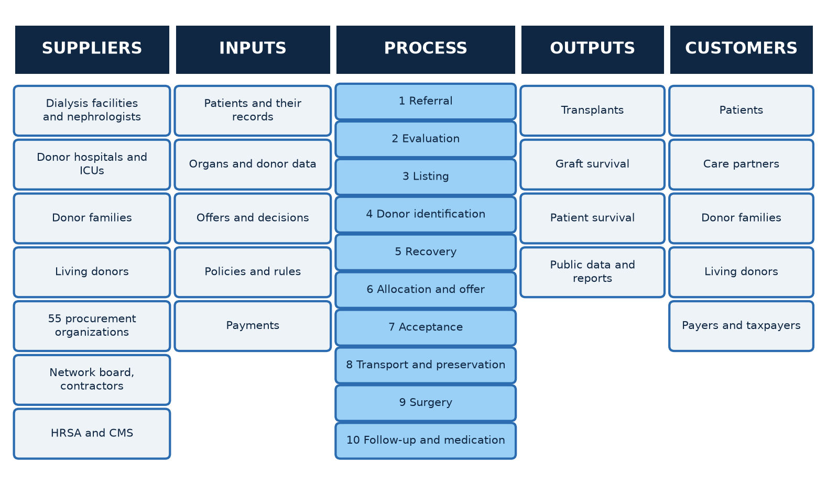
Figure 2.1. SIPOC diagram of the kidney transplant process. Author’s analytic framework.
On the supplier side stand dialysis facilities and nephrology practices that identify the patient, hospitals whose intensive care units identify potential deceased donors, the families who consent, the living donors who volunteer, and the 55 organ procurement organizations that coordinate recovery (Health Resources and Services Administration [HRSA], 2026a). The inputs are patients, organs, medical information, and money. The process itself runs through referral, evaluation, listing, donor identification, recovery, allocation, offer and acceptance, transport and preservation, surgery, and the long tail of follow-up. The outputs are transplants, graft survival, and patient survival. The customers are the patients, and, indirectly, everyone who pays.

The record: who governs what, as of this autumn
The governance of this process has been in motion for several years, and the past six months have been busy. Federal oversight agency HRSA describes the creation of an independent, elected board of directors for the national transplant network, one that is separate from the contractor structure and intended to clarify decision-making authority and to reduce potential conflicts of interest (HRSA, 2026a). In April 2026 that board appointed a new director to fill a vacancy and granted one-year extensions to its president and vice president, explaining that recent disruptions, including contractor transitions and funding interruptions, had impaired its ability to move initiatives forward (HRSA, 2026b).
Later monthly updates, which Chapter 9 examines in detail, describe a steady program of reconstruction: new contracts, new officers, new requirements for deceased donation, and a higher registration fee.
I want to be careful about the provenance of these facts. They come from the oversight agency’s own monthly summaries, so they reflect that agency’s framing, and I found no independent press coverage that tested them. They are reliable as a record of what was decided. They are not evidence that what was decided will work.

The reading: a process with many owners is a process with none
Lean thinking has a firm view about ownership. Every end-to-end process needs a single owner who is responsible for the whole, because a process that is owned only in pieces is optimized only in pieces. When I lay the kidney pathway across the page and ask who owns the whole of it, from the first nephrology appointment to the fifth year after surgery, I cannot find a name or an office. I find, instead, a relay of owners, each accountable for a segment and each measured by a different instrument.
The payment agency for Medicare measures organ procurement organizations by two rates and sorts them into tiers (Centers for Medicare & Medicaid Services [CMS], 2026). It measures kidney transplant hospitals, in its new payment model, by transplant volume, organ offer acceptance, and graft survival, with 60, 20, and 20 points available respectively (CMS, n.d.). It measures dialysis facilities, in a separate model, by home dialysis and by waitlisting and transplant rates (CMS, 2025). The oversight agency measures compliance with allocation policy (HRSA, 2026a). Each instrument is reasonable on its own. None of them is the patient’s own measure, which is a single and merciless one: did I get a working kidney in time?
The eight wastes, applied to the kidney pathway
Lean practitioners classify waste under eight headings, often remembered by the acronym DOWNTIME. Mapping them onto this system is a useful discipline, and every mapping below is the author’s analytic reading and not a finding of any agency.
Defects: recovered kidneys that are never transplanted. Overproduction: none apparent, since demand exceeds supply. Waiting: the list itself, and the hours between offers. Non-utilized talent: patients and care partners who could contribute to navigation but are never invited. Transportation: the movement of organs across distance, which converts into cold ischemic time. Inventory: a waiting list that is also a stockpile of human potential. Motion: the repeated phone calls that precede acceptance. Extra-processing: redundant tests and paperwork at the handoffs.

The handoffs where the process leaks
A process fails most often at its seams. Four handoffs in the kidney pathway deserve scrutiny, and each one receives a chapter in this book.
The first seam lies between the dialysis chair and the transplant center. A patient must be told, referred, and evaluated, and each of those verbs is a possible exit. The second seam lies between the donor hospital and the organ procurement organization, where decisions about a possible donor are made under time pressure and, as Chapter 10 documents, have recently drawn federal scrutiny. The third seam lies between the offer and the acceptance, where a kidney is accepted or declined by an individual clinician on call. The fourth lies between the cooler and the operating table, where hours accumulate.
A Lean Six Sigma team would add to this a fifth observation about the seams. Each of them is a place where information is passed from one party to another, and each is therefore a place where measurement is either possible or it is not. A transparent system measures the seams. An opaque system measures the segments and assumes the seams will take care of themselves. The remainder of this book is an inspection of the seams.

Why a map matters to a patient
I have laid out these diagrams and definitions with something close to affection, because I believe that a map is one of the most generous things one person can hand to another. Patients and care partners are routinely asked to navigate a process that no one can describe to them end to end. Services that offer a free orientation or a plain-language roadmap are not decoration; they are an attempt to supply, at the scale of one household, the map that the system as a whole has failed to supply at the scale of the nation. A country that handed every new dialysis patient a one-page SIPOC, and meant it, would be a better country.
In Part Two we begin to measure. The numbers are not kind, but they are clarifying, and clarity is the only kind of kindness that has ever fixed a bridge.

Chapter 3: A Field Guide to Reading Transplant Numbers
“There is something fascinating about science. One gets such wholesale returns of conjecture out of such a trifling investment of fact.”
Mark Twain, Life on the Mississippi (1883)

Why the numbers disagree
Anyone who spends time with transplant statistics will eventually experience a small crisis. Two reputable sources report different figures for what seems like the same quantity, and the reader wonders which one is wrong. In my experience the answer is usually that neither is wrong. They are answering slightly different questions. Because this book rests on numbers, and because many readers will want to repeat them, I will devote a chapter to the grammar of the numbers themselves. The material is dry, and I ask for patience. A reader who finishes it will be able to detect a bad statistic in a press release, a campaign flyer, or a hallway conversation.
Begin with the disagreements that appeared in the preceding chapters. The annual data report counted 143,982 adults listed for a kidney in 2024, and in the same publication family an overview counted 147,091 listings (SRTR & OPTN, 2026a, 2026b). The difference comes from counting. A candidate registered at two centers appears twice in one table, because the unit of analysis is the listing, and once in the other, because the unit is the person. Neither table is mistaken. They measure different things, and a careful writer states which one is being used.
A second disagreement concerns deaths on the list. In the registry’s removal table, 4,448 kidney candidates were removed for death in 2022, whereas the annual report cites 4,734 for the same year (OPTN, n.d.; SRTR & OPTN, 2026a). I cannot determine from the summaries available to me exactly why the two differ. The usual suspects are differences in the population included, in the way the categories are defined, and in the date on which the data were extracted, since registry records are revised as late information arrives. The lesson is practical: never splice figures from two tables into one trend line without confirming that they share a definition.
A third disagreement concerns nonuse. The report that counted 27.9% in 2023 explains that kidneys recovered together as a pair are counted once while kidneys recovered separately are counted twice (SRTR & OPTN, 2025). Another analysis reports a “discard” rate of 25% in 2021 using a different method and source, and the authors of the summary I read cautioned that it should not be compared directly with the registry’s nonuse figures. When someone tells you that the discard rate is “about a quarter,” the intelligent response is to ask which measure, which year, and which denominator.

Relative numbers hide absolute ones
The most common trick in health statistics requires no dishonesty at all, only a choice of which number to print. A relative change describes a ratio, and an absolute change describes a difference. They can differ enormously in their emotional force.
I have already used an example. Nonuse of hepatitis C-positive kidneys fell from 49.5% to 32.2%. The absolute drop is 17.3 percentage points. The relative drop is about 35%. Both are true, and both belong in an honest account, but only the first tells you how many kidneys were affected.
Now consider a figure that appeared in Chapter 6: a 27% lower risk of graft failure with machine perfusion over ten years, according to the device manufacturer (Organ Recovery Systems, 2025). That is a relative statement, and it cannot be translated into a benefit for a patient without knowing the baseline. Suppose, purely for illustration, that 30% of kidneys in a comparison group had failed by ten years. A 27% relative reduction would lower that to about 21.9%, an absolute difference of 8.1 percentage points, and about twelve patients would need to be perfused for one additional graft to survive. If the baseline were 10%, the same relative reduction would yield an absolute difference of 2.7 points, and about thirty-seven patients would need perfusion for one graft to benefit. The relative number is the same. The meaning is not. The hypothetical baselines are mine and are not data, and I use them only to show why a headline that gives only the relative figure cannot be evaluated.

A ratio per hour is a compounding machine
The French analysis in Chapter 6 reported that each added hour of cold ischemia raised the hazard of graft failure by a factor of 1.013 (Debout et al., 2015†). An increase of 1.3% sounds negligible, and a reader may dismiss it. But a hazard ratio per unit applies repeatedly across many units. Multiplying 1.013 by itself twenty-four times, which covers the difference between six hours and thirty, yields about 1.36. The small number turns into a large effect through nothing more exotic than arithmetic. I flag this because the opposite error is common. A speaker who wishes to downplay a risk will quote the per-hour figure, and a speaker who wishes to inflate it will quote the cumulative one, and in both cases the number is accurate.

Uncertainty is information, not decoration
A study reports a point estimate, such as an odds ratio of 0.68, and a confidence interval around it, such as 0.28 to 1.64. The temptation is to read only the first number. The interval is the more honest half of the report. It describes the range of effects that the data cannot rule out, and a wide interval means that the study knew little. The 2026 trial of normothermic perfusion reported a p-value of 0.38 (Normothermic versus hypothermic machine perfusion in kidney transplantation, 2026†). A careless summary would state that normothermic perfusion had no effect. A careful one would say that the trial was too small to tell, because its interval stretched from a large benefit to a substantial harm.
The same discipline applies to agreement statistics. When researchers measure how often clinicians agree on a decision, they typically report a coefficient that corrects for the agreement expected by chance. By the widely used benchmarks, values from 0 to 0.20 indicate slight agreement, 0.21 to 0.40 fair, 0.41 to 0.60 moderate, 0.61 to 0.80 substantial, and 0.81 to 1.00 almost perfect agreement (Landis & Koch, 1977). The survey result I cited in Chapter 7, 0.13, sits in the lowest band. Remember that the bands are conventions and not laws of nature, and the result came from a single small survey. It is a warning light and not a verdict.

Selection, confounding, and the healthy-patient problem
A great deal of misleading transplant commentary rests on a single fallacy, which is comparing groups that were different before the comparison began. Patients who receive transplants are healthier on average than patients who do not, because selection for transplantation favors the healthier. A crude comparison of survival between transplanted and non-transplanted patients therefore overstates the effect of the operation. Kidneys that undergo biopsy are more likely to be marginal, so a comparison of nonuse between biopsied and unbiopsied kidneys overstates the effect of the biopsy. Facilities that serve poorer communities differ from facilities that serve richer ones in dozens of ways, so a comparison of their waitlisting rates may reflect the patients and not the facility. The best studies address these problems with statistical adjustment, with matching, or, when possible, with randomization. When a study does not, the reader should adjust their confidence downward.
A related trap is the ecological fallacy, in which a property of a place is attributed to every person who lives there. A neighborhood disadvantage score describes a district. It does not describe the individual patient standing in a clinic, and conclusions drawn from the first should be applied to the second with humility.

Who is speaking?
The source of a statistic is part of its meaning. A government registry reports counts because the law requires it. A manufacturer announces a result because the result helps sell a product. An advocacy organization reports a tally of supporters because supporters are what advocacy is for. None of this makes the figure false. It makes the figure interesting for a particular reason, and the reader should know the reason. I have tried throughout this book to give each of the sources a grade for this purpose, and I commend the practice.
It also helps to know the ladder of publication on which a result sits. A tweet is not a press release. A press release is not an abstract at a conference. An abstract is not a peer-reviewed paper. A peer-reviewed paper from a single center is not a multicenter randomized trial, and a single trial is not a replicated finding. A great many claims that circulate in the transplant world are standing on the lowest rungs and are being described as though they stood on the highest.

The lag in the data
Registry reports describe the past. The annual data report that I cite for 2024 was published in 2026, which is typical, and the federal tier assignments for organ procurement organizations rest on data from 2024 as well (Holland & Knight, 2026). A policy discussed in October 2026 is therefore frequently argued with numbers from a year that ended nearly two years earlier. This does not make the numbers wrong. It does mean that a reader should always ask what year a number describes before asking what it implies about today.

Ten questions to ask of any number
The field guide in ten questions
1. Who counted this, and what was the unit: a person, a listing, a kidney, a hospital?
2. Which years does it cover, and when was it published?
3. What is the denominator?
4. What is it being compared with, and were the groups alike at the start?
5. Is the change reported in relative or absolute terms, and can I see both?
6. How uncertain is it? Is there an interval, and how wide?
7. Who is announcing it, and what do they gain?
8. Has anyone independent confirmed it?
9. Where does it sit on the ladder: tweet, press release, abstract, paper, trial, replication?
10. What would I expect to see if it were wrong?

Readers who adopt this habit will find, as I have, that most arguments about the transplant system are not really arguments about facts. They are arguments about which facts to emphasize. Knowing the grammar will not end such arguments, but it will make the reader an unusually difficult person to mislead.

PART TWO: MEASURE
“The cost of a thing is the amount of what I will call life which is required to be exchanged for it, immediately or in the long run.”
Henry David Thoreau, Walden (1854)
Measurement is where a quality project either earns its authority or forfeits it. A claim that cannot be expressed as a count, a rate, or a time is an impression, and impressions, however sincere, do not change budgets. Part Two takes three measurements that, in my judgment, define the performance of the kidney system: how many recovered kidneys go unused, how many patients never reach the list, and how many hours an organ spends in transit.

Chapter 4: The Number That Should Embarrass Us

The record: nonuse in 2024
Registry analysts avoid the word “discard,” preferring “nonuse,” and the preference is instructive, since it concedes that the fate of a recovered kidney is often a decision and not a destiny. The latest annual data report states that 29.3% of recovered kidneys were not transplanted in 2024, compared with 18.2% in 2013 (SRTR & OPTN, 2026b). The intervening reports trace the climb. Nonuse stood at 26.6% in 2022 and 27.9% in 2023 in the previous edition (SRTR & OPTN, 2025). Because registry definitions shift slightly between editions, for example in how a pair of kidneys recovered together is counted, the intermediate points should be read as approximate. The direction is not in doubt, and neither is the pace: nearly eleven percentage points in eleven years.
Three details in the 2024 report deserve to be isolated and examined, because each of them says something different about why kidneys go unused.
The first is the biopsy. Kidneys from donors who underwent a procurement biopsy went unused 40.8% of the time, against 6.4% for kidneys that were not biopsied (SRTR & OPTN, 2026b). The obvious explanation is selection: surgeons are likely to biopsy kidneys they already suspect are marginal. That explanation is surely part of the truth. It would be an error, however, to stop there, because a biopsy is also a subjective act. It samples a small fraction of the organ, and it is read by a pathologist who may be summoned at three in the morning. A rate of 40.8% is high enough to ask a respectful and unavoidable question about how consistently those readings translate into decisions.
The second detail is hepatitis C. Nonuse of kidneys from donors who were antibody-positive but had no detectable virus fell to 32.2% in 2024 from 49.5% in 2016, which the report attributes to broader use of direct-acting antiviral drugs (SRTR & OPTN, 2026b). Run the arithmetic and the relative decline is about 35%. A single innovation in a different corner of medicine, a drug that cured a disease, changed the fate of a third of the kidneys that had been carrying a certain stigma. That strikes me as instructive about the nature of nonuse. A large share of it is not biological. It is a function of what clinicians believe they can safely do, and beliefs respond to evidence and to innovation.
The third detail is about the reasons for nonuse. One analysis of registry data from 2010 through 2021 reported that “no recipient located” had become the most frequent stated reason, reaching about 60% of the reasons recorded (Transplantology, 2024†). I classify that figure as Grade C because I could confirm it only from a summary, and I would not stake an argument on it alone. But if even approximately true, it suggests that a major share of nonuse is a failure of placement and not a verdict on organ quality, meaning that the kidney was acceptable in principle and nobody could be found to take it in time.
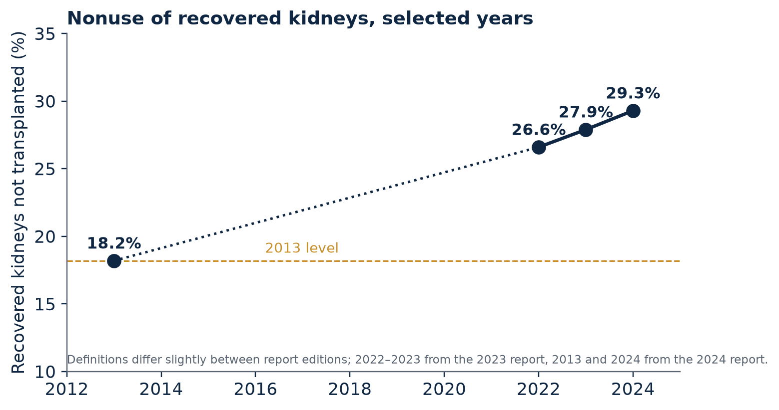
Figure 3.1. Share of recovered kidneys not transplanted, selected years. Sources: OPTN/SRTR annual data reports (2025, 2026b). Definitions differ slightly between editions.

Giving the problem an operational definition
Six Sigma insists on an operational definition: a rule so precise that two people applying it independently would count the same defects. Let me propose one. The unit is a recovered kidney. A defect is a recovered kidney that is not transplanted. The opportunity count is one per kidney. By these conventions, the defect rate in 2024 was 29.3%, or 293,000 defects per million opportunities.
By the usual convention of the discipline, which includes a long-term allowance of one and a half standard deviations of drift, that rate corresponds to a sigma level of roughly 2.04. For comparison, the 2013 rate of 18.2% corresponds to about 2.41, the 2023 rate to about 2.09, and a mature, well-controlled process, often described as operating at four sigma, would show about 6,200 defects per million, which is 0.6% (George et al., 2005). I calculated these values myself and they are illustrations, not official statistics.
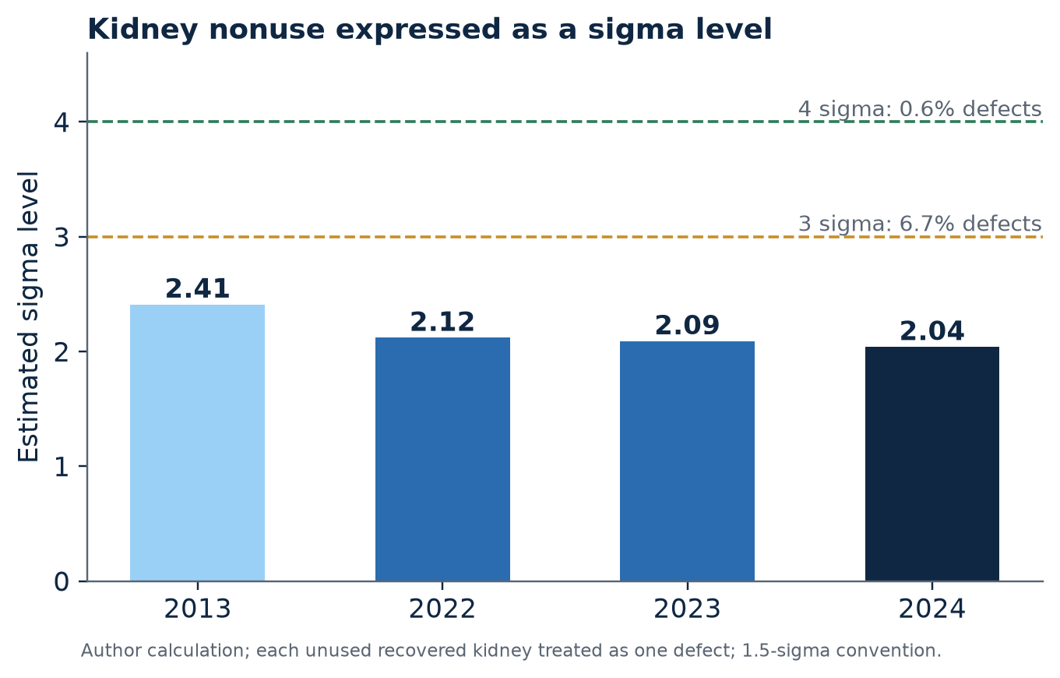
Figure 3.2. Estimated sigma level of kidney nonuse, 2013–2024, treating each unused recovered kidney as a defect. Author’s calculation from published nonuse rates.
A fair critic will object that not every unused kidney is a defect. Some organs are genuinely unsuitable, because of disease, injury, or anatomical problems, and no process could have transplanted them. That objection is correct, and it is the reason a real improvement project would begin by classifying each unused kidney as either unavoidable or potentially avoidable, using agreed criteria, and publishing the split. I do not know what that split is. I do know that the registry already records stated reasons, which means the raw material for the classification exists. The most useful single thing a policymaker could do about nonuse would be to ask for the Pareto chart, the ranked bar graph of reasons named for the Italian economist Vilfredo Pareto and made a staple of quality work by Joseph Juran (Juran, 1951). If three reasons account for most of the loss, the improvement target is obvious. If the reasons are diffuse, the target is the process itself.

The reading: what the arithmetic of nonuse implies
Here is a calculation that requires no special data. For every one thousand kidneys recovered, a nonuse rate of 29.3% means 293 are not transplanted. At the 2013 rate of 18.2%, the figure would have been 182. The difference is 111 kidneys per thousand recovered. I stress the proportion because the registry’s absolute counts shift with each year’s donation volume, but the proportion travels cleanly: if the system could return to the performance of a decade earlier, roughly one additional transplant would result for every nine recovered organs.
It would be glib to assume that recovery is easy. The report that documents the rise in nonuse also notes that broader geographic organ sharing, introduced to improve equity, has coincided with longer cold ischemia times and higher rates of delayed graft function, and it characterizes the progress of recent years as offset by those costs (SRTR & OPTN, 2026a). I read this as an honest admission that the system pursued one virtue, wider fairness in sharing, and incurred a cost in another, speed and organ condition. Well-run improvement projects expect trade-offs of this kind and treat them as inputs to design, and not as occasions for assigning blame.
I will lay out the competing explanations for rising nonuse so the reader can see which ones the record supports and which it merely invites. Donor drift: donors are, on average, older and sicker than they were, and some of the rise is real. Risk aversion: centers may decline marginal kidneys to protect their outcome statistics, a hypothesis frequently voiced and not directly quantified in the literature available to me. Logistics: sharing across greater distances adds hours. Placement bandwidth: the sequential offering of a kidney down a list consumes time that the kidney does not have. Information gaps: clinicians cannot see what they cannot measure, as the hepatitis C example suggests. The record supports the second-to-last of these most concretely, and the last most elegantly. It leaves the first and the second open.

What Chapter 4 asks of the reader
I would like the reader to carry one thought forward. A nonuse rate of 29.3% is not an accusation against any single surgeon or coordinator, and it should not be received as one. It is a property of the system as a whole, the way the failure rate of an assembly line is a property of the line. A property of a system can be changed only by changing the system, and a system changes when someone with authority decides that a published number is intolerable. That is the sense in which the number should embarrass us. It is not a verdict on anyone’s character. It is a verdict on our patience.

Chapter 5: The Gate Before the Gate
“Hope deferred maketh the heart sick: but when the desire cometh, it is a tree of life.”
Proverbs 13:12 (King James Version, 1611)

A funnel with five mouths
The list is not the first queue. Before a person can wait for a kidney, that person must pass through a series of gates, and each gate narrows. They must be told that transplantation is possible. They must be referred to a center. They must be evaluated. They must be accepted for listing. Only then does the organ-allocation process, the one that makes headlines, even begin. Quality engineers have a name for the cumulative performance of such a sequence. They call it rolled throughput yield, and it is computed by multiplying the pass rates of each stage.
A hypothetical will show why this matters. Suppose each of five gates passed eighty percent of the patients who reached it. Each stage would look respectable, but the rolled yield would be 0.8 multiplied by itself five times, or about 33%. Two out of every three patients would have exited before reaching the list. I offer these figures as arithmetic and not as findings, since the real stage-by-stage rates are not published in the sources I could reach. The purpose of the illustration is to explain why a system can be full of conscientious people at every gate and still lose most of its candidates in transit.

The record: who is told, and who is not
A national analysis of the federal forms that dialysis facilities file when a patient begins treatment, covering 133,414 patients between 2007 and 2019, found that 15% had not received information about transplantation (Villani et al., 2024†). Patients who were not informed were more often older, female, white, and covered by Medicare. Those who were informed reached the waiting list sooner and spent less time waiting. The study also found something subtler, a finding that complicates any simple story about corporate behavior: patients at chain facilities were more likely to be informed, yet that did not translate into higher rates of waitlisting or transplantation. Patients at independent facilities that were acquired by a chain were more likely to be informed after the acquisition but less likely to be added to the list.
An earlier analysis compared what 388 dialysis patients reported with what their clinicians reported to the federal government, and found that clinician-reported discussions about transplantation did not increase a patient’s likelihood of being waitlisted, which led its authors to suggest that better methods of informing patients may be needed (Healio, 2018). The finding is a quiet rebuke to checkbox compliance. A box that says “discussed” can be ticked without anyone having been understood.
Poverty and place leave measurable marks on the path. A cohort study published in 2026 found that more than one in ten maintenance dialysis patients had at least one documented social risk factor, such as transportation insecurity, and that such patients had higher odds of being neither transplanted nor actively waitlisted, with Black and American Indian patients showing higher odds than White patients (Social risk factors and kidney transplant waitlisting among patients receiving dialysis, 2026†). A second 2026 paper found that more than half of adults who began dialysis did so without a prepared vascular access or without any pre-dialysis kidney care, and that these unprepared starts were more common at for-profit and smaller facilities and among patients who were younger, Black or Hispanic, uninsured, not informed of transplantation, or living in high-poverty neighborhoods (Pre-dialysis care and access type, 2026†). A third analysis reported that Black candidates who lived in the most disadvantaged neighborhoods had an adjusted hazard of receiving a transplant of 0.60, with a confidence interval of 0.58 to 0.62, compared with White candidates in the least disadvantaged neighborhoods (Residential neighborhood disadvantage, n.d.†). In plain language, after adjustment the rate of receiving a transplant was about forty percent lower. Staff interviewed across four regions of the country described non-medical barriers, from transportation to documentation to the sheer complexity of the process, as obstacles that clinical eligibility criteria do not capture (Non-medical barriers, 2026†).

The record: ownership and incentives
The most contested piece of evidence in this territory concerns who owns the dialysis chair. A large retrospective study published in 2019 followed 1,478,564 patients across 6,511 facilities between 2000 and 2016 and found that patients treated at for-profit facilities were significantly less likely to be waitlisted than patients at nonprofit facilities (Gander et al., 2019). The senior author attributed the pattern to incentives, noting that for-profit facilities earn higher margins when more patients remain on dialysis. That attribution is an interpretation, and a plausible one. It is not an observed motive, and the study’s ownership categories are heterogeneous. I use it as a hypothesis the data are consistent with, and the fact that the study is seven years old reminds me to say so.
The federal government has tried to move that incentive. Under the ESRD Treatment Choices model, which began in January 2021 and was randomly assigned to dialysis facilities and clinicians in 31% of hospital referral regions, payments are adjusted according to a facility’s rates of home dialysis, waitlisting, and living-donor transplantation (CMS, 2025). The first-year evaluation reported that 663 patients were added to the waiting list among participating facilities, a 4% increase over the pre-model rate. After three years, the evaluators’ summary concluded that the model had no impact on waitlisting or on living-donor transplant rates, the two outcomes it was explicitly designed to move (CMS, 2025). I classify this as Grade B, since I read a summary and not the full evaluation.

The reading: when a modest incentive fails, what does that teach?
If a payment adjustment that targets the waitlist does not change waitlisting, there are at least three explanations. The first is that the adjustments were too small to alter behavior against a competing incentive that is larger. The second is that the bottleneck does not lie with the dialysis facility at all but with the downstream capacity of transplant centers to evaluate and list additional patients. The third is that the barriers lie with patients, in transportation, documentation, and distrust, which a facility’s payment cannot reach. The evidence in this chapter is consistent with all three, and a well-designed project would look to separate them by comparing facilities with similar incentives and different downstream capacity.
What the findings do not support is a comfortable conclusion that the referral gap is a problem of attitude that will yield to exhortation. Telling dialysis staff to care more has been tried. The result, as measured, is a 15% rate of patients who were not informed at the start (Villani et al., 2024†), a gap between clinician-reported discussion and actual waitlisting (Healio, 2018), and a persistent shadow of poverty over the likelihood of receiving a kidney (Residential neighborhood disadvantage, n.d.†).

A conservative argument for publishing facility-level numbers
This is the first place where I will put an argument on the table that readers of different political leanings may weigh differently. Facility-level waitlisting rates, adjusted for patient mix and published in an accessible, searchable form, would give patients and referring physicians information that no payment model can supply. This is not a regulatory burden of the heavy kind. It is a disclosure. It is also the kind of reform that a market-minded observer should favor, since markets work only when buyers can compare, and a patient choosing a dialysis facility is, at present, comparing blind. If the incentive to keep a patient on dialysis is real, the antidote is not a new bureaucracy. It is daylight.

Chapter 6: The Clock
“Life is short, and Art long; the crisis fleeting; experience perilous, and decision difficult.”
Hippocrates, Aphorisms I.1 (Adams translation, 1849)

Why the cooler matters
A kidney removed from a donor is cooled and flushed with a preservation solution, and from that moment it lives on borrowed time. The interval between the cessation of its blood supply and the restoration of circulation in the recipient is called the cold ischemia time, and it is the namesake of the foundation that sponsors this book. Cold slows the metabolism of the organ, buying hours. It does not stop injury. The longer the interval, the more cellular damage accumulates before the kidney is reconnected to a living circulation.

The record: what an hour costs
The most widely cited estimate of the price of an extra hour comes from a French cohort of 3,839 deceased-donor transplant recipients followed from 2000 to 2011. It found that each additional hour of cold ischemia raised the hazard of graft failure by a factor of 1.013 and the hazard of death by a factor of 1.018 (Debout et al., 2015†). The authors illustrated the effect with an example, noting that a recipient of a kidney with 30 hours of cold ischemia faced a risk of graft failure near 40% higher than a recipient of a kidney with 6 hours. My own extrapolation, compounding the per-hour ratio across the 24 intervening hours, gives about 36% for graft failure and about 53% for mortality. The difference between my number and the authors’ is the difference between a compounded estimate and a rounded statement, and I mention both so that no reader mistakes my arithmetic for theirs.
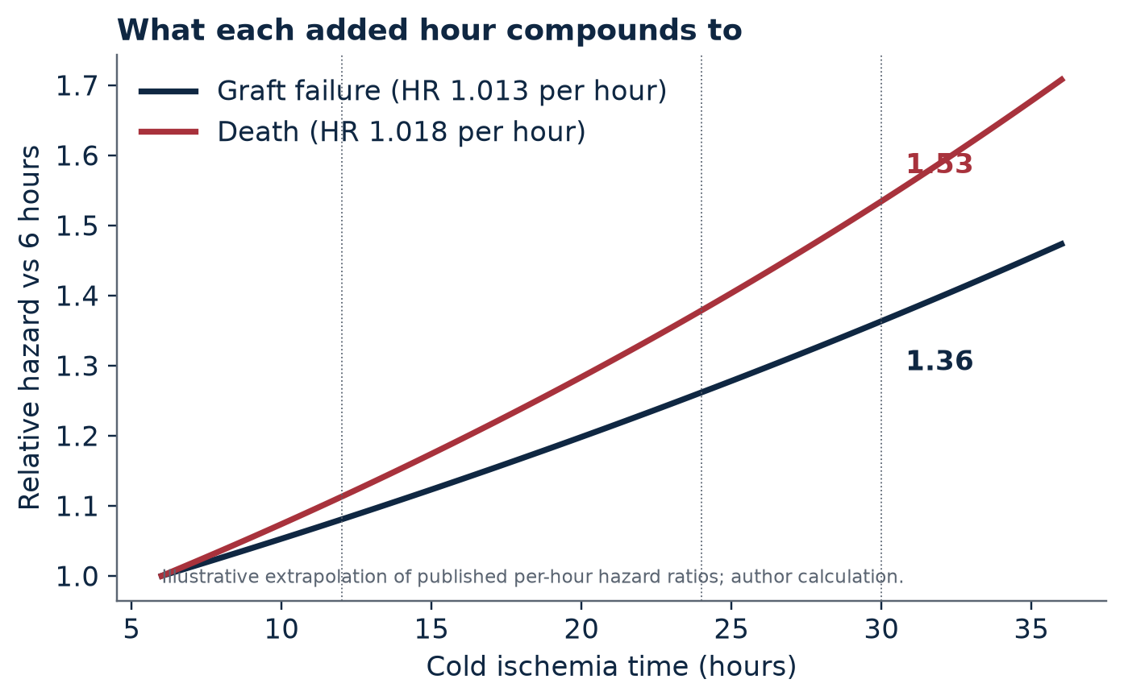
Figure 5.1. Relative hazard of graft failure by cold ischemia time, extrapolated from a published per-hour hazard ratio of 1.013 (Debout et al., 2015†). Author’s calculation; illustrative only.
A recent study offers a threshold perspective. Reported in June 2026, an analysis of 74 pairs of kidneys from older donors, in which the two kidneys of each donor were compared, found that cold ischemia beyond 12 hours, compared with less than 8 hours, was associated with a markedly higher risk of delayed graft function, with an adjusted odds ratio of 6.30 (95% confidence interval 1.52 to 26.06; p = 0.011), and with a tripling of the risk of death, even though death-censored graft survival was not affected (Transplant International, 2026†). The sample is small and comes from a single center, and the confidence interval is wide enough to drive a truck through. The result should be read as a signal worth replicating and not as a rule.
Another analysis estimated that regional sharing added about 2.9 hours to cold ischemia compared with local allocation (Appendix A, item E5). Studies of logistics add texture to the picture. In an analysis of 206 transplant centers, the median cold ischemia time for kidneys transplanted in the same hospital where they were recovered ranged from 3.3 to 29 hours (Appendix A, item E5). Weekend procurement has been associated with a higher chance that a kidney will be discarded and not transplanted, which the authors attributed to factors other than organ quality (Appendix A, item E5). A network analysis of 106,160 kidneys found that more sharing between organ procurement organizations lowered the odds of discard for high-volume organizations and raised them for low-volume ones (Appendix A, item E5). I place these in Grade B because I read them in a single literature summary. Taken together they describe a clock that does not run at one speed.

The record: the case that perfusion technique matters
If time is the enemy, the main weapon on offer is machine perfusion, the practice of continuously pumping cold preservation solution through the organ in place of storing it still on ice. A landmark randomized trial of 672 deceased-donor recipients, in which one kidney from each donor went to each arm, found that machine perfusion reduced delayed graft function and improved one-year graft survival (Moers et al., 2009). A ten-year follow-up was announced in November 2025 by the manufacturer of the perfusion device, which reported a 27% lower risk of graft failure over the full decade, with complete ten-year data for 92% of recipients (Organ Recovery Systems, 2025). I classify the follow-up as Grade C. The announcing party sells the device, the underlying publication carries a designation that may mark it as a letter and not a full trial report, and one summary describes the analysis as post hoc. The result may well be sound. It deserves confirmation from the paper itself before anyone repeats it as settled.

The reading: a continuous variable treated as a cliff
Here is the observation I find most useful in this chapter. The evidence describes the harm of cold ischemia as a slope. Each hour adds a little risk, and the slope may steepen beyond roughly half a day. Yet the behavior of clinicians, when they are offered a kidney, looks like a cliff. A national study of offers made between 2021 and 2023 found that centers varied sharply in their willingness to accept offers for suboptimal kidneys, and that the widest variation, with a median odds ratio of 4.86, concerned kidneys with cold ischemia beyond 36 hours (Quantifying center-level aggressiveness, n.d.†). The same study reported that the 193 adult centers accepted a median of 12.5% of offers for standard kidneys and only 7.2% for suboptimal ones.
When a continuous harm is converted into a binary rule, two kinds of error multiply. Some kidneys that would have served a patient well are declined because they crossed an arbitrary line. Others that crossed no line are accepted without adequate attention to the compounding costs. Quality engineers solve this class of problem with a decision aid that translates a continuous risk into a graded recommendation, one that tells the clinician what the expected benefit and the expected hazard are for this recipient and this kidney. I am not aware that such a tool is standard at the bedside, and I would argue that its absence is a design omission and not a fact of nature.

Make the cold chain visible
A final proposal for this chapter is the simplest in the book. Every kidney should carry a time-stamped record of its journey: clamp, packaging, first offer, each decline, acceptance, departure, arrival, and reperfusion. These events are already observed by someone. What is missing is the routine publication of the intervals, by organization and by center, so that the 3.3-to-29-hour spread can be understood, challenged, and narrowed. A hospital that wishes to explain why its median is high should be given the chance. A hospital that cannot explain it should be given the encouragement. In both cases the patients who are waiting should be able to see the clock that governs their lives.
Having measured, we turn in Part Three to the harder question of cause.

PART THREE: ANALYZE
“He who knows only his own side of the case, knows little of that.”
John Stuart Mill, On Liberty (1859)
Measurement tells you how large the problem is. Analysis tells you what is holding it in place. The method of Part Three is the discipline’s most venerable one: ask why, and then ask why again, and refuse to be satisfied by the first answer that blames somebody’s character. The four chapters that follow examine decision-making, payment, trust, and the one pathway that bypasses most of the machinery, the living donor.

Chapter 7: A Fishbone for a Wasted Kidney
“The one great principle of the English law is, to make business for itself.”
Charles Dickens, Bleak House (1853)

The diagram that shaped postwar quality
Across the middle of the twentieth century, the Japanese engineer Kaoru Ishikawa codified a simple drawing that has since traveled to every industry on earth. A horizontal spine runs toward a box that names the problem, and diagonal bones branch off the spine, each labeled with a category of cause. Ishikawa’s contribution was not mathematical. It was a way of forcing a room full of experts to put their theories on one page, where they could be examined together and discarded or kept on the strength of evidence (Ishikawa, 1976). The diagram earned its nickname, the fishbone, from its shape.
I have drawn one for the problem of Chapter 4, the kidney that is recovered but never transplanted. Traditional manufacturing categories, which are usually remembered as the six M’s, do not translate neatly to organ transplantation, so I adapted them into six categories of my own: people, policy, process, preservation, payment, and patient data.
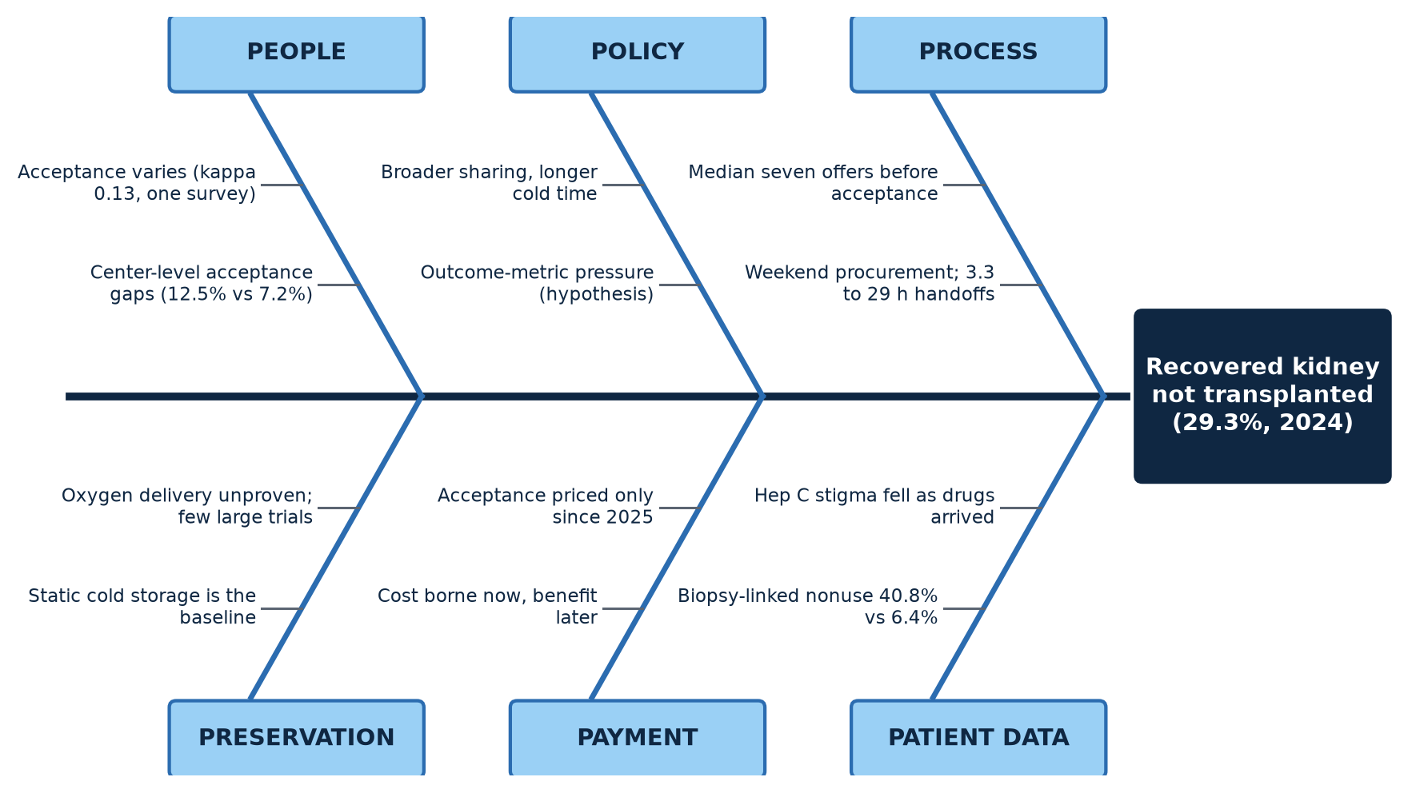
Figure 6.1. Cause-and-effect (Ishikawa) diagram for the problem “recovered kidney not transplanted.” Categories and causes are the author’s analytic hypotheses, each examined against evidence in the text.

People: the variance that lives inside one human mind
The record on decision-making is the most striking in the whole analysis. A national study of kidney offers made between 2021 and 2023 found that the 193 adult centers accepted a median of 12.5% of offers for standard-risk kidneys and 7.2% of offers for suboptimal ones, with the widest center-to-center variation concentrated in kidneys that had endured more than 36 hours of cold ischemia (Quantifying center-level aggressiveness, n.d.†). Variation among centers is not by itself damning, since centers serve different populations and have different surgical teams. The deeper question is whether the variation is explained by anything a patient would recognize as a reason.
Earlier work suggests that much of it is not. A 2017 randomized experiment in which 68 physicians were shown identical kidney offers found that the variation within a single center was roughly ten times greater than the variation among centers (Appendix A, item E2). A 2023 survey of transplant nephrologists reported that agreement among them on whether to accept a specific offer was poor, with a Fleiss kappa of 0.13 (Appendix A, item E2). By the benchmarks that statisticians customarily apply, a kappa between zero and 0.20 indicates only slight agreement (Landis & Koch, 1977). I classify these two findings as Grade B because I read them in a summary, and I treat them as strong hints and not as proof.

Measurement system analysis, applied to a human decision
Manufacturing has a technique for exactly this situation, called measurement system analysis, and its most famous application is the gauge repeatability and reproducibility study, or gauge R&R. The logic is as follows. Before you trust an inspector to reject defective parts, you check whether two inspectors, shown the same parts, reach the same verdicts, and whether one inspector reaches the same verdict on two occasions. If they do not, the inspection system is declared incapable, and no further conclusions are drawn from its output until it is repaired. A factory that discovered kappa of 0.13 among its inspectors would stop the line.
Kidney acceptance is an inspection. A human being examines a limited information packet about a donor and an organ, compares it with a prospective recipient, and issues a verdict that is irreversible for that organ. I do not claim that any individual decision is wrong. I claim that the system, taken as a whole, may be working with an inspection process whose reproducibility has never been publicly established. If that is true, the unused kidney is the visible product of an invisible variance.

Policy and process: sharing, sequencing, and the weekend
The officially published verdict on policy is worth quoting at the level of paraphrase. The 2024 annual data report observes that progress has been offset by rising nonuse, longer cold ischemia times, and higher rates of delayed graft function under broader geographic organ-sharing policies (SRTR & OPTN, 2026a). That sentence is an unusually candid one for a federal publication, and it should be read as a design review. A policy changed the geometry of the system, expanding the territory over which a kidney can be offered, and the geometry’s side effects are now appearing in the numbers.
The process around the policy contributes its own friction. An organ is offered to one candidate after another in a defined order, and a decline sends the offer to the next in line. Earlier registry analyses found that a deceased-donor kidney was offered a median of seven times before it was finally accepted (Appendix A, item E2). Every extra offer consumes minutes and, more often, hours. The rate at which kidneys procured on weekends are discarded, compared with those procured on weekdays, has also been reported as higher, which the authors attributed to factors other than organ quality (Appendix A, item E5). If that is true, the cause is not the kidney. It is the calendar.

Patient data: when information is the missing organ
The two details from the registry that I highlighted in Chapter 4, the biopsy rate and the hepatitis C trajectory, belong on this bone. A kidney’s fate is conditioned by what clinicians think they know about it, and what they think they know depends on tests whose results are imperfect and interpreted by tired people. Where a decision aid does not exist, intuition fills the vacuum, and intuition is where a kappa of 0.13 comes from.

Preservation and payment
Two bones remain, and I address them at greater length in later chapters. Preservation technology, the subject of Chapter 12, can in principle widen the margin of time and function that a kidney has. Payment, the subject of Chapter 8, determines whom the system rewards for taking a chance. I mention them here only to complete the diagram and to note that, in a well-formed analysis, no category is allowed to monopolize the blame.

A five-whys example
The final tool of this chapter is the humblest. The five whys technique asks a question and answers it, then asks why about the answer, and repeats until the chain reaches a cause that someone has the power to change. I offer an illustration, built from the elements assembled so far. It is a thought experiment and not a case study.
Why was this kidney unused? Because no recipient was located in time. Why was no recipient located? Because the offers were declined in sequence until the clock ran out. Why were they declined? Because each center’s clinician judged the kidney marginal for that center’s candidates. Why did the clinicians reach that judgment? Because the information available was limited and the decision was made under time pressure without a structured aid. Why was there no structured aid? Because no authority owns the quality of the acceptance decision, and no public measure exposes its variance.
Notice where the chain ends. It does not end at a wicked clinician. It ends at an unowned decision and an unpublished measure. That is a sign that the fish has been correctly filleted.

Chapter 8: Who Is Paid for What
“Interest speaks all sorts of tongues, and plays all sorts of parts, even that of disinterestedness.”
François de La Rochefoucauld, Maxims, No. 39 (Bund and Friswell translation, 1871)

An incentive map
Economists argue about almost everything, but they agree that behavior follows reward, and the reward structure of the kidney system is among the most intricate in American medicine. I have drawn a map of the principal payment streams and measures, and the reader will notice immediately that the arrows do not converge on a single objective.
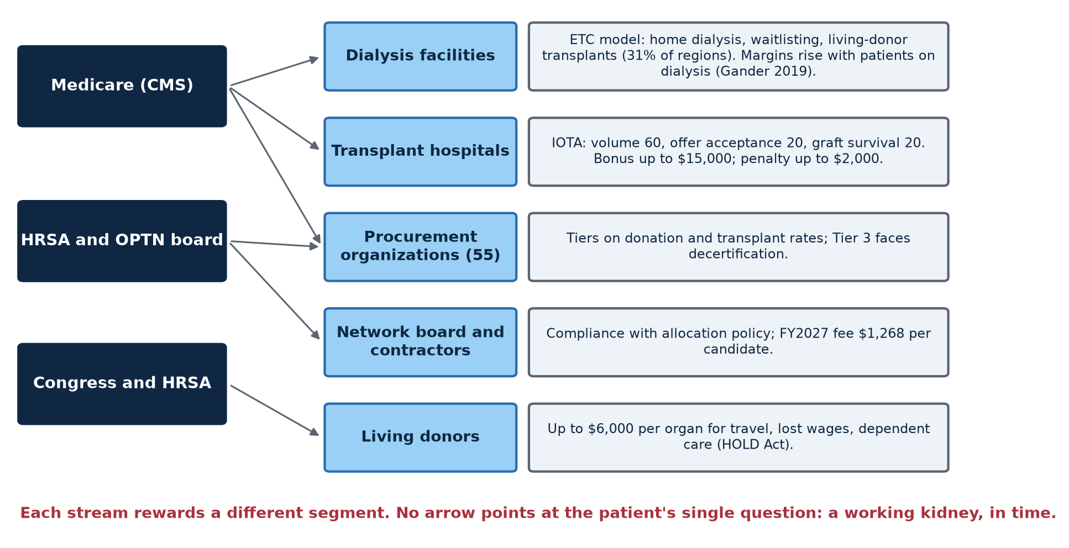
Figure 7.1. Incentive map: who is measured or paid for what in the kidney pathway, as of October 2026. Author’s synthesis of sources cited in this chapter.

The record: the dialysis side
The Medicare Payment Advisory Commission reported in July 2026 that fee-for-service Medicare spent $7.6 billion in 2024 on dialysis, dialysis drugs, and related laboratory tests, a decline of 6% in nominal terms from the year before, a fall it attributed in large part to the growing enrollment of dialysis beneficiaries in Medicare Advantage plans since 2021 (Medicare Payment Advisory Commission [MedPAC], 2026). The same source reports that the number of patients with kidney failure grew by about one percent a year between 2019 and 2023, and that nearly 44% of them were over 65 in 2023.
The figure is noteworthy because it understates the magnitude of the system’s economic weight. It excludes Medicare Advantage spending, and it excludes the care of patients covered by Medicaid and private insurers. What it illustrates is the scale of a revenue stream attached to the continuation of treatment. As I noted in Chapter 5, the senior author of the 2019 ownership study explained the lower waitlisting rates at for-profit facilities by observing that margins rise with the number of patients on dialysis (Gander et al., 2019). I do not allege that any provider acts on that incentive deliberately. I allege only that the incentive exists, that it points away from transplantation, and that a prudent designer would not rely on goodwill to offset it.

The record: the hospital side
On 1 July 2025, the Centers for Medicare & Medicaid Services launched the Increasing Organ Transplant Access model, a mandatory payment model that runs until 30 June 2031. In its first performance year the model covered 103 kidney transplant hospitals in roughly half of the country’s donation service areas, with the remaining areas serving as a comparison group, and 95 hospitals were selected for the second year (CMS, n.d.). The first year carried upside risk only, so hospitals could earn bonuses but could not be penalized. The second year adds downside risk.
Performance is scored out of 100 points across three domains. Achievement, measured by transplant volume, carries 60 points. Efficiency, measured by the rate at which a hospital accepts organ offers, carries 20. Quality, measured by graft survival, carries the final 20. A hospital can earn up to $15,000 for each Medicare kidney transplant it performs, and can be charged at most $2,000 (CMS, n.d.). A 2026 final rule, as I understand it from a secondary account, raised the minimum volume required for inclusion from 11 kidney transplants to 15 (Appendix A, item C1). The model’s first-year results have not been published, and the performance year closed only on 30 June 2026.

The reading: the first price on an acceptance decision
I want to draw attention to the 20-point efficiency domain, because it is the first mechanism I have encountered in federal policy that attaches money to the very decision I examined in Chapter 7. For decades the offer-acceptance decision was regulated by norms and peer expectation, with no explicit price. The new model creates one, and it creates a counterweight in the quality domain, since a hospital that accepts more marginal kidneys will see its graft survival suffer if the judgment was wrong. That is an elegant piece of design, in the sense that it addresses both sides of a trade-off.
Yet the model also tells us what its designers believe. A payment structure encodes a theory of the problem, and this one encodes the theory that hospitals decline too many usable offers and perform too few transplants. The asymmetry between a $15,000 maximum bonus and a $2,000 maximum penalty, a ratio of seven and a half to one, encodes a second belief: that the program should recruit participation before it demands sacrifice. Whether those theories hold is an empirical matter that the first year’s data will begin to answer.

The record: the organ procurement side
The 55 organ procurement organizations that recover organs from deceased donors operate as designated monopolies within defined service areas. Since 2020 they have been measured by two rates, a donation rate and a transplantation rate, and sorted into three tiers. The top quarter are placed in Tier 1 and are automatically recertified. Organizations that fall below the median on either rate are placed in Tier 3 and face decertification. Tier 2 organizations in between must compete to retain their service areas (Holland & Knight, 2026). The first recertification cycle ran from 1 August 2022 to 31 July 2026, and federal officials stated that Tier 3 organizations’ contracts would remain in effect through 31 January 2027 to allow time for appeals and to prevent disruption (Holland & Knight, 2026).
The rule that governs the transition remains in motion. A proposed rule published in the Federal Register on 30 January 2026 would decertify an organization that places in Tier 3 in all of its service areas, would grant a right to appeal the removal of any Tier 3 service area, and would clarify the administrative appeal process (CMS, 2026). Federal officials have said they expect a final rule in late 2026, with recertification and decertification actions to follow sixty days after it takes effect (Holland & Knight, 2026). I searched for a published roster of the organizations that would fall into Tier 3 in the 2026 cycle and did not find one. In an authoritative sense, the outcome of the first great competition among monopolists has not yet been announced.
A peer-reviewed analysis published in the journal Transplantation reached a finding that deserves to be quoted carefully. It reported that the organizations projected to fall into Tier 3, and so face automatic decertification, serve disproportionately high shares of non-White populations across the 55 organizations (Centers for Medicare and Medicaid Services performance metrics and the disproportionate impact of decertifying organ procurement organizations on minority populations, n.d.†). One reading of that finding is that the metrics, by failing to adjust for community characteristics, penalize organizations that serve disadvantaged communities. A second reading is that persistent underperformance in those communities is exactly what the tiers were designed to expose. I have not found, in the sources available to me, a rigorous attempt to adjudicate between the readings, and I regard the absence as a notable gap.

The reading: a contestable monopoly
A conservative economist will find something familiar in the tier system. Natural monopolies cannot be eliminated, since a donation service area is a geographic franchise, but they can be made contestable. The theory of contestable markets holds that a monopolist who knows a rival may take its place behaves more like a competitor than one who does not (Baumol et al., 1982). The tier system is an attempt to create that threat. Tier 2 organizations must compete, and Tier 3 organizations face loss of their franchise. If the threat is credible, the incentive to improve is real.
The threat is credible only if it is carried out. A decertification rule that is written but not executed teaches the regulated industry that the rule is theater. The nation witnessed one real act of enforcement in September 2025, when HHS decertified an organ procurement organization in Miami mid-cycle, a step the Secretary described as the first of its kind (Fierce Healthcare, 2025). I take up that episode in the next chapter, where the subject is trust.

The danger of a good metric
No analysis of incentives would be responsible without a warning, and the warning has a name. The anthropologist Marilyn Strathern put it in a form that has become canon: when a measure becomes a target, it ceases to be a good measure (Strathern, 1997). Every metric described in this chapter is vulnerable to the pattern. A transplant-volume score can be inflated by transplanting patients who would have done well anyway. A graft-survival score can be protected by declining difficult cases. An offer-acceptance rate can be improved by accepting offers that should be declined. A donation rate can be raised in ways that endanger a potential donor.
For that reason I would argue that metrics must be published in constellations and not in isolation. A hospital’s transplant volume should be shown beside its graft survival and its acceptance rate, adjusted for case mix, so that anyone who games one number reveals themselves in another. This is not a radical idea. It is the central insight of balanced measurement, and it is overdue.

Chapter 9: The Interregnum
“Quis custodiet ipsos custodes?” (“Who will guard the guards themselves?”)
Juvenal, Satires, VI.347–348 (c. 120 CE)

Governance is also a process
Most of this book treats the transplant system as a pipeline that moves patients and organs. A second pipeline runs alongside it, and it moves decisions. A policy begins as an idea, passes through a committee, goes out for public comment, is voted on by a board, is approved by a federal agency, is implemented by hundreds of organizations, and is then, in theory, monitored for its effects. Each stage takes time, each handoff can lose information, and the cycle time of the whole determines how quickly the system can correct itself. If the pipeline of organs is measured so poorly, it is worth asking how well the pipeline of decisions is measured.
The past six months have made that pipeline unusually visible, because it has been under repair. The national transplant network, which writes the rules for allocation, has been in the midst of a multiyear reconstruction directed by the federal oversight agency. For the purposes of this chapter I call the present period an interregnum, a stretch in which the old arrangements have been dismantled and the new ones are not yet proven. What follows is a close reading of what the record shows.

The record: a timeline of 2026
When | What happened | Source
January | The oversight agency reported an independent, elected board separate from the contractor structure, standardized allocation compliance reports for all 55 organ procurement organizations, and the start of safety and quality standards, beginning with those organizations | HRSA, 2026a
30 January | Proposed federal rule on organ procurement certification published | CMS, 2026
3 February | Honor Our Living Donors Act enacted | Appendix A, item G3
3 April | Board filled a vacancy and extended its president’s and vice president’s terms by a year, citing contractor transitions and funding interruptions | HRSA, 2026b
May | Patient safety and compliance task order awarded | HRSA, 2026c–2026f
1 July | New officers took office; comment requested on living donor reimbursement rules | HRSA, 2026c–2026f; HRSA, 2026g†
August | New requirements for donation after circulatory death approved; workgroup on international transplant policy convened | HRSA, 2026c–2026f
September | A standing oversight committee ended; board met in person 28 and 29 September | HRSA, 2026c–2026f
1 October | Higher patient registration fee and new ventilated patient form took effect | HRSA, 2026c–2026f
Late 2026 (expected) | Final rule on procurement organization certification | Holland & Knight, 2026
31 January 2027 | Contracts of organizations placed in the lowest tier remain in effect through this date | Holland & Knight, 2026

Several items in the table deserve elaboration. The April decision to extend the terms of the board’s president and vice president came with an admission. The board stated that recent disruptions, including contractor transitions and funding interruptions, had impaired its ability to move initiatives forward (HRSA, 2026b). In plain language, a body charged with improving the system reported that the machinery of the system itself had interrupted its work. Few organizations in any sector would publish such a sentence without discomfort, and I take its candor as a point in the agency’s favor.
The oversight agency awarded a task order for policy and committee support, which covers policy development, committee operations, implementation, education, and post-implementation monitoring, and a separate task order for patient safety and compliance, awarded in May 2026 to a technology contractor in partnership with a research organization (HRSA, 2026c–2026f). A separate research organization holds a five-year contract for governance and transparency work, including the nomination and election of an independent board (American Institutes for Research, n.d.). The board approved a patient registration fee of $1,268 for fiscal year 2027, up from $1,036, a rise of about 22%, by a vote of 26 to 1 (HRSA, 2026c–2026f). To give a sense of scale, and only as an arithmetic illustration, if the new fee applied to each of the 50,481 patients added to the kidney list in 2024, it would total roughly $64.0 million, against roughly $52.3 million at the old rate (SRTR & OPTN, 2026a). That calculation is not an accounting of actual revenue, since the fee may not apply to every registration and covers organs other than the kidney.

The reading: four patterns worth naming
Key-person and contractor risk. A governance structure that depends on one-year extensions of its leaders and on sequential contracts to vendors is fragile in the engineering sense. Reliability engineers call a component whose failure disables the whole a single point of failure. The April admission suggests that at least some points of failure were reached.
The dispersion of control. In September the board ended a standing committee that had overseen network operations, stating that technology and network oversight would continue through other committees and workgroups (HRSA, 2026c–2026f). Consolidation can be efficient. From the standpoint of a control plan, however, replacing a body whose single job is to watch a function with a diffuse responsibility shared among several bodies carries a risk. A function that everyone is partly responsible for may be, in practice, no one’s. I do not claim that this has happened. I claim that it is the pattern a control engineer would watch.
The value of daylight. The board met in person in late September with its open sessions livestreamed (HRSA, 2026c–2026f). That is a meaningful transparency measure, and it should be recognized as one. A public meeting is the beginning of accountability and not its end, because the audience matters, and a livestream with an audience of a few dozen insiders is less a window than a skylight.
The absence of independent observers. The sources I reviewed for this chapter were overwhelmingly the agency’s own monthly updates. I searched for independent press coverage or academic commentary on these decisions and did not find it. That does not mean it does not exist. It does mean that a patient trying to understand how the rules of allocation are changing must rely very heavily on the regulator’s description of its own work. The remedy is for independent organizations, patient groups, universities, and foundations such as this one to attend, summarize, and challenge. A system watched only by its operators is a system that has not yet been audited.

Two decisions I could not evaluate
I want to be candid about two decisions that bear directly on this book’s themes and whose texts I could not retrieve. The first is the board’s new set of requirements for donation after circulatory death, which the agency described as strengthening protections for potential donors and promoting greater consistency and accountability (HRSA, 2026c–2026f). Having devoted Chapter 10 to the events that provoked them, I would like to say whether the requirements are adequate. I cannot, because the agency’s summary does not state their content. Readers who care should read the text, and I would urge the board to publish a plain-language explanation with each new requirement.
The second is the new ventilated patient form, which replaces two legacy reporting mechanisms with what the agency calls a standardized approach intended to improve data quality while reducing the burden of reporting (HRSA, 2026c–2026f). It is exactly the kind of change that might improve the measurement problems described in Chapter 3, or might merely reshuffle them. Whether it does will be visible only if the data it produces are published in a form that allows comparison with the past.

A process-improvement question for the policy pipeline
A Lean practitioner would map the policy pipeline as a value stream and time every stage. How many days elapse between a problem being identified and a rule taking effect? How many proposals die in committee, and why? How long does public comment take, and how often does it change the outcome? What fraction of approved policies are evaluated afterward, and what happens when the evaluation is unfavorable? I have not found published answers to these questions, and I suspect the answers do not exist in compiled form. The stated scope of the policy-support task order includes post-implementation monitoring (HRSA, 2026c–2026f), and that is a hopeful sign. If it produces a published record of the cycle times and the results, the nation will have, for the first time, a measure of how quickly its transplant system learns.

What the interregnum asks of patients
It is easy to treat governance as remote. A patient waiting for a kidney has more urgent matters. But the rules written in these committees decide who is offered an organ and in what order, how a potential donor’s death is determined, what a transplant program is paid, and whether a fee is raised. A body that makes decisions of that weight deserves a public that is watching, and the public includes patients and care partners, who have more at stake than anyone. A modest practice would help: choose one of the board’s open meetings each year, read the agenda beforehand, and listen. The system is easier to improve when the people it serves are in the room, even if the room is a livestream.

Chapter 10: Trust Is a Process Variable
“It may seem a strange principle to enunciate as the very first requirement in a Hospital that it should do the sick no harm.”
Florence Nightingale, Notes on Hospitals (1863)

Why a quality book needs a chapter on trust
Engineers sometimes treat trust as a soft variable that lives in the marketing department. In the donation system that classification is a category error. Every deceased donation begins with a decision made by a grieving family, and that decision depends on a belief that the process which follows will be honest. Every registration on a state donor list is an act of advance trust. If belief erodes, supply contracts, and no allocation algorithm in the world can distribute organs that were never offered. Trust is therefore an input to the process in precisely the way a raw material is, and it can be depleted by the same carelessness.
This chapter examines the most consequential trust failure of recent years, together with the federal response and the regulatory action that followed. It is also the chapter where the discipline of separating fact from finding, allegation, and rumor matters most, because the subject is emotionally combustible and the temptation to repeat the most frightening version of every story is intense. I will therefore begin with a map of the vocabulary.
Fact, finding, allegation, rumor
Fact: a measurement that anyone can reproduce, such as the date on which an agency issued a report.
Finding: a conclusion reached by a body with authority and a stated method, such as a federal investigation. A finding is not a verdict in a court of law, and its precise wording matters.
Allegation: a claim made by a party to a dispute that has not been adjudicated, such as a complaint by a family or a defense by an organization.
Rumor: a claim with no traceable origin, or one whose origin is a retelling of something stronger than the original said.

The record: what the federal investigators reported
In March 2025, the Division of Transplantation within HRSA completed a report on its investigation into Kentucky Organ Donor Affiliates, an organ procurement organization that had since merged with a neighboring Ohio organization and now operates as Network for Hope (HRSA Division of Transplantation, 2025). The investigators reviewed roughly 350 cases in which a planned organ recovery had been authorized but was ultimately not completed. In 73 of those cases, they concluded that officials should have considered halting the process sooner because the patients had high or improving levels of consciousness. In 20.8% of the cases, the report found features that were not conducive to donation after circulatory death in the patient’s initial or subsequent neurological status. In at least 28 cases, representing 8.0% of the total, the records showed no documented time of cardiac death, which the investigators described as suggesting potential survival to hospital discharge (HRSA Division of Transplantation, 2025).
A summary issued by the Department of Health and Human Services in July 2025 stated that concerns were identified in 103 of 351 cases (Appendix A, item B5). The Energy and Commerce Committee of the House of Representatives held an oversight hearing on 22 July 2025 and afterward sent a bipartisan letter to HRSA (U.S. House Committee on Energy and Commerce, 2025). The agency ordered corrective actions that included a root-cause analysis and a policy under which any staff member may halt a donation. It directed the national transplant network to report every instance in which donation is paused over a safety concern, and to propose, for public comment, safeguards for patients who are candidates for donation after circulatory death. HRSA also stated that it had received reports of similar patterns at other organizations (HRSA Division of Transplantation, 2025).
The procedural history is part of the record. A review committee of the national network had closed a related case on 24 September 2024 without further action, and on 1 October of that year HRSA directed the network to reopen the matter (HRSA Division of Transplantation, 2025). The organization has disputed characterizations of its practices, and it has stated that it obtained a notice of full compliance following a separate audit by the Centers for Medicare & Medicaid Services (Appendix A, item B5). A widely reported individual account, concerning a man whose family says he showed signs of life as removal was prepared, has been contested by the organization, and I treat it as an allegation (Appendix A, item B5). A 2026 Kentucky bill, House Bill 510, titled an act relating to organ donation safety, noted that existing state law does not expressly require a pause in procurement when new indications of life arise and sought to address that gap; I could not confirm whether it passed (Kentucky General Assembly, 2026†).

The record: what the board and the regulator did next
By late summer 2026, the network’s board had adopted new rules for donation after circulatory death, which the oversight agency described as strengthening protections for potential donors and promoting greater consistency and accountability (HRSA, 2026c–2026f). The agency also reported the launch of standardized allocation compliance reports for all 55 organizations and the beginning of work on comprehensive safety and quality standards for organizations in the network, starting with the procurement organizations (HRSA, 2026a). Beginning on 1 October 2026, organizations moved to a new ventilated patient form designed to replace two legacy reporting mechanisms (HRSA, 2026c–2026f).
On the regulatory side, in September 2025 the federal government decertified a Miami-based procurement organization, Life Alliance Organ Recovery Agency, a division of the University of Miami Health System. The Secretary of Health and Human Services described the step as the first mid-cycle decertification of such an organization, and cited unsafe practices, inadequate training, chronic underperformance, understaffing, and paperwork errors (Fierce Healthcare, 2025; United Press International, 2025). The organization stated that it would not appeal and would cooperate with the transition. Separately, leaders of two House committees asked the organization for documents connected with reports of a Medicare fraud scheme. That is an allegation, and no finding has been announced in the accounts available to me.

The record: what the public did
The clearest measurement of trust in this entire story comes from the national registry of donors. In the week after news coverage of the Kentucky allegations in October 2024, an average of 170 people per day removed themselves from the national registry, which was ten times the rate in the same week of 2023. That count did not include requests sent by email or removals from state registries. The head of the national association of procurement organizations observed that organ donation is based on public trust, and that when it erodes, it takes years to regain (Associated Press, 2024). I found no published data showing whether registrations recovered in 2025 or 2026. That absence is itself worth noting. A system that measures its trust only when a crisis forces it to has chosen not to measure it.

Rumor control
The vocabulary introduced at the beginning of this chapter can now be applied to some of the sentences that have circulated about these events.
Claim as commonly repeated | Where it stands
“Dozens of patients were not dead when removal began.” | Overstated. The federal report found no documented time of cardiac death in at least 28 cases and described this as suggesting potential survival. That is a documentation finding with a worrying implication, and it is not a finding that 28 living patients underwent removal.
“A patient woke up on the table.” | An allegation from a family, disputed by the organization. It is not, in the sources I reviewed, a federal finding.
“The problem is limited to one organization.” | Not established. The agency stated that it had received reports of similar patterns elsewhere, but it did not publish the details.
“The decertified Miami organization committed Medicare fraud.” | Unsupported as stated. Document requests were reported; no finding was announced.
“Registrations collapsed.” | Partly true and incompletely measured. A tenfold spike in removals occurred in one week of 2024; longer-term effects are unreported.

The table is useful for a reason beyond its content. Notice how little distance separates a careful sentence from an inflammatory one. The change from “no documented time of cardiac death” to “not dead” consists of a few words, and the change from “alleged” to “proved” consists of one. Anyone who intends to advocate for patients must learn to resist the second kind of sentence, even when it would help the cause, because a cause built on an overstatement will sooner or later be discredited by the first reader who checks.

The reading: safety and supply are not opponents
A superficial reading of this episode sets safety against supply, as if every additional safeguard costs a kidney. I reject the framing for a reason that is both ethical and operational. The ethical reason is the one Florence Nightingale stated in the passage that opens this chapter: a medical institution must first avoid harm. The operational reason is that donation depends on belief, so a process that damages belief destroys the very resource it was built to harvest. Stronger safeguards at the moment of death determination are not a tax on supply. They are its insurance.
I would go further and argue that the Kentucky episode exposes a classic quality failure, which is the absence of a stop-the-line right. In the Toyota production system that gave Lean its name, any worker who sees a defect may halt the line without asking permission, because the cost of a halt is small beside the cost of a defect that reaches the customer (Liker, 2004). The corrective action that now allows any staff member to halt a donation is that principle transplanted into medicine. It is welcome. It would have been more welcome a decade earlier.
I would also argue that organizations granted exclusive franchises must expect to be examined without flattery, and that a regulator who examines them publicly is serving the donors and not betraying them. If the system is as good as its advocates say, it has nothing to fear from the light. If it is not, the light is the only disinfectant that has ever worked.

Chapter 11: The Living Donor Paradox
“The only gift is a portion of thyself.”
Ralph Waldo Emerson, “Gifts,” Essays: Second Series (1844)

The route around the shortage
If the deceased-donor pathway is a long chain with many seams, the living-donor pathway is a short one. A living donor can enter the process on their own initiative, the operation can be scheduled in advance, the cold ischemia time is measured in minutes and not in hours, and the transplanted kidney tends to last longer. In the old cohort data cited in Chapter 1, five-year survival was about 87.0% after a living-donor transplant against 73.7% after a deceased-donor transplant (USRDS, 2014). A system serious about shortening the list would treat living donation as its most efficient lever.

The record: where living donation stands
The numbers are modest and the sources are mixed. One report, drawing on registry data, states that 6,522 living people donated a kidney in 2025, up from 6,419 in 2024 and 6,290 in 2023, and notes that these totals were the highest since before the pandemic, since 6,867 living donors gave kidneys in 2019 (PhillyVoice, 2026†). I classify that as Grade C, because I could trace the figure to a single news article and not to the registry itself, and I recommend that anyone quoting it verify it against the official registry. If it is accurate, the trend is encouraging and the level is still below the pre-pandemic benchmark.
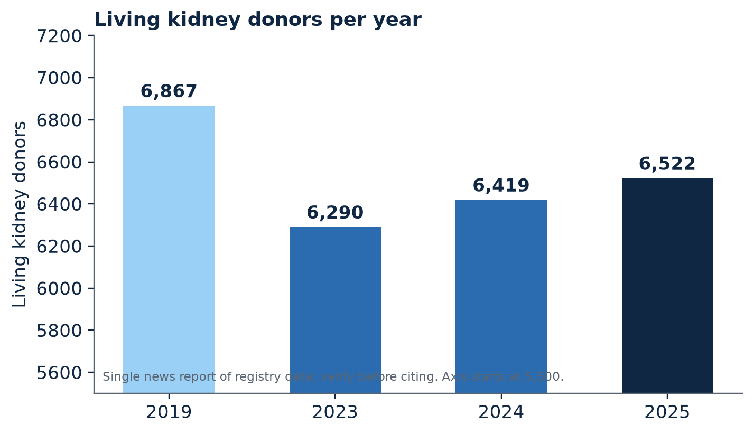
Figure 9.1. Living kidney donors per year, selected years. Source: single news report of registry data (PhillyVoice, 2026†); verify against OPTN before citing.
The longer arc of living donation is less flattering. An older analysis reported a steady decline in living kidney donation after a peak in 2004, most pronounced among men, Black adults, and younger and lower-income adults (Appendix A, item G2). The pattern is not uniquely American. A 2026 article reports that Australia performed 253 living-donor kidney transplants in 2024, down from 354 in 2008, with people from lower socio-economic groups disadvantaged (Appendix A, item G5). When a decline appears in different countries and concentrates among those with the least financial cushion, a reasonable inference is that the cause is structural and not cultural.

The record: the price of generosity
A consensus conference of transplant professionals published in 2015 identified the financial impact on donors as a potential source of the long decline, and recommended standardized reimbursement for lost wages and incidental costs, together with legal protections for employment and insurability (Tushla et al., 2015†). The medical costs of donation are generally covered. Many incidental costs are not: travel, lodging, child care, and weeks of lost income. The 2015 consensus is a decade old, and I cite it as background. What matters for the present book is that Congress acted in 2026.
The Honor Our Living Donors Act became law on 3 February 2026 as part of the Consolidated Appropriations Act, 2026 (Public Law 119-75). It prohibits the federal reimbursement program from considering the recipient’s household income when deciding whether a donor is eligible for help, which had been the heart of the previous rule, in which donors were reimbursed only if the recipient’s income fell below roughly 350% of the federal poverty guidelines (Appendix A, item G3). A donor’s own household income may still determine priority. Eligible donors can receive up to $6,000 per organ for travel, meals, lost wages, and child and elder care, and a physicians’ group has reported that 21% of donors in the program reach that cap. The act requires the program to report annually to Congress on how funds were spent, how many donors were reimbursed, and how many applied without being reimbursed. In July 2026, HRSA published a notice requesting public comment, and a later notice described the act’s effect on eligibility (HRSA, 2026g†, 2026h†).
State law is an uneven patchwork. The American Kidney Fund’s May 2026 report card found notable gains in several states and little or no progress in many others, and reported that 28 states have adopted laws addressing insurance discrimination against donors, though protection can be lost if a donor moves out of a covered state (American Kidney Fund, 2026). Private programs, such as wage-reimbursement and life-insurance protections offered through a national paired-donation registry, fill some gaps for those who happen to enter through them (Appendix A, item G4).

The reading: the paradox
The paradox is plain once the pieces are assembled. The most efficient pathway to a kidney is the one most sensitive to household finances. It asks a donor to absorb costs that the recipient’s insurance does not cover, in a country where the typical family has little slack. It should therefore surprise no one that the pathway is smaller than the need and that its decline is concentrated among lower-income donors. A well-intentioned society can honor donors in speeches and still deter them in practice.
The recent law narrows the paradox. It does not erase it. A $6,000 cap is a number, and a donor whose recovery requires eight weeks away from an hourly job may exhaust it quickly. That 21% of participants reach the cap suggests that the ceiling is binding for a meaningful minority. A conservative argument, and I mean the word in its most serious sense, is that a society that asks an individual to give an organ to a stranger or a relative should not also ask that person to pay for the privilege. Removing out-of-pocket cost for donors is an investment with a measurable return, because every successful living donation moves a candidate off the list and relieves the system of a stretch of dialysis spending.

The contentious proposal: should donors be paid?
The boldest proposal now before Congress goes further than reimbursement. The End Kidney Deaths Act, introduced in April 2025 as H.R. 2687, would create a refundable federal tax credit for people who make non-directed living kidney donations, which are gifts to a stranger and not to a particular recipient. The donor would receive $10,000 for the year of donation and each of the following four years, totaling $50,000. It would apply to kidneys removed after 31 December 2026 and would sunset after 31 December 2036 (End Kidney Deaths Act, 2025). The bill was in committee as of spring 2026. Its sponsors’ campaign reports some sixty cosponsors in the House, a figure I classify as Grade C, and a policy-tracking site assigns the bill a low chance of passage (Appendix A, item G6).
The law that stands in the way is the National Organ Transplant Act of 1984, which prohibits the transfer of human organs for valuable consideration (National Organ Transplant Act, 1984). The bill’s designers have chosen a tax credit and not a payment in an attempt to respect that principle while changing the incentive. Reasonable people differ on whether the distinction is meaningful.
The case against is serious and deserves its strongest statement. Payment may induce poor people to take medical risks they would otherwise decline, converting economic desperation into a supply chain. It may crowd out altruistic donors, whose gifts carry a moral meaning that a transaction does not. It may erode public trust in a system whose legitimacy rests on the perception that organs are given and not sold, a perception that Chapter 10 showed to be fragile.
The case for is also serious. The status quo already imposes real costs on donors, most of whom are not wealthy. The waiting list is a graveyard of preventable deaths. A bounded, time-limited credit available only for gifts to strangers and paired with independent evaluation could generate the evidence that argument alone cannot. In my judgment, the strongest version of the conservative position is neither enthusiasm nor refusal. It is a demand for a pilot designed in advance to answer the right questions: whether the credit increases donations, who responds, whether outcomes and donor well-being are protected, and whether public trust survives. Policy without evidence is a prayer. Policy with a pre-registered evaluation is an experiment, and an experiment is the form of boldness that a free society can afford.

What the paradox asks of the system
Whatever one thinks of payment, three things would be uncontroversial improvements. The reimbursement ceiling should be indexed to actual costs and reviewed annually. Eligibility should rest on a simple, published test that donors can apply to themselves in minutes. And the program’s reporting to Congress, now required, should include the one number that matters most to a prospective donor: how many applied and how many were denied. A donor deserves to know the odds before the incision.

PART FOUR: IMPROVE
“He that will not apply new remedies must expect new evils: for time is the greatest innovator.”
Francis Bacon, “Of Innovations,” Essays (1625)
Improvement, in the Six Sigma lexicon, is the phase in which solutions are generated, tested, and chosen. It is also the phase in which advocates are most tempted to abandon rigor, because solutions are exciting and evidence is slow. Part Four attempts to keep both qualities in view. It examines the technologies that might widen the margin of time and function, the awareness efforts that are supposed to widen the circle of donors and patients who understand the system, the financial barriers that block the poor, and a platform of reforms assembled from everything that came before.

Chapter 12: The Innovation Deficit
“Nothing will ever be attempted, if all possible objections must be first overcome.”
Samuel Johnson, Rasselas (1759)

Defining “lackluster” with care
Critics who describe the transplant industry as lackluster in innovation risk an injustice, and I want to avoid it. The field has produced real advances: machine perfusion has become established practice, hepatitis C-positive kidneys that were once discarded are now routinely used, and a gene-edited pig kidney has entered a formal clinical trial. A fair indictment must be narrower. My claim is that the system’s capacity to produce, test, and adopt improvements in organ preservation is out of proportion to the scale of its losses. A process that discards 29.3% of the organs it recovers (SRTR & OPTN, 2026b) and that moves only by the slow accumulation of small single-center trials is not an innovation engine. It is a pilot program that has been left running for decades.
To make the assessment concrete, I have arranged the principal preservation and replacement technologies on a ladder of evidence, in the spirit of the readiness scales that engineers use to track a technology from concept to deployment.
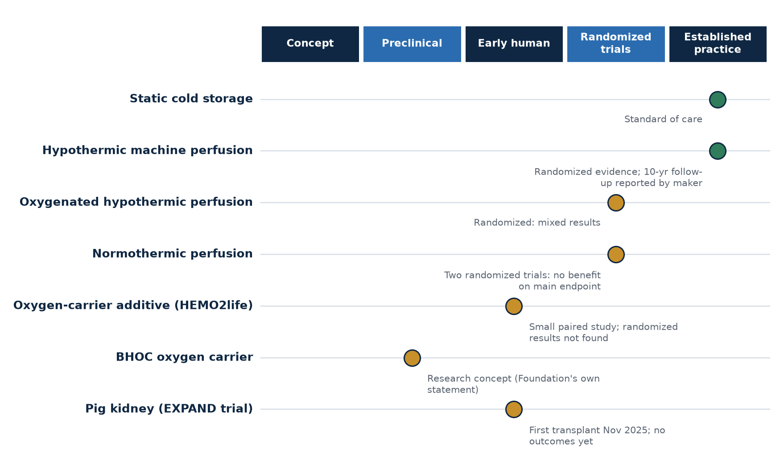
Figure 10.1. Evidence ladder for kidney preservation and replacement technologies, October 2026. Placement is the author’s reading of the evidence cited in this chapter.

The record: machine perfusion and the stubborn question of oxygen
At the base of the ladder sits static cold storage, the cooler of this book’s title, which remains the baseline against which everything else is compared. One rung up is hypothermic machine perfusion, supported by the randomized trial of 672 recipients discussed in Chapter 6 (Moers et al., 2009) and, according to the device manufacturer, by a ten-year follow-up reporting a 27% lower risk of graft failure (Organ Recovery Systems, 2025). A 2025 forward-looking review states that renal hypothermic perfusion today reduces delayed graft function and improves graft survival (Frontiers in Transplantation, 2025†).
The evidence above that rung is much thinner. Warming the organ to body temperature during perfusion, known as normothermic perfusion, has been tested in two randomized trials that I found. In a trial of kidneys from donors after circulatory death, normothermic perfusion proved feasible and safe but did not reduce delayed graft function, with rates of 60.7% against 58.5% under static cold storage and an adjusted odds ratio of 1.13 (Hosgood et al., 2023†). In a 2026 single-center trial that added two hours of normothermic perfusion at the end of hypothermic perfusion, immediate graft function occurred in 39% of the treated group (16 of 41) and 49% of the control group (19 of 39), an odds ratio of 0.68 with a 95% confidence interval of 0.28 to 1.64 (Normothermic versus hypothermic machine perfusion in kidney transplantation, 2026†). Total cold ischemia was balanced between the groups at 9.5 and 9.4 hours.
A responsible reader must resist two opposite temptations when facing such results. The first is to conclude that normothermic perfusion does not work. The confidence interval, which spans from a 72% reduction to a 64% increase in the odds, shows that the trial was too small to rule out a meaningful effect in either direction. The second is to conclude that it will eventually prove its worth because the biology is attractive. A 2025 review in a leading nephrology journal captured the position soberly: the addition of oxygen during hypothermic perfusion has shown mixed results, sometimes benefiting higher-risk donors, and the clinical benefit of normothermic perfusion remains unproven (Nature Reviews Nephrology, 2025†). Absence of evidence is not evidence of absence. It is, however, an absence.
Oxygenated hypothermic perfusion has a similarly mixed record. A randomized trial of expanded-criteria donor kidneys found that adding oxygen at the end of cold storage did not improve graft survival or function, though the authors acknowledged that the study was underpowered because overall graft survival was high (Appendix A, item F4). A single-center United States report described a lower rate of delayed graft function, 35.7% against 49.2%, despite longer cold times, though the difference did not reach statistical significance (Appendix A, item F4).

The record: oxygen carriers
Oxygen carriers are the newest rung that has any human data at all. The idea is to add to the perfusion fluid a molecule that carries oxygen as red cells do, but without the cells, so that an organ can be supplied with oxygen during the interval when it has no circulation. A French program tested one such product, derived from a marine worm and known as HEMO2life, as an additive to kidney preservation solution. In the first study, 60 kidney grafts at six centers were treated and compared with the contralateral kidneys from the same donors (Appendix A, item F6). The investigators reported that patient survival at 48 months was 98.3% in the treated group against 86% in the comparison group, a difference with a p-value of 0.016. The manufacturer’s materials add a figure for delayed graft function of 7% against 26% in some subgroups (Appendix A, item F6).
I classify all of this as preliminary and I would encourage readers to treat it with unusual caution, for three reasons. The comparison was non-randomized and based on pairing, and the design makes it hard to say what drove any difference. A difference in recipient survival at four years is a surprising thing to attribute to an additive in a preservation solution, and extraordinary results of that sort are usually the beginning of an investigation rather than the end of one. And the figures that are most favorable come from sources with an interest in the outcome. A registry entry for a four-year follow-up describes an observational case-control design with an estimated enrollment of 116, which differs from the 60-graft study described above, and a separate randomized trial exists, registered under NCT04181710, for which I found no published results (ClinicalTrials.gov, n.d.).
The Cold Ischemia Foundation has published educational material about one company in this space, BHOC Therapeutics, and I owe the reader the Foundation’s own stated position, which is stricter than any critic’s. The company describes a cell-free hemoglobin oxygen carrier designed to be compatible across blood groups, and its transplant program states that it is a research concept, that it is not an approved treatment, and that it has not been shown to prevent rejection or to change transplant outcomes (Cold Ischemia Foundation, n.d.-a). The Foundation’s evidence brief notes that no oxygen carrier has full regulatory approval for intravenous use in humans, and it recounts the history of safety setbacks that has kept this class of molecule out of routine use for twenty years (Cold Ischemia Foundation, n.d.-b). I repeat those statements here because they represent the correct posture toward any technology that is still on the lower rungs of the ladder. Interest is warranted. Promotion is not.

The record: replacing the organ
At the top of the ladder, in terms of ambition, stands xenotransplantation. The first clinical trial of a gene-edited pig kidney, called EXPAND and sponsored by United Therapeutics, announced its first transplant at NYU Langone Health on 3 November 2025. The organ comes from a pig with ten genetic modifications, six human genes added and four pig genes removed, and participants are monitored for 24 weeks, with lifelong follow-up to screen for infections that could pass from animal to human (United Therapeutics Corporation, 2025). The trial is designed to support a regulatory application and is intended for patients who are unlikely to receive a human kidney within five years.
I found no published patient outcome data from the trial in 2026. Earlier compassionate-use cases provide the only evidence so far. A review reports that a recipient at Massachusetts General Hospital had a pig kidney that functioned for 271 days before being removed for progressive dysfunction in October 2025, the longest survival reported to that date, while a New York recipient had a pig kidney removed in April 2025 after complications from an unrelated infection (Appendix A, item F8). These cases are extraordinary and they are anecdotes. A single trial’s first transplant is not a result. It is a beginning.

The reading: why the ladder is so slow to climb
Why does the ladder take decades, and why are its upper rungs occupied by so few technologies? I offer five hypotheses, each of which is the author’s analysis and not a finding.
The evidence threshold is rightly high. A mistake in organ preservation can cost a graft, and a graft is a life. That is a justification for rigor, and rigor is not the thing I am criticizing.
The trials are small. The two normothermic trials above enrolled 277 and 80 patients, and the oxygen-carrier studies enrolled 60. At those sample sizes, confidence intervals are cathedral-wide. Because no organization owns the question, no one has assembled the multicenter, registry-embedded randomized trials that could deliver an answer.
Payment is misaligned. The costs of better preservation fall on the center or the procurement organization that buys the device or the additive. Many of the benefits, fewer episodes of delayed graft function and longer graft survival, accrue later and to others. A cost borne now for a benefit enjoyed by a stranger later is a textbook case of an externality. The new federal payment model’s quality domain, which rewards graft survival, is the first attempt I know of to internalize it (CMS, n.d.).
Ownership is fragmented. As Chapter 2 argued, no one owns the cold chain end to end. A technology that crosses the seam between recovery and transplantation has no natural sponsor.
The development path is long and expensive, and small companies run out of money long before trials report. That is a structural feature of biotechnology and not a scandal. It does mean that a good idea needs a patient funder, and patience is a scarce commodity.

A conservative proposal: embed trials in the registry
The remedy I propose is not more enthusiasm. It is infrastructure. The national registry already captures nearly every transplant. A system that embedded randomization within routine allocation, offering a participating center a kidney that has been randomly assigned to one preservation method or another with the consent of the recipient, could generate in a few years the kind of evidence that single-center trials produce in decades. Regulators should require that favorable results announced by a manufacturer be replicated by an independent group before they are described as established. And funders, public and private, should be asked to pay for outcomes: graft survival at one, five, and ten years, measured by the registry and not by the vendor.

Chapter 13: What the Method Has Already Done
“Experience keeps a dear school, but fools will learn in no other.”
Benjamin Franklin, Poor Richard’s Almanack (1743)

A fair question for a book that borrows a method
By this point a skeptical reader is entitled to ask whether the factory vocabulary I have borrowed has ever accomplished anything in this particular field. It is a reasonable challenge. Lean and Six Sigma were developed in manufacturing, in companies that made identical objects by the million, and the leap from an assembly line to an operating suite is not self-evidently safe. The honest response is to look at what has been published. I found a modest body of work, mostly from single institutions, and I report it here with its limits in plain view, since a chapter that exaggerated the method’s record would violate the principles it recommends.

The record: six projects
Shortening the living-donor evaluation. A 2023 study in BMC Health Services Research applied the Six Sigma DMAIC framework, which stands for define, measure, analyze, improve, and control, to the evaluation of potential living kidney donors. The authors began from the observation that about 25% of potential living-donor transplants are missed because of inadequate timing in the assessment of donors. Their project aimed to shorten the donor evaluation, and they assessed the period afterward for reductions in total lead time, in the patient’s exposure to dialysis before transplant and its associated costs, and for an increase in preemptive transplants, those done before dialysis becomes necessary (BMC Health Services Research, 2023†). The summaries I could retrieve did not give the final numbers, so I cannot report the size of the improvement, and I regard that as a gap to be closed by reading the paper.
Reducing liver transplant hospital stays. A 2013 study in Progress in Transplantation mapped the liver transplant process from listing to discharge using DMAIC. Median length of stay fell from 11 days before the intervention to 8 days afterward, while the rate of readmission did not change. The authors credited clear expectations, improved teamwork, and a multidisciplinary clinical pathway (Progress in Transplantation, 2013†). The unchanged readmission rate matters, because it suggests that the shorter stay was not purchased by discharging patients too soon.
Speeding the road to the kidney list. Researchers in Hannover, Germany, reported at the 2016 American Transplant Congress that they had deployed Lean Six Sigma for the first time to evaluate and improve a transplant administration process, focusing on the interval between a patient’s first contact with the center and final listing on the European waiting list, with document cycle time as the primary metric (American Transplant Congress, 2016†).
Reducing waste and errors in donor records. A tissue bank presented a yellow-belt project, the entry-level tier of Six Sigma certification, aimed at reducing waste and errors in the process of obtaining a deceased donor’s medical records after recovery (American Association of Tissue Banks, 2023†). The abstract described the project’s focus and did not report outcomes.
Formalizing quality at a transplant center. A transplant center at a large academic medical center used DMAIC to build a formal quality assessment and performance improvement program, with a standard set of metrics and outcome reports (Appendix A, item J2). That is an organizational project and not a single process fix.
Lean thinking in organ donation coordination. A 2024 multiple-case study of three state transplant systems in Brazil examined lean principles in donation coordination, noting that lean had been applied in many areas of health services but not extensively in transplantation, and proposed a lean organ donation coordination model with initiatives to increase organ supply (International Journal of Services and Operations Management, 2024†). This study is descriptive and not a DMAIC project with before-and-after measurement.

The reading: what the six projects teach, and what they do not
Three observations emerge. The first is that the projects are local. Each one improved a process inside the walls of a single organization, such as a donor evaluation clinic, a liver service, or a records office. None of the work I found attempted to improve a seam between organizations, for example the handoff between a dialysis facility and a transplant center or between a procurement organization and an accepting hospital. Yet those seams are where, by the argument of this book, the largest losses occur.
The second is that the wins are modest and measurable, which is what the method promises. A three-day reduction in length of stay with no change in readmissions is not a revolution. It is a few hundred patient-days returned to the hospital in a year, and it is real. A system that accumulated a hundred such gains would be a different system.
The third is a caution about the evidence itself. Projects that fail rarely get published, and projects that succeed are written up by the people who ran them. The published record therefore overstates the method’s average performance. I cannot say by how much. An honest advocate of Lean Six Sigma in transplantation should say so and should call for a registry of projects, including failures, so that the field can learn from the denominator and not only the numerator.

A charter for the seam
Having argued that the seams have been neglected, I will offer a template for addressing one. The following is a sketch of a cross-organizational improvement project. It is an illustration of the method and not a protocol, and it would need to be adapted by the organizations involved.
Sample project: from first offer to final acceptance
Problem statement. A recovered kidney is offered to a sequence of candidates, and each decline consumes time. A study of offers found that kidneys were offered a median of seven times before acceptance (Appendix A, item E2).
Defect. An offer that is declined for a reason that, on review, was not clinical.
Critical-to-quality measures. Time from first offer to acceptance. Number of offers per transplanted kidney. Cold ischemia time at transplant. Agreement among reviewers on a sample of declined offers.
Team. A procurement organization, three transplant centers in its service area, a patient representative, and a registry analyst.
Data. Time-stamped offer logs, which the registry already collects.
Measure phase (weeks 1 to 4). Establish the baseline distribution of offer-to-acceptance times and the decline reasons, and run a reproducibility study on a sample of declined offers.
Analyze phase (weeks 5 to 8). Rank the decline reasons and identify the top three. Examine variation by time of day and day of the week.
Improve phase (weeks 9 to 14). Pilot a structured decision aid and a second-look review for kidneys declined three times. Share a standard information packet.
Control phase (weeks 15 and after). Chart the offer-to-acceptance time weekly with control limits. Name an owner. Publish the results.

I would add one remark about this template. Nothing in it requires new legislation, new technology, or new money. It requires four organizations to agree to look at the same numbers together. That, I submit, is the entire difficulty, and it is a difficulty of will and not of resources.

The reading: why the seams stay untouched
If seam projects are so promising, why are they absent from the literature? I can offer three explanations, each the author’s analysis. Within an organization, a project sponsor has the authority to change the process. Across organizations, nobody does, and the project requires the voluntary cooperation of parties whose incentives diverge. Second, the benefits of a seam project accrue to the system and to patients, not to any individual organization’s financial statement, so no one’s budget funds it. Third, a seam project exposes the performance of each participant to the others, which can feel threatening in a field where outcomes are publicly scored.
These are precisely the barriers that a single accountable office, of the kind proposed in Chapter 16, would be positioned to remove. An office with a mandate for the whole journey could convene the parties, fund the work from a national budget, and shield participants from adverse scoring during the pilot. Without it, the seams will go on being crossed by patients and unmeasured by everyone else.

What this means for the reader
I do not want to oversell the method. Lean Six Sigma is not a cure and it is not a creed. It is a discipline of looking carefully, counting honestly, changing one thing at a time, and checking whether the change held. Applied inside organizations it has produced small, genuine improvements. Applied across the seams it remains, as far as I can tell, untested. That is both the weakness of the record and the size of the opportunity.

Chapter 14: Awareness Without Evidence
“No man will take counsel, but every man will take money: therefore money is better than counsel.”
Jonathan Swift, Thoughts on Various Subjects (1711)

What awareness is for
Few ideas in public health are as generously funded and as poorly measured as awareness. Campaigns are launched, ribbons are tied, proclamations are signed, and the activity is counted by impressions and events. Yet awareness is only a means. The ends are behaviors: a person registers as a donor, a patient asks about transplantation, a family says yes in the hospital. A quality engineer would ask of every awareness program what a clinician asks of every medication: does it work, in whom, and by how much?

The record: how many people are registered?
National registration figures are surprisingly hard to pin down. A presidential proclamation in 2020 put the share of adults who are registered donors at approximately 60% (Appendix A, item I2). An undated health-system article cited 58% (Appendix A, item I2). A donation-industry report from 2013 had reported 45% (Appendix A, item I2). The figures reflect different definitions and different years, and I found no national percentage for 2025 or 2026. What a reader can responsibly conclude is that roughly half to three-fifths of American adults have registered at some point, and that the nation does not appear to publish an up-to-date figure.
A registration is, moreover, an input and not a transplant. The great majority of registrants will never die in circumstances that allow donation, so the connection between a registration and an organ is probabilistic and mediated by family consent, hospital practice, and organ procurement organization performance. That is a reason to measure awareness campaigns by their effect on registrations that stick and, ultimately, by the donation and transplant rates that follow, not merely by the number of people who say they approve.

The record: what the experiments show
The cleanest evidence I found is a field experiment published in the Journal of Marketing in 2021. Researchers intercepted customers at service locations in Ontario, 3,330 of them, with messages targeting information and altruistic motives at the moment of service, and streamlined the registration process. Registrations, which were actual behavior and not stated intention, increased significantly (Appendix A, item I1). An online experiment in Australia with 762 young adults found that a message emphasizing the ease of registration was most effective at producing intentions to register, and the finding informed the 2021 national campaign (Appendix A, item I1).
By contrast, a campaign in a Riyadh shopping mall reported that 90.9% of people surveyed decided to register as donors. That figure measures a stated decision in a short, subjective survey, and the authors themselves noted that the effect on actual registrations was unexamined (Appendix A, item I1). I mention it as an example of the weak outcomes against which stronger designs should be compared.
I also encountered, in the course of this research, a web page that claimed a 2026 campaign had produced a 12% rise in registrations across fourteen countries, citing the World Health Organization. It named no verifiable source and its own text broke off in mid-sentence. I did not use it, and I mention it for a reason. Awareness is a field in which weak statistics circulate easily, and an advocate who repeats them borrows against the credibility of the cause.

The reading: three lessons from the strong designs
The better experiments share three features. First, they target the moment of decision, not the abstract season of awareness: a message delivered where registration is possible outperforms a message delivered in a vacuum. Second, they reduce friction, since the Australian result suggests that people respond when they are told it is easy. Third, they measure actual behavior. The first two are design lessons. The third is a discipline of honesty.
What the experiments do not address is the problem that the Kentucky episode revealed. Awareness is built on trust, and trust, as Chapter 10 argued, can be lost in a week. A campaign that urges registration while the process behind it is visibly in doubt is pouring water into a bucket with a hole. For that reason I would urge that every donation-awareness program include a transparency component, a plain account of how death is determined, who is empowered to halt a donation, and what safeguards exist, together with a public monthly count of registry removals so that erosion is seen early.

The other awareness problem: patients do not hear about the options
A less discussed failure concerns patients and not donors. As Chapter 5 documented, 15% of patients starting dialysis in a large national sample had not been informed about transplantation (Villani et al., 2024†), and clinician-reported discussions of transplant did not translate into waitlisting (Healio, 2018). The same gap applies, with more force, to emerging science. A patient who has never heard of machine perfusion or oxygen carriers cannot ask a center whether it uses them. I do not suggest that every patient needs a lecture on preservation technology. I suggest that a patient who asks should be answered plainly, and that patients should be given enough plain-language material to know what to ask.
This is the sense in which the Cold Ischemia Foundation understands its own work, and I hold it to the standard I have just stated. An awareness effort should be judged by what it changes. Did a patient ask a question they would not have asked? Did a care partner find a form they would not have found? Did a family understand a decision they would otherwise have faced in fog? If the answer is a count of page views, the work is unfinished.

A design brief for the next campaign
Suppose a state donor registry or a national organization asked for a design brief for its next awareness campaign. Drawing on the experiments above, I would write six lines. Name the behavior: not “raise awareness” but “increase the number of registrations that are still active twelve months later.” Choose the moment: place the message where registration can happen in the next minute, whether at a service counter, a license renewal, or a clinic waiting room. Use the two messages that the evidence favors: a motive that is altruistic and specific, and a promise that the act is easy. Remove friction: if registration takes more than a minute and a half, the campaign has already failed, whatever the posters say. Include the transparency component: a plain statement of who determines death, who may halt a donation, and how concerns are reported. And pre-register the evaluation: state before launch what will be counted, over what period, against what comparison, and publish the result whether or not it flatters the campaign.
The last line is the one most often declined, because an evaluation can embarrass. That is the reason to insist on it. A campaign that cannot survive a measurement was not a campaign. It was an event.

Proposals
Pre-register the evaluation of every national campaign, naming in advance the behavior to be measured. Publish monthly registry registrations and removals. Replace the exhortation to “have the conversation” with the specific act that makes the conversation possible: a one-page plain-language map handed to every patient on the day they begin dialysis, and a navigation call that is free. And finally, measure what the campaign cost per additional registration that persisted for a year, because charity that does not know its own cost per outcome is only a mood.

Chapter 15: The Patient Who Cannot Afford to Be Saved
“The rich ruleth over the poor, and the borrower is servant to the lender.”
Proverbs 22:7 (King James Version, 1611)

The last gate is a pharmacy counter
A transplant is not a single operation. It is the first day of a lifelong prescription. The surgery replaces a failed organ, and the immunosuppressive medication that follows persuades the body not to reject it. If the medication stops, the organ is lost, and the surgery, the donor’s gift, and the years of waiting are all forfeit. A system that devotes enormous effort to delivering the kidney and little to ensuring that the recipient can keep taking the pills has built a bridge that ends at the water’s edge.

The record: the thirty-six-month cliff and its repair
For decades, Medicare coverage for patients whose only qualifying condition was kidney failure ended 36 months after a transplant, unless the patient was disabled or over 65. Since December 2022, a benefit known as Medicare Part B-ID has covered FDA-approved immunosuppressive drugs indefinitely, whatever the patient’s age or disability status. In 2023 the benefit carried a premium of $97.10 per month (Appendix A, item H1). Before the change, advocacy and clinical sources documented patients who rationed or skipped doses because of cost. A 2019 brief from the Department of Health and Human Services observed that for patients who lose Medicare at 36 months and have no other coverage, the cost of continuing immunosuppression may be prohibitive (Appendix A, item H1). Testimony to Congress cited a report in the New England Journal of Medicine that nearly 70% of kidney transplant programs had experienced a death or a lost transplant because a patient could not pay for antirejection drugs, although that figure reached me through secondary testimony and I could not confirm the original (Appendix A, item H1).
The repair appears to have been economically sensible as well as humane. A cost-effectiveness analysis modeled lifetime extension of immunosuppressant coverage and found that, from Medicare’s perspective, it was cost-saving and produced better outcomes than the policy it replaced, and a federal analysis estimated savings of up to $300 million over ten years (Appendix A, item H1). Here is a rare policy in which doing right and saving money pointed the same direction, and it took years to enact.
I could find no peer-reviewed study that measures how the new benefit has changed the burden of out-of-pocket cost or financial distress among recipients after 36 months. That is a measurement gap, and it is consequential, because a policy that cannot be evaluated cannot be improved.

The record: Medicaid, the new uncertainty
The next threat is not a cliff that has been built but one that has been forecast. The 2025 federal budget reconciliation law, known informally as the One Big Beautiful Bill Act, made changes to Medicaid whose effect on kidney patients has been analyzed mostly by advocacy organizations. The Congressional Budget Office, as cited by the National Kidney Foundation, estimated that more than 11 million people would lose Medicaid coverage and that more than $700 billion in federal funding would be removed over the budget window (National Kidney Foundation, 2025). The Foundation reports that nearly half of dialysis patients rely on Medicaid and that provisions on work requirements, provider taxes, and eligibility checks could reduce their access (National Kidney Foundation, 2025). A nephrology society newsletter notes that a transplant can cost more than $400,000, with $10,000 to $14,000 each year thereafter for immunosuppressive drugs (American Society of Nephrology, 2025).
Several provisions have dates attached. Work requirements of 80 hours per month are scheduled to begin in January 2027, with exceptions for certain groups, and required eligibility redeterminations every six months are scheduled to begin by December 2026, according to a fact brief published in August 2026 (Gigafact, 2026). One analysis of an earlier Senate draft cited a $35 per-treatment copayment for some dialysis patients above the poverty line, and I treat that figure as unverified, since it described a version of the bill that may have changed before enactment. The largest reductions and many implementation dates fall after 2026.
Let me state what I do and do not know. I know that the sources agree that Medicaid is a major payer for patients with kidney failure and that the law changes Medicaid’s rules. I do not know how many dialysis or transplant patients will lose coverage, how many transplant recipients will lose access to immunosuppressant coverage, or whether exceptions will protect them. The sources I reviewed are advocacy statements from mid-2025 and one fact brief from August 2026, and the enacted text should be consulted directly. This is a forecast and not a finding, and an honest book treats it so.

The reading: poverty compounds at every gate
When this chapter is laid beside Chapters 5 and 11, a pattern emerges that I think deserves to be called the compounding of poverty. At the first gate, patients in disadvantaged neighborhoods face lower odds of being listed and transplanted (Residential neighborhood disadvantage, n.d.†). At the donor gate, the financial cost of giving falls most heavily on the people with least slack (Tushla et al., 2015†). At the final gate, the cost of staying transplanted depends on insurance that is itself under strain. Each of these is a modest effect. Their product is a pathway on which the poorest patient is least likely to arrive and, if they arrive, least likely to remain.
I find this the most morally uncomfortable finding of the whole audit, and I want to describe it without partisanship. A person of the political right can state it as a failure of efficiency: a society that spends heavily to deliver a graft and then risks its loss for the sake of a premium has misallocated its money. A person of the political left can state it as a failure of justice: access to a life-saving treatment ought not to depend on a postal code. Both statements are correct, and neither requires the other’s premises.

What would help, in the order of cost
The cheapest reform is measurement. A national report, published annually, of the share of recipients who experience a gap in immunosuppressant coverage or who report skipping doses for cost would cost almost nothing and would turn a rumor into a number. The second is navigation. A free, plain-language service that helps a family map its coverage before the transplant and again at the thirty-sixth month could prevent losses that cost far more than the service. The third is policy design. Any change to Medicaid eligibility should include an explicit exception for transplant recipients on immunosuppressants, because the cost of the exception is trivial beside the cost of a lost graft. I make this argument knowing that I may be wrong about the details of enacted law. I am not wrong about the principle.

Chapter 16: A Conservative Case for Reform
“A state without the means of some change is without the means of its conservation.”
Edmund Burke, Reflections on the Revolution in France (1790)

What kind of conservative argument is this?
The word conservative has been appropriated by so many causes that it requires a definition before it is useful. I use it in the older sense, the one Edmund Burke would have recognized. A conservative, in that tradition, wants to preserve valuable institutions, and understands that preservation sometimes requires reform. The transplant system is a valuable institution. It was assembled by a gifted generation of surgeons, ethicists, and legislators, and it has saved an enormous number of lives. Precisely because it is valuable, it should be defended against its own decay, and decay is what the figures in this book describe.
The argument that follows rests on four conservative commitments. Institutions should be accountable to those they serve. Information is the cheapest regulator, and the best. Incentives should be aligned before behavior is lamented. And public programs should be judged by their outcomes and not by their intentions. None of these commitments belongs to a party, but together they point toward a program of reform that is modest in cost and demanding in transparency.

The platform
What follows is a twelve-point platform. Each plank is tied to a chapter that supplies its evidence, and each is the author’s argument and not a finding of any agency.
1. Publish the Pareto of nonuse. Classify every unused kidney by its recorded reason and by whether the nonuse was unavoidable, and publish the ranked chart annually (Chapter 4).
2. Audit the decision. Measure the reproducibility of kidney-acceptance decisions, publish the result, and provide structured decision aids and a second-look protocol for kidneys declined repeatedly (Chapter 7).
3. Publish referral and waitlisting by facility. Release adjusted, facility-level rates of patient information, referral, and waitlisting in a form that patients can search (Chapter 5).
4. Make the cold chain visible. Publish the median time from recovery to transplant by procurement organization and by center, with the distribution and not only the median (Chapter 6).
5. Score in constellations. Report transplant volume, graft survival, and offer-acceptance rate together, adjusted for case mix, so that no single number can be gamed unobserved (Chapter 8).
6. Make the franchise contestable in fact. Carry out the tiers as written, publish the roster, and adjust the metrics for community characteristics so that the system does not punish those who serve the hardest populations or excuse those who underperform (Chapter 8).
7. Preserve the stop-the-line right. Maintain the right of any staff member to halt a donation, publish the count of halts, and commission independent audits of death determination (Chapter 10).
8. Measure trust monthly. Publish registry registrations and removals every month, together with family-consent rates by organization (Chapters 10 and 14).
9. Remove every out-of-pocket cost for living donors. Index the reimbursement ceiling to actual costs, simplify eligibility, and publish the number of donors who applied and were not reimbursed (Chapter 11).
10. Pilot, do not presume. Authorize a time-limited, pre-registered pilot of a credit for non-directed donors with independent evaluation of its effect on donations, donor well-being, and public trust (Chapter 11).
11. Embed the trials. Build randomization into the registry, require independent replication of manufacturer-announced results, and pay for outcomes (Chapter 12).
12. Name an owner. Assign responsibility for the whole patient journey to a single accountable office, and give every dialysis patient a one-page map on the day they begin treatment (Chapter 2).
The cost of most of these planks is the cost of analysis and publication. They require data that are largely already collected. That is the reason I call the program conservative. It does not ask the nation to spend its way out of the problem. It asks the nation to look at its own ledger.

Sequencing: where to start
Twelve planks cannot be implemented on the same morning, and an honest platform says which come first. I would begin with the four that cost least and teach most: the Pareto of nonuse, the facility-level referral figures, the cold-chain intervals, and the monthly trust series. All four are acts of publication. They require analysts and a decision to disclose, and they require no new rule, no new payment, and no change in anyone’s clinical practice. They also have a useful property from the standpoint of reform politics. They are hard to oppose in principle, since the argument against publishing a number that a federal registry already holds must rest on something other than the public interest, and they generate the evidence needed to decide how much more should be done.
The second wave consists of the planks that require institutions to change how they decide: the reproducibility audit and decision aids, the constellation scoring, and the stop-the-line and audit arrangements. These need the cooperation of centers and procurement organizations, and they are likelier to receive it once the first wave has shown that disclosure is survivable. The third wave contains the planks that need Congress or a significant outlay: the reimbursement ceiling for living donors, the credit pilot, and the registry-embedded trials. Allocating the work among the actors is straightforward in principle. The oversight agency and the network board own most of the first two waves, the payment agency owns the franchise and metric reforms, Congress owns the third, and patients and care partners own the pressure that keeps all three moving.

The strongest objections, and the replies
Every serious reform should be tested against its best critics. I offer four, and my answer to each.
The equity objection. Advocates of broad organ sharing argue that expanding the geography of allocation was necessary to reduce unfair disparities, and that criticizing the resulting increase in cold ischemia time risks reversing a hard-won gain. This is a fair objection, and I do not propose to reverse the policy. I propose to measure its costs and to attack them directly, with faster logistics, better preservation, and decision support, so that equity and speed can be pursued together. The annual data report itself acknowledges the trade-off (SRTR & OPTN, 2026a).
The clinical-judgment objection. Surgeons will argue that variation in acceptance reflects legitimate judgment about individual patients and that standardization threatens the art of medicine. There is truth here, and a proper aid preserves judgment and does not replace it. But the measured agreement among clinicians looking at the same offer, with a kappa of 0.13 in one survey, is so low that it is hard to believe all of it reflects judgment (Appendix A, item E2). Some of it is noise, and noise is not an art.
The fairness-to-organizations objection. Procurement organizations argue that the tier metrics penalize those who serve disadvantaged communities, and the minority-impact analysis cited in Chapter 8 gives the argument weight. My reply is that the remedy for an imperfect metric is a better metric and not no metric. The metric should be adjusted, and the adjustment should be debated in public. But the franchise should remain contestable.
The ethics objection. Ethicists will argue that any payment for donation risks coercion. I share the concern, which is why my proposal is a pilot with pre-registered evaluation and not a program, and why I insist that reimbursement of costs, which no one disputes, should be complete before any further step is considered.

What would change my mind
A document of advocacy should say what evidence would lead it to retreat. If the publication of classification data showed that nearly all nonuse was unavoidable, the first plank would shrink in importance. If a rigorous study showed that acceptance decisions are highly reproducible after accounting for patient differences, the second would. If a well-run pilot of donor credits increased donations at the cost of exploiting the poor, the tenth would be dead, and I would say so. If independent trials showed that oxygen carriers, whatever their theoretical appeal, do not improve outcomes, the Foundation that publishes this book would have to say that too. Conviction without the possibility of refutation is only temperament.

PART FIVE: CONTROL
The last letter of the method is the one most often forgotten. Improvement that is not controlled decays, and a nation that has waited this long for better numbers should not lose them again through inattention. Part Five describes how to keep what is gained.

Chapter 17: A Control Plan for a Nation
“Order is Heaven’s first law.”
Alexander Pope, An Essay on Man, Epistle IV (1734)

Why improvement decays
The final phase of Lean Six Sigma is control, and it is the phase most often skipped. Teams that celebrate an improvement and then disband find, within a year or two, that the process has drifted back toward its old behavior. The reason is not mysterious. A process left unwatched reverts to the mean of the habits that created it. Control is the set of mechanisms, such as dashboards, alarms, owners, and review cycles, that prevent the reversion.
The most important of those instruments was invented by Walter Shewhart at Bell Laboratories in the 1920s. The control chart plots a metric over time and draws limits around the average, so that a viewer can distinguish ordinary variation from a signal that something has changed (Shewhart, 1931). It converts anxiety into rules. A point beyond the limits, or a run of points on one side of the average, means investigate. Anything else means leave the process alone. The nation’s transplant system publishes many numbers annually. It does not, so far as I could determine, publish them as control charts, and a number published once a year cannot reveal a drift that begins in March.

A dashboard for the journey
The scorecard below collects the measures proposed in this book. The baselines are drawn from the sources cited in earlier chapters. The targets are the author’s proposals and are anchored, wherever possible, to values the system has actually achieved.
Measure | Baseline | Proposed aim
Recovered kidneys not transplanted | 29.3% (2024) | Back to 26.6% within 12 months; 18.2% as a long-run aim
Deaths on list plus removals for being too sick | 3,743 plus 4,901 (2024, annual report) | Publish together, with 60-day follow-up of delisted patients
Patients not informed of transplant at dialysis start | 15% (2007 to 2019) | Under 2%
Agreement among clinicians on identical offers | Fleiss kappa 0.13 (one survey) | At least 0.60
Median cold ischemia, same-hospital transplants | 3.3 to 29 hours by center | Publish the distribution, then narrow the spread
Registry removals | Spike of 170 per day, October 2024 | Monthly public series with control limits
Living donors reaching the reimbursement cap | 21% | Under 5%
Recipients with a gap in immunosuppressant coverage | Not measured | Measure annually

Sources for baselines: SRTR & OPTN (2026a, 2026b); Villani et al. (2024†); Associated Press (2024); Appendix A items E2 and E5 and G3. Targets are author’s proposals.
I have deliberately included two measures for which no baseline exists. A dashboard that lists only what is already known would reinforce the assumption that the known is what matters.

Ownership, cadence, and the discipline of the boring
Control plans fail when they lack three things: a named owner, a regular cadence, and a response rule. The owner is the single accountable office proposed in Chapter 16. The cadence should be monthly for fast-moving measures such as registry removals and quarterly for slower ones. The response rule says what happens when a signal appears: who convenes, within what time, and what must be published about the investigation. These arrangements are tedious, and their tedium is the point. The discipline of the boring is what separates a reform from a press release.

A ninety-day and twelve-month plan
A control plan without a calendar is a wish. The sequence below is the author’s proposal. It assumes that the single accountable office of Chapter 16 exists, or that an existing agency has agreed to act as its interim host, and it relies almost entirely on data that are already collected.
In the first ninety days, five things can be done without new legislation. The host office can publish the design of the scorecard, with the definition of every measure, so that critics can attack the definitions before anyone’s performance is judged. The registry can release the classified breakdown of reasons for kidney nonuse in 2024 from existing records, which is the Pareto chart of Chapter 4. The federal forms that dialysis facilities already file at the start of treatment, which supplied the analysis of 133,414 patients in Chapter 5, can be summarized by facility and published. Registry registrations and removals can begin to appear monthly. And two service areas can be invited to run the seam project of Chapter 13, with a procurement organization, three centers, a patient representative, and an analyst around one table.
By twelve months, the work should reach the stage of control. The first control charts for nonuse and for registry removals should be public. The reproducibility study of acceptance decisions should be complete, with its agreement statistic reported alongside the 0.13 of the earlier survey. The annual report to Congress that the living-donor law now requires should include the count of applicants who were not reimbursed. Any national awareness campaign should be launched with a pre-registered evaluation. And a protocol for registry-embedded randomization of preservation methods should be circulated for comment.
A short risk register belongs in any plan of this kind. Metric gaming is the first risk, and the defense is the constellation scoring of Chapter 8. Data lag is the second, since annual reports describe a year that ended long ago, and the defense is monthly provisional series labeled as such. Resistance is the third, and it will come from some centers and some organizations that fear exposure. The defense is to protect participants from penalty during pilots, to publish the early results as learning and not as ranking, and to be unembarrassed about asking patients and families to read the numbers. A reform that depends on everyone’s enthusiasm will not survive. A reform that depends on a published number will.

What a patient or care partner can do tomorrow
Not every reader works in a hospital or an agency, and a book that offers a platform only to professionals has failed most of its audience. The following questions can be asked now, by anyone, without waiting for policy to change. I offer them as practical suggestions and not as medical advice.
Have I been told clearly that transplantation is an option for me, and who can refer me today? If I am already referred, what is the next step, and when is it due? Does the center that is evaluating me publish its waiting times and its rate of accepting organ offers, and may I compare it with another? Because the national report counts candidates once for every center where they are listed, it is evident that listing at more than one center is possible, and a patient may reasonably ask a transplant team whether it is appropriate in their case (SRTR & OPTN, 2026b). What will the medications cost me in the first month, in the first year, and after the thirty-sixth month, and who can help me map my coverage? If I am considering donating, what costs will I bear, and what reimbursement is available to me, in writing, before the operation?
A family that asks these questions is exercising the one form of quality control that has always been available to patients. It is the right to be a difficult customer.

A closing note on method
I said at the outset that the method of this book is Lean Six Sigma, and I should say plainly what I have and have not done with it. I have defined a customer, mapped a process, measured defects, analyzed causes, proposed improvements, and sketched controls. I have not run a controlled improvement project, and no one should mistake a book for one. The method has served here as a way of organizing arguments and as a standard of honesty about what is known. Its most valuable habit is the one I commend to every reader in every role: ask what the number is, ask who measured it, ask what would change it, and ask who is responsible for changing it.

Epilogue: The Readiness Is All
“The readiness is all.”
William Shakespeare, Hamlet, Act V, Scene 2
I began with a hum, and I will end with a silence. Every transplant story eventually arrives at a moment when the machinery stops being abstract. A telephone rings or it does not. A cooler is carried or it is not. A signature is written or withheld. In that moment, every table in this book collapses into a single human act, and the act is performed by a person who was trained, rushed, fatigued, and hopeful, working inside a system that someone designed.
I do not believe that the people who work inside this system are the problem. I believe they are, for the most part, its rescue. I believe the problem is the design they inherit, and that design is a human artifact, which is to say that it can be amended by human hands. That belief is not optimism. It is the opposite of fatalism, and the opposite of fatalism is the only available foundation for work of this kind.
I have lived in these corridors long enough to know what hope costs and what it buys. I know the arithmetic on the back of the envelope. What I have tried to do in these pages is to carry that arithmetic out of the corridor and set it on the table where policymakers, clinicians, and neighbors can see it. The numbers are imperfect and the sources have gaps, and I have said so wherever they occurred. But the direction is unmistakable, and the direction is toward a system that can be measured, owned, and improved.
Patients and care partners, you are the customer, and the customer is entitled to ask. Clinicians, you are the craftspeople, and craft improves when it is observed. Regulators, you hold the pen, and the pen is mightier when its ink is public. And to anyone who has read this far without a stake in any of it, I offer the simplest of invitations. Ask who pays, who measures, and who is responsible. Ask again next year. The cooler is on the move, and the readiness, as the old play has it, is all.

Appendix A: Evidence Ledger
This appendix lists the sources whose details are cited in the text by item number, together with the grade I assigned and what a publisher should confirm before an edition goes to press. Grade A is a primary document or registry. Grade B is a credible secondary account. Grade C is a single-source, manufacturer, or advocacy figure. A dagger (†) in the text and reference list marks a source whose bibliographic details are only partly confirmed.
Item | What it supports | Grade | To confirm before publication
B5 | Summary that concerns were identified in 103 of 351 cases; the organization’s statement of compliance after a CMS audit; the contested individual account | B | HHS announcement text; organization’s own statement; CMS audit letter
C1 | 2026 final rule raising the low-volume threshold for the transplant access payment model from 11 to 15 transplants | B | Federal Register text of the final rule
E2 | Kidneys offered a median of seven times before acceptance; 2017 randomized study of 68 physicians (within-center variation about ten times greater than among centers); 2023 survey with Fleiss kappa of 0.13 | B | Original papers, sample sizes, and exact definitions
E5 | Regional sharing adding about 2.9 hours of cold ischemia; same-hospital median cold ischemia from 3.3 to 29 hours across 206 centers; weekend procurement and discard; network analysis of 106,160 kidneys | B | Original papers, since the literature summary I read did not identify the authors
F4 | Randomized trial of oxygenated perfusion in expanded-criteria donor kidneys (no benefit, underpowered); single-center report of 35.7% against 49.2% delayed graft function | A for design; B for numbers | Original papers
F6 | HEMO2life first study: 60 grafts, six centers, paired comparison; 48-month patient survival 98.3% against 86%; manufacturer figure of 7% against 26% | C | Journal publication of the first study; reconcile registry numbers NCT02652520, NCT05050513, and NCT04181710
F8 | Pig kidney graft survival of 271 days and a graft removed in April 2025, from a review article | B | The review’s identity and the primary case reports
G2 | Long-run decline in living kidney donation after a 2004 peak, concentrated among men, Black adults, and younger and lower-income adults | B | Original analysis; update with current data
G3 | Honor Our Living Donors Act: enactment 3 February 2026, Public Law 119-75, recipient-income test removed, $6,000 cap, 21% reaching the cap | A for statute and notices; B for the 21% figure | Text of the law; final HRSA notice; source of the 21% figure
G4 | Private wage-reimbursement and life-insurance programs through a paired-donation registry | B | Program terms
G5 | Australian living-donor kidney transplants: 253 in 2024 against 354 in 2008 | B | Original article in the Medical Journal of Australia
G6 | End Kidney Deaths Act: campaign-reported cosponsor count; policy-tracker odds | C | Congress.gov for current status and cosponsors
H1 | Medicare Part B-ID coverage and its 2023 premium; 2019 federal analysis; cost-effectiveness analysis; congressional testimony citing a 2012 report and a $300 million savings estimate | B | Primary documents; the 2012 original
I1 | Ontario field experiment (3,330 customers); Australian online experiment (762 young adults); Riyadh mall survey (90.9% stated intent) | A for the first; B for the second; C for the third | Full papers
I2 | Registration rates of about 60%, 58%, and 45% from three different years and sources | B | Current figure from the national donor-designation report
J2 | Quality improvement program at a transplant center built with DMAIC | B | Original abstract and authors

Items awaiting verification, in plain terms
Five matters deserve special mention because the text relies on them. First, the ten-year follow-up of the machine-perfusion trial reached me only through the device manufacturer’s announcement, and its article type should be confirmed. Second, the organ-procurement tier outcomes for 2026 had not been published as of this writing, and the text says so. Third, the first-year results of the transplant access payment model had not been published. Fourth, the Medicaid provisions were described by advocacy organizations and a fact brief, and the enacted law should be read directly. Fifth, the count of living donors in 2025 comes from one news report.

Appendix B: A Short Glossary
Allocation. The rules that decide in what order candidates are offered an organ.
Cold ischemia time. The interval between the cooling of an organ in the donor and the restoration of blood flow in the recipient.
Confidence interval. A range of values consistent with the data; a wide range means the study learned little.
Control chart. A plot of a metric over time with statistical limits that separate ordinary variation from a true signal.
CTQ (critical to quality). A requirement the customer cares about, stated in a form that can be measured.
DCD (donation after circulatory death). Donation after death is declared on the basis of the permanent stopping of the heart and circulation.
Delayed graft function. A transplanted kidney that does not work promptly, usually defined as the need for dialysis in the first week.
DMAIC. Define, measure, analyze, improve, control: the five phases of a Six Sigma improvement project.
DPMO. Defects per million opportunities, the unit used to compare the performance of different processes.
Donation service area. The geographic territory assigned to a single organ procurement organization.
Fishbone diagram. A cause-and-effect diagram, introduced by Kaoru Ishikawa, that groups possible causes of a problem by category.
Gauge R&R. A study that tests whether a measurement process gives the same answer when repeated by the same person and when performed by different people.
Hazard ratio. The ratio of the rate of an event in one group to the rate in another; a value of 1.013 per hour means a 1.3% higher rate for each added hour.
HBOC (hemoglobin-based oxygen carrier). A cell-free preparation of hemoglobin designed to carry and release oxygen.
Hypothermic machine perfusion. Continuous pumping of cold preservation solution through an organ.
Kappa. A statistic that expresses the agreement between raters beyond what chance would produce.
Nonuse. The registry’s term for a recovered organ that is not transplanted.
Normothermic perfusion. Perfusion of an organ at or near body temperature.
OPO (organ procurement organization). A designated organization responsible for recovering organs from deceased donors in a defined area.
OPTN (Organ Procurement and Transplantation Network). The national network that sets policy for organ allocation.
Pareto chart. A ranked bar chart that shows which categories account for most of a problem.
Rolled throughput yield. The proportion of units that pass every stage of a multi-stage process without a defect; the product of the stage yields.
SIPOC. A one-page map of a process listing suppliers, inputs, process steps, outputs, and customers.
Sigma level. A conventional measure of process capability; higher values correspond to fewer defects.
SRTR (Scientific Registry of Transplant Recipients). The registry that analyzes transplant outcomes.
Voice of the customer. The statement of what the customer needs, gathered directly and translated into measurable requirements.

Appendix C: References
Entries marked † have bibliographic details that are partly confirmed and should be completed from the original before any edition is published.
American Association of Tissue Banks. (2023). Tissue continuous improvement and utilizing Lean Six Sigma: Deceased donor medical records process [Conference abstract]†. https://aatb.org/sites/default/files/2023/2023%20Abstracts/Tissue%20Continuous%20Improvement%20%26%20Utilizing%20Lean%20Six%20Sigma%3B%20Deceased%20Donor%20Medical%20Records%20Process.pdf
American Institutes for Research. (n.d.). Organ Procurement and Transplantation Network (OPTN) Board of Directors support [Project description]. https://www.air.org/project/organ-procurement-and-transplantation-network-optn-board-directors-support
American Kidney Fund. (2026, May). Sixth annual living donor protection report card [News report]. https://www.bakersfield.com/ap/news/american-kidney-funds-sixth-annual-living-donor-protection-report-card-shows-progress/article_2a0c0a4e-f605-59f0-a4f2-eacb06f0bd88.html
American Society of Nephrology. (2025, September). Kidney News. https://www.asn-online.org/publications/kidneynews/archives/2025/KN_2025_09_sep.pdf
American Transplant Congress. (2016). Lean Six Sigma for kidney waitlist administration [Conference abstract]†. https://atcmeetingabstracts.com/?p=11273
Associated Press. (2024, October 28). People opt out of organ donation programs after reports of a man mistakenly declared dead. https://www.bangordailynews.com/2024/10/28/nation/people-opt-out-of-organ-donation-programs-after-reports-of-a-man-mistakenly-declared-dead/
Baumol, W. J., Panzar, J. C., & Willig, R. D. (1982). Contestable markets and the theory of industry structure. Harcourt Brace Jovanovich.
BMC Health Services Research. (2023). Six Sigma DMAIC project to shorten living kidney donor evaluation† [Journal article]. https://link.springer.com/10.1186/s12913-023-09183-3
Centers for Medicare & Medicaid Services. (n.d.). Increasing Organ Transplant Access (IOTA) model fact sheet. https://www.cms.gov/priorities/innovation/files/iota-model-fs.pdf
Centers for Medicare & Medicaid Services. (2025). ESRD Treatment Choices (ETC) model third evaluation report: Annual evaluation at a glance. https://www.cms.gov/priorities/innovation/data-and-reports/2025/etc-3rd-eval-aag-rpt
Centers for Medicare & Medicaid Services. (2026, January 30). Medicare and Medicaid programs; organ procurement organizations conditions for coverage: Revisions to the conditions for coverage (Proposed rule CMS-3409-P). Federal Register. https://www.federalregister.gov/documents/2026/01/30/2026-01833/medicare-and-medicaid-programs-organ-procurement-organizations-conditions-for-coverage-revisions-to
Centers for Medicare and Medicaid Services performance metrics and the disproportionate impact of decertifying organ procurement organizations on minority populations. (n.d.)†. Transplantation. https://doi.org/10.1097/TP.0000000000005646
ClinicalTrials.gov. (n.d.). Evaluation of HEMO2Life for kidney graft preservation (OXYOP): 4 years follow-up (NCT05050513). https://clinicaltrials.gov/study/NCT05050513
Cold Ischemia Foundation. (n.d.-a). BHOC: The technology nobody’s explaining to patients. https://coldischemia.foundation/bhoc.html
Cold Ischemia Foundation. (n.d.-b). The evidence behind BHOC. https://coldischemia.foundation/bhoc-evidence.html
Debout, A., et al. (2015)†. Each additional hour of cold ischemia time significantly increases the risk of graft failure and mortality following renal transplantation. Kidney International, 87(2), 343–349.
End Kidney Deaths Act, H.R. 2687, 119th Cong. (2025). https://legiscan.com/US/drafts/HB2687
Fierce Healthcare. (2025). HHS moves to decertify Miami organ transplant group amid efforts to reform organ donation system. https://www.fiercehealthcare.com/regulatory/hhs-moves-decertify-miami-organ-transplant-group-it-seeks-reform-organ-donation-system
Frontiers in Transplantation. (2025)†. The Hitchhiker’s guide to isolated organ perfusion: A journey to 2040. https://www.ncbi.nlm.nih.gov/pmc/articles/PMC12381836/
Gander, J. C., Zhang, X., Ross, K., Wilk, A. S., McPherson, L., Browne, T., Pastan, S. O., Walker, E., Wang, Z., & Patzer, R. E. (2019). Association between dialysis facility ownership and access to kidney transplantation. JAMA, 322(10), 957–973. https://doi.org/10.1001/jama.2019.12803
George, M. L., Rowlands, D., Price, M., & Maxey, J. (2005). The Lean Six Sigma pocket toolbook. McGraw-Hill.
Gigafact. (2026, August 25). Fact brief on Medicaid work requirements and eligibility redeterminations†. https://gigafact.org/?p=18047
Healio. (2018, February 26). Study finds shortcomings in doctor-patient discussions about kidney transplantation. https://cm.healio.com/news/nephrology/20180226/study-finds-shortcomings-in-doctorpatient-discussi
Health Resources and Services Administration. (2026a, January). A year in review: Advancing OPTN modernization and strengthening the national transplant system. https://www.hrsa.gov/optn-modernization/updates/january-2026
Health Resources and Services Administration. (2026b, May). OPTN board updates: New director, extensions for president and vice president, membership status. https://www.hrsa.gov/optn/news-events/news/may-2026-board-of-director-updates
Health Resources and Services Administration. (2026c, June). Strengthening patient safety and advancing modernization efforts. https://www.hrsa.gov/optn-modernization/updates/june-2026
Health Resources and Services Administration. (2026d, July). Modernizing the transplant system through safety and transparency. https://www.hrsa.gov/optn-modernization/updates/july-2026
Health Resources and Services Administration. (2026e, August). Building a safer, more accountable transplant system. https://www.hrsa.gov/optn-modernization/updates/august-2026
Health Resources and Services Administration. (2026f, September). Advancing a safer, more transparent organ donation, procurement, and transplantation system. https://www.hrsa.gov/optn-modernization/updates/september-2026
Health Resources and Services Administration. (2026g, July 1). Notice requesting comment on living organ donor reimbursement† (Federal Register public inspection document 2026-13250). https://public-inspection.federalregister.gov/2026-13250.pdf
Health Resources and Services Administration. (2026h). Notice on living organ donor reimbursement eligibility† (Federal Register public inspection document 2026-19911). https://public-inspection.federalregister.gov/2026-19911.pdf
Health Resources and Services Administration, Division of Transplantation. (2025, March 24). Information memo to the Associate Administrator: Kentucky Organ Donor Affiliates. https://d1dth6e84htgma.cloudfront.net/Attachment_1_Information_Memo_to_the_Associate_Administrator_KYDA_8939df6443.pdf
Holland & Knight LLP. (2026, March). CMS issues additional guidance on the organ donation process. https://www.hklaw.com/en/insights/publications/2026/03/cms-issues-additional-guidance-on-the-organ-donation-process
Hosgood, S. A., et al. (2023)†. Normothermic machine perfusion versus static cold storage in donation after circulatory death kidney transplantation: A randomized controlled trial. Nature Medicine, 29, 1511–1519. https://doi.org/10.1038/s41591-023-02376-7
International Journal of Services and Operations Management. (2024)†. Lean organ donation coordination in three Brazilian state transplant systems. 49(4), 522–538. https://ideas.repec.org/a/ids/ijsoma/v49y2024i4p522-538.html
Ishikawa, K. (1976). Guide to quality control. Asian Productivity Organization.
Juran, J. M. (Ed.). (1951). Quality-control handbook. McGraw-Hill.
Kentucky General Assembly. (2026)†. House Bill 510: An act relating to organ donation safety (2026 Regular Session). https://apps.legislature.ky.gov/recorddocuments/bill/26RS/hb510/orig_bill.pdf
Landis, J. R., & Koch, G. G. (1977). The measurement of observer agreement for categorical data. Biometrics, 33(1), 159–174.
Liker, J. K. (2004). The Toyota way: 14 management principles from the world’s greatest manufacturer. McGraw-Hill.
Medicare Payment Advisory Commission. (2026, July). July 2026 data book, Section 11. https://www.medpac.gov/wp-content/uploads/2026/07/July2026_MedPAC_DataBook_Sec11_SEC.pdf
Moers, C., Smits, J. M., Maathuis, M.-H. J., et al. (2009). Machine perfusion or cold storage in deceased-donor kidney transplantation. New England Journal of Medicine, 360(1), 7–19. https://doi.org/10.1056/NEJMoa0802289
National Kidney Foundation. (2025, July). Big Beautiful Bill is downright ugly for kidney patients. https://www.kidney.org/press-room/big-beautiful-bill-downright-ugly-kidney-patients
National Organ Transplant Act, Pub. L. No. 98-507, 98 Stat. 2339 (1984).
Nature Reviews Nephrology. (2025)†. Review of kidney preservation methods and outcomes. https://doi.org/10.1038/s41581-025-00993-8
Non-medical barriers in access to kidney transplantation: Perspectives from dialysis and transplant center staff across four US regions. (2026)†. https://pmc.ncbi.nlm.nih.gov/articles/PMC13061390/
Normothermic versus hypothermic machine perfusion in kidney transplantation: A randomized controlled trial. (2026)†. American Journal of Transplantation. https://www.amjtransplant.org/article/S1600-6135(25)03191-0/fulltext
Organ Procurement and Transplantation Network. (n.d.). Removed from the waiting list, January 1995 to August 31, 2024, for organ = kidney, type = candidates [Data table]. https://aopo.org/wp-content/uploads/Removal-from-Waitlist-Reasons-by-Year_Deaths_OPTN.pdf
Organ Recovery Systems. (2025, November 5). Organ Recovery Systems announces publication of 10-year follow-up data of landmark hypothermic machine perfusion study featuring LifePort Kidney Transporter in the New England Journal of Medicine [Press release]. Business Wire. https://www.businesswire.com/news/home/20251105409077/en
PhillyVoice. (2026)†. Article on living organ donors and 2025 registry figures. https://www.phillyvoice.com/daryl-hall-kidney-transplant-living-organ-donors/
Pre-dialysis care and access type are associated with transplant referral, evaluation, and waitlisting. (2026)†. https://pmc.ncbi.nlm.nih.gov/articles/PMC13260918/
Progress in Transplantation. (2013)†. Six Sigma DMAIC project to reduce liver transplant length of stay. https://doi.org/10.7182/pit2013226
Quantifying center-level aggressiveness in transplanting suboptimal, deceased donor kidneys in the United States. (n.d.)†. https://www.ncbi.nlm.nih.gov/pmc/articles/PMC12795041/
Residential neighborhood disadvantage and access to kidney transplantation. (n.d.)†. https://pubmed.ncbi.nlm.nih.gov/41468017/
Scientific Registry of Transplant Recipients, & Organ Procurement and Transplantation Network. (2025). OPTN/SRTR 2023 annual data report: Introduction. https://srtr.hrsa.gov/adr/2023/Introduction
Scientific Registry of Transplant Recipients, & Organ Procurement and Transplantation Network. (2026a). OPTN/SRTR 2024 annual data report: Kidney. American Journal of Transplantation. https://www.amjtransplant.org/article/S1600-6135(26)00985-8/fulltext
Scientific Registry of Transplant Recipients, & Organ Procurement and Transplantation Network. (2026b). OPTN/SRTR 2024 annual data report: Overview of US solid organ transplantation. https://srtr.hrsa.gov/adr/2024/Overview/
Shewhart, W. A. (1931). Economic control of quality of manufactured product. Van Nostrand.
Social risk factors and kidney transplant waitlisting among patients receiving dialysis: A national cohort study. (2026)†. Kidney Medicine. https://pmc.ncbi.nlm.nih.gov/articles/PMC13019556/
Strathern, M. (1997). “Improving ratings”: Audit in the British university system. European Review, 5(3), 305–321.
Transplant International. (2026)†. Cold ischemia time thresholds and delayed graft function in kidneys from older donors. https://doi.org/10.3389/ti.2026.15840
Transplantology. (2024)†. Analysis of kidney discard in the United States, 2010 to 2021, 5(2), Article 6. https://www.mdpi.com/2673-3943/5/2/6
Tushla, L., et al. (2015)†. Living-donor kidney transplantation: Reducing financial barriers to live kidney donation. Clinical Journal of the American Society of Nephrology, 10(9), 1696–1702.
United Press International. (2025, September 18). Trump administration decertifies organ transplant program. https://www.upi.com/Health_News/2025/09/18/administration-decertifies-organ-transplant-program/1361758243808/
United States Renal Data System. (2014). 2014 annual data report, chapter 5: Mortality. National Institute of Diabetes and Digestive and Kidney Diseases. https://www.niddk.nih.gov/-/media/Files/USRDS/2014-Previous-ADR/Volume-2/Chapters/v2_ch_05_mortality_14.pdf
United Therapeutics Corporation. (2025, November 3). United Therapeutics Corporation announces first transplant in EXPAND clinical trial of UKidney in patients with end stage renal disease [Press release]. Business Wire. https://www.businesswire.com/news/home/20251103435431/en
U.S. House Committee on Energy and Commerce. (2025, July 22). Documents for the record: Hearing on concerning practices in the organ procurement and transplant system. https://docs.house.gov/meetings/IF/IF02/20250722/118517/HHRG-119-IF02-20250722-SD005.pdf
Villani, et al. (2024)†. Disparities in informing patients about transplant at the start of dialysis. Heliyon. https://doaj.org/article/4f6c545417a24e5aa5d798fe5f842ca8
Wolfe, R. A., Ashby, V. B., Milford, E. L., Ojo, A. O., Ettenger, R. E., Agodoa, L. Y. C., Held, P. J., & Port, F. K. (1999). Comparison of mortality in all patients on dialysis, patients on dialysis awaiting transplantation, and recipients of a first cadaveric transplant. New England Journal of Medicine, 341(23), 1725–1730.

Sources of the epigraphs
All epigraphs are quotations from works in the public domain. Boswell, J. (1791). The life of Samuel Johnson. Aurelius, M. (1862 translation by G. Long). The meditations, book 6. Carroll, L. (1865). Alice’s adventures in Wonderland. The Holy Bible, King James Version (1611): Ecclesiastes 9:11; Proverbs 13:12; Proverbs 22:7. Thoreau, H. D. (1854). Walden. Mill, J. S. (1859). On liberty. Dickens, C. (1853). Bleak House. Hippocrates (1849 translation by F. Adams). The genuine works of Hippocrates, Aphorisms I.1. La Rochefoucauld, F. de (1871 translation by J. W. Bund & J. Friswell). Reflections; or, sentences and moral maxims, no. 39. Nightingale, F. (1863). Notes on hospitals (3rd ed.). Emerson, R. W. (1844). Gifts. In Essays: Second series. Bacon, F. (1625). Of innovations. In The essays. Johnson, S. (1759). The history of Rasselas, prince of Abyssinia. Swift, J. (1711). Thoughts on various subjects. Burke, E. (1790). Reflections on the revolution in France. Pope, A. (1734). An essay on man, Epistle IV. Twain, M. (1883). Life on the Mississippi. Juvenal (c. 120 CE). Satires, VI. Franklin, B. (1743). Poor Richard’s almanack. Shakespeare, W. (c. 1600). Hamlet, act 5, scene 2. Virgil (29 BCE). Georgics, II.490. Kelvin, Lord (1883). Lecture to the Institution of Civil Engineers.

About the Author
Jeff Parke is the founder of the Cold Ischemia Foundation, an independent advocacy organization based in Ellenton, Florida, for patients, living donors, and care partners in the kidney and transplant communities. The Foundation accepts no donations, grants, or sponsorships and charges posted fees only for services that individuals request. The author has spent the better part of two decades inside the transplant system, in more than one role, and writes from the conviction that a system that can be measured can be improved.

