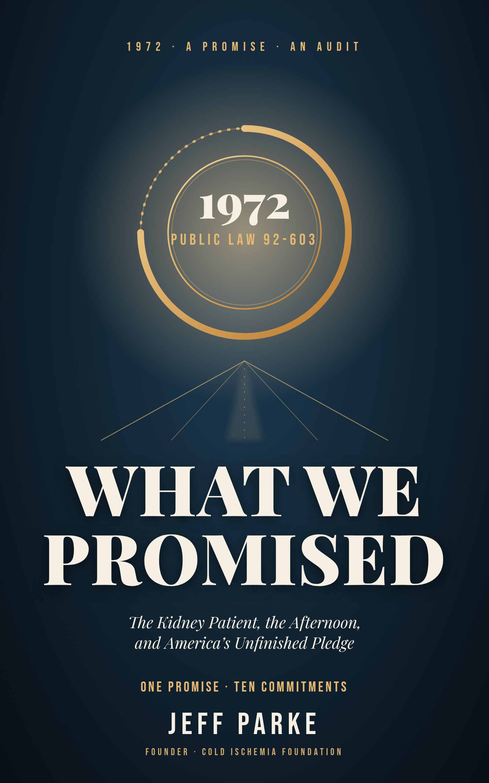
WHAT WE PROMISED
The Kidney Patient, the Afternoon, and America’s Unfinished Pledge
JEFF PARKE
Cold Ischemia Foundation
What We Promised
The Kidney Patient, the Afternoon, and America’s Unfinished Pledge
Copyright © 2026 Jeff Parke. All rights reserved.
Published by the Cold Ischemia Foundation, Ellenton, Florida. coldischemia.foundation
First edition, October 2026.
No part of this book may be reproduced, stored in a retrieval system, or transmitted in any form or by any means without the prior written permission of the publisher, except for brief quotations used in reviews or scholarly work with full attribution.
Educational purpose. This book describes systems and people. It is not medical, legal, or financial advice and does not replace the counsel of your own clinicians. In a medical emergency call 911. If you or someone you love is in emotional crisis, call or text 988.
On people and scenes. Named people appear because their stories are in the public record. Other individuals, identified by a first name or by no name, are composites built from documented patterns and are marked as such in the text.
On accuracy. Statements about organizations, investigations, and legal matters describe the sources cited. Sources marked with a dagger (†) have bibliographic details that should be completed from the original before any future edition. Corrections are welcome through the Foundation’s contact page.
Quotations. The epigraphs are drawn from works in the public domain.
For the ones who were told to wait, and for the ones who waited with them.
“With malice toward none, with charity for all, with firmness in the right as God gives us to see the right, let us strive on to finish the work we are in.”
— Abraham Lincoln, Second Inaugural Address (1865)

Contents
Prologue: The Man Who Would Not Leave the Room
A Note on Sources and Honesty
Part One: The Promise
Chapter 1: Sausage Casing and Orange Juice Cans
Chapter 2: Who Shall Live
Chapter 3: The Gift Nobody Had to Give
Part Two: The People the Promise Forgot
Chapter 4: The Afternoons
Chapter 5: The Body Nobody Mentions
Chapter 6: The Road, the Storm, and the Heat
Chapter 7: The Chair You Earn by Nearly Dying
Part Three: The Gift and Its Cost
Chapter 8: Strangers, Chains, and the Receipt
Chapter 9: The Hallway
Part Four: The Future We Could Keep
Chapter 10: The Pig, the Patient, and the Quiet Revolutions
Chapter 11: The Second Promise
Epilogue: The Window Nobody Looks Out Of
Appendix A: Source Notes
Appendix B: References
About the Author

Prologue: The Man Who Would Not Leave the Room
“To care for him who shall have borne the battle, and for his widow, and his orphan.”
Abraham Lincoln, Second Inaugural Address (1865)
In the fall of 1971, in a hearing room on Capitol Hill, a man in a business suit sat down beside a machine and let it take his blood.
His name was Shep Glazer. By the accounts that survive he was in his forties, a salesman, a husband, and the officer of a small organization of patients who depended on dialysis (Source Notes S1). The members of the House Ways and Means Committee had heard a great deal that season about the cost of keeping people like him alive. They had heard it from actuaries and from agency staff, in the dry vocabulary of appropriations. What they had not done, most of them, was watch it. Glazer arranged for them to watch.
I have tried many times to picture the room. The accounts differ in their details, and I will not pretend to a precision they do not support. But the outline is the same in all of them. A man sat at a witness table. Tubing ran from his arm to a machine. His blood left him, passed through a filter, and returned, while he spoke to the men who held the purse. He was not performing a trick. He was making an argument without raising his voice: that this was what staying alive looked like for people with failed kidneys, that it could be done, that it was being done in a few places for a few people who happened to be lucky, and that the luck was the thing he had come to talk about.
Think about what it takes to do that. Think about sitting in front of the most powerful committee in the House, with a needle in your arm, and asking strangers to decide whether you and people like you are worth the trouble. There is no way to do it without a certain terrible calm. He could not leave for the next four hours. He could not argue, and then stalk out, and then think of the thing he should have said. He had to stay, and let them look, and keep his voice even.
A year later, in October of 1972, President Nixon signed a large bill that touched Social Security in many ways, and one provision of it, tucked in among hundreds, did something that no nation had done. It extended Medicare, a program built for the old, to anyone of any age whose kidneys had failed (Source Notes S1). On the first of July, 1973, the promise took effect. The country had decided, in a few paragraphs and with remarkably little argument, that a person should not die for want of a machine.
I want you to hold on to the word promise, because the rest of this book is an audit of it.
The people who wrote that provision believed they were solving a problem with a boundary. The best estimates of the day, as the story is usually told, held that perhaps ten thousand Americans would need the benefit, at a cost to the government of something over a hundred million dollars (Source Notes S1). By 2012 the Medicare program was paying for more than 525,000 people with kidney failure, at a cost above $28 billion a year (Source Notes S1). By 2023 the figure had grown to $55.3 billion in a single year, and the share of the population living with kidney failure, adjusted for age and sex, stood at 2,327 for every million Americans (Source Notes S2). The line between those two numbers is the story of a promise that proved far larger than the people who made it.
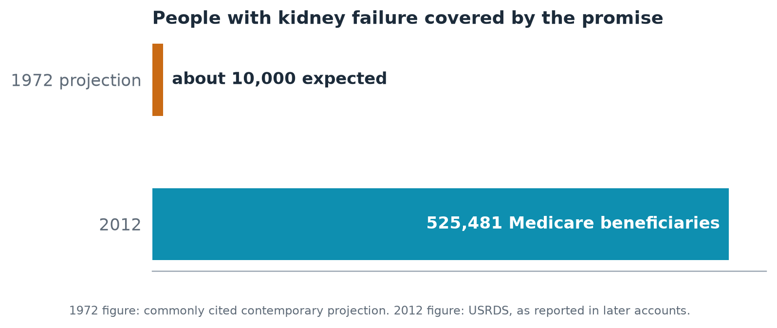
Figure 0.1. What the country expected in 1972 and what it later paid for. Expected enrollment is from commonly cited contemporary projections; the 2012 count and cost are from the Medicare end-stage renal disease program as reported in later accounts.
You might expect a book that begins this way to be a celebration. Part of it is. The promise worked in the plainest sense. People who would have died in the early 1970s lived, in numbers that no one at that hearing table could have counted, and they raised children, and buried their parents, and grew old. Anyone who dismisses that has forgotten, or never learned, what the alternative looked like.
But a promise is not what it says on paper. A promise is what the people on the receiving end can actually count on. And when you set out to measure the American promise to the kidney patient by what the patient lives through, rather than what the statute provides, the picture changes. A machine and a payment are not a life. A life has afternoons in it, and a body, and a front door a certain distance from the nearest chair, and a person on the other side of the dinner table who does not know what to say.
This book walks through the places where the promise and the person come apart. It begins, in Part One, with where the promise came from, because I have found that nobody improves a thing they do not understand, and because the history is more moving and more strange than most people who work inside it have been told. It goes on, in Part Two, to the people the promise has been hardest on: those whose afternoons it took, whose bodies it changed, whose roads it lengthened. In Part Three it turns to the gift at the center of transplantation, the strangers who give a kidney and the families who give an organ in their worst hour, and to what we do with those gifts once they are given. And in Part Four it looks ahead, to the machines and the biology that could make much of this obsolete, and to the smaller, more human obligations that no machine will remove.
I should tell you what I am and what I am not. I am not a clinician. I am not a politician. I have sat in the rooms this book describes, at more than one side of the table, over more than one stretch of years. I will not tell you my own story, because it belongs to me and to the few people who carried me through it, and because the people who fill these pages deserve the room. What I can offer is the habit of attention that those years teach. You learn to notice who is waiting. You learn what a waiting room sounds like at night. You learn that the thing nobody says out loud is usually the thing that matters.
Where I have invented a figure to stand for many, I will say so. The people in this book who are named are named because their stories are in the public record. The rest are composites built from what patients, families, nurses and researchers have described, and I mark them plainly.
Three promises of my own. I will not use a number to frighten you when a sentence will do. I will not hide the limits of what is known, and in this field there are many. And I will end every chapter by asking what you, or a clinic, or a community, or a lawmaker, can do next, because a book that makes you feel something and then gives you nowhere to put it has done only half its work.
Glazer finished his treatment that day and, so far as I know, went home. The committee did what it did. The history books say that the room was moved. I have never read an account that says how he felt, driving home with a pressure bandage on his arm, having shown a roomful of strangers the thing he would otherwise have shown no one. I like to think he felt the particular tiredness of a man who has said what he came to say.
He was asking, as we all are, to be counted. We will see whether the country kept its word.

A Note on Sources and Honesty
“A false balance is abomination to the Lord: but a just weight is his delight.”
Proverbs 11:1 (King James Version, 1611)
A book that asks for action owes its readers an account of how far its facts can be trusted. I owe you that, and I would rather over-explain than leave you with a false confidence.
What this book is. It is an advocacy narrative written by a patient-community founder, and not a systematic review. It draws on published studies, registry reports, news accounts, government notices and the history of the field. It does not present new research of its own.
How I checked. The searches for this book were run in October 2026 using summaries of published material. In many cases I could read only a summary and not the full paper. Where that is so, the Source Notes in Appendix A carry a grade. Grade A means a primary document or registry whose key figures I confirmed. Grade B means a credible secondary account. Grade C means a single source, an advocacy statement or a manufacturer’s claim. A dagger (†) marks bibliographic details, such as authors or page numbers, that are only partly confirmed. A reader preparing this for publication should complete those from the original papers.
History is older than six months. The early chapters describe events from 1943 to 1972. They are history, and I have used the retellings that appear most consistently in published accounts. I have hedged details that vary between sources and have flagged in the Source Notes that the primary texts should be consulted before any future edition.
Composites. Where a person appears without a full name or with a first name only, Marisol, Daniel, Aisha, Walt, Ray, Andre, and the unnamed men and women in hallways and clinics, the person is invented to stand for many. They are marked as such in the text. The named people in this book, among them Kolff, Scribner, Quinton, Shields, Murray, the Herrick brothers, Glazer, Slayman, Pisano, Looney and Andrews, are named because their stories are part of the public record, and I have limited what I say about them to what that record supports. I have not invented their words or their feelings.
Where the evidence runs out. I have tried to say so each time. Some figures are old, such as the emergency-only dialysis studies from 2018. Some come from small studies, such as the mentoring trials and the intensive-dialysis pregnancy cohorts. Some come from manufacturers or advocacy groups. A claim in this book is only as strong as its Source Note.
An interest to declare. The author founded the Cold Ischemia Foundation, which publishes information on kidney preservation technologies, including some mentioned in Chapter 10. The Foundation accepts no donations, grants or sponsorships. I mention the connection so that you can weigh that chapter accordingly.
PART ONE
THE PROMISE

Chapter 1: Sausage Casing and Orange Juice Cans
“Is there no balm in Gilead; is there no physician there? why then is not the health of the daughter of my people recovered?”
Jeremiah 8:22 (King James Version, 1611)
Imagine the Netherlands in the worst years of the occupation. It is 1943. A young physician named Willem Kolff has a ward in a small hospital in the town of Kampen, and on the ward there are people dying of a thing that, in those days, no one in the world could stop. Their kidneys have failed. Poisons that a healthy body quietly sweeps out each hour are building in their blood, and the doctors can do nothing but make them comfortable and watch the confusion come, and then the stupor, and then the end.
Kolff was not content to watch. He had read about earlier attempts to clean blood through a membrane, attempts that had worked in animals and failed in people, and he had a theory about why: the membranes were wrong, the anticoagulant was wrong, the machines were clumsy. So in a country where nearly everything was being taken by someone else, he began to build with what could be found. The account that has come down to us, repeated in nearly every history of the field, is of a rotating wooden drum wrapped in cellophane tubing, the sort used for sausage casings, turning through a bath of fluid, with parts borrowed from wherever parts could be borrowed, including the water pump of an automobile (Source Notes S3). The details have taken on a folklore sheen, and I would not stake much on every can and bolt. But the essential picture is secure. A doctor in an occupied country made a kidney out of scraps.
The first patients he treated died. This is the part of the story that gets trimmed in the retelling. He treated, by the standard account, more than a dozen people over those first years, and none of them survived. They died, one after another, of the very disease that the machine was meant to answer (Source Notes S3). Think of what it is to continue under those conditions. To tell the next family that the machine might help, having seen the last family bury someone. To keep building anyway.
In September 1945 a sixty-seven-year-old woman, her kidneys shut down by an acute illness, was connected to the machine for about eleven hours. She woke, as the story goes, and she lived for several more years (Source Notes S3). She was the first patient to be rescued by an artificial kidney, and with her the idea moved from a hope to a fact.
I begin the story of the American promise with this scene on purpose. The promise did not begin in Washington. It began with a man who was willing to be wrong in public, again and again, among the dying, until he was not.

The machine that could be used only once
There was a catch, and it is the one that shaped the next fifteen years of kidney medicine and the lives of everyone who came after.
Kolff’s machine could rescue a person whose kidneys had stopped suddenly and might recover, someone crushed in an accident, or poisoned, or run down by a severe infection. For such a patient, a few treatments could carry them across a gap until their own kidneys woke up. What the machine could not do was keep alive a person whose kidneys had failed for good. Dialysis required a way into the bloodstream. In those years that meant a surgeon cutting down to a vein and an artery, placing needles or tubes, and, when the treatment ended, tying them off. Each time, a piece of blood vessel was used up. After a handful of treatments there was nowhere left to cut.
So the people with permanent kidney failure, which is to say the people in whom the failure would come every week of the rest of their lives, were outside the promise of the machine. The device could clean their blood. It could not be plugged in more than a few times. A treatment that works twelve times is a treatment for a bad month. It is not a treatment for a life.
Many of us who live with chronic illnesses of our own have met a version of this problem. The technology is dazzling, and then you notice that it fails at the doorway, at the thing so ordinary that no one wrote a grant to fix it. The cure is there. The way in is missing.

The tube that made a life
In Seattle, in the winter and early spring of 1960, a physician named Belding Scribner and a young engineer named Wayne Quinton solved the doorway problem with a piece of plumbing. They took a tube of the new slippery plastic Teflon, shaped it into a small U, and placed one arm into an artery and the other into a vein in the patient’s forearm, leaving the loop outside the skin, where it could be opened and attached to the machine and then closed again so that blood simply flowed through the loop between treatments (Source Notes S3). A shunt, it was called. It was not elegant. It was a permanent opening in the body that had to be kept clean and covered and watched. But it did the single thing no one had been able to do. It made the same arm available again and again.
The first person to be treated with it was a machinist at Boeing, a man in his late thirties named Clyde Shields. He was dying of kidney failure. He had a wife and children. In March of 1960, he was connected to the new apparatus, and he did not die. He went on, on dialysis, for more than eleven years (Source Notes S3).
Let that sentence sit for a moment. For the first time in the history of medicine, a person whose kidneys had failed forever lived for more than a decade on a machine. Eleven years of Saturday mornings and school plays and arguments about money, of a wife who learned to flush the tubing, of children who grew up knowing their father by the odd way he held his forearm at the dinner table. That did not exist before. The gift of Scribner and Quinton, and of the man who dared to be first, was time. Not an abstraction, not a statistic. The ordinary stuff of a human life.
I think about Clyde Shields’s wife more than I think about the machine. The accounts are thin on her, and I will not invent her speech. But there is a particular loneliness in being the person who learns the apparatus, who stands at the edge of the room with the clamps in her hands, who understands that if she makes a mistake, the thing keeping her husband alive could fail. Families in this field have always been unpaid members of the clinical team, and the promise we are about to examine has never fully counted them.

What the tube taught us
The history of dialysis could be told as a tale of ever-better machines, and in a narrow way it is. But when I look at the turning points, what I see is a pattern that the field has been slow to learn.
First, the decisive advance was not the glamorous one. Kolff’s machine was the headline. Scribner’s shunt, a bit of plastic tubing a plumber might have devised, was the breakthrough that turned a rescue into a way of life. Today the same pattern recurs. The access to the bloodstream, whether by a surgically created connection in the arm or a catheter placed through the skin, remains the place where much of the trouble in dialysis begins. I did not find, in the sources open to me, a clean current figure for how often it fails, and I will not manufacture one. But anyone who has spent a year in a dialysis unit knows the sentence: the problem is the access.
Second, the people who made the leap were outsiders to the established wisdom. Kolff was a young doctor in a small town in an occupied country. Quinton was an engineer rather than a physician. Shields was a machinist who agreed to be the first. Progress came from people who were close enough to the problem to feel it and unburdened enough by the way things were done to try something else.
Third, and this is the one I want to stay on: each advance, when it arrived, immediately produced a new and harder question, one that no machine could answer. If you can keep a person alive on a device, and the device and the staff to run it are scarce, whom do you keep alive?

The first kitchen tables
The next chapter in the story is the one I find most affecting, because it is the one we nearly forgot. By the middle of the 1960s, in Seattle and in London, physicians had begun to train patients and their families to run the machines in their own homes (Source Notes S3). The reason was practical: there were too few chairs, too few nurses, and too many people who would die waiting. The consequence was extraordinary. Ordinary people, a machinist’s wife, a schoolteacher’s husband, learned to mix the fluids, prime the lines, insert the needles, watch the pressures, and respond to the alarms. They did it in spare rooms and basements and, as the later telling has it, at kitchen tables.
Imagine what it asked. A teenager, home from school, watching her father sleep with a machine beside the bed. A mother learning at forty to read a pressure gauge. A household reorganized around a schedule, with a spare bedroom becoming a clinic and a dinner hour becoming a window. These were not heroes in the usual sense. They were people who took on, without training, without pay, and mostly without applause, a duty that would be considered professional today.
Then something changed. When the national benefit arrived in 1973, it brought money, and money brought a new model: the dialysis facility, paid by the treatment, staffed by professionals, built to take patients in and put them in chairs. For many people that model was a mercy. It also, by most accounts, pushed home dialysis to the margins for decades. In the registry data for people starting dialysis, the share beginning on a home therapy was only 6.8 percent in 2010 and had reached 13.3 percent by 2020 (Source Notes S4). In other words, the most common way to get dialysis in the early 1960s became, within a lifetime, the uncommon way, and its return is still slow.
I raise this because it shows how a promise can reshape what it promises. The country offered to pay for dialysis. It did so in a way that made dialysis something done to people in a building rather than something done by them in a life. Neither choice was wrong. But a nation that pays for a thing is also deciding what that thing will look like, and we are still living inside that decision.

An honest accounting of what we know
Before the next chapter takes up that question, I owe you a note on the sources for this one. The story of Kolff and Scribner is among the most retold in medicine, and it appears in textbooks, memorial essays, hospital histories and the recollections of the people who worked beside them. I have drawn the outline from that body of accounts and have not been able, in this setting, to consult the original papers and obituaries for every detail. The broad facts are not in dispute: the wartime machine, the first failures, the first survivor in 1945, the Teflon shunt of 1960, Shields as its first patient and his long survival. The specifics, such as the exact number of Kolff’s early patients, the exact parts, and the precise ages, vary from source to source, and where they vary I have kept to the version that is both widely told and hedged. If you are citing this chapter for any purpose other than understanding, go to the primary record.

What I would have you do with this
It is easy to read a story like this one with a pleasant sense of distance. The inventors are dead, the machines are in museums, and the progress is complete. It is not. Every part of the dialysis experience I describe in the pages ahead, the hours, the access, the recovery, the isolation, exists in the shadow of design decisions made by people who were solving the problem they could see. The question for us is who is solving the problem we cannot see, and whether anyone who actually lives with it is in the room.
If you are a patient, or someone who loves one, the most useful thing you can do after reading this chapter is small. Next time you are at a unit, ask the technician or the nurse what, in their experience, is the most annoying part of the equipment, and what they would change if they could. Write down what they say. The best ideas in this field have always started that way, with a person at the bedside noticing what everyone else had stopped noticing.
If you work in a clinic, ask your patients the same question and keep a list on the wall. If you are a student, an engineer, a nurse, a person with an odd skill and an idle weekend, know that the most important invention in the history of chronic kidney failure was a piece of plastic tubing designed by an engineer who asked what the doctors needed.
And if you are none of those things, remember Clyde Shields. A machinist said yes, when the safest thing would have been to say no. The history we inherit is made of people like him, who stepped forward when stepping forward had no guarantee. We owe them a better afterward than the one we have so far written.

Chapter 2: Who Shall Live
“I have set before you life and death, blessing and cursing: therefore choose life, that both thou and thy seed may live.”
Deuteronomy 30:19 (King James Version, 1611)
Picture a conference room in Seattle in the early 1960s. It is evening. A handful of people, almost none of them doctors, sit around a table with folders in front of them. One is a minister, one a lawyer, one a banker. They have jobs and families, and they have been asked to do something that no committee of citizens had ever been asked to do, which is to decide which of several dying people will be given a place on the only dialysis machines in the region (Source Notes S3).
The center was new, and its machines were few. Scribner’s shunt had opened the door to long-term treatment, and within months the doctors discovered that they had more candidates than chairs. A doctor can refuse to treat a patient only with great difficulty and great pain. So the physicians made an extraordinary decision, and I find it, even now, both admirable and terrible. They stepped back from the choice. They gave it to a small panel of laypeople, who would see the candidates only on paper, anonymously, stripped of their names, and decide.
The accounts say the panel was reported to include a minister, a lawyer, a banker, a homemaker, a labor leader, a state official, and one physician, though the sources differ on the exact makeup (Source Notes S3). What I am sure of is that they met, that they read, and that for each place on the machine they turned someone away.

The article that named it
In November 1962, Life magazine published a long piece by a journalist named Shana Alexander under a title that would follow the committee for the rest of its existence: “They Decide Who Lives, Who Dies” (Source Notes S3). The nation had been told, in the idiom of the day, that medicine had performed a miracle, and now it was told what the miracle cost. A committee of citizens would assess a father’s worth against a mother’s, an engineer’s against a clerk’s. People began calling it the “God Committee.”
I have read how the members themselves felt about the work, in the accounts that quote them, and it is not what the title suggests. They were not enjoying the power. At least some of them wrestled with it for the rest of their lives. They tried to be fair. They also, being human, made judgments that today would make us wince. The criteria that were reported included things like a candidate’s dependents, income, education, and what was called “social worth,” which, in the bluntest reading, meant the committee preferred patients whose lives looked most like the committee’s own (Source Notes S3).
I do not say this to condemn them. They were handed an impossible task and did it in good faith. I say it because the history gives us a hard lesson about decisions that must be made when resources are scarce: someone will always make them. The question is whether it is done openly or in the dark, by people who know they are doing it or by people who have persuaded themselves that they are not.

The answer the country gave
The committee’s work eventually became unnecessary, and it became unnecessary in an unusual way: the public decided that nobody should be asked to do it. By the end of the 1960s, the idea that a nation of this wealth could let people die for lack of a machine, and let a committee choose among them, had become intolerable. Patients and their families organized. They testified. Some did it with their own blood, as Shep Glazer had.
The Social Security Amendments of 1972, signed on the thirtieth of October that year, contained a short provision that extended Medicare coverage to people of any age who needed dialysis or a transplant because their kidneys had failed (Source Notes S1). It is an oddity of American law. Medicare was designed for the old, and later extended to the permanently disabled. This was the first time the country had said that a single organ’s failure was enough to qualify a person of any age. By most accounts it passed with remarkably little debate, as a rider to a much larger bill, because few in Congress thought the stakes would be large. The projection, as it has been handed down, was something in the neighborhood of ten thousand patients and a bill of about $135 million (Source Notes S1). The accounts differ as to whether that figure was annual.
The benefit took effect on the first of July, 1973.

What the promise covered, and what it did not
To grasp the American promise to the kidney patient you have to read it the way a lawyer would, which is to say, for the sentences it leaves out.
It covered dialysis. It covered the transplant operation. It put the country’s money behind the thing Seattle’s committee had been unable to supply, which was chairs. And it did so quickly: in the decade after 1973 the number of dialysis patients in the United States grew many times over.
What it did not do, at the start, is worth noticing. It did not cover the cost of the drugs that keep a transplanted kidney alive for long. For many years, a person who qualified for Medicare only because of kidney failure lost that coverage thirty-six months after a successful transplant, and with it, the coverage for the immunosuppressive drugs without which the new kidney would be rejected. A person could be handed a gift of life by a donor and then lose the means of protecting it. Only in recent years has Congress created a narrower benefit, known as Part B-ID, to cover those drugs for people who would otherwise lose them, available since December of 2022 (Source Notes S5). The pharmacy counter is a place I return to later in this book. For now I want only to point out that the promise was written with the dialysis chair at its center, and it has taken half a century to fill in the rest of the picture.
It did not do anything about the shape of life around the chair. It did not say anything about work, or the body, or the distance between a house and the nearest unit. Those omissions were not malice. They were the natural limits of what a committee of lawmakers could imagine.

The arithmetic that nobody wants to say out loud
Let me do something now that makes some of my colleagues uncomfortable, which is to look at the cost without flinching.
The program has grown very large. In 2023 the Medicare program paid $55.3 billion for people with kidney failure (Source Notes S2). Beneficiaries with kidney failure are about one percent of all Medicare beneficiaries, and by one advocacy estimate their care accounts for about seven percent of spending in traditional Medicare (Source Notes S6). Anyone who tells you the cost is trivial is not being straight with you. A fiscal conservative has a right to ask whether the money is being well spent, and I would add that those of us who care about patients have a duty to ask it first.
Here is the figure that I wish more people carried in their heads. The per-person cost to traditional Medicare in 2021 was about $99,325 a year for a patient on in-center hemodialysis, about $86,976 for a patient on peritoneal dialysis, and about $43,913 for a patient with a functioning transplant (Source Notes S7). Put plainly, a functioning kidney costs the program less than half of what keeping the same person on a machine costs, and the person is, by almost every measure, better off.
Now set that beside this one: only 12.3 percent of prevalent dialysis patients were on the transplant waiting list in 2021 (Source Notes S7). Not 12.3 percent of those who could benefit. Of everyone on dialysis.
I do not claim that all the others could safely receive a kidney. Some are too sick, some are too old, some do not want it, and some cannot be matched. The wait, as those who live in it know, is measured in years. But the gap between the chance of a transplant and the reality is so wide that it should trouble anyone, whatever their politics. We have a program that pays more for the worse outcome, and then waits for patients to find the better one.

The committee no one sees
I said that a committee decides who lives. I want to tell you where the committee sits now.
It is not a room in Seattle. It is the series of small decisions that determine whether a given person with kidney failure is ever told about a transplant, ever referred to a transplant center, ever completes the evaluation, ever reaches the list. At each of those stages some people drop away, and not at random. A randomized trial at Emory University enrolled 401 patients and found that those who were given a patient navigator were more likely to be waitlisted, 32 percent against 26 percent, though they took longer to get there, by an average of 126 days (Source Notes S8). A larger trial run in dialysis facilities in Georgia, covering more than 9,000 patients in 134 facilities, found that a structured intervention improved referral to transplant centers and narrowed the racial gap (Source Notes S8).
These are the trials that deserve our attention, because they tell us that the invisible committee can be changed. A person who is hustled to the list by a navigator is not a person who deserved it more. She is a person who, absent the navigator, was not told. The historical committee at least looked the candidates in the eye on paper. The modern one often does not look at all.
Even the rules written to correct past injustice show how hard this is. For years, the formula used to estimate kidney function included a race adjustment that made Black patients appear healthier than they were, delaying their qualification for the waiting list. In 2023 the national transplant network adopted a policy to backdate waiting time for Black candidates whose listing had been delayed by that formula. One analysis found that the change was associated with more transplants, 5.3 more per 1,000 listings (Source Notes S9). It was a correction of a wrong long after the fact, and it is worth noticing how recent it is.

Choosing life
The verse at the head of this chapter comes at the end of a long speech in which Moses sets before a people the consequences of their choices and tells them to pick the harder, better path. The commandment is not abstract. “Choose life, that both thou and thy seed may live.” Two generations, in the one sentence.
I read it as a description of what the founders of the American kidney program were trying to do in 1972, and as a challenge to the rest of us. They chose life, and in the process of choosing it they created a machine of enormous scale, whose workings they could not have predicted. The challenge to us is not to un-choose it. The challenge is to finish choosing. A nation that decides, as ours did, that no one should die for want of a dialysis machine has committed itself to the next question: what kind of life, for how long, with whose help, and at whose elbow?

What you can do
If you are a patient or a family member and you are on dialysis, ask your care team this week, in writing if you can, one plain question: Am I a candidate for a transplant, and if not, why not? Ask for the answer in terms you can understand. If the answer is that you have never been evaluated, ask who can start the referral. The invisible committee is made of silences, and silences end when someone asks.
If you work in a dialysis unit, ask yourself what share of your patients have been asked about a transplant in the past year, and who in your building keeps that list. If no one does, that is the first fix.
If you are a legislator, a staffer, or a citizen who writes to one, ask the question that the 1972 bill’s authors did not: not how much we pay for dialysis, but how many of the people we pay for are being offered the cheaper, better thing.
And if you are simply someone who has read this far, I would ask that you remember the strangers at the table in Seattle, anonymous even now, who tried to be fair under an impossible weight. The system we have built should make their burden unnecessary. We do not yet fully deserve that.

Chapter 3: The Gift Nobody Had to Give
“Greater love hath no man than this, that a man lay down his life for his friends.”
John 15:13 (King James Version, 1611)
On the twenty-third of December, 1954, two young men lay in adjoining operating rooms in a Boston hospital, one of them healthy and the other close to death. They were identical twins. They were named Ronald and Richard Herrick, and by the time the day was out, one of them would be missing a kidney and the other would have it (Source Notes S3).
Imagine the night before. It is the week of Christmas, and the hospital is quiet in the way hospitals are quiet at the end of a year. Richard is twenty-three, a veteran, thin, yellowed by the poisons his failing kidneys are no longer clearing. He has been told that nothing can save him. He knows that the doctors have been talking about an idea so unusual that most of the profession thinks it improper: that a kidney might be taken from his brother and sewn into him.
Now imagine Ronald. He is, as far as anyone can tell, entirely well. If he does nothing, his life will go on unchanged. If he agrees, a surgeon will open him, remove a working organ that his body needs and that cannot be returned, and he will leave the hospital with one kidney, a scar, and a debt that his brother can never repay.
I have thought a great deal about what that decision costs, and I should say that I am not describing it from the outside only. There is a kind of knowledge that comes to the people who stand at the edge of a gift of this kind, and I will leave it at that. But I can tell you what the history records: that the surgical team, led by a young surgeon named Joseph Murray, worked for months to be sure the operation was right, that the physicians fretted over the ethics of operating on a healthy person for another’s sake, and that the brothers’ identical genetic makeup had been checked, by some accounts using fingerprints and skin grafts, before anyone dared to proceed (Source Notes S3).

What the twins proved
The operation worked. The kidney began to make urine on the table. Richard, within days, was clear-headed and hungry. The immune system, which rejects almost any foreign tissue, saw nothing foreign, because the tissue was his own in every way that mattered. He went on to marry, to have children, and to live for roughly eight more years before his original disease returned and took the kidney (Source Notes S3). Ronald lived on for decades, a man with one kidney and a clean conscience. Murray, in time, was awarded the Nobel Prize in Physiology or Medicine, in 1990, for what the twins had begun (Source Notes S3).
The scientific lesson was narrow and immense. A transplanted organ could function in a human being. The obstacle was not surgical. It was immunological. Almost every other patient with kidney failure had no identical twin, and the surgeons would spend the next decades learning to suppress the immune system enough to stop it from destroying the new kidney without letting the patient die of infection.
But there was a second lesson, and it is the one I want to dwell on, because it has been lost under the first.
The kidney did not come from a laboratory. It came from a person. The whole structure of transplant medicine, which now includes tens of thousands of operations a year, regulation, registries, hospitals, and a vast apparatus of coordinators, begins with a man in his twenties who had a spare organ and a brother he loved. The foundational act of transplantation was not a technical triumph. It was a gift.

The strange moral shape of the gift
We take it for granted now, but the principle at work in that operating room is unlike anything else in medicine. In nearly every other field, a physician treats the patient on the table. Here the physician harms one person in order to help another, and does it with the first person’s full agreement. The justification is not a medical benefit to the donor. It is the donor’s own decision, which the law and the profession agree to treat as sacred.
Later generations, wanting more organs than the gifts of family could supply, built an elaborate structure around that sacred decision. In 1984 Congress passed the National Organ Transplant Act, which, among other provisions, made it a federal crime to buy or sell a human organ (National Organ Transplant Act, 1984). The reasoning was and remains persuasive to many: that a market in organs would turn the poor into a supply, that the rich would buy the kidneys of the desperate, and that the whole practice would corrupt the thing that made it beautiful. Today the law stands, and a donor in the United States may be reimbursed for certain expenses but cannot be paid.
I say all this without taking a side in the argument about markets, which I will leave to the philosophers. What I want to draw out is the consequence for everyone else. If we insist that kidneys be given and not sold, we have taken on an obligation that the market would have discharged automatically, which is to make the gift as easy, as safe and as free of cost to the giver as we can. A system that depends on generosity cannot also be stingy with the generous.

Why a living kidney is different
A kidney from a living donor tends to last longer than one from a deceased donor, and the difference is not small. In a registry analysis, the median survival of a transplanted kidney from a deceased donor rose from about 8.2 years for transplants in the late 1990s to roughly 11.7 years for more recent ones. For living-donor kidneys the corresponding figures were 12.1 years and about 19.2 years (Source Notes S10).
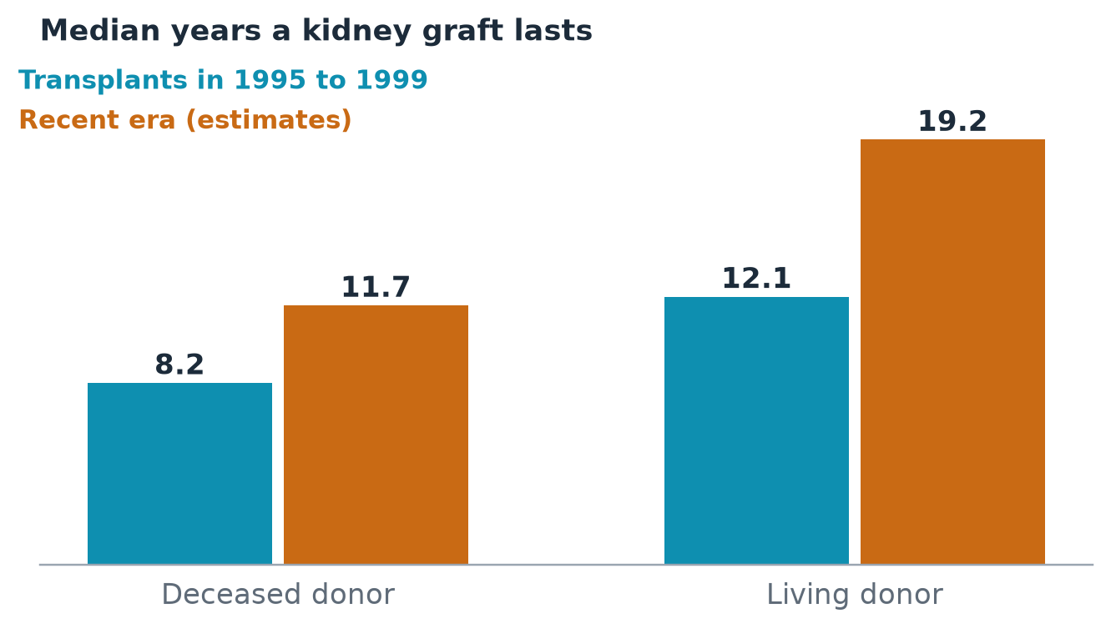
Figure 3.1. Median kidney graft survival in years, by donor type and era. Registry-based analysis of United States transplants.
That second number is the one to sit with. A living-donor kidney, on average, now lasts nearly two decades. For a young recipient, that can be a childhood and a career. For an older recipient, it can be the rest of life. It also arrives on a day of the surgeon’s choosing, with the donor and recipient prepared, the cold ischemia time, the hours an organ spends without blood flow, held to the shortest it can be. The deceased-donor kidney arrives at three in the morning, from a stranger, after a journey in a cooler. The living-donor kidney arrives at nine, from someone who says, I will do this for you.
The trouble is that the supply of such gifts is not growing the way we need it to. Living-donor kidney donation in the United States peaked in 2004 and then declined, with the drop concentrated among men, Black adults, and younger and lower-income adults (Source Notes S11). The problem is not confined to America. In Australia, a 2026 report in the Medical Journal of Australia found 253 living-donor kidney transplants in 2024, compared with 354 in 2008, a fall of roughly 29 percent (Source Notes S12). I did not find an equally clean figure for the United States as a whole for the most recent year, and I will not guess one. But a decline in the face of rising need is not what a healthy system looks like.

What stops a person from saying yes
Ask a hundred people whether they would give a kidney to someone they love, and a startling number will say yes. Ask them again after the first conversation with a transplant coordinator, and the number shrinks. The reasons are rarely hidden. Some are medical. Many are logistical. Lost wages. Travel and lodging. Child care during recovery. Fear of what the donation might do to future insurance. A donor can be a hero and also be unable to afford the weeks of recovery that follow.
Congress has begun to respond. The Honor Our Living Donors Act, enacted as part of the Consolidated Appropriations Act of 2026 on the third of February, 2026, directs federal action to broaden the reimbursement of living donors’ costs, and the agency responsible published notices that summer seeking comment on how it would be done (Source Notes S13). I will have more to say about how far these measures go in Part Three. Meanwhile private programs have grown up to cover some of the gap, offering wage reimbursement and life-insurance protection to certain donors (Source Notes S14). They are welcome. They are also a reminder of how much of the weight of this gift has been left to charity and chance.
There is a further factor that does not show up in any statute. Many people who would give a kidney do not offer, because they do not know that they are being asked. The patient is often the last person to say it. A woman on the waiting list will go years without asking anyone for a kidney, because it is among the hardest requests a person can make. She does not want to be a burden. She has watched her children’s faces. She hopes someone will volunteer.
A program called Live Donor Champion, developed at Johns Hopkins, was built around that silence. Instead of asking the patient to ask, it trains a friend or relative to speak for her, across six monthly sessions, to be her advocate in the community. In a pilot with fifteen candidates and fifteen matched controls, and a follow-up with 163 candidates, those who took part had substantially higher odds of a referral from a potential donor, about 5.5 times higher in the larger analysis (Source Notes S15). The evidence is preliminary, drawn from conference abstracts and a registered study, and not from a randomized trial. But the idea behind it is old and plain: a person is sometimes best helped by someone willing to ask on her behalf.

The debt in the gift
I return, before I end, to Ronald Herrick.
I do not know what the brothers said to each other, and I will not guess. The record is silent on that, as it usually is on the most important things. But I know what gifts of this size do. They bind. A person who has received a kidney from a brother, a friend, a stranger, carries it as a part of himself and as a fact about his life, and the person who gave it carries a scar and a quiet knowledge. The best of the transplant community understands this. The worst of it forgets that gratitude, like the kidney, can be damaged by neglect.
John’s gospel speaks of laying down a life for one’s friends. A kidney is not a life. But in a modern world where donors survive and flourish, it is as close as most of us will come to the offer. We should not make it harder than it must be.

What you can do
If you are waiting for a kidney, do not wait quietly. Tell one person this week that you need one. If you cannot say it, ask someone you trust to say it for you. Programs exist that train friends to do just that. Ask your transplant center whether it offers one.
If you are a potential donor, ask your recipient’s center for the donor advocate, the independent person whose job is to protect you. Ask what will be reimbursed and what will not. Write down the answers.
If you are a coordinator or a social worker, make a one-page sheet of the real costs of donation, in dollars, and give it to every person who asks about it, before they ask for it.
If you write laws, remember the first rule of any system built on gifts: it must never punish the givers.
PART TWO
THE PEOPLE THE PROMISE FORGOT

Chapter 4: The Afternoons
“So teach us to number our days, that we may apply our hearts unto wisdom.”
Psalm 90:12 (King James Version, 1611)
Meet a woman I will call Marisol. She is not a real person, and I say so plainly, because what follows is a composite assembled from what patients, nurses and researchers have described, and I would not want anyone to mistake an illustration for a case. But she is built from true parts, and if you have spent time in a dialysis unit you will have met her.
Marisol is thirty-eight. She rents a chair in a salon, which means she is, in effect, a small business: she sets her own hours, and no one pays her when she is not there. Her clients are people she has known for years. They tell her about their divorces and their mothers. Two years ago her kidneys began to fail, quickly and then all at once, and she learned a new vocabulary and a new calendar. Monday, Wednesday, Friday, one o’clock, four hours in the chair.
She has done the sum. Everybody does, eventually, in the car in the parking lot with the engine off. But she did not do the sum we are about to do. She did the one that counts only the hours on the machine.

The sum nobody does
Let us do it properly, because slowness is the point.
A common schedule for treatment in a dialysis center is three sessions a week, each about four hours. Over a year that is 156 sessions, and 624 hours in the chair. Now add the part nobody schedules. In an online survey of 359 people who dialyze in centers, the median time to recover from a session was three hours, and four in ten said it took four hours or longer. The most common complaint was feeling washed out, reported by 62 percent, followed by cramps at 44 percent and symptoms of low blood pressure at 42 percent (Source Notes S16). A separate review put the typical recovery at two to four hours, with about a quarter of patients reporting more than six, and a French cohort of 536 patients found that 15 percent needed more than twelve hours (Source Notes S17).
Take the survey’s median. Three hours of recovery after each of 156 sessions is another 468 hours.
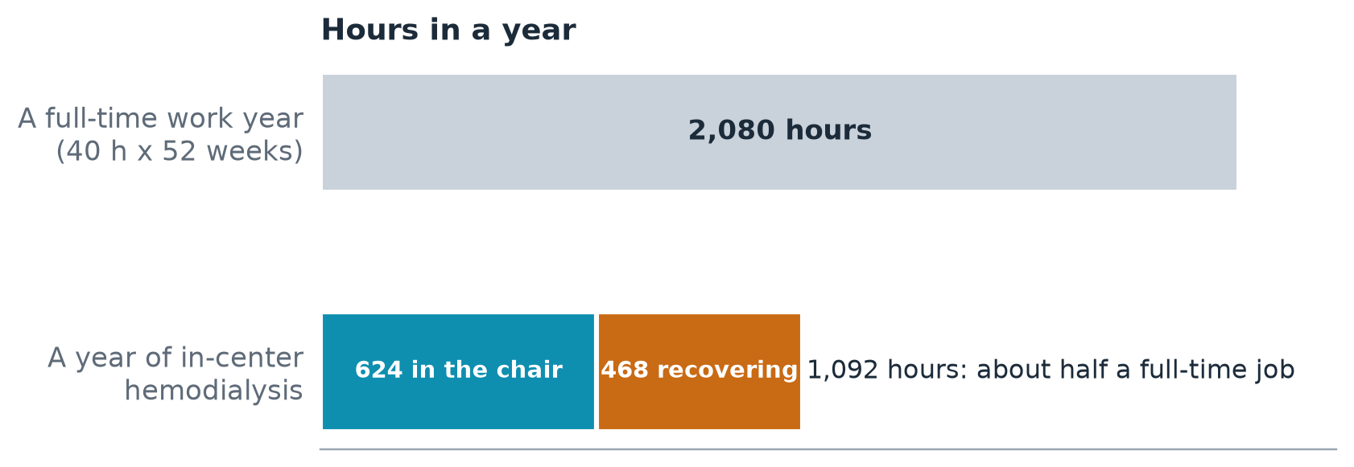
Figure 4.1. A year of in-center hemodialysis in hours, compared with a full-time work year. Illustrative arithmetic from a common three-session schedule and a published median recovery time; travel excluded.
Together, 1,092 hours. A full-time job occupies about 2,080 hours in a year. Kidney failure treated in a center takes something like half of a full-time job, and the person who holds it is not paid, cannot quit, and is often too tired to do any other job at all. I must be honest about the limits of that figure. The schedule is common but not universal, the recovery number comes from one modest survey, and recovery overlaps with sleep and rest in ways no questionnaire can untangle. Travel to and from the clinic is not counted. The point is not that the sum is exact. The point is that it is the right kind of sum, and that nearly no one does it.
Here is what the sum looks like from inside. It is Wednesday. Marisol has a cut and color booked for eleven, which will run to twelve-thirty. She has to leave by twelve-fifteen. She will sit in the chair until five, and she will walk out at ten past, and by the time she reaches her car the bottom of the day has dropped out of her. She will drive home slowly. She will lie on the couch with the television on, not watching it. At seven her daughter will ask whether there is anything for dinner. At eight she will wake up wondering where the evening went.
You will notice that I have not said she is in pain. She is not, particularly. What she is, is absent. For a stretch of each day she is physically somewhere, but the person who lives in her body has stepped out. Multiply that by three days a week, and by the years, and you begin to see the shape of what this treatment takes. It does not take her life. It takes her afternoons.

What the doctors count, and what Marisol counts
Here is a fact that has haunted me since I first came across it. In an international exercise to decide which outcomes should matter most in dialysis research, hundreds of patients, caregivers and clinicians from dozens of countries were asked to rate a list of possible outcomes. The patients and caregivers placed far greater weight than the professionals on the ability to travel, on time free from dialysis, and, to a lesser degree, on feeling washed out afterward (Source Notes S18).
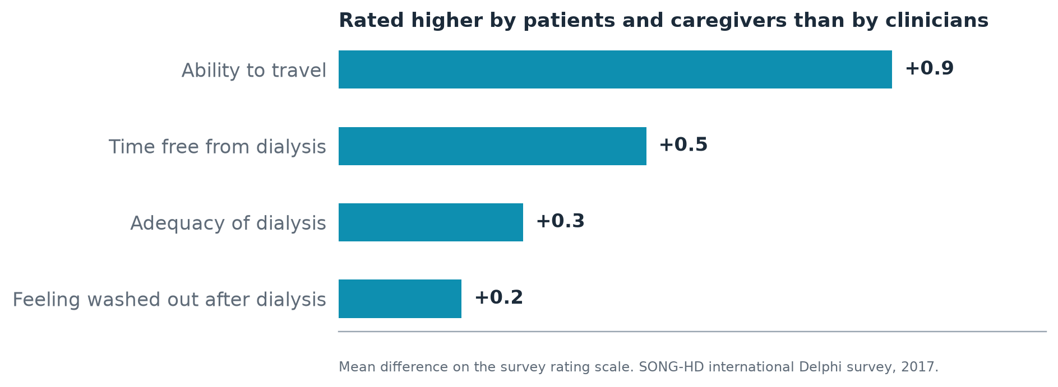
Figure 4.2. Outcomes that patients and caregivers rated higher than clinicians did in an international consensus exercise, in points on the rating scale.
Look at that again. The largest gaps were not about chemistry. They were about the ability to leave town for a wedding, and about hours that belong to the patient. I suspect the explanation is simple, and cruel in its simplicity. A physician sees a patient for a few minutes at the machine, and the training and the incentives point toward whether the blood is clean. A patient lives in the other twenty hours, and is judged by nothing, and so must make the judgments herself.
I do not blame the clinicians. I have known many nephrologists, nurses and technicians who give more of themselves than any employer could ask. But the system they work in measures what it can measure. It measures the adequacy of the treatment. It does not measure how long you were gone afterward, whether you made the recital, whether you had to turn down the job. And what a system does not measure it cannot manage.

Small changes with big afternoons in them
This is where the story should turn hopeful, and I think it can, because the evidence on recovery is more interesting than most people in the field have been told.
Consider something as plain as the temperature of the fluid. Standard dialysis fluid is warmed to about body temperature. Several small studies have tested cooling it a degree or two. In a 2024 quasi-experimental study in Pakistan involving 92 patients, researchers compared fluid at 36 degrees Celsius with fluid at 37. In an older crossover trial of 50 patients, comparing 35 degrees to 37, 76 percent of patients reported feeling more energetic after cooler treatments (Source Notes S19). These are small studies from varied settings, and none is the definitive trial. Larger registered trials in Iran and Turkey had not, in the sources I could reach, published results. So I will not tell you that cooler dialysis cures the washed-out feeling. I will tell you that a fix this cheap, one that requires no new machine and no new drug, deserves a proper test, and that the patients in those studies were telling us something.
Or consider a report on a change in prescription. In one study described in the trade press, the median recovery time fell from 210 minutes to 60 minutes at six months, and was 105 at twelve (Source Notes S20). Again I hold this loosely. It is a report, not a randomized trial, and the changes involved were of the kind a unit makes patient by patient. But think about what it means: three and a half hours reduced to an hour. If that held for even a fraction of patients, the arithmetic of my sum above would change by hundreds of hours a year.
And consider the large trials that tested giving patients more dialysis, more often. The Frequent Hemodialysis Network trials randomly assigned 245 patients to six sessions a week or to the usual three. The daily arm reduced the mass of the heart’s main pumping chamber by 13.1 grams, a meaningful improvement in a part of the body that kidney failure damages. The nocturnal trial, which tested long sessions overnight at home, did not reach statistical significance on its main outcome, though it showed better control of blood phosphate and blood pressure (Source Notes S21). The trials took time away from the day and gave some of it back at night, and in doing so they pointed to a possibility: that the shape of the treatment is not fixed.
What strikes me is that all of these ideas begin with the patient’s complaint and not the lab value. Nobody had to invent a new molecule. They only had to take seriously that three hours of washed-out is a harm.

The question of work
The deeper cost of the missing afternoons is not leisure. It is livelihood.
A large Danish registry study followed adults between 18 and 65 who began dialysis or received a transplant between 2005 and 2019. At the time dialysis started, 11 percent were employed, against 61 percent of matched people from the general population. Among transplant recipients the employment rate was 20 percent, against 67 percent of their matched counterparts. The authors concluded that transplantation produced only a small increase in employment (Source Notes S22).
Other studies give different numbers, because they ask different questions. A meta-analysis that pooled studies from 1966 to 2020 put the employment rate among dialysis patients at 26.3 percent, and at 36.9 percent before and 38.2 percent after transplant (Source Notes S23). A small 2025 study of 94 transplant recipients in one region of Poland found that 66 percent had gone back to work, 41.9 percent within six months, and that return was associated with higher education, better finances and more time since the surgery (Source Notes S24). If I had to carry one figure out of this literature, it would be the Danish one, because it compares like with like. It says that kidney failure removes most of a person’s working life, and that a transplant returns only part of it.
Marisol knows this without a registry. She has watched clients drift to other stylists on Mondays, Wednesdays and Fridays. She has watched her savings drop. She now takes new clients only on Tuesdays and Thursdays, and has begun to suspect the salon will not need her for long. The work she did, in the way she did it, was part of who she was. The people in the Danish study did not leave a job. They left a self.
I want to avoid being sentimental about this. A job is also rent, and insurance, and a pension, and the end of a particular kind of worry. But the conservative tradition I admire has always insisted that work is more than a wage. It is a form of belonging, a way of being useful that does not depend on anyone’s pity. A policy that rescues a person’s body and strands her identity has done half the job.

The people at the edge of the room
There is another person in this story, who rarely gets a chair of her own. Marisol’s mother, who lives forty minutes away, comes on Fridays to take the girl to school and to sit on the couch. Small studies of caregivers of hemodialysis patients, from places as far apart as Indonesia, Greece and India, have linked the hours spent in care with depression and strain (Source Notes S25). The samples are small and the instruments vary. But the direction is clear, and the people in them would not be surprised.
We have a habit, in this field, of counting the patient’s hours and ignoring the family’s. There are no “washed out” questionnaires for mothers.

What a better arrangement would look like
The sum I opened with is not a law of nature. Some of the 1,092 hours could be given back by tuning the treatment so that recovery is shorter. Some could be given back by moving treatment to evenings, or to nights, or home, where the patient is in control of the clock. Some could be preserved by employers who are willing to move a Wednesday meeting. And some could be given back only by a transplant, which is why the questions in the previous chapter matter so much.
What none of it requires is the invention of a miracle. It requires a change in what we measure. If the next national quality program counted, alongside the adequacy of the treatment, a single question asked monthly of every patient, how long did it take you to feel like yourself after your last treatment?, the field would begin to improve on this front within a year. People manage what they measure. We have not been measuring the right thing.

What you can do
If you are on dialysis, start a log. For one month, after each session, write down the time you left the unit and the time you felt like yourself again. Bring the log to your next care-plan meeting and ask your nephrologist what could be changed, including the temperature of the dialysate, the length or timing of the sessions, and whether a home option might fit your life. Ask to be taken seriously.
If you are a unit manager, add the recovery question to your monthly patient survey, and read the results aloud at your staff meeting. If you run a quality committee, bring one patient to every meeting and let her speak first.
If you employ someone on dialysis, ask them what their schedule is and then fit your schedule to theirs, rather than the other way around. It costs less than you fear.
And if you are one of the many who has never had to count your afternoons, I ask only that you take the psalmist’s verse seriously. We are all asked to number our days. A few of us have been handed a calculator.

Chapter 5: The Body Nobody Mentions
“After great pain, a formal feeling comes.”
Emily Dickinson, poem 341 (c. 1862; first published 1929)
There are subjects that a clinic’s waiting room will discuss and subjects it will not. Everyone will talk about the fluid limit, the potassium, the long drive. Almost no one will talk about what happens in the bedroom, in the mind, or in the space between two people at a kitchen table who have gone quiet.
This chapter is about those subjects. I have written it carefully, because the people it concerns have been silent for good reasons, and because I do not want to treat their silence as a gap in the data and nothing more. It is also the chapter in which I most want you to feel something, because the facts here are not in dispute and have changed very little in the way care is delivered.

A marriage, in outline
Consider a composite. I will call him Daniel. He is forty-four and has been on dialysis for three years. He and his wife have been married for eighteen. They have two children and a mortgage and a dog. Before his kidneys failed they were, like most couples, an ordinary mixture of affection and friction. Now there is a third presence in the marriage, which sits in a chair at the clinic three days a week and comes home in the evening, exhausted, with a bandage on its arm.
Daniel does not talk to his doctor about the fact that he and his wife have not been intimate in more than a year. He does not know that the problem has a name, or that the other men in the unit are living with it, or that it is among the best-documented consequences of his illness. His wife has not mentioned it either. She has decided that it is her job to be kind. He has decided that it is his job to be grateful. The two decisions, each made in love, have built a wall.
The research on this is not subtle. A recent meta-analysis, reported in a trade summary, found that sexual dysfunction affected about 71 percent of people with chronic kidney disease across studies, with higher rates among those on hemodialysis, at 77.6 percent, and those before dialysis, at 76.7 percent, and a lower rate among transplant recipients, at 56.9 percent. The condition was linked to poorer physical and mental quality of life and to more severe depression (Source Notes S26). An earlier meta-analysis in 2010 reached the same conclusion. In other words, in the most common forms of treatment, most people are affected.
Even so, the evidence is thinner than the problem. One review noted that there were twenty-one meta-analyses of sexual dysfunction in men with kidney disease and only two in women, and the figures that exist for women on hemodialysis range widely, from about a quarter to more than three quarters across small studies using different questionnaires (Source Notes S26). A woman on dialysis is, on this subject, less studied than a man. That alone should make us uneasy.
I want to be clear about what I am not saying. I am not saying that the research has found a cure that clinicians are withholding. I am saying that a condition affecting most patients is, in practice, hardly ever raised, and that the first thing a clinic can do is the cheapest: to ask. A nurse who says, “Many people on dialysis notice changes in intimacy, and there are things we can try. Would you like to talk about it?” has given a patient permission to be a whole person.

The question of children
Now picture a different room. A woman of twenty-nine, whom I will call Aisha, learns she is pregnant, three years into dialysis, and a week later is told by a clinician, with real kindness, that she should consider ending the pregnancy.
For decades that was the standard advice, because the odds were bad. A pregnancy on conventional dialysis was dangerous for the mother and rarely ended in a living child. What changed that picture, at least in part, was a finding from Toronto. A research group led by Michelle Hladunewich compared pregnancies in women receiving intensive hemodialysis, long and frequent sessions, with pregnancies in a large American registry of women on conventional dialysis. In the Toronto group, 86.4 percent of pregnancies ended with a live birth, against 61.4 percent in the American group, and the median pregnancy lasted 36 weeks against 27. The relationship appeared graded: live birth occurred in 48 percent of women dialyzing 20 hours or fewer a week and in 85 percent of those dialyzing more than 36 hours (Hladunewich et al., 2014).
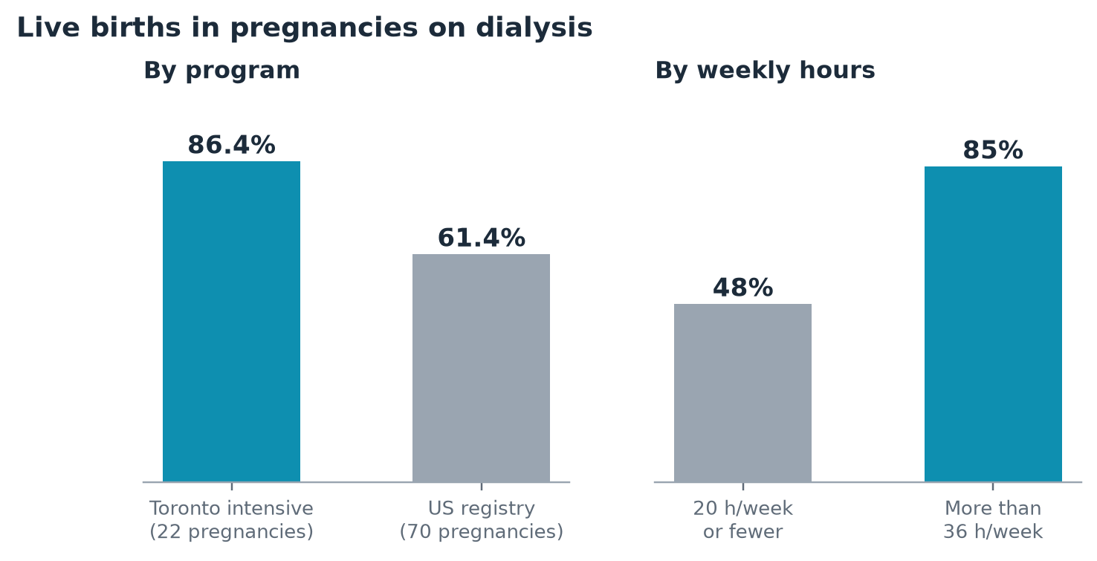
Figure 5.1. Live-birth rates in a Canadian intensive-dialysis cohort and a United States registry cohort, and by weekly dialysis hours. Retrospective comparison of 22 and 70 pregnancies.
The caution here is large. The Toronto cohort numbered only 22 pregnancies and the American 70. The comparison was retrospective, the women were not randomly assigned, and the places and eras differed. The authors themselves concluded only that pregnancy on intensive dialysis appeared feasible and safe. I would not tell any woman that the question is closed.
But think about what the study says, even with all its limits. In the right hands, with enough hours, a woman who was once told she should not have a child could be told that she might. That is not a statistic. That is a person on the other side of a door. The question for the field is why this finding, published in 2014, is not better known among the young women who most need to know it, and why intensive treatment for pregnancy is still treated as a boutique option and not a standard of care to be built into the health system.

The weight of the mind
Neither Daniel nor Aisha is likely to be asked, at their next visit, how they are feeling in the way a friend would ask. And the feelings are not minor.
A 2025 meta-analysis in Seminars in Dialysis, which pooled 137 cross-sectional studies covering 21,608 people on hemodialysis, estimated that 45.8 percent had depression (95 percent confidence interval 42.0 to 49.6), with a lower, but still striking, 38.9 percent in high-income countries (Source Notes S27). Other reviews report ranges from about 5 percent to more than 75 percent, depending on the instrument and the population. The spread reflects the difficulty of measuring a mood. The center of the evidence says that something like four in ten, give or take, are struggling.
Worse, they are struggling in the same room, day after day, with a group of people who might help and who have, in most clinics, no structure to do so. The social isolation that often accompanies chronic illness has its own cost. A 2026 population-based cohort study of people with chronic kidney disease found that those who were the most socially isolated had a mortality risk about 33 percent higher than others, and those who were lonely had a risk about 10 percent higher. The authors estimated that the most isolated lost around two to three years of life expectancy (Source Notes S28).
I would not call loneliness a disease. The authors of such studies are careful to say that association is not causation, and I share the caution. A person may be isolated because she is sicker, and not the reverse. But the finding fits what every dialysis nurse already knows. The patients who have someone, a husband, a sister, a friend from church who drives them on Friday, do better in ways that no lab test captures. And the ones who do not have someone are the ones I worry about at night.

The remedy that is not a pill
What would help? The honest answer is that no one knows with certainty, and the best trials have been modest. Peer mentoring, in which a person who has lived through kidney failure supports a newly diagnosed one, has been tested in a 200-patient hemodialysis trial reported in the Journal of the American Society of Nephrology in April 2025. A clinical event rate was lower in the mentored group, with an incidence rate ratio of 0.60 against 0.85, but the overall result did not reach statistical significance (Source Notes S29). A mentoring program for transplant candidates found no difference in time to listing or in quality of life (Source Notes S29). Not a triumph.
Yet I would resist the conclusion that mentoring does not work. A trial that fails to show a benefit has told us that this version, delivered this way, to these people, did not. It has not told us that a bad afternoon is no better with a veteran in the next chair. The lesson I draw is that we should invest in better-designed tests and keep the programs that people say they value. A person who has survived the first year can tell a newcomer in five minutes what the pamphlet takes forty pages to leave out.

The grief that has no funeral
There is a name for what many of these people are carrying, and it is not depression, though it keeps company with it. It is grief. They have lost something, a good many things, and nobody died.
They have lost the body they used to trust. A man learns that he can no longer drink what he likes, eat what he likes, or travel as far as he likes, and that a scar now runs along the inside of his arm where a vein was made to do a job it was not born for. A woman learns that her skin has changed color and her energy has changed hours. They have lost the long, careless sense of the future that healthy people carry and do not notice. And they have lost the right to be simply tired, because tired has become a symptom, and symptoms have to be reported.
Our culture has rituals for the death of a person and almost none for the death of a self. A widow gets casseroles. A man who loses his old life gets a pamphlet. The existential thinkers I have read tell us that the confrontation with finitude is the beginning of a more honest way of living, and I believe them. But it is a beginning that needs company. I have watched people go through it alone, in the vinyl chairs, with the television on, and I have watched people go through it beside someone who simply said, Yes. This is hard. I am here. The difference was not a medication.
A clinic cannot supply a funeral for a lost life, but it can supply a witness. A social worker who has ten minutes to sit with a patient, rather than two, is not a luxury. She is the nearest thing the system has to a chaplain, and in most units she is stretched across far more patients than she can ever sit with. When we talk about the cost of the promise, we should remember that the expensive part is the machine, and the part that matters most is a person with time.

What we call people
There is one more thing that belongs in a chapter about the body, and it is the smallest and most pervasive. It is the words.
In a clinic, a patient who misses treatments is often described in the chart as “noncompliant.” A person who is “a dialysis patient” is defined by the machine. A condition is called “end-stage,” as if the story had ended. These are not trivial labels. Guidelines from health systems and advocacy groups have long urged person-first language and the avoidance of terms like “noncompliant,” which attribute a failure to the patient’s character and not to the circumstances that made adherence difficult (Source Notes S30). One experiment, though not in nephrology, found that clinicians who read stigmatizing wording in a chart held more negative attitudes toward the patient and were more likely to blame the patient for failing to follow treatment (Source Notes S30).
I am not naive about this. Changing a word will not mend a marriage. A commentary in the nephrology literature warned that swapping one label for another would not fix the underlying inequity, and I accept the warning (Source Notes S30). But words are the first thing a patient meets. They tell her whether the person across the desk sees a human being or a problem. A clinic that stops writing “noncompliant” and starts writing, “had difficulty getting to treatment because the bus was late,” has given itself something harder to dismiss: a reason.

What you can do
If you are a patient, you have permission to ask the questions nobody asks. At your next visit, say one of these sentences aloud: I’d like to talk about intimacy. Or I think I may be depressed. Or I’m thinking about having a child. If the first clinician cannot help, ask for the social worker or for a referral. You will not be the first.
If you are a partner, say the thing. “I miss you” is a complete sentence. It will not solve the problem. It will end the silence, and silence is where marriages and spirits break down.
If you work in a clinic, add three questions to your standard assessment this month: one about intimacy, one about mood, one about whom the patient could call at two in the morning. Write down the answers. If you run a unit, look at your charts for the word “noncompliant” and ask what happens if you change it.
If you are a researcher, study women on dialysis. The literature owes them more than two meta-analyses.
And if you are none of these, remember that Dickinson’s formal feeling, the stiff politeness that settles over a house after great pain, is not peace. It is the sound of people trying not to cry. A kinder world would know how to say so.

Chapter 6: The Road, the Storm, and the Heat
“Every valley shall be exalted, and every hill and mountain shall be made low: and the crooked shall be made straight, and the rough places plain.”
Isaiah 40:4 (King James Version, 1611)
A dialysis chair is not a place. It is a distance.
Everyone who lives with kidney failure learns this early, though they learn it in different ways. For some it is the eleven minutes to the unit that feel like an hour on the days when the body is heavy. For some it is the pickup truck on a county road in winter. For some it is the bus that does not run on holidays, and for some it is a weekday rental room in a town an hour from home, because driving three times a week is no longer possible. The treatment itself is portable, in principle, to anywhere with electricity, water and a trained hand. But the people who need it are not portable at all. They live where they live.
This chapter follows three kinds of distance: the long road, the weather that closes it, and the heat that makes the body unable to bear it.

The long road
In April 2026, a reporter for KFF Health News described the closing of a small dialysis unit in rural Nebraska. Seventeen patients depended on it. One of them now faced a round trip of more than four hours for a treatment that lasts four. Another had rented a place near the new clinic, living away from home on weekdays and returning on weekends (Source Notes S31). I do not offer the story as proof of a national trend. It is one account. But it is a precise portrait of what happens, in human terms, when an administrative decision to consolidate a unit lands on a person who has already lost everything else he could give up.
The wider data say the story is not isolated. In 2023, the National Kidney Foundation wrote that roughly 170 dialysis facilities had closed within a year, citing staffing, supply chain pressures and costs, and noted a study finding that, in small-town and rural areas, the median one-way distance to a facility rose by about 6.6 miles when a nearby one closed (Source Notes S31). That figure rests on older data, and I mention it with that qualification. A registry-based study of closures in remote areas, covering the years 2001 to 2015, found that when a facility closed, patients nearby had more hospitalizations and more missed treatments, with a marginal rise in mortality, and that the burden fell more heavily on Black and Medicaid-enrolled patients (Source Notes S32).
The underlying economics are simple and unforgiving. Rural facilities more often have low patient volume and negative margins, with fewer stations and fewer late shifts (Source Notes S33). A unit with a dozen patients struggles to cover a nurse, a technician, a social worker and a water-treatment system. And behind the units stands a shortage of the physicians who oversee them. The fill rate for adult nephrology fellowship positions fell from 94.1 percent in 2010 to 65.8 percent in 2024, and, by one trade report, recovered to about 73 percent in the 2025 match (Source Notes S34). A rural health commentary from September 2026 made the same point with a stark contrast between the number of kidney specialists in rural and urban areas, and a federal projection of a 21 percent nephrologist shortage by 2037 (Source Notes S33).
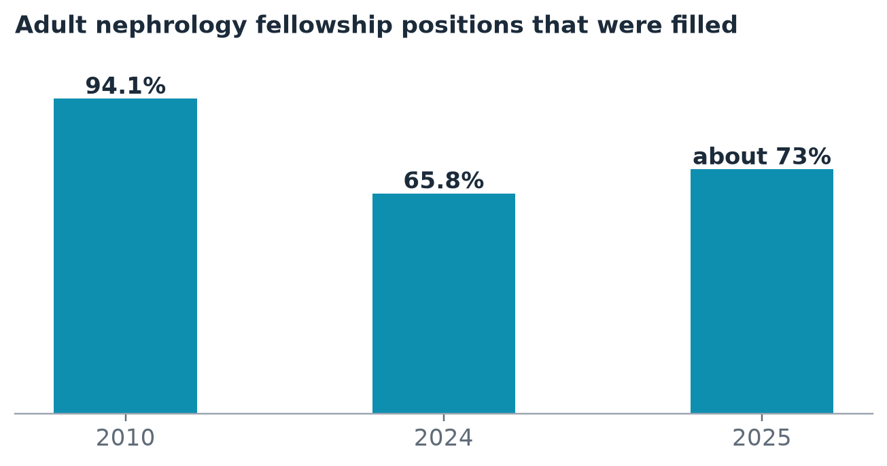
Figure 6.1. Adult nephrology fellowship fill rates: 94.1 percent in 2010, 65.8 percent in 2024, and about 73 percent in 2025.
I once thought of the rural nephrologist as a lonely figure, and in a sense she is. But when I try to imagine the system from the patient’s side of the windshield, I see a slow erosion of the one thing a chronic illness cannot survive: the nearness of help.

Harvest
Let me give the road a face, and let me say again that he is invented. Call him Walt. He is sixty-one, a wheat farmer in a county where the nearest dialysis unit is seventy miles away. He has gone to that unit three times a week for five years. In the winter it is merely tiring. In the fall, at harvest, it is a kind of grief, because the window to bring in a crop is short and the combine does not run itself, and the Tuesday, Thursday, Saturday schedule falls across the very days that the weather turns fair.
Last year he hired a neighbor’s son for the cutting. The year before he did half himself and lost part of the field. This year he is asking his nephrologist whether a home therapy could fit, which in his case would require a clean room, a reliable power line, a trained helper, and a supply truck that comes down a gravel road in all weathers. The answer will not be simple. But he is asking. And the question he asks is not really a medical one. It is whether the life he has built, on land his grandfather broke, can survive the treatment that keeps him alive.
I did not find a national count of how many patients travel an hour or more for dialysis, and I will not manufacture one. The figures I could verify measure what changes when a unit closes, which is the telling part. When the nearest chair moves away, people do not simply drive farther. They miss treatments, they land in hospitals, and the mortality figures drift upward. A distance is a dose.

The people at the end of a long road
No account of distance in American health care is honest if it leaves out the land that sits at the end of the longest roads. American Indian and Alaska Native communities have borne a heavier burden of kidney failure than almost any other group in the country. The American Kidney Fund reports that rates of kidney failure among American Indian and Alaska Native people run about double those of white Americans, though I could not locate the year and source underlying that comparison and offer it with that caution (Source Notes S35). The same advocacy source ties the disparity to health education, poverty, lack of insurance and, importantly, long travel distances to dialysis.
What interests me is the part of the story that has an unexpected ending. The Centers for Disease Control and Prevention reported in 2017 that the incidence of diabetes-related kidney failure among American Indians and Alaska Natives fell by 54 percent between 1996 and 2013, and by 2013 had reached the same level as among white adults with diabetes. Diabetes caused 69 percent of new kidney failure in this population against 44 percent overall. The agency credited a population-based approach to diabetes care pioneered by the Indian Health Service beginning in the mid-1980s (Centers for Disease Control and Prevention, 2017).
I want to underline what that means. A federal health program, working with tribal communities, applied unglamorous, sustained, upstream care to the disease that was driving kidney failure, and it worked. Not a miracle drug. Not a new machine. Decades of screening, follow-up, nutrition support and community health workers, delivered to people where they lived. If any single result in this book could be called a vindication of the conservative faith in patient institutions over grand schemes, this is it. And it did not end the disparity. The gap that remains is a measure of how much farther the same work would have to go.

When the road closes
Now put weather on the road.
A dialysis machine needs three things the way a lung needs air: electricity, clean water in large volumes, and a road that a person can drive on. Remove any one and the schedule of treatment turns into a countdown. A 2019 systematic review of studies in the Americas found that the loss of power, drinkable water and transportation, along with facility closures, can disrupt care and lead to missed sessions and more hospitalizations and emergency visits (Source Notes S36).
The studies are specific. After Hurricane Katrina, a survey of patients from nine New Orleans dialysis units found that 16.8 percent had missed three or more treatments and 23 percent were hospitalized in the following month (Source Notes S36). After Hurricane Sandy in 2012, researchers followed 13,264 in-center patients and compared them with others. In the storm zone, 4.1 percent visited an emergency department in the following week against 2.6 and 1.7 percent in the two comparison regions, 4.5 percent were hospitalized against 3.2 and 3.8, and 1.83 percent died within 30 days against 1.47 and 1.60 (Source Notes S36). These are modest differences in absolute terms and large in a vulnerable population.
What helped was almost embarrassingly simple. Fifty-nine percent of patients received an early dialysis session before the storm hit, and those who did were less likely to go to an emergency room or be hospitalized in the following week, with odds ratios of 0.75 and 0.77. The commentary on the study noted that about 40 percent did not get the early session, meaning the preparedness was good and incomplete (Source Notes S36).
Puerto Rico after Hurricane Maria is the example I take comfort in. A study of mortality there found that deaths among people on dialysis were not higher than expected afterward, and the authors credited adherence to disaster-preparedness guidelines and an early government response (Source Notes S36). On an island whose infrastructure had been shattered, a population dependent on electricity and water came through without excess death. Preparation is not glamorous. Nobody wins an award for a disaster that did not happen. But a unit that holds a plan, tells its patients where to go, and moves treatments up when the forecast turns is spending a few hours so that no one loses days.
Imagine the woman on the Gulf Coast, at her kitchen table, with a storm named and swerving and a recorded voice from the clinic saying it will close if the power goes. She counts forward. Her next session is Thursday. The storm will arrive Wednesday night. She has a folder, a bag by the door, a daughter two states away who has told her, firmly, to come. She is among the lucky ones. A daughter two states away is a plan. Many people do not have one.

The heat
There is a danger that has crept closer in recent years, and the research on it is young. In 2024, a nationwide analysis of 945,251 dialysis patients in 245 American cities found that deaths rose by 15 to 20 percent during extreme humid-heat events, with the largest relative increases in the urban Southeast (Source Notes S37). I treat this as an association and not as proof of cause, since many things differ between hot days and others. But the study’s message is plain enough. Bodies that have lost the ability to shed fluid and salt are poorly equipped for weather that attacks them from the outside.
I searched for evidence on whether heat also causes people to miss their treatments, and found, in the studies I could reach, that the question had not been fully answered. A 2023 analysis of weather and missed hemodialysis noted that high temperatures had not been examined at all (Source Notes S37). That is a gap, and a significant one, in a world where the average summer is growing hotter. If I had to name a research question in this field that could be answered quickly and cheaply, with the data already collected by the large dialysis providers, it would be this one.

An argument from stewardship
The conservative tradition, at its best, is a theology of stewardship: the belief that we hold things in trust, and that what we have been given should be handed on in better order than we found it. A road is held in trust. So is a clinic, a power line, a water main, a county’s only nephrologist. We tend to notice these things only when they fail.
The citizens who live at the far end of the system do not want special treatment. They want what the 1972 promise implied, which is that where you were born would not decide whether you could live. A promise that is kept only within an hour’s drive of a city is a different promise.

What you can do
If you are on dialysis, make a one-page disaster plan this week and give a copy to your unit. Write down three things: where you would go if the road closed, whom you would call, and what you would eat. Ask your unit whether it moves treatments up before a forecast storm, and ask in what circumstances. If the answer is vague, ask again.
If you live in a rural area and your unit is under threat, ask your county health officials and your state’s congressional delegation what plan exists for the patients. Ask in writing. Ask in public. A closed unit that is noticed in advance is often a unit that is rescued.
If you run a clinic, test your generator and your water supply this month and tell your patients the results. If you manage a transit service, ask the local dialysis units what time their patients need to travel, and ask yourself whether your schedule matches.
If you are a researcher, answer the heat question. The data are already sitting in someone’s server.
And if you are someone who simply drives past a dialysis unit on your way to somewhere else, I ask only that you think of it as a place with a long road behind it. Isaiah’s prophecy of a straightened path was not addressed to engineers. It was addressed to a people. But I like to think a grader and a surveyor would have understood him.

Chapter 7: The Chair You Earn by Nearly Dying
“I was a stranger, and ye took me in.”
Matthew 25:35 (King James Version, 1611)
It is one in the morning in a hospital emergency department in a city I will not name, and a man is sitting upright on a gurney because he cannot lie down. He is thirty-eight. His breathing is shallow and quick. His ankles are swollen to the shape of loaves. A monitor over his shoulder shows a heart rhythm that makes the resident look twice at the screen.
He is, in this account, a composite, drawn from the situations described in the research literature. He has lived in the United States for most of his adult life. He works, when he can, in jobs that do not ask for papers and do not offer insurance. A year ago his kidneys began to fail, and he did not know, because he did not go to a doctor, because doctors cost money he did not have and attention he could not afford to draw. Tonight the poison has built to the point where his body can no longer hide it.
They will dialyze him. They will do it urgently, and well, because the people in this room are good at their jobs. In a day or two he will go home, feeling better. And he will not be offered another chair until he gets sick enough to be rushed back.
This arrangement has a name: emergency-only hemodialysis. In some states, people who lack legal immigration status and have kidney failure can receive dialysis only when they arrive at an emergency department in a crisis. Between crises there is no schedule, no clinic, no nurse who knows his name.

A narrow question, asked plainly
I want to approach this subject with care, because it is politically charged and I do not intend to settle any argument about immigration in these pages. My question is narrower, and, I think, one on which people of very different convictions can agree. How well does this arrangement work as medicine? And what does it cost?
The most careful comparison I found followed 211 undocumented patients who started dialysis between 2007 and 2014 at three hospitals. Two of them, in Denver and Houston, offered emergency-only dialysis. The third, in San Francisco, offered standard, scheduled dialysis. After adjustment, the patients receiving emergency-only treatment had a higher risk of death: a three-year hazard ratio of 4.96, though its interval was wide enough to include no difference (0.93 to 26.45), and a five-year hazard ratio of 14.13, with an interval wider still (1.24 to 161). They also spent about ten times as many days in acute care as would be expected (Source Notes S38).
Read that with the care it deserves. This was an observational study, and patients differed in ways that adjustment could not fully remove: those who received standard care were more likely to start with a fistula or graft and to have better blood counts. The enormous intervals show how little the data can say about the size of the difference. They do not erase its direction.
A second study of 181 adults compared scheduled with emergency-only dialysis. One-year mortality was 3 percent for the scheduled group and 17 percent for the emergency-only group. The emergency-only patients made six more emergency-department visits per month, had 1.5 more hospitalizations and spent ten more days in the hospital over six months, and their care cost $5,768 more per month (Source Notes S39).

The costliest door
I have heard the argument made, in good faith, that offering scheduled dialysis to people who are not lawfully present is a benefit the country cannot afford. I will not rule on that. I will say only what the numbers imply. The emergency-only model is not cheap. It is expensive in the dollars spent on repeated crises, it is expensive in lives, and it is expensive in the quieter coin of hospital beds and clinicians’ conscience. A system that waits until a person is close to death before giving him the treatment that would have kept him well has chosen the costliest door.
Colorado offers a natural experiment, and the best one I could find. In 2019, the state decided to count kidney failure as a qualifying condition for emergency Medicaid, which extended coverage to scheduled outpatient dialysis three times a week for those who qualify. A published account reports that before the change, the state’s emergency Medicaid dialysis spending for this population came to close to $20,000 per patient per month in 2017 and 2018, and that after the change, the average monthly cost per patient was $5,574 even as the number of patients served rose to about 135 a month (Source Notes S40). The account relies on state data reported in a secondary publication, and the totals are not easy to reconcile with one another, so I lean on the direction and not the decimals. Scheduled care cost less per patient than emergency care.
A fiscal conservative should find this interesting. A humanitarian should find it interesting for a different reason. For once the arithmetic and the conscience point in the same direction.

The nurse’s side of the gurney
There is another witness to this arrangement, rarely quoted. In the qualitative literature I read, some nephrologists describe the moral distress of providing emergency-only care as among the hardest parts of their work. They know the patient will return, sicker. They know that the intervention they provide tonight, however skilled, is a repair they will have to make again. They are doing the right thing in a structure that makes it hard to do the right thing for long.
The oath that physicians have sworn for twenty-five centuries binds them to use treatment for the benefit of the sick. In the version translated by Jones in 1923, a physician swears to “use treatment to help the sick according to my ability and judgment, but never with a view to injury and wrong-doing.” The oath does not say which sick people. A profession that sends a man home after a rescue, knowing that he will return in worse condition, has not quite honored its oath, though it may have obeyed its rules. I have no quarrel with the people who work in this system. I have a quarrel with the system that puts them there.

The week of a man living on a threshold
Let me ask you to follow our composite home. He rents a room with two other men. His employer, who pays in cash, does not know he is ill. He learns, as people in his position do, to take the measure of his own body the way a sailor reads the sky. He knows what fluid in his legs means, and he knows the taste at the back of his throat when the poison is rising. He drinks as little as he can bear. He avoids the foods he has been told to avoid, which are most of the foods he can afford. He works as long as the weakness lets him, because a missed day is a missed payment, and then he makes a calculation no one should have to make: how bad can I let it get before I must go in?
This is the true cruelty of the arrangement. The system makes the patient his own triage nurse. It rewards the patient who waits and holds on, because only the sickest are served, and it punishes the one who comes early, because early is not an emergency. A man who presents too soon is told, politely, that he does not yet qualify. A man who waits too long may not reach the door.
I do not know how many people live this way at any moment, and I have not found a reliable national count. Estimates exist and they differ. What I know is the shape of the life, which I have heard from those who study it and from those who have lived near it, and it is this: a week arranged around a threshold, and a family that learns not to ask how he is.
A child in that home learns something, too. She learns that her father’s illness is a thing that comes in the night and leaves in the morning, that it is not to be discussed with teachers, and that the hospital is a place where he is helped and then, somehow, sent away. What she makes of a country that treats her father like this I cannot say. I suspect she will remember it for the rest of her life.

What I do not know
I should be exact about the limits of the evidence. I found no new study of emergency-only dialysis from 2025 or 2026. The principal cohort studies date from 2018 and rely on data that are now a decade old. I found no outcome data from Texas beyond the early cohort. Policies have shifted in some states since, and some of the changes may have altered the picture. The estimates of the difference vary, and the largest carry wide uncertainty.
But the shape is consistent, and it fits what the previous chapters have shown. People who cannot reach a chair on a schedule are not saved money. They are charged later, in worse form, at a higher price. The distance between a man and his treatment is not only measured in miles. It is measured in paperwork, in fear, and in the unwritten rule that you must be dying before you are served.

The stranger
The verse at the head of this chapter is from the passage in Matthew in which the king separates the righteous from the unrighteous by a single test: what did you do for the least of these? I was hungry, and ye gave me meat. I was thirsty, and ye gave me drink. I was a stranger, and ye took me in. The passage does not ask the stranger’s papers. It asks only whether the door opened.
You need not share my faith to find the point useful. The principle is old and widely held across traditions, and it is not partisan. A decent society is partly measured by what it does for the person it has no obligation to help. The emergency-only chair is a test of that principle, and it is a test the country has been failing slowly and expensively.
I think of the man on the gurney. He does not know about hazard ratios. He knows that the last time he was breathless, they helped, and that he will be told to come back when it gets bad again. He is waiting in a different kind of line, one whose only way forward is to become sicker. If there is a principle of kidney care in this book, it is this one: no one should have to earn a chair by nearly dying.

What you can do
If you live in a state that provides emergency-only dialysis, find out what your state’s rules are, in writing, from your health department. Ask your state representative one question: “What does it cost us per patient, per month, to treat people only in crises, compared with scheduled care?” Colorado has an answer. Ask why yours does not.
If you work in a hospital that provides emergency dialysis, keep a simple count, even if only on a whiteboard in the staff room: how many patients return, how sick they are when they do, and how many days they stay. Numbers on a whiteboard have changed more policies than speeches.
If you are a lawmaker, read the Colorado experience and ask your staff to repeat the analysis for your state.
If you are someone whose political convictions make you hesitant about this chapter, I ask you to set aside the larger argument for a moment and consider the narrow one. Whatever you believe about who should be here, a policy that appears to cost more and to cost lives, compared with the alternative, has a hard case to make for itself.
PART THREE
THE GIFT AND ITS COST

Chapter 8: Strangers, Chains, and the Receipt
“No man is an island, entire of itself; every man is a piece of the continent, a part of the main.”
John Donne, Meditation XVII (1624)
Think of a woman whose husband needs a kidney. She is willing to give him one. She goes through the evaluation, the blood tests, the questions, and is told, with great gentleness, that she cannot. Her blood type will not do. Her tissue is a wrong match. The thing she is most willing to give is the one thing she cannot give him.
For most of the history of transplantation, that was the end of the story. A willing donor and a needy recipient, sitting side by side in a room, each ready, the match refusing. They went home, and he went back on the list, and she carried the knowledge of what she would have done.
In the years after the turn of the century, a small group of physicians and coordinators saw a way out, and it began with a very simple observation. Somewhere in the country, there was another couple in exactly the same predicament, whose wife’s kidney was incompatible with her husband but would work for the first woman’s husband. If the pairs could find each other, they could trade.

The trade, and then the chain
That is the idea of paired kidney exchange, and it is one of the most beautiful pieces of applied mathematics in medicine. Two incompatible pairs swap donors, and two people receive kidneys who otherwise would not. Three pairs can swap in a cycle. As databases grew and matching software improved, the cycles grew longer, and then someone saw that the logic could be pushed further.
Suppose a person with no recipient in mind, an altruistic donor, walks in and offers a kidney to whoever needs it most. The kidney goes to the recipient of one pair. That pair’s willing donor, no longer needed by their own loved one, then gives to the next pair, whose donor gives to the next. The chain ends when the last donor’s kidney goes to a person on the deceased-donor waiting list. One act of pure generosity ripples down a line of people who would otherwise have been stranded.
In 2009 a group of researchers published a paper in the New England Journal of Medicine describing the first such chain that was not performed all at once but unfolded over months: a nonsimultaneous, extended, altruistic-donor chain, in which one anonymous donor set in motion a series of transplants (Rees et al., 2009). The surgeons knew the risk: a donor in the middle might back out after their own loved one had already been transplanted, and the chain would break. In that first chain, the pledge held. People kept their word.
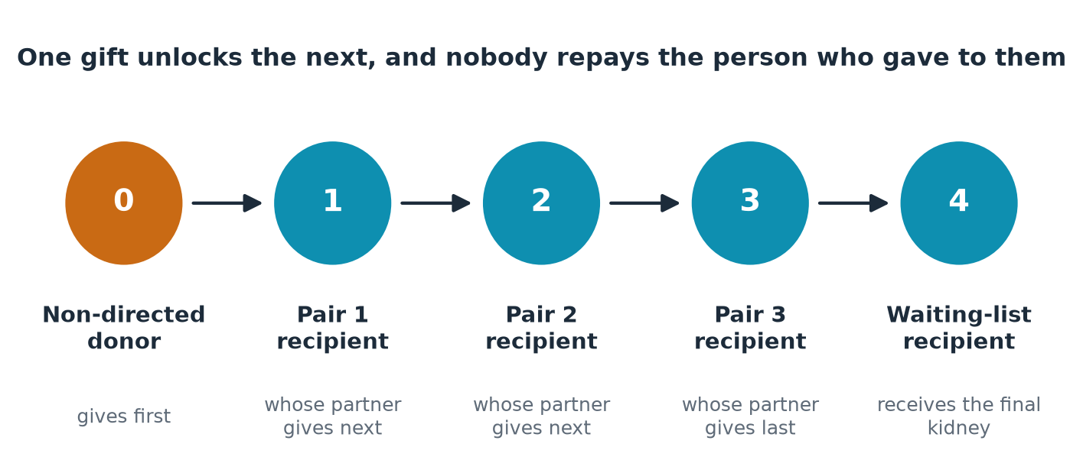
Figure 8.1. A schematic of a paired-donation chain. A non-directed donor gives first; each pair’s donor gives to the next recipient; the final kidney goes to a recipient on the waiting list.
The National Kidney Registry later reported a chain, begun in 2008, that included 30 transplants across 17 hospitals in 11 states over four months (Source Notes S41). The University of Alabama at Birmingham announced a single-center chain in which 74 donors and 74 recipients took part, with later reports of 100 or more recipients, though I could not confirm the current total (Source Notes S42). And the Registry has reported facilitating its ten-thousandth living-donor transplant, with 1,744 transplants in 2024 alone, a share of roughly 30 percent of all living-donor kidney transplants in the United States, according to its own figures (Source Notes S43). Those figures come from the organization itself and should be treated with that in mind. They are, nonetheless, a record of what strangers can do when a system invites them to.

The person who gives to no one
I have wondered about the first donor in each chain. The person who walks in with no name attached to the gift. In the language of the field, a non-directed or altruistic donor. They are not saints and they are not strange, as far as the studies of donors can tell. They have often described, when asked, a feeling that is hard to translate: that they had two of something and someone needed one.
Imagine a man of fifty-two, a postal worker, whom I will call Ray. He read an article one afternoon about a stranger who had given a kidney, put it down, and kept thinking about it for a year. He told no one. He called a transplant center. He sat through the psychological screening, which includes the question every candidate dreads, are you sure?, and went home to think again. When the surgery was done, he woke in a recovery room to a nurse who told him that his kidney had been flown to a city two states away, that it had started working at once, and that the woman who received it was a mother of three.
He never met her. He may never. But what interests me is what happened next. Somewhere in the country, because of that kidney, a husband had a reason to give to a stranger, because his wife’s match had just been made. And somewhere else the cycle continued. The gift was not a single event. It was a spark in a dry field.
I find this the most hopeful thing in the entire kidney ecosystem. It shows that we are not condemned to scarcity by fate. We are condemned by our failure to build the structures through which generosity can travel. Chains are such a structure. They convert a unique act of courage into a sequence of transplants, and they turn individuals who might have been turned away at the door into links.

The receipt
Now I must tell you something less inspiring, which is what the gift costs the person who gives it.
A living donor does not pay for the surgery. By custom and by law, the recipient’s insurance covers the donor’s evaluation and operation. What the donor does pay for, and what no insurer covers, is everything around it. Time off work, unpaid in many jobs. Travel, to a center that may be hundreds of miles away. Lodging for the donor and a companion. Child care. Lost income during the six weeks, give or take, of recovery. The donor who is self-employed, or paid by the hour, or caring for an elderly parent, has the highest bills and the least cushion.
Researchers who studied this decades ago, including a team publishing in the Clinical Journal of the American Society of Nephrology in 2015, argued that financial barriers to donation were real and could be reduced (Tushla et al., 2015)†. The evidence from the years since is that the barriers have not vanished. Living donation in the United States peaked in 2004, and then fell, most of all among men, Black adults, and the young and the poor (Source Notes S11). A system that asks for generosity and sends the generous a bill is a system that shifts its own failure onto the people it needs.
Congress has started, belatedly, to address it. The Honor Our Living Donors Act, enacted in the Consolidated Appropriations Act of 2026 on the third of February, 2026, directs federal action to expand reimbursement for living donors. The responsible agency published notices in the summer of that year seeking comment, and a physicians’ group letter I found put the proposed cap on one measure at about 21 percent, a figure I could not verify against the final notice (Source Notes S13). Private programs, including those described by the National Kidney Registry and the American Kidney Fund, now offer wage reimbursement and life-insurance protections to some donors (Source Notes S14). These help. They also depend on the charity of nonprofits and not the obligation of a government, and I think that matters.
A bill called the End Kidney Deaths Act, introduced in the 119th Congress, would go further, with a tax credit for living donors. Its supporters argue that it would increase donation and reduce the cost of dialysis. Its critics worry about the ethics of financial incentives. I could confirm its existence and its sponsors from a legislative tracker but could not verify either the odds of passage or the evidence supporting its projections, which come from campaign materials (Source Notes S44). I am neither endorsing nor condemning it. I raise it because it expresses a conviction I share: that the present arrangement, in which a donor’s generosity is rewarded with a bill, cannot be right.

A principle for the gift
I believe a donor should be able to give a kidney and be no worse off, financially, than the day before. Not better off. That would be a different thing, with different dangers. But no worse. I think that is a principle on which a conservative and a progressive can agree. The conservative sees in it the idea that you do not charge people to do a good deed. The progressive sees in it the idea that the poor must not be shut out of generosity. Both are right.
What would a gift without a receipt look like? It would be a donor who, from the first telephone call, is told in writing which costs will be covered, and who is reimbursed promptly. It would be a transplant center with a staff member whose sole job is the donor’s financial navigation. It would be an employer who has been told, by law, that donor leave cannot be punished. These are not fantasies. In some systems abroad they are routine. They require only that a country that says it values its donors acts as though it does.

The other receipt: the patient’s
There is a second bill I must set beside the first, and it is the one the recipient pays, or the family of the one still waiting.
When insurance does not cover everything, and when a transplant requires moving, taking leave, paying for drugs, and surviving a year of reduced income, families turn to the one resource that costs nothing to try. They open an online fundraising page. A study of transplant fundraising campaigns in Canada, published in 2019 in PLoS ONE, examined 258 kidney campaigns and found that they raised only about 11.5 percent of the amount requested, against nearly half for liver campaigns. The authors concluded that crowdfunding eases some financial burden but does not do so equitably (Source Notes S45). An American analysis of a smaller set of transplant campaigns found an average raised of about $10,700 against an average goal of about $30,400 (Source Notes S45). A summary of a larger study of nearly 20,000 American organ transplant campaigns reported that Black and Hispanic campaigners raised less on average and were less likely to meet their goals, though I could not reach the primary paper and offer that with caution (Source Notes S46).
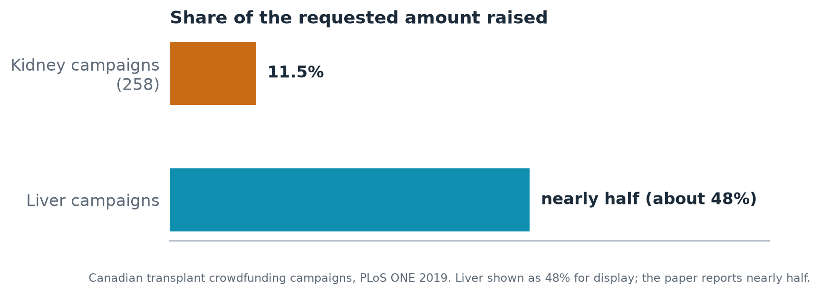
Figure 8.2. Share of requested amount raised by transplant crowdfunding campaigns in a Canadian study: kidney 11.5 percent, liver nearly half.
Think about what this means. The family with the largest circle of friends, the best photograph, the most followers, and the most time to craft a story gets the most help. The family with none of those gets less. A sick person’s worth is being weighed, in effect, by her social network’s generosity. We have, without deciding to, built a second selection committee, and it is worse than the first. The committee in Seattle at least tried to be fair. The crowd does not try.

What you can do
If you are considering donating a kidney, ask the transplant center for a written list of what will and will not be covered, and ask for the name of the financial coordinator. Do not accept “it depends.” Ask what depends on what.
If you are a patient with an incompatible donor, ask your center whether it participates in a paired-exchange program and which one. Ask how long the typical match takes. If the center does not participate, ask why.
If you run a transplant program, publish your donor-cost policy on your website in plain language. If you are an employer, write a donor-leave policy now, before an employee needs it.
If you are asked to share a fundraising page, share it. But also ask the harder question of yourself and your community: why are we making sick people do this?
And if you are a stranger, like Ray, who has been turning over a thought for a year, call a center. The paperwork is long. The chain is waiting.

Chapter 9: The Hallway
“’Tis better to have loved and lost than never to have loved at all.”
Alfred, Lord Tennyson, In Memoriam A.H.H. (1850)
Picture a corridor outside an intensive care unit at two in the morning. The lights are low and the vending machine hums. A woman in a cardigan sits with her hands between her knees. Her son is nineteen. He was in a car, and then he was in this building, and now a neurologist has told her, as gently as the words allow, that he will not wake up.
She has been awake for twenty hours. She has not eaten. She has been told things she has understood and things she has not. And now a second person approaches, a coordinator from the organ procurement organization, wearing a lanyard and a face arranged for this moment, to ask if she has thought about donation.
I have stood, in my life, in more than one corridor like it, and I will leave it at that. What I can tell you is that no room in the American health system carries more weight per square foot than this one. In it, a family’s worst hour meets the generosity on which the whole transplant enterprise depends. It is the hinge of the system. If the family says yes, a stranger may live. If the family says yes and then learns that the kidney was never used, a trust has been broken that no press release can mend.

What families say afterward
The question that matters most is whether people who say yes regret it. The literature on this is modest but consistent. An Australian interview study of 49 potential donor families found that no family that had consented expressed regret about the decision, while some who had declined did. The process was described as stressful, but not stressful enough to undo satisfaction with the choice (Source Notes S47). A review of the wider literature found that dissatisfaction with how hospital staff behaved was more likely to trouble a family than the donation itself (Source Notes S47).
Read that second finding twice. What hurts families, in the long run, is less often the decision than the treatment. The coordinator who hurried them. The nurse who could not look at them. The call that never came afterward. A donor family has given the most extraordinary gift one human being can give, and it is common, in many places, for them to hear nothing at all.
A survey of aftercare for donor families in fifteen European countries found great variation in what is offered, and an analysis of 1,613 letters exchanged between donor families and recipients, presented as a conference abstract, suggested how much both sides value the contact (Source Notes S48). I would not overread a conference abstract. But the pattern fits what every coordinator will tell you: grief that is acknowledged turns into something endurable, and grief that is ignored hardens.
The letters are the part I think about. Somewhere there are shoeboxes of them. Dear family, I do not know how to begin. A man who has been given a kidney, trying to write to a mother he will never meet. A mother, years later, reading that her son’s kidney has lasted. Whatever else may be said about the system that connects them, those pages are among the most moving documents produced by American medicine, and almost no one outside the field has seen them.

When trust cracks
Trust is not a sentiment. It is infrastructure, and it can be damaged.
In late October of 2024 the Associated Press reported that people were opting out of organ donor registries after stories about a man in Kentucky who had been mistakenly believed dead. The story was alarming, and the fear it set loose was entirely predictable (Source Notes S49). In the months that followed, the federal agency that oversees the transplant system opened its own inquiry into the organization involved, and in July of 2025 the Department of Health and Human Services released a summary of a review of cases at one procurement organization, reporting concerns in 103 of 351 cases (Source Notes S49). I report the number as the agency reported it. I do not know what proportion of those concerns would be borne out on full examination, and I would counsel patience before drawing grand conclusions. But I am certain about the direction of the harm. When people stop trusting that a donor is truly dead, the supply of organs dries up, and with it, hope for tens of thousands of people.
What the episode showed is that the trust at the center of the system is brittle. It rests on the assumption that the family in the corridor will be told the truth, that the doctors who care for the patient are separate from those who care for the organs, and that the process is watched by someone with the power to stop it. Where that assumption fails, it fails for everyone.
The response, as I read it, has been an attempt to bring the system closer to daylight: federal actions on transparency and accountability for organ procurement organizations, reorganization of the national network, new guidance from the Centers for Medicare & Medicaid Services on the donation process in 2026 (Source Notes S50). Whether these changes hold, and whether they reach the corridor, will not be known for a while. I would say only that a reform that never changes what the coordinator says to the mother in the cardigan is not yet a reform.

The gift that goes unused
Now I must describe the part of this chapter that I find hardest to write, because it is the part that the families do not know.
Suppose the woman in the corridor says yes. The kidneys are recovered. They are placed on ice, labelled, and offered through the national system to the transplant centers on a ranked list. And then, with startling frequency, someone says no.
Nationally, the share of recovered kidneys that were not transplanted has climbed. According to the national registry, it was 18.2 percent in 2013, and then 26.6 percent in 2022, 27.9 percent in 2023 and 29.3 percent in 2024 (Source Notes S51).
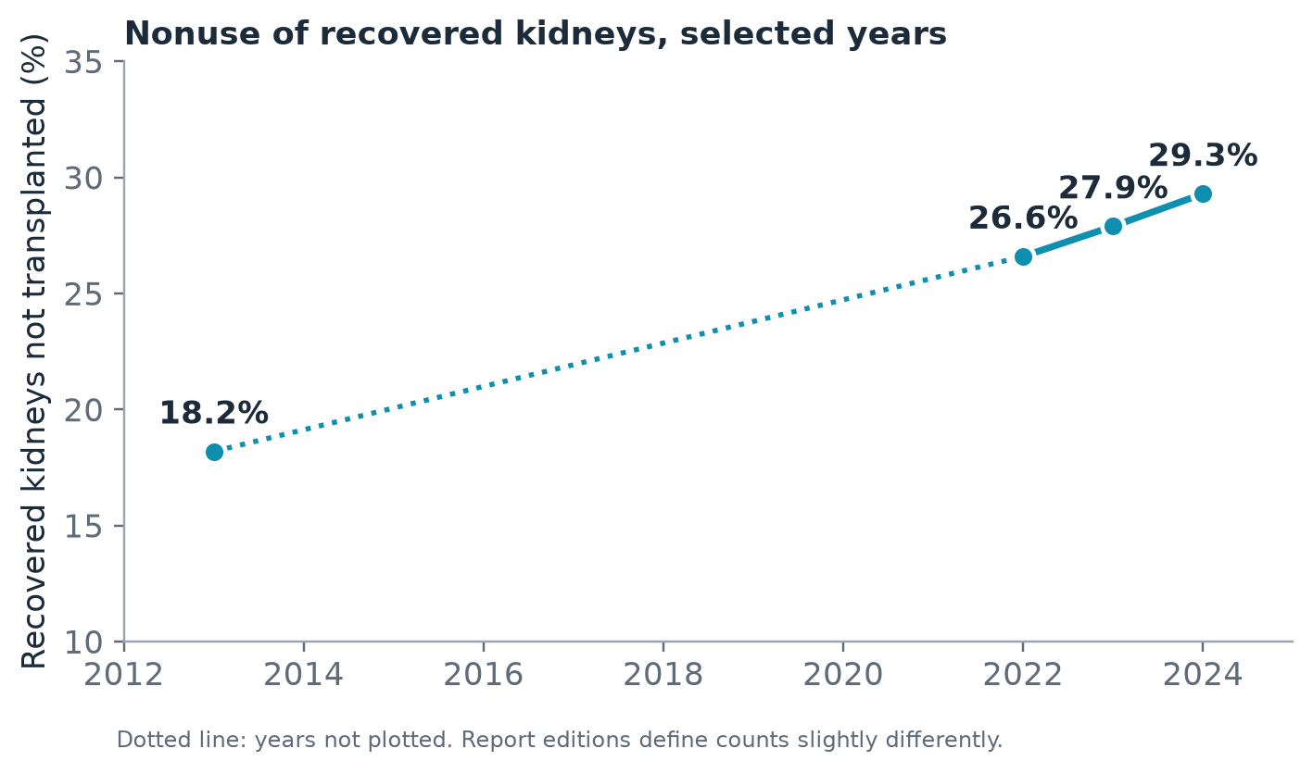
Figure 9.1. Share of recovered deceased-donor kidneys not transplanted, United States: 18.2 percent in 2013, 26.6 in 2022, 27.9 in 2023 and 29.3 in 2024.
Think about it. Nearly three out of every ten kidneys that families gave, at the worst moment of their lives, were not used. A federal monitoring report on the 2021 change to the allocation system noted that nonuse had risen from about 21 percent to 26 percent in the period around the change (Source Notes S50). Some of the discarded kidneys are in poor condition, and I am not suggesting that every recovered organ is fit for every recipient. Donors are older and sicker than they used to be, as the population is. But the pattern raises the question of what is being lost, and why.
Part of the answer is the behavior of the offering process itself. A literature on offer decisions reports that the median kidney was offered seven times before it found a taker, that a study of 68 physicians found greater variation in decisions within a transplant center than between centers, and that a survey of the agreement among reviewers produced a statistic, a kappa of 0.13, that indicates only slight agreement (Source Notes S52). A kappa that low means that two experienced doctors, shown the same offer, would often disagree. Which is another way of saying that whether a kidney is used can depend on who is on call.
Part of the answer is time. A kidney is a living organ held in a cooler, and the hours matter. A 2026 report in Transplant International, studying 74 pairs of kidneys from older donors, found that when the cold ischemia time exceeded twelve hours, the odds of delayed graft function were 6.3 times those when it was under eight (Source Notes S53). Earlier work by Debout and colleagues found that each additional hour in cold storage increased the risk of graft failure and death (Debout et al., 2015)†.
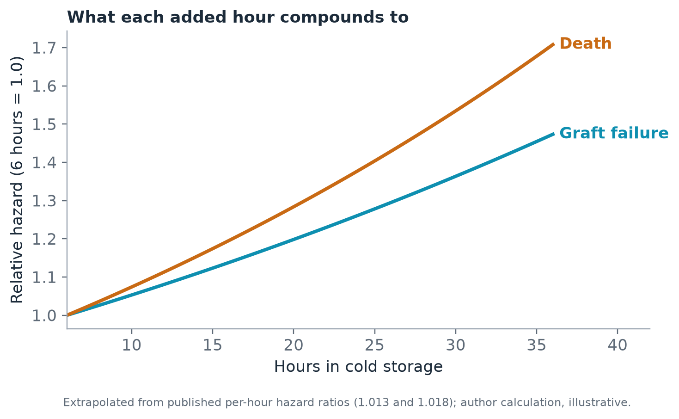
Figure 9.2. Relative hazard of graft failure and death rising with hours in cold storage, from about 1.0 at six hours to about 1.36 and 1.53 at thirty hours.
And the hours depend on logistics. The federal transport page now acknowledges a working group’s final report in 2025 with twenty recommendations, and an air-transport website for organs launched in 2025; an industry briefing in 2024 observed that the contract in force could not require organs to be tracked (Source Notes S50). A kidney is a gift. It is also a parcel, and parcels get lost.

The person with the lanyard
I should speak for a moment about the coordinator in the corridor, because she is usually the villain of the stories families tell, and she is more often a casualty of the same system.
Imagine her night. The call came at midnight, from a hospital three counties away. She drove there in the dark, rehearsing. She has done this many times, and it has not become easier. She reads the chart, finds the nurse, learns the family’s name, and waits, sometimes for hours, for the right moment, which does not exist. The professional guidance is that the conversation about donation should be separated from the news of death, so that no family feels pressed. She knows this. She also knows that the window is short and that the person in the bed will not be a donor if she waits too long. She is holding both of these truths while a mother weeps.
Then there is the rest of her night. If the family says yes, she coordinates the surgical teams, the flights, the lab tests, the allocation calls, the paperwork, perhaps for thirty hours without sleep. At some point she will stand in an operating room and watch an organ come out of a boy of nineteen. She will do it again in a week.
I have never met a coordinator who was not marked by the work. Few systems measure what it costs them. And fewer still measure what happens when a good coordinator is replaced by a tired one, in the middle of the night, in the hallway, with a mother. We speak of the supply of organs as though it were a matter of logistics and law. It is also a matter of the nerves of a few thousand people.
If we want families to say yes, and to be glad they did, we must invest in the people who ask. A coordinator who has had training in grief, supervision when she needs it, and the time to do the follow-up she knows she should do, is the best infrastructure the system can buy.

What a better system has done elsewhere
I do not wish to give the impression that every country does this badly. Spain’s approach has been studied for decades: a national organization, and in each hospital a physician coordinator whose job is to identify potential donors and talk with families. In 2025 Spain reported 51.9 deceased donors per million population, close to the record of 52.6 it had set the year before, and roughly 6,300 transplants in all (Source Notes S54). The comparison with the American system should be handled with care, because laws, cultures and counting methods differ. But what the Spanish model shares with the programs that work elsewhere is not technology. It is people, placed where the families are, with the time and the training to treat them like human beings.
It reminds me, as so much of this book does, that the most scalable intervention in medicine is often a person with time.

What I would ask of the system
I would ask for three things. I would ask for a promise to every donor family that they will hear, in writing, within a month, what happened to every organ: used, and where, or not used, and why. It is a small administrative act and a very large moral one. I would ask for honest, public reporting by every center of how many kidneys it declined and what happened to them. And I would ask that offers come with a clock, so that no kidney is lost for want of a decision.
The woman in the cardigan did not know to ask. Her son’s kidneys are, I hope, working somewhere. If they are not, someone owes her an explanation.

What you can do
If you are a donor family, you are entitled to ask the organ procurement organization what became of the organs. Ask in writing. Ask again if you are not answered. If you wish to write to a recipient, ask whether your organization will forward the letter.
If you are a registered donor, talk to your family. Say your decision aloud, at a dinner, in plain words, so that the woman in the corridor, if she is ever your mother or your wife, does not have to guess.
If you work for an organ procurement organization, send every donor family a follow-up within thirty days. If you work in a transplant center, post your offer acceptance data in a form a family could read.
If you write regulations or oversee them, treat nonuse as an emergency, because for every kidney discarded there is a person on a list.
And if you are someone who has put a heart on a driver’s license and moved on, thank you. Do one more thing: make sure someone knows.
PART FOUR
THE FUTURE WE COULD KEEP

Chapter 10: The Pig, the Patient, and the Quiet Revolutions
“Nature, to be commanded, must be obeyed.”
Francis Bacon, Novum Organum (1620)
In the autumn of 2025, a man in Massachusetts went back to dialysis.
His name was Tim Andrews. For nearly nine months he had lived without it, with a kidney from a gene-edited pig sewn into his body at Massachusetts General Hospital in January of that year. By the reports available to me, he was off dialysis for 271 days, a record for a patient living with a pig kidney, before the organ began to fail and was taken out (Source Notes S55). That is a little over thirty-eight weeks of Saturdays on which he did not sit in a chair.
Let me stay with that for a moment, because the news coverage tended to treat it as a failure, and I do not read it that way. For nine months a man had a life that his illness had denied him. He could plan a week without a machine in it. He could say yes to a weekend. And when the organ gave out, he returned to the chair, and some months later, in January of 2026, received a human kidney, becoming, by Harvard Medical School’s account, the first patient to progress from a pig kidney to a human one (Source Notes S55).
Everything I have written so far in this book describes a promise made in 1972 and imperfectly kept. This chapter asks what a promise would look like if the biology changed. The honest answer is that no one knows, and that anyone who tells you otherwise is selling something.

What has actually happened
The record is short and still being written. In March of 2024 surgeons at Massachusetts General Hospital transplanted a gene-edited pig kidney into Richard Slayman, a man with kidney failure; he died in May, and the hospital said at the time that there was no indication that his death was the result of the transplant (Source Notes S56). Later in 2024, a team at NYU Langone transplanted a pig kidney into Lisa Pisano, who also had severe heart disease. Then, in November, a pig kidney was placed in Towana Looney, who lived for roughly four months with it before it was removed in the spring of 2025 because of rejection (Source Notes S56). These accounts come from widely reported news coverage, and I was not able to re-confirm every number in this session. I offer them as the outline of what is known.
By the fall of 2025, the regulators had moved. The Food and Drug Administration cleared formal clinical trials. In September of that year, the pig producer eGenesis received approval for a trial of its gene-edited kidney, with a Massachusetts General nephrologist helping to lead it (Source Notes S57). In November 2025, United Therapeutics announced the first transplant in its EXPAND trial of the UKidney, in patients with end-stage kidney disease (United Therapeutics Corporation, 2025). The National Kidney Foundation, in an April 2026 explainer, described the trials as having started that fall (Source Notes S57). A journal review published in 2026 in the American Journal of Transplantation surveyed where the field stood, and one study in Nature Medicine in 2025 profiled the immune response in a living recipient of a gene-edited pig kidney (Source Notes S55).
Notice what the sentence structure of the whole story is. First, one patient. Then, a handful. Then, a trial. This is how medicine has always moved, and the pace is neither slow nor fast. It is the pace of evidence. I think this is the most important thing a patient can understand about the news: the headlines are a narrative of triumph and disaster, but the underlying reality is a long series of small, careful steps, and the decisive evidence has not yet come.

What a spare part would not fix
I want to be careful here, because the enthusiasm around xenotransplantation can distort the planning for everything else.
Suppose it works. Suppose that within a decade, pig kidneys can be offered to thousands of people each year, with the survival of the graft approaching that of a human organ. Even so, a pig kidney will not mend a marriage, or bring back a job, or lengthen a road, or pay the tab for the immunosuppressants, or reach a man in a county without a transplant center. It will reach, first, the people with the best access to a handful of academic hospitals. It will reach the people whom the navigator trials in Chapter 2 showed to be already reaching the list.
Every technology in this history has followed that law. The Scribner shunt made long-term dialysis possible, and then there were not enough chairs. The 1972 law made the chairs, and then the chairs did not reach the countryside. If the pig kidney arrives, it will be a magnificent solution with an old shadow: the question of who is first.
This is why I think we should treat the arrival of any new organ source as a deadline, and not a rescue. We have, at most, a few years to fix the parts of the system that new technology will exploit: referral, evaluation, listing, and the systems of follow-up. If we do not, then the future will be the present, only more expensive.

Quieter revolutions
The pig kidney will make the news. The revolutions I find most hopeful are the ones that do not.
Tolerance. The reason transplant recipients take drugs for life is that the immune system sees the new kidney as foreign. A long-sought goal has been to teach the body to accept it. A phase 3 trial of a cell-based therapy called MDR-101, from Medeor Therapeutics, treated 20 patients, compared with 10 controls, and was reported in the American Journal of Transplantation in July 2025. About 95 percent of treated patients had been able to stop all immunosuppression about a year after treatment, and about 75 percent remained off the drugs for more than two years, though four had to resume them (Source Notes S58). The numbers are small. The treatment applies to a specific group, recipients of kidneys from certain living donors. But think of what it implies. A person who has been taking drugs every day, with the infections, the cancers and the cost, could someday be free of them. A nephrologist described the field in an April 2026 interview as a frontier (Transplant tolerance, 2026)†.
Preservation. Chapter 9 described how much of a kidney’s fate is decided in the cooler. New technologies pump fluid through the organ while it waits, or oxygenate it. A trial that compared hypothermic machine perfusion with ordinary cold storage published in the New England Journal of Medicine in 2009 and was followed up over ten years, a result I know only through the device maker’s announcement (Moers et al., 2009; Organ Recovery Systems, 2025). A newer randomized trial of warm perfusion in kidneys from donors after circulatory death appeared in Nature Medicine in 2023 (Hosgood et al., 2023)†. Another approach adds an oxygen-carrying molecule derived from the hemoglobin of a marine worm to the preservation fluid; a French study of 60 grafts reported strong survival at 48 months, but the numbers come from the manufacturer and a small trial, and I grade them cautiously (Source Notes S59). The Cold Ischemia Foundation, of which I am the founder, has published its own explainers on this technology (Cold Ischemia Foundation, n.d.-a), and I note that as a disclosure and not as evidence.
The home and the wearable. A device to put the kidney on a person’s body has long been an engineer’s dream. A wearable artificial kidney trial reported in JCI Insight in 2016 found it well tolerated and effective at clearing waste, but was stopped after the seventh participant because of technical problems with the device (Source Notes S60). A research project in California reported a bioreactor that survived in a pig without an immune attack, and a university page suggested human trials might come in 2026 or 2027, which I could not verify (Source Notes S61). In the meantime, the Food and Drug Administration cleared a new home hemodialysis system in November 2024, according to a trade report (Source Notes S62). The incident share of home dialysis, as I noted in Chapter 1, was 13.3 percent in 2020, up from 6.8 percent a decade earlier.
Upstream. The most valuable kidney is the one that never fails. The Centers for Disease Control and Prevention estimated in March 2026 that 14 percent of American adults, about 37 million people, have chronic kidney disease (Centers for Disease Control and Prevention, 2026). An advocacy source puts the number at 35.5 million and says that nine in ten are unaware (Source Notes S63). An earlier federal analysis, reported in the trade press, found that 96 percent of people with early-stage disease were unaware of it, and 48 percent of those with severely reduced function and not yet on dialysis (Source Notes S64). Testing for the protein in urine that signals kidney damage, a cheap and simple test, was done in only 52.9 percent of adults with type 2 diabetes in one primary care analysis (Source Notes S65).
Meanwhile the treatments have improved. The FLOW trial, reported in 2024, was the first large trial dedicated to kidney outcomes of a drug in the semaglutide class in people with type 2 diabetes and chronic kidney disease, and found a benefit regardless of whether patients also took another class of drug, an SGLT2 inhibitor (Source Notes S66). The tools exist. What does not yet exist is the habit of using them.

A thought experiment for 2031
Let me describe a day that has not happened. I offer it as an exercise and not a forecast, and I ask you to read it with the suspicion it deserves.
It is a Tuesday in a clinic in a mid-sized city. A nephrologist is meeting with two patients. The first is a retired executive, sixty-eight, who has been on dialysis for two years. He has a good insurance plan and a daughter who is a lawyer. By the time he sits down she has read three papers and has a list of questions. He is offered a place in a pig-kidney trial in a month. The second patient is a home health aide, sixty-two, who has been on dialysis for six years and who drove ninety minutes to be here. She has heard of pig kidneys on the television. No one has told her she might qualify. She has never been evaluated for a transplant of any kind, because years ago someone said she was too old, and nobody asked again.
Which of the two is the better candidate? In a strict medical sense, perhaps neither, perhaps both. The point of the thought experiment is the gap in the room. The executive is surrounded by people who will carry him to a new technology. The aide is surrounded by people who are too busy to stop. The kidney, whatever its origin, will reach the first before the second, unless somebody builds a bridge.
You can build that bridge now. It is made of plain things: a referral for every patient who has not had one in two years; a navigator in every unit; a standard of reevaluation when guidelines change; a recruiting rule for trials that says, among other things, that the people who are hardest to reach must be reached first. None of it requires a laboratory. All of it requires a decision.

The humbling part
I have written enthusiastically, and I should now be honest about how often this field has been wrong. The artificial kidney was announced in 1945 and the wearable version was still being tested seventy years later. The first pig-to-human transplants in the modern era failed in months. The enthusiasm that surrounds any kidney breakthrough has a way of outrunning the evidence, and patients are the ones who bear the cost of disappointment.
So I will make a modest claim. I do not claim that these technologies will arrive. I claim that the possibility of their arrival changes our obligations in the meantime. A system that is about to change should be preparing for it, in the way a prudent household prepares for a birth. It should be building the registries to follow the first thousand recipients carefully. It should be training the nurses. It should be ensuring that the early trials enroll the people who have been left out of every earlier one, the rural, the poor, the old, the Black and Native, and the women. And it should write down now, before the first commercial offer, who gets the first kidney.

What you can do
If you have kidney disease, ask your nephrologist whether you are a candidate for any clinical trial, and ask where trials are recruiting. Ask whether you would qualify for a xenotransplant or tolerance trial. Do not be discouraged by the first no; eligibility rules change.
If you have diabetes or high blood pressure or a family history of kidney disease, ask your primary care clinician for two simple tests, one for kidney function in the blood and one for protein in the urine. Ask what the results mean. Ask again next year.
If you work in transplantation, ask your institution to describe in public how it will choose participants for early trials of new technologies, and whether people from communities that are usually left out will be invited.
If you are a journalist, remember that every first patient is also the last patient of a story that began with someone else.
And if you are a person who simply hopes, remember that hope is not the same as a plan. The plan is the part that needs you.

Chapter 11: The Second Promise
“And they that shall be of thee shall build the old waste places: thou shalt raise up the foundations of many generations.”
Isaiah 58:12 (King James Version, 1611)
In 1971, a man let a machine take his blood in front of a committee of Congress, and a year later the country made a promise. It was a good promise. It was kept, in part, with a seriousness that deserves our gratitude.
Now it is our turn.
I do not mean that every reader must become an activist, though some of you should. I mean something simpler and harder. A promise made by a previous generation is not discharged by admiring it. It is discharged by finishing it. Glazer and the lawmakers and the nurses and the families who organized in the 1960s did the first half. The second half belongs to people who are alive now, who have read what this book has laid out, and who can no longer say they did not know.
This chapter is the plainest in the book. It sets out ten commitments, each drawn from the evidence in the earlier chapters, each phrased so that it can be acted on by someone in the next week. None of them requires a miracle. Some require a decision. A few require courage. All of them are, I believe, within reach.

The arithmetic of urgency
Let me begin with the one calculation that should move even the hardest ledger-keeper.
In 2021, the per-person annual cost to traditional Medicare was about $99,325 for a patient on in-center hemodialysis and about $43,913 for a patient with a functioning transplant (Source Notes S7). The difference is $55,412. For every person who moves from the machine to a working kidney, the program saves, on this arithmetic, more than fifty-five thousand dollars a year, and the person gains the afternoons that Chapter 4 described. I do not claim that every patient can be transplanted, or that the saving is exact for any individual. I claim that we are paying a very large premium to keep people on the more expensive and less humane option, and that closing even part of the gap would pay for a good deal of what follows.
That is the conservative case, and I believe in it. The human case is the one that moves me, and it needs no arithmetic.

1. Count the hours
Every dialysis unit in the country should ask every patient, once a month, how long it took them to feel like themselves after their last treatment, and should publish the answer. The international consensus exercise described in Chapter 4 found that patients and caregivers valued time and travel above what clinicians did (Source Notes S18). Then measure what you value. A national quality program that adds this single question will do more for the quality of life of dialysis patients than most of the programs now in place.
Who can act: unit managers, the dialysis providers, the federal agency that designs the quality programs.

2. Ask everyone about a transplant, every year
Only 12.3 percent of prevalent dialysis patients were on the transplant list in 2021 (Source Notes S7). Every patient should be asked, annually and in writing, whether they have been evaluated, and if not, why not. A patient who is not a candidate should hear the reason, and should be able to ask again when circumstances change.
Who can act: nephrologists, social workers, patients.

3. Put a navigator in every unit
The Emory trial and the Georgia facility trial in Chapter 2 point in one direction: people are listed when someone is paid to walk beside them (Source Notes S8). The navigator need not be a physician. She needs time, a telephone and a clear mandate.
Who can act: providers, state health departments, insurers.

4. Make the gift cost nothing
A living donor should be no worse off financially than before. The Honor Our Living Donors Act is a start, and the federal rulemaking that implements it should be watched closely (Source Notes S13). Every transplant center should publish a plain-language list of what donors will and will not be reimbursed for, and every employer should have a written donor-leave policy.
Who can act: Congress, the agency writing the rules, transplant centers, employers.

5. End the chair you earn by nearly dying
No state should fund care for kidney failure only at the point of crisis. The evidence in Chapter 7, from patients in three cities and from Colorado’s experience, points to scheduled care as safer and cheaper per patient (Source Notes S38; Source Notes S40). Whatever one believes about immigration, a policy that appears to cost more and cost lives has no obvious defender.
Who can act: state legislators and Medicaid agencies.

6. Give every unit a witness
Intimacy, mood, loneliness and grief are in the room whether or not the chart asks about them. Every unit should have a social worker with time to sit down, a peer who has walked the road, and a routine of asking three questions: about intimacy, about mood, and about whom the patient could call at two in the morning (Source Notes S26; Source Notes S27). The peer-mentoring trials have been mixed (Source Notes S29), which tells us to improve the design and not abandon the idea.
Who can act: clinic leaders, patient groups, researchers.

7. Keep the roads open
A unit that is about to close should be required to publish a plan for its patients before it closes. Every unit should hold a tested disaster plan, move treatments up before forecast storms, and be ready for heat (Source Notes S36; Source Notes S37). The cost is small. The Sandy data show that early dialysis helped, and also that about four in ten patients did not receive it.
Who can act: providers, state and local emergency managers, the federal agency that certifies facilities.

8. Tell every donor family what happened to the gift
Within thirty days of a donation, every family should hear in writing what became of each organ, and every organ procurement organization and transplant center should publish its own record of kidneys recovered and not used. Nonuse reached 29.3 percent in 2024 (Source Notes S51). A figure that high should never be a surprise to the families.
Who can act: procurement organizations, transplant centers, the oversight agencies.

9. Open the trials to the people usually left out
As xenotransplantation and tolerance trials expand, their enrollment should be reported by race, geography, income and sex, in public, as they go. A technology that reaches only the well connected will deepen the divide it was meant to heal.
Who can act: trial sponsors, regulators, institutional review boards, journalists.

10. Change the words
Stop writing “noncompliant” in the chart. Stop calling a person a dialysis patient when she is a teacher who is on dialysis. Put the barrier, not the blame, in the record (Source Notes S30). A word costs nothing, and the people who read it are the ones who decide how much care to give.
Who can act: everyone who writes a note, a letter, a policy, a headline.

A Wednesday in a unit that kept the second promise
I want you to be able to see it, so let me describe a place that does not yet exist. It is a Wednesday, a little before one in the afternoon, and the chairs are filling.
A man named Andre, a patient who has been here four years, arrives and finds a clipboard, not the sort that asks him to sign for anything, but a single question printed large: How long did it take you to feel like yourself after Monday? He writes “two hours,” which is better than last month, when he wrote four. The nurse who collects it does not file it. She reads it aloud at the morning huddle, and the unit’s staff talk for five minutes about what changed, because they have been trying cooler fluid for the people who said they felt washed out, and for Andre it seems to have helped.
A younger woman in the next chair has a navigator, a quiet person with a laminated list, who stops by to tell her that her transplant evaluation is scheduled for the twelfth and that a ride has been arranged. On the wall hangs a sheet showing the unit’s plan if the river rises, with the telephone number of the shelter and the sequence of extra treatments. In the corner, a social worker with a calm face sits with a man who has not spoken in a month. She has an hour. She has been given an hour.
None of this is sentimental. It is a matter of who is employed to do what, and what the unit decides to count. Nothing in it needs a technology that does not exist. A unit like it could be built next year by a provider willing to treat these things as part of the job. I have seen pieces of it in the best clinics. I have not seen all of it in one.

The objections, answered
A book that asks for this much should answer the objections.
It costs too much. The arithmetic at the head of this chapter is a start. A navigator, a social worker with time, a disaster plan and a monthly question are not expensive set beside the cost of a hospital stay or the difference between dialysis and a working graft. Nobody should claim every dollar will return, but the burden of proof falls on the arrangement that costs $99,325 a year per person to keep people on a machine, not on the one that tries to move them off it.
The staff are already stretched. Yes. And a workforce that is asked to do more with less will leave, which is what the data on nephrology fellowships suggest is already happening (Source Notes S34). That is an argument for hiring the right people, not for abandoning the task. A social worker or navigator is a force multiplier for the nurses, not a burden on them.
Patients do not want to talk about these things. Some do not. Many do, and have never been asked. The correct response to the uncertainty is to offer, gently, and to allow refusal. A question asked kindly and left unanswered is better than silence.
It is not the system’s job. This is the objection I understand best and respect least. A system that took on the job of paying for these lives in 1972 took on, at the same time, the job of making them livable. The people who wrote that law did not mean the promise to stop at the door of the clinic. They did not imagine the whole of it.

What I fear
I should say what worries me. I fear that these ten commitments will be read by people who agree, and nodded at, and filed. I fear that the number of lines in the system where something can be done is exceeded only by the number of reasons each line has for waiting for another. The regulators will wait for the Congress. The Congress will wait for the evidence. The evidence will wait for the funding. The funders will wait for the regulators. And in the meantime the woman in the vinyl chair will go on counting her afternoons.
I also fear a slower thing, which is that we will do just enough. We will fix what a camera can see. We will leave alone the quiet cruelties that cost nothing to maintain and a good deal to remove: the silence about the body, the gap between a person and the list, the distances that no one counts.

What I believe
I also believe something, and I will say it plainly because this is the last chapter that carries an argument.
I believe that the kidney community is better than its system. I have spent years among nurses who stay late, technicians who learn a patient’s name and the name of her dog, surgeons who return to the hospital at three in the morning, coordinators who sit in hallways, donors who give without being asked twice. These are not people who need to be persuaded to care. They need a structure that lets them.
I believe that a person on dialysis is not a patient first. She is a mother, a mechanic, a teacher, a poet. The afternoons she lives through are hers. And I believe that a country that once decided, in a few paragraphs and almost without debate, that no one should die for want of a machine can decide, with more debate and more care, that no one should be left alone with the afternoons.
Isaiah’s line speaks of those who rebuild the old waste places and raise the foundations of many generations. It is a promise to the builders, not to the bystanders. The foundations here were laid by Kolff and Scribner and Shields, by the Herrick brothers, by the strangers in Seattle, by Glazer in a hearing room. What we build on them will be seen by people not yet born, some of whom will be sitting, someday, in a chair with a window nobody looks out of.
Let us give them a better view.

What you can do
Pick one of the ten. Choose the one that is closest to where you stand. Write it on a card. Put it where you will see it.
Then do one thing about it this week. Make one call. Ask one question. Send one letter. Give one hour. And then, because the work is slow, do it again next week.

Epilogue: The Window Nobody Looks Out Of
“Cast thy bread upon the waters: for thou shalt find it after many days.”
Ecclesiastes 11:1 (King James Version, 1611)
Return with me, once more, to the room.
A row of recliners. A window that nobody looks out of. A television bolted high in a corner, tuned to a program no one chose. Machines that hum at slightly different pitches, so that the room carries a kind of chord. It is one o’clock on a Wednesday. People are reading, dozing, answering email, watching their own blood travel through clear tubing and come back clean.
You have been in this room many times now. You have seen it as a clock, as a body, as a road. You have seen it from the hallway outside an intensive care unit and from the other end of a long chain of strangers. And I would like you to see it a last time as a room in which a promise is being kept, today, by every person in it, in the plain act of staying.
Because that is what these people do. They stay. They have been taught patience whether they wanted the lesson or not. The man in the third chair is learning to read the language of his own pulse. The woman by the window, who has not looked out of it in three years, has a daughter in college and has told no one at work. They are not waiting for rescue. They are, in the quiet, steady manner of people who have no alternative, living.
I think often of the man in the hearing room in 1971. I do not know what he looked at while the machine ran. I imagine he looked at the faces of the men across from him, one after another, trying to see which of them had understood. I imagine he saw some who had, and some who had not, and that he kept his voice level anyway.
What I take from him is not his courage, which was great, but his method. He did not argue with the committee about the theory of insurance. He made them watch. The most effective advocacy in the history of this disease has always had that shape: someone shows a roomful of people what a life looks like, and refuses to look away.
If this book has done its work, you have been shown something. I hope you leave it with an itch you cannot scratch, a sense that many small injustices are being committed in the course of a promise that mostly works. I hope you do not leave it with despair. The facts here support a kind of impatient hope. A gene-edited kidney sat in a man for 271 days. A chain of strangers carried a gift across eleven states. A state discovered that scheduled care costs less than crisis care. A federal program, applied patiently to a community’s diabetes, cut the rate of diabetes-related kidney failure there by more than half. These things happened. They are not fantasies. They are the work of people who decided that something was possible and went and did it.
Ecclesiastes tells us to cast our bread upon the waters, and promises that we shall find it after many days. I have always liked the verse for its refusal to promise quick returns. Reform in this field has always been slow. The seed that Kolff planted in a ruined country in 1943 flowered in a Seattle shunt in 1960 and in a hearing room in 1971 and in a federal law in 1972, and its fruit is still being gathered, and its roots are still unfinished. Whatever you do after reading this will probably bear fruit long after you have forgotten you did it. That is how it should be.
There is one small thing I would ask you to do before you close this book, because it is the thing I wish someone had done for me.
Write a letter to the next person. Not a grand one. Half a page, to a stranger who will sit in that chair next week, who is frightened and has not yet learned the vocabulary. Tell her the three things you wish you had known on the first day. Tell her which nurse to ask, and which question to ask the doctor, and what the first month will feel like, and that the washed-out feeling does not last forever, or that it does, and what helps. Tell her she is allowed to be angry. Sign it with your first name.
Hand it to the social worker. Ask that it be given to new patients. A hundred such letters, in a folder at the front desk, will do more for a frightened person than a pamphlet written by a committee. They are the oldest technology in medicine: one person who has been there, telling another where the stones are. And they are a way of keeping faith with the promise, in the smallest and most human unit in which it can be kept.
Someone will sit in that room next Wednesday who has never been there before. She will be frightened. She will look at the vinyl chair and the machine and the window, and she will wonder what it all will cost her. It is within our power to make sure that when she asks, someone is there with an honest answer, and a plan, and a hand.
That is the whole of it. A machine, a payment, and a promise. We have the first two. The third is ours to keep.

Appendix A: Source Notes
Sources cited in the text as “Source Notes S” and a number are described here, with the grade I assigned. Grade A is a primary document or registry whose key figures I confirmed. Grade B is a credible secondary account. Grade C is a single-source figure or one from an advocacy group or manufacturer. A dagger (†) marks details that are only partly confirmed.
Note | Grade | What it supports and where it was found | Still to confirm
S1 | B | Accounts of the 1972 entitlement: Shep Glazer’s dialysis demonstration before the House Ways and Means Committee (November 1971; sources differ on date and organization); Social Security Amendments of 1972, P.L. 92-603, signed 30 October 1972, effective 1 July 1973; projection of about 10,000 patients and $135 million (sources differ on whether annual); 525,481 Medicare ESRD beneficiaries and over $28.6 billion in 2012. Based on Institute of Medicine (1991), Kidney Failure and the Federal Government, and secondary summaries. | Primary hearing record; IOM volume
S2 | A† | USRDS 2025 Annual Data Report (American Journal of Kidney Diseases, 2026): Medicare ESRD spending $55.3 billion in 2023; adjusted prevalence 2,327 per million; first year since 2019 that prevalence did not fall. | Table numbers
S3 | B† | History of dialysis and transplantation (Kolff 1943 to 1945; Scribner and Quinton shunt 1960; Clyde Shields; Seattle admissions committee and the 1962 Life article by Shana Alexander; home dialysis from the mid-1960s; Herrick twins, 23 December 1954; Murray Nobel Prize 1990). Widely retold; I could not consult the primary texts, so counts, ages and parts vary between sources. | Primary texts (Kolff, Scribner, Alexander 1962, Murray Nobel lecture)
S4 | A† | Registry-based study of home dialysis uptake among incident patients (6.8% in 2010 to 13.3% in 2020). | Title, authors
S5 | B | Medicare Part B-ID (since December 2022; $97.10 per month in 2023); 2019 HHS analysis; cost-effectiveness analysis; congressional testimony citing a 2012 report. | Primary documents
S6 | B | ASN letter to CMS (15 May 2024): beneficiaries with ESRD are about 1% of Medicare beneficiaries and about 7% of traditional Medicare spending; over 800,000 with kidney failure nationally. | USRDS table
S7 | A† | USRDS 2023 Annual Data Report (data through 2021): traditional Medicare cost per person $99,325 (hemodialysis), $86,976 (peritoneal dialysis), $43,913 (functioning transplant); 12.3% of prevalent dialysis patients waitlisted. | Table numbers
S8 | A/B | Emory patient-navigation randomized trial (401 patients; 32% vs 26% waitlisted; 126 days longer to waitlisting) and RaDIANT dialysis-facility trial (more than 9,000 patients, 134 facilities, Georgia; improved referral, narrowed racial disparity). | Journal papers
S9 | B | JAMA Internal Medicine analysis of the waiting-time modification policy (more than 181,000 adults; more than 21,000 candidates; 5.3 more transplants per 1,000 listings), via a March 2026 trade report. | Journal article
S10 | A†/B | American Journal of Transplantation (2021) registry analysis of median graft survival; American Transplant Congress abstract with projected half-lives and 5- and 10-year survival. | Titles, authors
S11 | B | Older analysis of living kidney donation declining after a 2004 peak, most among men, Black adults, and younger and lower-income adults. | Primary analysis
S12 | B | 2026 article in the Medical Journal of Australia: 253 living-donor kidney transplants in 2024 against 354 in 2008. | Article
S13 | A/B | Honor Our Living Donors Act (Consolidated Appropriations Act, 2026, P.L. 119-75, enacted 3 February 2026); Federal Register notices 2026-13250 and 2026-19911; 21% cap figure from a physicians’ group letter. | Text of law, final notice, source of 21%
S14 | B | Private living-donor protection programs (wage reimbursement, life insurance) described by the National Kidney Registry and the American Kidney Fund. | Program terms
S15 | B | Live Donor Champion program (Johns Hopkins): pilot of 15 vs 15 matched candidates; 163-candidate follow-up with 81 referrals and 5.5-fold odds; conference abstracts and registry entry NCT03435510; no randomized trial found. | Published paper(s)
S16 | A† | Online survey of 359 in-center hemodialysis patients (Kidney Medicine, 2020): median recovery 3 h; 40% at least 4 h; washed-out 62%, cramps 44%, low-BP symptoms 42%. | Title, authors, volume
S17 | B | Review statement that typical post-dialysis recovery is 2 to 4 hours and about a quarter report more than 6 hours; French cohort of 536 patients (15% over 12 hours; sodium drop and lower frequency associated with longer recovery). | Primary papers
S18 | A† | International Delphi consensus survey on core outcomes in hemodialysis (2017): 1,181 first-round participants (202 patients and caregivers, 979 professionals) from 73 countries; patients and caregivers rated ability to travel, time free from dialysis, adequacy of dialysis and feeling washed out higher than professionals. | Title, authors
S19 | B† | Cooler dialysate studies: 2024 Pakistani quasi-experimental study (92 patients, 36 vs 37 degrees); older crossover study (50 patients, 35 vs 37 degrees, 76% more energetic); registered Iranian and Turkish trials without published results. | Primary papers
S20 | B | Trade report of a prescription-change study: median recovery fell from 210 to 60 minutes at six months and 105 at twelve. | Primary paper
S21 | A† | FHN Daily Trial (245 patients): left-ventricular mass reduced by 13.1 g (95% CI 5.0 to 21.3); nocturnal trial not significant but better phosphate and blood pressure control. | NEJM papers
S22 | A† | Danish registry study (2005 to 2019) of employment before and after dialysis or transplantation: 11% vs 61% at dialysis start; 20% vs 67% after transplant. | Title, authors
S23 | B† | Meta-analysis of employment in dialysis and transplant patients (26.3%; 36.9% before and 38.2% after transplant); US cohort of dialysis starters 1996 to 2013 (23 to 24%). | Primary papers
S24 | B† | 2025 cross-sectional study of 94 transplant recipients in Poland: 66% resumed work; 41.9% within six months. | Title, authors
S25 | B† | Small cross-sectional studies of caregivers of hemodialysis patients from several countries (e.g., Indonesia 2022, Greece, India 2025): hours of care linked to depression and strain. | Pick one or two primary papers to cite
S26 | B | Meta-analysis summarized in a trade report (2025 to 2026): sexual dysfunction 71.2% across CKD, 77.6% hemodialysis, 76.7% predialysis, 56.9% transplant, linked to depression and lower quality of life; 2010 meta-analysis; one review noting 21 meta-analyses in men and 2 in women; single studies in women ranging from about 25% to 76%. | Primary meta-analysis
S27 | A† | Seminars in Dialysis meta-analysis (2025; doi 10.1111/sdi.70043): 137 cross-sectional studies, 21,608 hemodialysis patients; pooled depression 45.8% (95% CI 42.0 to 49.6); 38.9% in high-income countries. | Authors
S28 | A† | 2026 population-based cohort of people with chronic kidney disease (PMC12825595): most socially isolated group 33% higher mortality, lonely group 10% higher; life-expectancy losses of roughly 2 to 3 years in the most isolated. | Title, authors; association, not causation
S29 | B | Peer mentoring: transplant-candidate program (no difference in time to listing or quality of life); 200-patient hemodialysis trial (JASN, April 2025; incidence rate ratio 0.60 vs 0.85, overall not significant); registered feasibility studies. | Journal papers
S30 | B | Person-first language guidance (Temple Health, “Our Words Matter”); Home Dialysis Central commentary on “non-compliant”; nephrology opinion piece warning against label substitution; non-nephrology vignette experiment on stigmatizing chart language. | Primary papers
S31 | B | National Kidney Foundation letter (October 2023): about 170 dialysis facilities closed in a year; median one-way travel increase of 6.6 miles in small-town and rural areas, from older data. | Original letter and cited study
S32 | A† | Registry-based study of dialysis facility closures in remote areas, 2001 to 2015: more hospitalizations, missed treatments, marginal mortality increase. | Title, authors
S33 | B† | USRDS-based analysis of rural patients with kidney failure (about 240,000); tele-nephrology case report from a rural critical-access hospital (more than 100 patients in 12 months). | Primary papers
S34 | B | Trade-press report of the 2025 nephrology fellowship match (about 73% fill). | Original match data
S35 | C | American Kidney Fund fact sheet: American Indian and Alaska Native kidney failure about twice the rate in white Americans; year and source of the comparison not found. | USRDS table
S36 | B† | Disaster literature: 2019 systematic review (Americas); Hurricane Katrina survey (16.8% missed 3 or more sessions; 23% hospitalized); Hurricane Maria mortality study. | Primary papers
S37 | A†/B | 2024 nationwide analysis of 945,251 dialysis patients in 245 US cities: deaths rose 15% to 20% during extreme humid-heat events, highest in the Southeast; a 2023 analysis of weather and missed hemodialysis did not examine high temperatures. | Authors, journal
S38 | A† | Cervantes et al., JAMA Internal Medicine (2018): 211 undocumented patients; emergency-only vs standard dialysis. | Confirm authors and article
S39 | A† | Nguyen et al., JAMA Internal Medicine (2018): 181 adults; scheduled vs emergency-only dialysis (one-year mortality 3% vs 17%; $5,768 less per month). | Confirm authors and article
S40 | B | Published account of Colorado’s 2019 change to emergency Medicaid for kidney failure (per-patient monthly spending about $20,000 before, $5,574 after); totals not reconciled. | Primary state data
S41 | B | National Kidney Registry reports of chain no. 124 (2008): 30 transplants, 17 hospitals, 11 states, four months. | Original report
S42 | B/C | University of Alabama at Birmingham announcements of its long kidney chain (74 donors and 74 recipients; later 100 or more recipients); current total not confirmed. | Current UAB figure
S43 | B | National Kidney Registry announcements: 10,000th living-donor transplant; 1,744 transplants in 2024; about 30% of US living-donor kidney transplants expected in 2025; 104 member centers. Organization’s own figures. | Independent registry confirmation
S44 | C | Policy-tracker and campaign figures on the End Kidney Deaths Act (cosponsors, chance of passage). | Congress.gov
S45 | A†/B | Canadian study of transplant crowdfunding (PLoS ONE, 2019): 258 kidney campaigns raised about 11.5% of requested amounts, liver campaigns nearly half; abstract of 1,324 US campaigns (mean raised $10,701; mean goal $30,365). | Authors, abstract source
S46 | C | Secondhand summary of a study of nearly 20,000 US organ-transplant campaigns: Black and Hispanic campaigners raised less and met goals less often. | Primary paper
S47 | B† | Australian interview study of 49 potential donor families; literature review on donor-family grief and satisfaction. | Titles, authors
S48 | B†/C | Fifteen-country European inventory of donor-family aftercare; analysis of 1,613 donor-family and recipient letters (conference abstract); Southern California aftercare department abstract. | Primary papers
S49 | B | Department of Health and Human Services summary (July 2025): concerns in 103 of 351 cases. | HHS announcement text
S50 | A/B | HRSA organ-transport page; McDermott+ 2024 briefing; UNOS tracking tool (16 OPOs); HRSA monitoring report on the 2021 kidney allocation change (nonuse 21% to 26%); OPTN Kidney Committee summary (28 July 2025, continuous distribution paused). | Current status of each
S51 | A† | OPTN/SRTR 2024 Annual Data Report (kidney): share of recovered deceased-donor kidneys not transplanted 18.2% (2013), 26.6% (2022), 27.9% (2023), 29.3% (2024). | Table numbers
S52 | B | Literature on offer decisions: median seven offers per kidney; 68-physician study with greater within-center variation; survey with kappa 0.13. | Primary papers
S53 | A† | Transplant International, June 2026 (doi 10.3389/ti.2026.15840): 74 kidney pairs from older donors; cold ischemia over 12 h vs under 8 h, odds ratio 6.30 for delayed graft function. | Title, authors
S54 | A/B | Spanish Ministry of Health release (January 2026): 51.9 deceased donors per million in 2025, 2,547 deceased donors, 408 living donors, about 6,335 transplants; 2024 record of 52.6 per million (La Moncloa, January 2025). | Method of counting
S55 | A/B | Tim Andrews (Massachusetts General Hospital; eGenesis EGEN-2784 kidney, January 2025): 271 days without dialysis, kidney removed October 2025, human kidney January 2026 (Harvard Medical School news); Nature Medicine immune-profiling report (2025); American Journal of Transplantation review (2026). | Peer-reviewed case report
S56 | C† | News coverage of Richard Slayman (Massachusetts General Hospital, March 2024; died May 2024, hospital reported no indication the transplant caused death), Lisa Pisano (NYU Langone, 2024) and Towana Looney (NYU Langone, November 2024; kidney removed spring 2025 for rejection). Not re-confirmed from primary sources in this session. | Hospital press releases and journal reports
S57 | B | National Kidney Foundation explainer (April 2026) and an Associated Press report (September 2025): FDA approval of formal pig-kidney trials from fall 2025; eGenesis trial approved. | Trial registry entries
S58 | A/B | Medeor MDR-101 phase 3 (American Journal of Transplantation, July 2025; ATC 2023 interim): 20 treated, 10 control; about 95% off immunosuppression at one year; 75% for more than two years. | Journal article
S59 | C | HEMO2life first study (60 grafts, six French centers; 48-month survival 98.3% vs 86%; manufacturer delayed-graft-function figures); registry entries NCT05050513 and NCT04181710. | Journal publication; reconcile registry numbers
S60 | A† | JCI Insight report of the wearable artificial kidney trial (NCT02280005), stopped after the seventh participant for device problems. | Title, authors
S61 | C | A 2026-dated university web page describing the Kidney Project as in animal testing with human trials expected 2026 or 2027; not verified. | Project website or trial registry
S62 | C | Trade report (MassDevice) of FDA clearance of the Quanta home hemodialysis system, November 2024. | FDA database entry
S63 | C | American Kidney Fund page (updated 2025): 35.5 million Americans; nine in ten unaware. The underlying calculation was not found. | Primary CDC source for the nine-in-ten figure
S64 | B | Federal analysis of chronic kidney disease awareness reported in the trade press (Becker’s Hospital Review): 96% of early-stage disease unaware; 48% of severely reduced function not on dialysis unaware. | CDC source
S65 | B | Median albuminuria testing in 52.9% of adults with type 2 diabetes in primary care across 24 organizations (cited in FLOW commentary). | Primary study
S66 | A† | FLOW trial (Nature Medicine 2024; PMC11485243): semaglutide in type 2 diabetes with chronic kidney disease; benefit regardless of concomitant SGLT2 inhibitor use. | Trial report

What is thin or unfinished
Several matters deserve a plain statement. The history in Chapters 1 to 3 rests on widely repeated accounts, and I could not consult the primary texts. The figures on the 1972 projection and cost differ between sources. The hemodialysis sexual-dysfunction figures come from a trade summary of a meta-analysis, and the evidence for women is thin. The pregnancy comparison is small and retrospective. Whether heat causes missed treatments has not, to my knowledge, been studied. The American Indian and Alaska Native comparison of overall kidney-failure rates comes from an advocacy source with no year attached. The crowdfunding studies are partly secondhand. The 103-of-351 case figure is the agency’s own summary, and I could not verify what proportion of concerns would be borne out. The accounts of the first pig-kidney recipients come from news coverage. The Registry’s figures on its own growth come from the Registry. The tolerance and oxygen-carrier results are small or manufacturer-reported.

Appendix B: References
Entries marked † have bibliographic details that are partly confirmed and should be completed from the original before any future edition. Works cited in the text only by author and year, such as the epigraph sources, appear at the end.
American Kidney Fund. (2026, May). Sixth annual living donor protection report card [News report]. https://www.bakersfield.com/ap/news/american-kidney-funds-sixth-annual-living-donor-protection-report-card-shows-progress/article_2a0c0a4e-f605-59f0-a4f2-eacb06f0bd88.html
American Society of Nephrology. (2025, September). Kidney News. https://www.asn-online.org/publications/kidneynews/archives/2025/KN_2025_09_sep.pdf
Artificial kidney breakthrough as bioreactor survives in pig model without immune response. (n.d.). Renal Interventions. https://renalinterventions.net/artificial-kidney-breakthrough-as-bioreactor-survives-in-pig-model-without-immune-response/
Association of social isolation and loneliness with the incidence and life expectancy of chronic kidney disease: A population-based cohort study. (2026)†. https://www.ncbi.nlm.nih.gov/pmc/articles/PMC12825595/
Associated Press. (2024, October 28). People opt out of organ donation programs after reports of a man mistakenly declared dead. https://www.bangordailynews.com/2024/10/28/nation/people-opt-out-of-organ-donation-programs-after-reports-of-a-man-mistakenly-declared-dead/
6 month waiting time modification and 1 year race-neutral eGFR monitoring report. (n.d.). Organ Procurement and Transplantation Network. https://hrsa.unos.org/media/k24brtvh/6-month-waiting-time-modification_1-year-race-neutral-egfr-monitoring-report.pdf
Burke, E. (1790). Reflections on the revolution in France. J. Dodsley.
Centers for Disease Control and Prevention. (2026, March). Chronic kidney disease in the United States. https://www.cdc.gov/kidney-disease/php/data-research
Centers for Medicare & Medicaid Services. (n.d.). Increasing Organ Transplant Access (IOTA) model fact sheet. https://www.cms.gov/priorities/innovation/files/iota-model-fs.pdf
Centers for Medicare & Medicaid Services. (2025). ESRD Treatment Choices (ETC) model third evaluation report: Annual evaluation at a glance. https://www.cms.gov/priorities/innovation/data-and-reports/2025/etc-3rd-eval-aag-rpt
Chesterton, G. K. (1908). Orthodoxy. John Lane.
Chesterton, G. K. (1929). The thing. Sheed & Ward.
ClinicalTrials.gov. (n.d.). Evaluation of HEMO2Life for kidney graft preservation (OXYOP): 4 years follow-up (NCT05050513). https://clinicaltrials.gov/study/NCT05050513
CMS releases first-year results of ESRD Treatment Choices model. (2023, August 16). Healio. https://www.healio.com/news/nephrology/20230816/cms-releases-firstyear-results-of-esrd-treatment-choices-model
Cold Ischemia Foundation. (n.d.-a). BHOC: The technology nobody’s explaining to patients. https://coldischemia.foundation/bhoc.html
Cold Ischemia Foundation. (n.d.-b). The evidence behind BHOC. https://coldischemia.foundation/bhoc-evidence.html
Debout, A., et al. (2015)†. Each additional hour of cold ischemia time significantly increases the risk of graft failure and mortality following renal transplantation. Kidney International, 87(2), 343–349.
Developing a set of core outcomes for trials in hemodialysis: An international Delphi survey. (2017)†. https://mdanderson.elsevierpure.com/en/publications/developing-a-set-of-core-outcomes-for-trials-in-hemodialysis-an-i
Diabetic kidney disease therapies keep flowing. (n.d.). The Hospitalist. https://blogs.the-hospitalist.org/content/diabetic-kidney-disease-therapies-keep-flowing
Dialysis care and death following Hurricane Sandy. (n.d.)†. https://pubmed.ncbi.nlm.nih.gov/25156306/
Effects of semaglutide with and without concomitant SGLT2 inhibitor use in participants with type 2 diabetes and chronic kidney disease in the FLOW trial. (2024)†. https://www.ncbi.nlm.nih.gov/pmc/articles/PMC11485243/
eGenesis. (2026, September)†. Patient update on EGEN-2784 expanded-access recipients [Company press release]. https://egenesisbio.com/news-media
Emergence of an Israel faith-based community organization facilitating live donor kidney transplantation. (2018)†. https://www.ncbi.nlm.nih.gov/pmc/articles/PMC5992728/
End Kidney Deaths Act, H.R. 2687, 119th Cong. (2025). https://legiscan.com/US/drafts/HB2687
ESRD facility characteristics by rurality and risk of closure. (2017)†. South Carolina Rural Health Research Center. https://caravel.sc.edu/study/colleges_schools/public_health/research/research_centers/sc_rural_health_research_center/documents/161esrdfacilitycharacteristicsbyruralityandriskofclosure.pdf
FDA clears Quanta home hemodialysis system. (n.d.). MassDevice. https://www.massdevice.com/fda-clears-quanta-home-hemodialysis-system/
Fierce Healthcare. (2025). HHS moves to decertify Miami organ transplant group amid efforts to reform organ donation system. https://www.fiercehealthcare.com/regulatory/hhs-moves-decertify-miami-organ-transplant-group-it-seeks-reform-organ-donation-system
Gigafact. (2026, August 25). Fact brief on Medicaid work requirements and eligibility redeterminations†. https://gigafact.org/?p=18047
Health Resources and Services Administration. (n.d.). Organ transport. https://www.hrsa.gov/optn/professionals/resources/organ-transport
Health Resources and Services Administration. (2026a, July 1)†. Notice requesting comment on living organ donor reimbursement (Federal Register public inspection document 2026-13250). https://public-inspection.federalregister.gov/2026-13250.pdf
Health Resources and Services Administration. (2026b, August). Building a safer, more accountable transplant system. https://www.hrsa.gov/optn-modernization/updates/august-2026
Health Resources and Services Administration. (2026c, May). OPTN board updates: New director, extensions for president and vice president, membership status. https://www.hrsa.gov/optn/news-events/news/may-2026-board-of-director-updates
Health Resources and Services Administration. (2026d, September). Advancing a safer, more transparent organ donation, procurement, and transplantation system. https://www.hrsa.gov/optn-modernization/updates/september-2026
Health Resources and Services Administration, Division of Transplantation. (2025, March 24). Information memo to the Associate Administrator: Kentucky Organ Donor Affiliates. https://d1dth6e84htgma.cloudfront.net/Attachment_1_Information_Memo_to_the_Associate_Administrator_KYDA_8939df6443.pdf
Holland & Knight LLP. (2026, March). CMS issues additional guidance on the organ donation process. https://www.hklaw.com/en/insights/publications/2026/03/cms-issues-additional-guidance-on-the-organ-donation-process
Hosgood, S. A., et al. (2023)†. Normothermic machine perfusion versus static cold storage in donation after circulatory death kidney transplantation: A randomized controlled trial. Nature Medicine, 29, 1511–1519. https://doi.org/10.1038/s41591-023-02376-7
Immune profiling in a living human recipient of a gene-edited pig kidney. (2025). Nature Medicine. https://www.nature.com/articles/s41591-025-04053-3
Kidney disease affects 1 in 7 Americans, says CDC. (n.d.). Becker’s Hospital Review. https://www.beckershospitalreview.com/quality/kidney-disease-affects-1-in-7-americans-says-cdc/
La Moncloa. (2025, January 16). Spain, with over 6,400 transplants, exceeds forecasts for 2024. https://www.lamoncloa.gob.es/lang/en/gobierno/news/paginas/2025/20250116-transplant-figures.aspx
Matthews. (2025). Dialysis centers: 2025 update [Market insight]. https://www.matthews.com/market_insights/dialysis-centers-2025-update
Ministerio de Sanidad. (2026, January). España vuelve a superar los 6.300 trasplantes en 2025. https://www.sanidad.gob.es/va/gabinete/notasPrensa.do?id=6828
Moers, C., et al. (2009). Machine perfusion or cold storage in deceased-donor kidney transplantation. New England Journal of Medicine, 360(1), 7–19. https://doi.org/10.1056/NEJMoa0802289
Nation’s longest single-site kidney chain reaches 100. (n.d.). Newswise. https://www.newswise.com/articles/nation’s-longest-single-site-kidney-chain-reaches-100
National Kidney Foundation. (2025, July). Big Beautiful Bill is downright ugly for kidney patients. https://www.kidney.org/press-room/big-beautiful-bill-downright-ugly-kidney-patients
National Kidney Registry. (n.d.). National Kidney Registry facilitates 10,000th living donor kidney transplant. https://kidneyregistry.com/news/national-kidney-registry-facilitates-10000th-living-donor-kidney-transplant
National Organ Transplant Act, Pub. L. No. 98-507, 98 Stat. 2339 (1984).
Nature Reviews Nephrology. (2025)†. Review of kidney preservation methods and outcomes. https://doi.org/10.1038/s41581-025-00993-8
Normothermic versus hypothermic machine perfusion in kidney transplantation: A randomized controlled trial. (2026)†. American Journal of Transplantation. https://www.amjtransplant.org/article/S1600-6135(25)03191-0/fulltext
Older patients and conservative kidney management. (2026)†. JAMA Network Open. https://doi.org/10.1001/jamanetworkopen.2026.36332
Organ Procurement and Transplantation Network. (n.d.). OPTN Board approves waiting time adjustment for kidney transplant candidates affected by race-based calculation. https://optn.transplant.hrsa.gov/news/optn-board-approves-waiting-time-adjustment-for-kidney-transplant-candidates-affected-by-race-based-calculation
Organ Recovery Systems. (2025, November 5). Organ Recovery Systems announces publication of 10-year follow-up data of landmark hypothermic machine perfusion study featuring LifePort Kidney Transporter in the New England Journal of Medicine [Press release]. Business Wire. https://www.businesswire.com/news/home/20251105409077/en
Patient who received pig kidney becomes first to progress to human kidney transplant. (2026). Harvard Medical School News. https://hms.harvard.edu/news/patient-who-received-pig-kidney-becomes-first-progress-human-kidney-transplant
PhillyVoice. (2026)†. Article on living organ donors and 2025 registry figures. https://www.phillyvoice.com/daryl-hall-kidney-transplant-living-organ-donors/
Prevalence of depression in hemodialysis patients: A meta-analysis. (2025)†. Seminars in Dialysis. https://doi.org/10.1111/sdi.70043
Quantifying center-level aggressiveness in transplanting suboptimal, deceased donor kidneys in the United States. (n.d.)†. https://www.ncbi.nlm.nih.gov/pmc/articles/PMC12795041/
Rees, M. A., et al. (2009)†. A nonsimultaneous, extended, altruistic-donor chain. New England Journal of Medicine, 360(11), 1096–1101.
Scientific Registry of Transplant Recipients, & Organ Procurement and Transplantation Network. (2025). OPTN/SRTR 2023 annual data report: Introduction. https://srtr.hrsa.gov/adr/2023/Introduction
Scientific Registry of Transplant Recipients, & Organ Procurement and Transplantation Network. (2026a). OPTN/SRTR 2024 annual data report: Overview of US solid organ transplantation. https://srtr.hrsa.gov/adr/2024/Overview/
Scientific Registry of Transplant Recipients, & Organ Procurement and Transplantation Network. (2026b). OPTN/SRTR 2024 annual data report: Kidney. American Journal of Transplantation. https://www.amjtransplant.org/article/S1600-6135(26)00985-8/fulltext
Strathern, M. (1997). “Improving ratings”: Audit in the British university system. European Review, 5(3), 305–321.
The pediatric nephrology workforce is in crisis. (2025). Healio. https://cm.healio.com/news/nephrology/20250207/nni0325weidemannfirstwordfinal
The rural nephrology workforce shortage is already here. (2026, September). National Rural Health Association. https://www.ruralhealth.us/blogs/2026/09-september/the-rural-nephrology-workforce-shortage-is-already-here
The Spanish model. (2025). Healthcare in Europe. https://healthcare-in-europe.com/en/news/the-spanish-model.html
They counted on a rural dialysis unit to keep them alive. Then it closed. (2026, April 15). KFF Health News. https://www.vpm.org/2026-04-15/they-counted-on-a-rural-dialysis-unit-to-keep-them-alive-then-it-closed
Transplant tolerance: The frontier of kidney care. (2026, April 23)†. HCPLive. https://www.hcplive.com/view/transplant-tolerance-frontier-kidney-care-joseph-leventhal
Tushla, L., et al. (2015)†. Living-donor kidney transplantation: Reducing financial barriers to live kidney donation. Clinical Journal of the American Society of Nephrology, 10(9), 1696–1702.
United States Renal Data System. (2014). 2014 annual data report, chapter 5: Mortality. National Institute of Diabetes and Digestive and Kidney Diseases. https://www.niddk.nih.gov/-/media/Files/USRDS/2014-Previous-ADR/Volume-2/Chapters/v2_ch_05_mortality_14.pdf
United Therapeutics Corporation. (2025, November 3). United Therapeutics Corporation announces first transplant in EXPAND clinical trial of UKidney in patients with end stage renal disease [Press release]. Business Wire. https://www.businesswire.com/news/home/20251103435431/en
What nephrologists learned from Hurricane Sandy. (2015, July 9)†. AJKD Blog. https://ajkdblog.org/2015/07/09/what-nephrologists-learned-from-hurricane-sandy
Wolfe, R. A., et al. (1999). Comparison of mortality in all patients on dialysis, patients on dialysis awaiting transplantation, and recipients of a first cadaveric transplant. New England Journal of Medicine, 341(23), 1725–1730.
Xenotransplantation in living human recipients: Where we stand in 2026. (2026). American Journal of Transplantation. https://www.amjtransplant.org/article/S1600-6135(26)00130-9/fulltext
Centers for Disease Control and Prevention. (2017)†. Vital signs: Decrease in incidence of diabetes-related end-stage renal disease among American Indians/Alaska Natives, United States, 1996–2013. Morbidity and Mortality Weekly Report, 66(1), 26–32.
Hladunewich, M. A., et al. (2014)†. Intensive hemodialysis associates with improved pregnancy outcomes: A Canadian and United States cohort comparison. Journal of the American Society of Nephrology, 25(5), 1103–1109.

Sources of the epigraphs
All epigraphs are quotations from works in the public domain. Lincoln, A. (1865). Second inaugural address. The Holy Bible, King James Version (1611): Jeremiah 8:22; Deuteronomy 30:19; Psalm 90:12; Isaiah 40:4 and 58:12; Matthew 25:35; John 15:13; Ecclesiastes 11:1; Proverbs 11:1. Dickinson, E. (c. 1862). After great pain, a formal feeling comes (Johnson no. 341; first published 1929). Donne, J. (1624). Devotions upon emergent occasions, Meditation XVII. Tennyson, A. (1850). In memoriam A.H.H. Bacon, F. (1620). Novum organum. Hippocratic Oath (1923 translation by W. H. S. Jones).

About the Author
Jeff Parke is the founder of the Cold Ischemia Foundation, an independent advocacy organization based in Ellenton, Florida, for patients, living donors, and care partners in the kidney and transplant communities. The Foundation accepts no donations, grants, or sponsorships and charges posted fees only for services that individuals request. The author has spent the better part of two decades inside the transplant system, in more than one role, and writes from the conviction that the people in these rooms deserve to be counted.

