Demo – Online Storage

## Setup a bucket for online storage

1. Login to the AWS Console
2. Check to see if you are in the desired region
3. From the “AWS Services” screen, choose “S3” under “Storage”
4. Click “+ Create bucket”
5. Give it a unique name. **NOTE:** Bucket names must be globally unique across all accounts and regions
6. Choose a region such as US East (Ohio)
7. Click “Create”

## Upload a File

1. From the list of buckets, click on the bucket name to navigate into the bucket
2. Click “Upload”
3. Drag and drop Greece-1 from the photos folder
4. Click Upload

### Examine the File Properties

1. Click the checkbox next to Greece-1.jpeg
2. Examine the overview, properties and permissions from the dialog that appears.
3. Under properties, the storage class should be “Standard” and encryption should be “None”
4. X out of the file information dialog

## Setup Default Encryption

1. Click on the “Properties” tab at the top of the page
2. Click on the “Default encryption” card
3. Choose “AES-256” and click “Save”
4. Click on the “Overview” tab
5. Click “Upload”
6. Drag and drop Greece-2 from the photos folder
7. Click Upload

### Questions

* Look at the file properties for Greece-2.jpeg. What is the server-side encryption?
* Look again at the properties for Greece-1.jpeg. What is the server side encryption for it?

## Explicitly Set the Storage Class

1. Click “Upload”
2. Drag and drop Greece-3 from the photos folder
3. Click “Next”
4. Click “Next” again in the Set permissions step leaving all the defaults set
5. Choose “One Zone-IA”
6. Leave Encryption set to “None” and click “Upload”

Questions:

* Look at the properties for Greece-3. What is the storage class?
* What is the encryption?

## Create Lifecycle Policies

1. Click on the “Management” tab
2. Click on “+ Add lifecycle rule”
3. For the rule name, enter “To Glacier”
4. Leave the “Prefix” field blank and click “Next”
5. Check “Current version”
6. Click “+ Add transition” to the right of “For current versions of objects”
7. Choose “Transition to Standard-IA” under Object creation
8. Enter 180 in the “Days after creation” field
9. Again, click “+ Add transition” to the right of “For current versions of objects”
10. Choose “Transition to Glacier” under Object creation
11. Enter 365 in the “Days after creation” field and click “Next”
12. Check “Current version” and leave the default of 730 days to expire the current version
13. Click “Next” to go to the Review step. It should be as follows:

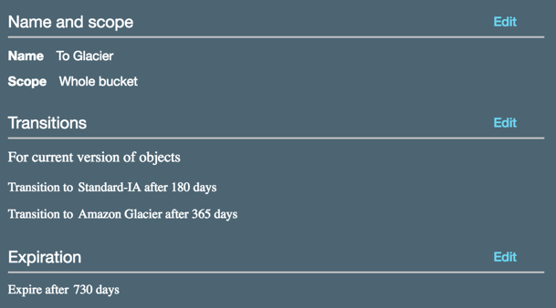

1. Finally, press “Save”
2. Verify the new lifecycle rule appears under Lifecycle in the Management tab

## Turn on Object versioning

1. Click on the “Properties” tab
2. Click on the Versioning card
3. Choose “Enable versioning” noting the warning that appears
4. We will fix it later, so click Save

## Upload multiple versions of a file

1. Click on the “Overview” table
2. Click “Upload”
3. Choose “constitution.txt” from the documents/v1 folder and click “Upload”
4. In the action bar, choose “Show” versions.
5. Now, upload “constitution.txt” from the documents/v2 folder

### Questions:

* What is the version ID for the previously uploaded Greece photos?
* How many versions exist for the constitution.txt file?

## Delete and Rename Files

1. Click “Hide” versions if they are showing
2. Click on Greece-1.jpeg between the name and last modified date
3. Choose “Delete” from the “More” menu confirming it on the delete objects dialog
4. Click on “constitution.txt” between the name and last modified date
5. Choose “Rename” from the “More” menu
6. Change the name to “our-constitution.txt” and click Save
7. Click “Show” versions from the action bar

### Questions:

* How many versions of Greece-1.jpeg, constitution.txt and our-constitution.txt exist?
* Can you download a copy of Greece-1.jpeg?

## Setup Cross Region Replication

### Step 1 – Create a receiver bucket

1. From the breadcrumb navigation, choose Amazon S3
2. Click on “+ Create Bucket”
3. Enter a same bucket name as you did before and append “-crr” to the end.
4. Choose different region than you did above such as “US West (Oregon)”
5. Under “Copy settings from an existing bucket” choose the bucket you created earlier.
6. Click “Create”
7. Navigate to your newly created bucket.

### Questions:

* Click on the “Properties” tab. Is versioning enabled or disabled?
* Click on the “Management” tab. How many lifecycle rules are shown?

### Step 2 – Configure Replication

1. Go back to the original bucket you created earlier
2. Click on the “Management” tab
3. Click on “Replication”
4. Click “+ Add Rule” and review the defaults
5. Click “Next” without changing anything
6. For destination bucket, choose second bucket you created
7. Leave both “Options” un-checked and press “Next”
8. Under “Select IAM Role” choose “Create a new role” and click “Next”
9. Review the replication rule and confirm it looks like mine below with, of course, your source and target bucket names
10. Press “Save” to save the new rule
11. Take a moment to review the replication dashboard noting the IAM role that was created so you can delete it later when cleaning up

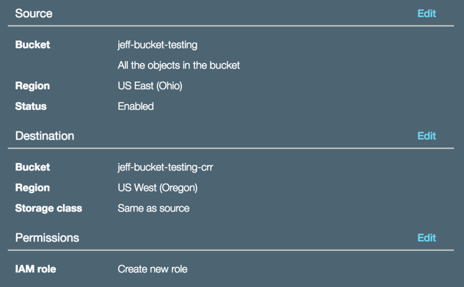

### Step 3 – Test replication

1. Click on the “Overview” tab
2. Upload Greece-4.jpeg from the photos folder.
3. After it appears in the file list, click on the row to reveal the properties. **Question:** What is the replication status?
4. Close out and repeat step 3 until the replication status is “completed”
5. Go to the replication target bucket. The file should also be there. If you don’t see it, refresh the page.
6. Go back to the source bucket and click on Greece-4.jpeg
7. Delete the file using the “More” button on the action bar and confirm the delete
8. Upload constitution.txt from the documents/v3 folder
9. Open a new tab so you have each bucket in their own tab.
10. Refresh each page to make sure you have the latest view
11. Choose show versions if that is not already selected

### Questions:

* For Greece-4.jpeg, is the version number with the delete marker the same in each bucket?
* How many versions of constitution.txt are in each bucket?
* Does the target folder have copies of files we uploaded prior to turning on cross region replication?

For more: https://docs.aws.amazon.com/AmazonS3/latest/dev/crr.html