**CIA-1 Assignment PSUP**

Name: A.Jeffrey D’souza

USN.no: 2092408001

Specialization: B.tech (Software Enginnering)

1. ***Revising For Loops***

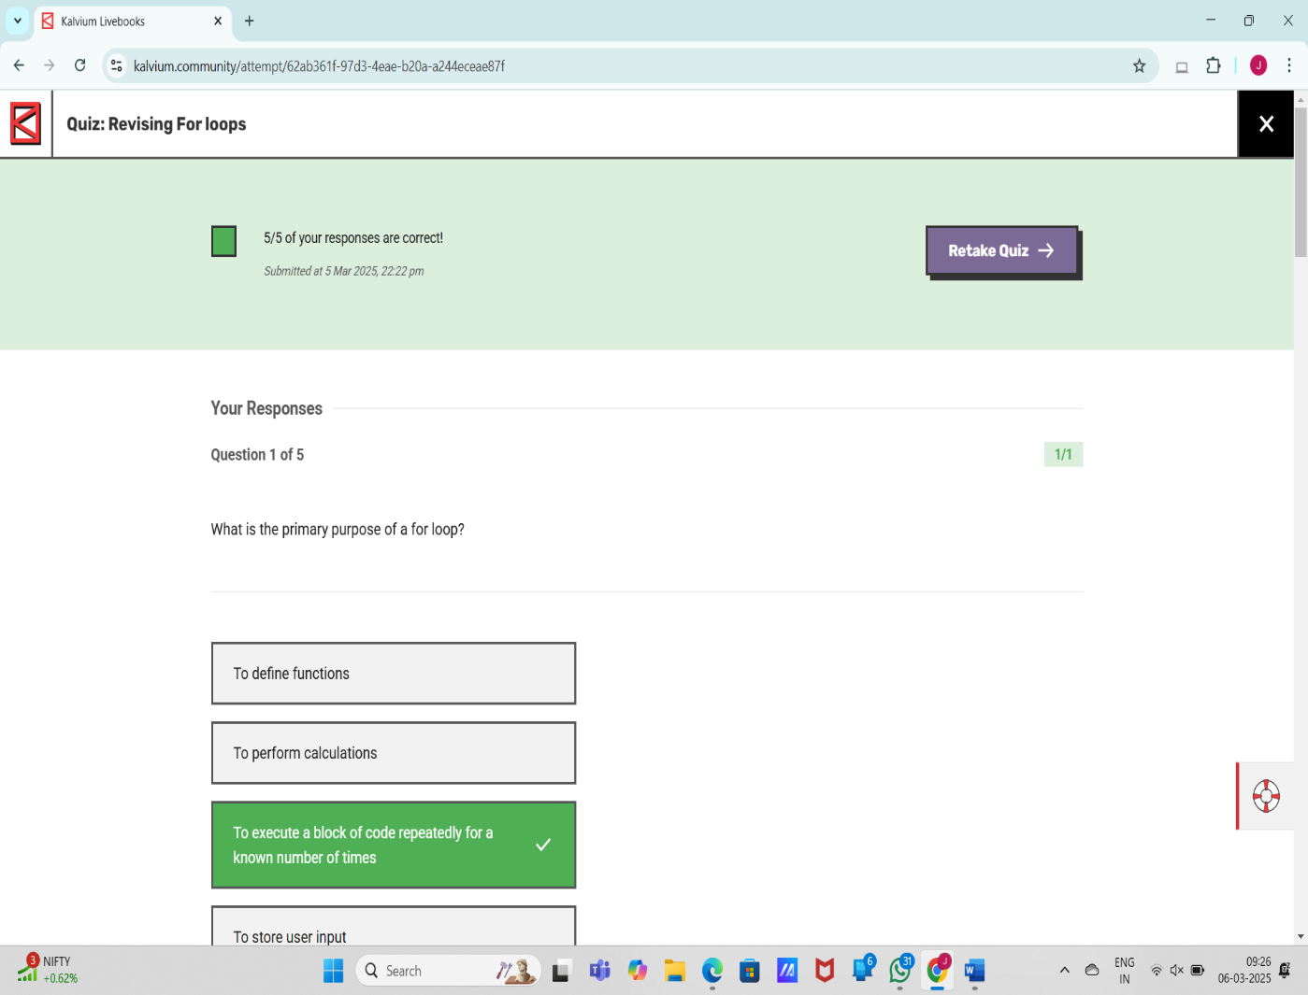

1. ***For Loops: Assignment***

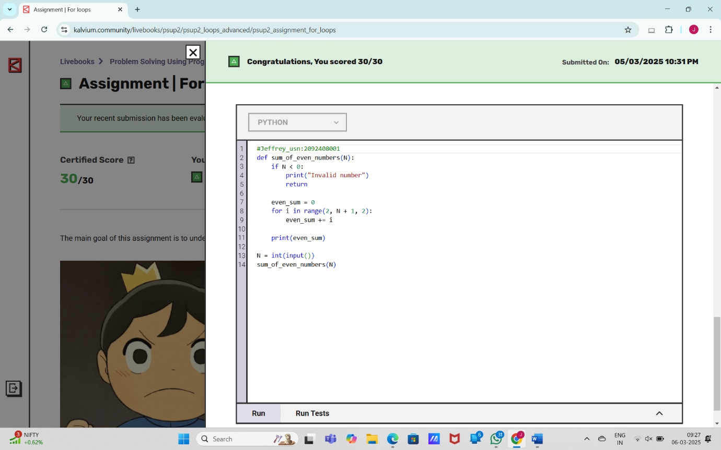

1. ***Revising while loops***

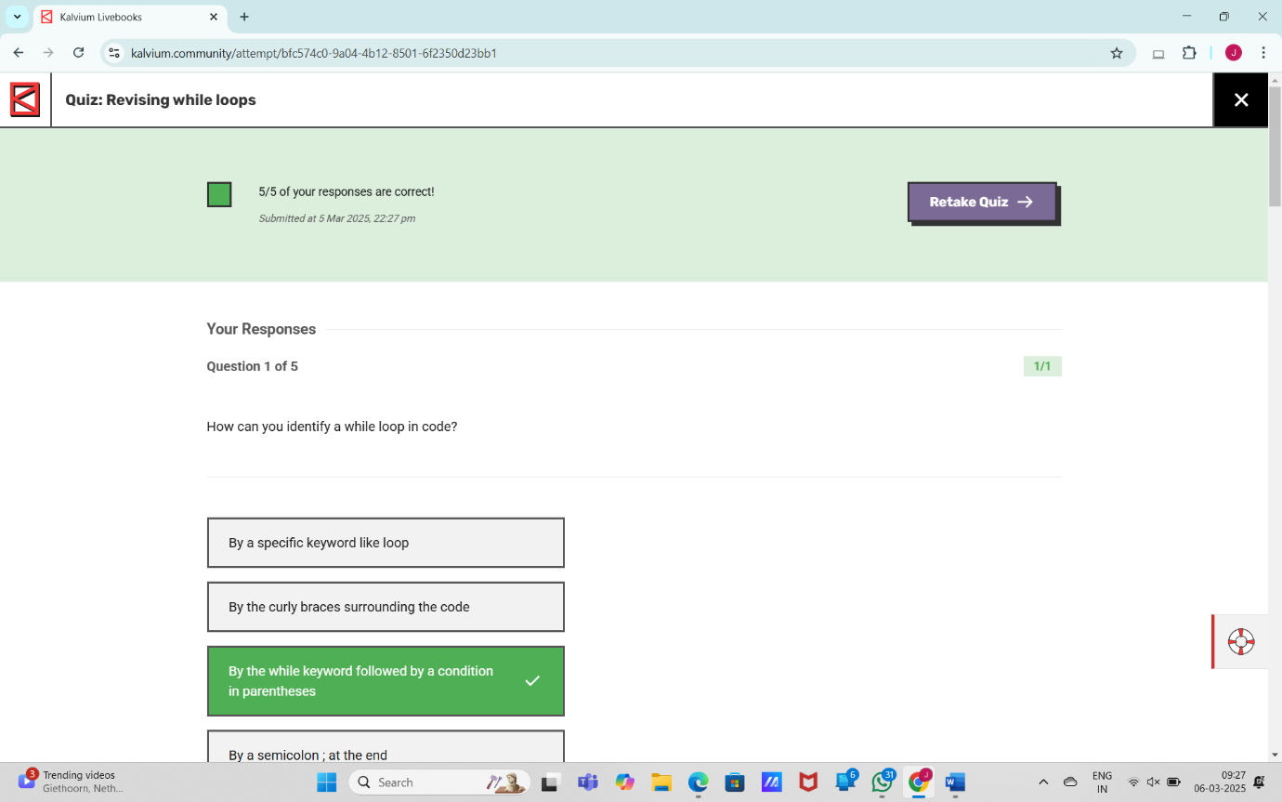

1. ***while loop: Assignment***

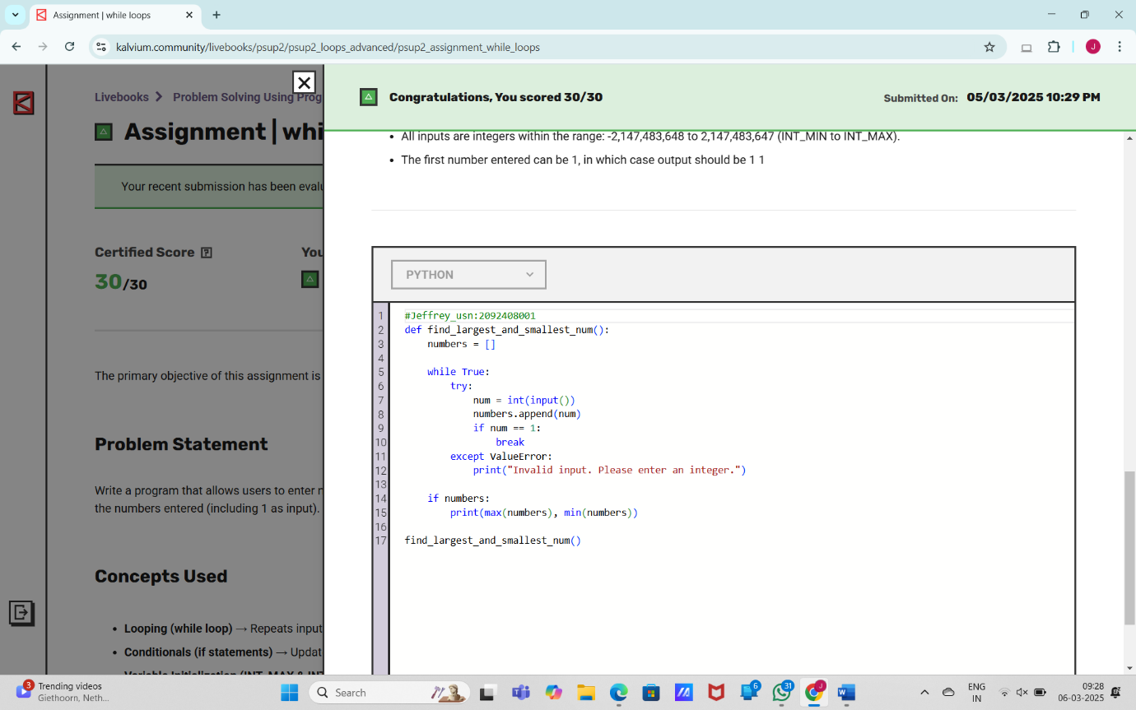

1. ***While loop in array***

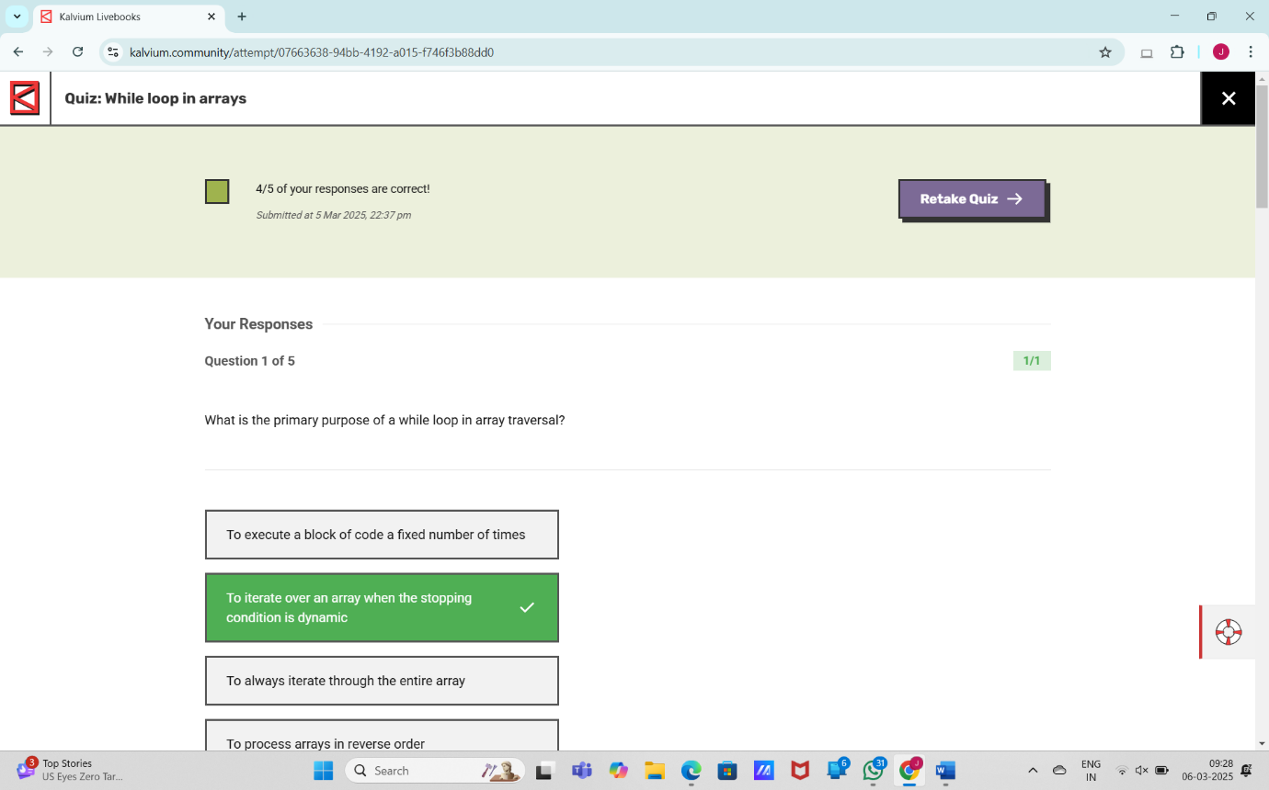

1. ***While loop in array: Assignment***

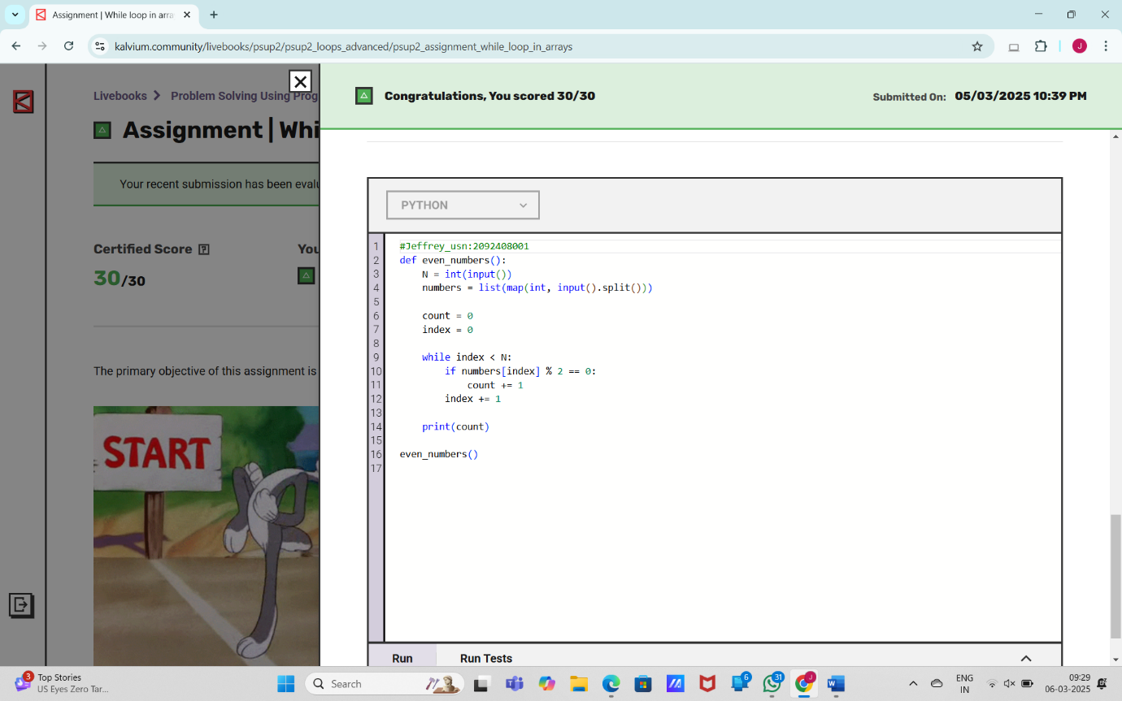

1. ***While loop in strings***

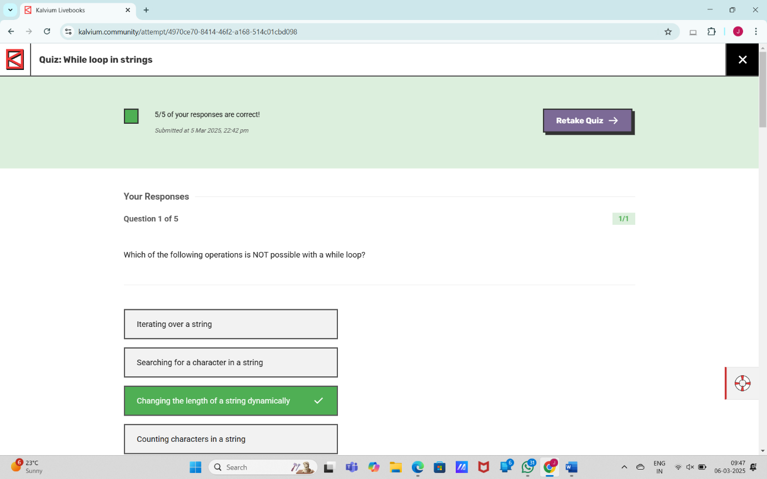

1. ***While loop in strings: Assignment***

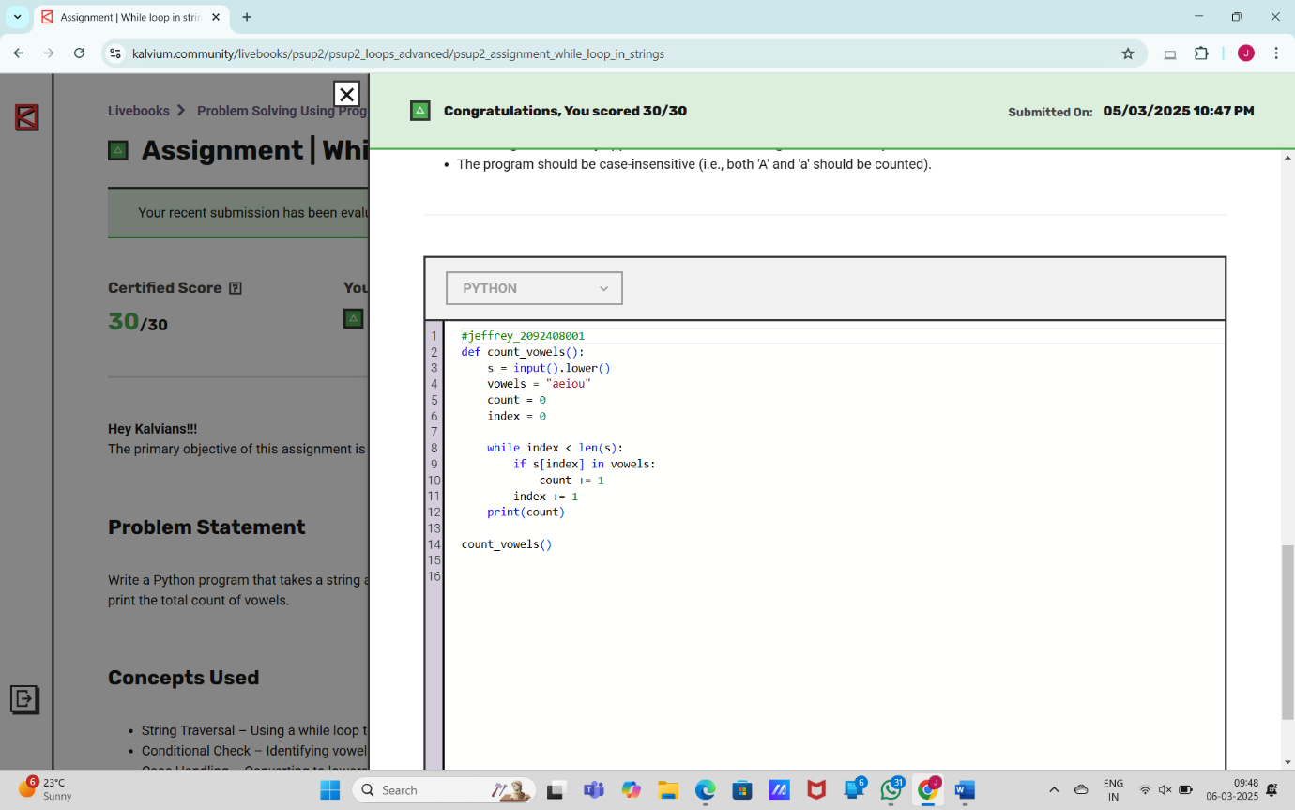

1. ***Nested for loop***

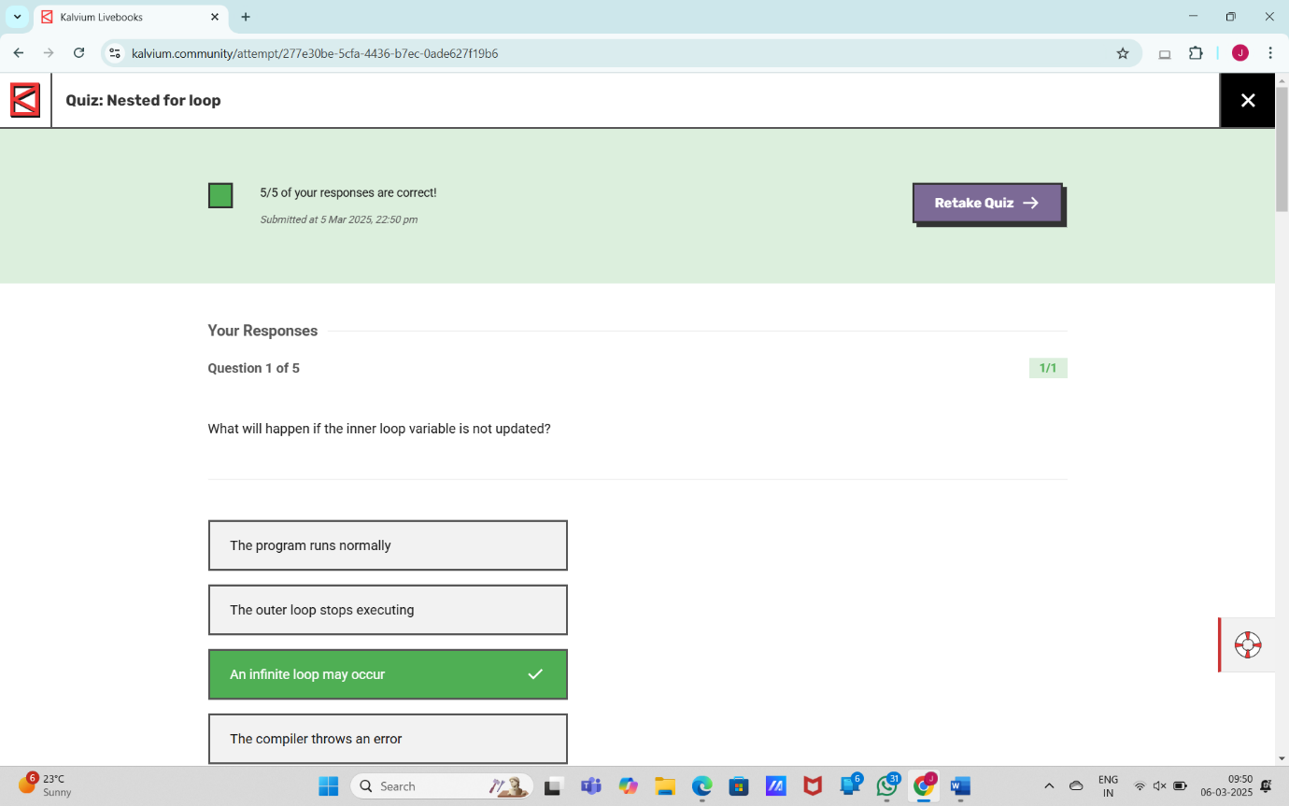

1. ***Nested for loop: Assignment***

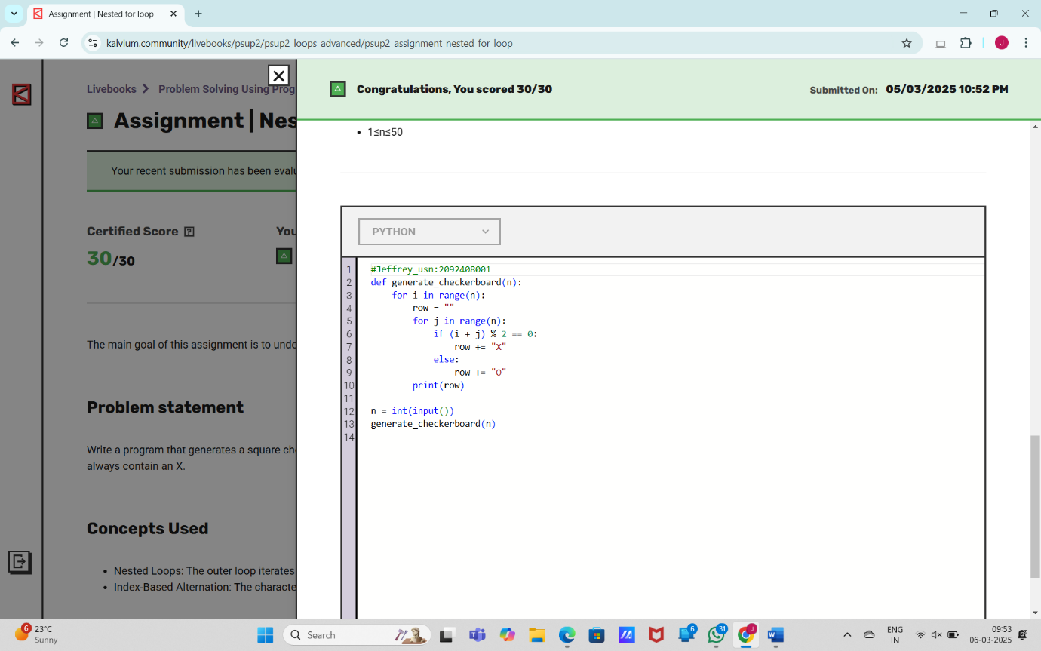

1. ***Nested while loop***

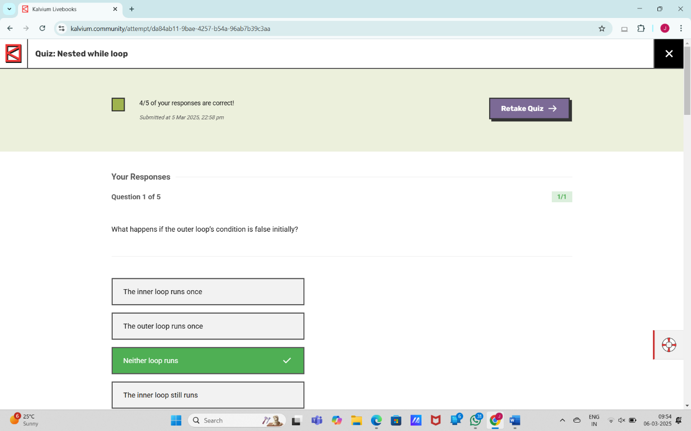

1. ***Nested while loop: Assignment***

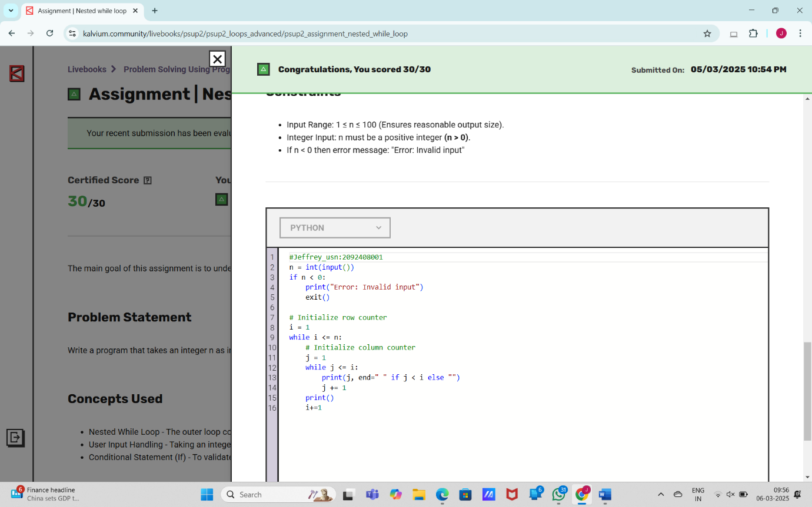

**Thank you!!!**