UTS **“500 Mile Walk for Parkinson’s”** Walk/Run Pledge Sheet

“Life’s most persistent and urgent question is, ‘What are you doing for others?’” Martin Luther King



Dear ,

Sponsor

Number of Laps Completed ____________

My school is raising money to support Parkinson’s Disease which has impacted a member of our school community. I will be walking and/or running laps around our school field on ____________________________ .. **All $$ needs to be returned to the school by Monday, May 9th, 2016.**

**All monies raised will be donated to the Michael J Fox Foundation for Parkinson’s Research**

I think I will be able to do laps. Please consider sponsoring me either by the lap or with a flat

donation. **Thank you for your contribution!**

|  |  |  |  |  |
| --- | --- | --- | --- | --- |
| **Sponsor’s Name** | **Amount per lap**  **($)** | **Flat**  **Donation ($)** | **Total to be collected**  **($)** | **Total amount**  **collected** |
| Example: **Per Lap** Pledge  Paul Jones | .25 .50 **1.00** 2.00  or per lap |  | If 50 laps, then $50 |  |
| Example: **Flat Donation** Pledge  James Jones | .25 .50 1.00 2.00  or per lap | $50 |  |  |
|  | .25 .50 1.00 2.00  or per lap |  |  |  |
|  | .25 .50 1.00 2.00  or per lap |  |  |  |
|  | .25 .50 1.00 2.00  or per lap |  |  |  |
|  | .25 .50 1.00 2.00  or per lap |  |  |  |
|  | .25 .50 1.00 2.00  or per lap |  |  |  |
|  | .25 .50 1.00 2.00  or per lap |  |  |  |
|  | .25 .50 1.00 2.00  or per lap |  |  |  |
|  | .25 .50 1.00 2.00  or per lap |  |  |  |
|  | .25 .50 1.00 2.00  or per lap |  |  |  |
|  | .25 .50 1.00 2.00  or per lap |  |  |  |
|  | .25 .50 1.00 2.00  or per lap |  |  |  |
|  | .25 .50 1.00 2.00  or per lap |  |  |  |
|  | .25 .50 1.00 2.00  or per lap |  |  |  |
|  | .25 .50 1.00 2.00  or per lap |  |  |  |

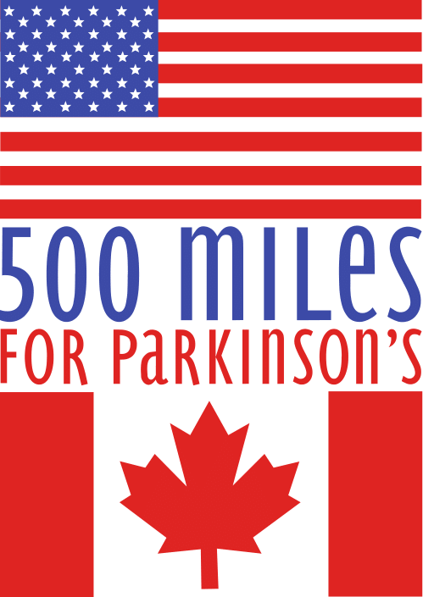

|  |  |  |  |  |
| --- | --- | --- | --- | --- |
| **Sponsor’s Name** | **Amount per lap**  **($)** | **Flat**  **Donation ($)** | **Total to be collected**  **($)** | **Total amount**  **collected** |
|  | .25 .50 1.00 2.00  or per lap |  |  |  |
|  | .25 .50 1.00 2.00  or per lap |  |  |  |
|  | .25 .50 1.00 2.00  or per lap |  |  |  |
|  | .25 .50 1.00 2.00  or per lap |  |  |  |
|  | .25 .50 1.00 2.00  or per lap |  |  |  |
|  | .25 .50 1.00 2.00  or per lap |  |  |  |
|  | .25 .50 1.00 2.00  or per lap |  |  |  |
|  | .25 .50 1.00 2.00  or per lap |  |  |  |
|  | .25 .50 1.00 2.00  or per lap |  |  |  |
|  | .25 .50 1.00 2.00  or per lap |  |  |  |
|  | .25 .50 1.00 2.00  or per lap |  |  |  |
|  | .25 .50 1.00 2.00  or per lap |  |  |  |
|  | .25 .50 1.00 2.00  or per lap |  |  |  |
|  | .25 .50 1.00 2.00  or per lap |  |  |  |
|  | .25 .50 1.00 2.00  or per lap |  |  |  |
|  | .25 .50 1.00 2.00  or per lap |  |  |  |
|  | .25 .50 1.00 2.00  or per lap |  |  |  |
|  | .25 .50 1.00 2.00  or per lap |  |  |  |
|  | .25 .50 1.00 2.00  or per lap |  |  |  |
|  | .25 .50 1.00 2.00  or per lap |  |  |  |
|  | .25 .50 1.00 2.00  or per lap |  |  |  |
|  | .25 .50 1.00 2.00  or per lap |  |  |  |

**All $$ needs to be returned to the school by ___________________________**

**Total $ Collected _** 