*PROJECT REPORT*

*RAILWAY TICKET RESERVATION SYSTEM*

Jeffrey Samuel S 2020506038

AIM:

To create and program code for a Railway Ticket Reservation System using C programming.

PROBLEM STATEMENT:

Railway reservation system enables us to do the train reservation and other things there is necessity to fill a form at the railway reservation counter, that is the user can directly select from the choices provided with train numbers, origin, date of travel, departure time, destination, the class of travel, insurance etc. The program gives user the final output as train ticket with the amount to be paid. Finally, it’s the user who has to decide whether to book the ticket or not.

KEY FUNCTIONS USED:

main():

The main backbone of the program. Gets the major travel details as well as allows access to other major functions like *seat()*, *bill()* and also gives the user the option of viewing past ticket bookings.

cal():

This function does the calculation of the final amount to be paid and it lets the user select the class of his/her seat.

add_node():

Adds the details of the user and the passengers who will be travelling via the ticket booked, by adding a node to the linked list data structure.

show_bookings():

This function gets the past booking details by accessing the text file and displays the contents of the file as per his/her discretion.

bill():

This is a major function that displays all the details for the ticket to the user and this is the function where details of the booking transaction are written onto a text file.

DATA STRUCTURES USED:

SINGLY LINKED LIST:

It is the simplest type of linked list in which every node contains some data and a pointer to the next node of the same data type. The node contains a pointer to the next node means that the node stores the address of the next node in the sequence.

Each record of the user is chained to the next through a pointer. This provides easy traversal of data records. This allows easier access to write data onto text files and store the data and retrieve it whenever needed.

OUTPUTS:

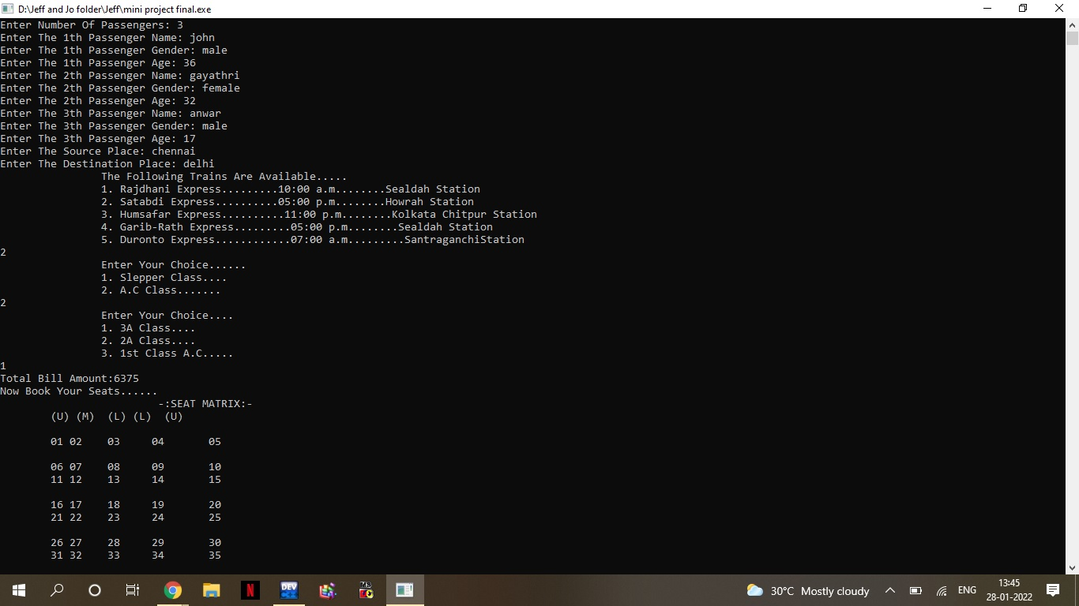

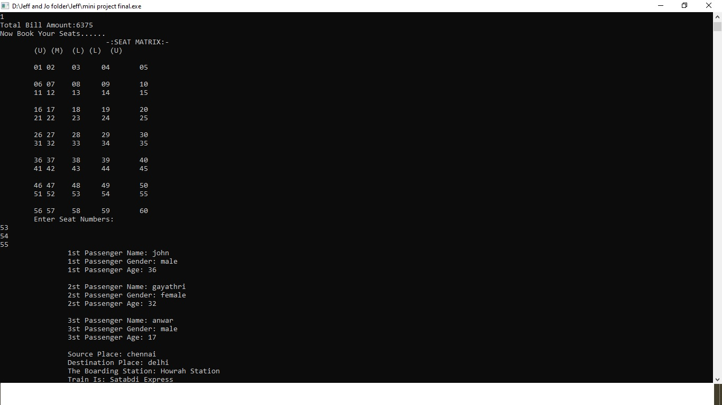

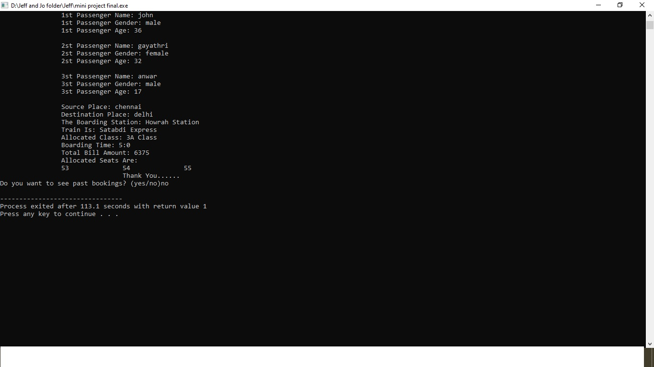

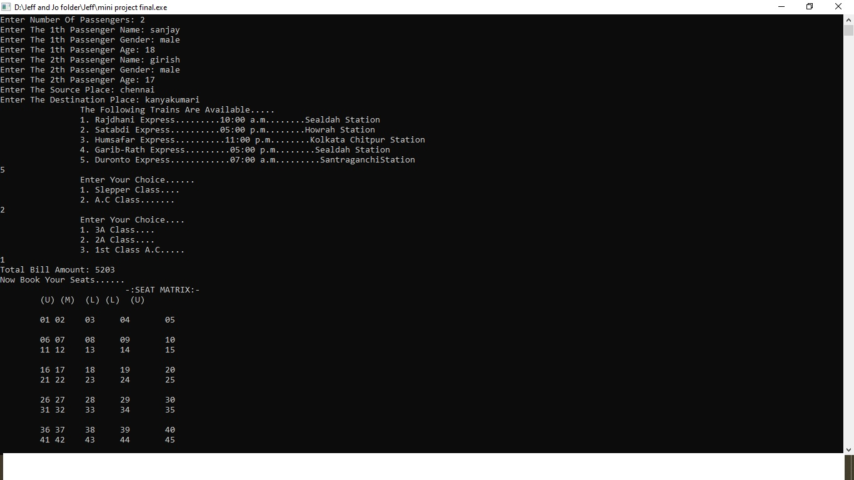

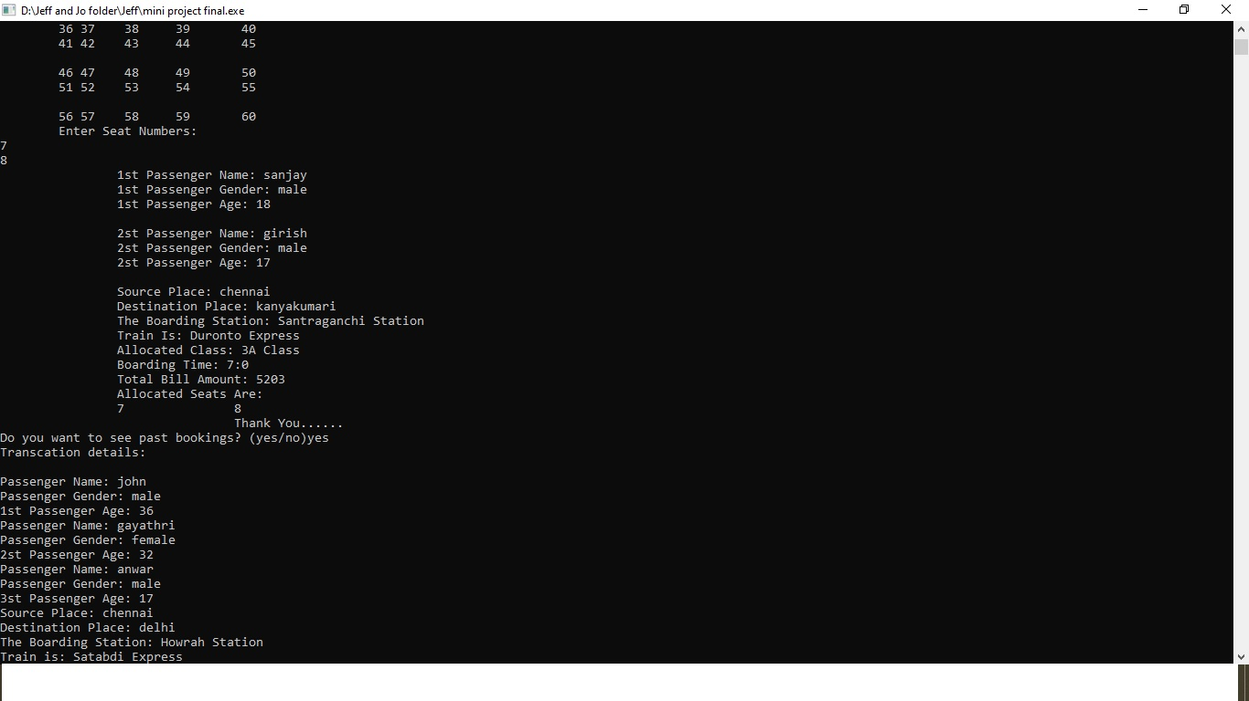

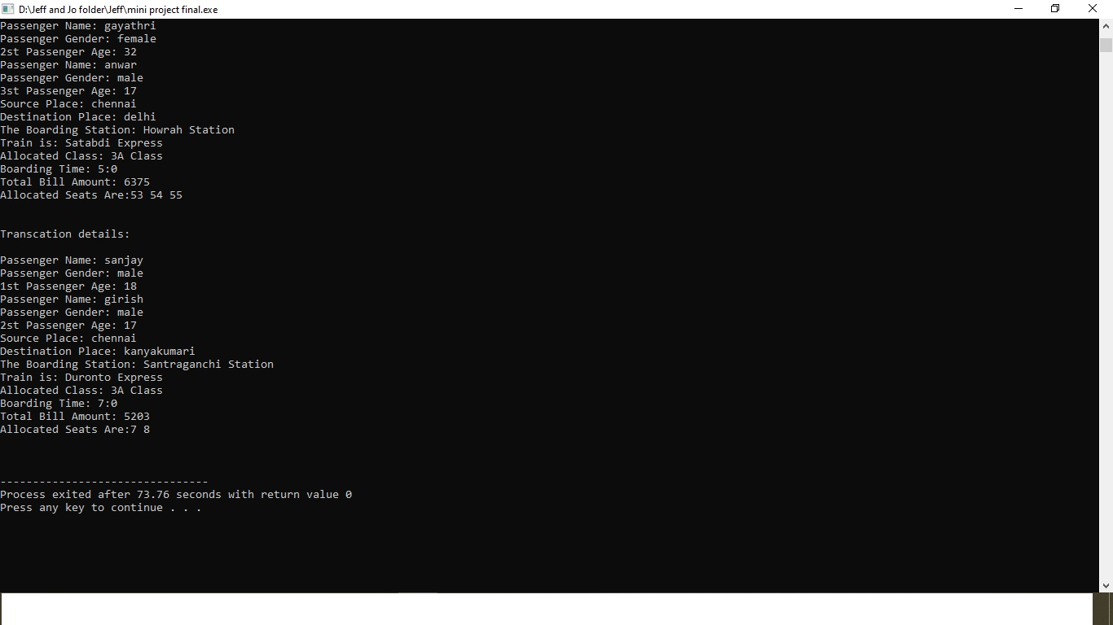

RESULT:

A user responsive and interactive menu driven Railway Reservation System was designed, executed and verified successfully.