Analytical Problem Solving
Given Problem
A delivery robot is working in a 5 × 5 warehouse grid.
- Starting cell: (1,1)
- Goal cell: (5,5)
- Blocked cells: (2,2), (2,3), (3,3), (4,2), (4,4)
- Allowed movements: Up, Down, Left, Right
- Cost of each movement: 1
For BFS and DFS, I use the movement order:
Up → Down → Left → Right
This makes the node expansion order clear and consistent.
(a) PEAS Description
PEAS stands for Performance Measure, Environment, Actuators and Sensors.
- Performance Measure
The main aim of the robot is to deliver the package to (5,5).
The robot should:
  - Reach the destination successfully.
  - Avoid blocked cells.
  - Stay inside the warehouse.
  - Use the minimum possible number of movements.

  - Complete the task efficiently.
Since every movement costs 1, a shorter path has a lower total cost.

- Environment
The environment is a 5 × 5 warehouse grid.
It contains:
  - Starting position (1,1)
  - Destination (5,5)
  - Blocked cells caused by shelves:
o (2,2) o (2,3) o (3,3) o (4,2) o (4,4)
  - Free cells where the robot can move.
The robot can move only horizontally or vertically.
- Actuators
The robot's actuators allow it to:
  - Move Up
  - Move Down
  - Move Left
  - Move Right
- Sensors
The robot needs sensors to know:
  - Its current position.
  - Whether nearby cells are blocked.
  - Whether it is at the boundary.
  - Whether it has reached the destination.

PEAS | Description
Performance Measure | Reach (5,5) safely with minimum movement cost
Environment | 5 × 5 warehouse grid with blocked cells
Actuators | Up, Down, Left, Right
Sensors | Position, obstacle, boundary and goal detection

Conclusion: This PEAS model describes what the robot has to achieve, where it works, how it moves and what information it receives.
- Type of Intelligent Agent
Goal-Based Agent
The most suitable agent for this problem is a Goal-Based Agent.
The robot has a specific goal: reach cell (5,5) from (1,1).
It has to consider different possible movements and choose a sequence that leads to the destination without entering blocked cells.
  - A Simple Reflex Agent mainly reacts to the current situation and does not properly plan a complete route.
  - A Model-Based Agent can maintain information about the environment, but the main requirement here is reaching a particular goal.
  - A Goal-Based Agent chooses actions based on whether they help achieve the destination.
  - A Utility-Based Agent would be more suitable if factors such as fuel, time, risk or energy had to be compared.
Therefore, the Goal-Based Agent is the best choice because the robot has a clearly defined destination and must plan a path to reach it.
- Search Problem Formulation
The warehouse problem can be represented as a search problem using five components.
- Initial State
The robot starts at (1,1).
- Goal State
The robot must reach (5,5).
- Actions
The possible actions are:
Up, Down, Left, Right
An action is allowed only if the resulting cell:
  - Is inside the 5 × 5 grid.
  - Is not blocked.
- Transition Model
The transition model tells us the new position after each movement.
For a position (r,c):
Up=(r-1,c)
Down=(r+1,c)
Left=(r,c-1) Right=(r,c+1)
For example: 5. Path Cost (1, 1)𝐷𝑜𝑤𝑛→(2, 1)
Every movement costs 1.
Therefore:
𝑃𝑎𝑡ℎ 𝐶𝑜𝑠𝑡 = 𝑁𝑢𝑚𝑏𝑒𝑟 𝑜𝑓 𝑚𝑜𝑣𝑒𝑚𝑒𝑛𝑡𝑠×1
So, the objective is to find a path from (1,1) to (5,5) with minimum cost.
- Breadth-First Search (BFS)
Program:
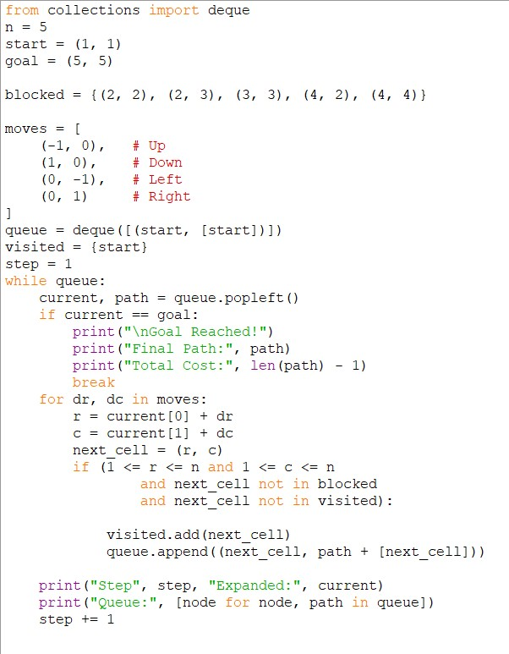

Output:
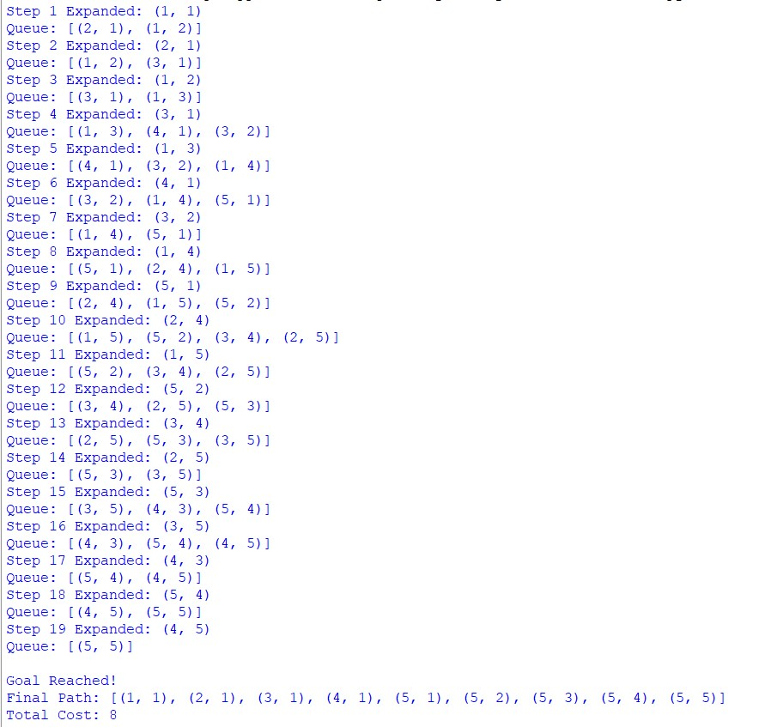

- Depth-First Search (DFS) Program:
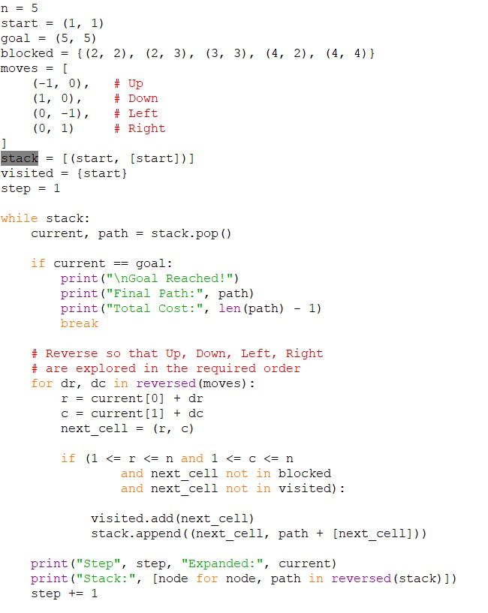

Output:
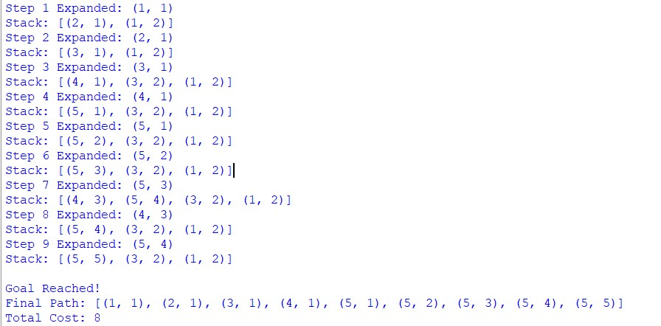
- BFS vs DFS – 10 Marks
Feature | BFS | DFS
Data structure | Queue | Stack
Search method | Level by level | Deepest branch first
Complete | Yes | Yes for this finite grid with visited-state  checking
Optimal | Yes, for uniform step  costs | No, in general
Time complexity | \(O(b^d)\) | \(O(b^m)\)
Space complexity | \(O(b^d)\) | \(O(bm)\)
Path found here | Cost 8 | Cost 8
Main advantage | Guarantees shortest path | Requires less memory
Main disadvantage | Uses more memory | May find a non-optimal path

Where:
  - b = branching factor
  - d = depth of the shallowest solution
  - m = maximum search depth
For this problem, BFS is more suitable.
The reason is that every movement has the same cost of 1. BFS searches level by level, so it finds the shortest path first.
DFS also finds a path with cost 8 in this particular case, but this happens because of the chosen movement order. DFS cannot guarantee that its first solution will always be the shortest.
Conclusion:
The warehouse robot is best modeled as a Goal-Based Intelligent Agent. The problem can be represented as a search problem with (1,1) as the initial state and (5,5) as the goal state.
Both algorithms successfully reach the destination:
𝐵𝐹𝑆 𝐶𝑜𝑠𝑡 = 8
However, BFS is the better choice because𝐷𝐹𝑆 all 𝐶𝑜𝑠𝑡 movements= 8 have equal cost and BFS guarantees the shortest path.
Therefore, the optimal delivery route is:
with: (1, 1) → (2, 1) → (3, 1) → (4, 1) → (5, 1) → (5, 2) → (5, 3) → (5, 4) → (5, 5)
8 𝑚𝑜𝑣𝑒𝑠 𝑎𝑛𝑑 𝑡𝑜𝑡𝑎𝑙 𝑐𝑜𝑠𝑡 8

