Constraint-Based Problem Solving

Given Problem
There are 5 courses:
- A – Artificial Intelligence
- B – Database Systems
- C – Computer Networks
- D – Operating Systems
- E – Software Engineering
There are 3 examination slots: {𝑆𝑙𝑜𝑡1, 𝑆𝑙𝑜𝑡2, 𝑆𝑙𝑜𝑡3}
The conflicting pairs that cannot be in the same slot are:
𝐴 − 𝐵, 𝐴 − 𝐶, 𝐵 − 𝐶, 𝐵 − 𝐷, 𝐶 − 𝐷, 𝐶 − 𝐸, 𝐷 − 𝐸
The objective is to create a timetable in which no conflicting courses are scheduled in the same slot. These are the exact constraints given in the assessmen
(a) PEAS Description
PEAS stands for Performance Measure, Environment, Actuators and Sensors.
P – Performance Measure The scheduling agent should:
- Schedule all 5 courses.
- Use only the 3 available slots.
- Ensure that no conflicting courses are placed in the same slot.
- Produce a valid and conflict-free examination timetable.

E – Environment
The environment consists of:
- 5 university courses: A, B, C, D and E.
- 3 examination slots: Slot1, Slot2 and Slot3.
- Student enrollment conflicts between specific pairs of courses.
- One examination slot available per day.
A – Actuators The agent can:
- Assign a course to Slot1.
- Assign a course to Slot2.
- Assign a course to Slot3.
- Change an assignment when a conflict occurs.

S – Sensors
The agent can check:
- The current course assignment.
- The available slots.
- Whether two conflicting courses are assigned to the same slot.
- Whether all courses have been successfully scheduled.

PEAS Summary

Component | Description
Performance | Produce a complete conflict-free timetable
Environment | 5 courses, 3 slots and enrollment conflicts
Actuators | Assign courses to examination slots
Sensors | Detect assignments, conflicts and available slots

Conclusion: The scheduling agent's main objective is to assign every course to a slot while
satisfying all the given conflict constraints.
(b) Type of Intelligent Agent

Goal-Based Agent
A Goal-Based Agent is the most suitable for this scheduling problem.
The main goal is:
Create a complete examination timetable in which no conflicting courses are assigned to the same slot.
The agent has to consider different possible assignments and select assignments that satisfy the goal.

Justification
- A Simple Reflex Agent only reacts to the current situation and is not suitable for systematically constructing the complete timetable.
- A Model-Based Agent can maintain information about previous states, but the important requirement here is achieving a specific valid timetable.
- A Goal-Based Agent can evaluate assignments according to whether they help achieve the conflict-free timetable.
- A Utility-Based Agent would be more suitable if the problem included preferences such as minimizing student inconvenience, balancing exams, or minimizing gaps between exams.

Therefore:
Goal-Based Agent is the most appropriate choice because the scheduling task has a clearly defined goal: find a conflict-free timetable.

(c) CSP Formulation + Constraint Graph
A Constraint Satisfaction Problem (CSP) consists of:
- Variables
- Domains
- Constraints

Variables
Each course is a variable: 𝑋 = {𝐴, 𝐵, 𝐶, 𝐷, 𝐸}
where:
- A = Artificial Intelligence
- B = Database Systems
- C = Computer Networks
- D = Operating Systems
- E = Software Engineering

Domains
Each course can be assigned to one of three slots:

𝐷(𝐴) = 𝐷(𝐵) = 𝐷(𝐶) = 𝐷(𝐷) = 𝐷(𝐸)

= {𝑆𝑙𝑜𝑡1, 𝑆𝑙𝑜𝑡2, 𝑆𝑙𝑜𝑡3}

Constraints
Conflicting courses must have different slots.

𝐴 ≠ 𝐵

𝐴 ≠ 𝐶

𝐵 ≠ 𝐶

𝐵 ≠ 𝐷

𝐶 ≠ 𝐷

𝐶 ≠ 𝐸
𝐷 ≠ 𝐸
Therefore, the complete constraint set is:
{𝐴 ≠ 𝐵, 𝐴 ≠ 𝐶, 𝐵 ≠ 𝐶, 𝐵 ≠ 𝐷, 𝐶 ≠ 𝐷, 𝐶 ≠ 𝐸, 𝐷 ≠ 𝐸}

Constraint Graph

Vertices
𝑉 = {𝐴, 𝐵, 𝐶, 𝐷, 𝐸}

Edges
𝐸 = {𝐴𝐵, 𝐴𝐶, 𝐵𝐶, 𝐵𝐷, 𝐶𝐷, 𝐶𝐸, 𝐷𝐸}
The graph can be represented as:
A
/ \
B---C
| / \
| / \
D-------E
More specifically, the edges are:
- A — B
- A — C
- B — C
- B — D
- C — D
- C — E
- D — E
An edge means that the two connected courses must be assigned different slots.

- Plain Backtracking Search Program:
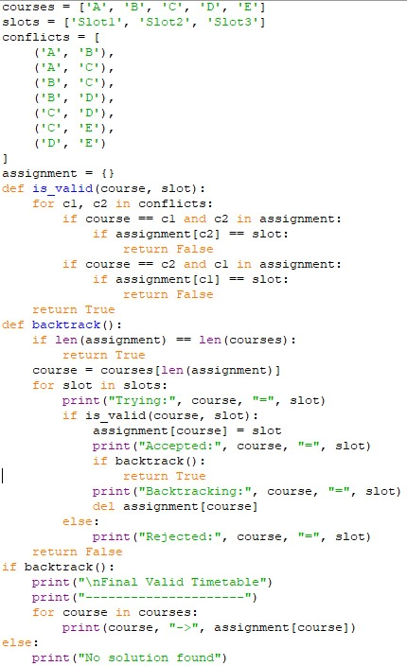

Output:
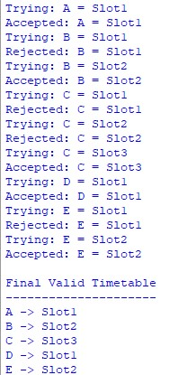

- Backtracking with Forward Checking Program:
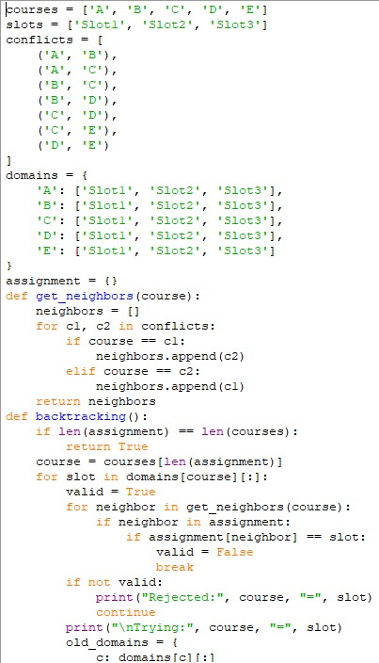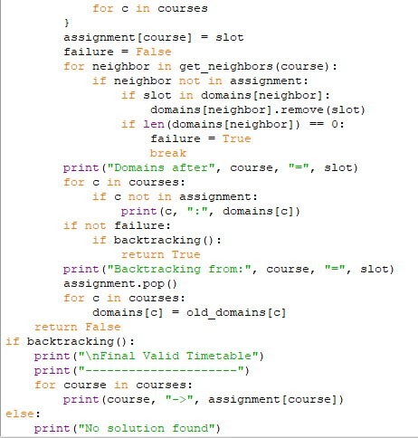

Output:
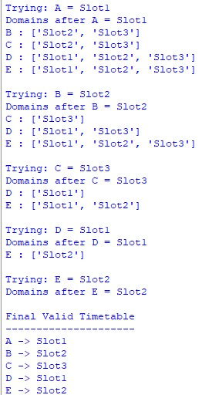

- Comparison
Feature | Plain Backtracking | Forward Checking
Variable order | A → B → C → D → E | A → B → C → D → E
Value order | S1 → S2 → S3 | S1 → S2 → S3
Assignment attempts | 9 | 5
Failed attempts | 4 | 0
Backtracks | 0 actual returns | 0
Domain pruning | No | Yes
Search effort | Higher | Lower
Efficiency | Lower | Higher

In ordinary backtracking, the algorithm may try an assignment even when it will create a conflict later.
For example, after:
𝐴 = 𝑆1
plain backtracking still tries: 𝐵 = 𝑆1
and discovers the conflict only after making the attempt.
Forward checking immediately removes S1 from B's domain:
𝐵 = {𝑆2, 𝑆3}
So the invalid assignment is never attempted.
Similarly, after: 𝐴 = 𝑆1, 𝐵 = 𝑆2
forward checking knows that C cannot use S1 or S2:
𝐶 = {𝑆3}
Therefore, C can be assigned directly to S3 without trying invalid values.

Final Analysis
Plain backtracking required:
9 attempts
while forward checking required:
5 attempts
So forward checking reduced the number of assignment attempts by:
9 − 5 = 4
4 fewer attempts
Percentage reduction:
9-5/9*100=44.44%
Thus, forward checking reduced the assignment attempts by approximately:
44.44%

Conclusion
The CSP has 5 variables, each with the domain: {𝑆𝑙𝑜𝑡1, 𝑆𝑙𝑜𝑡2, 𝑆𝑙𝑜𝑡3}
and 7 binary constraints:
𝐴 − 𝐵, 𝐴 − 𝐶, 𝐵 − 𝐶, 𝐵 − 𝐷, 𝐶 − 𝐷, 𝐶 − 𝐸, 𝐷 − 𝐸

Both methods produce the valid timetable:
Course | Examination Slot
A – Artificial Intelligence | Slot1
B – Database Systems | Slot2
C – Computer Networks | Slot3
D – Operating Systems | Slot1
E – Software Engineering | Slot2

[A=S1, B=S2, C=S3, D=S1, E=S2 ]
The Forward Checking approach is more efficient because it prunes inconsistent values immediately, reducing unnecessary assignment attempts from 9 to 5 while satisfying all constraints.

