Table of Contents

This report shows details for building.

Building Name: LADWP building

Building Use: office

Square Feet: 500000

Floor Count: 15

# Construction Details

|  |  |  |  |
| --- | --- | --- | --- |
| Application | Name | Rvalue | Comments |
| Roof | Typical Insulated Metal Building Roof | 15 | - |

# Equipment Details

|  |  |  |
| --- | --- | --- |
| Name | Application | Quantity |
| H.B. Smith Hot Water Boiler | BOILER | 1 |

# Contact Details

|  |  |  |  |  |
| --- | --- | --- | --- | --- |
| Title | First Name | Last Name | Email Address | Years Of Experience |

# Location Details

|  |  |  |  |  |  |
| --- | --- | --- | --- | --- | --- |
| Use Type | Name | Floor | Area | Conditioning | User |
| Office | 101 | 1 | 1000 ft2 | Heating cooling | Tenant |
| Office | 102 | 1 | 1500 ft2 | Unconditioned | Tenant |
| Hospital | 1 | 1 | 1000 ft2 | Unconditioned | Tenant |

# Boiler

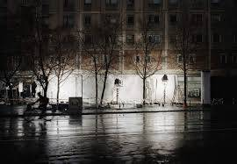 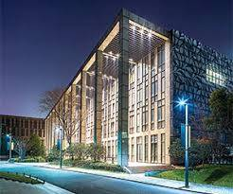 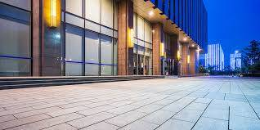

|  |  |  |  |
| --- | --- | --- | --- |
| Name | Application | Technology | Category |
| H.B. Smith Hot Water Boiler | BOILER | - | HEATING |