This report shows details for building.

Building Name: LADWP building

111 North Hope St, Los Angeles, CA 90012

Floor Count: 15

Build Year: 1901

# Construction Details

|  |  |  |
| --- | --- | --- |
| Application | Name | Rvalue |
| Wall | Typical Insulated Mass Wall | 6 |

# Contact Details

|  |  |  |  |  |  |  |
| --- | --- | --- | --- | --- | --- | --- |
| Title | First Name | Last Name | Company | Email Address | Phone Number | Years Of Experience |
| Mr | Gagan | Sharma | Aloha | Gagans@test.com | 8888888888 | 8 |

# Location Summary

|  |  |  |  |  |  |
| --- | --- | --- | --- | --- | --- |
| Use Type | Gross Floor Area | % of Common Area | % of Tenant Area | % of Conditioned Area | % of Unconditioned Area |
| Office | 2500 ft2 | 0.00% | 0.50% | 0.20% | 0.30% |
| Hospital | 1000 ft2 | 0.00% | 0.20% | 0.00% | 0.20% |

# Location Details

|  |  |  |  |  |  |  |  |
| --- | --- | --- | --- | --- | --- | --- | --- |
| Use Type | Name | Floor | Conditioning | User | Length | Width | Height |
| Office | 101 | 1 | Heating cooling | Tenant | 100 | 10 | 10 |
| Office | 102 | 1 | Unconditioned | Tenant | 15 | 10 | 10 |
| Hospital | 1 | 1 | Unconditioned | Tenant | 10 | 10 | 10 |

# Boiler

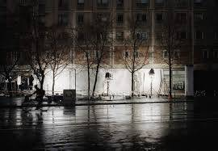 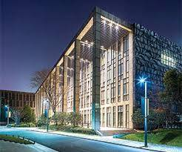 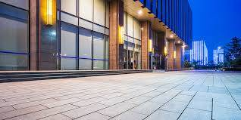

|  |  |  |
| --- | --- | --- |
| Name | Application | Quantity |
| H.B. Smith Hot Water Boiler | BOILER | 1 |