Table of Contents

# Location Summary

|  |  |  |  |  |  |  |
| --- | --- | --- | --- | --- | --- | --- |
| Use Type | % of Tenant Area | Gross Floor Area | % of Floor Area | % of Common Area | % of Unconditioned Area | % of Conditioned Area |
|
| Office | 0.50% | 2500 ft2 | 0.50% | 0.00% | 0.30% | 0.20% |
|
| Hospital | 0.20% | 1000 ft2 | 0.20% | 0.00% | 0.20% | 0.00% |

1. Test1
2. Test2
3. Test3
4. Test4
5. Test5
6. Test6
7. Test7

This is Test

Name: -

July 10, 2019

Component Count: -

Measure Count: -

Notes Count: -

Levels Count: -

Spaces Count: -

Zones Count: -

Schedules Count: -

1. Summary – Total Cost : $
2. Summary – Total Water : kGal
3. Summary – Total Steam : cubic ft.
4. Summary – Total Cost Per Square Foot : $/sf
5. Summary – Total Electricity : kWh
6. Summary – Total Gas : therms
7. Summary – Total Fuel Oil 4 : gallons
8. Summary – Total Fuel Oil 2 : gallons

|  |  |  |  |  |  |  |  |  |
| --- | --- | --- | --- | --- | --- | --- | --- | --- |
| Proposed Project | Description | Estimated Project Cost ($) | Estimated Annual Savings ($) | Estimated Electric Savings (kWh) | ROI (%) | Simple Payback (yrs) | 10 year NPV ($) | 10 year SIR |
| Total | - | - | - | - | - | - | - | - |

# Boiler

 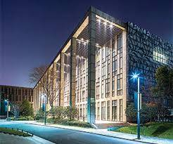 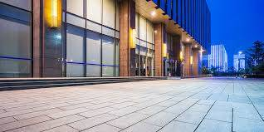

|  |  |  |  |  |  |  |  |
| --- | --- | --- | --- | --- | --- | --- | --- |
| Name | Application | Technology | Category | Description | Afue | Boiler Design | Brand |
| H.B. Smith Hot Water Boiler | BOILER | - | HEATING | - | [object Object] | [object Object] | [object Object] |