Table of Contents

1. Executive Summary 3

2. Facility and Baseline Description 4

3. Existing Equipment Descriptions 4

3.1 Mechanical Systems 4

3.2 Lighting Systems 5

4. Utility Information 7

4.1 Energy Consumption Data 7

4.2 Utility Rate Change Analysis 7

5. Energy Efficiency Measures 8

Lighting 8

Heating & Cooling 10

Appendix A - Measurement and Verification (M&V) Plan 11

Appendix B - Benchmarking 12



###### Comprehensive Energy Audit Report

Building Name: 1200 Hillcrest

Square Feet: 11,600

1200 Hillcrest Ct., Los Angeles, CA 90016

Prepared by:

support-LADWP

**TRC Advanced Energy Services**  
17911 Von Karman Ave, Suite #400  
Irvine, CA 92614

Created Date: February 19, 2020

# 1. Executive Summary

TRC Advanced Energy Services (TRC) has completed an HVAC, Lighting, and Process System audit of CUSTOMER NAME. Following the audits performed on DATE, TRC identified energy efficiency measures (EEMs) that have the potential to significantly reduce total utility, maintenance, and labor costs while also improving building comfort and reducing carbon output.  
  
Table 1 summarizes the proposed measures. Measure details can be found in later sections of the report. It is important to note that the EEMs are listed in the same order as the summary table, and the savings for each EEM assume that the EEMs listed above it have already been implemented.

|  |  |  |  |  |  |  |
| --- | --- | --- | --- | --- | --- | --- |
| Proposed Project | Estimated Electric Savings (kWh) | Estimated Gas Savings (therms) | Estimated Annual Savings ($) | Estimated Incentive ($) | Estimated Project Cost ($) | Simple Payback (yrs) |
| EEM 1: LED Troffers | 26,100 | 26,100 | 4,437 | 2,337 | 25,854 | 5.30 |
| EEM 2: LED Lamps and Fixtures | 13,800 | 13,800 | 2,346 | 561 | 11,067 | 4.48 |
| EEM-3: LED Exterior Lighting | 4,000 | 4,000 | 680 | - | 4,132 | 6.08 |
| Replace Older Vintage Packaged Units | 19,058 | 19,058 | 3,240 | - | - | - |
| Total | 62,958 | 62,958 | 10,703 | 2,898 | 41,053 | - |

##### Table 1: Savings Summary

Some measures may be implemented without requiring detailed engineering. Other measures will require this for feasibility and constructability. This report does not include specific design instructions and is not intended as a design document. Projects have not been developed to design level. The design professional or other persons following the recommendations shall accept responsibility and liability for the results. As technical consultants, TRC Advanced Services remains product and vendor neutral. The products were chosen based on their technological feasibility, efficiency, and impact on the project economics. The analysis herein is based on the performance and pricing of these products. It should be noted that if you would like to move forward with products other than those shown in this report, the analysis would need to be revised based on updated product performance and costs.

# 2. Facility and Baseline Description

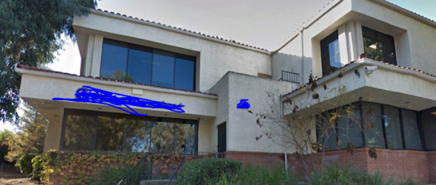

The Facility is a 11,600 sq. ft., two-story office building that hosts offices, exam rooms, and procedure rooms on the first floor. The second floor has a new call center and some vacant office spaces and conference rooms. The building consists of usage zones catered towards medical services, including private and open office spaces, exam rooms, waiting rooms, storage rooms, and a break/kitchen space.  
  
Adjacent to the building is 15,000 sq. ft. of outdoor parking, which is illuminated by LED pole mounted fixtures. The building is conditioned by several gas-electric packaged units. The building’s interior is lit by linear fluorescent T5 and T8 surface mounted fixtures, biaxial CFL recessed troffers, recessed CFL can fixtures, and MR16 spotlight fixtures. The exterior of the building is illuminated by motion sensor-controlled security fixtures along the perimeter of the building and CFL recessed cans.

# 3. Existing Equipment Descriptions

## 3.1 Mechanical Systems

The building is conditioned by (13) gas-electric rooftop packaged units, and (1) split-system heat pump unit dedicated to the building’s server room. The package units are controlled by a combination of manual and programmable thermostats. The thermostats currently operate on a basic schedule and predefined setpoints that can be overridden manually.  
  
All the HVAC units currently serve their zones with constant speed supply fan motors and no occupancy setback controls.  
  
Other miscellaneous equipment within the building include (1) steam sterilizer, (1) elevator, (2) refrigerators, (1) gas powered stove, and desktop computers.

#### Heating & Cooling

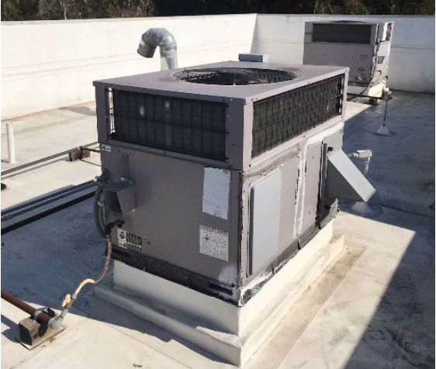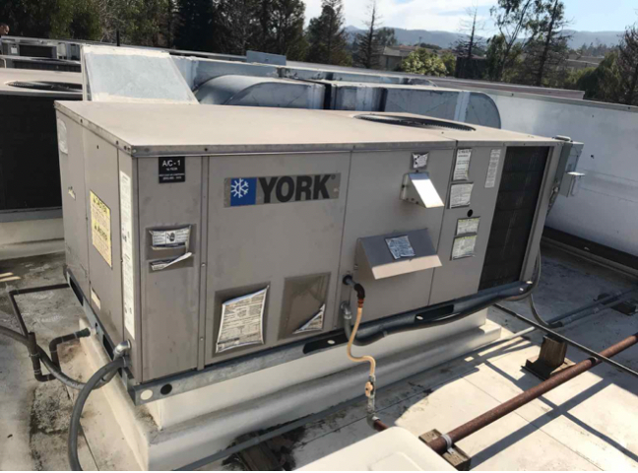

|  |  |  |  |  |  |
| --- | --- | --- | --- | --- | --- |
| Brand | Year of Manufacture | Cooling Capacity | EER | Heating Capacity | COP |
| Carrier | 2004 | 48000 | 9.6 | 90000 | 2.8 |
| Carrier | 2004 | 30000 | 9.6 | 40000 | 2.8 |
| Carrier | 2006 | 42000 | 9.8 | 60000 | 2.8 |
| Carrier | 2006 | 30000 | 9.8 | 40000 | 2.8 |
| Carrier | 2006 | 36000 | 9.8 | 60000 | 2.8 |
| Carrier | 2003 | 30000 | 9.5 | 40000 | 2.7 |
| Carrier | 2006 | 42000 | 9.8 | 60000 | 2.8 |
| York | 2009 | 36000 | 10.6 | 115000 | 3.1 |
| York | 2009 | 36000 | 10.6 | 115000 | 3.1 |
| York | 2009 | 36000 | 10.6 | 115000 | 3.1 |
| York | 2009 | 36000 | 10.6 | 115000 | 3.1 |
| York | 2009 | 48000 | 10.6 | 125000 | 3.1 |
| York | 2009 | 48000 | 10.6 | 125000 | 3.1 |

The buildings domestic hot water demand is served by (1) natural gas fired 60-gallon AO Smith domestic hot water heater and (1) electric 40-gallon Bradford White domestic hot water heater. Given the newer vintage of the units and visual inspection during the site audit, the units appear to be in good operating condition. Below is a summary table for the hot water heater units.

#### Water Heating

|  |  |  |  |
| --- | --- | --- | --- |
| Brand | Year of Manufacture | Input Capacity | Volume |
| Bradford White | 2012 | 24000 | 40 |
| A.O. Smith | 2017 | 120000 | 60 |

## 3.2 Lighting Systems

The building’s interior is lit by 2’x2’ and 2’x4’ fluorescent T8 and CFL Biaxial recessed parabolic troffers, 2 ft. and 4 ft. linear fluorescent surface mounted task lights, and a combination of CFL, PAR, and MR16 recessed cans within clerical and waiting room spaces. The exterior walls and parking lot are illuminated by two-head CFL motion sensor security fixtures, CFL cans, CFL canopy lights, and (11) LED photocell-controlled area parking lot lights.  
  
The office building lighting is mostly controlled by switches with integrated 10-minute timers, wall and ceiling mounted occupancy sensors, and some spaces are controlled by dimming switches. Please refer to Attachment A - Lighting Calculations for a detailed count on the lighting fixtures and controls. Although there are several large windows along the perimeter providing illumination to the interior, only recently upgrade LED fixtures within the Call Center, located on the second floor, are equipped with daylighting sensors.

#### Lighting

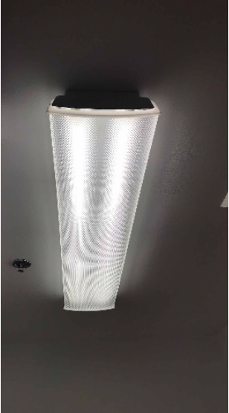

|  |  |
| --- | --- |
| Lamp Light Source Type | Total Input Power |
| Linear Fluorescent | - |
| Linear Fluorescent | - |

# 4. Utility Information

## 4.1 Energy Consumption Data

Utility data was obtained for this building and summarized below.

|  |  |  |  |
| --- | --- | --- | --- |
| Month | Total Demand | Total Usage | Total Usage Cost |
| January 2018 | - kWh | 15,360 kWh | $2,179.07 |
| February 2018 | - kWh | 14,913 kWh | $2,153.28 |
| March 2018 | - kWh | 15,852 kWh | $2,174.72 |
| April 2018 | - kWh | 14,986 kWh | $2,264.20 |
| May 2018 | - kWh | 15,078 kWh | $2,164.81 |
| June 2018 | - kWh | 15,466 kWh | $3,504.14 |
| July 2018 | - kWh | 18,918 kWh | $4,205.39 |
| August 2018 | - kWh | 17,567 kWh | $3,965.16 |
| September 2018 | - kWh | 16,732 kWh | $3,312.95 |
| October 2018 | - kWh | 16,069 kWh | $2,447.49 |
| November 2018 | - kWh | 15,606 kWh | $2,251.35 |
| December 2018 | - kWh | 14,794 kWh | $2,084.63 |

## 4.2 Utility Rate Change Analysis

In addition to exploring energy savings opportunities, TRC considered alternative utility rate structures for the site.

# 5. Energy Efficiency Measures

# Lighting

### EEM 1: LED Troffers

**Pictures of EEM 1: LED Troffers**

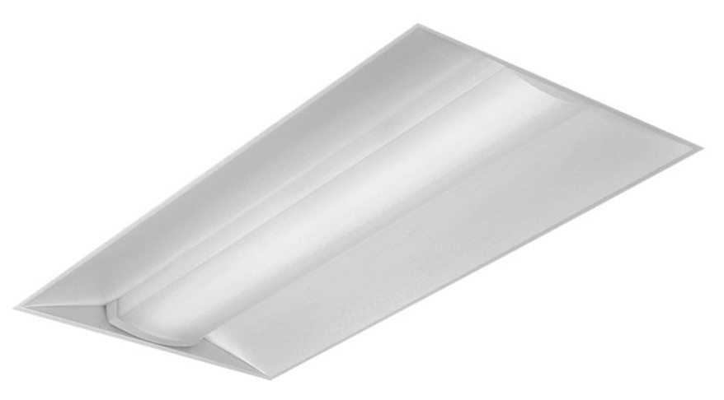

This measure recommends retrofitting the existing 2’x2’ and 2’x4’ troffers with equivalent LED retrofit kits. The proposed LED retrofit kits feature equivalent lighting output to the existing fixtures, thus maintaining lighting levels while reducing energy consumption 37%. Additionally, they offer truer color rendering values than conventional area lighting methods. LED lights also reduce maintenance costs associated with bulb and ballast replacement due to their significantly longer lifespans (50,000+ hours). LED fixtures create less waste heat, reducing the cooling load on their respective buildings. The proposed LED retrofit kits are listed in the Design Lights Consortium (DLC) Qualified Product Lists. In addition to consuming less energy upfront, the proposed LED retrofit kits are equipped with integrated occupancy sensing and daylight sensing technology. The sensors will turn off their dependent lighting fixtures when they sense that their space is unoccupied and will dim their dependent fixtures relative to the natural light entering the area through windows and skylights. On-bill savings are based on the actual annual operating hours of the buildings. Refer to Attachment A for more details on the actual operating hours of the different areas of the facility. This measure qualifies for SCE midstream incentives under the incentive category “2x4, 1x4, and 2x2 Integrated Retrofit Kit”, in the 3000-4500 lumen group.

|  |  |  |  |  |
| --- | --- | --- | --- | --- |
| Project Cost ($) | Wattage of Existing Fixtures | Wattage of Replacement Fixtures | Quantity | Annual Operating Hours |
| 25,854 | 59 | 30 | 450 | 2,000 |

|  |  |  |  |
| --- | --- | --- | --- |
| Estimated Costs and Savings |  | Estimated Return on Investment |  |
| **Total Project Cost ($)** | 25,854 | **First Year Cost ($)** | 19,080 |
| **Estimated Incentive ($)** | 2,337 | **Simple Payback (yrs)** | 5.30 |
| **Net Project Cost ($)** | 23,517 | **ROI (%)** | - |
| **Annual Savings ($)** | 4,437 | **10 year NPV ($)** | 14,014 |
| **Annual Electric Savings (kWh)** | 26,100 | **10 year SIR** | 1.54 |

### EEM 2: LED Lamps and Fixtures

**Pictures of EEM 2: LED Lamps and Fixtures**

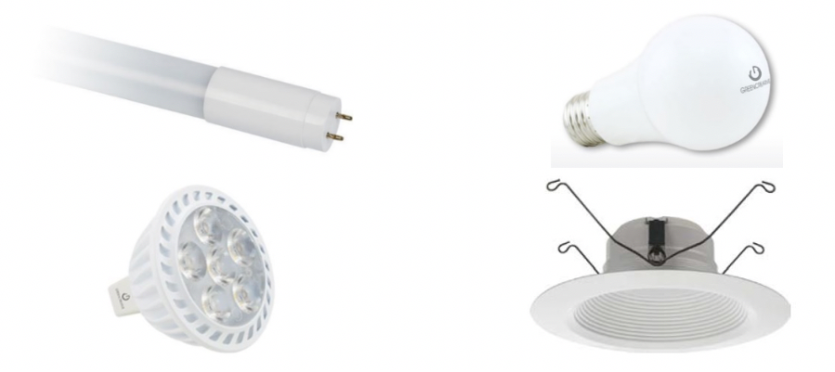

Hallways, lobbies, open offices, and miscellaneous spaces within the office building are lit by a variety of fixtures housing screw-in and plug-in lamps. This measure recommends replacing the standard fluorescent screw-in lamps inside the building with high-efficiency LED lamps. The prescribed T8 and T5 LED replacement lamps offer two options, plug-and-play (Type-A) and ballast bypass (Type-B). These two options will reduce cost by allowing for immediate replacement through the plug-and-play if the ballast still has usable life but provide options for direct wiring in the future when ballasts reach their end of life. The screw-in A-19 and plug in MR16 LED lamps will provide a quick replacement, while existing cans that do not accommodate lamp replacement will be retrofit with an LED recessed can kit. The LED lamps are capable of providing lighting output equal to the existing lamps, with increased color rendering capacity, all while consuming 46% less energy. Savings are not only realized through reduced energy consumption – the longer lifespans of the T5 and T8 tubes (50,000+ hours), recessed downlighting (35,000+ hours), and lamps (25,000+ hours) reduce maintenance costs associated with replacement, and the cooler temperatures the lamps burn at reduce the cooling load on the building. All proposed LED lamps are listed in the Design Lights Consortium (DLC) Qualified Product Lists. On-bill savings are based on the actual annual operating hours of the buildings. Refer to Attachment A for more details on the actual operating hours of the different areas of the facility. This measure is eligible for incentives under SCE midstream incentive category “12 Watt Down Light (Non Res) LED Fixture”.

|  |  |  |  |  |
| --- | --- | --- | --- | --- |
| Project Cost ($) | Wattage of Existing Fixtures | Wattage of Replacement Fixtures | Quantity | Annual Operating Hours |
| 11,067 | 40 | 10 | 230 | 2,000 |

|  |  |  |  |
| --- | --- | --- | --- |
| Estimated Costs and Savings |  | Estimated Return on Investment |  |
| **Total Project Cost ($)** | 11,067 | **First Year Cost ($)** | 8,160 |
| **Estimated Incentive ($)** | 561 | **Simple Payback (yrs)** | 4.48 |
| **Net Project Cost ($)** | 10,506 | **ROI (%)** | - |
| **Annual Savings ($)** | 2,346 | **10 year NPV ($)** | 9,338 |
| **Annual Electric Savings (kWh)** | 13,800 | **10 year SIR** | 1.84 |

### EEM-3: LED Exterior Lighting

**Pictures of EEM-3: LED Exterior Lighting**

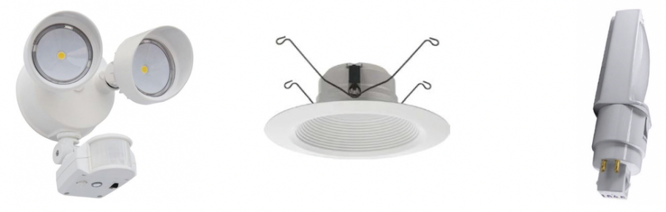

The building’s façade is illuminated by motion sensors CFL security lighting fixtures, recessed CFL cans and CFL lit canopy lights along the underside of the building walkways, and photosensor controlled LED area lights throughout the parking lot. This measure covers replacing exterior CFL fixtures and lamps with equivalent LED fixtures and lamps. LED exterior lamps and fixtures offer a number of advantages over standard fixtures. In addition to requiring roughly 73% less energy, they also produce less glare and up light than their CFL counterparts, creating a more comfortable environment for nearby residents and reducing overall light pollution. The longer life span of LED fixtures (50,000+ hours) and the LED lamps (50,000+ hours) is especially advantageous at reducing maintenance costs for hard-to-reach elevated fixtures. This long useful life will be yielded for both the recommended LED perimeter security fixtures and LED recessed can retrofit kits. All proposed LED fixtures are listed in the Design Lights Consortium (DLC) Qualified Product Lists. On-bill savings are based on a dusk to dawn schedule. Refer to Attachment A for more details on the actual operating hours of the different areas of the facility.

|  |  |  |  |  |
| --- | --- | --- | --- | --- |
| Project Cost ($) | Wattage of Existing Fixtures | Wattage of Replacement Fixtures | Quantity | Annual Operating Hours |
| 4,132 | 60 | 20 | 50 | 2,000 |

|  |  |  |  |
| --- | --- | --- | --- |
| Estimated Costs and Savings |  | Estimated Return on Investment |  |
| **Total Project Cost ($)** | 4,132 | **First Year Cost ($)** | 3,452 |
| **Estimated Incentive ($)** | - | **Simple Payback (yrs)** | 6.08 |
| **Net Project Cost ($)** | 4,132 | **ROI (%)** | - |
| **Annual Savings ($)** | 680 | **10 year NPV ($)** | 1,620 |
| **Annual Electric Savings (kWh)** | 4,000 | **10 year SIR** | 1.39 |

# Heating & Cooling

### Replace Older Vintage Packaged Units

Of the (13) packaged units serving 1200 W Hillcrest Dr., (7) are approaching the end of their useful life and utilize a phased-out refrigerant R22. This measure recommends replacing the units in their entirety. The proposed packaged units come equipped with economizers, high efficiency condensing coils, advanced control mechanisms, and premium efficiency variable speed fans.

|  |  |  |  |  |  |  |  |  |  |
| --- | --- | --- | --- | --- | --- | --- | --- | --- | --- |
| Project Cost ($) | Rated Cooling Capacity (Btu/hr) | Rated Heating Capacity (Btu/hr) | SEER for Existing Equipment in Cooling Mode | HSPF for Existing Equipment in Heating Mode | Replacement SEER | Replacement HSPF | Indoor Temperature Setpoint (F) | Location (Zip Code) | Number of Units |
| - | 36,000 | 50 | 10.6 | 8 | 14 | 10 | 70 | 90,016 | 7 |

|  |  |  |  |
| --- | --- | --- | --- |
| Estimated Costs and Savings |  | Estimated Return on Investment |  |
| **Total Project Cost ($)** | - | **First Year Cost ($)** | - |
| **Estimated Incentive ($)** | - | **Simple Payback (yrs)** | 0.00 |
| **Net Project Cost ($)** | - | **ROI (%)** | - |
| **Annual Savings ($)** | 3,240 | **10 year NPV ($)** | 27,405 |
| **Annual Electric Savings (kWh)** | 19,058 | **10 year SIR** | - |

# Appendix A - Measurement and Verification (M&V) Plan

# Appendix B - Benchmarking