Japanese Culture:

*A Comprehensive Training Guide*

**Cultural Researchers:**

Lazar Anderson   
Jeff Baird  
Jessica Barnett  
Jay Barreto   
Corey Hudson

**Current As Of:** April 24th, 2010

* Table of Contents

1. 1.1) An Introduction – Jay - UNUSABLE 4

History 4

Location 4

Climate 4

Topography 4

Minerals and Resources 4

1. 1.2) Demographics - Jay - UNUSABLE 4

Subcultures 4

Education & Literacy 4

Birthrate, Death Rate, Population 4

1. 1.3) Politics & Legalities - Jay – UNUSABLE 4

Political System 4

Legal System 4

Foreign Relations 4

1. 1.4) GDP, Rate of Growth, Per Capita Income & Family Income, Distribution of Wealth - Corey H. 5
2. 1.5) Principal Industries & Products, Top MNCs - Jeff – PROOFED – needs source 6

Top Multinational Corporations 6

1. 1.6) Trade Statistics: Imports, Exports, Balance of Payments, Trade per Capita, Labor – Lazar – Proofed, needs sources 7

Imports 7

Exports 8

Trade Balance 9

Trade Per Capita 10

1. 1.7) Labor – Lazar (Corey in italics.) – Proofed- Needs corrections 11

Labor Force 11

Unemployment Rates 11

1. 1.8) Level of Technology (Telecommunications, computers), Infrastructure - Jeff 12
2. 1.9) Japan’s Living Conditions and Life Styles – Corey 13

Living Conditions 13

Life Styles 14

1. 1.10) Diet, Housing, Clothing, Recreation & Leisure Activities - Corey 15

Diet 15

Housing 15

Clothing 16

Recreation & Leisure 16

1. 1.11) Regional Trade Agreement Participation - Jeff 17
2. 1.12 Religion - Trade 18

Shinto 18

Buddhism 18

1. 1.13) Family Structure: Nuclear vs. Extended, Parental Roles, Marriage/Dating – Jessica – NOT DONE 19
2. 1.14) Social Classes, Women’s Rights, Child Labor - Lazar 19
3. 1.15) Aesthetics - Corey 22

Gardens 23

Theater 24

Music 24

Martial Arts 24

Dance 25

1. 1.16) Greetings, Emotions, Face, Gift Giving, Titles - Corey H. 26

Greetings 26

Gift Giving 26

Names & Titles 26

1. 1.17) Holidays, Conversation Topics, Blunders – Jeff 27

Holidays 27

Conversation Topics, Blunders 27

1. 1.18) Business Entertaining (Food, Meal Times, Manners, Tips) - Jeff 28
2. 1.19) Languages - Jeff 29
3. 2.1) Kluckhohn & Strodtbeck- 29
4. 2.2) Hofstede’s Five Value Dimensions - Jay B. 31
5. 2.3) Schwartz’s Values Survey- Jay – NOT DONE 33
6. 2.4) Hall’s High and Low Context – Corey – Needs Proofing 33

Uncertainty Avoidance 33

Power Distance 34

Collectivism I 34

Collectivism II 34

Gender Egalitarianism 34

Assertiveness 35

Future Orientation 35

Performance Orientation 35

Humane Orientation 35

1. 2.8) Nonverbal Communication - Corey 39
2. 2.10) Ting-Toomey’s Four Verbal Communication Styles – Jeff – NOT DONE 39
3. 2.11) Ethics & Social Responsibility – Lazar – NOT DONE 39
4. 2.12) Negotiation and Conflict Styles - Corey 40

Negotiation 40

Conflict Styles 40

1. 2.13) How U.S. Culture Is Viewed - Jeff 41
2. 2.15) Japanese Proverbs – Jeff 42

Deru kui wa utareru 42

Koketsu ni irazunba koji wo ezu 42

Saru mo ki kara ochiru 42

Kaeru no ko wa kaeru 42

Nito woo u mono wa itto wo mo ezu 43

1. 2.16) Japanese Current Events - Jeff 43
2. 2.17) NGOs & Nonprofits – Lazar – NOT DONE 44
3. 2.18) Relevant Employment Laws – Jeff 44
4. 2.19) International Entrepreneurship – Jeff – Done –short? 44
5. 2.20) TBD – Corey - Must See Places in Japan? – NOT DONE 45

# 1.1) An Introduction – Jay - UNUSABLE

## History

## Location

## Climate

## Topography

## Minerals and Resources

# 1.2) Demographics - Jay - UNUSABLE

## Subcultures

## Education & Literacy

## Birthrate, Death Rate, Population

# 1.3) Politics & Legalities - Jay – UNUSABLE

## Political System

## Legal System

## Foreign Relations

# 1.4) GDP, Rate of Growth, Per Capita Income & Family Income, Distribution of Wealth - Corey H.

Japan’s industrialized and free market economy is the second largest in the World. Japan’s currency is the Yen. One dollar in the United States is equal to 82.46 yen. The GDP in Japan is $5,468 billion dollars which equals a lot of yen. This is also equal to 8.87 percent of the world economy.

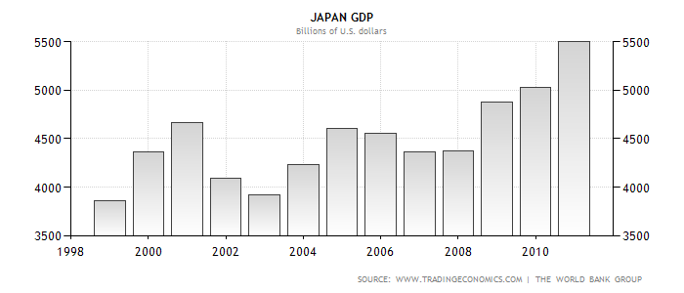

The annual growth rate for the GDP of Japan is .6 percent and the GDP growth rate is .2 percent. The GDP per capita is $39,310 and the GDP per capita PPP is $33,753. The difference between the two is that the GDP per capita takes in to consideration the inflation and the GDP per capita PPP is the most useful because it takes in to account the relative cost of living and the inflation rates of the country. According the to the nationals encyclopedia Japans distribution of wealth is mostly spent on health insurance. This is because the Japanese must take part in the public or semi-public health insurance policies in Japan. Other than health insurance the Japanese like to spend their money on electronic devices and household appliances because the Japanese have high living standards.

# 1.5) Principal Industries & Products, Top MNCs - Jeff – PROOFED – needs source

Japan’s economy is the third largest in the world behind the United States and China (Lah). Japan has a per capita GDP of $34,362. Also, 68 of the Fortune 500 companies are located in Japan.

The country imports about 60% of its caloric intake, as only 12% of its land is suitable for farming (The CIA World Fact Book). Japan does boast one of the largest fishing fleets in the world, accounting for nearly 15% of the world catch. Japan’s service sector accounts for about three-quarters of it’s total economic output (Economy of Japan).

Japan is one of the largest creditors in the world since it consistently runs a trade surplus (Chandler). Due to this, banking has become one of the largest industries along with other service-based businesses insurance, real estate, retailing, transportation, and telecommunications (Chandler) (Economy of Japan). These service based activities account for three quarters of Japan’s economic output.

## Top Multinational Corporations

The largest MNCs in Japan fall into one of two categories, chain-type food service companies (i.e. McDonalds or Starbucks), and financial services companies (i.e. Citigroup and Metlife) (Langlois). One of the most recent challenges to these MNCs was the earthquake in 2011. Starbucks was forced to close 100 of its 900 locations and McDonalds closed about 300 of theirs. The Multi-National financial firms suffered much less as they were located mostly in Tokyo.

Japan’s multinational corporations face some unique challenges. Japan is subtly culturally diverse. While they do have a very strong nationalism ingrained in their culture, many Western executives have the tendency to treat businessmen from Osaka the same as they treat a Japanese businessman from Tokyo. Another challenge the MNCs face is the very different corporate work environment in Japan. It is often expected for Japanese businessmen to spend a majority of their leisure time with coworkers or clients. This is an important part of doing business in Japan since so much is based on the personal relationships formed (Chandler).

# 1.6) Trade Statistics: Imports, Exports, Balance of Payments, Trade per Capita, Labor – Lazar – Proofed, needs sources

## Imports

Japan has a surplus in its export/import balance. Over the past 25 years Japan has seen a steady rise in imports. They have grown considerably over the last three years and are close to their level before the economic crisis of 2008. As of January 2012, Japan had imported $77,455,788,000 worth of goods, year-to-date. This is a 17.7% increase from the previous year.

Of all the countries Japan imports from, China is far and away their largest trading partner. Japan imported 17.2 billion dollars worth of goods from China. That’s almost three times as much as the 6.4 billion imported from the United States, Japan’s second largest good supplier. Other significant suppliers include Australia, Saudi Arabia, South Korea, Indonesia and the United Arab Emirates.

The most important import goods are raw materials such as oil, foodstuffs and wood.

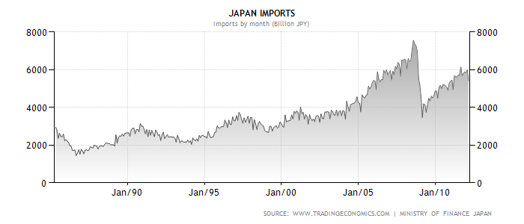

## Exports

As of January 2012, Japan has exported $58,448,231,000 worth of goods, year-to-date. This is a small, 2.6% decrease from the previous year, showing that Japanese exports largely holding steady. Over the last 25 years Japan’s exporting activities have mirrored their importing activities, and they have also shown significant recovery since 2008.

Japan’s largest trading partners are the United States and China, who purchased 9.8 and 9.6 billion dollars of Japanese exports respectively. Other important trading partners are South Korea, Taiwan, Hong Kong, Singapore, Thailand and Germany.

Japan's main export goods are cars, electronic devices and computers.

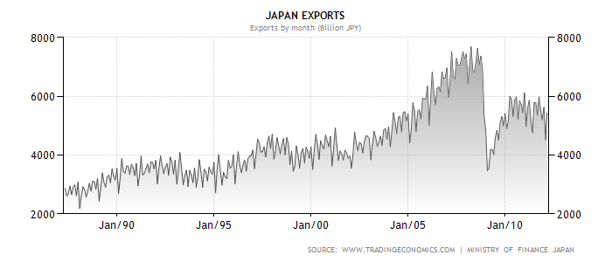

## Trade Balance

Over the past twenty-five years, Japan has enjoyed a general trade surplus. The global economic downturn that began in 2008 had a significant effect on the Japanese economy, causing a sharp decline in both imports and exports. After 2008, Japan showed a significant trade deficit for the first time in over two decades, and its current deficit is even larger. Year-to-date, Japan has run a 19 billion dollar trade deficit, up from 13.25 billion in the previous year.

The following graph displays the balance of trade in Japan from January 1987 to April 2012. It should be noted that as of the most recent data, Japan’s balance of trade is showing a very small surplus. The cause of this is related to a large increase in imports because of the Tsunami disaster of 2011. According to The U.S. Department of State:

In order to ensure stability, the Bank of Japan injected more than $325 billion in yen into the economy. Estimates of the direct costs of the damage--rebuilding homes and factories--range from $235 billion to $310 billion. In August 2011, the government revised downward its fiscal year inflation-adjusted GDP forecast to 0.5%. Government plans called for massive spending, as high as $295 billion, on reconstruction efforts in disaster-affected areas to stimulate economic growth.

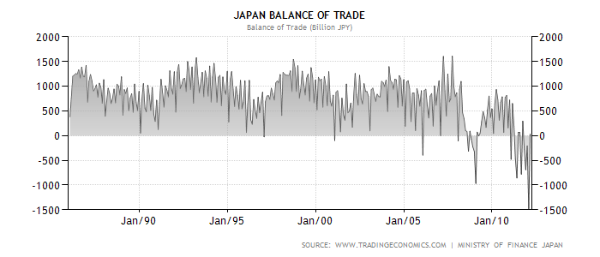

The Bank of Japan under the supervision of the Ministry of Finance creates the Balance of Payments.

## Trade Per Capita

According to the WTO, from 2008-2010 Japan’s trade per capita was $12,418

# 1.7) Labor – Lazar (Corey in italics.) – Proofed- Needs corrections

## Labor Force

Japan’s labor force is made up of 64.97 million people and of this, 48.5% are women.

The force is concentrated in urban areas, and less than 1% of the population works in agriculture. Because of Japan’s limited natural resources, even less work in the mining industry. Most Japanese work in the manufacturing, construction, distribution, real estate, services, and communication industries. *Approximately 70% of the labor force is service and the remainder is industry.*

## Unemployment Rates

Unemployment rates have been historically low in Japan, from the late 70’s to the early 90’s they were estimated at around 2-3%. Those rates rose steadily through the 90’s and early 2000’s, peaking at around 5.5% in the early 2000’s. The economic crisis of 2008 resulted in another spike in unemployment, which Japan has been steadily lowering.

The unemployment rate fell slightly since XYZ year and is currently about 4.5 percent.

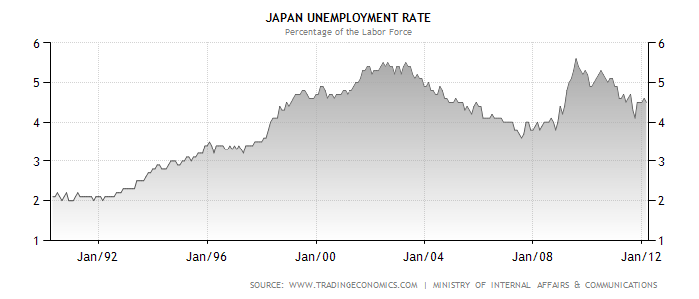

Sources:

<http://www.tradingeconomics.com/japan/unemployment-rate>

<http://www.state.gov/r/pa/ei/bgn/4142.htm>

<http://www.japan-guide.com/e/e644.html>

<http://stat.wto.org/CountryProfile/WSDBCountryPFView.aspx?Country=JP&Language=S>

# 1.8) Technology (Telecommunications, computers), Infrastructure - Jeff

Only a few years ago Japan was the world leader in memory chips, semiconductors, TVs, phones and other technology hardware products. In the last three years Japan has experienced a precipitous drop in this sector (Bremner). This is widely thought to be because most manufacturing is now done overseas by Japanese multinationals. In a recent Business Week article by Brian Bremner, the Japanese technology sector was referred to as an empty shell.

Despite this recent loss of technology manufacturing activity, Japan leads the world in Internet broadband speeds with an average speed of 63.6 megabits per second (Alverez). The United States ranked 15th on this same list with an average speed of 4.9 megabits per second (Alverez).

As of 2010 over 78 percent of its population was connected to the Internet with many of the major Japanese providing high-speed, free, public Wi-Fi. (Japan Internet Usage).

Even though Japan already leads the world in broadband speed, it is reported that they are taking part in a joint venture with a Canadian company to connect London and Tokyo via and undersea cable through Canada’s Northwest Passage. As the sea ice continues to melt this becomes increasingly possible. This would add a level of speed and connectivity between some of the largest financial markets in the world, as long as bringing high-speed internet to the far north of Canada (Boswell).

Despite the quick drop in technology manufacturing, Japan continues to lead the world in technological hardware innovation. This is due, in large part, to the high amounts of engineering talent Japan continues to produce.

# 1.9) Japan’s Living Conditions and Life Styles – Corey

## Living Conditions

[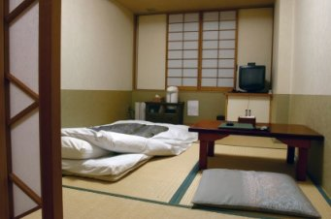](http://www.how-to-teach-english-in-japan.com/images/iStock_000004384333XSmall.jpg)Living in Japan is expensive. It is one of the more expensive countries to live in throughout the world. The most expensive city to live in is Tokyo. Apartments tend to be the way to live in the cities of Japan. The living conditions have gotten better over the years but there are still many small apartments in Japan. Most apartments have tatami flooring which is made of straw and usually measure 180cm x 90cm. You can still find apartments with tile or wood flooring but will rarely find carpeted floors anywhere. When looking for places to live the Japanese use the tatami mats to determine how big the apartment is unlike Americans who use square feet. A Japanese apartment is roughly on average 400 square feet.

Utilities such as gas, water, and electric are also expensive in Japan. If living in the city is too expensive then there are options of living just outside the city in gaiijin or guesthouse. These are relatively less expensive than apartments in the city.

There are also some living conditions in Japan that differ from America. Usually when entering a Japanese home you would remove your shoes before going into the home. After entering the home many Japanese wear house slippers or just go barefoot. Another living condition that the Japanese do different from Americans is that when taking a bath they rinse off before even getting into the bathtub or shower. Also when applying soap they step out of the tub or bath and rinse off before getting back in the shower or tub. This is because they share the bath water. If the water in the tub is still hot then they would not unplug the tub and leave it for the next person to use. The toilets in Japan are also different. They have two types Japanese and Western Style toilets. The western style is the kind we are accustomed too but the Japanese toilets are different. To use the Japanese toilet men and women would have to squat over the toilet instead of actually sitting on it. Also nothing other than toilet paper is allowed to be flushed down the toilet.

## Lifestyle

Three major aspects of Japanese culture influence their fast, long, and lively lifestyle: work, socialization, and recreation.

Because homes in Japan usually tend to be small, most socializing is done outside the home in clubs, bars and recreation centers.

Crowded streets and lack of cheap parking cause most transportation to happen on foot or by subway. Their workday starts early and they typically walk to meals. A typical Japanese worker walks two to five kilometers a day.

Their active lifestyle is a major contributing factor in them having some of the longest lifespans in the world.

# 1.10) Diet, Housing, Clothing & Activities - Corey

## Diet

The Japanese diet is one that appeals to the eye as well as the taste. A typical diet includes a bowl of rice or noodles, a bowl of miso soup, pickled vegetables, and some type of fish or meat. There are many types of rice that the Japanese use in their diets. The noodles on the other hand, are mainly consisting of three different types. The wheat flour noodle is one of the types used in the diet and is known as udon. The second type of noodle is a buckwheat noodle known as soba. The third type is the ramen noodle which is popular in America as well with college kids. But the main focus on the Japanese food is fish. On average a Japanese person consumes about half a pound of fish a day. The fish is either served hot or cold. Another ingredient used in a lot of food in Japan is soy. The Japanese diet is really healthy and is one factor of why the Japanese have such a long life span.

## Housing

Japanese housing is fairly small and apartment style living. The Japanese housing usually consist of being built with wooden pillars and use tatami flooring. This type of flooring has been used for more than six hundred years in Japanese houses and is made of thick brushes. A typical apartment in the city is roughly around four hundred square feet. Today you can see both modern styles of decorating and traditional styles. The entrance to any house is called the genkan and this is where you would remove and store your shoes before going further into the house. Traditional homes are usually centered around the living room and the rest of the house like the bathroom, bedrooms, and kitchen are extensions to the living room. When searching for modern day homes in Japan you would look for them by listings which include the number of the rooms followed by the letter of which room it is. For example 1R and 2LDK. This means one designated room, 2 living rooms, dining room, and kitchen. Because of such small space in the houses in Japan, people keep their space cluttered free and everything has its own place so it makes the rooms feel larger than they are.

## Clothing

The fashion in Japan ranges from street fashion to traditional fashion. The most known traditional fashion in Japan is the kimonos. There are many different types of kimonos that would be worn for different occasions. Everyday clothing is pretty much like Western Style clothing. Men and women wear business attire to work and when not working would wear jeans and t-shirts and dresses for women. One of the more popular fashions in Japan is Lolita. The Lolita style is for the girls and is made for them to look kind of like porcelain dolls. There are many different types of the Lolita style such as Punk, Gothic, and Classic. As with any culture fashion is always changing and the more traditional style of Japanese fashion is fading but still worn on certain occasions.

## Recreation & Leisure

Japanese recreation is a big part of their life style because the Japanese like to be active. There are many different activities that they partake in. These include swimming, surfing, skiing and snowboarding, marathon running, gate ball, and other activities. Swimming is a big recreation in Japan. Nearly every school in Japan has an outdoor swimming pool and swimming lessons are taught in the school curriculum in elementary school to get the kids to feel safe around the water. When it is nice out the pools and beaches are usually packed with people. Another popular sport in Japan is marathon running. When marathons are announced they often fill their quota within days of the announcement. In 2011 the Tokyo Marathon had only 36,000 openings but receive 336,000 applications. So as you can see, marathon running is a big deal in Japan.

Some other recreational sports are surfing, snowboarding and skiing, and scuba diving. Not only does Japan have natural beaches with breaks to surf they also have many indoor beaches that offer surfing. This goes for snowboarding and skiing too. The northern part of Japan is where most of the ski resorts are located but Tokyo has the largest indoor slope for skiing. This indoor ski slope is called Lalasport Ski Dome. There are also many theme parks in Japan. For instance, there is Disneyland and a Universal Studios. For the older community gate ball keeps them entertained. Gate ball is modeled after crochet and is a team sport with usually up to five members on a team. Gate ball is not just for the elderly and is becoming more popular with the younger generations. Japan lives an active lifestyle and are always usually on the go either working or enjoying recreations such as these.

# 1.11) Regional Trade Agreement Participation - Jeff

Japan’s participation in regional trade agreements is complicated at best. The organization Japan is most active in is the ASEAN Plus Three. This group includes the countries involved in the ASEAN trade organization (Brunei, Indonesia, Malausia, Philippines, Singapore, Thailand, Myanmar, Cambodia, Laos, and Vietnam) along with China, Japan and South Korea (the “Plus Three). This is an institutionalized forum for cooperation between ASEAN and the East Asian countries. There are several proposals concerning an Asian Currency Unit (ACU) to be modeled after the European Union’s Euro. However, there are few trade policies heavily enforced between the countries and tends to serve as more of a loose affiliation. This is thought to be due, in part, to the nationalism that is presenting many Asian countries (ASE12).

Japan is currently pursuing other economic trade agreements with Canada and Australia who are both large trade partners. Japan is also seeking to strengthen ties with the signatories of NAFTA (ASEAN Plus Three).

However, free trade agreements are not incredibly popular with Japanese citizens since they are seen as the cause of the first trade deficit in 30 years in 2011 (RTE Business). In truth, the earthquake is one of the main causes of the trade problems as the trade deficit with China was five times larger than it was in 2010.

# 1.12) Religion – Jeff – Proofed

## Secularism

Over the past century, religion in Japan has decreased in popularity and the country has become overwhelmingly secular. While some studies conclude up to 96% of the population adhere to either Shinto or Buddhism, these figures are based on family affiliation with a temple. When based on self-identification surveys, about 70% of Japanese claim no religious membership, 64% identify as fully atheist and 55% do not believe in Buddha (Scheid).

Japan has the highest literacy rate in the world at 99.9%. Literacy is linked to Japan’s religious decline as citizens stay in touch with the scientific world and view religion as mostly superstition (Lockard).

Marquis Hirobumi Ito, four time Prime Minister of Japan, said, "I regard religion itself as quite unnecessary for a nation's life; science is far above superstition, and what is religion - Buddhism or Christianity - but superstition, and therefore a possible source of weakness to a nation? I do not regret the tendency to free thought and atheism, which is almost universal in Japan because I do not regard it as a source of danger to the community (Lockard)."

## Shinto

Shinto is the most commonly practiced religion in Japan and is indigenous to the country. Most citizens (83 percent) have some affiliation with Shinto. Shinto is not rigid in its rules for acceptance, accepting some of the tenants is enough to be considered a member.

Shinto began with a deep respect for nature and through their respect each evolved into a separate deity. This formed a large polytheistic mythology with no clear leader or dogma (Scheid). Each of the many sects of Shinto has a different leader and a different dogma. After the arrival of Buddhism to the country in the sixth century, Buddhism and Shinto began to be practiced together (Scheid).

In 1868 The Emperor Meiji instituted State Shinto or the belief that the Emperor was a deity. This merged the most commonly practiced versions of Shinto, Imperial Shinto and Folk Shinto. This made Japan a Theocracy and Shinto spread to Taiwan and Korea as Japan conquered them. This lasted until the United States’ occupation of Japan forced the Emperor to admit that he was a normal person (Lockard).

## Buddhism

Buddhism is the second largest religion in Japan, claiming 93 million members. The school of Buddhism most commonly adhered to in Japan is Mahayana (Lockard).

## Other

Japan has full religious freedom and several minority religions are practiced. The percentages are small but some minority religious ceremonies and celebrations, such as the Christian holiday, Christmas, have become mainstream, secular celebrations (Lockard).

# 1.13) Family Structure – Jessica – NOT DONE

## Nuclear vs. Extended

## Parental Roles

## Marriage & Dating

# 1.14) Social Issues - Lazar

## Social Classes

Social Classes do not exist in modern day Japan. Like all democratic, free market economies, Japan’s class distinctions are based on wealth; the upper, middle, and lower class familiar with any democratic society. About 90% of Japanese consider themselves middle class, and there is less class difference than in most countries with modern economies. There is still some stigma for and discrimination against the Burakumin people, which are not a race but rather the decedents of those in the lower end of the now abolished Japanese caste system. According to international humanist and ethics union:

Burakumin are a Japanese social minority group: Japan’s “invisible race.” No physical characteristics distinguish them, unlike other main minority groups, from the majority population. There are about six million burakumin in modern Japan (about 2 per cent of the population). Originally, those people were called senmin (“despised citizens”). The Japanese caste system was formally abolished by the Kaihorei (Emancipation or Liberation Edict) in August, 1871. The term “new commoner” (shin- heimin) was used in government documents and the word “burakumin” (literally “hamlet people”) came into use as another euphemism for “senmin”. Their settlements were called hisabetsu buraku (“discriminated hamlets” because they live in their own secluded places, originally outside the city walls)

According to an article in the Harvard Human Right Journal, “*Burakumin* still face outright discrimination in education, in employment, and in marriage. According to a survey of residents in Asaka *buraku*, thirty percent of *burakumin* have experienced discrimination, mostly verbally but thirty percent demonstrated through “attitudes, actions or gestures.” Some were investigated by detective agencies for matters related to employment or marriage, or their homes marked by discriminatory graffiti.”

## Women’s Rights

Discrimination in the workplace is not limited to social class. The problem of sex discrimination in Japan is much more rampant. According to the Washington Post:

The number of working women in Japan picked up after the burst of the economic bubble here in 1991, when companies began hiring more of them as a cheaper source of labor. Many of those new hires were brought on as part-time or contract workers without benefits or job security. Although many assumed that those positions would evolve into better-paying full-time jobs, statistics show that hasn't happened.”

Japan has also falls well behind even the minimum Western legal standards in the workplace in terms of sex discrimination. The article goes on to say that “A U.N. study released last year said Japan ranked behind all other industrialized nations in terms of empowerment of women”

A few facts about sex discrimination in Japan:

10.7 percent of senior corporate and political positions held by women, compared with 42 percent in the United States.

Japan has a record 8 million part-time workers -- more than 90 percent of them women.

In Japan, women on average earn 44 percent of what men earn -- the widest income gap between the sexes in the developed world.

Although the percentage of women in the workforce rose from 37 to 41 percent between 1980 and 2005, the number of women in top management positions climbed only slightly, from 1 percent to 2.8 percent

Women occupy only 9% of parliament seats.

Women make up 3.7% of university department heads and 11% of researchers;

Only 20% of university science graduates are women.

In addition to hiring and advancement discrimination practices, the culture of a Japanese office is beyond politically incorrect by American standards. Women are hired not for their skills in the workplace, but for their friendly disposition and attractiveness. Many Japanese companies separate their employees into ‘administrative’ and ‘career’ tracks. These separations occur almost entirely along gender lines. Women with ‘administrative’ career paths are paid less, and given meager benefits if any. “Office Ladies” are routinely hired to do the same work as men, for less pay, and also are expected (or even required) to pour drinks for the men, arrange flowers in the office, and perform other duties that are considered ‘women’s work.’ Despite a 2007 law that bans the discriminative hiring practice, it is still widespread.

## Child Labor

Child labor, unlike the rest of Asia, does not seem to be a large problem in Japan. Child labor laws restrict parents from contracting their children, and restrict specifically the type of work available to children, and at what age they become eligible for which types of employment. According to the Library of Congress:

The Constitution [of Japan] provides that children shall not be exploited. The Labor Standards Law has provisions to protect child workers. The Labor Standards Law prohibits employers from employing children until the March 31 immediately following the child becoming fifteen years old. March 31 is the end of a school year. Children are obliged to go to school usually until that time. Children thirteen years old or older, however, may be employed if the labor is light and not injurious to their health and welfare, and if the employer obtains permission from the local Labor Standards Administration office. Children under thirteen years old can be employed only in motion picture production and theatrical performance enterprises, upon permission of the Labor Standards Administration office. An employer cannot employ a person under eighteen years old for extended-hour or nighttime work. An employer also cannot assign a person under eighteen years old to dangerous work, e.g., maintenance or repair of machinery during its operation and mining.

A parent or a guardian cannot make a labor contract for a minor, in this case a person under twenty years old. This provision aims to prohibit a parent or guardian from forcing a minor to work for a parent or guardian’s economic benefit. The parent or guardian cannot receive the wages earned by the minor in place of the minor.

Japan however is a destination for human trafficking, including Children, according to humantrafficking.org. Organized crime syndicates traffic women and children from Southeast Asia and Eastern Europe to work as forced laborers and prostitutes. In response to the tarnished image it received by being placed on the second tier of the 2007 U.S. Department of State’s Trafficking in Persons Report, Japan has increased its efforts to stop human trafficking. Laws have been created to make it a crime, and punishments increased for sexual trafficking were made as well.

Sources

<http://www.iheu.org/untouchability-japan-discrimination-against-burakumin>

<http://www.law.harvard.edu/students/orgs/hrj/iss12/reber.shtml>

<http://www.washingtonpost.com/wp-dyn/content/article/2007/03/01/AR2007030101654_2.html>

<http://news.change.org/stories/japan-reaches-all-time-low-in-gender-equality-report>

<http://www.loc.gov/law/help/child-rights/japan.php>

<http://www.humantrafficking.org/countries/japan>

# 1.15) Aesthetics - Corey

The Japanese is a highly artistic culture with beautiful music, dance, fashion, sculptures, gardens and paintings.

The ancient Japanese art of paper folding which usually involves no scissors or glue is called Oragami. Some of the most popular forms of origami are cranes, flowers, balloons, frogs, and gold fish.

## Bonsai & Gardens

Bonsai is a form of cultivating miniature pine trees, practiced by many in Japan. It takes much skill and knowledge to know exactly when to cut the stems or change the trees into other pots. Another form of art that deals with plants and trees is Japanese gardens. This form of art has been practiced over a thousand years. The strolling gardens are large and include islands, artificial hills, and ponds that can be viewed from many different viewpoints from the path. Some of the most famous gardens are Kanazawa’s Kenrokuen and Tokyo’s Rikugien.

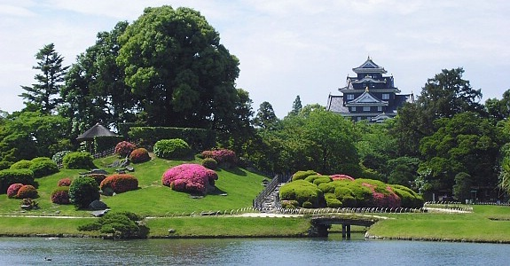

Modern gardens in Japan have some aspects of the strolling garden but is hard because the cities have grew and there is not enough space needed to build the garden. Some of the more popular gardens today are the Zen gardens in Kyoto and the stone gardens on Koyasan.

## Theater

The Japanese also have many different types of theater that they practice. These include Bunraku, kabuki, and the Noh Theater. The Bunraku Theater is a form of puppet theater. It has been around since the Edo period and has similar story lines to the Kabuki Theater. The puppets are accompanied by music performed on traditional Japanese instruments. The Kabuki Theater is a form of theater created for the townsfolk during the Edo Period. The plays are about historical events, moral decisions, and love relationships. The stage is a rotating stage equipped with trap doors and gadgets that make the actors appear and disappear. Because women were not allowed to act, many men specialized in playing roles of women during the plays. The Noh Theater is a very old form of theater for the Japanese. The actors traditionally wore masks and spoke in monotonous voices. This type of theater was formed during the fourteenth century. The stages are outdoors with a roof over the stage.

## Music

Music in Japan is big. J-Pop is the popular music with young kids and is much like music in America except the lyrics and songs are in Japanese. Many of the artists are famous and appear on many television ads such as in America. Enka music was a popular form of music and is still listened to today but mostly by older people. Traditional enka musicians especially the women would have performed in kimonos. The traditional Japanese music has many forms.

First there is the gagaku. This is the oldest type of Japanese traditional music and was played in the ancient courts. Other types of traditional music include biwagaku, nohgaku, sokyoku, and shakuhachi. These types of music would be the ones heard during theater performances.

## Martial Arts

Martial arts play a big role in Japanese culture. There are many different forms such as Judo, Karate, Sumo, and many others. Judo is known as the gentle way, and was formed in the nineteenth century. The art of Judo means that softness exceeds hardness and technique is very important. Not only does it focus on winning the fight but also trains one’s body and spirit. Karate is a form of martial art that is similar to the Chinese Kung-Fu and Koreas Taekwondo. Karate translates into the way of the open hand and is used by ones fists, elbows, and feet. No weapons are used when taking part in Karate.

Sumo is the Japanese style of wrestling and is Japans national sport. Because sumo has been around for a long time many religious practices are still going strong today when it comes to Sumo matches. The matches take place on a dohyo which is an elevated ring made of clay and covered with sand. The rules are simple. The first wrestler to leave the ring or have any other part of the body other than their feet loses the match. The matches are quick and rarely last a minute.

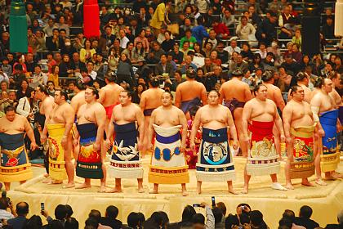

## Dance

Japanese dance is very important and the most famous form of dance is called the Bon dance. The Bon dance means welcoming ancestors souls and holding memorial services for them. Every summer in August the Japanese take a week for Bon festivals. The dance usually involves some of the traditional music and the dancers dress in appropriate kimonos for the dance. It usually takes place at nighttime because that is when the Japanese think their ancestors souls return. So as you can see the Japanese take great pride in their aesthetics and have many different types they partake in.

# 1.16) Greetings, Emotions, Face, Gift Giving, Titles - Corey H.

## Greetings

Greetings in Japan are very important. Greeting and parting phrases are called aisatsu. If someone does not give an aisatsu then they are considered cold and dysfunctional. Like many languages there are many different phrases for different parts of the day. For example, ohayou means good morning and is usually used until eleven in the morning, konnichiwa means hello, good afternoon, and konbanwa means good evening. Some other forms of greetings are sayournara which means goodbye and many people have heard this before. The Japanese have many formal and informal ways of using words when greeting someone or saying goodbye. It all depends on the context of you leaving or coming.

## Gift Giving

Gift giving in Japan is often. There are many occasions in which people give gifts. In December and June, Oseibo and Ochugen gifts are given. These gifts are from co-workers, relatives, and friends. This is when many people receive bonuses from work and the gifts include food, alcohol, or some type of gift for the house. These gifts usually cost are five thousand yen. When receiving and giving gifts in Japan, it is customary to use both hands. When thanking somebody, one will give them a gift called temiyage which is usually some sort of sweets or sake. A lot of the Japanese bring back souvenirs from business trips or vacations. These types of gifts are called omiyage. When giving gifts in Japan you should be careful because many gifts that we think are appropriate could mean bad luck in Japan.

## Names & Titles

In Japan the family name comes before the first name. Usually when addressing someone in Japan you would address them by their family name. When addressing children or close friends then you would use their first name. Not only do the Japanese use the family name they use some sort of title to go along with it. Some of these titles are San, Sama, Kun, Chan, and Sensei. San is the most neutral and famous out of the titles and can be used almost anywhere except in really formal situations. Sama is a more polite form of san and is used in letter writing and in formal situations. Kun is a title given to young men and boys who are younger than you. Chan is informal and is used when talking to close friends, family members, and children. Sensei is a title given to teachers, doctors or other people in which you receive teachings from. Titles are very important and need to be used in the right context.

# 1.17) Holidays, Conversation Topics, Blunders – Jeff

## Holidays

Holidays in Japan stem from varied sources, from ancient religions to adopted western holiday’s the Japanese enjoy a chance to escape and enjoy time with their families.

The largest holiday in Japan is the New Year (shogatsu or oshogatsu) where most businesses close from January 1st to the 3rd. Years are viewed as completely independent with each year starting with a clean slate. It is traditional to watch the first sunrise of the New Year. It is also widely held that the day should be stress free and no work should be done on that day (Japaenese New Year).

Another popular traditional Japanese holiday is the Coming of Age Festival (seijin no hi) (Coming of Age). This is celebrated the second Monday of January. Celebrations are held nationwide with all the men turning 20 attending in formal dress.

## Conversation Topics & Blunders

Social conversation in Japan can be a treacherous place for westerners. Japanese view themselves as one and are very proud of their Japanese heritage. It is always a safe bet to discuss the country, national pastimes such as baseball, Japanese food and places to visit.

Subjects that should be avoided are questions about professions, prices, economic questions, topics pertaining to their social life or direct comparisons between your country and theirs.

The Japanese try to avoid conflict when all possible so it is always important to stay calm. Restraint and self-respect are viewed as very important to Japanese culture. This can lead to difficulty between Japanese executives and their western counterparts. The Japanese avoid direct “no’s” as to avoid conflict, so western business people must focus on reading between the lines so as not to force the Japanese executive into a situation where they may loose face. Directly related to the avoidance of conflict is eye contact. In Japan, eye contact is viewed as confrontational and should be kept to a minimum or avoided all together.

Silence is also a very large part of Japanese conversation. This is viewed as an opportunity to reflect on the conversation as a whole. Westerners, often uncomfortable with silence, may try to fill this space with jokes or a topic change. This is viewed as impolite or impatient in Japanese culture.

One of the most important blunders that can be made in Japanese conversation is physical contact. This is considered a gross infringement on a person. Also hand gestures and loud outburst should be avoided.

As a general rule, in Japanese conversation, one can be safe if it is remembered to remain as subtle and reserved as possible. The indirect routes are always the best routes and avoid topics that can lead to any type of disagreement or confrontation (Nguyen).

# 1.18) Business Entertaining - Jeff

As mentioned earlier, there is a very strong culture of doing business based on personal relationships. This is a key factor for any MNC attempting to move into Japan. It is very common for businessmen to entertain clients and potential clients after hours at hostess and karaoke bars.

Another key factor to the Japanese is the notion of “face.” Face can be earned through praise and thanks and lost through criticism. The Japanese will try to avoid direct “no’s” in business dealings. Instead, they will respond with, “It is inconvenient” or “It is under consideration.” Both of these statements should be interpreted as a “no.”

Also, since conflict is seen as such a negative thing, more can be interpreted from body language and non-verbal communication than any verbal communications. According to a Japanese etiquette guide, “Expressions to watch out for include inhaling through clenched teeth, tilting the head, scratching the back of the head, and scratching the eyebrow.” (Japan Country Profile)

# 1.19) Languages - Jeff

Japanese is the official language of Japan and is spoken by the vast majority of residents of the country. The language is written in a mixture of three characters: Chinese characters, a script of modified Chinese characters and a Latin script. While Japanese is written using Chinese characters and has imported many words from China, the two languages are not related.

Japanese is a member of the Japonic languages family, which includes languages from the Ryukyu islands. These languages are so close they are often confused as dialects of Japanese.

The Japonic language family as a whole is entirely unique from any other languages in the world. This is due to their historical isolation from outside cultures. Also, Japan is a mountainous country and this has led to extensive internal isolation and the formation of many Japanese dialects as well (Miyagawa).

# 2.1) Kluckhohn & Strodtbeck- Jay UNUSABLE

<http://academic3.american.edu/~zaharna/mcgrath/WWW/japan/culture.htm>

<http://scholarworks.gvsu.edu/cgi/>

Kluckhohn and Strodtbeck in their research to prove their theory that humans share biological traits and characteristics which form the basis for the development of culture, and that people typically feel their own cultural beliefs and practices are normal and natural, and those of others are strange, or even inferior or abnormal. Researching Japan’s nature and culture I was able to find that:

“The Japanese culture's relationship with nature is that of harmony with nature. Harmony with nature”refers to man not controlling or trying to conquer nature but rather, both man and nature live together as one and are accepting of each other's forces. The Japanese people respect nature and don't attempt to manage or control nature but instead, they feel a spiritual bond with nature and this is evident through various practices. For example, Japanese gardening, such as rock gardens, express their belief in living harmoniously with nature. Such appreciative origins date back to the beliefs of ancient Shinto, a widely practiced religion in Japan. (Mac Leod, 1) Their appreciation for the simplicity of nature is apparent in the structure and design of rock gardens.

This value orientation deals with the innate nature of man and whether man is good, evil or a mix of the two. The Japanese believe they are inherently good, with an immutable predisposition, meaning men are good and that is unalterable. This belief among Japanese society is reflected in Buddhism, an also widely practiced religion in Japan. Buddhism believes that humans are born good because they are a creation of nature, which is good. Man is part of nature, and God created nature, than man must be good.

This value orientation places great importance on human activity and its measurable accomplishments. Japanese society believes in the being ”orientation where mans activity is defined by his relationships and not by development or materialism. “Achievement and development are not as important in a traditional vertical society such as Japan where an individual's birth, family background, age and rank is much more important.”(Zaharna, 5) In a “being ”culture the “emphasis is on spontaneity and fully experiencing each moment. In these cultures, “one works to live, one does not live to work! Work gets done, but is not necessarily prioritized over other things; people who do work a lot do so because they want to, not because they think they should. ”(DiStefano) As opposed to the American belief in “doing, ”where man is defined by what he does. American culture places an emphasis on achievement, materialism and weather the achievements can be measured.

[Considering time] Japanese is a past time oriented country because it is a traditionalistic culture. Japan defines time by tradition and experience. For example, the Japanese strongly value ancestry and tradition, which reflects that it is a past oriented culture. More specifically, the elderly and ancestors are worshipped in Japanese society. There are viewed as being intellectual and guiding figures to others. Another example is the Buddhist religion, where the conceptions of reincarnation and karma are widely practiced. Those ideas reflect the past-oriented characteristics of Japan. More specifically, what one has done in the past, good or bad, will determine one's future. One's behavior and action in one's life determines their future. It is a belief that each life is present life is dictated by the past.

The three integral parts of this value orientation include: individual, collateral and linear. This part categorizes relationships as a whole, more specifically family. The nuclear family, or the immediate family members including, mother, father, brother and sister, is indicative to the individualistic orientation. Collateral consists of more family bonds compared to the individualistic pattern. Collateral includes the immediate family, but is also extended to include grandparents, uncles and aunts and cousins etc. Linear ”goes even further to include all of the above family members and distant relatives, “both genealogically and chronologically...Japanese culture reflects the linear” orientation to include all family members near and far. “Linear also includes ancestors, who are highly regarded in Japanese society. Making decisions for the collective group, or the entire family, is more important than making individual decisions. Important decisions are made to include all the family members, nuclear, immediate and extended.”

So overall what we see is that the Japanese culture believes in harmony with nature, that men are good and that is unalterable, values family and groups, and value tradition and experience.

# 2.2) Hofstede’s Five Value Dimensions – Jay - UNUSABLE

Hofstede is a great source for insights information about national and organisational culture around the world. Hofstede research measures a country’s Power Distance (PDI), Individualism versus collectivism (IDV), Masculinity versus femininity (MAS), Uncertainty avoidance (UAI), Long-term versus short-term orientation (LTO), and Indulgence versus Restraint (IVR) Japan has a distinct way of doing business. Hofstede defines each dimension as:

“Power Distance (PDI)

This dimension expresses the degree to which the less powerful members of a society accept and expect that power is distributed unequally. The fundamental issue here is how a society handles inequalities among people. People in societies exhibiting a large degree of power distance accept a hierarchical order in which everybody has a place and which needs no further justification. In societies with low power distance, people strive to equalise the distribution of power and demand justification for inequalities of power.

Individualism versus collectivism (IDV)

The high side of this dimension, called Individualism, can be defined as a preference for a loosely-knit social framework in which individuals are expected to take care of themselves and their immediate families only. Its opposite, Collectivism, represents a preference for a tightly-knit framework in society in which individuals can expect their relatives or members of a particular in-group to look after them in exchange for unquestioning loyalty. A society's position on this dimension is reflected in whether people’s self-image is defined in terms of “I” or “we.”

Masculinity versus femininity (MAS)

The masculinity side of this dimension represents a preference in society for achievement, heroism, assertiveness and material reward for success. Society at large is more competitive. Its opposite, femininity, stands for a preference for cooperation, modesty, caring for the weak and quality of life. Society at large is more consensus-oriented.

Uncertainty avoidance (UAI)

The uncertainty avoidance dimension expresses the degree to which the members of a society feel uncomfortable with uncertainty and ambiguity. The fundamental issue here is how a society deals with the fact that the future can never be known: should we try to control the future or just let it happen? Countries exhibiting strong UAI maintain rigid codes of belief and behaviour and are intolerant of unorthodox behaviour and ideas. Weak UAI societies maintain a more relaxed attitude in which practice counts more than principles.

Long-term versus short-term orientation (LTO)

The long-term orientation dimension can be interpreted as dealing with society’s search for virtue. Societies with a short-term orientation generally have a strong concern with establishing the absolute Truth. They are normative in their thinking. They exhibit great respect for traditions, a relatively small propensity to save for the future, and a focus on achieving quick results. In societies with a long-term orientation, people believe that truth depends very much on situation, context and time. They show an ability to adapt traditions to changed conditions, a strong propensity to save and invest, thriftiness, and perseverance in achieving results.

Indulgence versus Restraint (IVR)

Indulgence stands for a society that allows relatively free gratification of basic and natural human drives related to enjoying life and having fun. Restraint stands for a society that suppresses gratification of needs and regulates it by means of strict social norms.”

According to Hofstede’s research, Japan has a 54 PDI, 46 IDV, 95 MAS, 92 UAI, and 80 LTO.

# 2.3) Schwartz’s Values Survey- Jay – NOT DONE

<http://www.imo-international.de/index_englisch.htm?/englisch/html/svs_info_en.htm>

<http://faculty-staff.ou.edu/R/David.A.Ralston-1/12.pdf>

# 2.4) Hall’s High and Low Context – Corey – Needs Proofing

Japan is a high context culture. According to Hall, high context cultures have many factors and reasons why the culture is considered high context. In high context cultures like Japan they convert and implicit messages with a metaphor and read between the lines. Also emotions are reserved and rarely shown. The Japanese are big on family and in high context cultures there is a strong sense of family and people bonds as well as they tend to care more about the relationships they form rather than the task. Time care for the Japanese is complex and includes both monochromatic and polychromatic traits. For example when making business meetings they are usually precise and on time but once the meeting starts polychromatic behaviors take place. So when using Hall’s high or low context, Japan is considered high context because of their business traits and how they view certain aspects of business and culture.

2.5) GLOBE’s Cultural Dimensions – Lazar – DONE

## Uncertainty Avoidance

Japan has extremely high uncertainty avoidance. Their reliance on social norms, rituals, and bureaucratic practices is rigid and standard in the business world. Change can be difficult to come by in Japan as managers seek all the details before making a decision. Part of the cause of their uncertainty avoidance is rooted in their location, where they are continually the victims of earthquakes, tsunamis, typhoons, and even volcanic eruption. The Japanese have adopted a culture that prepares for any uncertain situation and the recent tsunami and nuclear disaster no doubt further reinforced this.

## Power Distance

Surprisingly, Japan does not have a great power distance. Though it may score slightly higher than the U.S. on a Hofstede rating, there are key differences. There are a lot of formalities in how one approaches and interacts with another in a higher position. Japanese negotiation can also be much slower as each decision must be approved by someone in a higher position. However, as much as 90% of Japanese people think of themselves as middle class, and pay differences are nowhere near as much as in the United States.

## Collectivism I

Japan can have a very collectivist culture at times, however this is more of a middle of the road rating. On their Geert-Hofstede National Culture Dimensions ratings, Japan scored a 46 for individualism. A somewhat individualistic society (meaning they only seek to benefit themselves and their closes family and friends), sometimes when a Japanese person shows extreme loyalty to their company it may not be because of a collectivist nature, but because they have placed their company within the realm of their individualist inner circle.

## Collectivism II

Japan has a medium to high collectivist culture. It places a great deal of pride, loyalty, and cohesiveness in their organization and families. However, expression is typically subtle. Loud expression is not a part of traditional Japanese culture.

## Gender Egalitarianism

In Japan this would be a high rating. Japanese women are routinely and structurally discriminated against. The discrimination would be considered blatant in the U.S.; however, even the Japanese legal system does not reflect a practice of equality among genders.

## Assertiveness

Japan would have a medium rating. The actions of Japanese are fairly deliberate, yet they tend to seek a minimal confrontation. For example, the decision of a Japanese manager may seem deliberate and assertive, yet his or her implementation of that decision may seem passive.

## Future Orientation

Delayed gratification is a staple of Japanese culture. Their future orientation scores very high, as Japanese students and employees alike are very hard working and will sacrifice much of today for the pride of building their tomorrow.

## Performance Orientation

The Japanese are notorious workaholics and work best when competing against one another. Because they are a somewhat collectivist society, there are not as outspoken about their performance. They would score in a medium to high range.

## Humane Orientation

As both a matter of cultural pride and a reflection of their collectivism, Japan does believe in doing their part to help the world, most notably as a leader in innovative green technologies and international environmental movements. However, there is little funding of a relatively small number of NGOs, making their score relatively mediocre (Hofstede).

1. The World Values Survey (WWS) Expression (Traditional/Secular-Rational & Survival/Self - **Lazar - in progress**

Traditional Vs. Secular/Rational Values  
One would think that Japan certainly falls on the side of traditional values. Japan’s centuries of isolation may have officially ended over 150 years ago; however, the country did not truly modernize and become intermixed within global society until have World War II. Meaning that Japan was almost entirely traditional, with almost no exposure to other cultures, until the past 2-3 generations. Japanese people value extremely their feeling of national pride, respect for authority, and obedience in general. Yet the most recent WVS survey found they were the absolute highest in terms of Secular-Rational Values. This is likely attributed to Japan’s cultural respect for privacy. Japan does not infuse religion into their culture. In fact, the Confucian religion is not one that actively seeks conversion or a loud voice in society, the way other main stream religions do. 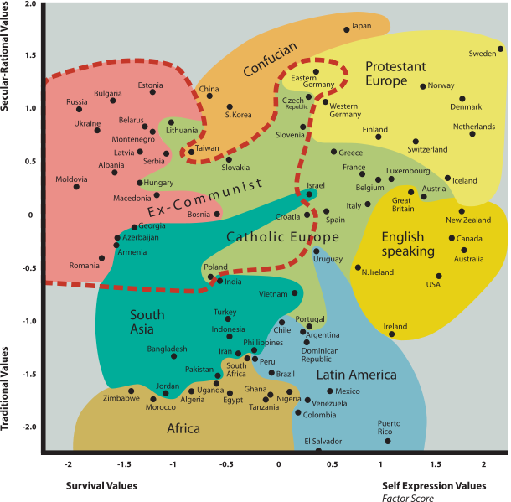  
  
Survival vs. Self-Expression Values  
Japan’s high uncertainty avoidance gives reason that, although they are a democratic society with increasing civil liberties (most notably for women, all be it a slow and disappointing process for many), they would somewhat walk the fence of these two values as a society. In terms of their views on homosexuality, for example, Japanese people are neither accepting nor actively hostile to gays. Being a high collectivist society, gays are somewhat ostracized for not being part of the group. Yet there is not a pattern of bigotry in the society.  
Sources:  
"Data Files of the Values Studies." *World Values Survey*. World Values Survey, June-July 2009. Web. 10 Apr. 2012. <http://www.wvsevsdb.com/wvs/WVSData.jsp>.

Research NGOs/Nonprofits in the country (Major NGOs in country, Opportunities)

The scope of work that NGOs are doing is growing in Japan. In the past, there was a large government reliance to provide foreign aid. More recently, there has been a question by Japan’s citizens and political parties of the potential for corruption, causing a shift towards NGO’s. Many still partner with the government to focus on issues such as poverty, famine, the AIDS epidemic in Africa and especially Southeastern Asia, and most notable environmental causes. Most every NGO can be labeled one of four categories: development, environment, human rights, and peace. There are also chapters of the World Wildlife Federation and Green Peace in Japan, in addition to locally established and operated NGOs.  
However, the actual number of NGOs in Japan has decreased since 2000. They are considered a relatively small body, especially given the country’s large economy. Most NGOs struggle to find continuous funding and are supported largely by single-donation. There has been a recent push to create a larger culture of NGOs, especially since the Tsunami disaster of 2011.  
Sources:  
JANIC. "NGO Data, Japan NGO Center for International Cooperation (JANIC)." *Janic.org*. JANIC. Web. 10 Apr. 2012. <http://www.janic.org/en/data.html>.

# 2.8) Nonverbal Communication - Corey

Nonverbal communication is very important in business in Japan. Some aspects of nonverbal communication in Japan would be when first meeting with someone, you should bow. Bowing shows status and in business meetings business inferiors must bow lower than their superiors. Another form of nonverbal communication used in Japan is eye contact or lack of eye contact. In Japan try to avoid long eye contact because it tends to show disrespect and can mean you are being too aggressive. Pointing with the index finger is also considered rude or disrespectful so when in Japan you should point with your whole hand. The Japanese do not like physical contact but have accustomed to the Western Style handshake for business, but other than that it is rude to hug or show any other physical contact when doing business. Nonverbal communication is very important and if you are doing business abroad in Japan it would be beneficial to understand the Japanese culture and forms of nonverbal communication.

# 2.10) Ting-Toomey’s Four Verbal Communication Styles – Jeff – NOT DONE

(Direct/Indirect, Instrumental/Affective, Elaborate/Succinct, Personal/Contextual style)

Don’t have my book currently! This part is coming soon!

# 2.11) Ethics & Social Responsibility – Lazar – NOT DONE

# 2.12) Negotiation and Conflict Styles - Corey

## Negotiation

The Japanese negotiation style is calm, quite, and patient. When negotiating with the Japanese they would rather get to know the person first before starting negotiations. They like to develop long term, personal relations before any negotiations begin. When negotiating with the Japanese you should understand their culture. The Japanese tend to be polite and hide their emotions very well when discussing business. It seems they always have a smiling face on when discussing business in serious situations. Another negotiating style that the Japanese use is they would rather leave the room or be evasive than give a negative answer. This is because they value harmony. Another aspect of Japanese culture is they tend to have concern for the welfare of the group and view decisions very carefully for long term consequences. When making decisions from negotiations they tend to use objective, analytic thought patterns, and take time for reflection about the decision that is going to be made.

## Conflict Styles

Conflict styles in Japan are usually hidden because Japan tends to want to keep the illusion of harmony. The Japanese tend to see the ability to hide their feelings and interests when conflict arises as a sign of maturity. Self-control, duty, and endurance are highly valued and in a conflict many Japanese may fall silent or use humble gestures but would not express their anger outright. The only time someone would lose their temper or say what they feel is if they hold a higher status than someone else. So as you can see, the Japanese have the ability to put their personal feelings on the back burner when dealing with conflicts in business and tend to value harmony very much.

# 2.13) How U.S. Culture Is Viewed - Jeff

Most views of Americans in Japan center on general cultural differences and the context in which Japanese and Americans interact. On a whole Japanese perception of American and western culture is a positive one. Many aspects of western culture have found their way into Japanese mainstream culture.

There are three main ways Japanese come in contact with Americans: business, American military presence, and tourists. Each context can translate into varying degrees of acceptance and allowance for cultural differences.

In business, most Japanese recognize that American ways of doing business is very different than the Japanese way. What tends to take place is that both sides make an effort to be accommodating to the other party’s cultural norms, which tends to lead to very harmonious dealings. The Japanese value the trade relationship they have with the United States so this can often result in a certain amount of accommodation for differences. The Japanese tend to view American business people to be overly direct and aggressive, focusing too little on the development of personal relationships.

American military presence has been a point of contention since the end of World War II. Many Japanese view members of the American military to be entitled, rude and disrespectful to Japanese culture. This is considered a greater affront than a business partner or client ignoring cultural norms since they actually reside in Japan. There has been an effort in recent years by American military leaders to increase efforts to educate American military members on Japanese culture before they are deployed.

American tourists are usually very welcome in the larger Japanese cities. As long as tourists don’t live up to stereotypes of being loud and rude they will be welcomed into most Japanese establishments and treated courteously. There have been reports of tourists having police being called on them in smaller communities that are not accustomed to foreigners.

# 2.15) Japanese Proverbs – Jeff

Proverbs are used frequently in Japanese culture. Many of them stem from Japan’s agricultural heritage. Below are some favorites and a brief interpretation of them (Japanese Proverbs).

## Deru kui wa utareru

**Literally:** The stake that sticks out gets hammered down

This is a fascinating look into Japanese culture and reflects the attitude of oneness that permeates it. To stick out is considered bad form

## Koketsu ni irazunba koji wo ezu

**Literally:** If you do not enter the tiger’s cave, you will not catch its cub.

This means that if one doesn’t take risks one cannot succeed.

## Saru mo ki kara ochiru

**Literally:** Even monkeys fall from trees.

This means that even someone very skilled in a certain activity fails from time to time.

## Kaeru no ko wa kaeru

**Literally:** Child of a frog is a frog.

Similar to the American expression, “The apple doesn’t fall far from the tree” meaning that one can’t escape ones heritage. This is an important concept in Japan because much is placed on who you parents are.

## Nito woo u mono wa itto wo mo ezu

**Literally:** One who chases after two hares won’t catch even one.

This saying is about focus. If one doesn’t focus on a single goal, nothing will be accomplished.

# 2.16) Japanese Current Events - Jeff

One of the major events in past few months has been the ongoing disagreement with Japan’s North Korean neighbor. A recent announcement that North Korea was planning to launch a long-range missile test has the entire region up in arms, literally. Japan has promised to shoot down any part of the rocket that enters its territory. The Japanese defense minister issued an official order to prepare its missile defense shield.

China has attempted to defend the North Korean regime internationally and will likely block any resolutions against North Korea in the UN. The missile launch will likely provoke a response from the United States, South Korea and Japan, which could lead to an escalation of tensions in the region (Crawford).

In the financial sector Japanese stocks have seen some of the strongest gains in recent memory in the first quarter. The growth has been attributed to changing monetary policy and economic improvement of trading partners. It is unsure whether or not these trends can continue (Turner).

# 2.17) NGOs & Nonprofits – Lazar – NOT DONE

# 2.18) Relevant Employment Laws – Jeff

The Labor Standards Act of 1947 set the majority of the standards for working conditions now experienced in Japan. The act has been amended numerous times, most recently in 2003.

The basics of the act provide standards for hiring and firing. There can be no discriminatory hiring, although discrimination of women continues to be a problem in the workplace. If an employee is fired they must receive thirty-day notice or thirty days of pay. Firing is prohibited during maternity leave and for thirty days after and hospitalization following a job-related illness or injury and for thirty days after.

Japan has minimum wage laws but it is based upon the local cost of living and varies by region. Maximum full-time working hours are eight hours per day and forty hours per week. Regulations for overtime provide for a twenty-five percent premium for additional work on a workday, thirty-five percent on a holiday and twenty-five percent for shifts between 10 PM and 5 AM. Despite these regulations, Japanese employers and employees often dispute overtime premiums.

The Labor Standards Act also provides for paid annual leave after six months of service and minimums correspond to seniority (Law).

# 2.19) International Entrepreneurship – Jeff – Done

American fast food chains are becoming increasingly popular in Japan. According to one article, when Japan opened up its first Krispy Kreme, there were hour-long lines for months after (Lutynec).

Most large franchise restaurants that have large international presences can be found in Japan. Also, there are several financial franchises that have spread to Japan, mainly in the insurance industry.

Some in Japan find the increased presence of American fast food to be a serious health concern. In recent years studies have shown that forty percent of men and women over forty are overweight. This has led to a government program that requires Japanese firms to measure the waistlines of all their employees over forty years old. Anyone over a standard waist size (33 inches) will be referred to counseling. If the employee fails to trim down the company will be fined (Fujita).

# 2.20) TBD – Corey - Must See Places in Japan? – NOT DONE

Hofstede, Geert. *Culture’s Consequences: Comparing Values, Behaviors, Institutions, and Organizations Across Nations*. 2nd ed. Thousand Oaks, CA: Sage Publications, 2001. *Japan*. Itim International. Web. 10 Apr. 2012. <http://geert-hofstede.com/>.

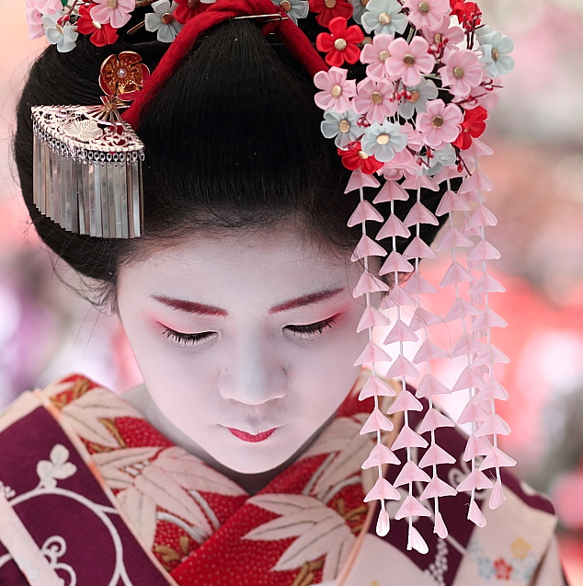

Bibliography

# Works Cited

Alverez, Mike. U.S. Broadband 100 Years Slower than Japan's. 2008 йил 15-August. 2012 йил 1-April <http://www.atelier.net/node/214036>.

ASEAN Plus Three. 2012 йил 1-April <http://en.wikipedia.org/wiki/ASEAN_Plus_Three#ASEAN_Plus_Three>.

Boswell, Randy. Undersea FIbre Optic Cable Would Boost Communications. 2012 йил 27-March. 2012 йил 1-April <http://www.vancouversun.com/news/national/Undersea+fibre+optic+cable+would+boost+communications+North/6368201/story.html>.

Bremner, Brian. Japanese High Techs Five Circles of Hell. 2012 йил 11-March. 2012 йил 1-April <http://www.businessweek.com/articles/2012-03-11/japanese-high-techs-five-circles-of-hell>.

Chandler, Marc. The yen is a safe haven as Japan is the world’s largest creditor. 2011 йил 19-August. 2012 йил 1-April <http://www.creditwritedowns.com/2011/08/japan-safe-haven.html>.

Coming of Age. 2012 йил 1-April <http://www.japan-guide.com/e/e2280.html>.

Crawford, Jaime. CNN Security Blog. 2012 йил 6-April. 2012 йил 6-April <http://security.blogs.cnn.com/2012/04/06/north-koreas-neighbors-apprehensive-angry-over-upcoming-rocket-launch/>.

Economy of Japan. 2012 йил 1-April <http://en.wikipedia.org/wiki/Economy_of_Japan>.

Fujita, Akiko. Diminishing Waistlines a National Health Problem in Japan. <http://abcnews.go.com/blogs/headlines/2012/02/diminishing-waistlines-a-national-health-problem-in-japan/>.

Japaenese New Year. 2012 йил 1-April <http://www.japan-guide.com/e/e2064.html>.

Japan Country Profile. 2012 йил 1-April <http://www.kwintessential.co.uk/resources/global-etiquette/japan-country-profiles.html>.

Japan Internet Usage. 2010. 2012 йил 1-April <http://www.internetworldstats.com/asia/jp.htm>.

Japanese Proverbs. 2012 йил 1-April <http://en.wikiquote.org/wiki/Japanese_proverbs>.

Lah, Kyung. Japan: Economy slips to third in world . 2011 йил 14-February. 2012 йил 1-April <http://edition.cnn.com/2011/BUSINESS/02/13/japan.economy.third/index.html>.

Langlois, Shawn. US companies forge ahead in Japan. 2011 йил 15-March. 2012 йил 1-April <http://articles.marketwatch.com/2011-03-15/markets/30712169_1_japan-aflac-employees>.

Law. 2012 йил 1-April <http://www.jetro.go.jp/en/invest/setting_up/laws/section4/>.

Lockard, Craig A. Societies, Networks, and Transitions: Since 1450. Cengage Learning, 2010.

Lutynec, Joanne. American Junk Food is a Big Hit in Japan. <http://www.slashfood.com/2007/04/04/american-junk-food-is-a-big-hit-in-japan/>.

Miyagawa, Shigeru. Japanese Language. 2012 йил 1-April <http://web.mit.edu/jpnet/articles/JapaneseLanguage.html>.

Nguyen, Dat. Japanese Etiquette. 2012 йил 1-April <http://www.culture-4-travel.com/japanese-etiquette.html>.

RTE Business. 2012 йил 12-January. 2012 йил 1-April <http://www.rte.ie/news/2012/0125/japan-business.html>.

Scheid, Bernhard. Religion in Japan. 29 February 2012. 1 April 2012 <http://www.univie.ac.at/rel_jap/an/Hauptseite>.

The CIA World Fact Book. 2012 йил April. CIA. 2012 йил 1-April <https://www.cia.gov/library/publications/the-world-factbook/geos/ja.html>.

Turner, Sarah. Japanese Stock Gains. 2012 йил 4-April. 2012 йил 6-April <http://articles.marketwatch.com/2012-04-04/markets/31286438_1_japanese-stocks-stock-gains-cheap-stocks>.