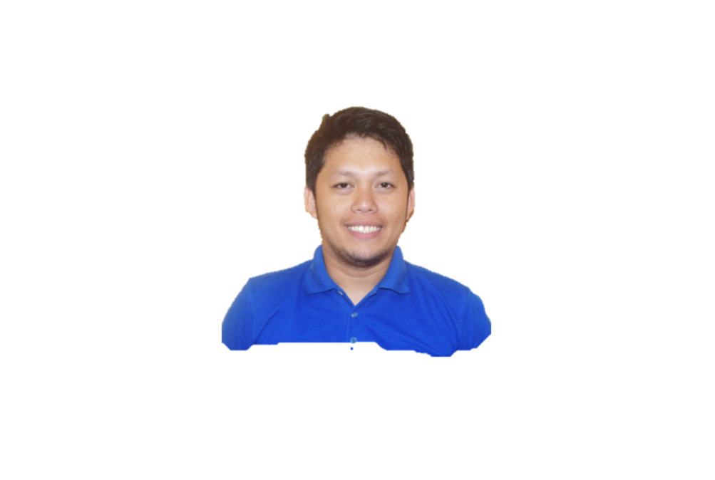

**JEFFREY B. RIVERA**

Blk 3 Lot 88 Windfields Subd.,  
Consolacion Cebu Phil, 6001  
Email ad. jeffreyrivera0318@gmail.com

Contact no. 0995 743 8434

**____________________________________________________________________________________**

**SYNOPSIS**

Self-starter and fast learner with positive attitude regarding goal direction.  
A good communicator with the ability to project and elicit interest and enthusiasm using a common sense approach. Adept at analyzing and sizing up situations; diligent, hard working.

**EDUCATION**

UNIVERSITY OF SAN CARLOS

Bachelor of Science in Electronics and Communications Engineering

**LICENSES AND CERTIFICATION**

PRC Licensed Electronics and Communications Engineer

Instrumentation and Control Servicing NC II

**PROFESSIONAL EXPERIENCE:**

**MICRODATA SYSTEMS AND MANAGEMENT INCORPORATED**

**SYSTEM SUPPORT ENGINEER (AUGUST 2019 – FEBRUARY 2021)**

* Conduct site survey to estimate the requirements the client needs in their network:
  + Network requirement may include Access Point, Network switch, Router, Firewall, Endpoint security, and Video Conference needs.
* Designing and providing the Bill of Materials to be propose for the project
* Coordinate with the client for the status and their other requirements for the project.
* Install cables and telephone for clients PABX system.
* Configure PABX system (NEC device).

**SURFACE TECHNOLOGY INTERNATIONAL PHIL.**

**TEST ENGINEER (OCTOBER 2014 – APRIL 2019)**

* Run Test on different kinds of Circuit Boards (Digital and Analog Devices)
* Operate on Test machines (Takaya Flying Probe Tester, Yxlon X-Ray, IFR 4220 ICT machine)
* Maintenance of Test jigs, In-Circuit Tester, Programmers
* Analyze and Troubleshoot No Good/Failed PCB board through the aid of a schematic diagrams and a PCB layout
* Create jig, including purchase of materials to be use, and the electrical lay-out for more efficient process on Functional testing.

**CEBU MITSUMI INCORPORATED**

**AUTOMATION ENGINEER/PROCESS IMPROVEMENT (2013 – 2014)**

* Implement an equipment/semi-auto machines that is useful for productivity improvement.
* Implement process improvement that could lead to labor cost reduction.
* Conducts machine verification for optimal use during production
* Conducts Experiment on Line for Process Improvement basis.

**IN PROCESS QUALITY CONTROL (TECHNICAL ENGINEER) (2012 - 2013)**

* Improve Yield rate through continuous process improvement.
* Reduce waste disposal of the production by an aid of SPC.
* Conducts Experiment as a reference for future process and material improvement.
* Material Verification before it is use on production.
* Monitors the quality control of a company's products.

**ADDT’L WORKING EXPERIENCE**

* On-the-job trainee at PLDT Mandaue
* Working Scholar of University of San Carlos

**Organizational Affiliation**2010- presentInstitute of Electronics Engineers of the Philippines, Inc. Visayas Regional Student Council

2005-2009

Carolinian Working Scholar Association

**TRAINING**

* Instrumentation and Control Servicing
* CISCO Network Associate training modules 1, 2 and 3
* NEC PBX Phone System
* IPC-A-610E Specialist (Certified)
* Mechatronics Servicing NC II
* Solidworks (2008)
* Basic Electronics Soldering

**CHARACTER REFERENCE:**

**MR. MAEV VERDE**

ENGINEERING MANAGER

Surface Technology International – Phil.

MEZ 1 Lapu-Lapu City, Cebu

Cel # 09173210460

**MS. EMMA CONCEPTION DELA CERNA**

REGIONAL PROGRAM EXECUTIVE

KUEHNE+NAGEL SHARED SERVICE CENTER

17th Floor HM Tower, IT Park Cebu City

Cel #09077279777