CS 6120: Toxicity Detection with Classical and Transformer-based Models
Jeffrey Chen, Ksheeraj Prakash, Nishnath Kandarpa
Northeastern University
{chen.jeffr, prakash.ks, kandarpa.n}@northeastern.edu

Abstract

This project investigates toxicity detection in online comments, with a focus on distinguishing harmful language from casual Gen Z and "brainrot" style slang. We compare classical machine learning approaches (TF-IDF + MLP) against transformer-based models pretrained on different domains: general text (BERT), social media (BERTweet), and abusive content (HateBERT). Using the Jigsaw Toxic Comment Classification dataset (159,571 Wikipedia comments across 6 toxicity categories), we address both binary toxicity classification and multi-label category prediction. Our preliminary MLP baseline achieves 69.0% F1 score and 91.31% exact match rate on validation data, demonstrating feasibility while highlighting challenges with class imbalance (89.83% non-toxic samples).
- Introduction
The primary goal of this project is to compare classical machine learning approaches (TF-IDF + Logistic Regression/MLP) with transformer-based models pretrained on different domains: general text (BERT), social media text (BERTweet), and toxic Reddit content (HateBERT). This comparison aims to quantify the extent to which domain-specific pretraining improves the detection of harmful uses of contemporary internet slang and meme-driven expressions.
Our study is organized around three subtasks that together evaluate both classification and transformation capabilities. Subtask A focuses on binary toxicity classification, predicting whether a comment is toxic or non-toxic, evaluated using accuracy, precision, recall, ROC-AUC, and macro-F1. Subtask B extends this to multi-label classification, where the model predicts which specific toxicity categories apply (toxic, severe toxic, obscene, threat, insult, identity hate) using sigmoid outputs and binary cross-entropy loss, evaluated with per-class F1 and macro-F1. Subtask C explores toxicity rewriting as an optional extension, where a seq2seq model generates non-toxic rephrasing of toxic comments, treating this as an exploratory milestone.
- Data
We use the Jigsaw Toxic Comment Classification Challenge dataset from Kaggle, which contains crowd-annotated Wikipedia comments with six binary toxicity labels which are toxic, severe_toxic, obscene, threat, insult, and identity_hate.
- Dataset Statistics
The dataset consists of 159,571 training samples and 153,164 test samples. Table 1 shows the class distribution in the training set.
Table 1: Class distribution in the Training Set.
Category | Count | Percentage
Non-toxic | 143,346 | 89.83%
Toxic | 15,294 | 9.58%
Obscene | 8,449 | 5.29%
Insult | 7,877 | 4.94%
Severe Toxic | 1,595 | 1.00%
Identity Hate | 1,405 | 0.88%
Threat | 478 | 0.30%
- Data Characteristics
Class Imbalance: The dataset is heavily imbalanced, with 89.83% of comments being non-toxic. This presents a significant challenge for model training, as models may achieve high accuracy by simply predicting non-toxic for most samples.
Multi-label Nature: Toxic comments often have multiple labels, with an average of 2.16 labels per toxic comment. Only 3.99% of samples have exactly one label, while 6.18% have two or more labels. Notably, 31 comments (0.02%) exhibit all six toxicity categories.
Text Length: Comments average 394 characters (median: 205, max: 5,000), indicating significant length variability.
Rare Categories: The "threat" category is particularly rare (0.30%), making it the most challenging category to detect.
Preprocessing: For the MLP baseline, we perform the following preprocessing:
- Fill missing values with empty strings
- Introduced unigrams and bigrams
- Apply TF-IDF vectorization with a maximum of 20,000 features and English stopword removal
- Apply TruncatedSVD dimensionality reduction to 512 components
- Convert to float32 for efficient computation
For future transformer models, we will use the respective tokenizers (BERT, BERTweet, HateBERT) with appropriate preprocessing for each model's pretraining scheme.
- Models

3.1 Baseline Model: TF-IDF + MLP
Our baseline approach uses traditional NLP feature extraction combined with a multi-layer perceptron classifier.
Feature Extraction: We convert text to sparse vectors using Term Frequency-Inverse Document Frequency (TF-IDF) with a maximum of 20,000 features. English stopwords are removed to focus on content-bearing words. We then apply TruncatedSVD to reduce the sparse TF-IDF vectors from 20,000 dimensions to 512 dense features, retaining the most important semantic information while reducing computational complexity.
Model Architecture: The MLP consists of three layers:
- Input layer: 512 features (from TF-IDF + SVD)
- Hidden layer 1: 1,024 neurons with ReLU activation and 20% dropout
- Hidden layer 2: 512 neurons with ReLU activation and 20% dropout
- Output layer: 6 neurons (one per toxicity category)
3.2 Planned Transformer Models
We plan to fine-tune three transformer-based models to compare the effects of domain-specific pretraining:
BERT: A general-purpose transformer (Devlin et al., 2019) pretrained on BookCorpus and Wikipedia, providing a baseline for transformer performance without domain-specific knowledge.
BERTweet: Pretrained on 850M English tweets (Nguyen et al., 2020), designed to capture informal social media language patterns similar to modern internet slang.
HateBERT: BERT further pretrained on abusive Reddit content (Caselli et al., 2021), specifically adapted for hate speech and toxicity detection.
For all transformer models, we will fine-tune the classification head while experimenting with freezing/unfreezing base model layers.
- Results

4.1 MLP Baseline Performance
Our model was trained using a set random with seed 42 for both the torch and the random library for reproducibility. Our best epoch was epoch 4 with the following training metrics. Train Loss: 0.051, Val Loss: 0.060, Val F1: 68.3%, Label Accuracy: 97.98%, Exact Match: 91.63%.
4.2 Loss Analysis
Looking at the loss graph below, when looking at the dev loss, we can see that it seems to converge quickly at around 2-4 epochs. This shows that the model learns quickly, but our data is not that complex.
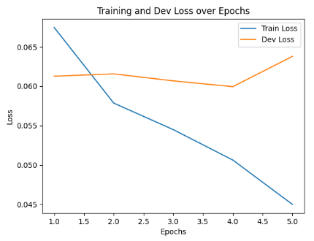
Fig 1: Loss result of MLP model during training
4.3 Accuracy Analysis
For our accuracy, we calculated two different types of accuracy. The dev accuracy measures if at least 3 out of the 6 labels are predicted correct for the given example while the exact match accuracy measures if all 6 predictions are correct. From what we can see with the table and the graph, the MLP model is able to distinguish non-toxic and toxic text, achieving relatively strong performance on both the dev accuracy and exact match metrics.
4.4 General Analysis and Next Steps
Even with good metrics in our model, there might be an issue with the complexity of our data. From our observations when training, we saw that the model seemed to converge quickly, which is probably due to our data not being complex.
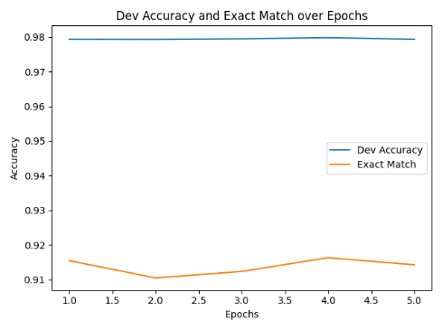
Fig 2: Accuracy result of MLP model during training
In addition, our dataset contains 89.83% of data that is non-toxic, which might be causing our model to overfit non-toxic data. This is probably why we are getting a low F1 score at around 69%.
- Conclusion
We implemented a TF-IDF + MLP baseline for multi-label toxicity classification on the Jigsaw dataset, achieving 69.0% F1 score and 91.31% exact match rate. Despite 89.83% non-toxic samples causing class imbalance, the model converges within 2-3 epochs. However, validation loss increases at epoch 5, indicating overfitting and need for early stopping or regularization. After our check-in we plan to better balance our dataset and work on the transformer models.
- References
Jacob Devlin, Ming-Wei Chang, Kenton Lee, and Kristina Toutanova. 2019. BERT: Pre-training of deep bidirectional transformers for language understanding. In Proceedings of the 2019 Conference of the North American Chapter of the Association for Computational Linguistics: Human Language Technologies, Volume 1 (Long and Short Papers), pages 4171–4186, Minneapolis, Minnesota. Association for Computational Linguistics.
Dat Quoc Nguyen, Thanh Vu, and Anh Tuan Nguyen. 2020. BERTweet: A pre-trained language model for English tweets. In Proceedings of the 2020 Conference on Empirical Methods in Natural Language Processing: System Demonstrations, pages 9–14, Online. Association for Computational Linguistics.
Tommaso Caselli, Valerio Basile, Jelena Mitrović, and Michael Granitzer. 2021. HateBERT: Retraining BERT for abusive language detection in English. In Proceedings of the 5th Workshop on Online Abuse and Harms (WOAH 2021), pages 17–25, Online. Association for Computational Linguistics.
Ellery Wulczyn, Nithum Thain, and Lucas Dixon. 2017. Ex machina: Personal attacks seen at scale. In Proceedings of the 26th International Conference on World Wide Web, WWW '17, pages 1391–1399, Republic and Canton of Geneva, CHE. International World Wide Web Conferences Steering Committee.
Daniel Borkan, Lucas Dixon, Jeffrey Sorensen, Nithum Thain, and Lucy Vasserman. 2019. Nuanced metrics for measuring unintended bias with real data for text classification. In Companion Proceedings of The 2019 World Wide Web Conference, WWW '19, pages 491–500, New York, NY, USA. Association for Computing Machinery.
Paula Fortuna and Sérgio Nunes. 2018. A survey on automatic detection of hate speech in text. ACM Computing Surveys, 51(4):1–30.

