2 A)

<?xml version="1.0" encoding="utf-8"?>

<packages>

<package id="filezilla" />

<package id="skype" />

<package id="dropbox" />

<package id="ruby" />

</packages>

* User are require to add all the package ID which they wanted to install into the packages.config file.

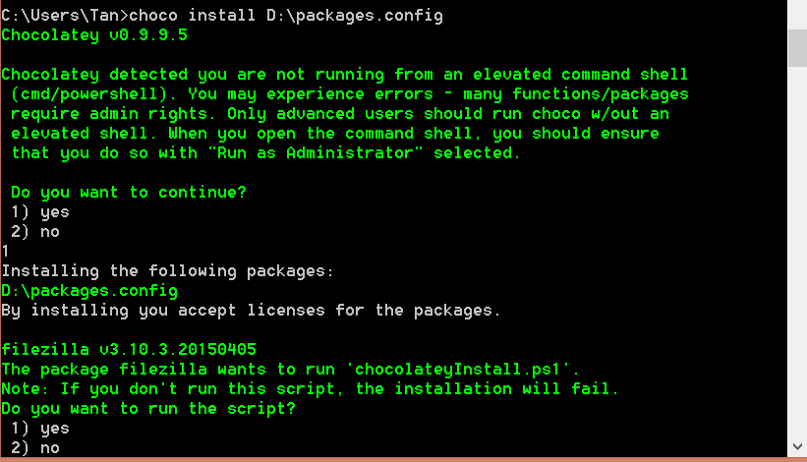

* When user wanted to install multiple programs through Chocolatey, they are require to launch CMD and type “choco install D:\packages.config”.
* Chocolatey will prompt a confirmation message for user.
* When user enter “1”, chocolatey will install the multiple program into the specific directory.

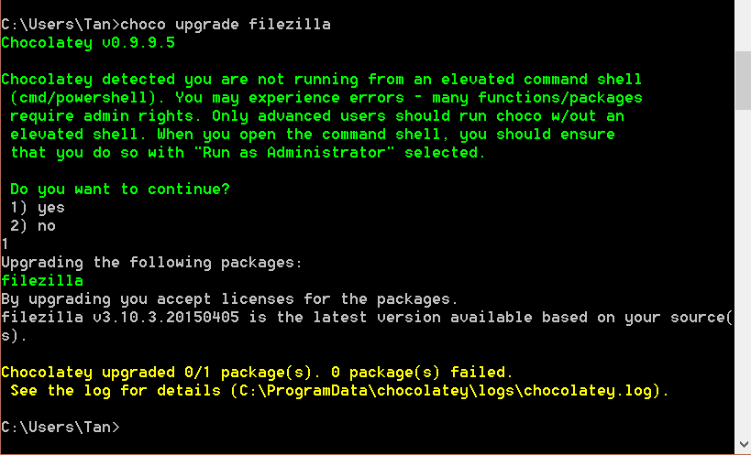

* When user wanted to update/upgrade their existing program through Chocolatey, they are require to launch CMD and type “choco upgrade filezilla”.
* User are require to use the package name to update/upgrade instead of using the packages.config file.
* Chocolatey will prompt a confirmation message to user.
* When user enter “1”, Chocolatey will update the program.

B)

* While installing with chocolatey, the package is pre-configured to install to specific directory. It does not ask the user where the software should be installed.
* It uses the path variable stored in the system’s environment variables to determine where to install a software. The package can refer back to this variable to determine the installer’s installation directory. However, it does not activate the software.
* Update and uninstall procedures follow the same steps as installing a software but when uninstalling, they do not necessarily deactivate the software.
* The softwares do not adapt to changes as chocolatey still require the user to update them manually.

In conclusion, Carzaniga’s software deployment model is more preferred over chocolatey model because the latter has an incomplete model and may not necessarily be efficient.

C) Suppose the computer labs in a university has recently had their computers reformatted and needs all the necessary softwares installed within three days. Chocolatey could aid in this situation by simply running a script to automatically install all the required software in all computers without much user interaction.