Project Title: Galaxy Classification
Contents
Preliminary Work 2
Which of these galaxies are spiral? (check all that apply) 2
Which of these galaxies are elliptical? (check all that apply) 3
Describe some common features of spiral galaxies. Which features did you use to distinguish them from elliptical galaxies? For example: shape, color, etc. 3
Describe some common features of elliptical galaxies. Which features did you use to distinguish them from spiral galaxies? For example: shape, color, etc. 3
Describe some common features of elliptical galaxies. Which features did you use to distinguish them from spiral galaxies? For example: shape, color, etc. 3
Galaxy Zoo Citizen Science 4
Following Questions 4
The images provided to you on Galaxy Zoo should look significantly different than the images above. Compared with the images we provided above, in general, the galaxy zoo images are... 4
Explain your answer above. Why do you think so? (It may help to consider how you answered questions nos. 3 and 4) 4
While classifying in Galaxy Zoo, which type of galaxy did you see more frequently? 4
In general, which galaxies appear to be mostly (or more) red? 5
In general, which galaxies appear to be mostly (or more) blue? 6
OK! Now, keeping in mind that the color of main-sequence stars indicates their masses and life-spans (see Dr. Impey's textbook, Chapter 13), which types of galaxies appear to contain many young stars? 6
And what type of galaxies appear smoother and more symmetric? 6
From these features, which galaxies appear to be younger, have more structure, and have more young stars? 7
And which types of galaxies appear to be older, and contain mostly old stars? 7
Finally, to connect this line of reasoning back to the galaxies you classified using Galaxy Zoo, think back to question 8 ("Which types of galaxies did you see more frequently in Galaxy Zoo?") do you think the galaxies you saw in galaxy zoo are mostly older or younger galaxies? 7

Preliminary Work

Which of these galaxies are spiral? (check all that apply)
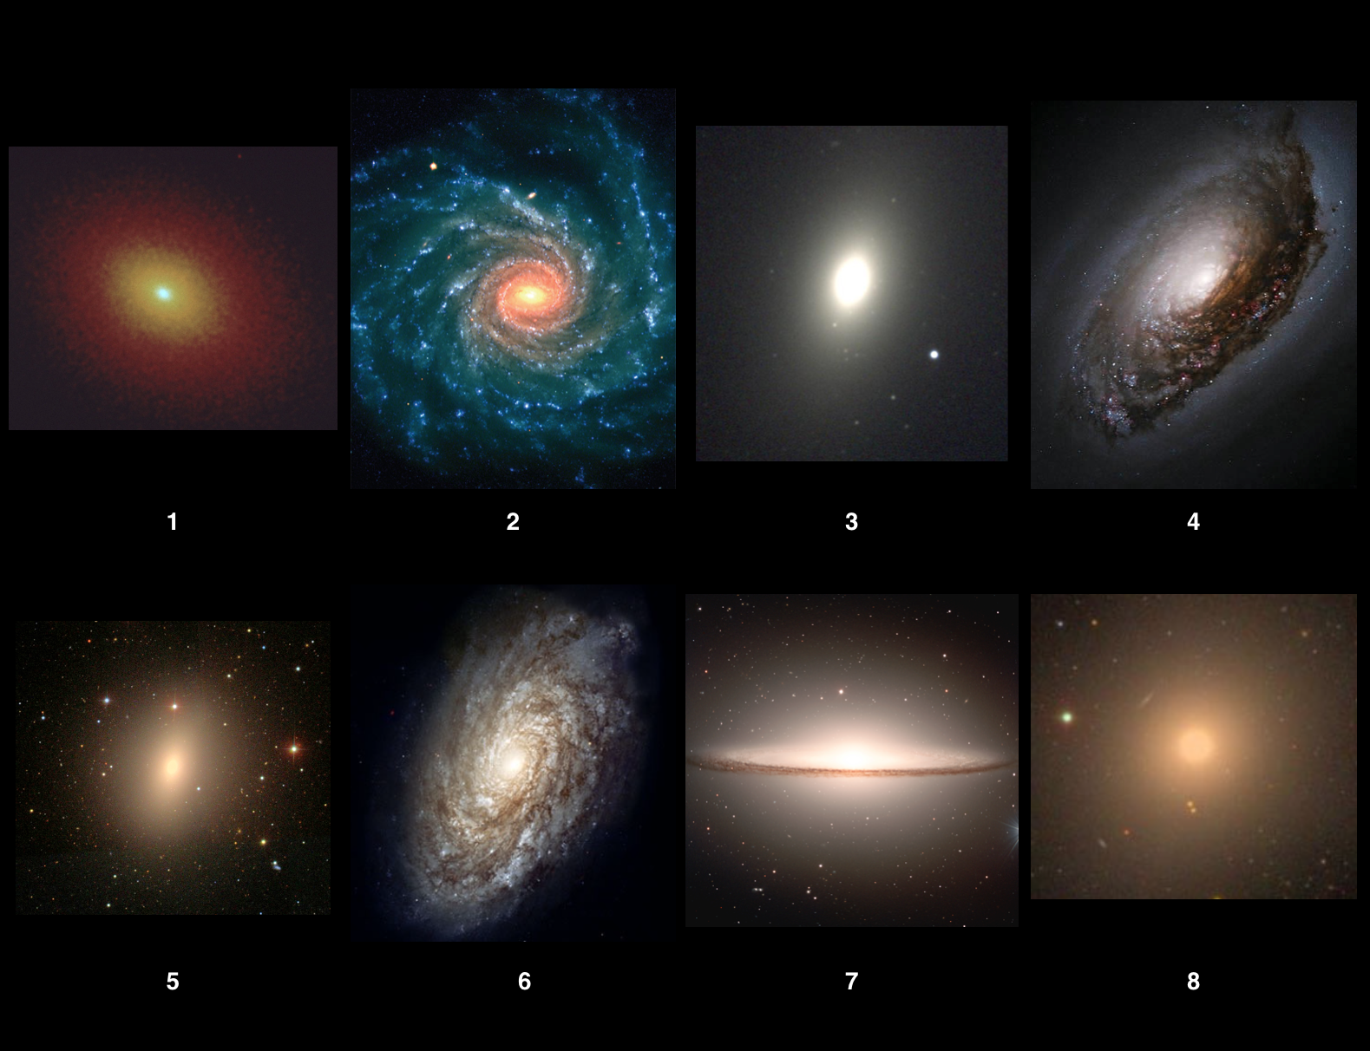
Spiral galaxies =

Which of these galaxies are elliptical? (check all that apply)
Elliptical galaxies =

Describe some common features of spiral galaxies. Which features did you use to distinguish them from elliptical galaxies? For example: shape, color, etc.
Text

Describe some common features of elliptical galaxies. Which features did you use to distinguish them from spiral galaxies? For example: shape, color, etc.
Text

Describe some common features of elliptical galaxies. Which features did you use to distinguish them from spiral galaxies? For example: shape, color, etc.
Text

Galaxy Zoo Citizen Science

Now click to join our group on Galaxy Zoo (If you haven't already, you will need to create an account, with an email and username of your choice): http://www.galaxyzoo.org/#/user_groups/cuddly_galaxies_0%22
https://www.zooniverse.org/projects/klmasters/galaxy-zoo-3d/classify
Once here, spend some time navigating the website and reading their story! When you are ready to classify some galaxies, click "Classify" up on the top left.
We ask that you classify at least 20 galaxies, but feel free to do as many as you like!

Following Questions
(The following questions should be answered after you have finished classifying galaxies on Galaxy Zoo.)

The images provided to you on Galaxy Zoo should look significantly different than the images above. Compared with the images we provided above, in general, the galaxy zoo images are...
Harder / Easier to classify

Explain your answer above. Why do you think so? (It may help to consider how you answered questions nos. 3 and 4)
Text

While classifying in Galaxy Zoo, which type of galaxy did you see more frequently?
Elliptical galaxies // Spiral galaxies

In general, which galaxies appear to be mostly (or more) red?
Elliptical galaxies // Spiral galaxies

In general, which galaxies appear to be mostly (or more) blue?
Elliptical galaxies // Spiral galaxies

OK! Now, keeping in mind that the color of main-sequence stars indicates their masses and life-spans (see Dr. Impey's textbook, Chapter 13), which types of galaxies appear to contain many young stars?
Elliptical galaxies
Spiral galaxies

And what type of galaxies appear smoother and more symmetric?
Elliptical galaxies
Spiral galaxies

From these features, which galaxies appear to be younger, have more structure, and have more young stars?
Elliptical Galaxies
Spiral Galaxies

And which types of galaxies appear to be older, and contain mostly old stars?
Elliptical Galaxies
Spiral Galaxies

Finally, to connect this line of reasoning back to the galaxies you classified using Galaxy Zoo, think back to question 8 ("Which types of galaxies did you see more frequently in Galaxy Zoo?") do you think the galaxies you saw in galaxy zoo are mostly older or younger galaxies?
Older
Younger

