**Introduction to Clustering**

Often, the data you encounter in the real world won't have flags attached and won't provide labeled answers to your question. Finding patterns in this type of data, unlabeled data, is a common theme in many machine learning applications. *Unsupervised Learning* is how we find patterns and structure in these data.

**Clustering** is the most well-known unsupervised learning technique. It finds structure in unlabeled data by identifying similar groups, or *clusters*. Examples of clustering applications are:

* **Recommendation engines:** group products to personalize the user experience
* **Search engines:** group news topics and search results
* **Market segmentation:** group customers based on geography, demography, and behaviors
* **Image segmentation:** medical imaging or road scene segmentation on self-driving cars

Let's get started!

Instructions

**1.**

In the visualization on the right, how many clusters (groups) do you see?

To find out the answer, add the following code at the bottom of **script.py**:

plt.show()

And run!

import codecademylib3_seaborn

import matplotlib.pyplot as plt

import numpy as np

from os.path import join, dirname, abspath

from mpl_toolkits.mplot3d import Axes3D

from sklearn.cluster import KMeans

from sklearn import datasets

iris = datasets.load_iris()

x = iris.data

y = iris.target

fignum = 1

# Plot the ground truthd

fig = plt.figure(fignum, figsize=(4, 3))

ax = Axes3D(fig, rect=[0, 0, .95, 1], elev=48, azim=134)

for name, label in [('Zombies', 0),

('Programmers', 1),

('Vampires', 2)]:

ax.text3D(x[y == label, 3].mean(),

x[y == label, 0].mean(),

x[y == label, 2].mean() + 2, name,

horizontalalignment='center',

bbox=dict(alpha=.2, edgecolor='w', facecolor='w'))

# Reorder the labels to have colors matching the cluster results

y = np.choose(y, [1, 2, 0]).astype(np.float)

ax.scatter(x[:, 3], x[:, 0], x[:, 2], c=y, edgecolor='k')

ax.w_xaxis.set_ticklabels([])

ax.w_yaxis.set_ticklabels([])

ax.w_zaxis.set_ticklabels([])

ax.set_xlabel('hates sunlight')

ax.set_ylabel('likes garlic')

ax.set_zlabel('canine teeth (in)')

ax.set_title('')

ax.dist = 12

# Add code here:

plt.show()

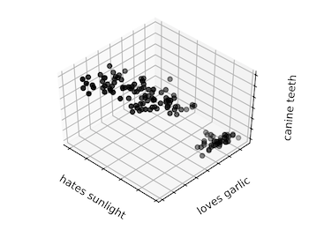

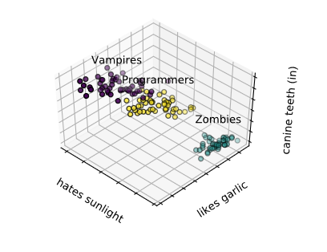

**K-Means Clustering**

The goal of clustering is to separate data so that data similar to one another are in the same group, while data different from one another are in different groups. So two questions arise:

* How many groups do we choose?
* How do we define similarity?

**K-Means** is the most popular and well-known clustering algorithm, and it tries to address these two questions.

* The "K" refers to the number of clusters (groups) we expect to find in a dataset.
* The "Means" refers to the average distance of data to each cluster center, also known as the *centroid*, which we are trying to minimize.

It is an iterative approach:

1. Place k random centroids for the initial clusters.
2. Assign data samples to the nearest centroid.
3. Update centroids based on the above-assigned data samples.

Repeat Steps 2 and 3 until *convergence* (when points don't move between clusters and centroids stabilize).

Once we are happy with our clusters, we can take a new unlabeled datapoint and quickly assign it to the appropriate cluster.

Instructions

In this lesson, we will first implement K-Means the hard way (to help you understand the algorithm) and then the easy way using the sklearn library!

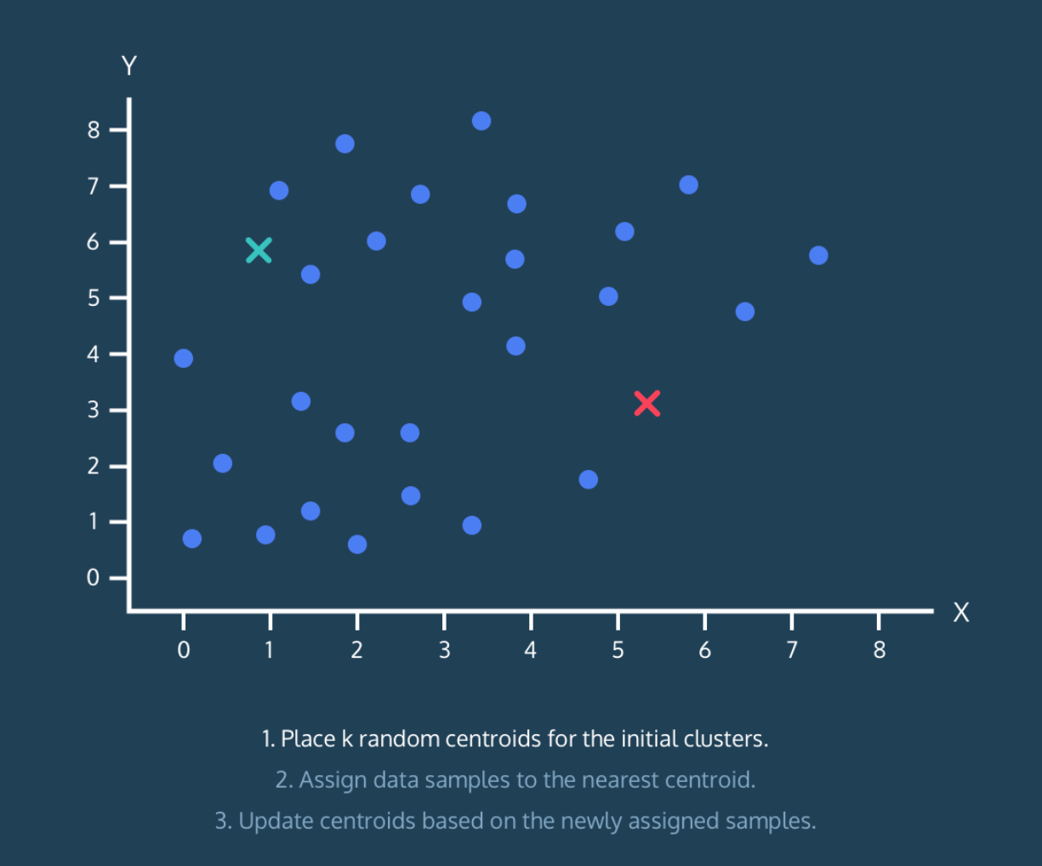

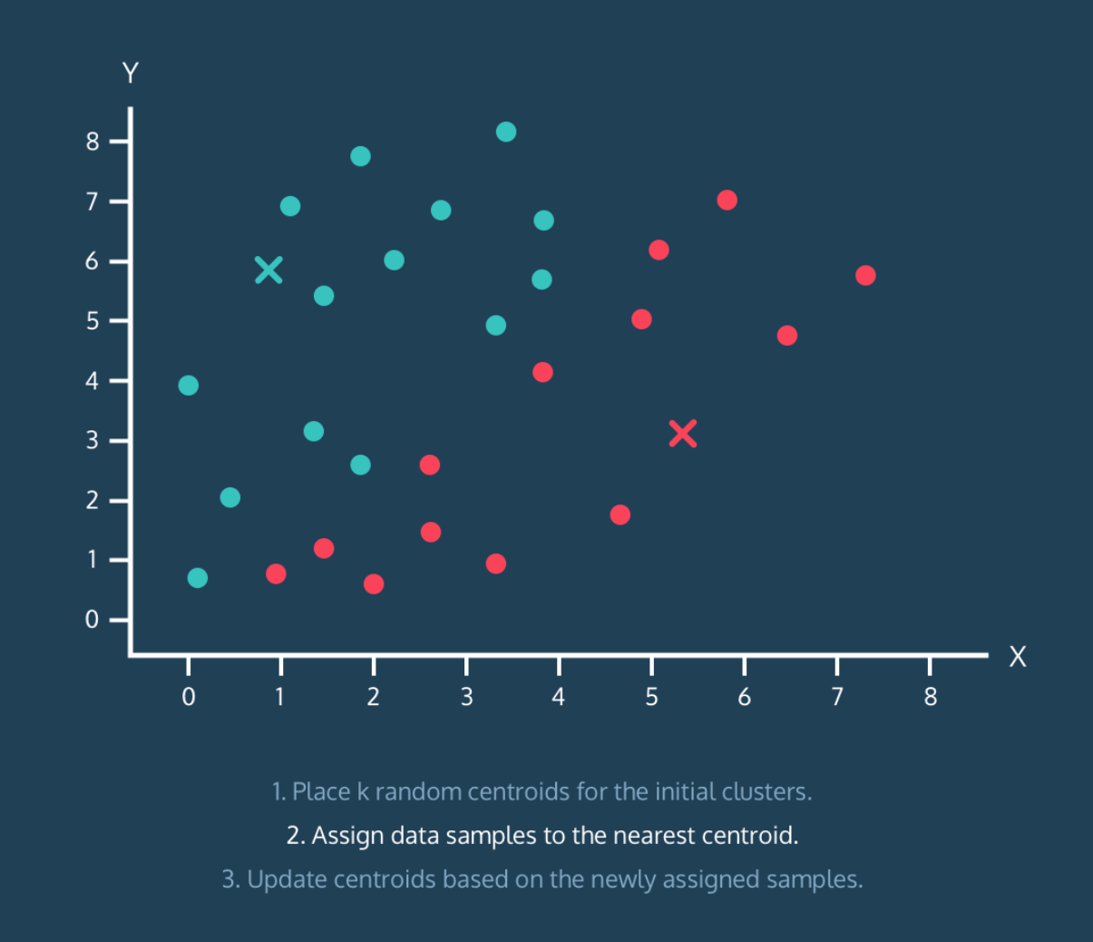

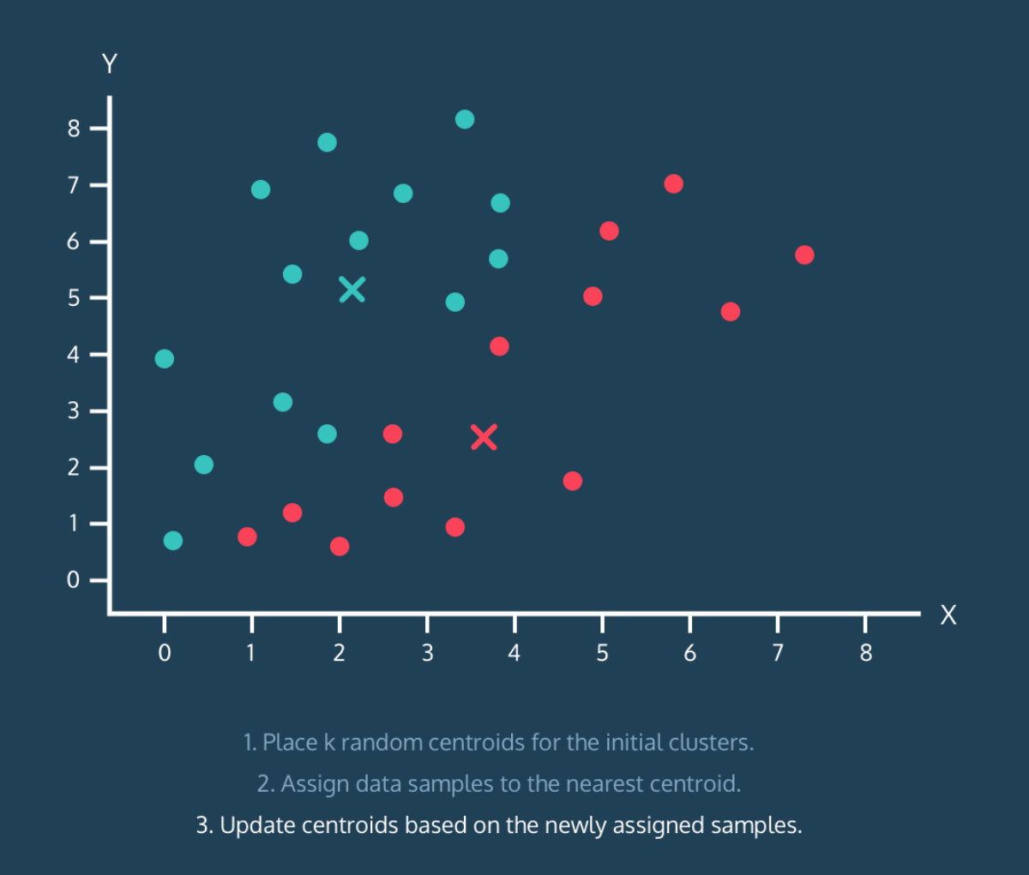

**Iris Dataset**

Before we implement the K-means algorithm, let's find a dataset. The sklearn package embeds some datasets and sample images. One of them is the [Iris dataset](https://en.wikipedia.org/wiki/Iris_flower_data_set).

The Iris dataset consists of measurements of sepals and petals of 3 different plant species:

* *Iris setosa*
* *Iris versicolor*
* *Iris virginica*

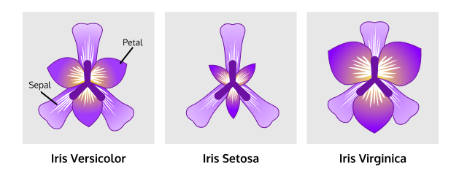

The sepal is the part that encases and protects the flower when it is in the bud stage. A petal is a leaflike part that is often colorful.

From sklearn library, import the datasets module:

from sklearn import datasets

To load the Iris dataset:

iris = datasets.load_iris()

The Iris dataset looks like:

[[ 5.1 3.5 1.4 0.2 ]

[ 4.9 3. 1.4 0.2 ]

[ 4.7 3.2 1.3 0.2 ]

[ 4.6 3.1 1.5 0.2 ]

. . .

[ 5.9 3. 5.1 1.8 ]]

We call each piece of data a *sample*. For example, each flower is one sample.

Each characteristic we are interested in is a *feature*. For example, petal length is a feature of this dataset.

The features of the dataset are:

* **Column 0:** Sepal length
* **Column 1:** Sepal width
* **Column 2:** Petal length
* **Column 3:** Petal width

The 3 species of Iris plants are what we are going to cluster later in this lesson.

**1.**

Import the datasets module and load the Iris data.

**2.**

Every dataset from sklearn comes with a bunch of different information (not just the data) and is stored in a similar fashion.

First, let's take a look at the most important thing, the sample data:

print(iris.data)

Each row is a plant!

**3.**

Since the datasets in sklearn datasets are used for practice, they come with the answers (target values) in the target key:

Take a look at the target values:

print(iris.target)

The iris.target values give the *ground truth* for the Iris dataset. Ground truth, in this case, is the number corresponding to the flower that we are trying to learn.

**4.**

It is always a good idea to read the descriptions of the data:

print(iris.DESCR)

Expand the terminal (right panel):

* When was the Iris dataset published?
* What is the unit of measurement?

# Visualize Before K-Means

To get a better sense of the data in the iris.data matrix, let's visualize it!

With Matplotlib, we can create a 2D scatter plot of the Iris dataset using two of its features (sepal length vs. petal length). The sepal length measurements are stored in column 0 of the matrix, and the petal length measurements are stored in column 2 of the matrix.

But how do we get these values?

Suppose we only want to retrieve the values that are in column 0 of a matrix, we can use the NumPy/Pandas notation [:,0] like so:

matrix[:,0]

[:,0] can be translated to [all_rows , column_0]

Once you have the measurements we need, we can make a scatter plot by:

plt.scatter(x, y)

To show the plot:

plt.show()

Let's try this! But this time, plot the sepal length (column 0) vs. sepal width (column 1) instead.

**1.**

Store iris.data in a variable named samples.

**2.**

Create a list named x that contains the column 0 values of samples.

Create a list named y that contains the column 1 values of samples.

**3.**

Use the .scatter() function to create a scatter plot of x and y.

Because some of the data samples have the exact same features, let's add alpha=0.5:

plt.scatter(x, y, alpha=0.5)

**4.**

Call the .show() function to display the graph.

If you didn't know there are three species of the Iris plant, would you have known just by looking at the visualization?

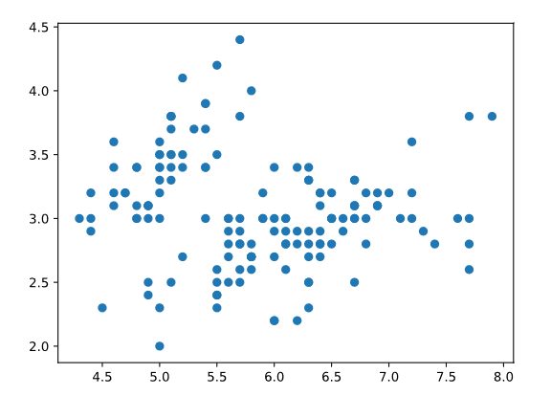

import codecademylib3_seaborn

import matplotlib.pyplot as plt

from sklearn import datasets

iris = datasets.load_iris()

# Store iris.data

samples = iris.data

# Create x and y

x = samples[:,0] # sepal length

y = samples[:,1] # petal length

# Plot x and y

plt.scatter(x,y,alpha=0.5)

# Show the plot

plt.show()

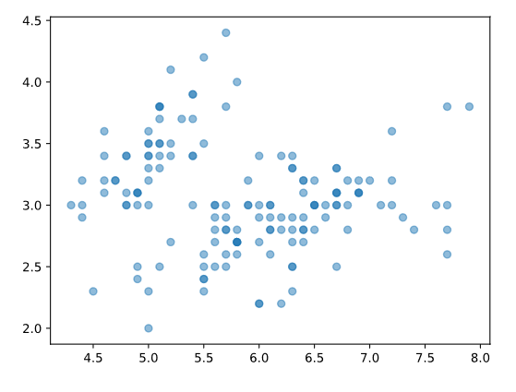

**Implementing K-Means: Step 1**

The K-Means algorithm:

1. **Place k random centroids for the initial clusters.**
2. Assign data samples to the nearest centroid.
3. Update centroids based on the above-assigned data samples.

Repeat Steps 2 and 3 until convergence.

After looking at the scatter plot and having a better understanding of the Iris data, let's start implementing the K-Means algorithm.

In this exercise, we will implement Step 1.

Because we expect there to be three clusters (for the three species of flowers), let's implement K-Means where the k is 3.

Using the NumPy library, we will create 3 *random* initial centroids and plot them along with our samples.

**1.**

First, create a variable named k and set it to 3.

**2.**

Then, use NumPy's random.uniform() function to generate random values in two lists:

* a centroids_x list that will have k random values between min(x) and max(x)
* a centroids_y list that will have k random values between min(y) and max(y)

The random.uniform() function looks like:

np.random.uniform(low, high, size)

The centroids_x will have the x-values for our initial random centroids and the centroids_y will have the y-values for our initial random centroids.

**3.**

Create an array named centroids and use the zip() function to add centroids_x and centroids_y to it.

The zip() function looks like:

np.array(list(zip(array1, array2)))

Then, print centroids.

The centroids list should now have all the initial centroids.

**4.**

Make a scatter plot of y vs x.

Make a scatter plot of centroids_y vs centroids_x.

Show the plots to see your centroids!

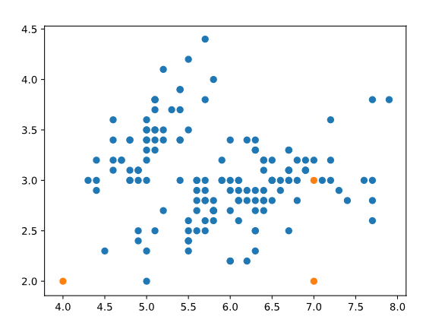

iris = datasets.load_iris()

samples = iris.data

x = samples[:,0]

y = samples[:,1]

# Number of clusters

k = 3

# Create x coordinates of k random centroids

centroids_x = np.random.uniform(min(x),max(x),k)

# Create y coordinates of k random centroids

centroids_y = np.random.uniform(min(y),max(y),k)

# Create centroids array

centroids = np.array(list(zip(centroids_x, centroids_y)))

# Make a scatter plot of x, y

plt.scatter(x,y,alpha=0.5)

# Make a scatter plot of the centroids

plt.scatter(centroids_x, centroids_y)

# Display plot

plt.show()

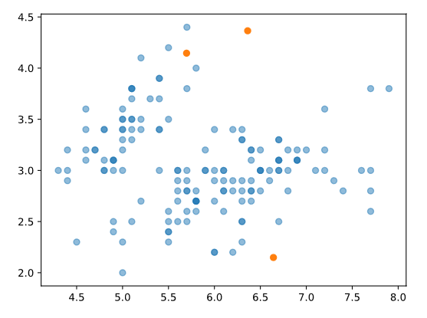

**Implementing K-Means: Step 2**

The K-Means algorithm:

1. Place k random centroids for the initial clusters.
2. **Assign data samples to the nearest centroid.**
3. Update centroids based on the above-assigned data samples.

Repeat Steps 2 and 3 until convergence.

In this exercise, we will implement Step 2.

Now we have the 3 random centroids. Let's assign data points to their nearest centroids.

To do this we're going to use the [Distance Formula](https://en.wikipedia.org/wiki/Distance) to write a distance() function. Then, we are going to iterate through our data samples and compute the distance from each data point to each of the 3 centroids.

Suppose we have a point and a list of three distances in distances and it looks like [15, 20, 5], then we would want to assign the data point to the 3rd centroid. The argmin(distances) would return the index of the lowest corresponding distance, 2, because the index 2 contains the minimum value.

**1.**

Write a distance() function.

It should be able to take in a and b and return the distance between the two points.

**2.**

Create an array called labels that will hold the cluster labels for each data point. Its size should be the length of the data sample.

It should look something like:

[ 0. 0. 0. 0. 0. 0. ... 0.]

Create an array called distances that will hold the distances for each centroid. It should have the size of k.

It should look something like:

[ 0. 0. 0.]

**3.**

To assign each data point to the closest centroid, we need to iterate through the whole data sample and calculate each data point's distance to each centroid.

We can get the index of the smallest distance of distances by doing:

cluster = np.argmin(distances)

Then, assign the cluster to each index of the labels array.

**4.**

Then, print labels (outside of the for loop).

Awesome! You have just finished Step 2 of the K-means algorithm.

**Implementing K-Means: Step 3**

The K-Means algorithm:

1. Place k random centroids for the initial clusters.
2. Assign data samples to the nearest centroid.
3. **Update centroids based on the above-assigned data samples.**

Repeat Steps 2 and 3 until convergence.

In this exercise, we will implement Step 3.

Find *new* cluster centers by taking the average of the assigned points. To find the average of the assigned points, we can use the .mean() function.

**1.**

Save the old centroids value before updating.

We have already imported deepcopy for you:

from copy import deepcopy

Store centroids into centroids_old using deepcopy():

centroids_old = deepcopy(centroids)

**2.**

Then, create a for loop that iterates k times.

Since k = 3, as we are iterating through the forloop each time, we can calculate mean of the points that have the same cluster label.

Inside the for loop, create an array named points where we get all the data points that have the cluster label i.

There are two ways to do this, check the hints to see both!

**3.**

Then (still inside the for loop), calculate the mean of those points using .mean() to get the new centroid.

Store the new centroid in centroids[i].

The .mean() fucntion looks like:

np.mean(input, axis=0)

**4.**

Oustide of the for loop, print centroids_old and centroids to see how centroids changed.

**Implementing K-Means: Step 4**

The K-Means algorithm:

1. Place k random centroids for the initial clusters.
2. Assign data samples to the nearest centroid.
3. Update centroids based on the above-assigned data samples.

**Repeat Steps 2 and 3 until convergence.**

In this exercise, we will implement Step 4.

This is the part of the algorithm where we repeatedly execute Step 2 and 3 until the centroids stabilize (convergence).

We can do this using a while loop. And everything from Step 2 and 3 goes inside the loop.

For the condition of the while loop, we need to create an array named errors. In each error index, we calculate the difference between the updated centroid (centroids) and the old centroid (centroids_old).

The loop ends when all three values in errors are 0.

**1.**

On line 40 of **script.py**, initialize error:

error = np.zeros(3)

Then, use the distance() function to calculate the distance between the updated centroid and the old centroid and put them in error:

error[0] = distance(centroids[0], centroids_old[0])

# do the same for error[1]

# do the same for error[2]

**2.**

After that, add a while loop:

while error.all() != 0:

And move *everything* below (from Step 2 and 3) inside.

And recalculate error again at the end of each iteration of the while loop:

error[0] = distance(centroids[0], centroids_old[0])

# do the same for error[1]

# do the same for error[2]

**3.**

Awesome, now you have everything, let's visualize it.

After the while loop finishes, let's create an array of colors:

colors = ['r', 'g', 'b']

Then, create a for loop that iterates k times.

Inside the for loop (similar to what we did in the last exercise), create an array named points where we get all the data points that have the cluster label i.

Then we are going to make a scatter plot of points[:, 0] vs points[:, 1] using the scatter() function:

plt.scatter(points[:, 0], points[:, 1], c=colors[i], alpha=0.5)

**4.**

Then, paste the following code at the very end. Here, we are visualizing all the points in each of the labels a different color.

plt.scatter(centroids[:, 0], centroids[:, 1], marker='D', s=150)

plt.xlabel('sepal length (cm)')

plt.ylabel('petal length (cm)')

plt.show()

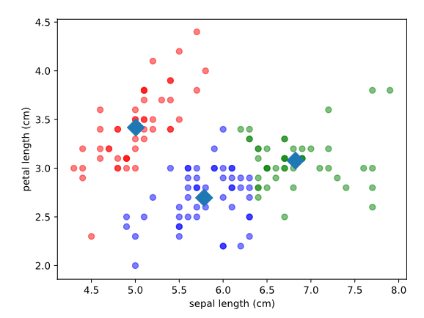

import codecademylib3_seaborn

import matplotlib.pyplot as plt

import numpy as np

from sklearn import datasets

from copy import deepcopy

iris = datasets.load_iris()

samples = iris.data

x = samples[:,0]

y = samples[:,1]

sepal_length_width = np.array(list(zip(x, y)))

# Step 1: Place K random centroids

k = 3

centroids_x = np.random.uniform(min(x), max(x), size=k)

centroids_y = np.random.uniform(min(y), max(y), size=k)

centroids = np.array(list(zip(centroids_x, centroids_y)))

def distance(a, b):

one = (a[0] - b[0]) ** 2

two = (a[1] - b[1]) ** 2

distance = (one + two) ** 0.5

return distance

# To store the value of centroids when it updates

centroids_old = np.zeros(centroids.shape)

# Cluster labeles (either 0, 1, or 2)

labels = np.zeros(len(samples))

distances = np.zeros(3)

# Initialize error:

error = np.zeros(3)

error[0] = distance(centroids[0], centroids_old[0])

error[1] = distance(centroids[1], centroids_old[1])

error[2] = distance(centroids[2], centroids_old[2])

# Repeat Steps 2 and 3 until convergence:

while error.all() != 0:

# Step 2: Assign samples to nearest centroid

for i in range(len(samples)):

distances[0] = distance(sepal_length_width[i], centroids[0])

distances[1] = distance(sepal_length_width[i], centroids[1])

distances[2] = distance(sepal_length_width[i], centroids[2])

cluster = np.argmin(distances)

labels[i] = cluster

# Step 3: Update centroids

centroids_old = deepcopy(centroids)

for i in range(3):

points = [sepal_length_width[j] for j in range(len(sepal_length_width)) if labels[j] == i]

centroids[i] = np.mean(points, axis=0)

error[0] = distance(centroids[0], centroids_old[0])

error[1] = distance(centroids[1], centroids_old[1])

error[2] = distance(centroids[2], centroids_old[2])

colors = ['r', 'g', 'b']

for i in range(k):

points = np.array([sepal_length_width[j] for j in range(len(samples)) if labels[j] == i])

plt.scatter(points[:, 0], points[:, 1], c=colors[i], alpha=0.5)

plt.scatter(centroids[:, 0], centroids[:, 1], marker='D', s=150)

plt.xlabel('sepal length (cm)')

plt.ylabel('petal length (cm)')

plt.show()

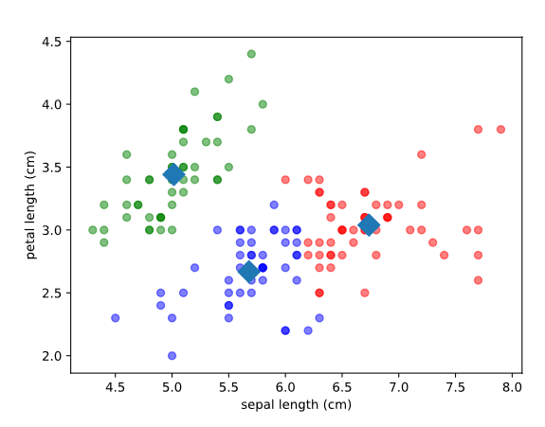

# Implementing K-Means: Scikit-Learn

Awesome, you have implemented K-Means clustering from scratch!

Writing an algorithm whenever you need it can be very time-consuming and you might make mistakes and typos along the way. We will now show you how to implement K-Means more efficiently – using the [scikit-learn](https://www.http:/scikit-learn.org/) library.

Instead of implementing K-Means from scratch, the sklearn.cluster module has many methods that can do this for you.

To import KMeans from sklearn.cluster:

from sklearn.cluster import KMeans

For Step 1, use the KMeans() method to build a model that finds k clusters. To specify the number of clusters (k), use the n_clusters keyword argument:

model = KMeans(n_clusters = k)

For Steps 2 and 3, use the .fit() method to compute K-Means clustering:

model.fit(X)

After K-Means, we can now predict the closest cluster each sample in X belongs to. Use the .predict() method to compute cluster centers and predict cluster index for each sample:

model.predict(X)

**1.**

First, import KMeans from sklearn.cluster.

**2.**

Somewhere after samples = iris.data, use KMeans() to create an instance called model to find 3 clusters.

To specify the number of clusters, use the n_clusters keyword argument.

**3.**

Next, use the .fit() method of model to fit the model to the array of points samples:

**4.**

After you have the "fitted" model, determine the cluster labels of samples.

Then, print the labels.

import codecademylib3_seaborn  
import matplotlib.pyplot as plt  
from sklearn import datasets  
  
# From sklearn.cluster, import Kmeans class  
from sklearn.cluster import KMeans  
iris = datasets.load_iris()  
  
samples = iris.data  
  
# Use KMeans() to create a model that finds 3 clusters  
model = KMeans(n_clusters=3)  
# Use .fit() to fit the model to samples  
model.fit(samples)  
# Use .predict() to determine the labels of samples  
labels = model.predict(samples)  
# Print the labels  
print(labels)

# New Data?

You used K-Means and found three clusters of the samples data. But it gets cooler!

Since you have created a model that computed K-Means clustering, you can now feed new data samples into it and obtain the cluster labels using the .predict() method.

So, suppose we went to the florist and bought 3 more Irises with the measurements:

[[ 5.1 3.5 1.4 0.2 ]

[ 3.4 3.1 1.6 0.3 ]

[ 4.9 3. 1.4 0.2 ]]

We can feed this new data into the model and obtain the labels for them.

**1.**

First, store the 2D matrix:

new_samples = np.array([[5.7, 4.4, 1.5, 0.4],

[6.5, 3. , 5.5, 0.4],

[5.8, 2.7, 5.1, 1.9]])

To test if it worked, print the new_samples.

**2.**

Use the model to predict labels for the new_samples, and print the predictions.

The output might look like:

[0 2 2]

Those are the predicted labels for our three new flowers. If you are seeing different labels, don't worry! Since the cluster centroids are randomly initialized, running the model repeatedly can produce different clusters with the same input data.

import codecademylib3_seaborn  
import matplotlib.pyplot as plt  
import numpy as np  
from sklearn import datasets  
from sklearn.cluster import KMeans  
  
iris = datasets.load_iris()  
  
samples = iris.data  
  
model = KMeans(n_clusters=3)  
  
model.fit(samples)  
  
# Store the new Iris measurements  
new_samples = np.array([[5.7, 4.4, 1.5, 0.4], [6.5, 3. , 5.5, 0.4], [5.8, 2.7, 5.1, 1.9]])  
print(new_samples)  
# Predict labels for the new_samples  
predictions = model.predict(new_samples)  
print(predictions)

**Visualize After K-Means**

We have done the following using sklearn library:

* Load the embedded dataset
* Compute K-Means on the dataset (where k is 3)
* Predict the labels of the data samples

And the labels resulted in either 0, 1, or 2.

Let's finish it by making a scatter plot of the data again!

This time, however, use the labels numbers as the colors.

To edit colors of the scatter plot, we can set c = labels:

plt.scatter(x, y, c=labels, alpha=0.5)

plt.xlabel('sepal length (cm)')

plt.ylabel('petal length (cm)')

Instructions

**1.**

Create an array called x that contains the Column 0 of samples.

Create an array called y that contains the Column 1 of samples.

**2.**

Make a scatter plot of x and y, using labels to define the colors.

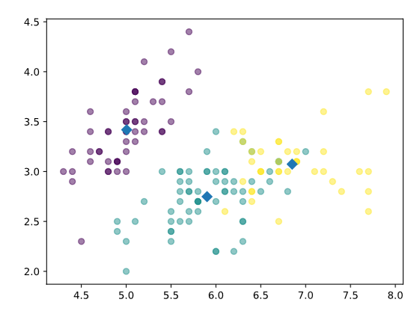

import codecademylib3_seaborn  
import matplotlib.pyplot as plt  
from sklearn import datasets  
from sklearn.cluster import KMeans  
  
iris = datasets.load_iris()  
  
samples = iris.data  
  
model = KMeans(n_clusters=3)  
  
model.fit(samples)  
  
labels = model.predict(samples)  
  
print(labels)  
  
# Make a scatter plot of x and y and using labels to define the colors  
x = samples[:,0]  
y = samples[:,1]  
plt.scatter(x,y,c=labels,alpha=0.5)  
plt.xlabel('sepal length (cm)')  
plt.ylabel('petal length (cm)')

**Evaluation**

At this point, we have clustered the Iris data into 3 different groups (implemented using Python and using scikit-learn). But do the clusters correspond to the actual species? Let's find out!

First, remember that the Iris dataset comes with target values:

target = iris.target

It looks like:

[ 0 0 0 0 0 ... 2 2 2]

According to the metadata:

* All the 0's are *Iris-setosa*
* All the 1's are *Iris-versicolor*
* All the 2's are *Iris-virginica*

Let's change these values into the corresponding species using the following code:

species = np.chararray(target.shape, itemsize=150)

for i in range(len(samples)):

if target[i] == 0:

species[i] = 'setosa'

elif target[i] == 1:

species[i] = 'versicolor'

elif target[i] == 2:

species[i] = 'virginica'

Then we are going to use the Pandas library to perform a *cross-tabulation*.

Cross-tabulations enable you to examine relationships within the data that might not be readily apparent when analyzing total survey responses.

The result should look something like:

labels setosa versicolor virginica

0 0 2 36

1 50 0 0

2 0 48 14

(You might need to expand this narrative panel in order to the read the table better.)

The first column has the cluster labels. The second to fourth columns have the Iris species that are clustered into each of the labels.

By looking at this, you can conclude that:

* *Iris-setosa* was clustered with 100% accuracy.
* *Iris-versicolor* was clustered with 96% accuracy.
* *Iris-virginica* didn't do so well.

Follow the instructions below to learn how to do a cross-tabulation.

**1.**

pandas is already imported for you:

import pandas as pd

Add the code from the narrative to get the species array:

species = np.chararray(target.shape, itemsize=150)

for i in range(len(samples)):

if target[i] == 0:

species[i] = 'setosa'

# finish elif

# finish elif

**2.**

Then, create:

df = pd.DataFrame({'labels': labels, 'species': species})

print(df)

**3.**

Next, use the the crosstab() method to perform cross-tabulation:

ct = pd.crosstab(df['labels'], df['species'])

print(ct)

Expand the right panel (output terminal).

*How accurate are the clusters?*

import codecademylib3_seaborn  
import matplotlib.pyplot as plt  
import numpy as np  
from sklearn import datasets  
from sklearn.cluster import KMeans  
import pandas as pd  
  
iris = datasets.load_iris()  
  
samples = iris.data  
  
target = iris.target  
  
model = KMeans(n_clusters=3)  
  
model.fit(samples)  
  
labels = model.predict(samples)  
  
# Code starts here:  
species = np.chararray(target.shape, itemsize=150)  
  
for i in range(len(samples)):  
 if target[i] == 0:  
 species[i] = 'setosa'  
 elif target[i] == 1:  
 species[i] = 'versicolor'  
 elif target[i] == 2:  
 species[i] = 'virginica'  
  
df = pd.DataFrame({'labels': labels, 'species': species})  
print(df)  
  
ct = pd.crosstab(df['labels'], df['species'])  
print(ct)  
'''  
[150 rows x 2 columns]  
species b'setosa' b'versicolor' b'virginica'  
labels   
0 50 0 0  
1 0 48 14  
2 0 2 36  
'''

**The Number of Clusters**

At this point, we have grouped the Iris plants into 3 clusters. But suppose we didn't know there are three species of Iris in the dataset, what is the best number of clusters? And how do we determine that?

Before we answer that, we need to define what is a *good* cluster?

Good clustering results in tight clusters, meaning that the samples in each cluster are bunched together. How spread out the clusters are is measured by *inertia*. Inertia is the distance from each sample to the centroid of its cluster. The lower the inertia is, the better our model has done.

You can check the inertia of a model by:

print(model.inertia_)

For the Iris dataset, if we graph all the ks (number of clusters) with their inertias:

Notice how the graph keeps decreasing.

Ultimately, this will always be a trade-off. The goal is to have low inertia *and* the least number of clusters.

One of the ways to interpret this graph is to use the *elbow method*: choose an "elbow" in the inertia plot - when inertia begins to decrease more slowly.

In the graph above, 3 is the optimal number of clusters.

**1.**

First, create two lists:

* num_clusters that has values from 1, 2, 3, ... 8
* inertias that is empty

**2.**

Then, iterate through num_clusters and calculate K-means for each number of clusters.

Add each of their inertias into the inertias list.

**3.**

Plot the inertias vs num_clusters:

plt.plot(num_clusters, inertias, '-o')

plt.xlabel('Number of Clusters (k)')

plt.ylabel('Inertia')

plt.show()

import codecademylib3_seaborn  
import matplotlib.pyplot as plt  
import numpy as np  
import pandas as pd  
from sklearn import datasets  
from sklearn.cluster import KMeans  
  
iris = datasets.load_iris()  
  
samples = iris.data  
  
# Code Start here:  
num_clusters = list(range(1, 9))  
inertias = []  
  
for n in num_clusters:  
 model = KMeans(n_clusters=n)  
 model.fit(samples)  
 inertias.append(model.inertia_)  
  
plt.plot(num_clusters, inertias, '-o')  
plt.xlabel('Number of Clusters (k)')  
plt.ylabel('Inertia')  
plt.show()

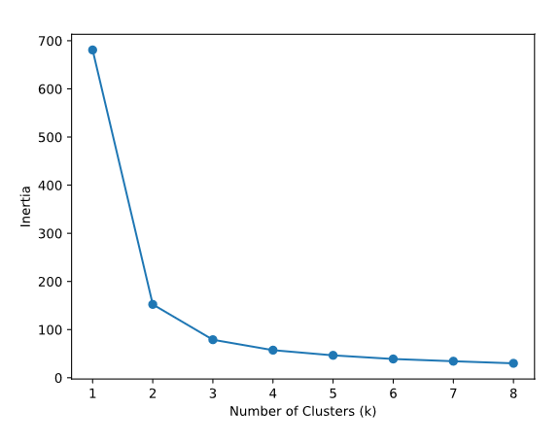

**Try It On Your Own**

Now it is your turn!

In this review section, find another dataset from one of the following:

* The [scikit-learn](http://scikit-learn.org/stable/datasets/index.html) library
* [UCI Machine Learning Repo](https://archive.ics.uci.edu/ml/index.php)
* Codecademy GitHub Repo (coming soon!)

Import the pandas library as pd:

import pandas as pd

Load in the data with read_csv():

digits = pd.read_csv("http://archive.ics.uci.edu/ml/machine-learning-databases/optdigits/optdigits.tra", header=None)

Note that if you download the data like this, the data is already split up into a training and a test set, indicated by the extensions **.tra** and **.tes**. You’ll need to load in both files.

With the command above, you only load in the training set.

Happy Coding!

Instructions

Implement K-Means clustering on another dataset and see what you can find.

If you think you found something interesting, let us know by posting it on Facebook, Twitter, or Instagram.

import pandas as pd  
from sklearn import datasets  
from sklearn.cluster import KMeans  
import matplotlib.pyplot as plt  
import numpy as np  
  
wine = datasets.load_wine()  
#print(wine.data)  
#print(wine.target)  
#print(wine.DESCR)  
  
# How Many Clusters Should we Recognize?  
num_clusters = list(range(1, 9))  
inertias = []  
for n in num_clusters:  
 model = KMeans(n_clusters=n)  
 model.fit(wine.data)  
 inertias.append(model.inertia_)  
  
print(inertias)  
plt.plot(num_clusters, inertias, '-o')  
plt.xlabel('Number of Clusters (k)')  
plt.ylabel('Inertia')  
plt.show()

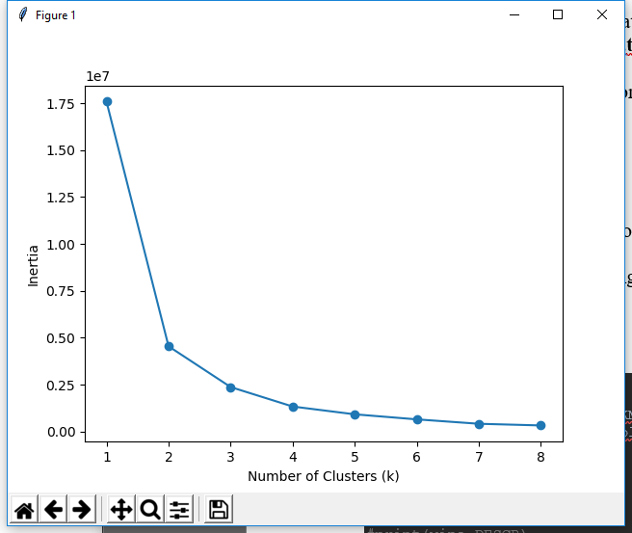

# 4 wine clusters

import pandas as pd  
from sklearn import datasets  
from sklearn.cluster import KMeans  
import matplotlib.pyplot as plt  
import numpy as np  
  
wine = datasets.load_wine()  
#print(wine.data)  
#print(wine.target)  
print(wine.target_names)  
print(wine.DESCR)  
  
# How Many Clusters Should we Recognize?  
num_clusters = list(range(1, 8))  
inertias = []  
for n in num_clusters:  
 model = KMeans(n_clusters=n)  
 model.fit(wine.data)  
 inertias.append(model.inertia_)  
  
plt.plot(num_clusters, inertias, '-o')  
plt.xlabel('Number of Clusters (k)')  
plt.ylabel('Inertia')  
plt.show() # looks like the inertia plot concurs that there are 3 clusters (different types of wine)  
  
model = KMeans(n_clusters=3)  
model.fit(wine.data)  
labels = model.predict(wine.data)  
x = wine.data[:,4]  
y = wine.data[:,12]  
plt.scatter(x,y,c=labels,alpha=0.3)  
plt.xlabel('Magnesium')  
plt.ylabel('Proline')  
plt.show()

