**Perceptron Logic Gates**

In this project, we will use perceptrons to model the fundamental building blocks of computers — logic gates.

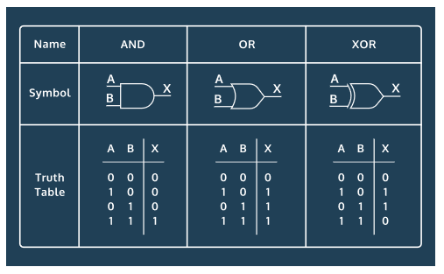

For example, the table below shows the results of an AND gate. Given two inputs, an AND gate will output a 1 only if both inputs are a 1:

| **Input 1** | **Input 2** | **Output** |
| --- | --- | --- |
| 0 | 0 | 0 |
| 0 | 1 | 0 |
| 1 | 0 | 0 |
| 1 | 1 | 1 |

We'll discuss how an AND gate can be thought of as linearly separable data and train a perceptron to perform AND.

We'll also investigate an XOR gate — a gate that outputs a 1 only if one of the inputs is a 1:

| **Input 1** | **Input 2** | **Output** |
| --- | --- | --- |
| 0 | 0 | 0 |
| 0 | 1 | 1 |
| 1 | 0 | 1 |
| 1 | 1 | 0 |

We'll think about why an XOR gate isn't linearly separable and show how a perceptron fails to learn XOR.

If you get stuck during this project, check out the **project walkthrough video** which can be found at the bottom of the page after the final step of the project.

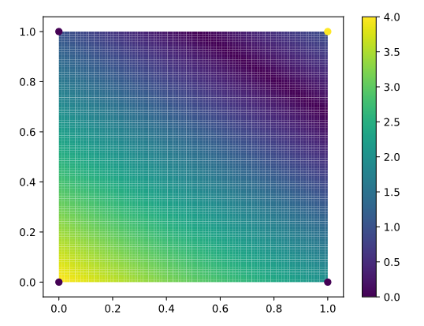

### Creating and visualizing AND Data

1.

To begin, let's think of an AND gate as a dataset of four points. The four points should be the four possible inputs to the AND gate. For example, the first point in the dataset should be [0, 0].

Create a variable named data that is a list that contains the four possible inputs to an AND gate.

2.

Each data point should have a label associated with it. The label will be the result of the AND gate given the input.

Create a variable named labels. This should be a list where each label corresponds to a point in data. For example, if the last item in data is [1, 1], the last label should be 1.

3.

Let's plot these four points on a graph.

Call plt.scatter() using three parameters:

* The first parameter should be a list of the x values of each point. You can get this using list comprehension — [point[0] for point in data].
* The second parameter should be a list of the y values of each point. The third parameter should be c = labels. This will make the points with label 1 a different color than points with label 0.

After calling plt.scatter() call plt.show(). As you continue to write your code, make sure plt.show() is always the last line of code.

Why is this data linearly separable?

### Building the Perceptron

4.

Now that we have our data, let's build a perceptron to learn AND. Create a Perceptron object named classifier. For now, set the parameter max_iter to 40.

max_iter sets the number of times the perceptron loops through the training data. The default is 1000, so we're cutting the training pretty short! Let's see if our algorithm learns AND even with very little training.

5.

We'll now train the model. Call the .fit() method using data and labels as parameters.

6.

Let's see if the algorithm learned AND. Call classifier's .score() method using data and labels as parameters. Print the results. This will print the accuracy of the model on the data points.

Note that it is pretty unusual to train and test on the same dataset. In this case, since there are only four possible inputs to AND, we're stuck training on every possible input and testing on those same points.

7.

Your perceptron should have 100% accuracy! You just taught it an AND gate!

Let's change the labels so your data now represents an XOR gate. The label should be a 1 only if one of the inputs is a 1. What is the accuracy of the perceptron now? Is the data linearly separable?

8.

Try changing the data to represent an OR gate. The label of a point should be a 1 if any of the input values are a 1.

Before running your code, predict what will happen. Is the data linearly separable? What do you expect the accuracy of the perceptron to be?

### Visualizing the Perceptron

9.

We know the perceptron has been trained correctly, but let's try to visualize what decision boundary it is making. Reset your labels to be representing an AND gate.

Let's first investigate the classifier's .decision_function() method. Given a list of points, this method returns the distance those points are from the decision boundary. The closer the number is to 0, the closer that point is to the decision boundary.

Try calling classifier's .decision_function() method using [[0, 0], [1, 1], [0.5, 0.5]] as a parameter. Print the results.

Is the point [0, 0] or the point [1, 1] closer to the decision boundary?

10.

Even though an input like [0.5, 0.5] isn't a real input to an AND logic gate, we can still check to see how far it is from the decision boundary.

We could also do this to the point [0, 0.1], [0, 0.2] and so on. If we do this for a grid of points, we can make a heat map that reveals the decision boundary.

To begin, we need to create a list of the points we want to input to .decision_function().

Begin by creating a list named x_values. x_values should be a list of 100 evenly spaced decimals between 0 and 1. np.linspace(0, 1, 100) will do this.

Do the same for y_values.

11.

We have a list of 100 x values and 100 y values. We now want to find every possible combination of those x and y values.

The function product will do this for you. For example, consider the following code:

list(product([1, 2, 3], [4, 5, 6]))

This code will produces the following list:

[(1, 4), (1, 5), (1, 6), (2, 4), (2, 5), (2, 6), (3, 4), (3, 5), (3, 6)]

Call product() using x_values and y_values as paramters. Don't forget to put list() around the call to product(). Store the result in a variable named point_grid.

12.

Call classifier's .decision_function() method using point_grid as a parameter. Store the results in a variable named distances.

13.

Right now distances stores positive and negative values. We only care about how far away a point is from the boundary — we don't care about the sign.

Take the absolute value of every distance. Use list comprehension to call abs() on every point in the list and store it in a new variable called abs_distances.

14.

We're almost ready to draw the heat map. We're going to be using Matplotlib's [pcolormesh() function](https://matplotlib.org/api/_as_gen/matplotlib.pyplot.pcolormesh.html).

Right now, abs_distances is a list of 10000 numbers. pcolormesh needs a two dimensional list. We need to turn abs_distances into a 100 by 100 two dimensional array.

Numpy's reshape function does this for us. The code below turns list lst into a 2 by 2 list.

lst = [1, 2 ,3, 4]

new_lst = np.reshape(lst, (2, 2))

new_lst now looks like this:

[[1, 2],[3, 4]]

Turn abs_distances into a 100 by 100 list and name it distances_matrix.

15.

It's finally time to draw the [heat map](https://matplotlib.org/gallery/images_contours_and_fields/image_annotated_heatmap.html)! Call plt.pcolormesh() with the following three parameters:

* x_values
* y_values
* distances_matrix

Save the result in a variable named heatmap.

Then call plt.colorbar() using heatmap as a parameter. This will put a legend on the heat map.

Make sure plt.show() is still below these function calls.

16.

Great work! You now have a great visualization of what the perceptron is doing. You should see a purple line where the distances are 0. That's the decision boundary!

Change your labels back to representing an OR gate. Where does the decision boundary go?

Change your labels to represent an XOR gate. Remember, this data is not linearly separable. Where does the decision boundary go?

Perceptrons can't solve problems that aren't linearly separable. However, if you combine multiple perceptrons together, you now have a neural net that can solve these problems!

This is incredibly similar to logic gates. AND gates and OR gates can't produce the output of XOR gates, but when you combine a few ANDs and ORs, you can make an XOR!

17.

If you are stuck on the project or would like to see an experienced developer work through the project, watch the following project walkthrough video! <https://youtu.be/grb4LlTg1RE>

import codecademylib3_seaborn  
from sklearn.linear_model import Perceptron  
import matplotlib.pyplot as plt  
import numpy as np  
from itertools import product  
  
## AND Gate  
data = [[0,0],[0,1],[1,0],[1,1]]  
labels = [0, 0, 0, 1] # result of data through an AND gate  
plt.scatter([point[0] for point in data], [point[1] for point in data], c=labels, alpha=0.5)  
plt.title('AND Gate')  
plt.show()  
# AND data set is linearly seperable... line with -1 slope and intercept > 1 would do it.  
  
classifier = Perceptron(max_iter=40)  
classifier.fit(data, labels)  
print(classifier.score(data,labels)) # 1.0 ... no surprise  
  
  
## OR Gate  
data = [[0,0],[0,1],[1,0],[1,1]]  
labels = [0, 1, 1, 1] # result of data through an OR gate  
plt.scatter([point[0] for point in data], [point[1] for point in data], c=labels, alpha=0.5)  
plt.title('OR Gate')  
plt.show()  
# OR data set is linearly seperable... line with -1 slope and intercept < 1 would do it.  
  
classifier = Perceptron(max_iter=40)  
classifier.fit(data, labels)  
print(classifier.score(data,labels)) #1.0 no surprise  
  
  
## XOR Gate  
data = [[0,0],[0,1],[1,0],[1,1]]  
labels = [0, 1, 1, 0] # result of data through an XOR gate  
plt.scatter([point[0] for point in data], [point[1] for point in data], c=labels, alpha=0.5)  
plt.title('XOR Gate')  
plt.show()  
# XOR data set could not be linearly seperable, unless there is some mechanism to only classify objects ON a boundary  
  
classifier = Perceptron(max_iter=40)  
classifier.fit(data, labels)  
print(classifier.score(data,labels)) #0.5 ... coin flip  
  
  
## Visualizing the Perceptron  
  
data = [[0,0],[0,1],[1,0],[1,1]]  
labels = [0, 0, 0, 1] # result of data through an AND gate  
classifier = Perceptron(max_iter=40)  
classifier.fit(data, labels)  
print(classifier.decision_function([[0,0],[1,1],[0.5,0.5]])) # [-4. 1. -1.5]  
  
x_values = np.linspace(0,1,100)  
y_values = np.linspace(0,1,100)  
point_grid = list(product(x_values, y_values))  
distances = classifier.decision_function(point_grid)  
abs_distances = abs(distances)  
  
distances_matrix = np.reshape(abs_distances, (100,100))  
heatmap = plt.pcolormesh(x_values, y_values, distances_matrix)  
plt.colorbar(heatmap)  
plt.title('Decision Boundary Heatmap for AND gate')  
plt.show()  
  
data = [[0,0],[0,1],[1,0],[1,1]]  
labels = [0, 1, 1, 1] # result of data through an OR gate  
classifier = Perceptron(max_iter=40)  
classifier.fit(data, labels)  
  
x_values = np.linspace(0,1,100)  
y_values = np.linspace(0,1,100)  
point_grid = list(product(x_values, y_values))  
distances = classifier.decision_function(point_grid)  
abs_distances = abs(distances)  
  
distances_matrix = np.reshape(abs_distances, (100,100))  
heatmap = plt.pcolormesh(x_values, y_values, distances_matrix)  
plt.colorbar(heatmap)  
plt.title('Decision Boundary Heatmap for OR gate')  
plt.show()  
  
  
data = [[0,0],[0,1],[1,0],[1,1]]  
labels = [0, 1, 1, 0] # result of data through an XOR gate  
classifier = Perceptron(max_iter=40)  
classifier.fit(data, labels)  
  
x_values = np.linspace(0,1,100)  
y_values = np.linspace(0,1,100)  
point_grid = list(product(x_values, y_values))  
distances = classifier.decision_function(point_grid)  
abs_distances = abs(distances)  
  
distances_matrix = np.reshape(abs_distances, (100,100))  
heatmap = plt.pcolormesh(x_values, y_values, distances_matrix)  
plt.colorbar(heatmap)  
plt.title('Decision Boundary Heatmap for XOR gate')  
plt.show()

