Java Project QA Process

**Pre Testing Phase:**

* Reviewing of TDD with Dev, QA, PJM

<http://dev.paypal.com/cgi-bin/twiki/bin/view/AppSec/TDDJavaProtected>

* Dev and QA Provides the swag for the projects

\\sjd-xntfs-001.tpa.ebay.com\Qaidc\IDC_QA_App_Security\65.1\Java_Protected\32464\06_QA Swag Estimation\Version 1

* Dev should provide the information on external interfaces and parameters of those interfaces(In the form of Flow chart or Diagram)
* Dev starts coding and QA started preparing Test Plan and Integration Test Cases based on external interfaces provided by Dev
* Need to identify and finalize the test environment and test data required and work towards to get them ASAP. (Ex: Protected Packages, Solaris Environment, Different JDK versions)
* Dev has to share the Unit Test cases and Source Code. All the unit test cases should pass and coverage should be 80% while handing over the code to QA for testing

Source code and Unit Test Cases path:

<http://10.253.32.23/svn/projects/appsecurity/protectedpkg/trunk/>

* Test Plan and Test Cases

\\sjd-xntfs-001.tpa.ebay.com\Qaidc\IDC_QA_App_Security\65.1\Java_Protected\32464\07_Test_Plan\ 03_QA_Test_Plan\32464 _Test_Plan-v5.doc

\\sjd-xntfs-001.tpa.ebay.com\Qaidc\IDC_QA_App_Security\65.1\Java_Protected\32464\08_Test Cases\03_QA TCs\Version 1\32464_TCs.doc

* Test Plan and Test cases should undergo Peer review sign off
* Test Plan and Test cases should undergo Dev review and sign off
* QA reviews the source code and unit test cases
* QA should look for the project under <http://10.253.32.23/svn/projects/appsecurity/qa/trunk>
* If the project already exists (if QA working on phase-2 etc) he can use the existing source code under trunk and enhance it.
* If the project doesn’t exists QA has to create a new project under
  + http://10.253.32.23/svn/projects/appsecurity/qa/trunk

Ex: The Java protected package project is crated as shown below <http://10.253.32.23/svn/projects/appsecurity/qa/trunk/infra-qa-protected-pkg/>

**Testing Phase:**

* QA writes the scenario which was not covered in unit test cases and also integration test cases (end to end test cases). The main focus should be on end to end testing.
* The QA test case coverage and code is reviewed by dev and signed off
* Create a suite file to run all the cases If the test cases are distributed across multiple files as shown below

**package** com.paypal.infra.qa.protectedpkg;

**import** junit.framework.TestSuite;

;

**public** **class** TestSuites **extends** TestSuite {

**public** **static** TestSuite suite() **throws** Exception {

TestSuite suite = **new** TestSuite("Test for com.paypal.infra.prtectedpkg");

// ProtectedPackageUtil.setupForInputViaSystemProperty();

// $JUnit-BEGIN$

suite.addTestSuite(TestKeyStoreRegistry.**class**);

suite.addTestSuite(TestProtectedProvider.**class**);

suite.addTestSuite(TestE2EScenarios.**class**);

suite.addTestSuite(TestPinProvider.**class**);

// $JUnit-END$

**return** suite;

}

}

* Now QA has to execute the test cases with following JDK versions on windows platform using eclipse
  + IBM JDK 1.6 version
  + Sun JDK 1.6 version
  + Sun JDK 1.5 version
  + IBM JDK 1.5 version

To change the versions following the instructions given below

* Download and install all JDK versions
* Change the version in eclipse
* Update the maven dependencies

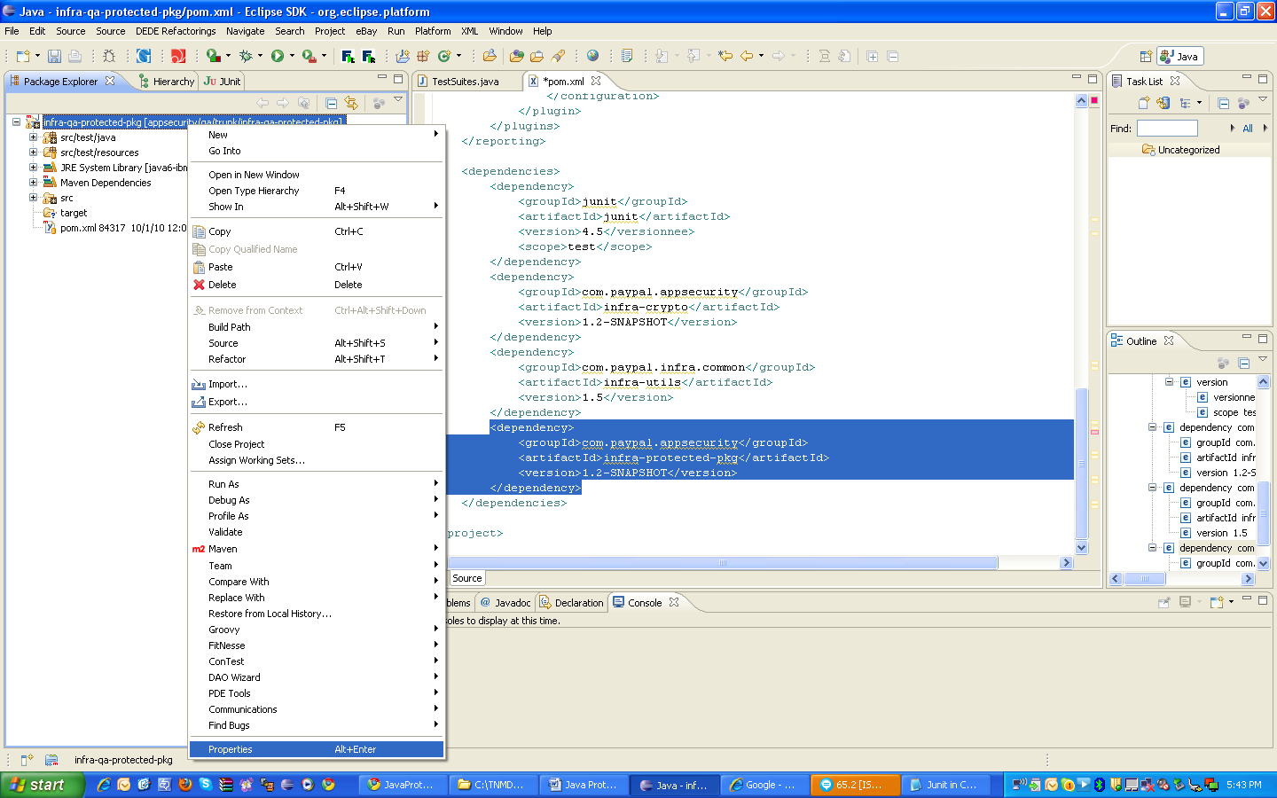

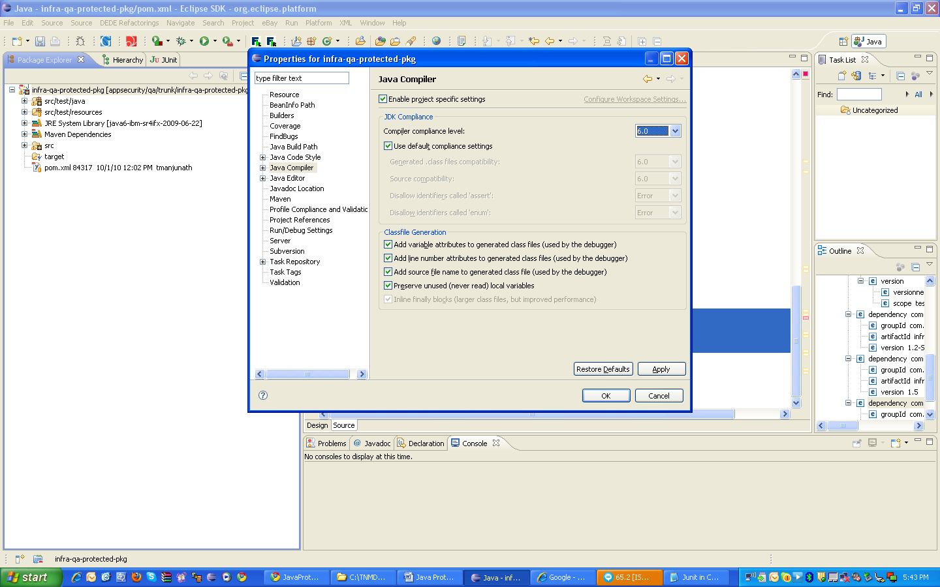

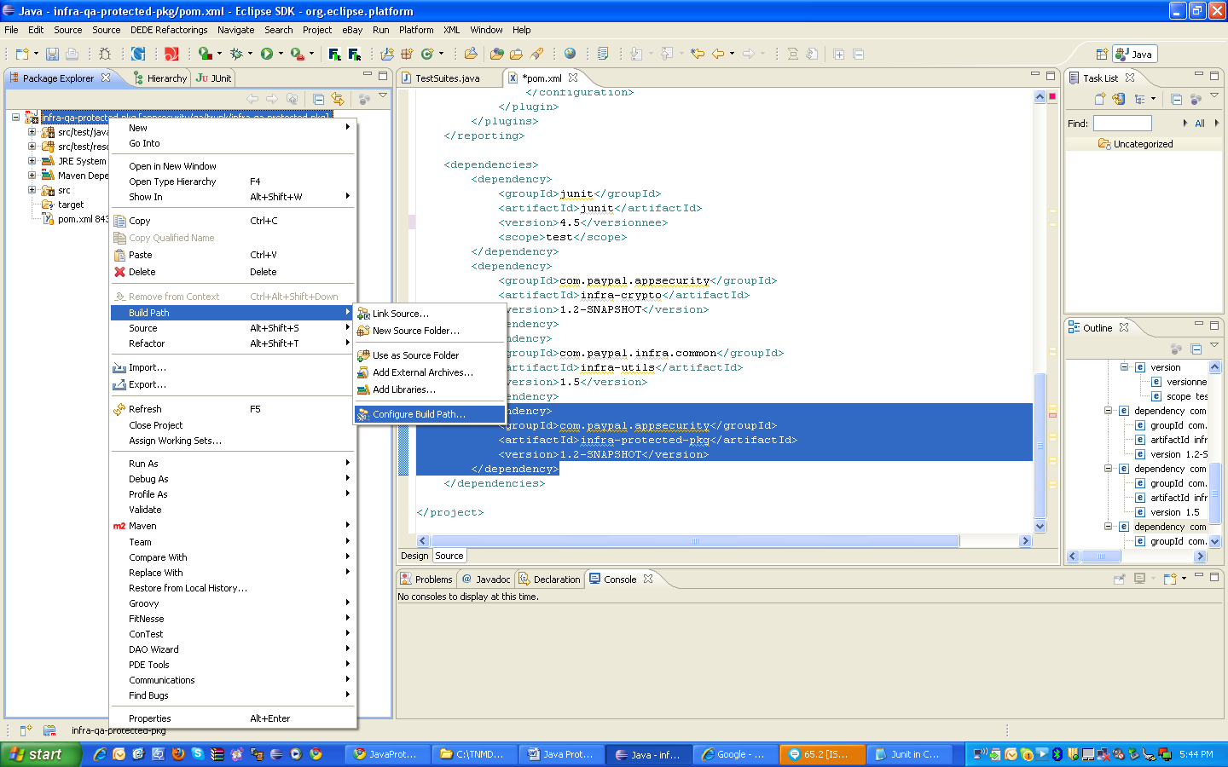

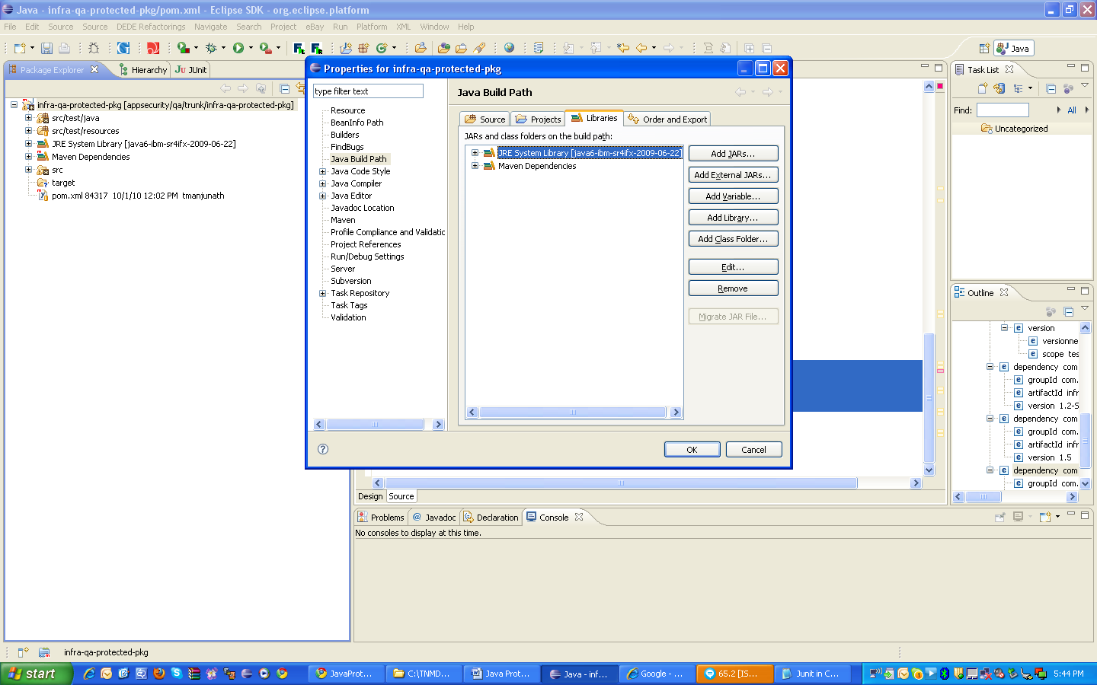

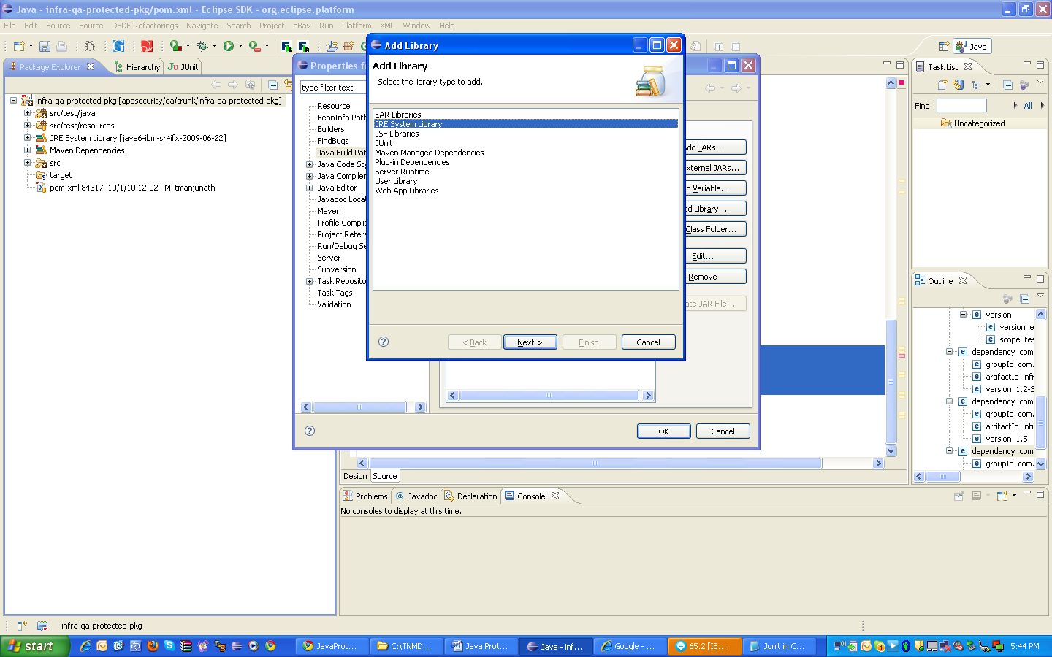

Select the JRE version if there or else install the new version

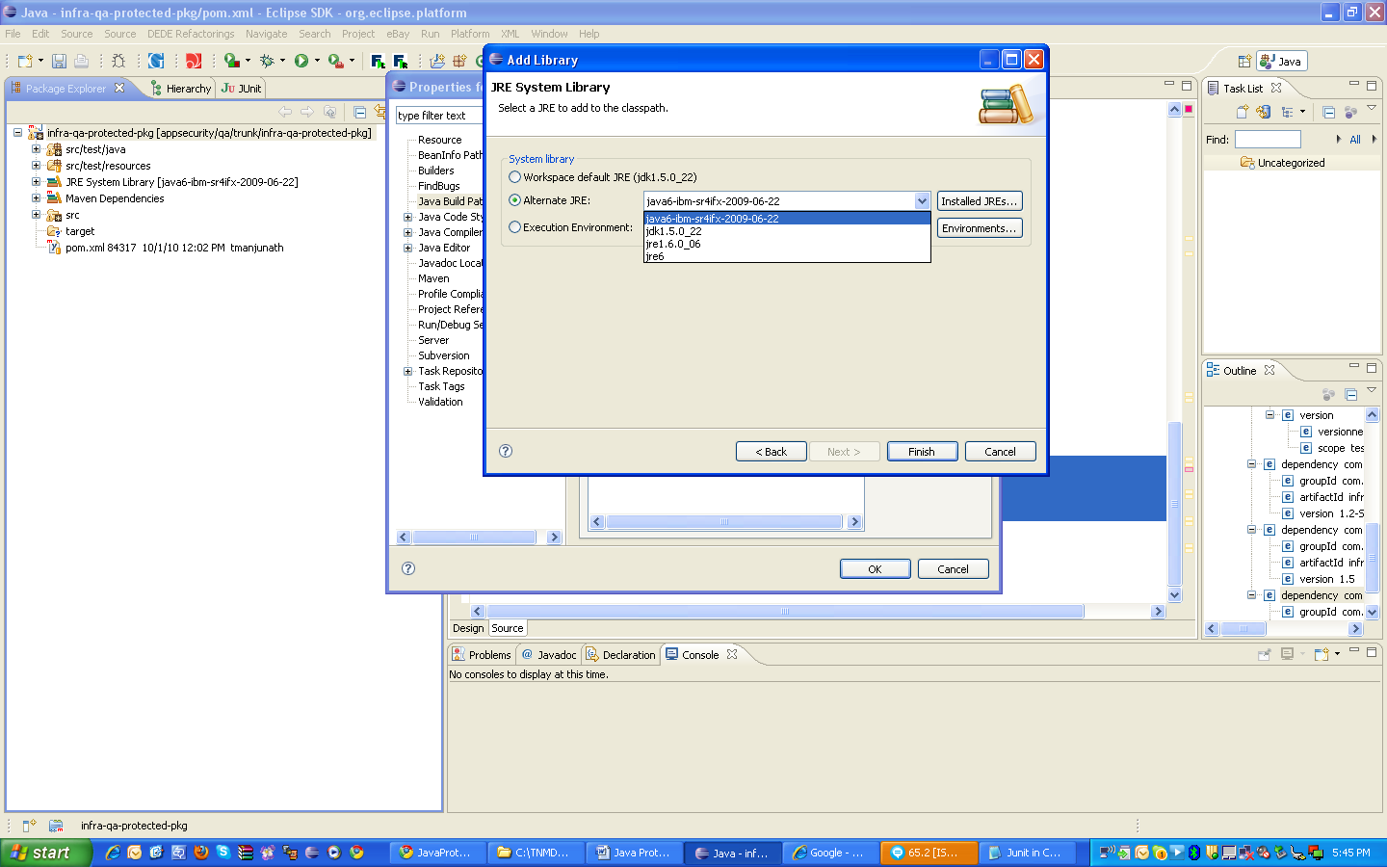

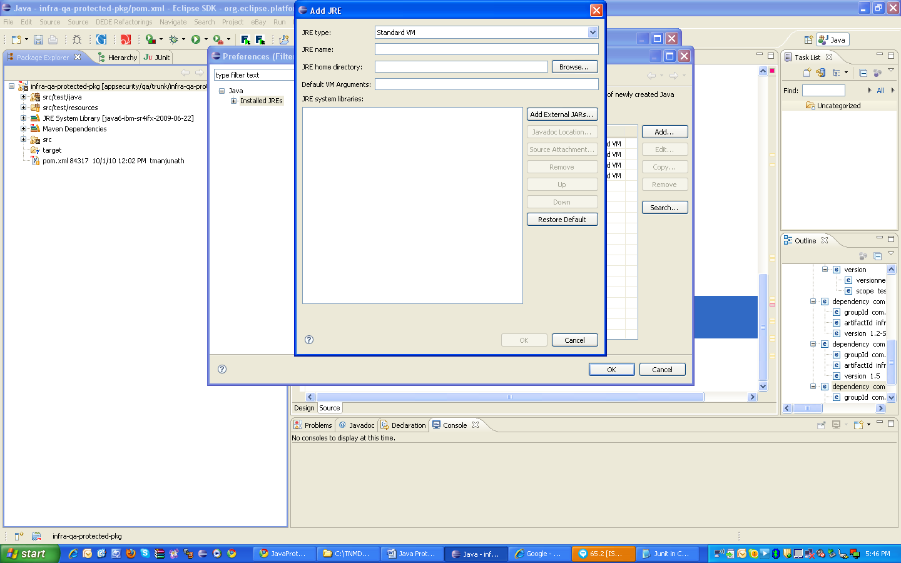

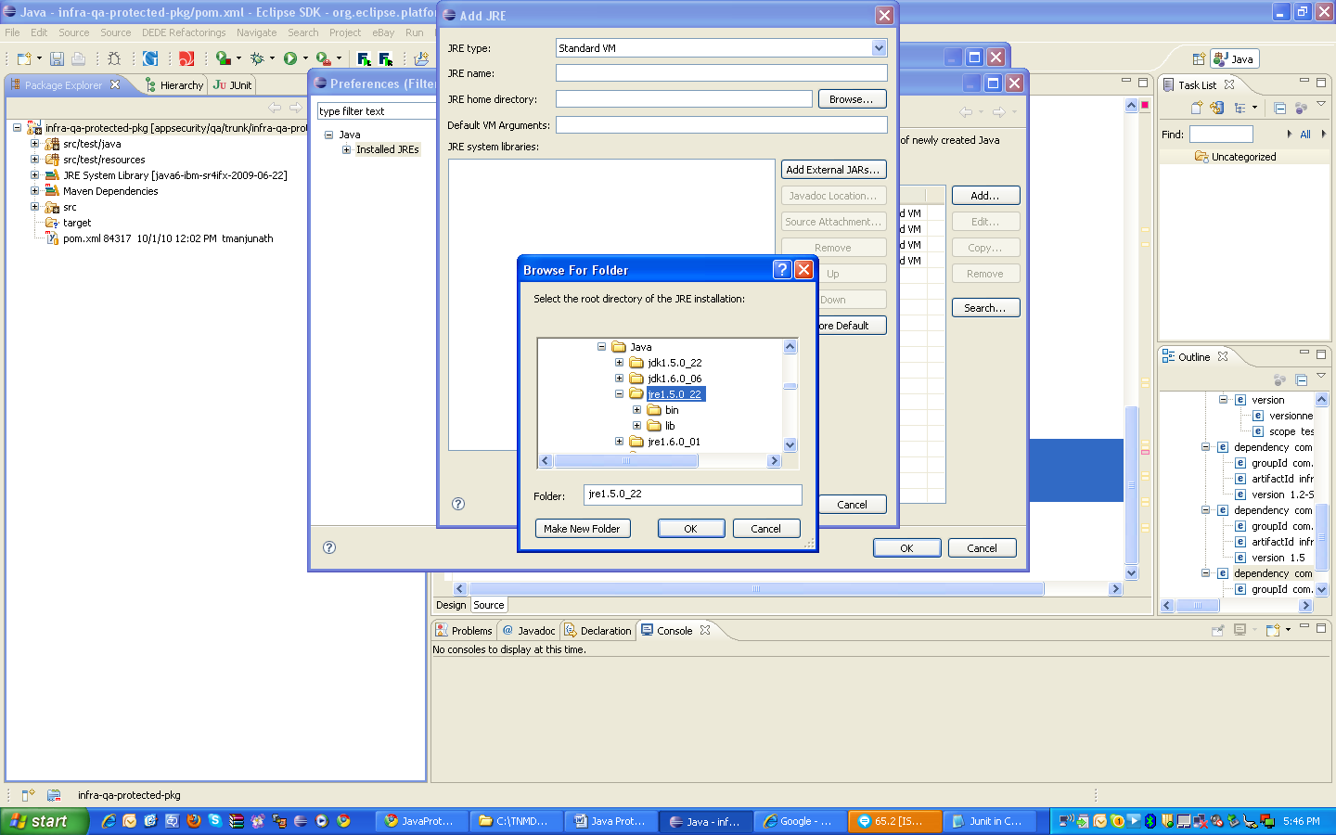

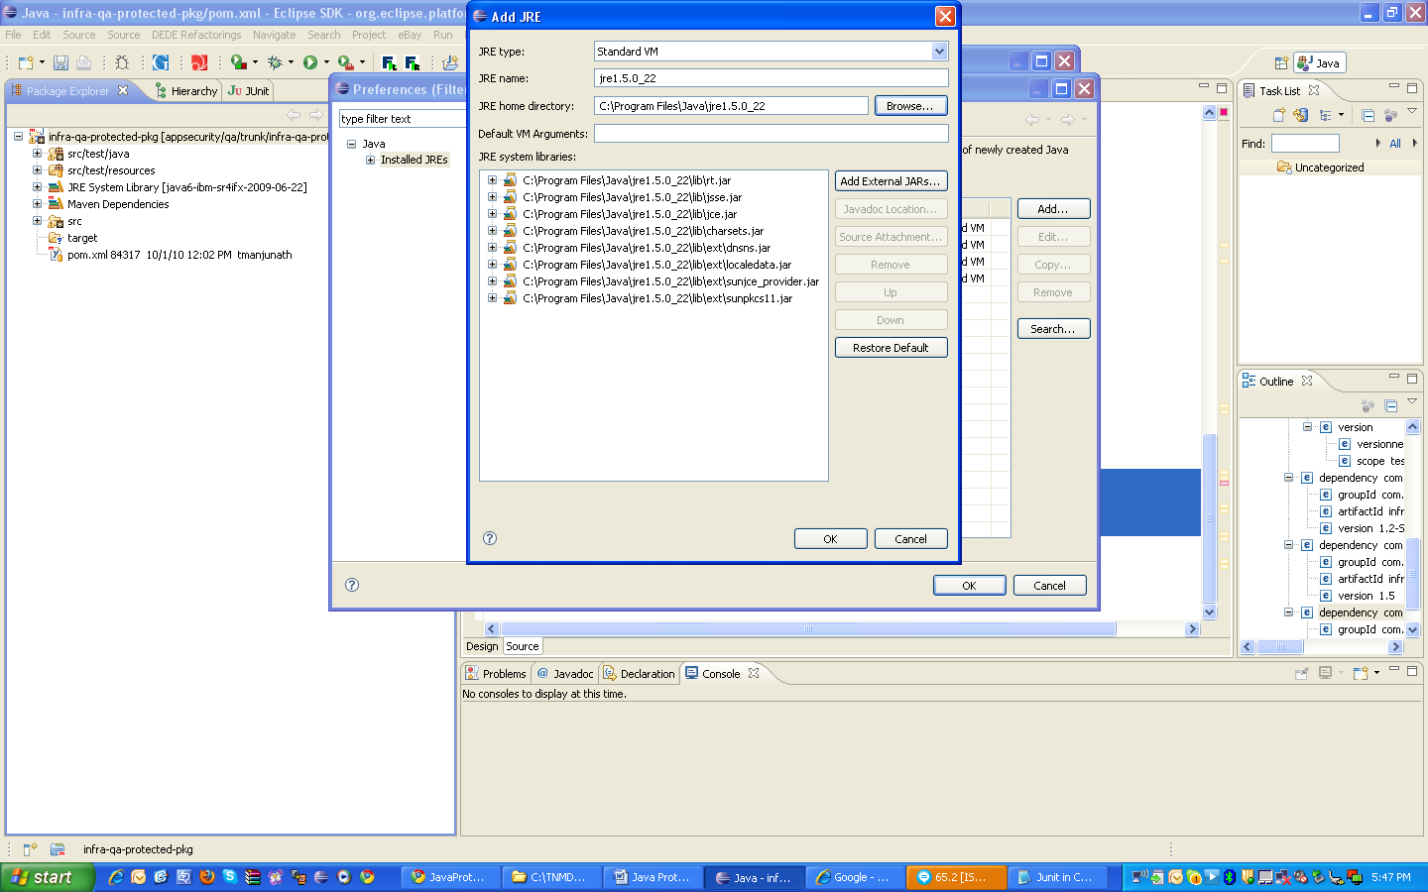

* Now QA has to execute the test cases with following JDK versions on windows platform in command prompt if there is any manual intervention. Here TestSuites is the file which contains all the java files in which test cases are written.
  + Run the following command (make sure all the dependent jar files are in the same folder)
  + java -cp .;infra-protected-pkg-1.2-SNAPSHOT.jar;infra-crypto-1.2-SNAPSHOT.jar;infra-utils-1.5.jar;junit-4.5.jar;commons-lang-2.4.jar org.junit.runner.JUnitCore com.paypal.infra.qa.protectedpkg.TestSuites
* Create a build using Hudson to make sure that the test cases works fine with Linux environment as well and build is stable
  + Load Hudson <http://hudson.mpdev.corp.ebay.com/>

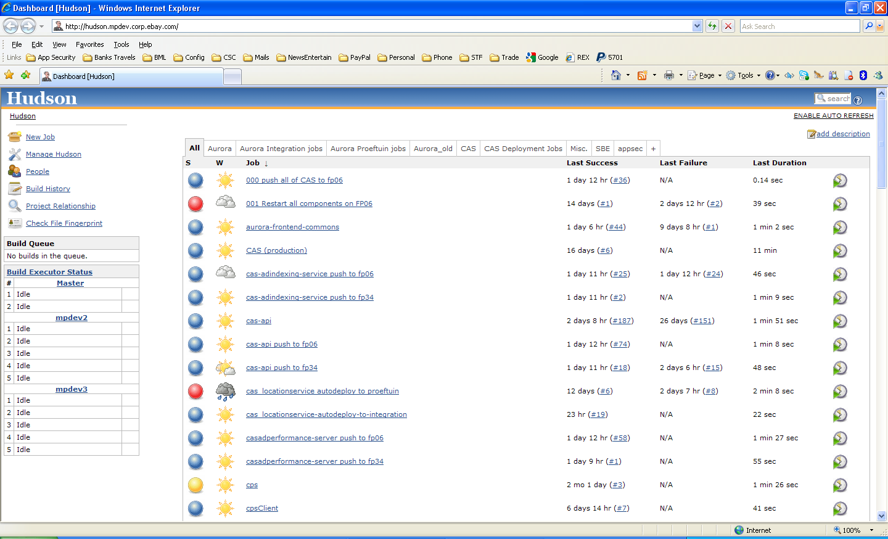

* + Select AppSec

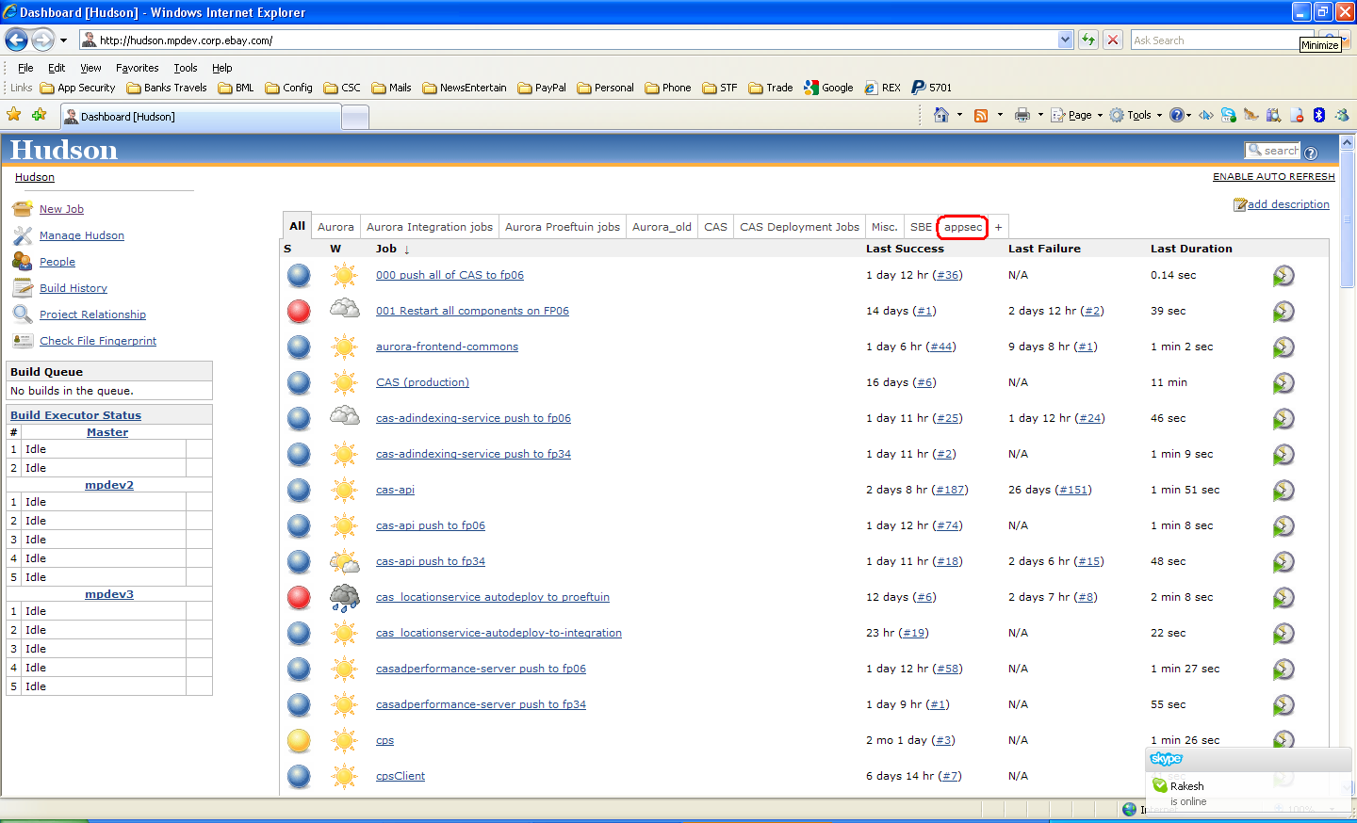

* + Click on New Job link
  + Enter the Job Name and copy the job If it’s similar to already created job by mentioning the job name
  + Once the job is created it will be listed as shown below

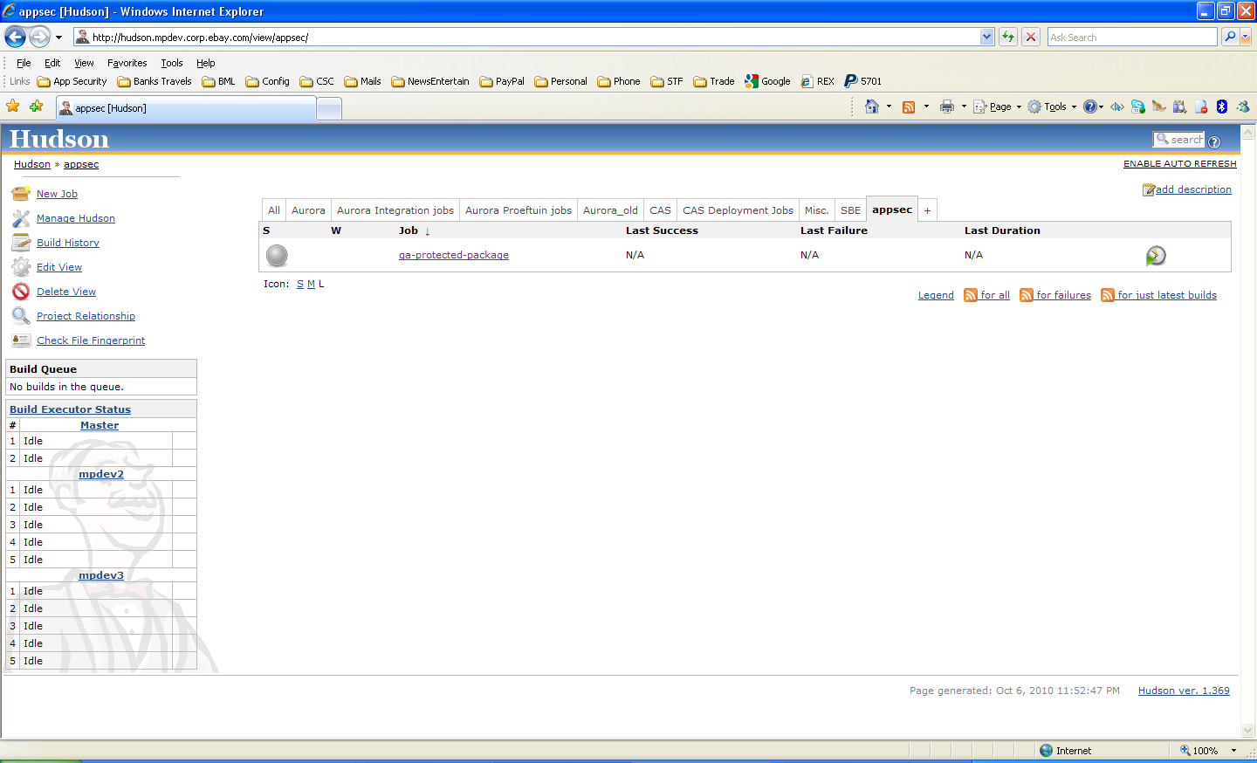

* + Click on the job name to build, configure, see the test result etc

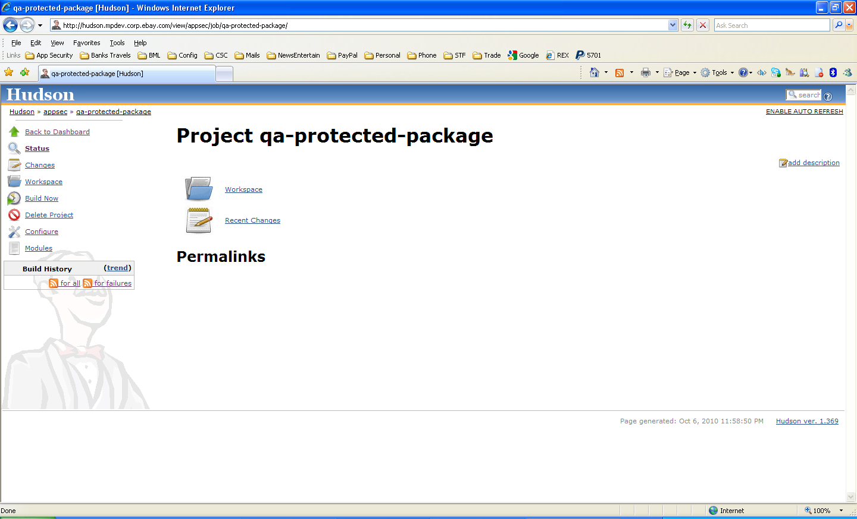

Click on Build now link to compile and Build the code, once the build is complete you will see the status at the left bottom

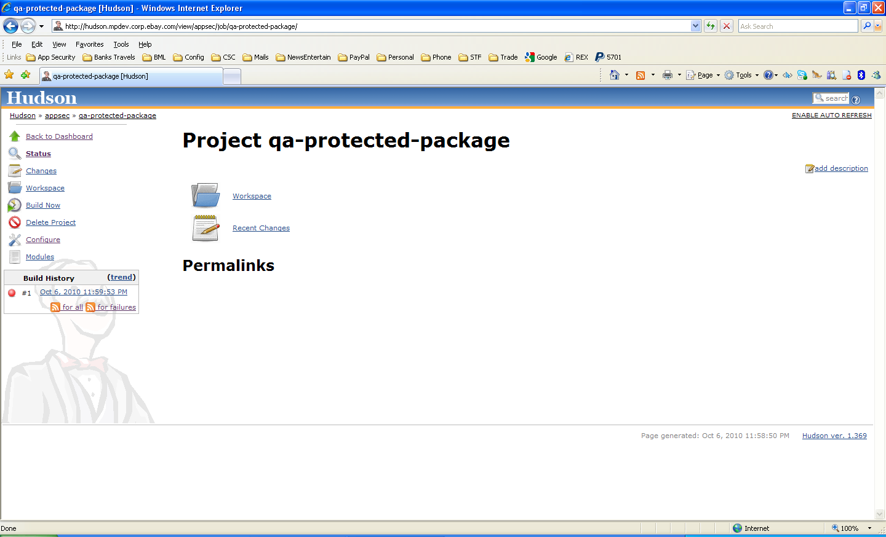

Click on the link to see the results

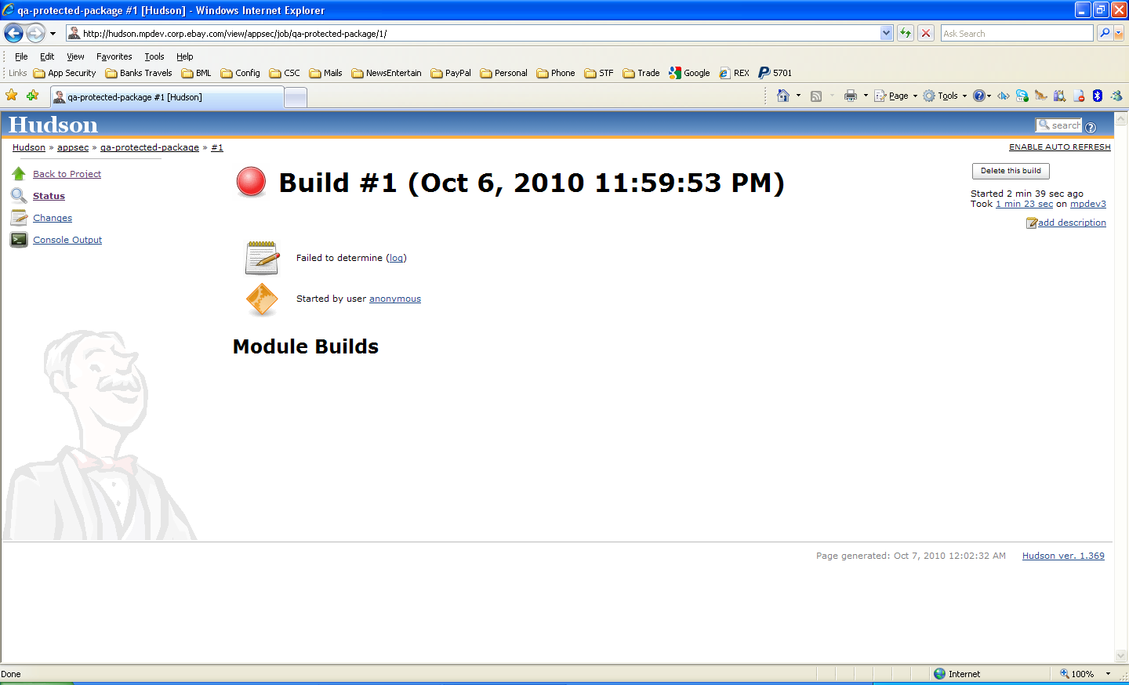

* Repeat the above steps for JDK 1.6 and JDK 1.5 and create stable build
* The Test cases should be run under different JDK versions on Stage2 environment if applicable
  + If there is manual input in the test cases
  + If the project is depending on any stage2 environment
    - Copy all the dependent jar files, class files and java files to stage2 environment using winscp
    - Run the following command
    - java -classpath .:infra-protected-pkg-1.2-SNAPSHOT.jar:infra-crypto-1.2-SNAPSHOT.jar:infra-utils-1.5.jar:junit-4.5.jar:commons-lang-2.4.jar org.junit.runner.JUnitCore com.paypal.infra.qa.protectedpkg.TestSuites
    - give the full java path if it’s in a different version
    - /x/home/tmanjunath/java/jre1.6.0_21/bin/java -classpath .:infra-protected-pkg-1.2-SNAPSHOT.jar:infra-crypto-1.2-SNAPSHOT.jar:infra-utils-1.5.jar:junit-4.5.jar:commons-lang-2.4.jar org.junit.runner.JUnitCore com.paypal.infra.qa.protectedpkg.TestSuites
* The Test cases should be run under different JDK versions on Solaris environment
  + Running Test Cases with IBM JDK 1.5
  + Running Test Cases with IBM JDK 1.6
  + Running Test Cases with Sun JDK 1.5
  + Running Test Cases with Sun JDK 1.6
  + Repeat the steps given in the above activity (stage2) and run the command

**Post Testing Phase:**

* Need to make sure backward compatibility is possible with previous versions
  + All the test cases which were written for the previous version should pass with the current version
* QA has to make sure source code is red from Snapshot and Release
  + Modify the pom file with the latest snapshot and run the test cases. This will read the jar file from snapshot

<dependency>

<groupId>com.paypal.appsecurity</groupId>

<artifactId>infra-protected-pkg</artifactId>

<version>1.2-SNAPSHOT</version>

</dependency>

* + Modify the pom file as shown below. This will read the jar file from release

<dependency>

<groupId>com.paypal.appsecurity</groupId>

<artifactId>infra-protected-pkg</artifactId>

<version>1.2 </version>

</dependency>

* Once everything looks good and release is done, create a tag for the project using eclipse as explained below

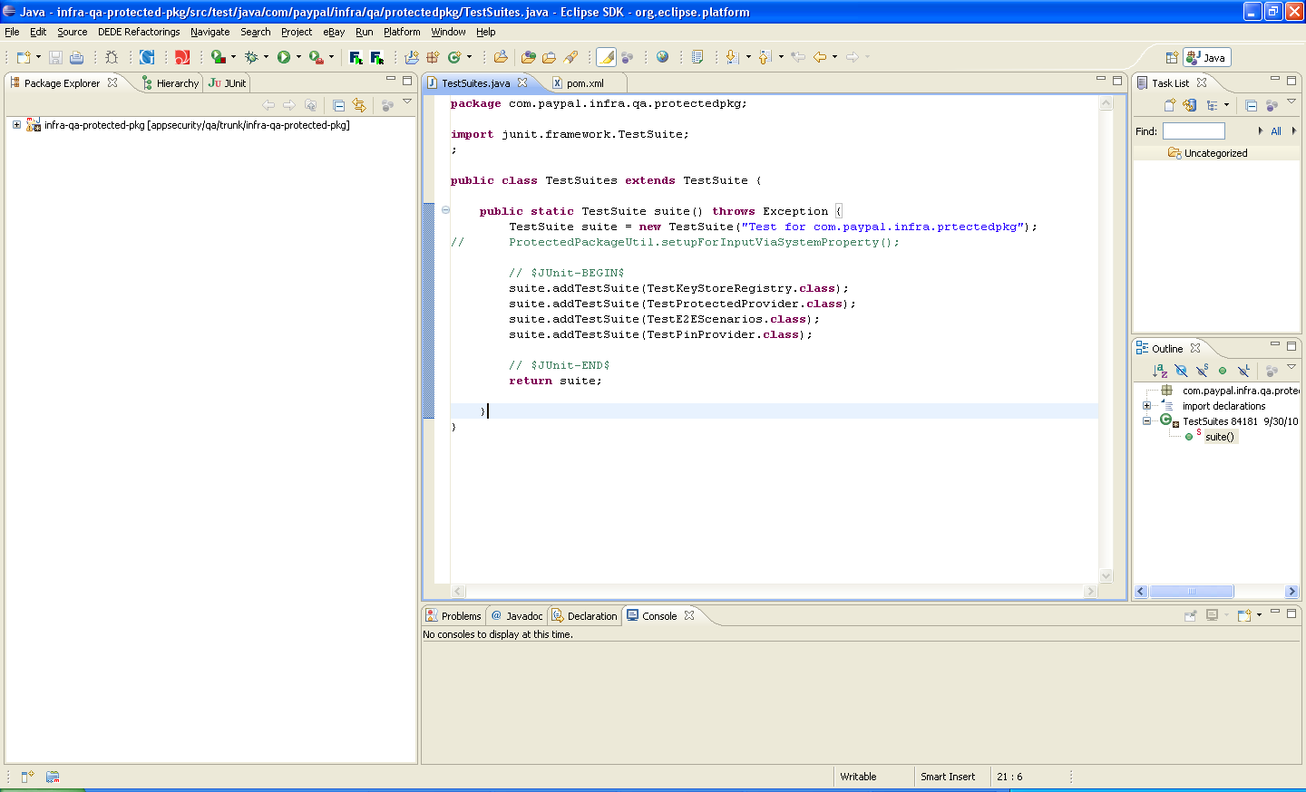

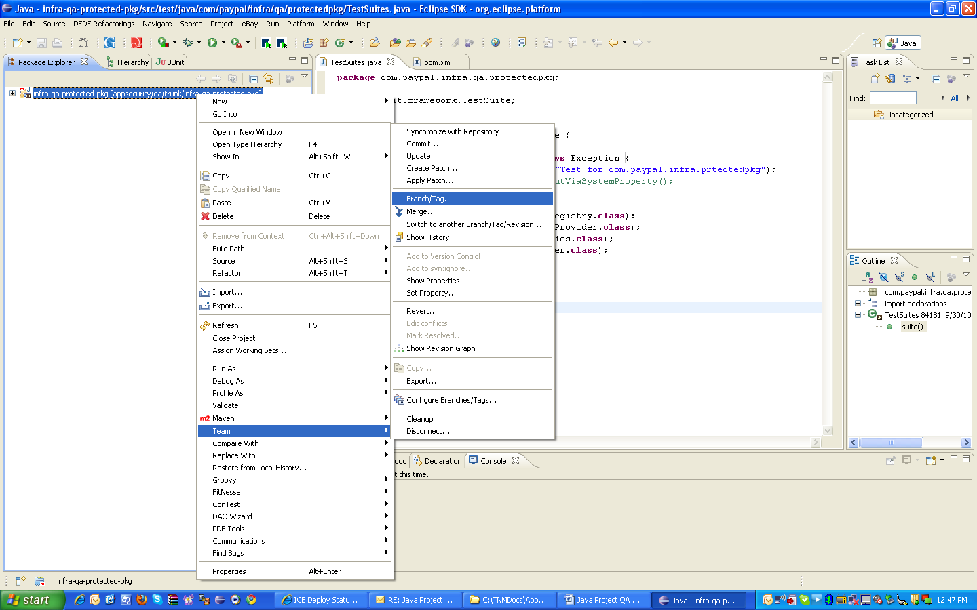

* Create the project tag under the URL
* <http://10.253.32.23/svn/projects/appsecurity/qa/tags>

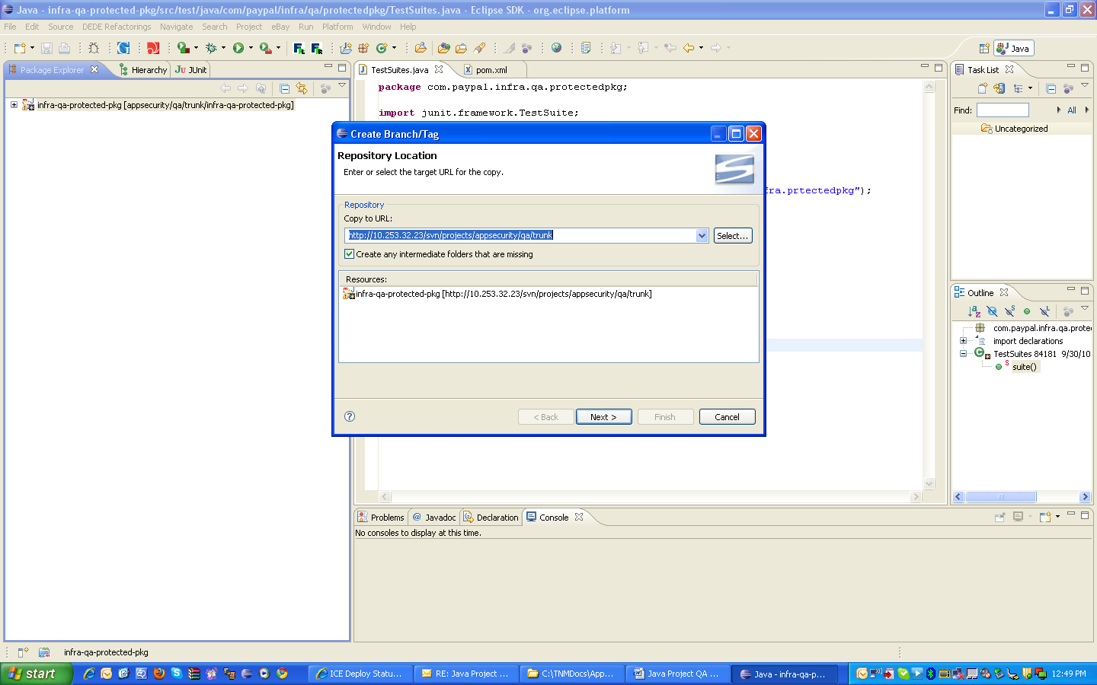

* Once tag is created it should be shown under tags as shown below

