Stream Cipher & Linear Feedback Shift Register
Jeffrey Clarke Jackson

CECS 564 - Introduction to Cryptology
Dr. Ahmed Desoky

Introduction

The linear feedback shift register is a mechanism to perform encryption at the bit level. By using a 32 bit buffer (the LFSR) in conjunction with a mod 2 primitive polynomial a file stream was created to perform file encryption on the fly. Since the sequence of encryption relies on the previous state of the Linear Feedback Shift Register, streaming a file through the buffer was convenient.
The following program demonstrates how using a LFSR class, and binary manipulation class made this possible. Special class methods were created that allowed the following:
Linear Feedback Shift Register class
1. Byte frequency distribution analysis for input and output files.
2. Input and output file streams that are connected by a LFSR buffer.
3. Seeding the register from a 4 byte key word.

Binary Manipulation class
1. Converting bytes to binary strings and vice versa.
2. Converting bytes to a decimal representation for indexing distributions.
Program Instructions
To use the Linear Feedback Shift Register program simply have your file ready, and a 4-byte (8-character) keyword in hexadecimal format to enter in the designated field.
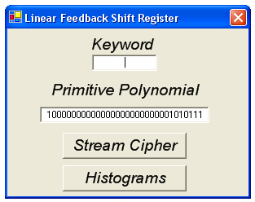

Step 1: Choose a 4 byte keyword and enter it into the text field.
Step 2: Specify a 32 bit Linear Feedback Shift Register. The default mod 2 primitive polynomial is:
X^32 + X^7 + X^5 + X^3 + X^2 + X + 1
(10000000000000000000000001010111)
Step 3: Click “Stream Cipher”

Step 4: Use the open file dialog to specify which file will be encrypted.

Step 5: Use the save file dialog to specify how to save the ciphered file.

Step 6: Depending on the file size and computer performance will determine how long it will take to perform the shifting algorithm. When it is complete a message box will display signaling that the stream cipher completed successfully. At this time the “Histograms” button can be used to analyze input and output byte frequency distributions.

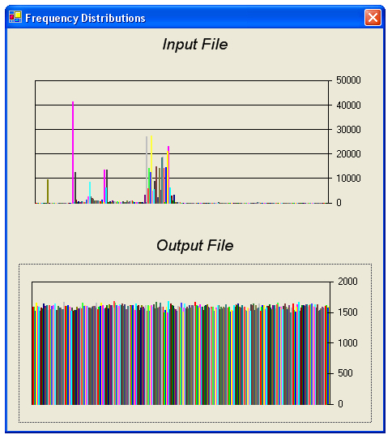
Source Code Details
The heart of the program is a class designated LFSR. This class contains methods to create frequency distribution arrays, a 32 bit encrypting buffer, as well as input and output file streams.
When the stream cipher is initiated, the first step is an input validity check to determine whether the keyword specified in is byte notation. Once this has been verified, an instance of LFSR is created and the user is prompted with an open plain file dialog, followed by a save cipher file dialog to assist in file handling. At this point the file streams are created and the stream cipher begins.
The stream cipher reads the first set of bytes in and performs a XOR shifting algorithm for the entirety of the buffer size. Once the whole buffer has been updated, the output file stream is utilized and the register is updated. This process repeats until the input file stream is empty. At this point the while loop concludes, file streams are closed, and the user regains GUI operability.
During each byte read from the input stream the byte value is converted to its decimal representation and used as the index for the 256 element distribution array. Since there are 256 values for a byte, a static int[256] array was created. Likewise on every byte write to the file output stream, the byte is converted to decimal and counted in it’s corresponding array element. At the end of the cipher stream these arrays are passed back to the parent class to be used for histogram analysis.
The chart object accepts the int[] array natively to its .ChartData property. However, during development it was noticed that it would only accept signed data type arrays, and not unsigned. This limits the ability of the program for very large files, but this would undoubtedly fall outside of this program’s scope anyways. It is unlikely that one single byte would occur more than 2,147,483,647 times in a normal user file.
A binary manipulation class is also used to convert the bytes read in to binary strings to assist in the shifting XOR algorithm. After the shifting of a full buffer has been conducted, the binary buffer is converted back to byte notation and wrote to the cipher file output stream. This class is instantiated within the LFSR class. C# has built in methods to convert to byte notation which made the creation of these classes straight forward. For example to convert a binary string to a byte the following method was used:

Convert.ToByte(stringBinary,2);

The second parameter ‘2’, represents the base of the string. Therefore a decimal string could be passed by changing the ‘2’ to a ‘10’. To convert bytes to binary strings, a method was created that uses a masking algorithm to step through the byte bit by bit to create the string.

Frequency Distribution Analysis

The first file analyzed through the Histogram function was a plain html file. This file is the Gentoo Linux Handbook and is simply a large instruction file on a normal Linux distribution installation. It is mostly plain text with some color highlighting and font adjustments.
It is easily seen that the Linear Feedback Shift Register takes a non-uniform distributions of bytes and converts them into a file containing a very uniform distribution. This would be expected since the shifting is conducted at the bit level instead of the byte level. The input file contains a couple spikes which most likely represents either white spaces or brackets “< & >” commonly found in html files. By having this uniform distribution, periodic spikes like those previously found in the Vigenere algorithm can’t be used for key size exploitation.

The second file analyzed was a picture of a music recording studio, also home to the development of this program. This file was approximately 1.8 MB in file size and took about 10 seconds to conduct the stream cipher. The machine used had dual AMD Opterons, however additional threads were not added to the source code to make more efficient use of this platform.

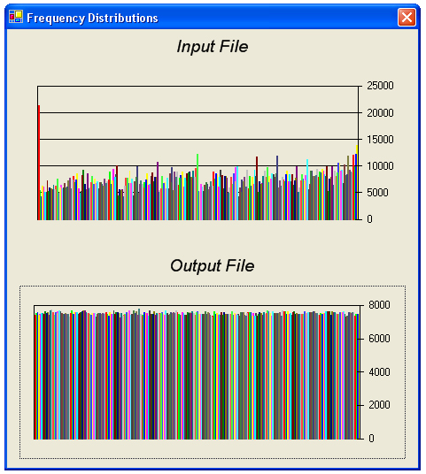

This algorithm took a file with some structure, meaning it had significant accounts of certain bytes occuring more frequently than others, and converted it to a cipher file without any distinguishability. It is a safe assumption to say that an encryption like this would be difficult like this to find an exploit at the byte level. A better analysis could possible be at the bit level, where if the file type was previously known, an exploitation might be easier since most files types end with only a certain set of characters. In an HTML file, the beginning character would most likely be a “<”, therefore the amount of brute force attacks could be reduced. From there the brute force algorithm would have to test all possible keys and register sizes. This is still a lengthy computation.
Conclusion
This program was tested for correctness by running the cipher file back through the Linear Feedback Shift Register to test for whether it actually worked. The output file was analyzed normally and at the byte frequency distribution level.
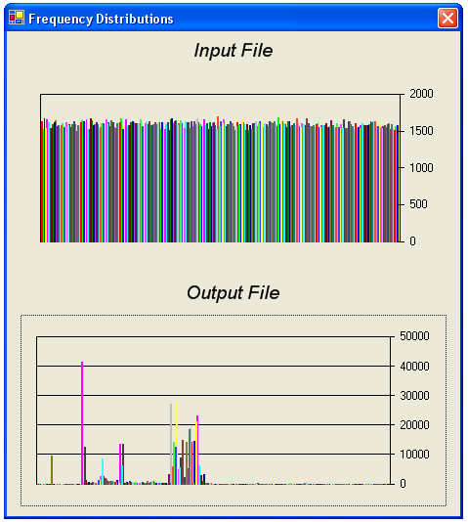
In conclusion, the Linear Feedback Shift Register encrypts at the bit level which makes recognizing file types and key sizes less predictable. By using file streams and the register as the encrypting medium for the input and output, stream ciphering made this project very feasible.

