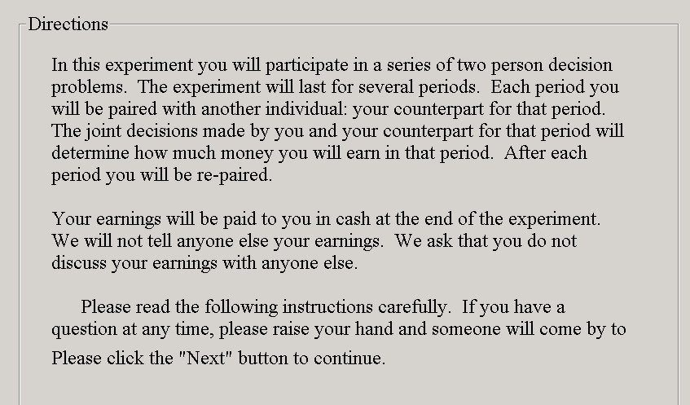

In this experiment you will participate in a series of two person decision problems. The experiment will last for several periods. Each period you will be paired with another individual: your counterpart for that period. The joint decisions made by you and your counter part for that period will determine how much money you will earn in that period. After each period you will be re-paired.

You earnings will be paid to you in cash at the end of the experiment. We will not tell anyone else you earnings. We ask that you do not discuss you earnings with anyone else.

Please read the following instructions carefully. If you have a question at any time, please raise you hand and someone will come by to help you.

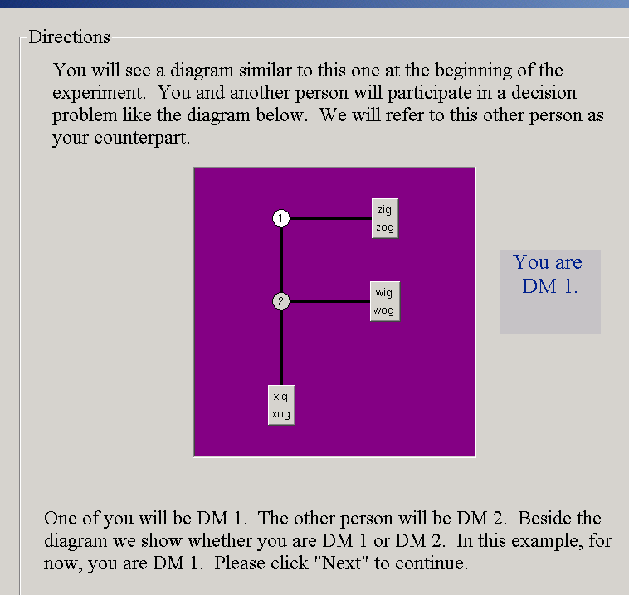

You will see a diagram similar to one on your screen at the beginning of the experiment. You and another person will participate in a decision problem like the diagram below. We will refer to this other person as you counter part.

One of you will be person 1. The other will be person 2. in the title bar of the window you will see weather you are person 1 or person 2.
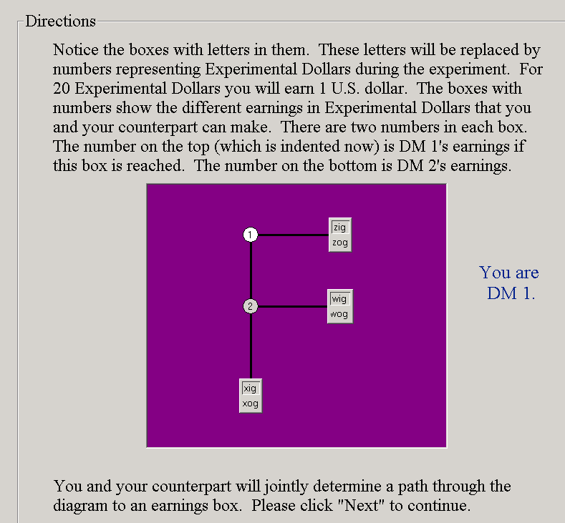

Notice the squares with numbers in them, this is an earnings box. The earnings boxes show the different earnings you and your counterpart will make. There are two numbers, person 1 will earn what is in the bottom box and person 2 will earn what is in the top box if that decision is reached.

There is a legend in frame on the top left of you screen.

You and your count part will jointly determine a path through the diagram to an earnings box.

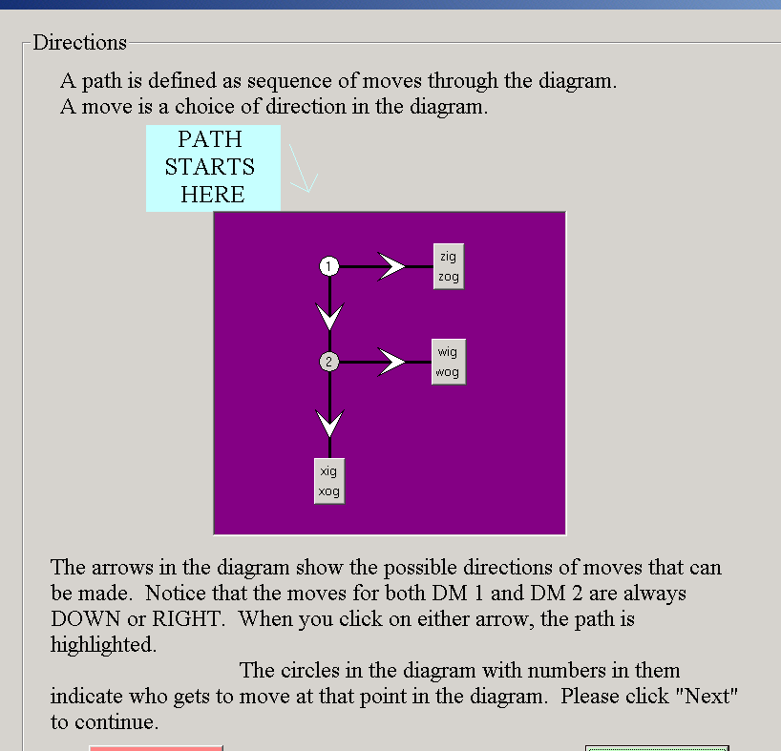

A path is defined as a sequence of moves through the diagram.

A move is defined as a choice of direction in the diagram.

Notice that the nodes are color coded to indicate weather person 1 or person 2 will be making that decision. You will always have to two options; those options will include some combination of clicking on an earnings box or clicking on a circle.

If a circle is chosen, control will be transferred to your counter part and they will make the next decision, one level lower in the tree.

If an earnings box is chosen the round will be over and you will received the respective earnings show in the earnings box.

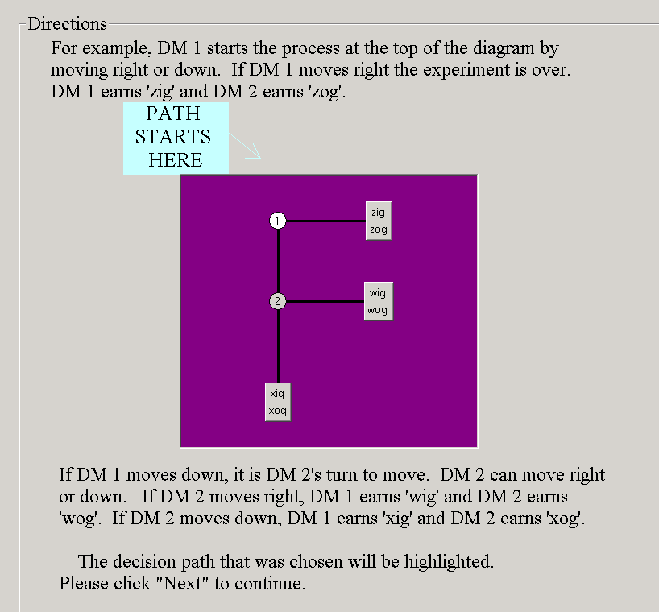

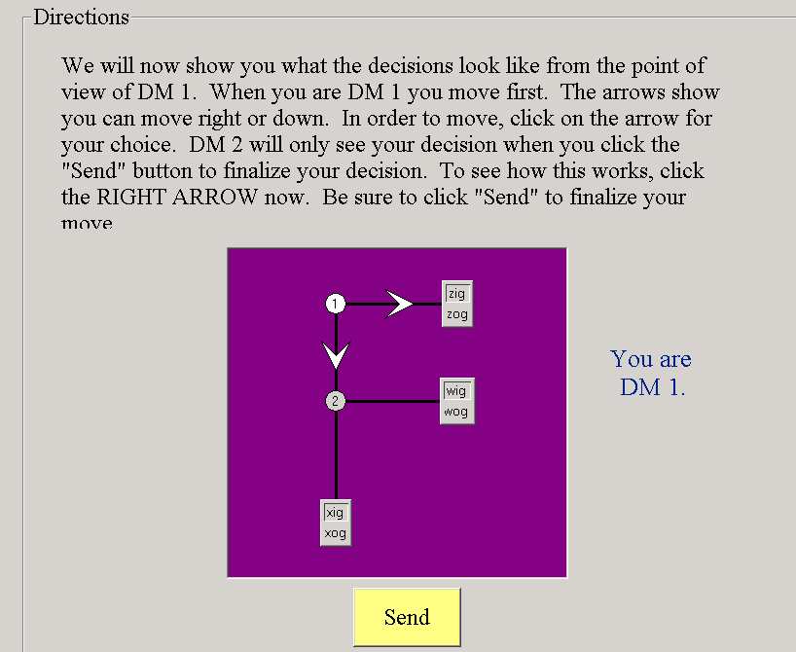

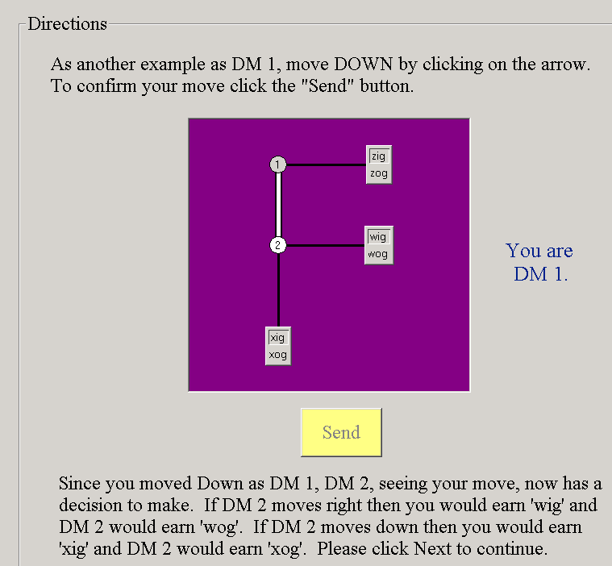

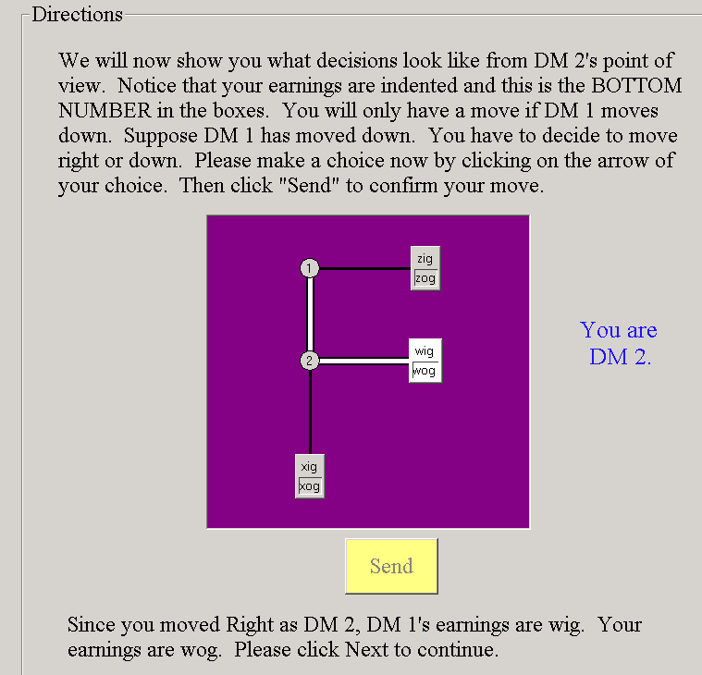

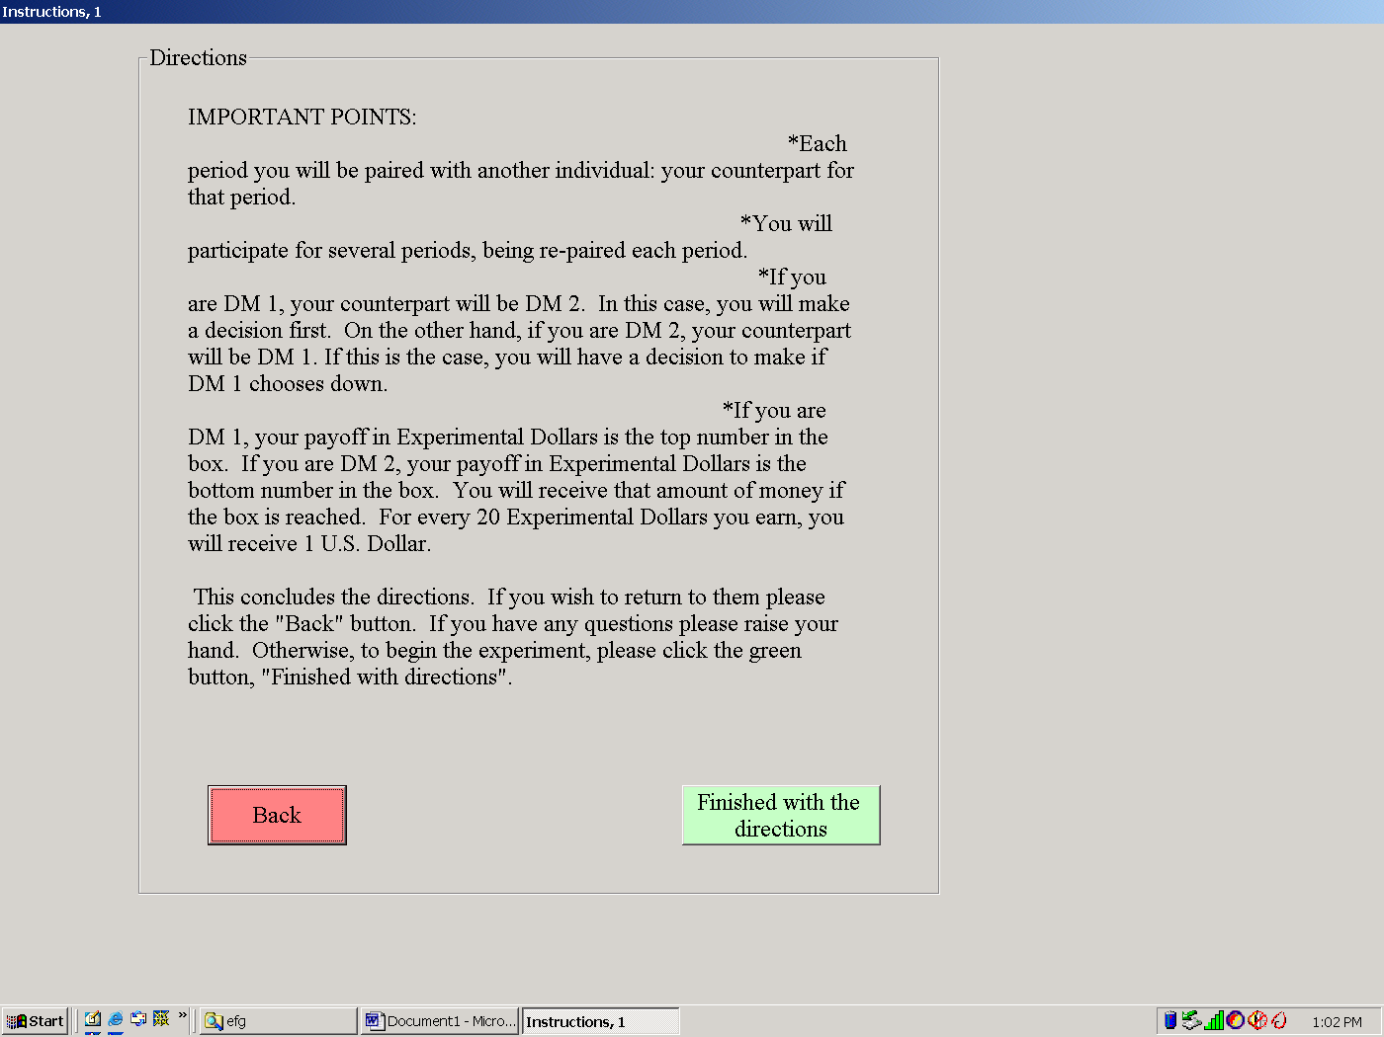

Important points:

Each period you will be paired with a counterpart

Person one always makes the first decision in a round.

Once you are assigned to be a person 1 or a person 2 you will stay that way for the entirety to the game.

