**Are COVID Vaccines Safe?**

**A Geospatial Statistical**

**Analysis of the COVID Vaccines**

**in the United States.**

Author: Jeffrey Ledbetter, Graduate Student

Department of Geography and Environmental Sustainability

Geographical Information Technology

University of Oklahoma

**Abstract**

This research project is aimed to answer the question, “are the COVID vaccines truly safe for humans?” Vaccine and vaccine development normally take years. In 2020, the vaccines were rolled out in record time and received Emergency Use Authorization (EUA) from the Food and Drug Administration (FDA) without the stringent testing that all other vaccines go through. In an EUA the subjects that receive the vaccine become the test group and are to be monitored closely. However, the US, like most countries, began mandating and mass vaccinating the population. This started with the elderly and emergency services and slowly moved to the general population as the vaccines became readily available. The test monitoring became the job of individual doctors’, and they were to report adverse events to the Vaccine Adverse Event Reporting System database (VAERS). The VAERS website provides data on all adverse events from all vaccines per year. In 2020, there were 918,561 total adverse events reported to the VAERS system, 10,423 of which were from the COVID vaccines (1%). In 2021, there were 747,840 total adverse events reported, and 736,793 were from the COVID vaccines (98%). These seem statistically significant, however when calculated against the total number of COVID vaccines distributed, the significance could change. This research will answer that question and the question of how many adverse events should be allowed before a vaccine is removed from EAU for additional research. Additionally, there have been sates with higher adverse events reported than others. This research will explore the geospatial correlation between adverse events and geographical locations.

**Introduction**

Between 2020 and 2022, the United States has been subjected to a pandemic of an unprecedented nature. In March of 2020 the first case of COVID-19 was reported. However, it is believed that cases were in the US as early as October and November of 2019 (“Scientists Report Earliest Known Coronavirus Cases in Five US States - The New York Times,” 2021). COVID-19 became the global killer virus, lock downs and business closures became the new norm. With these new mandates the race was on to develop a vaccine to protect against this new virus. The FDA was directed by the sitting president to “fast-track” vaccine testing and approval, as early as July, testing had begun. By December 2020, the FDA approved the Emergency Use Authorization (EUA) for Moderna, Pfizer, and BioNTech vaccines (Li et al., 2021). With the speed at which the vaccines were developed and pushed to the public, there are several rising concerns that the testing was not as stringent as past vaccines and more adverse events have been emerging (Sallam, 2021). However, with the underreporting on the Vaccine Adverse Event Reporting System (VAERS) database it is difficult to track these numbers accurately. According to the FDA and CDC a mere 1% of adverse events have been reported to VARES since it was launched in 1990 (“Vaccine Adverse Event Reporting System (VAERS),” 2022).

Chart 1 in Appendix A represents that 1% of reporting. Now imagine if the numbers seen here were inflated to even 40% of adverse events, this is a very “hot topic” that people do not want to discuss. An adverse event is defined as any untoward medical occurrence associated with the use of a drug or vaccine in humans. This is very important to understand to make an informed decision. **Hypothesis 1:** Is there enough quantitative data to provide a statistically significant value on the safety of the vaccines? Is the outcome of the statistical analysis random? **Hypothesis 2:** Does geospatial analysis show “hotspots” of adverse events throughout the United States? Are these locations autocorrelated? **Hypothesis 3:** Does VARES provide statistically significant data to suggest that vaccines should be removed from Emergency Use Authorization for additional testing?

Since 2020, the United States along with the entire world has seen an event that dwarfs anything that has ever been recorded in history. With global lockdowns, closure of businesses, economic collapse and fear perpetuated by media outlets. Everyone knows where they were and what they were doing the weekend that it all began, not unlike the World Trade Center, the Challenger explosion, and the JFK assassination. With the emergence of COVID-19, all the stops were taken out to find a cure, treatment, and vaccine. An unprecedented nine months from emergence to vaccine rollout begs the questions of efficacy and safety.

In 1990, the program Vaccine Adverse Event Reporting System (VAERS) was established and is managed by the US Food and Drug Administration and Centers for Disease Control to track any unforeseen reactions and side effects of vaccines. The program’s use is required of doctors and researchers to report these issues about their patients for further study (“Vaccine Adverse Event Reporting System (VAERS),” 2022). The data collected can be used to halt the use of a vaccine if the data is statistically significant. According to the CDC and FDA, it is believed that only 1% of adverse events are reported to VAERS. This study is to establish if 1,168,894 reported adverse events from 2020 – 2022 is a statistically significant number of adverse events to the COVID-19 vaccines and if there are any “hotspots” in the United States where there are significantly more or less adverse events based on the roughly 1% of reporting to VAERS. It is currently reported that 556 million doses have been administered in the United States and 215 million people are currently considered fully vaccinated (“Vaccine Adverse Event Reporting System (VAERS),” 2022).

In a Pfizer report from January 2022, Paardekooper found that there were 375,397 cases of musculoskeletal and connective tissue disorders in female from 18 – 64 years of age and 44,560 nervous system disorders in males from 18 -64 (Paardekooper, 2022). These are only the two highest recorded numbers by one vaccine manufacture. According to the VAERS website and CDC these numbers are significantly higher when adding additional manufactures. In a 10,000-page FOIA document issued by Pfizer in 2022, these, along with multiple other adverse events were known to occur and Pfizer failed to report these findings to the FDA or CDC(Worldwide Safety Pfizer, 2021). Additionally, when these events began being reported, the FDA and CDC denied the occurrences and the media refused to report on them, claiming it was false information. On June 27th ,2022 the Texas Senate Committee on Health and Human Services heard testimony from Dr. Robert Malone, MD and Dr. Peter McCullough, MD who stated the CDC and FDA grossly under reported adverse events and the vaccines should have been removed from EUA in early 2020 because of the death rate alone(Bob Hiller, 2022). Dr. Peter McCullough, MD, further explained in his testimony that the global standard for a vaccine to be removed due to death from a vaccine is 50 deaths(*Senate Committee on Health & Human Services - Jun 27th, 2022*, n.d.). Currently in the United States the death rate from the COVID vaccines is 15,285(*Vaccine Adverse Event Reporting System (VAERS)*, n.d.) In 2022 the World Council on Health called for a total recall on all COVID vaccines worldwide due to the adverse events and deaths being attributed to the vaccines(*Senate Committee on Health & Human Services - Jun 27th, 2022*, n.d.)

**Study Region**

This research project, which could be done globally, will focus on the United States only. Due to the amount of data collected and the amount of data available in the coming months this project had to be limited geographically. According to the CDC, 560,181,791 total vaccine doses have been administered as of March 2022 (CDC, 2022). Map 1, in Figure 2, shows the population density in the United States. This is an important part of this project because the states with higher population density will have the higher rates of adverse events. Additionally, Map 2, in Figure 3, shows preliminary analyzation between Total Population Vaccinated in 2021 and the Number of Adverse Events reported.

**Data / Methods**

The data used for this research will come from the US Census Bureau, CDC, FDA, and the VARES website. All data is available and up to date. New data is downloaded daily from <https://datadashboard.fda.gov/ora/index.htm>, <https://data.cdc.gov/>, and <https://vaers.hhs.gov/data.html>. A cutoff date of 1 June 2022 was established, and no additional data could be gathered after that date. Raw data was collected, analyzed, and filtered to only necessary data relevant to this research. For example, the vaccination site on the human body is not relevant to this study. This variable exceeds the scope of this study. The analyzed data was uploaded to Excel, R Studio and ArcGIS for statistical analysis and mapping. Figure 8 contains all of the code used for analysis. All data is saved in a local geodatabase and uploaded to Open Refine and OSF in case of an unexpected server crash. The VAERS data is multiple text files that contain demographic information of patients that have had an adverse reaction to a vaccine in a particular year. As well as the patient age and state location and various other information such as injection site, vaccine batch number, vaccine name and manufacture. These text files contain all vaccine adverse events, not just those resulting from the COVID-19 vaccines. The first step was to import the text files to Excel and convert them to CSV files, then isolate only the adverse events from the COVID-19 vaccine. This information, along with the CDC data for number of total doses administered nationwide and by state was uploaded to R Studio for statistical analysis. The data was analyzed nationwide, regional, and then by state to locate any relationship. The goal of the statistical analysis is to provide locations of autocorrelation and “hotspots”, also to analyze if these locations are random or if there is a correlation between the variables. It was believed that Kriging, Moran’ I, and Getis-Ord G methods would provide sufficient interpolation data to make these inferences. However, these methods would not populate sufficient evidence to show significant “hotspots” because the data were so closely related. Population data and the statistical analysis data was then uploaded to ArcGIS desktop for mapping purposes. This information was then broken down into smaller categories such as events by age, race, gender, location, and death, and then compared to all other vaccines adverse events and death reporting since 1990 (Figure 1, 5).

**Results**

When analyzing this data, it was imperative to look at the correct variables. Vaccine adverse events had to be compared to the vaccinated population and not the total population. The vaccinated male and female population would also need to be analyzed against the total vaccinated population. Additionally, the data had to be broken down to the state level. It was considered to break these numbers down even further to the county level but that was abandoned after understanding the more rural areas were vaccinating and treating people from other counties. The following statistical calculation values are defined as *Correlation* being the relationship between the variables being tested. The *Confidence Interval* is the range of values so defined that there is a specific probability that the value as a parameter lies between it. The *T-statistic* is the ration of the departure of the estimated value of a parameter from its hypothesized value to the standard error (greater than 1.96 is significant). *Degrees of freedom* are the number of values in the final calculation that are free to vary (in the case of this analysis there are 51 states including Washington D.C). *R2* or “Goodness of Fit” is the proportion of the variation in the dependent variable that is predictable from the independent variable. Finally, the *P-value* is the number describing how likely it is that the data would have occurred under the null hypothesis (this number indicates the randomness of the data).

The initial analyzations were to compare the number of adverse events and total vaccinated population by year. A Pearson’s correlation test was run for the 2020 data. Resulting in *Correlation* = .697 with 95% *CI = [.522-.816],* *T-statistic =* 6.81, with 49 *degrees of freedom (df)*. A linear regression model was then run with the results of *R2* = 48% and *P-value* = 1.301e-08, indicating a statistically significant correlation. This process was repeated with the 2021 data and 2022 data. In the 2021 data *Correlation* = .696, 95% *CI = [.520 - .815]* with, *R2* = 48%, *P* = 1.426e-08, *T statistic* = 6.78, and *df* = 49. In the 2022 data, *Correlation =* .631, 95% *CI = [.430 - .772]*, *R2* = 40%, *P-value* = 6.9e-07, *T-statistic* = 5.694, and *df* = 49 again indicating a statistically significant correlation in all three years. Next, an analyzation of the 2020 Census estimated population and the total vaccinated population was run using Pearson’s and a Linear Regression model. The results were *Correlation* of .726, 95% *CI = [.564 - .835]*, *R2* = 53%, *P-value =* 1.552e-09, *T-statistic* = 7.408, and *df* = 49 indicating a statistically significant correlation.At this point the data was further broken down between the male vaccinated population and female vaccinated population by year. In 2020, the female vaccinated population data showed *Correlation* = .700, 95% *CI = [.525 - .817]*, R*2* = 50%, *P-value* = 1.087e-08 *T-statistic* = 6.861, and *df* = 49 also indicating a statistically significant correlation. The 2020 male vaccinated population data showed *Correlation* = .677, 95% *CI = [.677 - .803],* *R2* = 45%, *P-value* = 4.762e-08, *T-statistic* = 6.44, and *df* = 49 again indicating a statistically significant correlation. However, there was not enough statistical evidence supporting the claim that the female vaccinated population was more likely to have an adverse event over the male vaccinated population. In the 2021 data, the female vaccinated population results were *Correlation* = .688, 95% *CI = [.500 - .810],* *R2* = 47%, *P-value* =2.339e-08 *T-statistic* = 6.64, and *df* = 49. In the male vaccinated population for 2021 the data showed *Correlation =*.700, 95% *CI = [.52 - .81],* *R2* = 49%, *P-value* = 1.056e-08, *T-statistic* = 6.86, and *df =* 49 also indicating a statistically significant correlation between the vaccinated and the adverse events but not enough significance to indicate female over male. In the 2022 data, the female vaccinated population results were *Correlation* = .61, 95% *CI = [.41 - .76],* *R2* = 38%, *P-value* = 1.3e-06, *T- statistic* = 5.51 and *df* = 49. In the 2022 male vaccinated population the results were *Correlation* = .59, 95% *CI = [.38 - .74],* *R2* = 35%, *P-value = 3.739e-06, T-statistic* = 5.21 and *df* = 49,again indicating a statistically significant correlation.

After completing the individual years and male and female analysis, the years were combined for each male and female to verify the above results. For the combined adverse events for the female population vaccinated the results were, *Correlation* = .685, *95% CI* = [.505 - .808], *R2* = 49%, *P-value* = 2.876e-08, *T-statistic* = 6.58, and *df* = 49. For the combined adverse events in the male vaccinated population the results were, *Correlation* = .690, *95% CI = [.517 - .814], R2* = 49%, *P-value =* 1.166e-06, *T-statistic =* 2.09, and *df* = 49. Both results indicate a statistically significant correlation but do not indicate a statistical significance male over female or female over male. Figure 6 contains Map 3 of the Moran’s I calculations across the United States.

With the initial statistical analysis completed, Spatial Autocorrelation testing on the total adverse events on the male and female populations. Global Moran’s I was selected and for the results of the female events the *Statistic value = -.051, Expectation = -.021, Variance = .0087, and the P-value = .626*, indicating the data to be statistically spatially autocorrelated. The results of the male events were, *Statistic value = -.023, Expectation = -.021, Variance = .0086 and the P-value = .50,* also indicating statistically spatially autocorrelated.

Finally, there have been significant concerns raised about the death rate post COVID vaccination. A linear regression model was completed between COVID vaccine deaths and total population vaccinated. The results were *Correlation =* .288, *95% CI =* [.012 - .521], *R2* = 8%, *P-value =* .041, *T-statistic =*2.09 with *df* = 49. Where the P-value is not at the .05 threshold that is necessary to be considered statistically significant, it falls into a category of moderately statistically significant and can be considered an indication of correlation.

**Discussion**

Taking into consideration the vast number of doctors that have discussed how quickly the COVID vaccines rolled out with little to no oversite from the FDA, the limited amount of testing and control groups, and the reported adverse events. It is safe to conclude that there is a problem with the safety of the vaccines. After completing this analysis and showing the correlation between the vaccines and the adverse events (H1) there should be no question there is a safety concern. Additionally, the geospatial statistical analysis of the male and female adverse events clearly showed evidence of spatial autocorrelation and was verified but a second combined analysis(H2). Even with the believed 1% of reported data to VARES there is clearly enough evidence to show that the vaccines showed be pulled from circulation and the population that received the vaccines should be monitored with monthly testing by the FDA. In the Pfizer documentation, it is known that adverse events occur at an alarming rate, and they are directly linked to the vaccines. This analysis validates those known and hidden facts. The question is why is the media not reporting on these facts. All the evidence and data are available on the VAERS database. However, with all this evidence-based data, it is believed that there will still be a part of the population that will question the methods or data that was used in this analysis. Therefore, one more calculation was completed to further prove there is a significant concern about the safety of these vaccines. A comparison between the deaths caused by the COVID vaccines and the deaths reported by all the other vaccines on the market since 1990 by state was performed and is available in Figure 5. Each state was categorized in alphabetical order and listed by state abbreviation. This is the most concerning analysis of this research. Additionally, the three vaccine manufactures, Janssen, Moderna and Pfizer were analyzed by deaths and broken down to the state level. Figure 7 shows this charted data. There was a fourth category of unknown vaccine, meaning the death was attributed to the COVID -19 vaccine but the manufacture was not reported. The totals were Jannsen 865 deaths, Moderna 4985 deaths, Pfizer 5424 deaths and the unknown was 36 deaths in the United States. This is significantly higher than the global standard of 50 deaths worldwide to have a vaccine pulled from use, as stated by Dr. Peter McCullough, MD (*Senate Committee on Health & Human Services - Jun 27th, 2022*).

**Conclusion**

It has been shown that there is a direct correlation between the COVID-19 vaccines and adverse events, in both men and women. As well as a direct correlation between the COVID-19 vaccination and the death rate after taking the vaccination. The vast number of reports of adverse events from the COVID-19 vaccinations compared to the data on every other vaccination in the history of the VAERS system should be considered evidence enough. However, there are a group of the population that feel it necessary to shame and ridicule the portion of the population that refused to receive the vaccinations. Unfortunately, the media is also a part of the population that refuses to look at the facts of the data. My personal feeling on the issues is that it is not the job of the government or any other entity to force their will on any other human being because of their beliefs. If there is data to suggest that there should be a safety concern over a vaccine, it is the reasonability of the agency that oversees the vaccine to remove it from human use to save lives. In this case, this is not happening. In fact, not only is that not happening, there are businesses and government agencies firing employees for not receiving the vaccine. The most ironic times this has happened is in the aviation field. The Federal Aviation Administration (FAA) and airlines mandated that all airline crews receive the vaccine. The air crews that refused were terminated. One of the major adverse events is the development of blood clots. It has been found that the clots develop faster and larger when flying above 5000 feet. The airlines are now facing employee shortages because over half of their air crews are unable to fly because of the blood clots. The most ironic part to this is not the blood clot issue. It is the fact that the FAA violated its own regulations. Title 14 CFR Ch1 Subchapter D part 67 states that an airman that takes any experimental medication or treatment must have their medical certification revoked for no less than one year (*14 CFR Part 67 -- Medical Standards and Certification*, 2022). The COVID-19 vaccines are considered experimental because they are under EUA.

**References**

*14 CFR Part 67—Medical Standards and Certification*. (n.d.). Retrieved July 26, 2022, from https://www.ecfr.gov/current/title-14/chapter-I/subchapter-D/part-67

Bob Hiller (Director). (2022, July 2). *Robert Malone testimony Texas Senate Committee on Health & Human Services Jun 27th, 2022*. https://www.youtube.com/watch?v=50v2PrQyxi0

CDC. (2021, September 1). *COVID-19 Vaccination*. Centers for Disease Control and Prevention. https://www.cdc.gov/coronavirus/2019-ncov/vaccines/index.html

*COVID-19 vaccines: Safety, side effects –– and coincidence—Harvard Health*. (n.d.). 2.

Kai, X., Xiao-Yan, T., Miao, L., Zhang-Wu, L., Jiang-Nan, C., Jiao-Jiao, L., Li-Guo, J., Fu-Qiang, X., & Yi, J. (2021). *Efficacy and safety of COVID-19 vaccines: A systematic review*. 16.

Li, Y., Tenchov, R., Smoot, J., Liu, C., Watkins, S., & Zhou, Q. (2021). A Comprehensive Review of the Global Efforts on COVID-19 Vaccine Development. *ACS Central Science*, *7*(4), 512–533. https://doi.org/10.1021/acscentsci.1c00120

Olliaro, P., Torreele, E., & Vaillant, M. (2021). COVID-19 vaccine efficacy and effectiveness—The elephant (not) in the room. *The Lancet Microbe*, *2*(7), e279–e280. https://doi.org/10.1016/S2666-5247(21)00069-0

Paardekooper, C. (n.d.). Effects of Covid 19 Vaccines Gender Differences. *Endocrine Disorders*, 7.

Pormohammad, A., Zarei, M., Ghorbani, S., Mohammadi, M., Razizadeh, M. H., Turner, D. L., & Turner, R. J. (2021). Efficacy and Safety of COVID-19 Vaccines: A Systematic Review and Meta-Analysis of Randomized Clinical Trials. *Vaccines*, *9*(5), 467. https://doi.org/10.3390/vaccines9050467

Sallam, M. (2021). COVID-19 Vaccine Hesitancy Worldwide: A Concise Systematic Review of Vaccine Acceptance Rates. *Vaccines*, *9*(2), 160. https://doi.org/10.3390/vaccines9020160

*Scientists Report Earliest Known Coronavirus Cases in Five US States—The New York Times*. (n.d.). Retrieved April 19, 2022, from https://www.nytimes.com/2021/06/15/health/coronavirus-usa-cases.html

*Senate Committee on Health & Human Services—Jun 27th, 2022*. (n.d.). Retrieved July 5, 2022, from https://tlcsenate.granicus.com/MediaPlayer.php?view_id=52&clip_id=16963

*Understanding-the-Vaccine-Adverse-Event-Reporting-System-(VAERS).pdf*. (n.d.).

*Vaccine Adverse Event Reporting System (VAERS)*. (n.d.). Retrieved March 9, 2022, from https://vaers.hhs.gov/

Worldwide Safety Pfizer. (2021). *Cumulative Analysis of Post-authorization Adverse Event Reports*. Pfizer.

**Acknowledgements:**

Dr. Michael C. Wimberly

Professor

Department of Geography and Environmental Sustainability

University of Oklahoma

Dr. Thomas Neeson

Associate Professor

Department of Geography and Environmental Sustainability

University of Oklahoma

**Figure 1:** *Figure 1 shows the number of reported adverse events from 1990 to 2022 of all other vaccines compared to the number of adverse events from the COVID vaccines from 2020 – 2022.*

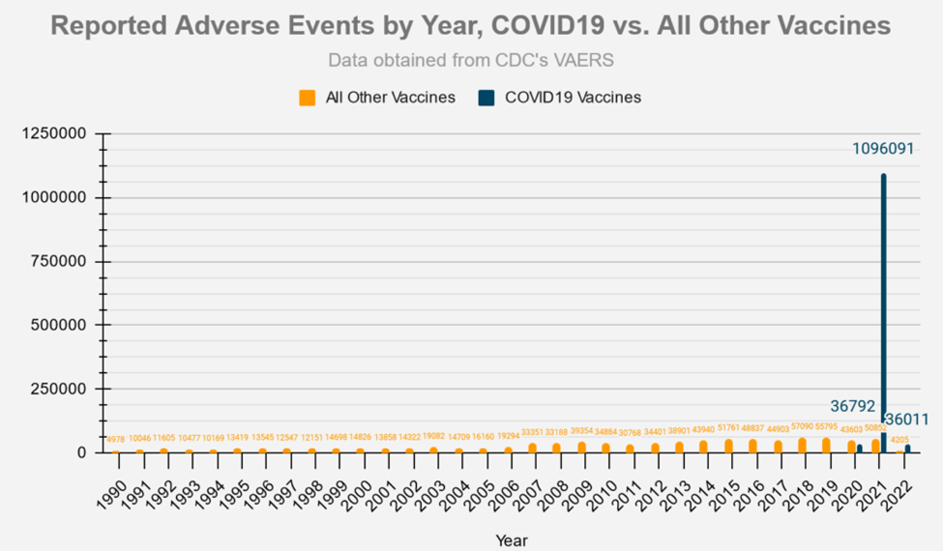

**Figure 2:** *Map 1 shows the population density in the United States from the 2020 estimated census data.*

**Figure 3:** *Map 2 show the adverse events reported per 1000 people by state in 2020.*

**Figure 4:** *Map 3 shows the reported adverse events per 1000 people by state in 2021.*

**Figure 5:** *Chart 2 shows the comparison between the reported deaths of the COVID vaccines and all other vaccine deaths since 1990 by state.*

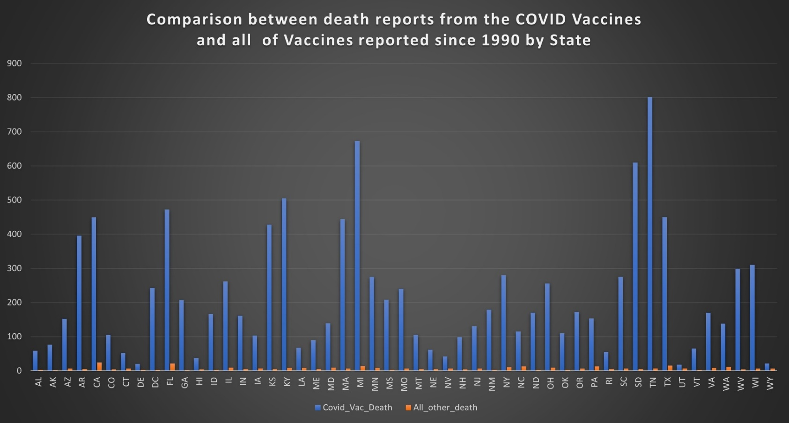

**Figure 6:** *Map 4 shows the Moran’s I “hotspot” analysis of the reported male and female population from 2020 – 2022.*

**Figure 7:** *Chart 3 shows the comparison between each of the COVID vaccine manufactures and their reported death rate from 2020 – 2022.*

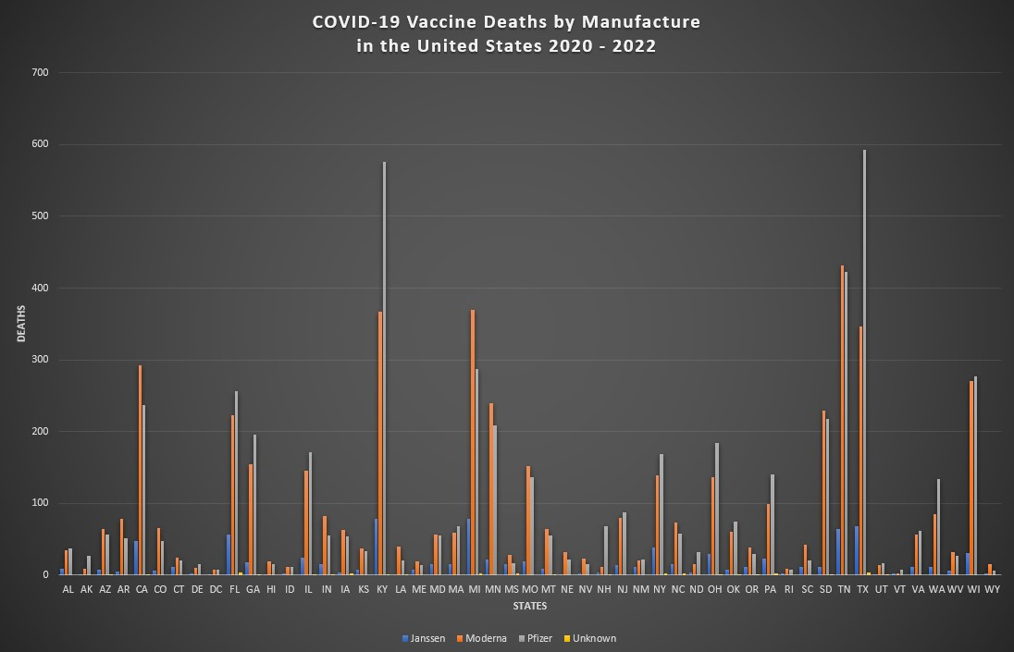

**Figure 8:** *The images below show the Rstudio code that was used to complete the statistical analysis of the COVID vaccine data as well as the reported death data.*

*library(maptools)*

*library(spdep)*

*library(rgdal)*

*library(GISTools)*

*library(raster)*

*setwd("/Users/Jeffrey/Documents/OU_GIS/Cap_Stone/R_analysis")*

*dat<- read.csv("STATES.csv")*

*states <- shapefile("STATES.shp")*

*hist(dat$Total_2020)*

*hist(dat$Total_2021)*

*plot(dat$Total_2021)*

*popvac <- lm(PopVac_2022 ~ POP2020, data = dat)*

*summary(popvac)*

*predict(popvac)*

*plot(popvac)*

*cor.test(dat$PopVac_2022, dat$POP2020)*

*datreg<- lm(VacTot2020 ~ Total_2020, data= dat)*

*summary(datreg)*

*predict(datreg)*

*plot(datreg)*

*cor.test(dat$VacTot2020, dat$Total_2020)*

*datreg.2 <- lm(VacTot2021 ~ Total_2021, data = dat)*

*summary(datreg.2)*

*predict(datreg.2)*

*plot(datreg.2)*

*cor.test(dat$VacTot2021, dat$Total_2021)*

*datareg.3 <- lm(PopVac_2022 ~ Total_2022, data = dat)*

*summary(datareg.3)*

*predict(datareg.3)*

**Figure 8 continued:**

*plot(datareg.3)*

*cor.test(dat$PopVac_2022, dat$Total_2022)*

*female20 <- lm(VacTot2020 ~ Female_2020, data = dat)*

*summary(female20)*

*predict(female20)*

*plot(female20)*

*cor.test(dat$VacTot2020, dat$Female_2020)*

*male20 <- lm(VacTot2020 ~ Male_2020, data = dat)*

*summary(male20)*

*predict(male20)*

*plot(male20)*

*cor.test(dat$VacTot2020, dat$Male_2020)*

*female21 <- lm(VacTot2021 ~ Female_2021, data = dat)*

*summary(female21)*

*predict(female21)*

*plot(female21)*

*cor.test(dat$VacTot2021, dat$Female_2021)*

*male21 <- lm(VacTot2021 ~ Male_2021, data = dat)*

*summary(male21)*

*predict(male21)*

*plot(male21)*

*cor.test(dat$VacTot2021, dat$Male_2021)*

*female22 <- lm(VacTot2022 ~ Female_2022, data = dat)*

*summary(female22)*

*predict(female22)*

*plot(female22)*

*cor.test(dat$VacTot2022, dat$Female_2022)*

*male22 <- lm(VacTot2022 ~ Male_2022, data = dat)*

*summary(male22)*

*predict(male22)*

*plot(male22)*

*cor.test(dat$VacTot2022, dat$Male_2022)*

**Figure 8 continued:**

*female.global <- lm(PopVac_2022 ~ Female_2020 + Female_2021 + Female_2022, data = dat)*

*summary(female.global)*

*female.resid <- resid(female.global)*

*dat$female.resid <- female.resid*

*plot(female.resid)*

*moran.test(dat$female.resid)*

*pv203 <- as.numeric(states$PopVac_203)*

*fe202 <- as.numeric(states$Female_202)*

*fe203 <- as.numeric(states$Female_203)*

*fe204 <- as.numeric(states$Female_204)*

*female.global <- lm(pv203 ~ fe202 + fe203 + fe204, data = states)*

*summary(female.global)*

*cor.test(dat$PopVac_2022, dat$Female_total)*

*female.resid <- resid(female.global)*

*states$female.resid <- female.resid*

*plot(female.resid)*

*par(mfrow = c(1,1))*

*states.nb <- poly2nb(states)*

*states.lw <- nb2listw(states.nb)*

*moran.test(states$female.resid, states.lw)*

*ma202 <- as.numeric(states$Male_2020)*

*ma203 <- as.numeric(states$Male_2021)*

*ma204 <- as.numeric(states$Male_2022)*

*male.global <- lm(pv203 ~ ma202 + ma203 + ma204, data = states)*

*summary(male.global)*

*cor.test(dat$PopVac_2022, dat$Male_total)*

*male.resid <- resid(male.global)*

*states$male.resid <- male.resid*

*plot(male.resid)*

*par(mfrow = c(1,1))*

**Figure 8 continued:**

*barplot(dat$Covid_Vac_Death)*

*barplot(dat$All_other_death)*

*moran.test(states$male.resid, states.lw)*

*Vac_Death <- lm(PopVac_2022 ~ Covid_Vac_Death, data = dat)*

*summary(Vac_Death)*

*cor.test(dat$PopVac_2022, dat$Covid_Vac_Death)*