Memo: Are localities actually trying to attract seniors (or not)?

- Colorado is literally doing this
  - https://dpt.colorado.gov/exemptions
- Claude deep research
  - (see Zotero)
- Neat CBPP article showing how terribly targeted/regressive these are
  - The senior tax breaks are poorly targeted because of their design: most states provide them regardless of the recipient’s income or savings. In particular, exemptions for retirement income such as pensions benefit those higher up the income scale more.
  - https://www.cbpp.org/research/states-should-target-senior-tax-breaks-only-to-those-who-need-them-free-up-funds-for
  - lot of simple neat facts in here in fact it’s in Zotero.
    - 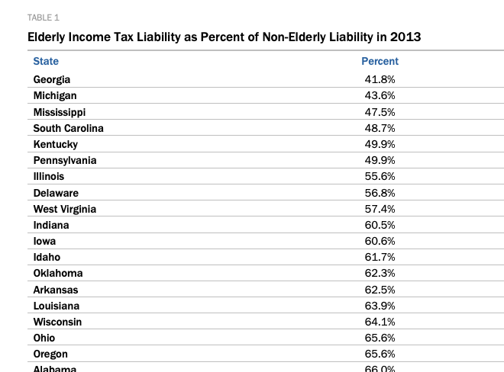
    - 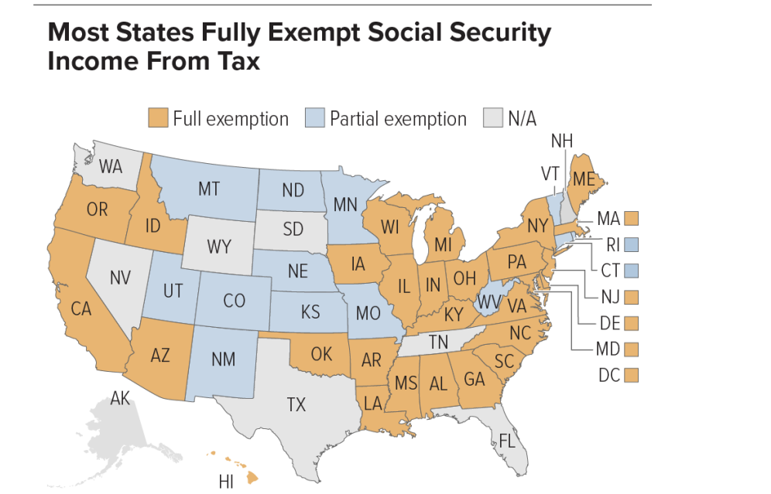
    - 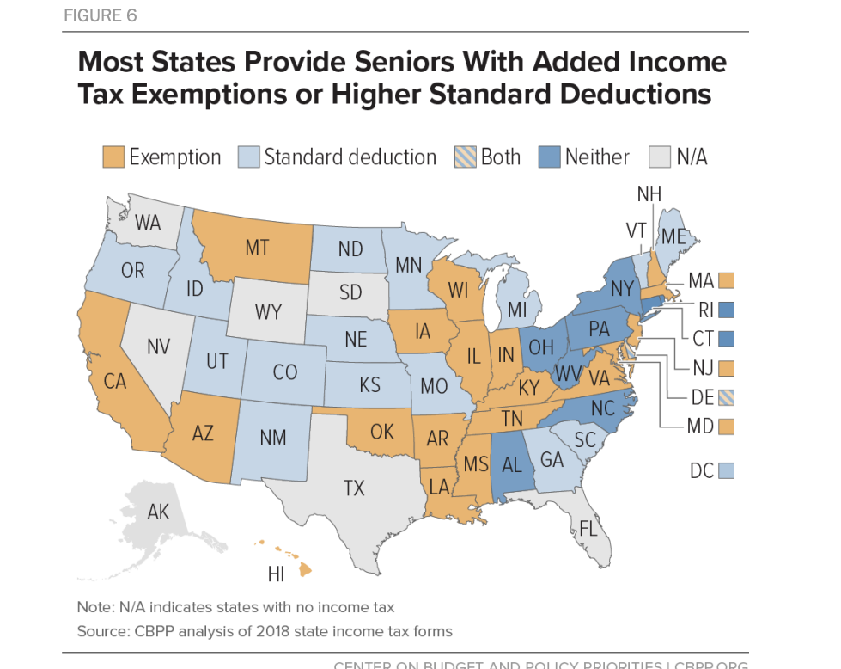
    - 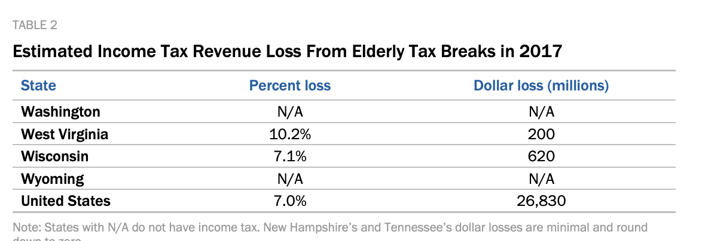
  - Ok you can’t just write about age-absed property tax exemptions
    - “AGE-BASED PROPERTY TAX EXEMPTIONS published in JUE
      - Many local jurisdictions offer property tax exemptions or similar concessions to older citizens. Such exemptions represent substantial intergenerational transfers and may have important implications for local public finances. The consequences of age-based property tax exemptions depend upon the extent to which they influence households' location decisions, housing tenure decisions, and housing consumption. We provide the first evidence on (long-term) changes in household composition and housing consumption attributable to local, age-based property tax exemptions. We construct a unique database of local property tax exemptions in Georgia covering 100 years of county, school district, and selected city property tax laws. We use these data to estimate the effect of age-based property tax exemptions on the number of older homeowners from 1970–2010 attributable to the exemption. Using a "quadruple-difference" estimation strategy, we find a significant increase in older homeowners attributable to the combined effect of age-based property tax exemptions on location decisions and housing tenure. We also find evidence that age-based property tax exemptions increase housing consumption among older households. Finally, we estimate a sorting model to estimate the equilibrium effects of different tax policies.
    - And earlier (and maybe better) Property taxes and elderly mobility Hui Shan

