1
High-Speed Beginner Ramp Up
This chapter covers
- Explanation of the MVC pattern
- Dissecting the default application template
- Creating your first ASP.NET MVC 2 Project
- Creating Controllers & Actions
- Handling User Input
- Working with the View
- Simple View Models

In the first edition of this book, we made a decision to address some of the more advanced, real-world concepts of the ASP.NET MVC Framework. While a noble goal, the book was clearly missing a quick, soup-to-nuts introduction to the entire framework. This chapter is intended to provide you with a quick, high level overview of the framework. We'll create a very basic sample application, collect user input, and display some web pages. But first, let me introduce you to your new friend…

1.1 Welcome to ASP.NET MVC
ASP.NET MVC is a new web application framework from Microsoft. It was first unveiled in November of 2007 and has since seen more than 10 releases and 2 major versions. The name stands for Model-View-Controller, a pattern that is becoming increasingly popular with web development frameworks.

ASP.NET MVC is an alternative to WebForms, which means you won't be dealing with Pages and Controls, PostBacks or ViewState, or any complicated event lifecycle. Instead, you'll be defining controller, actions, and views. The underlying ASP.NET platform is the same, however, so things like HttpHandlers & HttpModules still apply.

We'll cover all of the major features of the framework throughout this book, but quickly some of the benefits are:
- Full Control over HTML
- Full Control over URLs
- Better Separation of Concerns
- Extensibility
- Testability
As you read the chapters in this book, these items will become increasingly apparent. For now, we will briefly look at the underlying pattern the framework is based on. Why MVC? Where did it come from?

1.2 The MVC Pattern
The MVC pattern, or Model-View-Controller, is an adaptation of a pattern generated from the Smalltalk community in 197x by Trygve Reenskaug. It was popularized for use on the web with the advent of Ruby on Rails in 2003.
The components of MVC are very straightforward:

The Model - the "thing" that your software is built around. If you were building a blog, your models might be Post and Comment. In some contexts, this might simply refer to a view-specific model, which you'll learn about in the next chapter.

The View - a visual representation of a model, given some context. It's the resulting HTML that the framework renders to the browser.

The Controller - a mediator. The controller processes input, acts upon the model, and decides what to do, render a view, redirect somewhere else, etc.

Now that you have a rudimentary overview of the ASP.NET MVC Framework and the MVC pattern in general, you are armed to create your first project.
1.3 Creating Your First ASP.NET MVC 2 Project

We are now going to dive right in and create a new ASP.NET MVC 2 project.
The rest of this book assumes that you have ASP.NET MVC 2 installed, either on Visual Studio 2008 or on Visual Studio 2010. If you do not, check the Appendix for instructions on how to obtain it.

Fire up Visual Studio, and go to File New Project. You are presented with the dialog pictured in Figure 1.1.

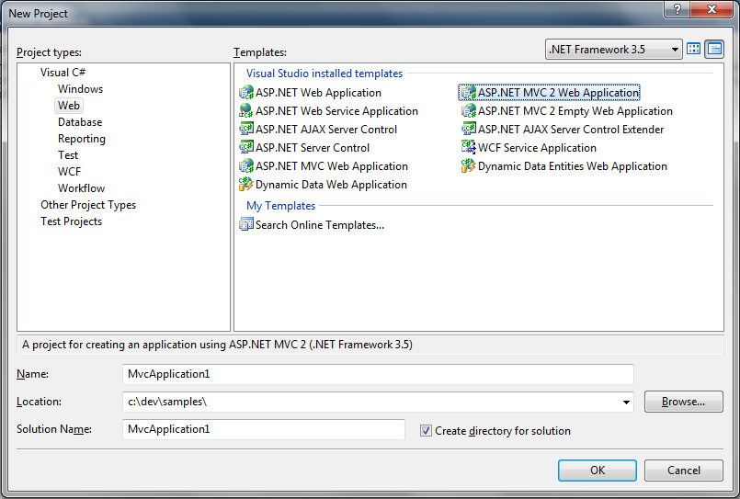
Figure 1.1 - The New Project Dialog. Notice the ASP.NET MVC 2 Project Templates
On the left pane, under Project types, select Web. For the Template, select ASP.NET MVC 2 Web Application. Give the application a name and location and click OK.

You are greeted with a dialog box (Figure 1.2) that asks you if you want to create a Unit Test project. Normally I'd recommend creating a unit test project, however to keep this chapter focused, we'll select No for now.

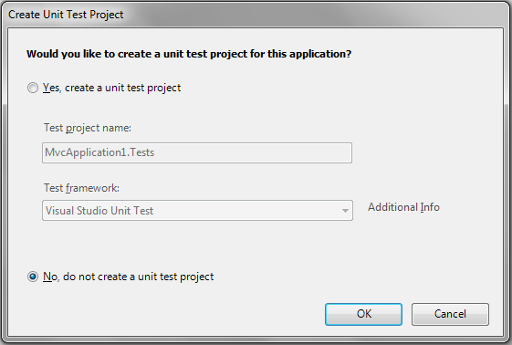
Figure 1.2 - Visual Studio prompts you to create a Unit Test project. For now, select No.

Your project is ready to go. Visual Studio created a number of folders for you. Let's examine them and see what their purpose is:

Content/ Static files such as CSS and images
Controllers/ Your application's controller classes
Models/ Your application's models
Scripts/ JavaScript files
Views/ Your application's views

Take a look at the folder structure for a minute. You'll work with this structure for all of your ASP.NET MVC projects, so everything will eventually look familiar.

The application that Visual Studio has given us is a working sample of the ASP.NET MVC Framework. That means we can just run it (CTRL-F5) and see how it works. Go ahead and do that now.

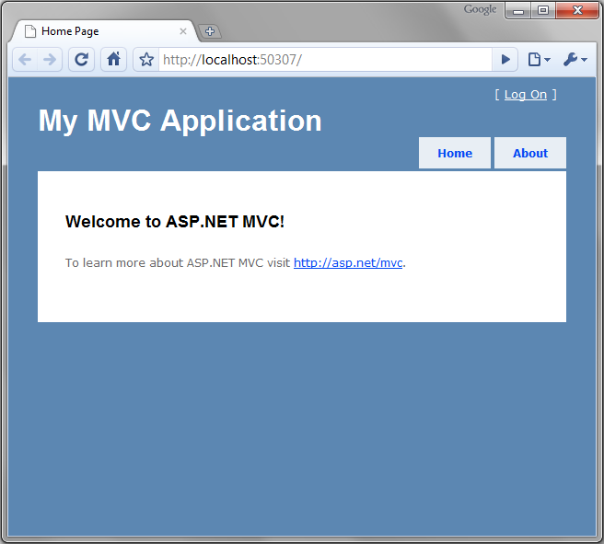
Figure 1.3 - The default ASP.NET MVC project template is fully functional
Your browser should be opened and you should be looking at a page that looks like Figure 1.3. Notice that the URL is simply http://localhost:(port)/. There is no path specified. Let's examine how this view was rendered.

First, we made a request to / (the root of the site), so we must check the routes to see how the application responds to URLs. Routes are a way for you to customize the URLs that users use when interacting with your site. You'll learn about routing in depth in Chapter 16 but we'll cover what you need to know to get started.

Routes are (by default) defined in the Global.asax. Open up this file and you should see the code shown in Listing 1.1.

Listing 1.1 - Route definitions
public static void RegisterRoutes(RouteCollection routes)
{
routes.IgnoreRoute("{resource}.axd/{*pathInfo}");

routes.MapRoute(
"Default", (#1)
"{controller}/{action}/{id}", (#2)
new { controller = "Home", action = "Index", id = "" } (#3)
);
}

#1 - Route name
#2 - URL parameters
#3 - Default values
(Cueballs in Listing and Text)

Notice that two entries are defined. The first is an IgnoreRoute, and that basically tells the framework to not worry about anything matching the path. In this case, it means don't try to process any of the axd paths, such as Trace.axd. The second entry, MapRoute, is what defines how URLs are processed. This built-in route will suffice for a while, but later on you will want to add more routes the application.

Each route has a name (#1), a URL definition (#2), and optional default values (#3). Our first request for / doesn't have any of these URL pieces, so we look to the defaults. The default values are:

controller "Home"
action "Index"
id "" (empty string)

So we know now that the controller is "Home" and the action is "Index." Take a look in the Controllers folder and you will see a class called HomeController. By convention, all controller classes end with the word Controller. Open up this class and you'll see your first controller class (Listing 1.2).

Listing 1.2 - The HomeController
[HandleError]
public class HomeController : Controller
{
public ActionResult Index()
{
ViewData["Message"] = "Welcome to ASP.NET MVC!";

return View();
}

public ActionResult About()
{
return View();
}
}

So what defines a controller in ASP.NET MVC anyway? For a class to be considered a controller, it must:
- End with the word "Controller"
- Inherit from System.Web.Mvc.Controller (or implement IController)
- Contain public methods that return ActionResult (these are called actions)

We know that the Index action is going to be called. In this action method, we have these 2 statements:

ViewData["Message"] = "Welcome to ASP.NET MVC!";
return View();

The first adds a string into a dictionary called ViewData. This is one way of passing data over to the view. The second line returns the result of a method called View(). This is a helper method, defined in the Controller base class. It simply returns a new ViewResult object. ViewResult is just one of the many ActionResult derivatives that you can return from actions. To get started, we'll only talk about a couple of them in this chapter. You'll learn about others as you read on.
This ViewResult tells the framework to render a view. You have the option of providing a name for the view, however if you don't - like in our case - it will just use the same name of the action.
So where is this view located? We learned a few minutes ago that the default project structure contains a Views folder. By convention, views are located in a subfolder corresponding the controller name. The name of the action (again by convention) is the same as the name of the view.
Inside of the Views folder you'll find a folder for each controller in the application, along with a special one named Shared. Open up the Home folder (since we're dealing with HomeController, and open the Index.aspx file. It should look like Listing 1.4.

Listing 1.4 - The Index.aspx view
<%@ Page Language="C#" MasterPageFile="~/Views/Shared/Site.Master" Inherits="System.Web.Mvc.ViewPage" %>

<asp:Content ID="indexTitle" ContentPlaceHolderID="TitleContent" runat="server">
Home Page
</asp:Content>

<asp:Content ID="indexContent" ContentPlaceHolderID="MainContent" runat="server">
<h2><%= Html.Encode(ViewData["Message"]) %></h2> (#1)
<p>
To learn more about ASP.NET MVC visit <a href="http://asp.net/mvc" title="ASP.NET MVC Website">http://asp.net/mvc</a>.
</p>
</asp:Content>

#1 - Using the data provided by the controller.
This view uses a master page, which is similar to what you would see in an ASP.NET WebForms project. If you're curious, you can find this in /Views/Shared/Site.Master, however for now we can just focus on the view.
Our view will simply render the data provided by the controller. It should not contain any complex logic. Keeping the view simple makes it easy to read and maintain, especially since we'll be mixing code with HTML. In Listing 1.4, you can see that we simply output a message inside a code block denoted by <%= %> tags.

To illustrate working with the ASP.NET MVC Framework we will add some guestbook features to this application. The first step is adding a new controller.

1.4 Creating Controllers & Actions

To add a new controller to our site, we can right click on the Controllers folder. Visual Studio presents us with a context menu containing an item "Add Controller". You can see this in Figure 1.4.

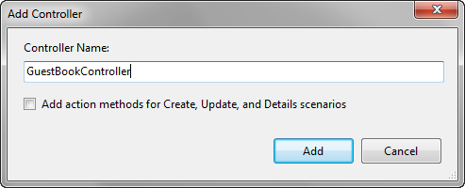
Figure 1.4 - The Add Controller dialog in Visual Studio
For the name, type "GuestBookController." For now, don't check the checkbox as we want to write our own actions.

Note:
All ASP.NET MVC Controllers must end with the word "Controller".
A class will be created for you that looks like Listing 1.5.

Listing 1.5 - Creating your first controller
public class GuestBookController : Controller
{
//
// GET: /GuestBook/

public ActionResult Index()
{
return View();
}

}

Notice that an initial action method Index is created for you. For this action, we don't need to do anything except to render a view. Let's do that now.
1.4 Creating views

To create a view, right-click on the action method name and select "Add View" (shown in Figure 1.6.
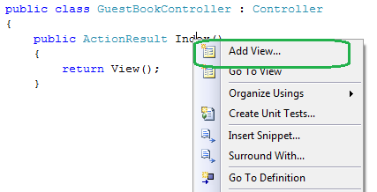
Figure 1.6 - Right click on an action to create a view.
You'll see a dialog box asking you for some information about the view (shown in Figure 1.7). The view name (by default) is the same name as the action, so verify that it says "Index." You can ignore the other options for now and click Add.

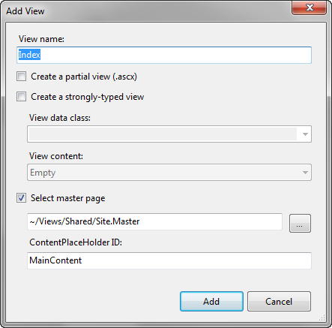
Figure 1.7 - The Add View dialog
Visual Studio will automatically create the appropriate folder and place the Index.aspx file in it. Open up this file and modify it so that it looks like Listing 1.6.

Listing 1.6 - The GuestBook Index view
<%@ Page Title="" Language="C#" MasterPageFile="~/Views/Shared/Site.Master" Inherits="System.Web.Mvc.ViewPage" %>

<asp:Content ID="Content1" ContentPlaceHolderID="TitleContent" runat="server">
Index #1
</asp:Content>

<asp:Content ID="Content2" ContentPlaceHolderID="MainContent" runat="server">

<h2>Guest Book</h2>

<p>Please sign the Guest Book!</p>

<form method="post" action="/GuestBook/Sign"> #2
<fieldset>
<legend>Guest Book</legend>

<%= Html.Label("Name") %> |#3
<%= Html.TextBox("Name") %> |
|
<%= Html.Label("Email") %> |
<%= Html.TextBox("Email") %> |
|
<%= Html.Label("Comments") %> |
<%= Html.TextArea("Comments", new { rows=6, cols=30 }) %> |

<div>
<input type="submit" value="Sign" />
</div>
</fieldset>
</form>

</asp:Content>

(#1) Content controls to change the title of the page
(#2) This action does not exist (yet)
(#3) These are HTML Helpers
Cueballs in text
Using Content controls you can have sections of content that are placed in different areas on your page. The Master Page defines the various ContentPlaceHolders you can use. (#1) shows how you can change the title of the page without having to hard code it in the Master Page.
Our view has some form fields, so we need a <form> tag. Unlike WebForms, ASP.NET MVC does not create any implicit forms for you. We create a simple form that posts to the URL "/GuestBook/Sign" (#2). This action doesn't exist yet, but we will create it in just a minute.
Inside the form we have some HTML helpers that generate form controls for us (#3). For now, just know that these output the HTML required for each element, but have some friendly functionality to deal with validation errors & automatic binding of data.

Before we run the application, we can add a couple of CSS entries to make the form look decent. Open up the /Content/Site.css file and add the following code somewhere in the file:

fieldset label
{
display: block;
}

fieldset input
{
display: block;
margin-bottom: 5px;
}
We're ready to run the application. Go ahead and press CTRL+F5 and see the site open. Navigate to http://localhost:{port}/GuestBook. You should see the page in Figure 1.7.
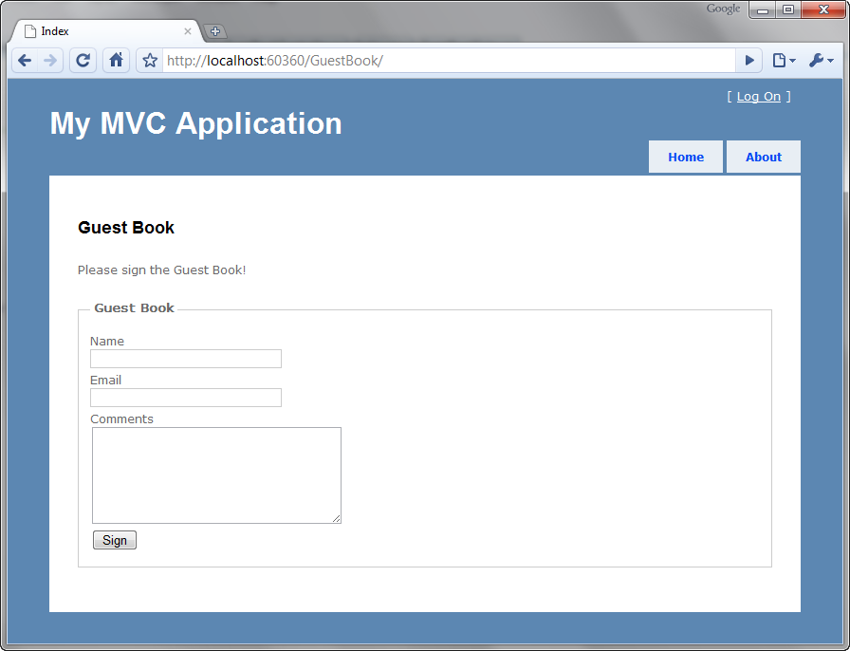
Figure 1.7 - Our GuestBook view
Notice that we only supplied "GuestBook" in the URL. The Index part was implied. How did this happen? Remember the routing rule from before? The default action is defined as "Index", which is what is happening here.
If you tried to fill out the form, you'll quickly find out that an error occurs. This is because we haven't written the action that the form posts to yet! We'll do that next.
Open up GuestBookController and write the action in listing 1.7
Listing 1.7 - An action to respond to the form post
public ActionResult Sign(string name, string email, string comments) #1
{
//do something with the values, such as send an email

ViewData["name"] = name; |#2
ViewData["email"] = email; |
ViewData["comments"] = comments; |

return View("ThankYou"); #3
}

#1 Form values are passed in as method arguments
#2 Putting data into the ViewData dictionary
#3 Returning a specific view

In this action, you can see that the arguments match the names of our form values. This is intentional because the ASP.NET MVC Framework will automatically convert values from posted form values, query string values, and other places.
We want to access this data on the view (so that we can present the entry to the user). To do this, we utilize a feature called ViewData. This is a dictionary object (which means you put objects in a data structure which are referenced by a key.
Finally we return a specific view, called "ThankYou". You don't necessarily have to choose a view name that matches the action name, though in many cases that is most desirable. We'll create this view now (listing 1.8).
Listing 1.8 - The ThankYou.aspx view
<%@ Page Title="" Language="C#" MasterPageFile="~/Views/Shared/Site.Master" Inherits="System.Web.Mvc.ViewPage" %>

<asp:Content ID="Content1" ContentPlaceHolderID="TitleContent" runat="server">
ThankYou
</asp:Content>

<asp:Content ID="Content2" ContentPlaceHolderID="MainContent" runat="server">

<h2>Thank You!</h2>

<p>Thank you for signing the guest book! You entered:</p>
Name: <%= ViewData["name"] %><br />
Email: <%= ViewData["email"] %><br />
Comments: <i><%= ViewData["comments"] %></i>

</asp:Content>

In the view we access the data that was provided by the controller. Notice how we use code blocks <%= %> to output the values.

Now we're done with our feature. If we run the application one more time and fill out some values (figure 1.8) then we should be taken to a new page that shows us what we submitted (figure 1.9).

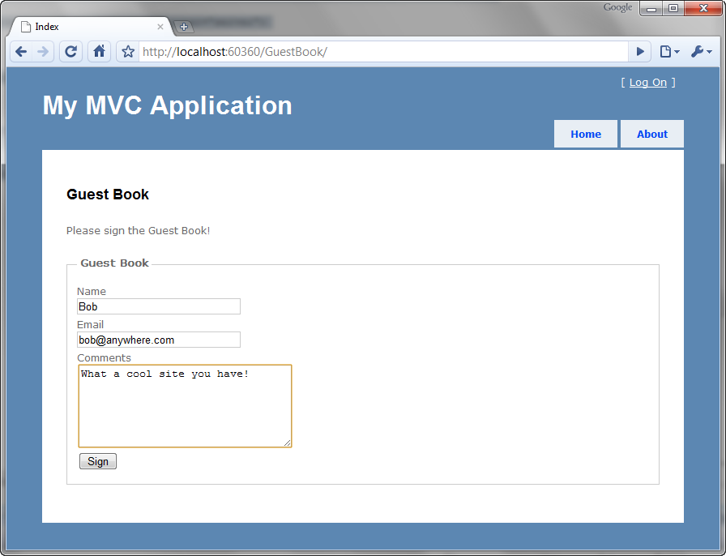
Figure 1.8 - Submitting the Guest Book form.
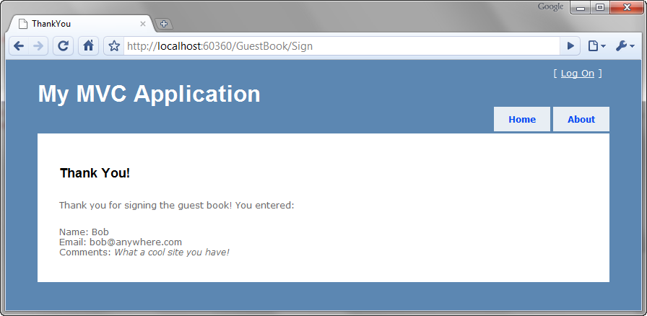
Figure 1.9 - Our data is displayed back to us.
Our first application is complete. While it is functional, it contains a number of problems that your authors consider bad practices. Namely:
- No Model. We dealt purely with primitive values.
- Using ViewData["foo"] utilizes magic strings and relies on casting to do anything meaningful with the data
- The URL still says "Sign" even though we rendered the ThankYou view. This is because we didn't redirect to a success page, we simply rendered one. This causes the next unfortunate aspect of the site…
- If you refresh this page, it will prompt you to submit the data again. If the user obliges, then two records will be posted with the same data.
This example is complete (and probably representative of many examples you'd find online) however it demonstrates some real problems that should not be present in a real application. This book is about practical ASP.NET MVC development practices that we would recommend. Let's take the remainder of this chapter to clean up some of these shortcomings.
1.5 Improving our Application
The first step is to create a Model. The Model does not have to be a domain entity or inherit from any special class. It can be any class at all. Let's create a model class that represents the data that the user will be posting back to the server (listing 1.10).

Listing 1.10 - Creating a View Model for our GuestBook application
public class GuestBookEntry
{
public string Name { get; set; }
public string Email { get; set; }
public string Comments { get; set; }
}

Notice that the class doesn't contain any logic, nor does it have any dependencies on other objects. It is simply a data container.

Next let's move our attention to the Sign action in our GuestBookController class. Instead of taking separate parameters in the action, we change simply use our newly created model, GuestBookEntry. Listing 1.11 shows this change.
Listing 1.11 - Accepting a complex object as an action parameter
public ActionResult Sign(GuestBookEntry entry)
{
/* snip */
}

You're probably wondering how it is possible to accept a complex object like that. The answer lies in the magic of Model Binding. You'll learn all about model binding later, but for now, just understand that the ASP.NET MVC Framework is smart enough to bind these objects where the property names match keys contained in the Request.Form collection as well as Request.Querystring.
We don't necessarily want anyone to be able to sign our guest book by visiting a URL. This (in HTTP terminology) is a GET request. In general a GET request should not alter the system in any way. It should instead be reserved solely for retrieving. To protect this action against GET requests, we can apply the [HttpPost] attribute to the action method.
On the Index.aspx view, we have a hand-written form tag. This in itself is not bad, however we have hard-coded the URL. Using different routing rules, our URLs could easily change and that would cause this form to break. Instead, let's leverage the framework to build our form tag for us. We can use Html.BeginForm to generate a form tag like this:

<% using(Html.BeginForm("Sign")) { %>
<!-- form fields here -->
<% } %>
Html.BeginForm is a special HTML helper. It doesn't directly return a string (where we'd have to use <%=). Instead it uses the IDisposable pattern to gracefully wrap the form contents in a <form> </form> set of tags. The first argument is the name of the action. We can simplify this further by

Listing 1.12 contains the change.
Listing 1.12 - Using the Html.BeginForm helper to generate a form tag
<h2>Sign the Guest Book!</h2>

<% using (Html.BeginForm("Sign")) {%>

<fieldset>
<legend>Fields</legend>
<p>
<%= Html.LabelFor(model => model.Name) %>
<%= Html.TextBoxFor(model => model.Name) %>
</p>
<p>
<%= Html.LabelFor(model => model.Email) %>
<%= Html.TextBoxFor(model => model.Email) %>
</p>
<p>
<%= Html.LabelFor(model => model.Comments) %>
<%= Html.TextBoxFor(model => model.Comments) %>
</p>
<p>
<input type="submit" value="Create" />
</p>
</fieldset>

<% } %>

View Model (GuestBook)
Strongly-typed ViewPage<T>
Model Binding
TempData
Post-Redirect-Get pattern

1.6 What did we learn?
Look back at the concepts in the chapter
Set the stage for the rest of the book
Explain Part I, II, III
Introduce next chapter -> "The Presentation Model"

