13
Controller Factories
This chapter covers
- Building Custom Controller Factories
- Dependency Injection with Controllers
- Working with StructureMap
- Working with Ninject
- Working with Castle Windsor

One common technique in building applications is to accept dependencies in the constructor of your objects. Leveraging various tools we can automatically wire-up these dependencies and provide the arguments without having to write mundane, repetetive code. In order to enable this for our controllers we will need to take responsibility for creating them. In this Chapter, you will learn about Controller Factories and how you can use them to help enable such scenarios.
13.1 What are Controller Factories?
Controller Factories are an important extension point in the ASP.NET MVC Framework. They allow you to take on the responsibility of creating controllers. This enables you to apply a set of logic for every single controller in your application. You can use Controller Factories to apply a custom IActionInvoker instance to all of your controllers, or perhaps to add custom logging.
The most common case of a controller is to enable support for dependency injection tools. Not sure what all this dependency injection mumbo-jumbo is?
The Inversion of Control principle and Dependency Injection
Normally when code executes other code, there is a linear flow of creation and execution. For instance, if I have a class that depends on another class, I will create that class with the “new” operator, then execute the class by calling a method. If I used Inversion of Control (IoC), I would still call methods on the class, but I would require an instance of the class passed into my constructor. In this manner, I yield control of locating or creating my dependency to the calling code. DI is the act of injecting a dependency into a class that depends on it. Often used interchangeably, IoC and DI yield loosely coupled code and are often used with interfaces. With interfaces, classes declare dependencies as interfaces in the constructor arguments. Calling code then locates appropriate classes and passes them in when constructing the class.
IoC containers come into play to assist with managing this technique when used through an application. There are plenty of IoC containers to choose from, but the favorites at this time seem to be StructureMap, Ninject, and Castle Windsor found at http://structuremap.sourceforge.net, http://ninject.org and http://www.castleproject.org/container respectively.
Controllers can leverage dependency injection by declaring their dependencies as constructor parameters. This _inverts_ the control where the caller is responsible for supplying the dependencies of a class, rather than the class newing up concrete instances itself. It allows you to decouple controllers from concrete instances of its dependencies (such as a repository or service). It is quite liberating, not to mention it helps facilitate decoupled unit testing.

Constructor Injection
When we ask for dependencies in the constructor, we call it constructor injection. There is another technique called property injection but it is not as apparent that these components are required for the object to do its job. IoC tools can usually do both, but constructor injection is preferred for required dependencies.
If you were to define a constructor with a dependency, the framework (by default) will no longer be able to build up your controllers for you. If you try, you're likely to get an error like in Figure 13.1.

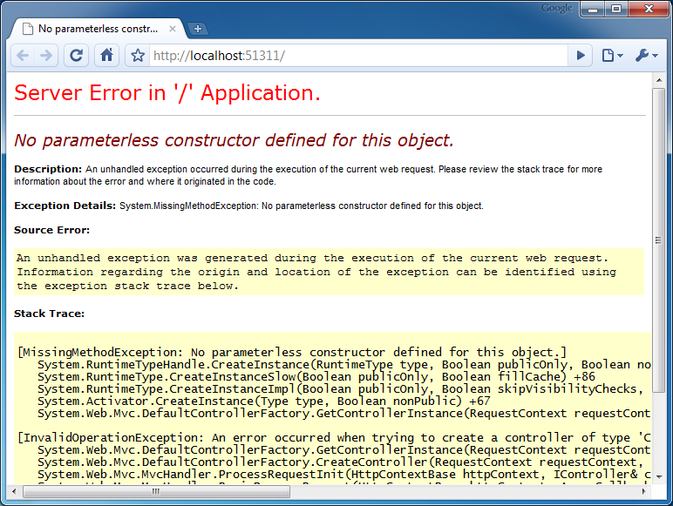
Figure 13.1 - Trying to use constructor dependencies without replacing the Controller Factory
The reason is because the DefaultControllerFactory simply uses Activator.CreateInstance and knows nothing about the controller's constructor arguments. To fix this, you'll need to create your own custom Controller Factory.

13.2 Creating a Custom Controller Factory
To create a custom Controller Factory class you simply derive from either IControllerFactory or the more friendly base class: DefaultControllerFactory. Listing 13.1 shows a sample controller factory class.
Listing 13.1 - A custom Controller Factory
public class MyCustomControllerFactory : DefaultControllerFactory
{
protected override IController GetControllerInstance(RequestContext requestContext,
Type controllerType)
{
/* implement controller creation logic */
}
}

You could implement the IControllerFactory interface directly; however the DefaultControllerFactory has some logic for determining the controller's Type based on the name. You simply override this method and plug in your behavior.

Once you have a custom Controller Factory, how do you use it? At application startup, in your Global.asax.cs file, you can register your implementation like this:

ControllerBuilder.Current.SetControllerFactory(new
MyCustomControllerFactory());

The framework will now use your class to build all instances of controllers. We can use this feature to implement IoC support in our controllers, but perhaps you're wondering why this is even needed?
13.3 Enabling Dependency Injection in your Controllers

One of the benefits of the ASP.NET MVC Framework is the separation of concerns that it allows. When you segment your code into controllers, models, and views, it becomes easy to understand and maintain. Separation of Concerns is one of the best attributes your code can have if you wish it to be maintainable.
It is not hard to imagine your controller growing and growing until it gets out of hand. Packing too many responsibilities into your controller is a sure-fire way to a messy project that makes it so difficult to work with it feels like you're wading through mud.
Here is a small list of things your controller should not do:
- Perform data access queries directly
- Talk to the file system directly
- Send emails directly
- Call web services directly
Notice a pattern? Any external dependency on some sort of infrastructure is a great candidate to extract out into an interface and be utilized by your controller. This has a couple benefits:
- Controller becomes thinner, thus easier to understand
- Controller becomes testable - we can write unit tests and stub out the dependencies, isolating the class under test.

We can also take this idea to any areas of the code where the controller is performing complex business logic. This should really be the responsibility of either the Model or perhaps a Domain Service (which is really just a stateless class that holds business logic that applies outside the context of a single entity).
It is not uncommon to see a controller that looks like Listing 13.2.
Listing 13.2 - A Controller that accepts dependencies in its constructor
public class ProductsController : Controller
{
public ProductsController(IProductRepository repository,
IShippingCalculator shippingCalculator,
ITaxService taxService)
{
/* ... */
}

/* ... */
}

Creating controllers like this by hand would be an effort in extreme tedium, and luckily you don't have to do it by hand. This is where IoC tools (also known as IoC containers) come in handy. There are quite a few to choose from, but currently the three most popular are:
- StructureMap (http://structuremap.sourceforge.net)
- Ninject (http://ninject.org)
- Castle Windsor (http://www.castleproject.org/container)
Each has its own strengths and weaknesses and I encourage you to take a look at each to see which one feels best and fits the needs of your applications. We'll briefly cover these in order to create a custom Controller Factory for each one.
For the sample application, we'll have an interface called IMessageProvider that our controller will depend on (in the constructor) and the implementation of this interface will not be known to the controller at all. In other words it is decoupled from the implementation.
We'll start with StructureMap.
13.4 Creating a StructureMap Controller Factory

The first step is to download the StructureMap binaries and include them somewhere in your project, such as a lib folder. Go ahead and add a reference to the StructureMap.dll to your ASP.NET MVC project.
StructureMap, as with any IoC tool, needs to be initialized upon application startup. We could place the initialization code directly in Global.asax.cs in Application_Start however this tends to be a breeding ground for tons of unrelated code. Instead, we'll leverage a small class called a bootstrapper (which will be kicked off in Application_Start. The bootstrapper simply abstracts initialization code away from the Global.asax.cs to keep things clean and simple. Listing 13.3 shows this class implementation.

Listing 13.3 - Initializing StructureMap in a bootstrapper class
using StructureMap;

public static class StructureMapBootstrapper
{
public static void Initialize()
{
ObjectFactory.Initialize(x => x.AddRegistry(new MyStructureMapApplicationRegistry()));
}
}

In order to initialize StructureMap and tell it about our components, we use the ObjectFactory.Initialize() method. This accepts a lambda expression that we use to interact with the framework. In our case, we're utilizing a registry (which we haven't created yet). Other, more advanced StructureMap scenarios exist where you can utilize conventions, but that is subject to more advanced study. Listing 13.4 contains the definition of MyStructureMapApplicationRegistry.

Listing 13.4 - A StructureMap registry for our component(s)
using ControllerFactories.Models;
using StructureMap.Configuration.DSL;

namespace ControllerFactories
{
internal class MyStructureMapApplicationRegistry : Registry
{
protected override void configure()
{
//wire up IMessageProvider => StructureMapMessageProvider
ForRequestedType<IMessageProvider>()
.TheDefaultIsConcreteType<StructureMapMessageProvider>();
}
}
}

In a StructureMap registry, you're given the ability to match up interfaces to their concrete implementations. You can also do advanced things like set their behaviors (singleton, per-web request, transient, etc) so that you can control how StructureMap builds it. For now, we won't worry about this (but it will become important later).

One thing you'll notice about StructureMap is it reads very much like English. It can help, especially to someone not familiar with the concept of dependency injection; it seems pretty obvious what is happening here. At times it can be a tad verbose, but it is certainly a matter of personal preference.

We're still not done yet. We need to define the IMessageProvider interface and the StructureMapMessageProvider class. In your Models folder, go ahead and add these. They should look like Listing 13.5.

Listing 13.5 - A simple interface & concrete implementation
public interface IMessageProvider
{
string GetMessage();
}

public class StructureMapMessageProvider : IMessageProvider
{
public string GetMessage()
{
return "This message was provided by StructureMap";
}
}

Let's now make your HomeController dependent on this new IMessageProvider interface. To do this, we'll add a constructor that accepts and argument, as shown in Listing 13.6.

Listing 13.6 - "Declare" dependencies by accepting them as constructor arguments
public class HomeController : Controller
{
private IMessageProvider _messageProvider;

public HomeController(IMessageProvider messageProvider)
{
_messageProvider = messageProvider;
}

/* snip */
}

At this point if we were to try to run the application it would break. Why? Because the DefaultControllerFactory doesn't know how to build this controller anymore, since now it requires an IMessageProvider. Let's create our StructureMapControllerFactory to solve this problem. Add a new class to the project (at the root is fine) and name it StructureMapControllerFactory. Listing 13.7 shows the details.

Listing 13.7 - A StructureMap Controller Factory
public class StructureMapControllerFactory : DefaultControllerFactory
{
protected override IController GetControllerInstance(RequestContext requestContext, Type controllerType)
{
return ObjectFactory.GetInstance(controllerType) as IController;
}
}

Notice that we inherit from DefaultControllerFactory. We don't have to - at the very minimum we have to implement IControllerFactory - but by deriving from DefaultControllerFactory we're given some easier methods to override. The only method we really need to override in this case is GetControllerInstance. We'll use StructureMap's ObjectFactory.GetInstance method to pull an object out of the container. StructureMap will notice that we have a constructor that accepts arguments and try to fulfill those also. If you haven't registered any types ahead of time then you'll receive an error here.
The last step is simply plugging it in! In your Global.asax.cs, add the following line of code:

ControllerBuilder.Current.SetControllerFactory(
new StructureMapControllerFactory()
);

You're done! The last step is to actually add a view to call this controller & display the dynamic message on the view. Figure 13.2 shows an example of this.

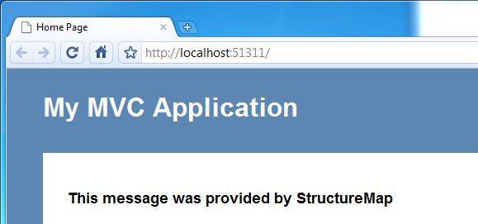
Figure 13.2 - The controller is sent a StructureMapMessageProvider to send the message to the view.
13.5 Creating a Ninject Controller Factory

Introduce Ninject
Walk through code sample

13.6 Creating a Castle Windsor Controller Factory

Introduce Castle Windsor
Walk through code sample

13.7 Summary
What did we learn?
Segue into Model Binders & Value providers

