1
Getting started with the ASP.NET MVC Framework
This chapter covers:
- Running the starter project
- Progressing through “Hello World” examples
- Routing basics
- Unit testing basics
Depending on how long you’ve been building web applications on the Microsoft platform, you’ll relate to some or all of the following pain. In the 1990s, developers built interactive websites using executable programs that ran on a server. These programs (Common Gateway Interface [CGI] was a common technology at the time) accepted a web request and were responsible for creating an HTML response. Templating was ad hoc, and the programs were difficult to write, debug, and test. In the late 1990s, Microsoft, after a brief stint with HTX templates and IDC connectors, introduced Active Server Pages, or ASP. ASP brought templating to web applications. The server page was an HTML document with dynamic script mixed in. Although this was a big step forward from the alternatives, the world soon saw massive server pages with code indecipherable from the markup.
In early 2002, along came ASP.NET and the Web Forms Framework. Web Forms were a complete shift for ASP developers, partly because they moved most program logic into a class file (called a code-behind) and replaced the HTML markup with dynamic server controls written in an XML syntax. Although performance increased, and the debugging experience improved, new problems arose.
The new server-side postback event lifecycle caused newsgroups to explode with activity as confused developers searched for that magic event in which to add those two simple lines of code necessary to make the page work as needed. ViewState, although good in theory, broke down as the application scaled with complexity. Simple pages broke 100KB in size, as the entire state of the application had to be stored in the output of every generated page. Development best practices were ignored as tools like Visual Studio encouraged data access concerns like SQL queries to be embedded within view logic. Perhaps the greatest sin of the Web Forms Framework was the tight coupling to everything in the System.Web namespace. There was no hope of unit testing any code in the code-behind file, and today we see Page_Load methods that take several trees to print. Although early versions of Web Forms had some drawbacks, ASP.NET, and the larger .NET Framework, have made huge inroads into the web application market. Today we see major websites such as CallawayGolf.com, Dell.com, Newsweek.com, and Match.com all running on ASP.NET. The platform has proven itself in the marketplace, and when combined with IIS running on Windows, ASP.NET can easily support complex web applications running in large data centers. The ASP.NET MVC Framework leverages the success of ASP.NET and Web Forms to propel ASP.NET forward as a leader in the web application development space.
The ASP.NET MVC Framework has been introduced to simplify the complex parts of Web Forms application development while retaining the power and flexibility of the ASP.NET pipeline. The ASP.NET infrastructure and request pipeline, introduced in .Net 1.0, stay the same, and ASP.NET MVC provides support for developing ASP.NET applications using the Model View Controller web presentation pattern. The concerns of the data model, the application logic, and data presentation are cleanly separated, with the application logic kept in a class separated from hard dependencies on how the data will be presented. Server pages have become simple views, which are nothing more than HTML templates waiting to be populated with objects (models) passed in by the controller. The postback event lifecycle is no more, and ViewState is no longer necessary. In this chapter, we’ll walk through your first lines of code built on top of the ASP.NET MVC Framework. After this primer, you’ll be ready for more advanced topics.
Integrating with or migrating from ASP.NET Web Forms applications
Can we create screens that leverage the ASP.NET MVC Framework while others continue to work using Web Forms? Of course we can. They can run side by side until the entire application is MVC. Using the MVC Framework is not an all-or-nothing proposition. There are many, many ASP.NET applications in production using Web Forms. If a software team wants to migrate the application from Web Forms to ASP.NET MVC, it’s possible to do a phased migration and run the two side by side in the same AppDomain. ASP.NET MVC does not replace core ASP.NET libraries or functionality. Rather, it builds on top of existing ASP.NET capabilities. The UrlRoutingModule that we registered in the web.config file causes an incoming URL to be evaluated against the existing routes. If a matching route is not found, ASP.NET will continue on and use Web Forms to fill the request, so it’s pretty simple to mix and match features during a migration or for the purpose of application extension.
Although Web Forms is not going away any time soon, we believe that controllers, actions, and views will be the preferred way to write ASP.NET applications going into the future. Although Microsoft will continue to support both options (and active development on the next version of Web Forms continues), we believe that the ASP.NET MVC Framework will be favored over Web Forms much like we see C# favored over VB in documentation, industry conferences, and technical books.
In this chapter, and throughout the book, we assume that the reader has knowledge of ASP.NET. If you’re new to ASP.NET, please familiarize yourself with the ASP.NET request pipeline as well as the .NET runtime. Throughout this chapter, we’ll take you through creating an ASP.NET MVC Framework web application project, creating your first routes, controllers, and views. We’ll comb through the default application and explain each part. Then we’ll extend it, and you’ll create your first controller and view. First, let’s explore the MVC pattern and the default application template provided with the framework.
1.1 Picking apart the default application
In this section, we’ll explain what the MVC pattern is and create our first ASP.NET MVC Web Application. We’ll focus first on the controller because in the model-view-controller triad, the controller is in charge and decides what model objects to use and what views to render. The controller is in charge of coordination and executes first when the web request comes in to the application. The controller is responsible for deciding what response is appropriate for the request.
The Model-View-Controller pattern is not new. A core tenet of the MVC pattern is to separate control logic from the view, or a screen. A view is only responsible for rendering the user interface. By separating domain logic and decoupling data access and other calls from the view, the UI can stay the same even while logic and data access changes within the application. Figure 1.1 shows a simple diagram of the MVC triad. Note that the controller has a direct relationship with the view and the model, but the model does not need to know about the controller or the view. The web request will be handled by the controller, and the controller will decide which model objects to use and which view objects to render.
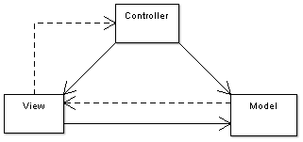
Figure 1.1 A simple diagram depicting the relationship between the Model, View, and Controller. The solid lines indicate a direct association, and the dashed lines indicate an indirect association (graphic and description used with permission from Wikipedia).
To begin, we’ll open up Visual Studio 2008 SP1 and create our project. The edition of Visual Studio 2008 makes a difference. Although there are some workarounds to using the ASP.NET MVC Framework without SP1, System.Web.Abstractions.dll and System.Web.Routing.dll are in the GAC (global assembly cache) as of SP1. You can use Visual Studio 2008 Professional, a Team Edition SKU, or Visual Web Developer Express SP1. Note that the ASP.NET MVC Framework builds on top of Web Application Projects, and although it’s possible to make it work with Web Sites, the development experience is optimized for use with Web Application Projects.
Note
You must already have Visual Studio 2008 SP1 or Visual Web Developer 2008 SP1, .NET 3.5 SP1, and the ASP.NET MVC Framework installed to proceed. The MVC Framework is an independent release that builds upon .NET 3.5 Service Pack 1. The examples in this book will use Visual Studio 2008 SP1, but you can find information on using the free Visual Web Developer Express 2008 SP1 on the ASP.NET MVC website: http://www.asp.net/mvc/.
We'll begin in Visual Studio 2008 Professional SP1 by creating a new ASP.NET MVC Web Application project. When you pull up the New Project dialog, make sure you have .NET Framework 3.5 selected. If you have .NET Framework 3.0 or 2.0 selected, Visual Studio will filter the list, and you’ll not see the project template for ASP.NET MVC Web Application. Now that you understand the basics of the pattern and how to install the MVC framework, we’ll dive into our first project.
1.1.1 Creating the project
Creating your first ASP.NET MVC Web Application project will be one of the simplest things you do in this chapter. In Visual Studio 2008, when you have .NET Framework 3.5 selected as the target framework, you’ll see a new project template named ASP.NET MVC Web Application. Choose this project template. The new project dialog will look like that shown in figure 1.2.
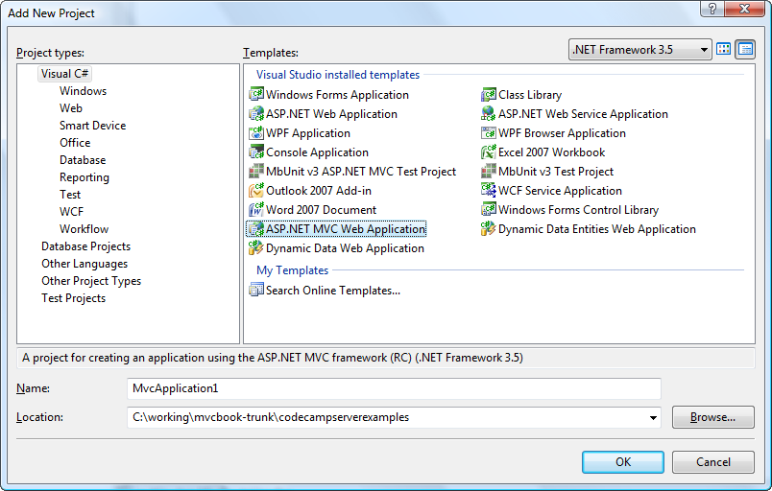
Figure 1.2 The MVC Web Application project is a project template added to the C# and VB.NET sections of the New Project dialog. It’s only available when you have .Net Framework 3.5 selected as the target framework.
We’re going to be working with a C# ASP.NET MVC Web Application project. You have two options for creating the project. When you click OK, the IDE will ask you about creating a test project. Decide if you’d like it done for you or if you’d rather create the unit test project yourself. For this example, we’ll move forward and choose the ASP.NET MVC Web Application with the test project. Figure 1.3 shows the solution structure of the default Visual Studio template. Since this is not a beginners’ book, we’ll skip the hand holding and go straight into the project.
NOTE
More ASP.NET MVC starter kits and sample applications are available from the community on the ASP.NET website. At the time of writing, http://www.asp.net/community/projects/ and http://www.asp.net/mvc/ have several starter kits and sample applications for starting ASP.NET MVC projects (as well as ASP.NET Web Forms starter kits). The options include:
- Kigg Starter Kit–A Digg like application
- Contact Manager Sample Application
- Storefront Starter Kit
Although the starter kits are quite basic, you should also check out more complete starter kits like those found at http://CommunityForMvc.net. This site contains a bare-bones template as well as one complete with MvcContrib, StructureMap, NHibernate, NUnit, NAnt, AutoMapper, Tarantino, Naak, NBehave, Rhino Mocks, WatiN, Gallio, Castle, 7zip, and more.
If you’re new to .NET development in general, you should first become familiar with Microsoft's default template. Then use a more robust starter kit or sample application provided by the community to have a better jumping-off point. When you have mastered the framework, think about contributing your own starter kits.
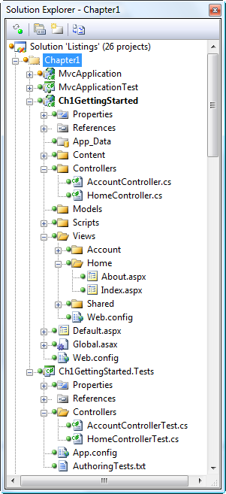
Figure 1.3 The default structure for a web application project using the ASP.NET MVC Framework uses conventions for the placement of files.
The first thing to notice is that in contrast to the very sparse structure of a default Web Forms project template, the default MVC template creates several folders: Content, Controllers, Models, Scripts, and Views. These folders represent part of the MVC application development conventions, which, if adhered to, can make the experience of developing with the MVC Framework a breeze.
The Happy Path
ASP.NET MVC developers (and developers using other convention-centric frameworks) will often mention the Happy Path. This refers to the notion that following the MVC Framework’s conventions will make the developer’s experience both enjoyable and relatively painless. The MVC Framework does not require you to adhere to any particular convention, but the farther you stray from the Happy Path the greater the effort will be required by the developer. The MvcContrib project enhances the path, and you’ll certainly find ways to enhance it in your system. Staying on the path gains you a great deal in consistency.
For now, the most important of these folders to become familiar with are the three which have been named after their MVC pattern counterparts (the Model, View, and Controller folders). As you’d expect, the purpose of each of these folders is to provide logical separation of the three MVC concerns, as well as to tap into a nice feature of Visual Studio that will automatically namespace any class created within a folder with that folder’s name.
The Controllers folder is probably the least interesting. The folder should contain only classes which are to be used as controllers, or base classes and interfaces that controllers might inherit from. The Views folder is special because it will contain code that will probably be the most familiar to Web Forms developers. The Views folder contains the aspx (views), ascx (partial views), and master pages used to present the data. Typically you’ll have a folder inside the Views folder for each controller which will contain views intended to be used specifically by that controller, as well as a Shared folder to contain shared views.
For most nontrivial projects, you probably won’t place your models in the Models folder. Generally speaking it’s a best practice to keep your domain model in a separate project so that other applications can use it without taking a dependency on your MVC application. We recommend that you put only presentation concerns in the Web Application project.
In the default project, you may be familiar with the Default.aspx file that is provided for you, and we'll discuss shortly why it is there. First, we must understand the concept of a route.
1.1.2 Your first routes
Routes will be discussed in great detail in chapter 5; however, you should be aware of some route basics to move through this section. Although Web Forms mandated a strict convention for URLs, the MVC Framework provides a mechanism to allow developers to hand-craft URLs, and have them map automatically to an object in the system that can handle the incoming web request. Routing was added to ASP.NET in the .NET Framework 3.5 Service Pack 1 release, and is available to all ASP.NET applications. The Global.asax.cs file contains basic routes that are provided with the MVC Web Application project to help you get started. Before continuing, we should define a route.
A route is the complete definition for how to dispatch a web request to a controller, usually using the System.Web.Mvc.MvcRouteHandler. In the past we have had little control over message dispatching without resorting to external tools like ISAPI filters or carefully crafted HttpModules for URL rewriting. With Web Forms, the URL of the web request was tightly coupled to the location of the page handling the request. If the page was named Foo.aspx in a folder named Samples, the URL was sure to be something like http://MvcContrib.org/Samples/Foo.aspx. Many teams have resorted to URL rewriting to wrangle some control over the URLs and how they are produced. With the ASP.NET MVC Framework, and ASP.NET 3.5 SP1 in general, routes are first class citizens that can be managed directly in the web application. We start with defining how we want our URLs structured. The project template gives us a few routes to start, as shown in listing 1.1.
Listing 1.1 Default routes for a new project
using System.Web;
using System.Web.Mvc;
using System.Web.Routing;

namespace Ch1GettingStarted
{
public class MvcApplication : HttpApplication
{
public static void RegisterRoutes(RouteCollection routes)
{
routes.IgnoreRoute("{resource}.axd/{*pathInfo}");

routes.MapRoute(
"Default", #A
"{controller}/{action}/{id}", #B
new {controller = "Home", action = "Index", id = ""} #C
);
}

protected void Application_Start ()
{
RegisterRoutes(RouteTable.Routes);
}
}
}

#A Route name
#B URL with parameters
#C Parameter defaults

Routes must be defined before any request can be received by the application, so the project template adds the routes to the Application_Start method in the Global.asax.cs file. Later in the book, you'll see that we do not leave the routes in this location except for the most trivial of web applications.
note
We’ll follow long-standing best practices of separation of concerns (SoC) and the single responsibility principle, or SRP, by moving the routes to a dedicated location separated by an interface. We'll go further into these principles later, but, in short, the responsibility (or concern) of the Application_Start method is to kick off operations that must happen at the beginning of the application's life. The responsible approach is to avoid performing every bit of work that must happen on start. Any operations that must happen when the application starts should reside in separate classes and merely be called in the appropriate order in the Application_Start method.
Note that the URL portion of the route is simply a matching mechanism for the request. If the URL matches a particular route, then we specify what controller should handle the request and what action method should execute. You can create as many routes as you like, but one route is provided for you. This route has the template, {controller}/{action}/{id}.
Note
The route with the template, {controller}/{action}/{id} is a generic one and can be used for many, many different web requests. Tokens are denoted by the inclusion of {braces}, and the word enclosed in braces matches a value the MVC Framework understands. The most common values that we'll be interested in are controller and action. The controller route value is a special value that the System.Web.Mvc.MvcHandler class uses to call into the IControllerFactory interface. This is also the route we’ll be using for the rest of the chapter, so we’ll be content with a URL in the form of http://MvcContrib.org/controllername/actionname. The basic route handler is an instance of IRouteHandler named MvcRouteHandler. We have complete control and could provide our own implementation of IRouteHandler if we wished, but we’ll save that for a later chapter.
Before we spin up our first controller, let’s examine what is different about the web.config file in an MVC Web Application project. The differences are easy to spot. Just look for “routing” or “MVC.” One difference we see is that a new IHttpModule is registered in the config file. We see the UrlRoutingModule in listing 1.2
Listing 1.2 Unique addition to the web.config file
<add name="UrlRoutingModule" type="System.Web.Routing.UrlRoutingModule, System.Web.Routing, Version=3.5.0.0, Culture=neutral, PublicKeyToken=31BF3856AD364E35" />

The UrlRoutingModule evaluates a request and checks it matches a route that is stored in the RouteTable. If the route matches, it overrides the default handler (IHttpHandler) for the request so that the MVC Framework handles the request. We’re going to examine our first controller as a means to handle a route for the URL /home. In the next section you’ll see how all the pieces of the starter project fit together.
1.1.3 Running with the starter project
We’re going to move through the starter project quickly looking at each piece of provided code. Each serves as an example of how to fit code together when writing an application with the presentation layer powered by the ASP.NET MVC Framework. Before looking at code, run the web application by pressing CTRL+F5, and you should see a screen that resembles figure 1.4.

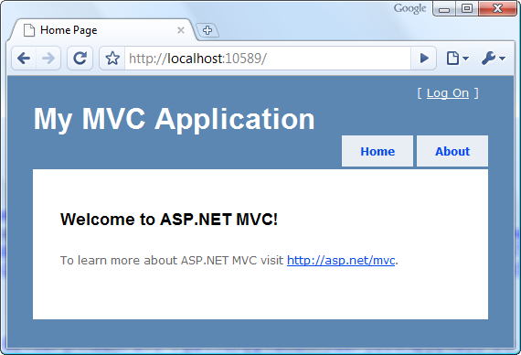
Figure 1.4 The starter project comes with a basic layout and CSS.
The starter project includes some navigation, a Log On, and content. The CSS provides simple formatting on top of XHTML. Notice the URL in the address bar is /. "/home" also will bring up the same page since our route specifies "home" as the default controller. This URL does not have an extension, so if you’re planning on running your application on IIS 6, you must either add a wildcard mapping or install an ISAPI filter that provides this functionality. Deployment to IIS 6 will be covered in more detail in chapter 10.
Since you’re familiar with the ASP.NET request pipeline, we’ll briefly move through how this request makes its way to an ASP.NET MVC controller. The following outlines how the request moves through ASP.NET, to the controller and through the view:
- Request comes in to /Home.
- IIS determines the request should be handled by ASP.NET.
- ASP.NET gives all HttpModules a chance to modify the request.
- The UrlRoutingModule determines that the URL matches a route configured in the application.
- The UrlRoutingModule gets the appropriate IHttpHandler from the IRouteHandler that is used in the matching route (most often, MvcRouteHandler) as the handler for the request.
- The MvcRouteHandler constructs and returns MvcHandler.
- The MvcHandler, which implements IHttpHandler, executes ProcessRequest.
- The MvcHandler uses IControllerFactory to obtain an instance of IController using the "controller" to route data from the route {controller}/{action}/{id}.
- The HomeController is found, and its Execute method is invoked.
- The HomeController invokes the Index action.
- The Index action adds objects to the ViewData dictionary.
- The HomeController invokes the ActionResult returned from the action, which renders a view.
- The Index view in the views folder displays the objects in ViewData.
- The view, derived from System.Web.Mvc.ViewPage, executes its ProcessRequest method.
- ASP.NET renders the response to the browser.
These steps represent the simplified life of a request handled by the ASP.NET MVC Framework. If you’re curious about the details, you can browse the source code at http://www.codeplex.com/aspnet. The 15 steps are sufficient for understanding how to write code based on the ASP.NET MVC Framework, and most of the time you’ll need to pay attention only to the controller and the view. You have already seen the route used in the starter project. Let’s look at the HomeController, shown in listing 1.3.
Cueballs in code and text
Listing 1.3 The HomeController
using System.Web.Mvc;

namespace Ch1GettingStarted.Controllers
{
[HandleError]
public class HomeController : Controller #1
{
public ActionResult Index() #A
{
ViewData ["Message"] = "Welcome to ASP.NET MVC!"; #2

return View(); #B
}

public ActionResult About() #C
{
return View();
}
}
}

#A Default action for controller
#B Return default view for action
#C Another action method

Notice how simple the controller is. There is not much generated code to wade through, and each action method returns an object derived from ActionResult. This controller derives from System.Web.Mvc.Controller (#1). You’ll probably find this base class adequate, but there are others to choose from in the MvcContrib project, and as time goes on, the community will likely make many more available. It also may be a good practice to create your own "Layer Supertype" to use in your application.
Inside each action method, you’ll typically put some objects into a dictionary called ViewData (#2). This dictionary will be passed to the view upon rendering. The controller can provide any objects the view requires in this ViewData dictionary; the primary object the view will render should be assigned to the ViewData’s Model property. This can be done automatically by passing the object into the controller’s View() method. In the starter project, the objects are simple strings, but in your application, you’ll use more complex objects like those in figure 1.5.
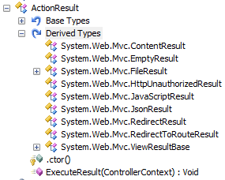
Figure 1.5 Classes that derive from ActionResult. This screenshot is from Red Gate's .Net Reflector.
Each default action returns the result of the View() method, which returns a System.Web.Mvc.ViewResult object. This ActionResult subclass will likely be a common result given than your applications will have many screens. In some cases, you may use the other ActionResult types as shown in figure 1.5. Your controller action can return any type. The Controller base class will call ToString() on your object and return that string in a ContentResult object. Next, let’s look at the view shown in listing 1.4, which can be found in the project in the following path: /Views/Home/Index.aspx.
Listing 1.4 A simple view
<%@ Page Language="C#" MasterPageFile="~/Views/Shared/Site.Master"
Inherits="System.Web.Mvc.ViewPage" %>

<asp:Content ID="indexTitle" ContentPlaceHolderID="TitleContent" runat="server">
Home Page
</asp:Content>

<asp:Content ID="indexContent" ContentPlaceHolderID="MainContent" runat="server">

<h2><%= Html.Encode(ViewData ["Message"]) %></h2>
<p>
To learn more about ASP.NET MVC visit
<a href="http://asp.net/mvc" title="ASP.NET MVC
Website">http://asp.net/mvc</a>.
</p>
</asp:Content>

The view shown in listing 1.4 is the one rendered in the browser screenshot shown in figure 1.4. With the MVC Framework, markup files do not use a code-behind file. Since the view uses the Web Forms templating engine, you could use it, but by default just a simple markup file is generated.
This view uses a master page, as you can see in the MasterPageFile attribute in the Page directive. The master can be specified by the controller for compatibility with many view engines, but some view engines support the view specifying the layout, which is the case with the Web Forms view engine, the default view engine that ships with the MVC framework.
NOTE:
A ViewResult leverages the IViewEngine interface, which is an abstraction that allows the usage of any mechanism for rendering a view. View engines will be covered in more depth later, but some alternatives can be found in the MvcContrib open source project.
In the body of this view, the server-side tags are pulling objects out of ViewData and rendering them in line with HTML. The responsibility of the view is to take objects in ViewData and render them for consumption by the user. The view does not decide what to render, only how to render. The controller has already decided what needs to be rendered.
In listing 1.5, examine the code of the layout. You immediately see that it’s a plain master page, not much different from those found in Web Forms. The difference is that master pages in MVC projects do not need to use code-behind files.
Listing 1.5 The starter project master page
<%@ Master Language="C#" Inherits="System.Web.Mvc.ViewMasterPage" %>

<!DOCTYPE html PUBLIC "-//W3C//DTD XHTML 1.0 Strict//EN" "http://www.w3.org/TR/xhtml1/DTD/xhtml1-strict.dtd">
<html xmlns="http://www.w3.org/1999/xhtml">
<head runat="server">
<meta http-equiv="Content-Type" content="text/html; charset=iso-8859-1"/>
<title><asp:ContentPlaceHolder ID="TitleContent" runat="server" />
</title>
<link href="../../Content/Site.css" rel="stylesheet" type="text/css" />
</head>
<body>
<div class="page">
<div id="header">
<div id="title">
<h1>My MVC Application</h1>
</div>
<div id="logindisplay">
<% Html.RenderPartial("LogOnUserControl"); %> #A
</div>
<div id="menucontainer">

<ul id="menu">
<li><%= Html.ActionLink("Home", "Index", "Home")%></li> #B
<li><%= Html.ActionLink("About", "About", "Home")%></li>
</ul>
</div>
</div>
<div id="main">
<asp:ContentPlaceHolder ID="MainContent" runat="server" />
<div id="footer">
</div>
</div>
</div>
</body>
</html>

A Render another view
B Render hyperlinks

The master page here is in charge of navigation. It uses view helpers (Html.ActionLink in this case) to render the links. View helpers are available for most common dynamic needs and for all form elements. More view helpers are available in MvcContrib, and third-party component vendors will not be far behind in offering commercial view helpers.
Now that you have seen how the code in the starter project fits together, let’s see how to test the controller code. View code will still need to be tested with a tool like Selenium, Watir, or WatiN, but controller code can easily be test-driven since it’s decoupled from the view and the ASP.NET runtime. Listing 1.6 is a unit test for the starter project. When you start a new MVC project, a dialog will ask you which unit testing framework you’d like to use.

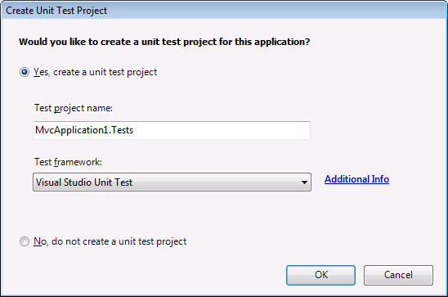
Figure 1.6 The Create Unit Test Project Dialog
If you’re using Visual Studio 2008 Professional then “Visual Studio Unit Test” will already be in the list and selected. Most common unit testing frameworks have templates that show up in the list when they are installed. For now we’ll look at using MSTest (Visual Studio Unit Test), but we recommend using NUnit. If you’re just starting out in automated testing, any mainstream framework will do. Listing 1.6 shows an MSTest test method included in the default test project template.
Listing 1.6 The unit test for the Index action
using System.Web.Mvc;
using Ch1GettingStarted.Controllers;
using Microsoft.VisualStudio.TestTools.UnitTesting;

namespace Ch1GettingStarted.Tests.Controllers
{
[TestClass]
public class HomeControllerTest
{
[TestMethod]
public void Index()
{
HomeController controller = new HomeController();

ViewResult result = controller.Index() as ViewResult;

ViewDataDictionary viewData = result.ViewData;
Assert.AreEqual("Welcome to ASP.NET MVC!",viewData["Message"]);
}
}
}

Believe it or not, we have walked through the complete ASP.NET starter project, and you now know the basics of the new framework. Obviously, we’ll be moving into more complex topics throughout this book, and if any topic along the way does not sink in completely, please to crack open Visual Studio and poke around while reading. Working with the code directly, along with reading this text, will give you a solid understanding of this technology. In fact, now is a great time to download the code samples for this book and open your IDE default application.
1.2 Your first ASP.NET MVC controller from scratch
Look at listing 1.7 to understand how a web request is processed by the controller. Note the only requirement is to implement the IController interface.
A cueball in code and text
Listing 1.7 Our first controller
using System;
using System.Web.Mvc;
using System.Web.Routing;

namespace MvcApplication.Controllers
{
public class HelloWorld1Controller : IController #1
{
public void Execute(RequestContext requestContext)
{
requestContext.HttpContext.Response.Write(
"<h1>Hello World1</h1>");
}
}
}

As with everything in the ASP.NET MVC Framework, there is very little the developer must do to create custom functionality. In the case of the controller, the only—I will say it again— the only requirement is that the class implement the IController interface (#1). This interface only requires that you implement a single method: Execute. How you handle the request is entirely up to you. In the controller in listing 1.7, we’re intentionally violating all principles of sensible programming as well as the Law of Demeter in order to get the message "Hello World" written out to the screen as quickly as possible. In this case, I've chosen not to make any use of a view. Rather, I'm formulating incomplete HTML markup and directing it to the response stream. We’ll run the sample and note the output in figure 1.6. In the code solution that comes with the book, you can find HelloWorld1ControllerTester that illustrates how you’d unit test a simple controller like this.
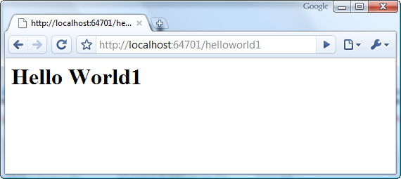
Figure 1.6 Our web application running in the browser. Note the simple URL and the absence of .aspx.
Listing 1.7 shows the absolute and complete power you have when creating a controller class. It’s very important to have complete control; however, most of the time, we’re working in a handful of scenarios that repeat over and over. For these scenarios, the product provides a base class that gives extra functionality. The base class for these common controllers is System.Web.Mvc.Controller. It implements the Execute method for us and uses the route values to call different action methods depending on the URL and the route defaults.
Note:
System.Web.Mvc.Controller is only one option to choose as a base class for your controllers. As mentioned earlier, it’s often appropriate to create your own Layer Supertype for all of your controllers. This type can inherit from System.Web.Mvc.Controller, implement IController or derive from any other controller base class.
Our first use of the Controller base class will need only one action method, and we’ll go with the convention for the default action and call it Index. Observe in listing 1.8 what our controller looks like while we leverage the Controller base class. This base class implements the IController interface for us and provides the capability of invoking action methods based on the current Route.
Listing 1.8 Using the Controller base class
using System.Web.Mvc;

namespace MvcApplication.Controllers
{
public class HelloWorld2Controller : Controller #A
{
public string Index()
{
return "<h1>Hello World2</h1>";
}
}
}

#A Inherit from Controller

The public Index action method is all that is necessary for this controller to be web-callable. Simple content action methods need not return ActionResult. Returning any other type will result in that object being rendered as content to the response stream.
If we point our browser to /HelloWorld2, we'll see that our controller sends the same response to the browser as shown in figure 1.7
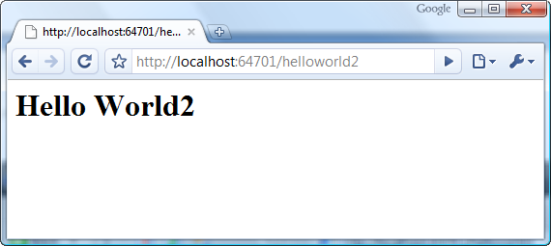
Figure 1.7 The web page has the same output as before. The end result is the same even though the controller implementation has evolved.
Now that we know how to craft a controller, we’ll explore our first view.

1.3 Our first view
Recall that the ASP.NET MVC Framework uses a convention for locating views. The convention is to find a .aspx file in a directory tree that matches /Views/controllername/actionname.aspx. In our next example, we’ll modify our controller by calling a method on the Controller base class called View(). We'll set the model, which is a string with the text, "Hello World", to an entry in the ViewDataDictionary object on the ViewData property of the Controller base class. This ViewDataDictionary instance will be forwarded to the view. Although ViewDatais a ViewDataDictionary we recommend you depend only on the IDictionary<string, object> interface if you’re replacing the view engine. View engines will be discussed in more detail in chapter 4. In listing 1.9, we see that our action returns ActionResult instead of string. After an action method returns, the ActionResult executes to perform the appropriate behavior, which is rendering a view in this case. Examine listing 1.9 for the current implementation of our controller. ViewData contains the object that will be forwarded on to the view. The View() method also supports passing a single object to the view that is then accessible via ViewData.Model, which we’ll explore later.
Listing 1.9 Using a view to render the model
using System.Web.Mvc;

namespace MvcApplication.Controllers
{
public class HelloWorld3Controller : Controller
{
public ActionResult Index()
{
ViewData.Add("text", "Hello World3"); #A
return View();
}
}
}

#A Add objects to ViewData

If you’re following along with this example, you’ll want to create a HelloWorld3 folder inside /Views in your project as shown in figure 1.8.
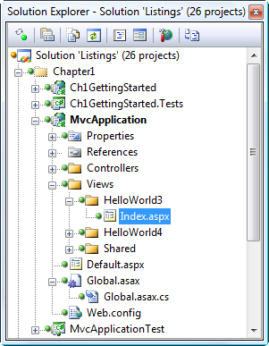
Figure 1.8 The proper location of the HelloWorld3 folder is inside the /Views folder. The default view factory uses this convention. You can override this behavior if you wish.
Next, add a view to the project inside /Views/Helloworld3. You can use the New Item dialog for the project and select the MVC View Page; a quicker way is to use the context menu (right click) off of the action and select Add View… as shown in figure 1.9. This tool will create a view with the proper name inside the proper folder. Your project should now look similar to figure 1.8. Our new view, Index.aspx, resides in the HelloWorld3 folder.
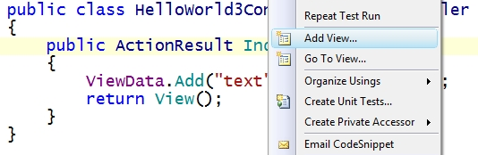
Figure 1.9 Adding the view to our project via the context menu
Our markup within the view will be very simple. After all, this application is so trivial that all it has to do is output "Hello World3" to the screen in big text. We'll use the <% server-side operators to pull out our model (which is a string) from the ViewData dictionary and render it to the screen. Listing 1.10 has our markup for the view. The base class is System.Web.Mvc.ViewPage. This is a very important difference from Web Forms.
Listing 1.10 Accessing ViewData from within the view
<%@ Page Language="C#" Inherits="System.Web.Mvc.ViewPage" %>
<!DOCTYPE html PUBLIC "-//W3C//DTD XHTML 1.0 Transitional//EN"
"http://www.w3.org/TR/xhtml1/DTD/xhtml1-transitional.dtd">

<html xmlns="http://www.w3.org/1999/xhtml" >
<head runat="server">
<title></title>
</head>
<body>
<div>
<h1><%=ViewData ["text"]%></h1>
</div>
</body>
</html>

The flow from our controller to our view is simple. The controller designates one or many objects to be forwarded to the view, then optionally specifies the name of the view. The MVC Framework will locate the view, instantiate it, push in the ViewData, and have the view render itself to the response stream. The ViewPage base class fully supports rendering, but ViewState, postbacks, and the server-side postback events no longer happen. Rendering events still fire since ViewPage derives from System.Web.UI.Page.
The view’s only responsibility is to transform objects passed to it into HTML. This is a key part of the SoC, a key best practice that Microsoft is focusing on with this product. The controller does not know how the view is doing the formatting. The only point of coupling is that the controller names the view, either implicitly with the name of the action, or explicitly with the View method. It does not matter that the System.Web.Mvc.WebFormViewEngine is executing. The same controller could function quite well with an NVelocity view (supported in MvcContrib) since the controller's only coupling to the view is the view name. For now, we’ll forward "Hello World3" to the view, and figure 1.10 shows the rendered page. This example has shown how to get a simple case working, but there are maintenance concerns you should be aware of while building an application with this framework.
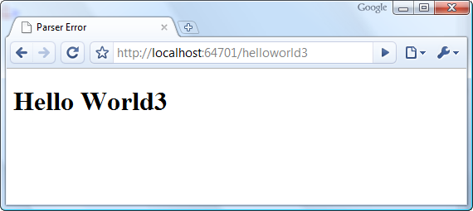
Figure 1.10 The output is the same as previous examples, except now, we have a full HTML page and not an HTML fragment.
1.4 Ensuring the application is maintainable
You might have cringed when you saw that the domain model object was being pushed into an IDictionary with a string key as the way to identify the object in the view. .NET has conditioned us to want everything to be strongly typed, so string identifiers are sometimes viewed as a negative. That point is subjective and controversial, and you have several options depending on your preferences.
NOTE
Using a dictionary to pass objects between different parts of an application (typically called a property bag) allows the various parts of the application to be loosely coupled. The downside is that objects coming out of the property bag may need to be cast before being used.
The use of an IDictionary<string, object> for ViewData is the default mechanism in the Controller base class. As the number of objects forwarded to the view increase, it’s easy to create helpers in the view to avoid casting operations everywhere. However, many controller actions will forward only one object to the view, and for those cases, we can make use of the ViewData.Model property as well as strongly typed views. For our next example, we’ll make a small change to our controller and view to enable a strongly typed reference.
Listing 1.11 shows our controller discarding the use of the IDictionary<string, object> and passing the domain model object directly to the View() method. This works well for many scenarios and it scales to large applications with the use of a view model, which is a presentation object specifically crafted for use in a single view. For composed views using ViewData as a dictionary may be necessary, but partial views, covered in chapter 4, can also provide for composed views.

NOTE
In listing 1.11 we have to cast our string “Hello World4” to an object when we pass it to the View method. This is because one of the overloads of View takes a single string as a parameter, which is used to specify a particular view to be rendered.
Listing 1.11 Passing in the presentation model to the RenderView method
using System.Web.Mvc;

namespace MvcApplication.Controllers
{
public class HelloWorld4Controller : Controller
{
public ActionResult Index()
{
return View((object)"Hello World4"); #A
}
}
}

#A Cast so correct overload called

Listing 1.12 Strongly typed view with master page
<%@ Page Language=”C#” Inherits="System.Web.Mvc.ViewPage<string>"
MasterPageFile="~/Views/Shared/HelloWorld.Master"%>
<%@ Import Namespace="MvcApplication.Controllers"%>

<asp:Content ID="Content2" ContentPlaceHolderID="Main" runat="server">

<h1><%=Model%>! I'm strongly typed in a layout!</h1>

</asp:Content>

Notice that we have a Model property (a shortcut to ViewData.Model) available that is the type declared as the generic parameter for ViewPage<T> in the Inherits tag. In listing 1.12 we have chosen System.Web.Mvc<string>. The generic base class allows us to strongly type the ViewData.Model property because the ViewData property is of type ViewDataDictionary<T>, and the Model property is of type T.
In this example, the view has chosen the master page, but as we’ve said before, you can also choose the master inside the controller action. It’s up to you, but not all view engines support the view specifying the master, so if there is a chance you may want to change view engines later, you may want to consider specifying the master in the controller. The downside to this is that you increase the tightness of coupling to the views.
Master pages function the same as in Web Forms for templating, but the server-side postback and ViewState mechanisms are irrelevant. Rendering is the only responsibility of the view and the master page. Listing 1.13 shows our master page, which outlines the structure for the page. The layout declares System.Web.Mvc.ViewMasterPage as the base type.
Listing 1.13 The layout for our view
<%@ Master Language="C#" AutoEventWireup="true"
Inherits="System.Web.Mvc.ViewMasterPage" %>

<!DOCTYPE html PUBLIC "-//W3C//DTD XHTML 1.0 Transitional//EN"
"http://www.w3.org/TR/xhtml1/DTD/xhtml1-transitional.dtd">

<html xmlns="http://www.w3.org/1999/xhtml" >
<head runat="server">
<title>Hello!!</title>
<asp:ContentPlaceHolder ID="head" runat="server">
</asp:ContentPlaceHolder>
</head>
<body>
<div style="border: solid 4px red">
<asp:ContentPlaceHolder ID="Main" runat="server">

</asp:ContentPlaceHolder>
</div>
</body>
</html>
If we run the project (CTRL + F5) and point our browser to /HelloWorld4, we see our strongly typed view and master page in action. To make it stand out, we have given it a strong, red border as shown in figure 1.11. Most views that we’ll work with in this book will use the ViewPage<T> base class to enable a strongly typed Model property and the easy usage of view models, which will be covered in chapter 2.
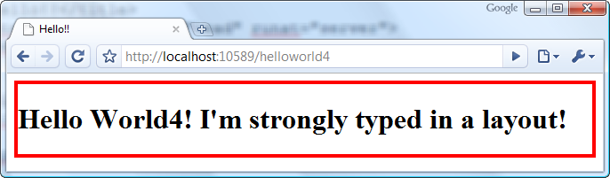
Figure 1.11. This is our final view, complete with layout, strong typing, and a little CSS to spice it up
Congratulations! You have created your first controller, and it handles its responsibility perfectly. From this point forward, we won’t cover every small step of developing with the MVC Framework. If you’re reading this book, you should already be well versed in ASP.NET, so we’ll be covering only the items that are new with the ASP.NET MVC Framework. We’ll be using best practices and advanced software development techniques throughout the examples. The first important practice we’ll cover is unit testing. Because the MVC Framework allows us to keep our controllers separate from the views, we can now easily test the controlling logic. We consider testing an important part of getting started with the MVC Framework, so we’ll touch on it now and keep a strong emphasis on testing throughout this book. Although we won’t print every unit test in the book, you can find more unit tests in the examples for this book, which can be downloaded from the publisher’s website.
1.5 Testing controller classes
For this section you’ll need the unit testing framework NUnit installed. It can be found at http://www.nunit.org, and is free. After installing the latest version, you should open the NUnit GUI and select: Tools -> Options -> Visual Studio (on the left) and check the box that says Visual Studio Integration. This will make it easier to work with NUnit from within Visual Studio.
Now return to the unit test project we created earlier. You’ll need to remove the references to MSTest, and add a reference to NUnit. We have created a class named HelloWorld4ControllerTester to house the unit tests that verify the controller functions correctly. See in figure 1.12 that we’re grouping controller unit test fixtures in a Controllers folder. As you browse through the code listings, you’ll notice that we have created stubs for several classes that the controller needs to function. This unit test example is the simplest one we’ll see in this book. Listing 1.14 depicts the NUnit test fixture for HelloWorld4Controller.
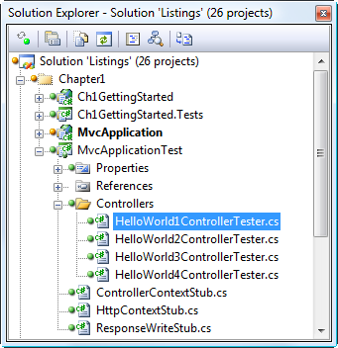
Figure 1.12 In your unit test project, after adding a reference to nunit.framework.dll, you’re ready to add a test fixture.
Listing 1.14 Unit test fixture with NUnit
using System.Web.Mvc;
using MvcApplication.Controllers;
using NUnit.Framework;
using NUnit.Framework.SyntaxHelpers;

namespace MvcApplicationTest.Controllers
{
[TestFixture]
public class HelloWorld4ControllerTester
{
[Test]
public void IndexShouldRenderViewWithStringViewData()
{
var controller = new HelloWorld4Controller(); #1
var viewResult = (ViewResult) controller.Index(); #2

Assert.That(viewResult.ViewName, Is.EqualTo("")); #3
Assert.That(viewResult.ViewData.Model, Is.EqualTo("Hello World4"));
}
}
}

Cueballs in code and text
Let's examine our simple unit test inside HelloWorld4ControllerTester. Our test is IndexShouldRenderViewWithStringViewData. We create an instance of the class under test, HelloWorld4Controller (1). We then call our Index method (2) capturing the ActionResult returned. Our test expects it to be a ViewResult instance, so we cast it as such. If the code returns the wrong type, our test will fail appropriately. At the end of the test, we easily assert our expectations (3). Unit tests normally follow an arrange, act, assert flow, and this test is a perfect example of that. This was a very simple unit test, and chapter 3 will cover unit testing controllers in more depth. Figure 1.13 shows the test being run with UnitRun from JetBrains. UnitRun is also a feature of ReSharper.
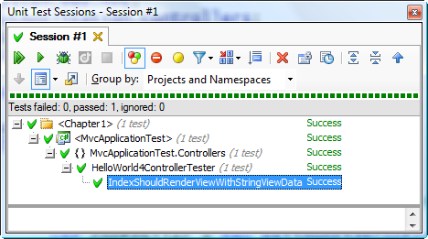
Figure 1.13 When we run this unit test using JetBrains ReSharper, it passes as we expect.
Creating automated unit tests for all code and running these tests with every build of the software will help ensure that as the application scales with complexity, the software continues to be maintainable. Typically as an application grows, it becomes more difficult to manage. An automated test suite helps counter that natural tendency for entropy. Fortunately, it’s easy to test controllers with the MVC Framework. In fact, the team at Microsoft used test-driven development (TDD) while developing the framework.
NOTE:
Along with the MVC Framework, Microsoft has wrapped some of the ASP.NET code and provided abstract classes to some of the key APIs such as HttpResponseBase, HttpRequestBase, and most importantly, HttpContextBase. A Google search will reveal how many people have had trouble testing against HttpContext because of its sealed and static members. Providing abstract classes for these key APIs loosens the coupling to them, increasing testability.
We have mentioned unit testing several times in the text, and it’s important to understand the connection to TDD. Test-driven development is a development style where unit tests (and other tests) are created before code is written to make the tests pass. In this chapter we have not adhered strictly to the TDD process, in an attempt to focus on key areas of the MVC framework without adding the mental overhead of a new development process.
It’s a good practice to ensure that as you’re writing your unit tests, they do not call out to any database or web service. This helps keep the testing portion of your build running fast, and ensures maintainability by not adding a dependency to an external system that is not guaranteed to not change. It’s reasonable to run a build containing 2000 automated tests in five seconds; if many of your unit tests involve a database, your build will likely take much longer. Other tests that integrate with external things like a database are still valuable, but they can take several seconds each in some cases, so you want to concentrate on keeping controller tests at the unit level. To help with this, you can stub out (or “mock”) controller dependencies.
1.6 Summary
We have now seen how easy it is to get started with the ASP.NET MVC Framework, and for the rest of this book, the examples will not be so trivial. You now know how to add a route to the application and that the route defines what controller and action should be invoked for a given URL. Once the controller is invoked, an action method is in charge of determining what should be passed to the view for the given request. The view takes the objects passed and formats the objects using a view template. The view does not make any decisions about the objects passed but merely formats them for display. This separation of concerns contributes to a more maintainable application than what we have seen with Web Forms.
For most of this book, we’ll be using CodeCampServer in our examples. Along with being included in the downloads for this book, CodeCampServer can be found at http://CodeCampServer.org. It’s an ASP.NET MVC Framework application that can host a conference for a user group. It uses a decoupled Onion Architecture, domain-driven design, the ASP.NET MVC Framework, and NHibernate to show how a real enterprise application would look. It has a complete build process with NAnt, which is monitored by a build server such as CruiseControl.Net or JetBrains TeamCity. The entire application is meant as a living example of how to write a real application with the ASP.NET MVC Framework. Since its inception, more volunteers have joined the project, and now it’s a full community effort. It will live on well past the life of this book, so the copy of the code you receive with this book is a snapshot in time. We invite you to join the project as it continues to progress.
We’ll use this real-world application in our examples going forward. What this means is that you’ll need to be up to speed with the concepts and patterns discussed. As an author team, we have decided that we could provide more value with advanced, real-world examples that might cause the reader to have to do a bit of research than we could by over-simplifying the examples. We’re choosing not to compromise on software design, even if it makes the book a bit more difficult to write. The first topic we cover in depth is the Model portion of Model View Controller in the next chapter.

