4
The view in depth
This chapter covers:
- Rendering views
- Techniques for working with ViewData
- Error reporting
- Handling complexity
Views have long been abused in the Microsoft web application space. In Classic ASP, and in IDC/HTX before that, the view was the primary programming tool for the Microsoft-centric developer. Using the Server Page pattern, developers used IDC and ASP pages as transaction scripts to perform a single operation and render a screen. Each page has logic, behavior, and a UI. ASP.NET 1.0 sought to separate logic from the UI rendering to make applications easier to maintain and extend, because having logic intermixed with screen rendering had often proved to be an unworkable solution for many teams. Although it certainly was possible for teams to separate the concerns in their applications, Microsoft had provided no guidance on how to do so, and most samples and demo applications encouraged the intermingling of concerns.
ASP.NET set the foundation for how a Windows web server would handle web requests. The framework has proven highly scalable and robust. Web Forms, one part of the .NET framework, has faced maintainability challenges. Although Web Forms allowed scores of VB6 programmers to make the transition from Windows applications to web applications, these developers did not fall into the “pit of success.” The code-behind idea did, in fact, separate logic from UI rendering, but in practice, and coupled with guidance available in the industry, the logic ended up merely separated in a separate file instead of the logic abstracted into new concepts. Web Forms continued the Server Page pattern started in IDC and carried through Classic ASP. The ASP.NET MVC Framework attempts to provide developers with an alternative to the Web Forms Server Page pattern. In this chapter, we’ll see how simple a view can be and how to handle complex views. We’ll cover techniques for working with ViewData, view helpers, form validation, and other complex issues. Before diving into a specific topic, let’s look at the major differences between ASP.NET MVC views and Web Forms.
4.1 How ASP.NET MVC views differ from Web Forms
ASP.NET MVC views and Web Forms views can exist side-by-side, so it is possible to do a phased port from Web Forms to ASP.NET MVC. Web Forms serve a much bigger purpose in the application than MVC views. By the time your code executes in a Web Form Page_Load, the framework has already:
- Selected the Web Form to execute
- Constructed the Web Form and all its design-time controls
- Processed any ViewState received
With a Web Form, your code runs as the page is executing. There are plenty of ways to get into the pipeline before the page starts executing, but it is not obvious or easy. A Web Form is built upon the concept of a control, which is the building block of the page. Controls can have child controls, and System.Web.UI.Page derives from System.Web.UI.Control. A control’s purpose is to be responsible for the behavior and rendering of what will ultimately become an HTML element on the page. During the heyday of browser wars and incompatibility, controls were able to render different markup based on the browser receiving the page. This was a useful feature in 2002 and 2003. With Internet Explorer 7 and FireFox 2+ now responsible for more than half of the markup rendering, most web users are employing a more standards-compliant web browser than in 2002; the need to render different markup to different browsers has diminished.
ASP.NET MVC Views take back control of HTML markup. Although it is possible to use the rendering capabilities of some existing controls, the guidance with MVC Views is to lay out the HTML by hand and use server delimiters to make parts of the view dynamic. MVC Views leverage the Web Forms rendering engine but jettison the postback logic, ViewState, and control hierarchy. An MVC View renders top-to-bottom and then goes away. It also has much less responsibility than a Web Form. The view accepts objects in its ViewData dictionary and transforms those objects into a response suitable for the web. That is it. No decision logic, no permissions, no database access, no web service calls, just rendering. MVC Views do not use a code-behind file, but you can retain a code-behind while migrating from Web Forms if necessary. This ability comes from the fact that System.Web.Mvc.ViewPage derives from System.Web.UI.Page.
If you are porting an application from Web Forms to ASP.NET MVC and you have not rigorously factored logic into many supporting classes, you will find yourself moving much of your code-behind logic into a controller. You will also probably find that much of the logic does not belong in a controller. You will most certainly need to develop additional classes to absorb logic that has inappropriately lived in a Web Form code-behind file. We’ll begin by exploring the folder structure for views and some of the basics.
4.2 Folder structure and view basics
Views employ conventions for naming and placement. Although these are overridable, we find that the default structure and naming work well for many small and midsize projects. For larger projects, the architecture needs to be modular, so it then becomes necessary for views to live with the parent module.
In figure 4.1, we see the solution explorer for CodeCampServer. The Views folder inside the web application is the home for folders that match controller names. Inside each folder, named for the parent controller, are individual views that may or may not match a controller action’s name.
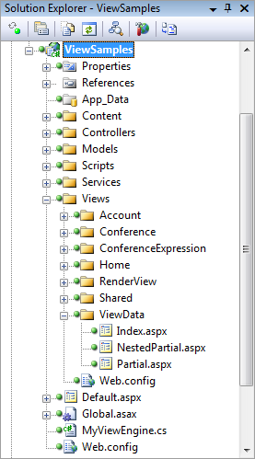
Figure 4.1 Default folder structure demonstrating convention for organizing views. The green dots you see next to each file are part of the VisualSVN plugin. CodeCampServer uses Subversion for source control.
The ASP.NET MVC Framework will work hard to locate a view to use for rendering. The framework will search each registered view engine before giving up with an exception. Out-of-the-box, ASP.NET MVC comes with a single view engine, WebFormViewEngine. This default view engine has several paths where views can reside, and views can be named with either the aspx or ascx extension. In listing 4.1, we see some of the code from the ASP.NET MVC Framework itself showing where the framework looks for views.
Listing 4.1 In the constructor of WebFormViewEngine, the default paths are set
public WebFormViewEngine () {
MasterLocationFormats = new[] {
"~/Views/{1}/{0}.master",
"~/Views/Shared/{0}.master"
};

ViewLocationFormats = new[] {
"~/Views/{1}/{0}.aspx",
"~/Views/{1}/{0}.ascx",
"~/Views/Shared/{0}.aspx",
"~/Views/Shared/{0}.ascx"
};

PartialViewLocationFormats = ViewLocationFormats;
}
If you need your view to live elsewhere, you can extend the framework to provide a custom location. What happens if your view is not found? To demonstrate the answer, I have defined a controller that returns a ViewResult, but I have purposely left out the view. See how, in figure 4.2, the ASP.NET MVC Framework throws an exception listing the specific places searched just to find that view.
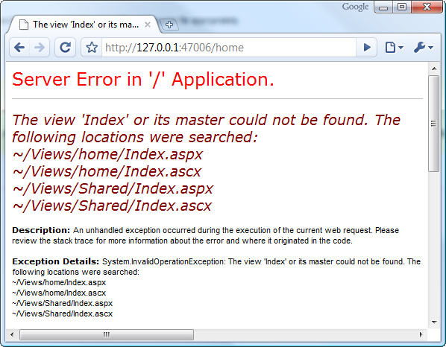
Figure 4.2 When looking for a view, the framework searches four paths before giving up.
A view is an instance of the System.Web.Mvc.IView interface. You can see the definition of this interface in listing 4.2.
Listing 4.2 The IView interface has a single Render operation.
public interface IView {
void Render(ViewContext viewContext, TextWriter writer);
}

The only type of view included with the MVC Framework is System.Web.Mvc.WebFormView. This class leverages the Web Forms infrastructure to perform rendering. Let’s examine the order of events that occur when a particular view is rendered.
- The ViewResult returned from an action method executes.
- The ViewResult uses the ViewEngineCollection to find the view.
- The ViewEngineCollection gives each registered IViewEngine a chance to resolve the view. The order is determined by the order of the view engines within the collection.
- The ViewResult creates a ViewContext using the ControllerContext, view name, ViewData, and TempData.
- The ViewResult calls Render() on the IView passing in the ViewContext and the response stream.
- If the IView instance derives from WebFormView, the following steps occur.
- The WebFormView uses IBuildManager to create a ViewPage or ViewUserControl from a virtual path.
- The WebFormView sets the MasterLocation on the ViewPage, sets the ViewData and calls RenderView() passing in the ViewContext.
- The ViewPage stores the ViewContext, initializes HtmlHelper, AjaxHelper, and UrlHelper, then delegates to base.ProcessRequest(), with which you are already familiar because it is the primary method on IHttpHandler.
From the time an action method returns a ViewResult to the time the existing response pipeline executes, you, as the developer have several places to customize the behavior of the rendering process. The following interfaces are extensibility points where you can insert your own logic and alter the default behavior once an action method has returned:
- IView
- IViewDataContainer
- IViewEngine
- IViewLocationCache
A widely used extension point is IViewEngine because that is the extension point required to integrate other view engines like NVelocity, Brail, or Spark. It is also quite easy to derive a class from WebFormViewEngine and merely override the FileExists() method or CreateView() method. Refer to chapter 6 for more information about view engines.
4.3 Overview of view basics
As we said before, views are responsible for rendering objects for consumption by a user. Decision logic should be limited, if not eliminated from views in order to ensure maintainability; we’ll focus on how views are organized and leveraged to render a screen. We’ll assume decision logic is retained in the controller, domain objects, and supporting presentation objects.
At first glance, it may seem that the view is not doing much, and that is correct. Intentionally, a view’s responsibility should be limited. Inherently, views are more brittle than other types of code because to verify the correctness of a view, one has to run the application and physically look at the screen to ensure it is correct. Even with automated tools like Selenium and Wati(r/N)), you often have to wait because these types of tests take a long time to run (measured in seconds, not milliseconds). There are ways to independently test views, but we have found the return on the large investment to be less than ideal. Our approach to views is to limit decision logic by factoring any necessary logic out into other objects. The views become simple HTML markup with variable tokens. When working with views, the basic topics include view engines, master pages, ViewData, and partials. We’ll begin with view engines.
4.3.1 Examining the IViewEngine abstraction
System.Web.Mvc.IViewEngine is the interface responsible for locating a view or a partial view. The full definition is in listing 4.3.
Listing 4.3 IViewEngine defines the contract used to location views and partials
public interface IViewEngine {
ViewEngineResult FindPartialView(ControllerContext controllerContext,
string partialViewName, bool useCache);
ViewEngineResult FindView(ControllerContext controllerContext,
string viewName, string masterName, bool useCache);
void ReleaseView(ControllerContext controllerContext, IView view);
}

Regardless of whether a view or a partial is found, each method returns a ViewEngineResult, which contains the IView instance as well as an IEnumerable<string> that contains the paths searched in order to locate the view. This interface is all that is necessary to:
- Change the default directory where views live
- Change the default names of views
- Amend the searched locations
- Add a new file extension for valid views
- Adapt a third party view engine

The ASP.NET MVC Framework provides one view engine right out of the box, WebFormViewEngine. This is the view engine supported by the file templates registered with Visual Studio and works with .aspx and .ascx views. We can expect most of the market to stick with this view engine because it is familiar and supported by tools such as Visual Studio and JetBrains ReSharper. When you want to leverage an alternate view engine, register the second view engine in an HTTP Module or in the Global.asax.cs file as shown in listing 4.4.
Cueball in code and text
Listing 4.4 Registering our view engine in Global.asax.cs
protected void Application_Start()
{
RegisterRoutes(RouteTable.Routes);
ViewEngines.Engines.Add(new MyViewEngine()); #1
}

public class MyViewEngine : IViewEngine
{
public ViewEngineResult FindPartialView(ControllerContext
controllerContext, string partialViewName, bool useCache)
{
return new ViewEngineResult (new string[0]); #A
}

public ViewEngineResult FindView(ControllerContext controllerContext,
string viewName, string masterName, bool useCache)
{
return new ViewEngineResult (new string[0]); #B
}

public void ReleaseView(ControllerContext controllerContext,
IView view)
{
#C
}
}

A Find a partial view
B Find a view
C No need to implement ReleaseView

We have created a naïve implementation of IViewEngine for the purposes of this example. In the Global.asax.cs file, we use one line of code to add this new view engine to the collection (1). When the view name cannot be found by the WebFormViewEngine, MyViewEngine will get a chance to find the view. Now that we understand the mechanics of locating and invoking a view, let’s explore master pages.
4.3.2 Understanding master pages in the ASP.NET MVC Framework
Layout is a fundamental element of screen design. A layout is known as a master page in ASP.NET, but the term precedes master pages. ASP.NET MVC carries master pages forward as one way to componentize the view necessary for a single screen. Just as with Web Forms, view master pages can be nested. In fact, System.Web.Mvc.ViewMasterPage derives from System.Web.UI.MasterPage; it has all the same capabilities. When using ASP.NET MVC, you use master pages in a manner similar to Web Forms. You specify the screen frame with specific sections marked as placeholders for content specific to the screen. Web applications typically have a common page border and color scheme. The master page is the perfect place to put the common elements as well as style sheets and site-wide JavaScript libraries such as jQuery. Figure 4.3 shows the portion of the screen that is specific to the page shown. The area not shadowed is rendered from the master page.
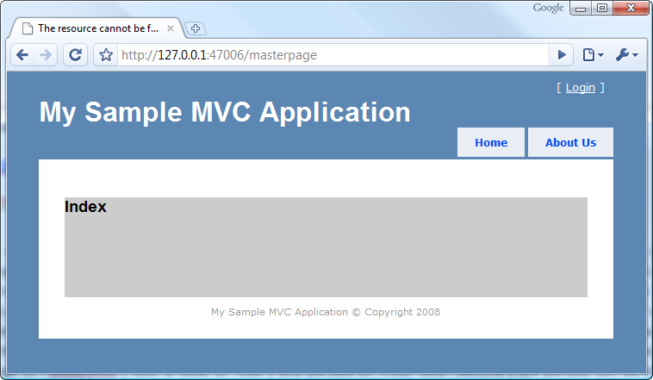
Figure 4.3 The master page represents the area around the shadowed section.
A view engine is in complete control of handling master pages:view engine handles. A view engine could allow only a single master page, but the IViewEngine interface allows a view engine to support many, each named with a string name. For instance, the FindView method accepts masterName as an argument. With this key, the view engine can locate a master page. Although it is possible to mix views within an application, and even to mix views on a single page with different partial views from different view engines, the master page chosen must be of the same view engine as the view to be found and rendered. Although a single screen could have a master page of SiteLayout, with a view of Edit, and partials of First and Second, the partials can be of any type of view, but the SiteLayout and Edit must be from the same view engine. Remember: If you are transitioning to a different view engine, you can use two master pages, but you will have to duplicate the markup so that during the transition you have the same master page coded in both view engine formats.
Because the WebFormViewEngine leverages master pages from Web Forms, the experience should be familiar to current ASP.NET developers. The difference is that view master pages have no postback capabilities or server-side form posting. It should be used for common markup for screen borders and navigation. Each aspx view can declare a master page directly, or the controller action can specify it. If the view specifies a master page, but the controller action also specifies one, the action wins, and the view’s selection is overridden. This is behavior specific to the WebFormViewEngine. Each view engine is free to implement arbitrary rules on precedence or requirements.
Listing 4.5 is a simple master page, and we see it rendering objects in ViewData the same way as with a regular view. All markup is the same. The only difference is that we use the ContentPlaceHolder control to designate where the view should be placed. In a master page, you can use any of the normal or custom view helpers you may have at your disposal.
Listing 4.5 A layout using WebFormViewEngine
<%@ Master Language="C#" AutoEventWireup="true" Inherits="System.Web.Mvc.ViewMasterPage" %>
<%@ Import Namespace="System.Web.Mvc.Html"%>

<!DOCTYPE html PUBLIC "-//W3C//DTD XHTML 1.0 Strict//EN" "http://www.w3.org/TR/xhtml1/DTD/xhtml1-strict.dtd">
<html xmlns="http://www.w3.org/1999/xhtml">
<head runat="server">
<meta http-equiv="Content-Type" content="text/html; charset=iso-8859-1"
/>
<title><%= Html.Encode(ViewData ["Title"])%></title>
<link href="../../Content/Site.css" rel="stylesheet" type="text/css" />
</head>

<body>
<div class="page">
<div id="header">
<div id="title">
<h1>My Second Sample MVC Application</h1>
</div>

<div id="menucontainer">

<ul id="menu">
<li><%=Html.ActionLink("Home", "Index", "Home")%></li>
<li><%=Html.ActionLink("About Us","About","Home")%>
</li>
</ul>

</div>
</div>

<div id="main">
<asp:ContentPlaceHolder ID="MainContent" runat="server" />

<div id="footer">
My Sample MVC Application &copy; Copyright 2008
</div>
</div>
</div>
</body>
</html>

To help you understand how views are selected and how you can modularize them, we’ll explore the common object structure that all views use to get objects to render.
4.3.3 Using ViewData to send objects to a view
ViewData is the bag of state (sometimes referred to as a “property bag”) that is passed to a view. A view should get all the information it needs from ViewData, which is implemented as a dictionary. It contains key/value pairs as well as some special properties, like Model. The controller is responsible for filling the ViewData dictionary with objects, but action filters can add to the dictionary as well. In fact, ViewData is a property on System.Web.Mvc.ControllerBase, so anywhere you can access the controller you can access ViewData. As the view is executing, it pulls objects from ViewData during the rendering process.
In chapter 1, you saw a simple use of ViewData, so we won’t repeat that here. In any nontrivial application, your view will be composed of a master page, a main view, and many partials—possibly nested partials. It will help to know how ViewData is segmented among the views. For instance, it is important to consider a partial view that might be used by several other views. If the partial view needs an object in ViewData, whose responsibility is it to put the object into the dictionary? The following is an example that illustrates just what happens in this complex scenario. Examine the source of the controller in listing 4.6, the Index.aspx view in listing 4.7, Partial.aspx in listing 4.8 and NestedPartial.aspx in listing 4.9.
Listing 4.6 The controller puts objects into ViewData
using System.Web.Mvc;

namespace ViewSamples.Controllers
{
public class ViewDataController : Controller
{
public ActionResult Index()
{
ViewData.Add("one", "onevalue"); #A
ViewData.Add("two", "twovalue");
ViewData.Add("three", "threevalue");
return View(3); #B
}
}
}

A Add objects to ViewData
B Render default view with model

Listing 4.7 Accessing ViewData from the view
<%@ Page Language="C#" AutoEventWireup="true"
Inherits="System.Web.Mvc.ViewPage<object>" %>
<%@ Import Namespace="System.Web.Mvc.Html"%>
<!DOCTYPE html PUBLIC "-//W3C//DTD XHTML 1.0 Transitional//EN"
"http://www.w3.org/TR/xhtml1/DTD/xhtml1-transitional.dtd">
<html xmlns="http://www.w3.org/1999/xhtml" >
<head runat="server">
<title></title>
</head>
<body>
<div>
This view: <%=GetType().Name %>
Model: <%=ViewData.Model %><br />
Model Type: <%=ViewData.Model.GetType().Name %>
ViewDataDictionary hashcode: <%=ViewData.GetHashCode()%>
<br />
<%foreach (KeyValuePair<string, object> pair in ViewData){%>
View data <%=pair.Key%> : <%=pair.Value %><br />
<% } %>

<hr />
PARTIAL
<%Html.RenderPartial("partial"); %>

<hr />
NESTED PARTIAL PASSING IN MODEL
<%Html.RenderPartial("nestedpartial", 89); %>

<hr />
NESTED PARTIAL PASSING IN MODEL AND VIEWDATA
<%Html.RenderPartial("nestedpartial", 89,
new ViewDataDictionary {{"first", "1"} , {"second", "2"}}); %>

<hr />
NESTED PARTIAL PASSING IN VIEWDATA
<%
var dictionary = new ViewDataDictionary {{"first", "value"}};
dictionary.Model = 100;
Html.RenderPartial("nestedpartial", dictionary);
%>
</div>
</body>
</html>

Listing 4.8 Partial.aspx is loaded as a partial and loads a partial itself
<%@ Page Language="C#" AutoEventWireup="true"
Inherits="System.Web.Mvc.ViewPage<object>" %>
<%@ Import Namespace="System.Web.Mvc.Html"%>
<div style="border:solid 5px Lime">
This view: <%=GetType().Name %>
Model: <%=ViewData.Model %><br />
Model Type: <%=ViewData.Model.GetType().Name %>
ViewDataDictionary hashcode: <%=ViewData.GetHashCode() %>
<br />
<%foreach (KeyValuePair<string, object> pair in ViewData){%>
View data <%=pair.Key%> : <%=pair.Value %><br />
<% } %>
<hr />
<%Html.RenderPartial("nestedpartial"); %>
</div>

Listing 4.9 NestedPartial.aspx is loaded two views deep.
<%@ Page Language="C#" AutoEventWireup="true"
Inherits="System.Web.Mvc.ViewPage<object>" %>
<div style="border:solid 5px Red">
This view: <%=GetType().Name %>
Model: <%=ViewData.Model %><br />
Model Type: <%=ViewData.Model.GetType().Name %>
ViewDataDictionary hashcode: <%=ViewData.GetHashCode() %>
<br />
<%foreach (KeyValuePair<string, object> pair in ViewData){%>
View data <%=pair.Key%> : <%=pair.Value %><br />
<% } %>
</div>
Notice the values that are added in the controller in listing 4.6. We have three key/value pairs and an object set to the Model property (by virtue of passing in “3” to the View method). It is important to know that when a view renders a partial, the partial will get the same ViewData objects; anything passed from the controller will also make it to any partial and any master page (not shown here). This is because ViewData is a member of ControllerBase, and ControllerBase is part of System.Web.Mvc.ControllerContext. System.Web.Mvc.ViewContext derives from ControllerContext, so it has everything ControllerContext has and more.
We also see in listing 4.7 that while rendering a partial, a view can decide to override the ViewData passed into the partial. Even though each view will have access to the same objects in the ViewData dictionary, the instance of ViewDataDictionary is different for each one. Multiple views do not share instances of ViewDataDictionary. We cannot expect to use ViewData as a mechanism for a partial to pass an object back to the parent view. In fact, views should be isolated and should not try to communicate with one another.
Views are functional, and once they begin rendering, they should expect to have all the information necessary to complete rendering. Note the hash code values printed with the data when rending /viewdata/index in a browser. The output is shown in figure 4.4. We see that the hash code values are different, even for the multiple instances of the nested partial view. Shared state and global variables can cause maintainability problems; each view receives a fresh instance of ViewData to avoid these issues.
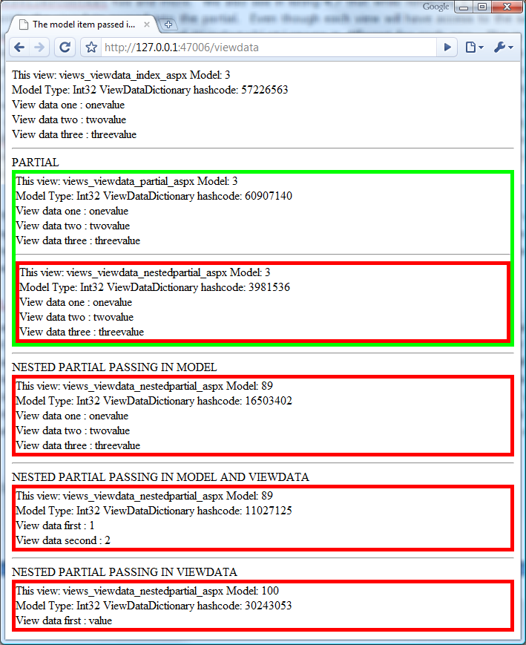
Figure 4.4 Each view and partial view receives a fresh instance of ViewData
You can see from figure 4.4 that ViewData is the central object that is passed to a view. A view relies completely on ViewData to get the information it needs to render. The view can choose to pass on all or some of the same objects to partial views, and the master page has access to the ViewData values as well. For proper segmentation, each view/master page/partial gets its own instance of ViewData even if the contents are identical. Partial views can be used to segment complex views into isolated sections that can be reused within multiple views. You should take special note of partials.
4.3.4 Partial views can help decompose a complex screen
In section 4.3.3, you saw a demonstration of nested views, but there is much more to know about partial views. First, a view is not partial based on its file extension. You can have partial views with either the aspx or ascx extension. The view engine does not care, and the view will render in the same fashion. What makes a view partial is how it is used. There are infinite uses for partial views. Conceptually, you could break your site into pieces and have each partial handle a section of your site. I will leave the exact layout up to you, but there are plenty of ways to determine which partial to render, and you can even choose what class makes the decision about what partial to use. You have already seen the scenario in which the view makes the decision about which partial to render. The following example puts the controller in control. Please examine listing 4.10 where the controller decides which partial to use by putting a ViewResult into ViewData.
Cueball in code and text. Also reference to listing 4.11 confirmed by author as correct
Listing 4.10 RenderViewController puts a pointer to a partial view into viewdata
using System.Web.Mvc;

namespace ViewSamples.Controllers
{
public class RenderViewController : Controller
{
public ViewResult Index()
{
ViewResult partialResult = View("next"); #1
return View(partialResult);
}
}
}
In listing 4.10 the controller is deciding which partial view to use. The controller passes a ViewResult to the view inside the ViewData’s Model property (1). The view, in listing 4.11, is a strongly typed view expecting a ViewResult, and it executes the ViewResult passing in the ViewContext. Although this is a contrived example, it shows that there is flexibility in who makes the decision about which partial view to use. Most often, a view will decide which partial view to use because the responsibility for rendering belongs to the view, not the controller. In cases where data or user input changes a section of the screen, it may be appropriate for the controller to handle the logic and decide. As with everything in software, it depends on your application.
Listing 4.11 shows a view that renders any view passed to it.
Listing 4.11 Index.aspx is a view that renders any partial passed to it
<%@ Page Language="C#" AutoEventWireup="true"
Inherits="System.Web.Mvc.ViewPage<ViewResult>" %>
<%@ Import Namespace="System.Web.Mvc"%>
<!DOCTYPE html PUBLIC "-//W3C//DTD XHTML 1.0 Transitional//EN"
"http://www.w3.org/TR/xhtml1/DTD/xhtml1-transitional.dtd">
<html xmlns="http://www.w3.org/1999/xhtml" >
<head runat="server">
<title></title>
</head>
<body>
<div>
<%=GetType().Name %>
<br />
<% ViewData.Model.ExecuteResult(ViewContext); %>
</div>
</body>
</html>

Listing 4.12 shows the simple partial view that outputs the type name. In figure 4.5, the output of the rendered page shows that both of these views rendered in the correct order. If the controller had decided to pass a different partial, this output would be different.

Listing 4.12 Next.aspx is a simple partial view
<%@ Page Language="C#" AutoEventWireup="true"
Inherits="System.Web.Mvc.ViewPage<object>" %>
<div>
<%=GetType().Name %><br />
</div>

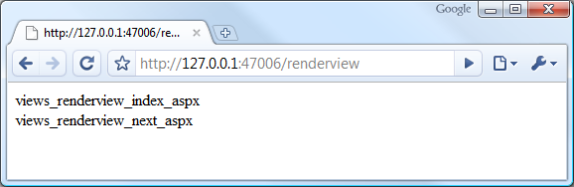
Figure 4.5 The output shows that the correct partial was rendered to the screen.
ViewData, views, master pages, ViewEngines, and partials are all important concepts in the view story of the ASP.NET MVC Framework. Now that we have covered the basics, the next section will explore view helpers, which are the building blocks of dynamics views developed with ASP.NET MVC.
4.4 Leveraging the view to create dynamic screens
We have already seen how controllers, views, and our model objects fit in, but there is more to formatting objects into HTML, posting forms, and creating dynamic web pages. Getting the objects to the view seems easy, but what is the best way to transform those objects into HTML? We could certainly build all HTML by hand, but we would end up with much of the markup being duplicated. View helpers take similar markup and handle the generation for us given a part of the view model. Form posting with model binding and validation make accepting user input a snap. This section explores all these topics.
In chapter 2, we saw how to use a domain model and even a presentation model. We saw how in some cases it works well to pass domain objects to the view, but in nontrivial applications, it becomes necessary to put a translation mechanism between our domain model and our UI toolkit. In smart client applications, we rely on the statefulness of the platform, and we want our domain model to be active at all times so that we can send events to it and consume quick responses. In a stateless application, we need to take care that our domain model does not become corrupted by the stateless paradigm of the web. The domain model does not need to know that it is living within a web application, a smart client, an autonomous process or a test harness.
In the following examples, we’ll keep the concerns separate and map from the domain model to the view model and back. This simulates real-world scenarios in enterprise applications.
4.4.1 Rendering forms with view helpers and data binding
The ASP.NET MVC Framework does not emphasize web controls as heavily as Web Forms. The concept is altogether different, and that concept is the view helper. There are numerous types of view helpers:
- System.Web.Mvc.HtmlHelper<T>—Used to help render HTML input elements
  - Html.TextBox ()
  - Html.CheckBox()
  - Etc.
- System.Web.Mvc.UrlHelper—Used to generate URLs
  - Url.Action()
  - Url.Content()
  - Url.RouteUrl()
  - Etc.
- System.Web.Mvc.AjaxHelper<T>—Used to render links and form elements used in an AJAX request
  - Ajax.ActionLink()
  - Ajax.BeginForm()
  - Etc.
In this section, we concentrate on the HtmlHelper<T>. We are using strongly typed views almost everywhere, and the ViewData.Model type flows all the way through the helpers. Although we can use view helpers with any object, including our domain model, we are focused here on leveraging them with our view model.
When moving from complex objects to HTML and back, several things need to happen, such as HTML encoding, null checking, and formatting as a string. We easily think of HTML encoding because many of us have been bitten by HTML characters making their way into data, but why null checking? In listing 4.13, we have a Conference object with a start date. Because this property is a nullable date, we could potentially experience a NullReferenceException when we attempt to format it as a short date string. This raises the question of who is responsible for checking values for null and formatting as a string. Certainly the domain object is not responsible for this because it does not care that we have a web front end at all. This is where the M in MVC comes in: the model. No just any model, but the type of model that represents the shape necessary for our presentation layer. We can call it presentation model, form model, edit model, DTOs, view model, and so on, but these objects exist for the sole purpose of working well with a view. As an aside, the term view model is gaining popularity. In nontrivial applications, it is impractical to pass raw domain objects to views because views often need a clean, projected view of the domain. Listing 4.13 shows our sample domain object, the Conference.
Listing 4.13 The Conference object is abbreviated for this sample
using System;

namespace ViewSamples.Models
{
public class Conference
{
public virtual int Id { get; set; }
public virtual string Name { get; set; }
public virtual string Description { get; set; }
public virtual DateTime? StartDate { get; set; }
public virtual DateTime? EndDate { get; set; }
}
}
At first we might be tempted to pass this simple object straight to the view, but the DateTime? properties will cause problems. For instance, we need to choose a formatting for them such as ToShortDateString() or ToString(). The view would be forced to do null-checking to keep the screen from blowing up when the properties are null. Views are difficult to unit test, so we want to keep them as thin as possible. Because the output of a view is a string passed to the response stream, we’ll only use objects that are string-friendly; that is, objects that will never fail when ToString() is called on them. The ConferenceForm view model object is an example of this. Notice in listing 4.14 that all of the properties are strings. We’ll have the dates properly formatted before this view model object is placed in view data. This way, the view need not consider the object, and it can format the information properly.
Listing 4.14 View model has simple properties and is dedicated to a single view
namespace ViewSamples.Models
{
public class ConferenceForm
{
public string Id { get; set; }
public string Name { get; set; }
public string Description { get; set; }
public string StartDate { get; set; }
public string EndDate { get; set; }
}
}
We have an obvious gap now between our domain model Conference and the view model ConferenceForm. The controller action could be the place to map from the domain model to the view model, but our controller already has enough responsibility. In listing 4.15, see how the ConferenceController delegates to a mapper for this specific purpose. The mapper is pretty simple code, and only the interface is listed here.
Listing 4.15 ConferenceController uses a view model to enable easy binding
using ViewSamples.Models;

namespace ViewSamples.Services
{
public interface IConferenceMapper
{
ConferenceForm Map(Conference conference);
Conference Map(ConferenceForm form);
}
}

public class ConferenceController : Controller
{
private readonly IConferenceMapper _mapper;
private readonly IConferenceRepository _repository;
private readonly IConferenceFormValidator _validator;

public ConferenceController(IConferenceMapper mapper,
IConferenceRepository repository,
IConferenceFormValidator validator)
{
_mapper = mapper;
_validator = validator;
_repository = repository;
}

public ViewResult Edit(int conferenceId)
{
Conference conference = _repository.GetById(conferenceId); #A

ConferenceForm form = _mapper.Map(conference); #B

return View(form);
}

[AcceptVerbs(HttpVerbs.Post)]
public ActionResult Edit(ConferenceForm form)
{
ModelStateDictionary dictionary = _validator.Validate(form); #C
ModelState.Merge(dictionary); #D

if (ModelState.IsValid)
{
Conference conference = _mapper.Map(form); #E

_repository.Save(conference);
return Redirect("/conference/current");
}

return View();
}
}

#A Retrieve Conference from store
#B Map from Conference to ConferenceForm
#C Validate the form
#D Merge validation errors
#E Map ConferenceForm to Conference

Listing 4.16 contains the view that renders the input form. Notice how clean this view is. There is no conditional logic, no date formatting— it’s clean. It is a strongly typed view around ConferenceForm, so ViewData.Model is the type we expect. In fact, the view helpers, such as the TextBox, will automatically bind from objects in ViewData. Our view has no code that specifically places a value inside of a TextBox, as is necessary when editing an existing conference.
Listing 4.16 New.aspx view binds to the view model to allow data entry
<%@ Page Title="" Language="C#" MasterPageFile="~/Views/Shared/Site.Master"
Inherits="System.Web.Mvc.ViewPage<ConferenceForm>" %>
<%@ Import Namespace="ViewSamples.Models"%>

<asp:Content ID="Content1" ContentPlaceHolderID="MainContent"
runat="server">
<h3><%=Html.ValidationSummary()%></h3>
<p>
Create new conference
</p>
<%using (Html.BeginForm()){%>
<p>
Name:<%=Html.TextBox ("Name")%>
<%=Html.ValidationMessage("Name", "*")%>
</p>
<p>
Description:<%=Html.TextBox ("Description")%>
<%=Html.ValidationMessage("Description", "*")%>
</p>
<p>
Start Date:<%=Html.TextBox ("StartDate")%>
<%=Html.ValidationMessage("StartDate", "*")%>
</p>
<p>
End Date:<%=Html.TextBox ("EndDate")%>
<%=Html.ValidationMessage("EndDate", "*")%>
</p>
<input type="submit" value="Save" />
<%}%>
</asp:Content>

In figure 4.6, we see the screen that displays when we navigate our browser to /conference/edit?conferenceId=XXXX. The controller uses the repository and the mapper to obtain a ConferenceForm view model object. Then the controller passes the view model to the view, and the view renders an edit form with a TextBox for each property.
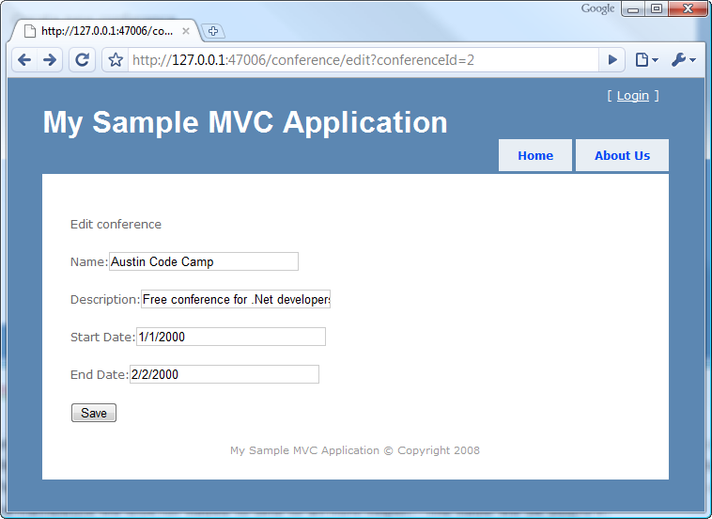
Figure 4.6 The edit screen renders a form for editing the conference.
The framework knows how to bind directly from ViewData.Model to the HTML text boxes on this view. The fact that the model passed to this strongly typed view contained data was enough for the view helper to bind to the values. The built-in view helpers will work hard to find a value suitable for rendering. The following is the order in which the framework will look for values to bind to a view helper. The value will be bound if:
- The name is found in ModelState
- The name is found as an explicit key in ViewData
- The name is found as a property of ViewData.Model
- The name is an expression interpretable, such as Product.Name or Products[2].Name
Rendering a screen is one of the easiest things to do in the MVC Framework, but how do we post information back to the server so that our controller can save the conference? The next section tackles methods for taking this rendered form and posting it back to the server so that we can save modified information back to our data store.
4.4.2 Posting HTML forms back to the server
A web application is only a website without the posting of information. Saving information on the server makes the web interesting, and the ASP.NET MVC Framework delivers a compelling experience. In the following example, you will see that you can save a new conference without fishing around in the Request object or writing tedious mapping code. In listing 4.16, you saw a view that contains a form that will post back to the “edit” relative path. We used the Html.BeginForm() view helper to render the form tag, which renders the following: <form action="/conference/edit" method="post">.
With the form properly rendered, the page will post to the /conference/edit URL, which is exactly what we want. In listing 4.17 we see the Edit action method that receives the post. The single parameter this method receives is of type ConferenceForm. Because the properties of this object are types that have built-in type converters, the ASP.NET MVC Framework is able to bind these properties without a custom IModelBinder instance being registered. Take special notice that the controller does not have to dig into the form collection within the request object. If you have done ASP classic programming or even advanced Web Forms development, you are familiar with working with form posts. The ASP.NET MVC Framework nearly eliminates the need to access Request.Form directly. Instead a form post can come in directly to an action method, and that method can work with it as it does any other object. In this case, we map it back to a Conference object, save it, and then redirect to another URL.
Cueball in code and text
Listing 4.17 The save action binds the request and handles it
[AcceptVerbs(HttpVerbs.Post)] #1
public ActionResult Edit(ConferenceForm form)
{
ModelStateDictionary dictionary = _validator.Validate(form);
ModelState.Merge(dictionary);

if (ModelState.IsValid)
{
Conference conference = _mapper.Map(form);
_repository.Save(conference);
return Redirect("/conference/current");
}

return View();
}

When using the same action name for a GET request as well as a POST request, we have to use an ActionMethodSelectorAttribute such as the System.Web.Mvc.AcceptVerbsAttribute (1) to limit a single URL request to a single action. Without this attribute the controller class would not know which action method to select when handling the URL, /controller/edit. At this point we see how simple it is to craft a view with a form on it and post it back to the server. So far, we are only handling the happy path. If anything went wrong, we don’t yet have the capability to handle it. In any real business application, we need the capability to validate user input and redirect the user back to the data entry form if something is left out or submitted in an invalid state. The next section dives into the validation capabilities included in ASP.NET MVC.
4.4.3 Validation and error reporting
The ASP.NET MVC Framework has a concept called ModelState which contains information about those objects in ViewData that are not valid. On almost every data entry screen, the user might enter data that is invalid for processing. In these cases, we want to redirect the user back to the data entry screen to give him an opportunity to correct the mistakes and try again. Let’s quickly fast-forward to a case where our system would reject the saving of a conference. Our system needs to validate the user input and report any errors that occur. I will intentionally post invalid data, and figure 4.7 shows the resulting screen.

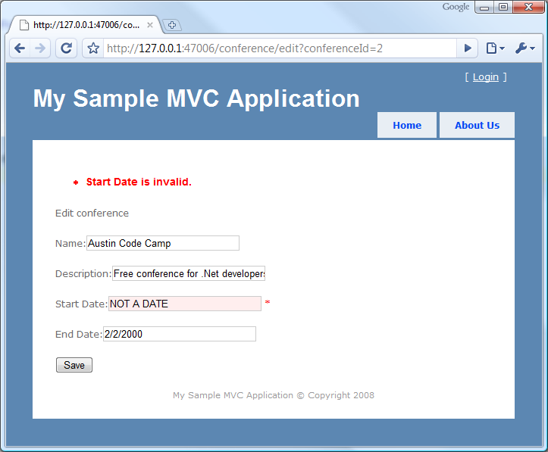
Figure 4.7 The screen reports an error as a result of the validation.
The built-in view helpers will match the keys in the ModelStateDictionary with the names of the form elements and tag them with a CSS class that calls attention to them on the screen. The ASP.NET MVC Framework uses three CSS classes to report form validation errors:
- input-validation-error—On the <input> tag
- field-validation-error—On the <span> tag of Html.ValidationMessage()
- validation-summary-errors—On the <ul> tag of the Html.ValidationSummary()
At the top of the screen, we have a validation summary, and we have an individual message that describes the problem. This validation summary will take any errors in the ModelStateDictionary and format them as an unordered list. These errors can get into the ModelState dictionary in several places. In this case, our custom UI validator performed the validation and added a ModelState object to the dictionary. The ASP.NET MVC Framework will also add an error to ModelState when it encounters an error binding an action parameter. You are free to add errors inside the controller action, in action filters and anywhere you have access to the controller object. In our case, and in complex business applications, you want to keep validation away from your controller because the business rules can become quite detailed. In fact, implementing a small business rules engine quickly pays dividends in maintainability. Listing 4.18 shows our IConferenceFormValidator interface and the implementing class.
Listing 4.18 Validating the view model object posted from the form
public interface IConferenceFormValidator
{
ModelStateDictionary Validate(ConferenceForm form);
}

public class ConferenceFormValidator : IConferenceFormValidator
{
public ModelStateDictionary Validate(ConferenceForm form)
{
var dictionary = new ModelStateDictionary ();
ValidateStartDate(form, dictionary);
return dictionary;
}

private void ValidateStartDate(ConferenceForm form,
ModelStateDictionary dictionary)
{
DateTime result;
if (!DateTime.TryParse(form.StartDate, out result)) #A
{
var state = new ModelState ();
state.Value = new ValueProviderResult(form.StartDate, |#B
form.StartDate, |#B
CultureInfo.InvariantCulture); |#B
state.Errors.Add("Start Date is invalid."); |#B

dictionary.Add("StartDate", state); #C
}
}
}

#A Check if start date valid
#B Create ModelState entry
#C Add ModelState entry

Although we validate only one property, you will want to implement full validation to check all the necessary properties. Even with a single property, validation can consume twenty lines of code. Imagine how large this class would be if we had to validate thirty fields! The need for a business rules engine comes on quickly.
This view model and mapping implementation is just one way to do it. Another excellent way to do binding is through an object mapper tool that specializes in mapping objects to objects. By following the conventions of the AutoMapper library, found at http://automapper.codeplex.com/, you can reduce tedious mapping code.
NOTE
The ASP.NET MVC Framework also provides support for System.ComponentModel.IDataErrorInfo. If your view model implements this interface, it can integrate seamlessly with IModelBinder and ModelState. Unfortunately, this requires the view model to handle the validation. We have seen the need to separate validation logic from the view model itself; therefore, only consider implementing this interface on the most trivial of ASP.NET MVC web applications.
Another great way to accomplish data entry validation is to use the validation classes from the Castle Project (http://www.castleproject.org/) in the Castle.Components.Validator namespace. The Castle validators have a complete array of attributes that describe the validation to be performed. This leads to a declarative way to specify validation, and it removes the need for lots of imperative coding in each view model object.
While reading through the example, you have probably wondered why each field requires so much markup just for a label, input box, and validation message. The following section shows us how we can reduce the markup required in the form by extending HtmlHelper.
4.4.4 Extending HtmlHelper
If you have seen any presentations with the ASP.NET MVC Framework, you probably have noticed the volume of string identifiers used in the views. With a bit of work we can drastically reduce the amount required to render the same view while reducing the risk of a typo causing a functional bug in one of our screens. The view in listing 4.19 uses a custom view helper that we’ll explore shortly.
Listing 4.19 By using a custom view helper, we can eliminate many string literals
<%@ Page Title="" Language="C#" MasterPageFile="~/Views/Shared/Site.Master"
Inherits="System.Web.Mvc.ViewPage<ConferenceForm>" %>
<%@ Import Namespace="ViewSamples.Views.Conference"%>
<%@ Import Namespace="ViewSamples.Models"%>

<asp:Content ID="Content1" ContentPlaceHolderID="MainContent"
runat="server">
<h3><%=Html.ValidationSummary()%></h3>
<p>
Edit conference
</p>
<%using (Html.BeginForm()){%>
<%=Html.Hidden(x=>x.Id) %>
<p><%=Html.TextBox (x=>x.Name)%></p>
<p><%=Html.TextBox (x=>x.Description)%></p>
<p><%=Html.TextBox (x=>x.StartDate)%></p>
<p><%=Html.TextBox (x=>x.EndDate)%></p>
<input type="submit" value="Save" />
<%}%>
</asp:Content>

Notice how little markup is required to render the same edit screen as we saw before. By using .NET 3.5 LINQ Expressions and a strongly typed view, we can to describe the property we wish to display and bind without coupling to the name using a string literal. We leverage view model binding, specific error reporting, and seamless form post binding all without string literals cluttering the view. Reducing the number of repetitive string literals is a good idea, but you may be wondering what is necessary to use this type of technique when creating a custom view helper.
The HtmlHelper class itself does not contain any view helpers. You cannot render a text box, a check box, or a button with the HtmlHelper class alone. All view helpers are implemented as extension methods off of the HtmlHelper class in a class called InputExtensions. The above example uses a custom view helper implemented as an extension method. This custom view helper:
- Renders a label with the property text
- Renders the textbox with the appropriate ID, name and value
- Renders a validation message span tag ready for form validation
The custom view helper is invoked by calling Html.TextBox (x=>x.Name) where x.Name is a property of ConferenceForm. It is represented as a lambda expression, which is part of the LINQ extensions in .NET 3.5. The code for this view helper is in listing 4.20. This is advanced code, and it is not necessary for basic use of ASP.NET MVC, but extensions like this are useful in applications with many, many screens.
Cueballs in code and text
Listing 4.20 A custom view helper that enables easy view code
using System;
using System.Linq.Expressions;
using System.Reflection;
using System.Web.Mvc;
using System.Web.Mvc.Html;

namespace ViewSamples.Views.Conference
{
public static class HtmlHelperExtensions
{
public static string Hidden<T>(
this HtmlHelper<T> helper, Expression<Func<T, object>> expr)
where T : class
{
MemberInfo property = GetMemberInfo(expr); #A
string propertyName = property.Name; #1
Func<T, object> func = expr.Compile();

object propertyValue = func.Invoke(helper.ViewData.Model); #B
return helper.Hidden(propertyName, propertyValue);
}

public static string TextBox<T>(this HtmlHelper<T> helper,
Expression<Func<T, object>> expr)
where T : class
{
MemberInfo property = GetMemberInfo(expr);
string propertyName = property.Name;
Func<T, object> func = expr.Compile();

object propertyValue = func.Invoke(helper.ViewData.Model);
string textBoxString =
helper.TextBox(propertyName, propertyValue); #2

return string.Format(
"<label for=\"{0}\">{1}:&nbsp;</label>{2}&nbsp;{3}",
propertyName, propertyName, textBoxString,
helper.ValidationMessage(expr));
}

public static string ValidationMessage<T>(
this HtmlHelper<T> helper, Expression<Func<T, object>> expr)
where T : class
{
MemberInfo property = GetMemberInfo(expr);
string propertyName = property.Name;
return helper.ValidationMessage(propertyName, "*"); #3
}

public static MemberInfo GetMemberInfo<T>(
Expression<Func<T, object>> expr)
{
if (expr.Body.GetType() == typeof (UnaryExpression))
return ((MemberExpression)
(((UnaryExpression) expr.Body).Operand)).Member;

return ((MemberExpression) expr.Body).Member;
}

}
}

#A Get property from expression
#B Get value from view model

Notice that the view helper reuses the TextBox view helper that already comes with the ASP.NET MVC Framework (2). This ensures that the built-in binding and error CSS class labeling logic are also included when this view helper renders. You can see that this view helper examines the expression passed in and uses the property name as the name for the form elements (1) as well as the validation message if an error occurs (3). This automatically matches up keys, and when combined with the validation logic shown in listing 4.17, no string literals are necessary anywhere. All keys are kept in sync, and this makes for a trivial data entry programming task.
4.5 Summary
Views have changed significantly from early web technologies, through Web Forms and now with ASP.NET MVC views. The most obvious change is that views have become simpler. When realizing that a view should have the responsibility only for rendering, we find that much logic can be factored out to other classes.
In this chapter, we have seen how to create views of various types and work with layouts and partial views. We have explored the intricacies of ViewData and the mechanics of view engines and the sequence of events that happen when rendering a view. Our deep dive into views concluded with a complex scenario with all the pieces coming together to provide a complete data entry scenario that included binding, validation, error reporting, and a custom view helper that enabled the elimination of string literals in the view. With the basics in place, we’ll now dive into routing, which is a major topic itself. Up to this point, we have used the default route of {controller}/{action}/{id}. Chapter 5 explores routing in greater detail.

