6
Customizing and extending the ASP.NET MVC Framework
This chapter covers:
- Customizing route handlers
- Creating your own controller factory
- Extending the controller
- Decorating controller actions for additional behavior
- Building and using custom view engines
One of the greatest aspects of ASP.NET MVC is its flexibility. The majority of the framework is built upon interfaces and abstract base classes, which enables unit testing of components in isolation. This also gives us the ability to substitute our own implementations of these features. ASP.NET MVC comes with functional default implementations, but sometimes these don’t meet our needs. Sometimes we don’t agree with the choices that Microsoft bakes in, and by customizing these components we are free to make our own choices.
In this chapter we’ll cover some of the extension points of the ASP.NET MVC Framework. We’ll surround their use with examples and mention the purpose of each one. By the end of the chapter, you will be familiar with most of the extensible components of ASP.NET MVC and how to apply them.
First we’ll examine URL routing. We'll take a look at how it functions and then explore how to enhance it to behave differently.
6.1 Extending URL routing
The UrlRoutingModule is an implementation of IHttpModule and represents the entry point into the ASP.NET MVC Framework. This module examines each request, builds up the RouteData for the request, finds an appropriate IRouteHandler for the given route matched, and finally redirects the request to the IRouteHandler's IHttpHandler. Make sense?
In chapter 5 we discovered how routing works. Our default route looked like listing 6.1. The MapRoute method is actually a simplified way of specifying routes. The same route can be specified more explicitly, as is shown in listing 6.2.
Listing 6.1 A simple way of specifying routes
routes.MapRoute("default", "{controller}/{action}/{id}",
new { Controller="home", Action="index", id=""});

Listing 6.2 A more detailed way of specifying routes
routes.Add(new Route("{controller}/{action}/{id}",
new RouteValueDictionary(new { Controller = "home", Action = "index",
id = "" }), new MvcRouteHandler()));

That third argument in listing 6.2 is telling the framework which IRouteHandler to use for this route. We are using the built-in MvcRouteHandler that ships with the framework. By default we are using this class when using the MapRoute method. We can change this to be a custom route handler and take control in interesting ways. An IRouteHandler is responsible for creating an appropriate IHttpHandler to handle the request given the details of the request. This is a good place to change the way routing works, or perhaps to gain control extremely early in the request pipeline. The MvcRouteHandler simply constructs an MvcHandler to handle a request, passing it a RequestContext, which contains the RouteData and an HttpContextBase.
A quick example will help illustrate the need for a custom route handler. When starting to define your routes, you'll sometimes run across errors. Let's assume you have defined the route shown in listing 6.3.
Listing 6.3 Adding another route
routes.MapRoute("conferenceKey", "{conferenceKey}/{action}",
new { Controller = "Conference", Action="index" });

Here we’ve added a new custom route at the top position that will accept URLs like /HoustonCodeCamp2008/register, use the conference controller, and call the register action on it, passing in the conferenceKey as a parameter to the action as shown in listing 6.4.
Listing 6.4 A controller action that handles the new route
public class ConferenceController : Controller
{
public ActionResult Register(string conferenceKey)
{
return View();
}
}

This is a good example of a custom route that makes your URLs more readable.
Now let's assume that we have another controller called Home. HomeController has an Index action to show the start page as shown in listing 6.5.
Listing 6.5 A controller action to respond to the default route
public class HomeController : Controller
{
public ActionResult Index()
{
return View();
}
}

We'd like the URL for the action in listing 6.4 to look like /home/index. If we try this URL, we'll get a 404 error as shown in figure 6.1. Why?

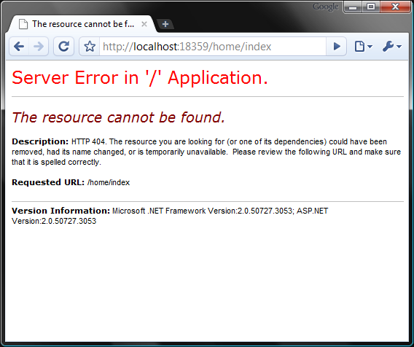
Figure 6.1 This message doesn’t tell us much about what’s wrong. An action couldn’t be found on the controller, but which one?
The problem is not apparent from that error message. We certainly have a controller called HomeController, and it has an action method called Index. If you dig deep into the routes you can deduce that this URL was picked up by the first route, {conferenceKey}/{action}, which was not what we intended. We should be able to quickly indentify a routing mismatch, so that we can fix it speedily.
With lots of custom routes, it is easy for a URL to be caught by the wrong route. Wouldn't it be nice if we had a diagnostics tool to display which routes are being matched (and used) for quickly catching these types of errors?
What we’d like to do is have an extra querystring parameter that we can tack on if we want to see the route information. The current route information is stored in an object called RouteData, available to us in the IRouteHandler interface. The route handler is also first to get control of the request, so it is a great place to intercept and alter the behavior for any route as shown in listing 6.6.
Cutball in code and text
Listing 6.6 A custom route handler creates an associated IHttpHandler
public class CustomRouteHandler : IRouteHandler
{
public IHttpHandler GetHttpHandler(RequestContext requestContext)
{
if(HasQueryStringKey("routeInfo", #1
requestContext.HttpContext.Request))
{
OutputRouteDiagnostics(requestContext.RouteData,
requestContext.HttpContext);
}

var handler = new CustomMvcHandler(requestContext);
return handler;
}

private bool HasQueryStringKey(string keyToTest,
HttpRequestBase request)
{
return Regex.IsMatch(request.Url.Query,
string.Format(@"^\?{0}$", keyToTest));
}
}

A route handler’s normal responsibility is to construct and hand off the IHttpHandler that will handle this request. By default, this is MvcHandler. In our CustomRouteHandler we first check to see if the querystring parameter is present (1) (we do this with a simple regular expression on the URL query section). The OutputRouteDiagnostics method is shown in listing 6.7.
Listing 6.7 Rendering route diagnostic information to the response stream
private void OutputRouteDiagnostics(RouteData routeData, HttpContextBase context)
{
var response = context.Response;
response.Write(
@"<style>body {font-family: Arial;}
table th {background-color: #359; color: #fff;}
</style>
<h1>Route Data:</h1>
<table border='1' cellspacing='0' cellpadding='3'>
<tr><th>Key</th><th>Value</th></tr>"); #A
foreach (var pair in routeData.Values)
{
response.Write(string.Format("<tr><td>{0}</td><td>{1}</td></tr>",
pair.Key, pair.Value));
}

response.Write(
@"</table>
<h1>Routes:</h1>
<table border='1' cellspacing='0' cellpadding='3'>
<tr><th></th><th>Route</th></tr>"); #B
bool foundRouteUsed = false;
foreach(Route r in RouteTable.Routes)
{
response.Write("<tr><td>");
bool matches = r.GetRouteData(context) != null;
string backgroundColor = matches ? "#bfb" : "#fbb"; #C
if(matches && !foundRouteUsed)
{
response.Write("&raquo;"); #D
foundRouteUsed = true;
}
response.Write(string.Format(
"</td><td style='font-family: Courier New;
background-color:{0}'>{1}</td></tr>",
backgroundColor, r.Url));
}

response.End();
}

#A Create an HTML table
#B Display the routes
#C Green if matching, Red otherwise
#D Chevron (») next to route selected

This method outputs two tables, one for the current route data, and one for the routes in the system. Each route will return null for GetRouteData if the route doesn’t match the current request. The table is then colored to show which routes matched, and a little arrow indicates which route is in use for the current URL. The response is ended to prevent any further rendering.
To finalize this change, we have to alter the current routes to use our new handler as shown in listing 6.8.
Listing 6.8 Assigning routes to our custom route handler
RouteTable.Routes.Add(
new Route("{conferenceKey}/{action}",
new RouteValueDictionary( new { Controller="Conference" }),
new CustomRouteHandler()));

RouteTable.Routes.Add(
new Route("{controller}/{action}/{id}",
new RouteValueDictionary(
new { Controller="Home", Action="Index", id="" }),
new CustomRouteHandler()));

The end result (shown in figure 6.2) is incredibly helpful. Let’s use the /home/index URL (that resulted in a 404 in figure 6.1) but this time we’ll add ?routeInfo to the querystring. We can see in the route data table that the value home was picked up as a conference key. The route table confirms that the conference key route was picked up first, since it matched.

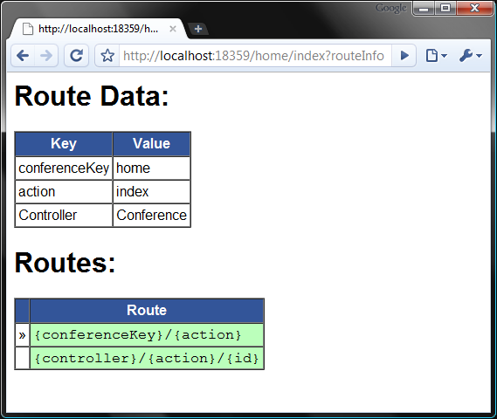
Figure 6.2 Appending the querystring parameter ?routeInfo to our URL gives us detailed information about the current request’s route. We can see now that the wrong route was chosen.
Now you can immediately tell that the current route used is not the one we intended. We can also tell whether or not other routes match this request by the color of the cell. If you’re reading the print version of this book this might not be apparent, but if you run the sample application you’ll see that both rows are green. We now quickly identify the issue as a routing problem and can fix it accordingly. In this case, if we add constraints to the first route such that conferenceKey isn’t the same as one of our controllers, the problem is resolved. Remember that order matters! The first route matched is the one used.
Of course you wouldn’t want this information to be visible in a deployed application, so use it only to aid your development. You could also build a switch that changes the routes to the CustomRouteHandler if you’re in debug mode, which would be a more automated solution. I’ll leave this as an exercise for the reader.
NOTE
This example was inspired by Phil Haack’s route debugger that he posted on his blog when the ASP.NET MVC Framework was in Preview 2. It is a great example of what you can do with the information provided to you by the routing system. You can see his original example of here:
http://haacked.com/archive/2008/03/13/url-routing-debugger.aspx
Another potential use of a custom route handler would be to append a specific identifier to the querystring automatically. This could be useful in scenarios where you rely on cookie-less sessions or have a company identifier that limits what is displayed on the screen (your authors have interfaced with such a framework). An IHttpHandler that would satisfy this requirement might look like listing 6.9:
Cueball in code and text
Listing 6.9 An MvcHandler that can enforce querystring parameters
public class EnsureCompanyKeyHandler : MvcHandler
{
public EnsureCompanyKeyHandler(RequestContext requestContext)
: base(requestContext)
{
}

protected override void ProcessRequest(HttpContextBase context)
{
var controller =
(string)RequestContext.RouteData.Values["controller"];
var company = context.Request.QueryString["company"];

if (controller != "login" && company == null) #1
{
context.Response.Redirect("~/login"); #A
}
else
{
base.ProcessRequest(context);
}
}
}

#A Force user to login

In this example, every request must have a company key (1), and the ProcessRequest method will not continue unless the URL contains one. Since we have guaranteed that every request will contain the company key, why don't we pass this on to our controllers automatically? That is an interesting question, and is the subject of the next section.
6.2 Creating your own ControllerFactory
Controllers are the core of any model-view-controller framework. The flexibility (or inflexibility) of a framework in this regard can make it ultimately useful (or not). Microsoft shipped the MVC framework with an IController interface and the abstract base class: Controller. Controller makes many decisions for us, and controllers that derive from it are automatically instantiated by the framework.
The ability to take control of controller instantiation gives us the flexibility to pass in arguments to the Controller’s constructor or even create different implementations of IController. We'll start with the controller factory for passing in arguments, continuing the example from the previous section.
6.2.1 The ControllerFactory implementation
Let's assume that we want all our controllers to be given the specific company object (based on the company key) from the database. Listing 6.10 shows our base controller class.
Listing 6.10 A base controller that requires specific constructor arguments
public abstract class CompanyControllerBase : Controller
{
private readonly Company _company;
protected Company Company
{
get { return _company; }
}

protected CompanyControllerBase(Company company) #A
{
_company = company;
}
}

#A No default constructor exists

By making our only constructor take the Company object in as a parameter, we are enforcing all derived classes to also accept this as a constructor argument.
In this example, we will have a Company class, uniquely identified by a friendly identifier companyKey. The companyKey would be something like "MSFT" or "AAPL." To get the company object, assume that we can utilize an ICompanyService (which takes care of data access and caching for us).
This controller base could be extended as shown in listing 6.11:
Listing 6.11 CompanyControllerBase subclasses require a nondefault constructor
public class EmployeeController : CompanyControllerBase
{
public EmployeeController(Company company) : base(company)
{
}

public ActionResult List()
{
return View(Company.Employees);
}
}

If we try to run this code and access the list action, we'll get an error and shown in figure 6.3.

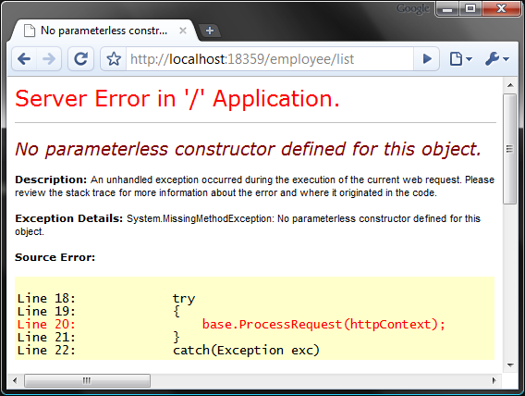
Figure 6.3 By default, controllers cannot be created without a no-arg constructor.
We need to assume control over building the controller to fix this. If we examine the stack trace closely, we can see which object is trying to build our controller class as shown in figure 6.4:
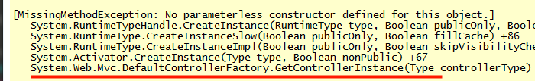
Figure 6.4 Examination of the stack trace shows us the culprit.
Reflector comes to the rescue here. Using Reflector, we can pry open the assembly and take a look at what DefaultControllerFactory is doing that causes the error as shown in figure 6.5.
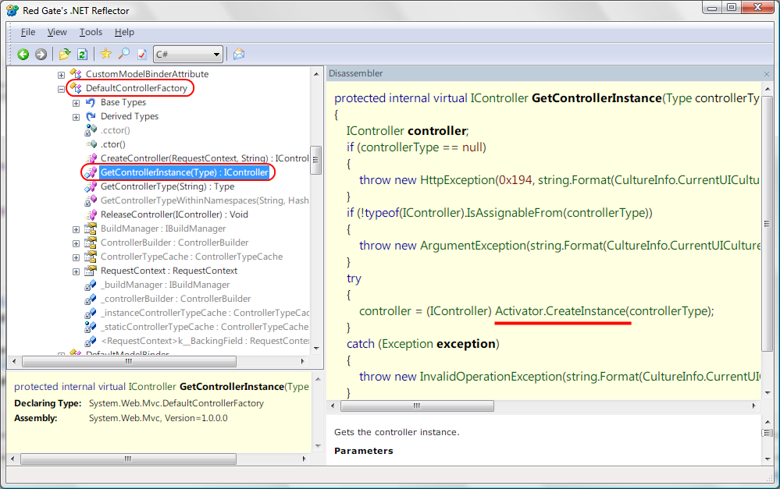
Figure 6.5 Digging into the framework using Reflector. Reflector is a free download at http://www.red-gate.com/reflector
Browsing the source code of the ASP.NET MVC Framework
Reflector can be a powerful tool, as you can see in Figure 6.5; however it won't retain original variable names or comments from the source code. Fortunately the ASP.NET team released the source code for this framework (under the MS-PL license), and you can download it to browse around and see how it is implemented. Often there are helpful comments that can give you insights and aid your learning of the framework.
It is unfortunate that we even need to see the source to understand how to extend the framework, but thankfully the source is available to us.
You can download the source code directly from http://asp.net/mvc. Alternatively, you can use the Microsoft Reference Symbol Servers to automatically step into and debug code built into the framework. That's right, you can actually debug .NET Framework code! In May 2009 the ASP.NET MVC source code was added to this reference. For more details, visit the Microsoft Reference Source Code Center at http://referencesource.microsoft.com/ .
As you can see in figure 6.5, Activator.CreateInstance is being used to create the controller. This requires a parameter-less constructor. If we could somehow tell the ControllerBuilder to let us create the controller, we could pass in the company object ourselves. Well, guess what? We can.
The ControllerBuilder is a singleton class that allows you to specify which IControllerFactory to use when instantiating controllers. To wire up your custom IControllerFactory, type the following code in the Application_Start event:

ControllerBuilder.Current.SetControllerFactory(
typeof(CompanyControllerFactory));

The CompanyControllerFactory is our custom class. Like most extension points in the ASP.NET MVC Framework, it is based on an interface as shown in listing 6.12.
Cueballs in code and text
Listing 6.12 A ControllerFactory to build CompanyController-based Controllers
public class CompanyControllerFactory : IControllerFactory
{
private readonly ICompanyService _companyService;

public CompanyControllerFactory() :
this(ServiceLocator.Resolve<ICompanyService>())
{
}

public CompanyControllerFactory(ICompanyService companyService) #1
{
_companyService = companyService;
}

public IController CreateController(RequestContext context,
Type controllerType)
{
if (controllerType.IsSubclassOf(typeof (CompanyControllerBase)))
{
string companyKey = |#2
context.HttpContext.Request.QueryString["company"]; |#2

Company company = _companyService.FindCompany(companyKey); #3

if (company == null) |#4
context.HttpContext.Response.Redirect("~/login"); |#4

return (IController) Activator.CreateInstance( |#5
controllerType, company); |#5
}

return (IController) Activator.CreateInstance(controllerType); #6
}

public IController CreateController(RequestContext context,
string controllerName)
{
string fullControllerName = "MvcApplication.Controllers."
+ controllerName + "Controller";
var controllerType = Type.GetType(fullControllerName, false, true);
return CreateController(context, controllerType);

}

public void ReleaseController(IController controller)
{
if(controller is IDisposable)
((IDisposable)controller).Dispose();
}
}

The CompanyControllerFactory utilizes the ICompanyService to retrieve the company based on the company key (3), which we can guarantee exists in the querystring (2). If the company key was valid and a company object was returned, we would pass this in the constructor to the controller in question (5) and we'd be done. If the specified company does not exist then the user will be redirected to the login page (4).
Obviously your LoginController must not inherit from CompanyControllerBase or you'll be in an infinite redirect loop. Any controller class that doesn’t inherit from the base class will be built assuming no constructor arguments (6).
You might have noticed that the ControllerFactory itself accepted an ICompanyService in its constructor (1). This is called IoC (or dependency injection), and it is a technique used often to decouple systems and make them more testable. IoC containers are tools that allow you to declare your dependencies, and request to resolve them at runtime. If you aren't familiar with IoC, read up on http://martinfowler.com/articles/injection.html. We'll utilize this technique in our next example.
NOTE
The CompanyControllerFactory has two constructors, one that accepts an instance of ICompanyService and one that does not. We can use the detailed constructor for testing, and the framework will use the default constructor. When you cannot control the creation of the class, but you still want to allow your dependencies to be injected, you can use the Service Locator pattern, as we have here. A .NET implementation of Service Locator is available at http://www.codeplex.com/CommonServiceLocator. It works in conjunction with a number of popular DI frameworks. You will learn more about dependency injection later in this chapter.
6.2.2 Leveraging IoC for your controllers
Earlier we added support for injecting a single custom object into the controllers to make our lives easier. That technique, although useful for this scenario, breaks down once you add a second type of object, then a third, and so on. If we leverage an IoC container, our controllers will be more flexibile.
Within a week of the first CTP of ASP.NET MVC, community members added support for "The Big 3" Inversion of Control containers: Spring.NET, Castle Windsor, and StructureMap. (They are called "The Big 3" because they were the three most widely used at the time). Since then, others such as Unity have been implemented. Let’s take a look at how a couple of these are implemented.
A Castle Windsor ControllerFactory
The Castle Project is a collection of useful frameworks and components used to build applications. Castle Windsor is just a small part of this project. You can configure Windsor to store the types of objects you want to build either in an XML configuration file or in a code file. I prefer to configure it with code, because it is far less verbose, and you get the added benefit of IntelliSense.
To add Windsor to your application, download the binaries from http://castleproject.org and reference these assemblies in your project:
- Castle.Core
- Castle.MicroKernel
- Castle.DynamicProxy2
- Castle.Windsor
For this example, let’s assume that we have a controller that lists sessions for a conference. Our SessionsController will take an implementation of IConferenceRepository to get the conference in question as shown in listing 6.13.
Listng 6.13 A controller that has a dependency listed in the constructor
public class SessionsController : Controller
{
private readonly IConferenceRepository _conferenceRepository;

public SessionsController( |#A
IConferenceRepository conferenceRepository) |#A
{
_conferenceRepository = conferenceRepository;
}

public ActionResult Index(string conferenceKey)
{
var conf = _conferenceRepository.GetConference(conferenceKey);
var sessions = conf.GetSessions();
return View(sessions);
}

}

#A Dependencies passed through constructor
NOTE
When we ask for dependencies in the constructor, we call it constructor injection. There is another technique called property injection but it is not as apparent that these components are required for the object to do its job. Windsor can do both, but constructor injection is recommended.
In Windsor, you store objects (or types) in a container. These can be requested later by type (or by interface) and Windsor will do the dirty work of arranging the dependency chain to build up a fully constructed object and hand it to you. So if your dependency has dependencies, and those have more dependencies, Windsor wires it all up for you. The first thing we need to do is register all the types we are going to use in the container. For starters, all of the controllers need to be added, because Windsor will be building them for us. Listing 6.14 shows this in detail.
Listing 6.14 Initializing Windsor
private void InitializeWindsor() #A
{
_container = new WindsorContainer();

_container.AddComponentLifeStyle<SessionsController>( |#B
LifestyleType.Transient); |#B

_container
.AddComponent<IConferenceRepository, ConferenceRepository>(); #C

}

#A Called by Application_Start
#B Ensure controllers are Transient.
#C Add other components

It can be tedious to manually add each controller, so you might consider using the Windsor registration extension methods in MvcContrib, or consider adding a snippet like this to automatically add all of your controllers:

var assemblyTypes = typeof(SessionsController).Assembly.GetTypes();
foreach(var controllerType in
assemblyTypes.Where(t=>typeof(IController).IsAssignableFrom(t)))
{
container.AddComponentLifeStyle(controllerType.Name.ToLower(),
controllerType, LifestyleType.Transient);
}

Now that Windsor is wired up, we need to create a simple controller factory that will use Windsor to build our controllers as shown in listing 6.15.
Listing 6.15 A simplified controller factory for Windsor
using System;
using System.Web;
using System.Web.Mvc;
using System.Web.Routing;
using Castle.MicroKernel;
using Castle.Windsor;

public class MyWindsorControllerFactory : IControllerFactory
{
private readonly IWindsorContainer _container;

public MyWindsorControllerFactory(IWindsorContainer container)
{
_container = container;
}

public IController CreateController(RequestContext requestContext,
string controllerName)
{
try
{
controllerName = controllerName.ToLower() + "controller"; #1
var controller =
_container.Resolve<IController>(controllerName); #2
return controller;
}
catch (ComponentNotFoundException)
{
throw new HttpException( |#3
404, "The controller was not found"); |#3
}
}

public void ReleaseController(IController controller) #4
{
_container.Release(controller);
}
}

The class implements the IControllerFactory interface, which requires two methods: CreateController and ReleaseController. Each of these is trivial; we simply ask the container to resolve our type (2). The name needs to be lower case and suffixed with “controller” (1) in order for the key to match what we entered in listing 6.13. If the component is not found in the container, an exception will be thrown. We don’t want our users seeing a nasty exception if they type in a bad URL. In this instance, a 404 (Not Found) error code should be thrown back to the browser (3). Finally, the ReleaseController method (4) asks Windsor to dispose of the controller.
Now that we have a controller factory, how do we tell the framework to use it? Place the following code at the bottom of the InitializeWindsor method:

ControllerBuilder.Current.SetControllerFactory(new MyWindsorControllerFactory(_container));

From this point on, all our controllers will be built using our new controller factory. This example works, but a more full-featured version is available in MvcContrib along with a handful of others. One of these is the StructureMapControllerFactory, which we will examine next.
A StructureMap Controller Factory
For this example we will simply leverage the existing work within MvcContrib. You can find the latest releases at http://mvccontrib.org. Better yet, download the source and build it yourself. Reading the source is an excellent learning tool. Assuming you now have the MvcContrib binaries, copy the following files into your project:
- StructureMap.dll
- MvcContrib.dll
- MvcContrib.StructureMap.dll
In StructureMap, you don’t have to add the controllers to the container. You can simply request the object, and its dependencies will be fulfilled. Registering other dependencies is as easy as this:

StructureMapConfiguration.ForRequestedType<IConferenceRepository>()
.TheDefaultIsConcreteType<ConferenceRepository>();

Next is setting the controller factory to the StructureMapControllerFactory, which by now should be obvious:

ControllerBuilder.Current.SetControllerFactory(
new StructureMapControllerFactory());

That’s all there is to it. We can now access the controller from listing 6.12, and the dependency will be satisfied by StructureMap. I have barely scratched the surface on what Windsor and StructureMap can do, but we can easily see how they satisfy controller dependencies.
Now that you’ve seen two complete IoC controller factories, others are straightforward. Any IoC controller factory will be so similar that you won’t even notice which one you’re using. Just declare your dependencies as constructor arguments and everything works. The only thing that changes is the configuration to register the dependencies and the code to manage the container. Understanding and leveraging an IoC container is a great way to decouple your applications and embrace testability.
We've taken a look at how to customize the creation of controllers. Next, we’ll see how to gain additional behavior by extending the Controller class, given to us by the framework.
6.3 Extending the controller
Creating a replacement implementation for Controller is straightforward. The only requirement is that you implement the IController interface, which has one required method: Execute. This gives the implementer ultimate control when deciding how a controller should behave. Microsoft ships with a functional default implementation, but if you need something drastically different, you can roll your own.
You’ll rarely have to start from scratch and implement IController directly. A lot of work is required to translate a single Execute method into something useful. If you don’t care for the way actions are invoked, or perhaps don’t like the ActionResult way of returning objects, you might roll your own IController implementation. For more basic modifications you can simply inherit from Controller and override the desired method to add or alter behavior.
The Controller class, which derives from ControllerBase, provides these virtual methods that you can override and handle in inherited classes:
- ExecuteCore—the entry point. Everything starts here.
- HandleUnknownAction—called when action cannot be found.
- OnAuthorization—occurs when an authorization filter runs.
- OnActionExecuting—occurs before an action is executed.
- OnActionExecuted—occurs after an action is executed.
- OnResultExecuting—occurs before an ActionResult is executed.
- OnResultExecuted—occurs after an ActionResult is executed.
- OnException—occurs if an action throws an exception.
In addition, you can override and alter the built-in ActionResult helper methods, namely:
- Content—returns a ContentResult with the literal content passed in
- File—returns a FileResult with appropriate response headers
- JavaScript—returns a JavaScriptResult that contains JavaScript to be executed on the client
- Json—returns a JsonResult with a JSON serialized object
- PartialView—returns a PartialViewResult that renders a partial
- Redirect—returns a RedirectResult with the given URL
- RedirectToAction—returns a RedirectToRouteResult that redirects to the given action
- RedirectToRoute—returns a RedirectToRouteResult that redirects to the given route
- View—returns a ViewResult object corresponding to the view
These extension points allow you to intercept and alter behavior at many levels, at each step in the controller pipeline. Next is an example that will show this in action.
6.3.1 Creating a FormattableController
Ruby on Rails has a feature that allows actions to be rendered in a variety of formats. A request for /products would render an HTML page to be displayed by the browser. A similar request of /products.xml would call the same action; however the result would be formatted as an XML document. JSON could also be requested with /products.json. This allows you to easily reuse actions for use in AJAX requests, or allows your customers to use your URLs as an API for your application. We are going to walk through creating a controller called FormattableController with this feature.
NOTE
When the formattable controller feature was first introduced in Ruby on Rails, it was designed to help advance the RESTful nature of that framework. (We learned a little bit about REST in chapter 5.) This technique can help support a RESTful architecture by providing different representations for our models.
We added the formattable feature to ASP.NET MVC by subclassing Controller. Let’s take AttendeesController, from Code Camp Server as an example. We want the Index action to render an HTML document, an XML document, or a JSON object with the attendee data that is passed to the view.
We’ll start with the basic action. This returns predefined data; however the real application would probably get items from the database as shown in listing 6.16.
Listing 6.16 A simple action that returns Attendees to the view
public ActionResult Index()
{
var attendees = new[] {
new Attendee { Name="Fred Flinstone",
City = "Bedrock", Comments = "yabba dabba doo",
Registered = DateTime.Parse("Mar 03 1942")},
new Attendee { Name="Charlie Chaplin",
City="Manhattan", Comments=".....",
Registered=DateTime.Parse("Jul 18 1918")},
new Attendee { Name="John Smith",
City="Tulsa, OK", Comments="howdy",
Registered=DateTime.Parse("Apr 7 1999")}
};

return View(attendees);
}
This action renders a simple list of attendees, as you can see in figure 6.6. The result contains an entire HTML document, with the content portion formatted as a table according to our view template.

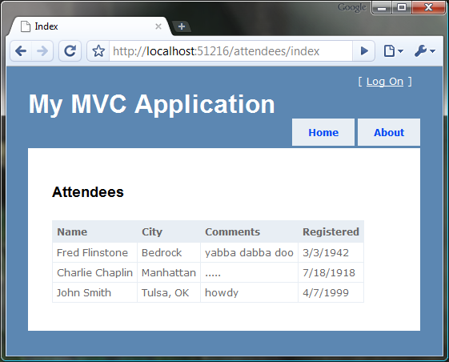
Figure 6.6 Our action renders a simple HTML table with the attendee listing.
What if we wanted to allow a separate application to retrieve the current list of attendees from our site? It would be easier for that application to consume XML or JSON instead of screen-scraping the HTML for the needed data.
Let’s create a new route that understands formats:

//global.asax
routes.MapRoute("Format", "{controller}/{action}.{format}/{id}",
new {id = ""});

This route will match /attendees/index.xml. When this happens, we will have a route value called format that we can use in the controllers. Armed with this, we can create a base class that can handle the various formats that we allow. Listing 6.17 shows our new base controller in detail.

Listing 6.17 A base controller that understands formats
public abstract class FormattableController : Controller
{
private static readonly string[] ValidFormats =
new[] {"xml", "html", "json"};
protected string Format { get; set; }

protected override void OnActionExecuting( |#1
ActionExecutingContext filterContext) |#1
{
base.OnActionExecuting(filterContext);

var routeValues = filterContext.RouteData.Values;
var formatKey = "format";
if(routeValues.ContainsKey(formatKey))
{
string requestedFormat =
routeValues[formatKey].ToString().ToLower();
if (Array.Exists(ValidFormats, x => x == requestedFormat)) #2
{
Format = requestedFormat;
return;
}
}

Format = "html";
}
}

In this class we override the OnActionExecuting method (1) to intercept the call and check to see if we have a format specified in the route values. We also ensure that the format matches one of the formats that we intend to handle (2). The FormatResult method (listing 6.18) will be called from the actions instead of the other ActionResult methods.
Listing 6.18 The FormatResult method returns the correct ActionResult
protected ActionResult FormatResult(object viewModel)
{
switch(Format)
{
case "html" : return View(viewModel);
case "xml": return new XmlResult(viewModel); #1
case "json": return Json(viewModel); #2
default:
throw new FormatException(
string.Format("Cannot handle the requested format '{0}'",
Format));
}
}

For each supported type, we simply return the correct ActionResult derivative that handles the type. The XmlResult class comes from MvcContrib (1), which serializes the object into XML. The Json method returns a JsonResult (2) and automatically serializes the object into JSON format. If there were other formats, we could add them to this class and return the appropriate ActionResult instance.
Now we can inherit the AttendeesController from FormattableController and change the return call from listing 6.16 to utilize the new FormatResult method. Listing 6.19 demonstrates these changes (in bold).

Listing 6.19 Changing the base class using the new FormattableController
public class AttendeesController : FormattableController
{
public ActionResult Index()
{
var attendees = new[] {
new Attendee { Name="Fred Flinstone",
City = "Bedrock", Comments = "yabba dabba doo",
Registered = DateTime.Parse("Mar 03 1942")},
new Attendee { Name="Charlie Chaplin",
City="Manhattan", Comments=".....",
Registered=DateTime.Parse("Jul 18 1918")},
new Attendee { Name="John Smith",
City="Tulsa, OK", Comments="howdy",
Registered=DateTime.Parse("Apr 7 1999")}
};

return FormatResult(attendees);
}
}

We can try the same URL again to make sure the HTML result still renders (and it does). We can also try /attendees/index.xml (figure 6.7) and /attendees/index.json (figure 6.8) to verify the new formats work!
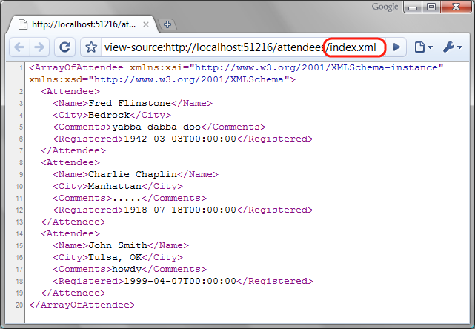
Figure 6.7 Requesting with an .xml extension gives us an XML document with the data
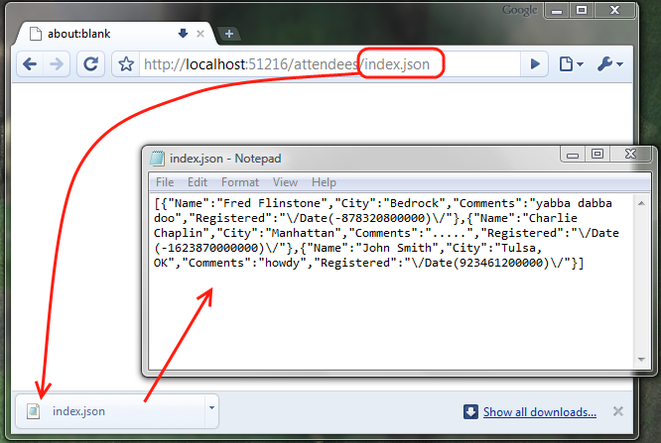
Figure 6.8 Requesting with a .json extension yields a JSON object.
What is JSON?
JSON is a format that is easily consumed via JavaScript. If you are not familiar with the JSON format, refer to chapter 9 for details.
Our simple example demonstrated some of the extension points available to controllers. Next up, we will see how to apply functionality to a single action across many controllers. These are called action filters
6.3.2 Working with action filters
Action filters are typically attributes that you can decorate on an action (or controller) that execute before the action is called. Because action filters are backed by interfaces, you can implement them as simple classes as well. Just as we wrote code to capture the format for a request, we can write action filters that handle the events thrown by the controller. Examples of built-in action filters are:
- [Authorize]—Allows you to secure an action to a set of roles/users
- [HandleError]—Captures exceptions thrown and allows you to display friendly error pages
- [OutputCache]—Caches the output of the action for future requests
- [AcceptVerbs]–Limits the HTTP verbs that are allowed to call the action
Creating your own action filters is easy. You simply inherit from ActionFilterAttribute and override the methods provided.
Let’s create a simple action filter. In a login page, you usually want to utilize SSL to protect the user’s credentials from being sent in plain-text across a network. Often sites will require certain URLs to be accessed with SSL. We can accomplish this with a simple action filter that redirects to the SSL URL. You can set the Result property on the ActionExecutingContext or use the HttpContext directly. Listing 6.20 has the action filter, while its usage is shown in listing 6.21.
Listing 6.20 A custom action filter to require SSL for an action
[AttributeUsage(AttributeTargets.Method | AttributeTargets.Class)]
public class RequireSSLAttribute : ActionFilterAttribute
{
public override void OnActionExecuting(
ActionExecutingContext filterContext)
{
var requestUri = filterContext.HttpContext.Request.Url;
if(requestUri.Scheme == "http")
{
string url = requestUri.ToString() |#A
.Replace("http://", "https://"); |#A

filterContext.HttpContext.Response.Redirect(url);
}
}
}

#A Ensure URL begins with https

Listing 6.21 Using the RequireSSL action filter
[RequireSSL]
public class LoginController : Controller
{
public ActionResult Index()
{
return View();
}
}

The action filter is placed on the class element when you want all actions in the controller to have the attribute. To be selective, place the action filter on the methods in question. Now, a request for /login will result in an HTTP 302 redirect to the equivalent https:// URL. The HTTP headers for this example are shown in figure 6.9.
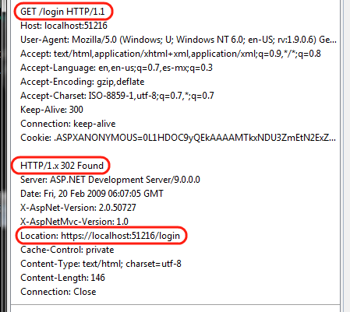
Figure 6.9 Requesting /login from http:// with a RequireSSL action filter yields a redirect to https://
Action filters provide an easy way to share common functionality across controllers without bloating a controller base class with unrelated functionality.
NOTE
The action filter classes are created by the ControllerActionInvoker calling the ReflectedActionDescriptor, which constructs the filter using a default (no-arg) constructor. To inject dependencies in your action filters, you have a couple of options. You can use the Service Locator pattern, as we saw earlier, or you can write your own IActionInvoker (or derive from ControllerActionInvoker) that understands how to request the filters from the container. With Windsor (or other IoC frameworks) you register an implementation for IActionInvoker in the container and it will be set (via property injection) on all controller instances. For most people, using a service locator will be a quicker solution.
Now that we have seen how to extend controllers, we can examine how to customize the way views are rendered portion of MVC.
6.4 Creating a custom view engine
Most of the samples in this section use the default, WebFormViewEngine. Indeed it is usually a smart choice for benefits it provides:
- Familiar experience
- Strongly typed
- IntelliSense
- Compiled form
Why would you want anything else? At times the strong typing and code block syntax can get in your way. Visual Studio statement completion and autocode formatting tends to make code blocks inside views look awkward. In C# we prefer curly braces on their own line. In a view, it is easier to read if the open curly brace is on the same line. In Visual Studio 2008 you cannot have two separate rules for code formatting. What you choose for your code will also affect your views.
In addition, the WebFormViewEngine templates contain excessive line noise to accomplish something simple (we'll see a great example in a bit). Often views can be expressed much more concisely with a template syntax like NVelocity. Those who have used the Castle MonoRail framework might also prefer Brail as a template language. Both of these exist (along with others) in MvcContrib.
NVelocity
NVelocity is a port of the Apache Velocity project. You can read more about NVelocity at http://nvelocity.sourceforge.net.
Brail
Brail is a template language that uses Boo, which is a dynamic CLS-compliant language for .NET. Read more about Brail at the MonoRail website here: http://www.castleproject.org/MonoRail/documentation/trunk/viewengines/brail/index.html.
Details about Boo are located at http://boo.codehaus.org.
Consider the code in listing 6.22.

Listing 6.22 A WebFormViewEngine user control for display login info
<%@ Control Language="C#" Inherits="System.Web.Mvc.ViewUserControl" %>
<%
if (Request.IsAuthenticated) {
%>
Welcome <b><%= Html.Encode(Page.User.Identity.Name) %></b>!
[ <%= Html.ActionLink("Log Off", "LogOff", "Account") %> ]
<%
}
else
{
%>
[ <%= Html.ActionLink("Log On", "LogOn", "Account") %> ]
<%
}
%>

This is taken from the default project template LoginUserControl.ascx, which is located in the Shared folder. There is lots of “gunk” here (to appease the compiler) that takes away from the actual content being displayed. Now look at the same thing, implemented with NVelocity (listing 6.23)

Listing 6.23 Showing the same login status with NVelocity syntax
#if($isAuthenticated)
Welcome <b>$html.encode($httpcontext.user.identity.name)</b>!
[ $html.actionlink("Log Off", "LogOff", "Account") ]
#else
[ $html.actionlink("Log On", "LogOn", "Account") ]
#end

This is much easier to write and read, but NVelocity has drawbacks. One drawback is the limited number of helper methods available on the view. Most helper methods are extension methods on HtmlHelper, so they don’t come automatically. MvcContrib contains a facility for adding new HtmlHelper extension types to get around this limitation. In addition, NVelocity does not automatically have Visual Studio integration for IntelliSense, compile-time checking of views, or refactoring. If these drawbacks are too significant to ignore, you can revert to the WebFormViewEngine. If you like easy to write/read, concise view code then read on. We’ll discover how to write a trivial (and quite naïve) view engine.
There are two main components of a view engine. The IViewEngine implementation finds and builds an appropriate IView implementation. The latter usually does the heavy lifting. Our SimpleViewEngine will simply find the template on disk (the template could be from anywhere) and construct a SimpleView to return. The SimpleView will interpret the template, along with ViewData and emit the result to the response stream as shown in listing 6.24.
Listing 6.24 A simple IViewEngine implementation
public class SimpleViewEngine : IViewEngine
{
public ViewEngineResult FindPartialView(
ControllerContext controllerContext, string partialViewName,
bool useCache)
{
return FindView(controllerContext, partialViewName); #A
}

public ViewEngineResult FindView(ControllerContext controllerContext,
string viewName, string masterName, bool useCache)
{
return FindView(controllerContext, viewName);
}

private ViewEngineResult FindView(ControllerContext controllerContext,
string partialViewName)
{
var controllerName = controllerContext.Controller.GetType().Name
.Replace("Controller", "");
var server = controllerContext.HttpContext.Server;
var extension = "st";

string pathPattern = string.Format("~/Views/{{0}}/{0}.{1}", |#B
partialViewName, extension); |#B
var paths = new[] { |#B
string.Format(pathPattern, controllerName), |#B
string.Format(pathPattern, "Shared") |#B
}; |#B

foreach(var path in paths)
{
if(File.Exists(server.MapPath(path)))
return new ViewEngineResult( |#C
new SimpleView(server.MapPath(path)), this); |#C
}

return new ViewEngineResult(paths); #D
}

public void ReleaseView(ControllerContext controllerContext,
IView view)
{
if(view is IDisposable)
((IDisposable)view).Dispose();
}
}

#A Same logic for partial views
#B Construct view locations
#C Build SimpleView and return
#D Report where we looked

The responsibility of the view engine is to locate the view (we chose to look on disk) and construct an appropriate view instance for return. The view we created is shown in listing 6.25.
Listing 6.25 A simple view
public class SimpleView : IView
{
private readonly string _file;

public SimpleView(string file)
{
_file = file;
}

public void Render(ViewContext viewContext, TextWriter writer)
{
Regex propertyPattern = new Regex(@"\$\[(?<property>[^\]]+)\]"); #A
string fileContents = File.ReadAllText(_file);
foreach(Match match in propertyPattern.Matches(fileContents))
{
var property = match.Groups["property"].Value;
var value = viewContext.ViewData[property].ToString();
fileContents = fileContents.Replace(match.Value, value);
}

writer.Write(fileContents);
}
}

A. Matches $[variable] format

We configure our view engine in the Application_Start event like this:

ViewEngines.Engines.Add(new SimpleViewEngine());

NOTE
Notice that Engines is a collection, so you can have multiple view engines in the same application. The collection has order, so the first view engine to find a matching view will be rendered.
Our naïve view simply finds properties in the template with the format $[propertyName]. Each of these is matched with an element in ViewData and replaced on the view. Finally the result is written to the TextWriter. This view engine is not very usable, because we don’t have any conditional branching, loops, child templates, or support for complex types, It does show the basic steps required for any custom view engine implementation. A sample view is shown in listing 6.26, and the rendered output is displayed in figure 6.10.
Listing 6.26 A simple template (index.st)
<html>
<head>
</head>
<body>
<h1>Awesome view!</h1>
<p>$[Message]</p>
<p>This was rendered at $[Time]</p>
</body>
</html>

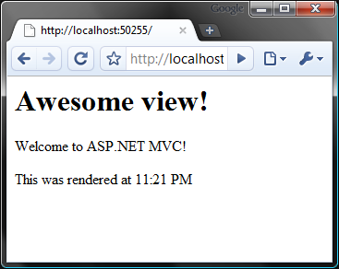
Figure 6.10 A rendered template based on the simple view engine
One other aspect of our example is flawed—the way we are sending the content to the TextWriter. We do it all in one chunk. To take advantage of buffering it is important to render the content as you process it. This adds significant complexity to the rendering logic. For the sake of brevity we have shown a simplified version here.
Having flexibility to choose different view engines is a wonderful property of the ASP.NET MVC Framework. Leveraging a view engine that fits your development style and leads to less friction will help you be more productive as a developer. One major area of ASP.NET MVC customization remains: customizing some of the Visual Studio tooling around the framework.
6.5 Customizing Visual Studio for ASP.NET MVC
As you saw earlier, specific tooling within Visual Studio makes building ASP.NET MVC applications faster. We will look at two quick ways of customizing these tools.
6.5.1 Creating custom T4 templates
If you right click on an action, you’ll see an option to open the Add View dialog, shown in figure 6.11. In this dialog, you can choose the name of the view, the view model type, and the master page. If you select a strongly typed view, you have the option of choosing an automatic view template. The options are Empty, List, Create, Details, Delete. Figure 6.11 shows us selecting Create for our view content and Conference for our view model.
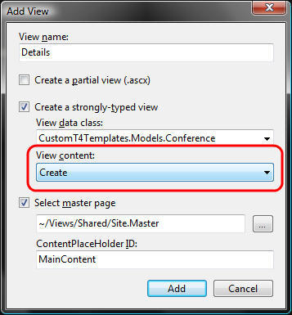
Figure 6.11 The Add View dialog allows you to autogenerate scaffolding for your model.
The options in the View Content dropdown list are T4 templates that are located in
C:\Program Files\Microsoft Visual Studio 9.0\Common7\IDE\ItemTemplates\
CSharp\Web\MVC\CodeTemplates\AddView
NOTE
T4 templates are a little-known feature of Visual Studio. They are code generation template processors built into Visual Studio. T4 templates allow you to customize how files are generated using a familiar syntax.
If we press Add, we’re given a complete form, generated for us by Visual Studio using the default template. Our view now looks like listing 6.27
Listing 6.27 The autogenerated Create view based on the Conference object
<h2>Details</h2>

<%= Html.ValidationSummary("Create was unsuccessful. Please correct the errors and try again.") %>

<% using (Html.BeginForm()) {%>

<fieldset>
<legend>Fields</legend>
<p>
<label for="Name">Name:</label>
<%= Html.TextBox("Name") %>
<%= Html.ValidationMessage("Name", "*") %>
</p>
<p>
<label for="Description">Description:</label>
<%= Html.TextBox("Description") %>
<%= Html.ValidationMessage("Description", "*") %>
</p>
<p>
<label for="StartDate">StartDate:</label>
<%= Html.TextBox("StartDate") %>
<%= Html.ValidationMessage("StartDate", "*") %>
</p>
<p>
<label for="EndDate">EndDate:</label>
<%= Html.TextBox("EndDate") %>
<%= Html.ValidationMessage("EndDate", "*") %>
</p>
<p>
<input type="submit" value="Create" />
</p>
</fieldset>

<% } %>

<div>
<%=Html.ActionLink("Back to List", "Index") %>
</div>

As you can see, lots of code is generated for us. It contains a basic form, with fields corresponding to the object, complete with validation, Submit button, and back link. This can get us started building the application quickly. Of course this is just a starting point, and you’re free to customize it from here. This template is static, and you can create a different, application-specific template for the Create view.
Add a folder in your project called CodeTemplates. Into this folder, copy the contents of the default template folder. You can create subfolders corresponding to the different types of templates (figure 6.12).
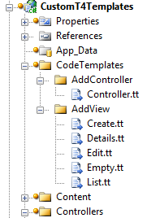
Figure 6.12 Copy the templates from C:\Program Files\Microsoft Visual Studio 9.0\Common7\IDE\Templates\CSharp\Web\MVC into your project under a CodeTemplates folder to customize them.
These templates will be effective for the current project only. You are free to alter the templates here for your project. You can also add more items to this list. Adding another .tt file in this folder will enable it for selection in the Add View dialog as show in figure 6.13.
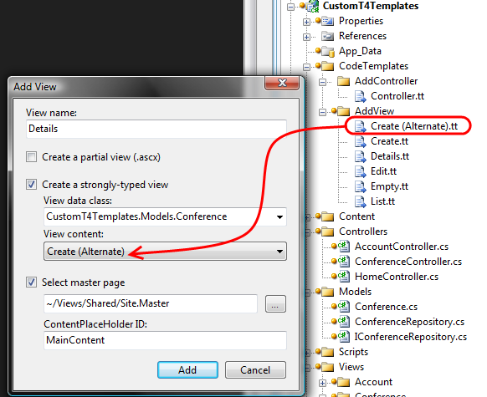
Figure 6.13 Adding new template files in the Add View folder enables them for selection in the Add View dialog.
The templates themselves are fairly complex. Here is an excerpt from the Controller.tt template:

<#@ template language="C#" HostSpecific="True" #>
<#@ output extension="cs" #>
<#
MvcTextTemplateHost mvcHost = (MvcTextTemplateHost)(Host);
#>
using System;
using System.Collections.Generic;
using System.Linq;
using System.Web;
using System.Web.Mvc;
using System.Web.Mvc.Ajax;

namespace <#= mvcHost.NameSpace #>
{
public class <#= mvcHost.ItemName #> : Controller
{
//
// GET: /<#= mvcHost.ControllerRootName #>/

...... more ....

As you can see, code blocks are denoted by <# #> blocks. Each template has a Host property that contains basic context information. For MVC templates, this is actually of type MvcTextTemplateHost, so we can see here that the template is casting the Host property and storing it in a variable called mvcHost for use later in the template.
T4 templates can be a little intimidating but you can do a lot of things with them. If you are interested in customizing the templates, download Visual T4 Editor for Visual Studio 2008 Community Edition (free) from Clarius Consulting. This will give you syntax highlighting, which is really helpful when you find yourself writing code that writes code! The tool can be downloaded at http://www.visualt4.com/downloads.html. To learn more about T4 Template syntax and the ASP.NET MVC integration, check out http://blogs.msdn.com/webdevtools/archive/2009/01/29/t4-templates-a-quick-start-guide-for-asp-net-mvc-developers.aspx.
6.5.2 Adding a custom test project template to the new project wizard
When you first create an ASP.NET MVC project, you’re eventually greeted with the dialog shown in figure 6.14:
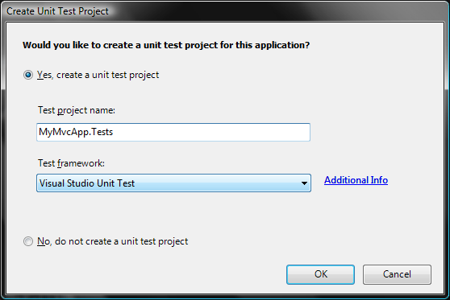
Figure 6.14 When you create a new project, you are asked if you want to create a unit test project.
Unfortunately, the only available test framework that is provided out of the box is the Visual Studio Unit Test framework. Developers who are experienced with testing will no doubt prefer NUnit, MbUnit, or xUnit.NET. There is hope! You can add your framework of choice to this dialog box (and simultaneously implement a custom project template).
The first step is to create a project that represents what you want when you create new ASP.NET MVC applications with the test project included. Make sure all third-party references (such as NUnit, Rhino Mocks) are set to Copy Local. Then go to File > Export Template. Follow the wizard here, which will result in a single zip file. Copy this zip file to:
C:\Program Files\Microsoft Visual Studio\9.0\Common7\IDE\ProjectTemplates\CSharp\Test.
(If you’re running on a 64-bit machine, then adjust the path to C:\Program Files (x86) accordingly). Now that you’ve got the template in the right place, close all instances of Visual Studio, open up the Visual Studio 2008 Command Prompt (as Administrator if UAC is enabled), and run:

devenv /installvstemplates

This will take a few seconds. Now that you have a project template installed into Visual Studio, open regedit and navigate to

HKEY_LOCAL_MACHINE\Software\Microsoft\VisualStudio\9.0\MVC\TestProjectTemplates

Here you’ll find the default Visual Studio Unit Test key. To create a custom entry, make a new key here, and add the following String values:
- Package–Leave blank unless you have a custom Visual Studio package GUID to register here.
- Path–Usually CSharp\Test.
- TestFrameworkName–The name that you want to appear in the Unit Test Framework dropdown.
- AdditionalInfo–A URL that provides the user more information about your framework or template. When the user clicks on Additional Info, the browser will navigate to this URL.
- Template–The name of the zip file that contains the template.
Figure 6.15 shows a new template installed in this location.
Note
On 64-bit machines–like the one we are using–the registry path is slightly different (…SOFTWARE\Wow6432Node\Microsoft…). In addition, the Program Files path is actually C:\Program Files (x86)\. Be sure to adjust accordingly for your system as shown in figure 6.15.
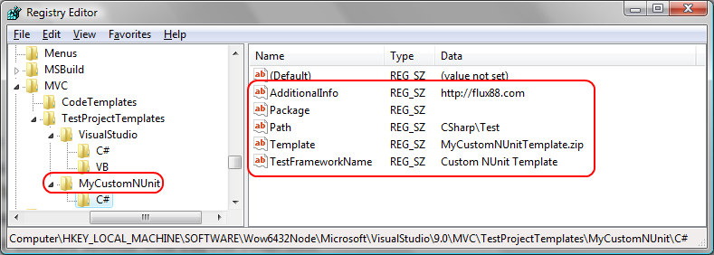
Figure 6.15 Adding a registry entry for a new custom test project template. Note that this registry path is for 64-bit machines.
With all of this in place, we can launch Visual Studio, create a new ASP.NET MVC Web Application project, and be greeted with this the message shown in figure 6.16.
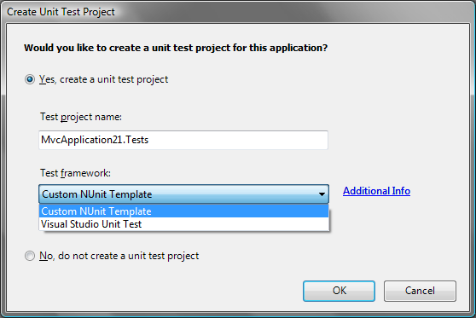
Figure 6.16 Our new test template is now available in the Create Unit Test Project dialog box.
6.6 Summary
In this chapter, you have seen some of the extension points in the ASP.NET MVC Framework. You learned how to create a custom IRouteHandler, to add behavior surrounding the life of MVC requests. You learned how to create custom base controllers to encapsulate and reuse functionality. You also learned how to leverage Dependency Injection and custom controller factories for building these controllers. To accommodate cross controller concerns, you learned how to use attributes to decorate actions with custom behaviors. We implemented a naïve view engine to demonstrate the moving parts, and also discovered how to customize Visual Studio to evolve with you as you adopt new styles for developing applications.
Hopefully you noticed how easy it was to extend the framework. Because most objects that you interact with are either interfaces or abstract base classes, the framework allows you to completely (or almost completely) substitute behavior for your own. At this level of flexibility the ASP.NET MVC Framework shines. Running parallel to the ASP.NET MVC project is the open source project called MvcContrib (http://mvccontrib.org). This is the playground for customizations and extensions that people find useful. Your authors recommend that you examine MvcContrib regularly for extensions that might be useful to you (and contribute back if they would be useful to others!).
The next chapter will use some of these extension points and cover tools and techniques for letting the framework scale in the face of complex web applications.

