7
Scaling the architecture for complex sites
This chapter covers:
- Taming large controller actions
- Leveraging view helpers
- Using partials
- Creating components
- Applying action filters
- Organizing controllers into areas
Most applications we write grow beyond their originally intended use. Often we see quick-and-dirty, low-quality demos graduate directly to production. These applications have to be maintained, and likely by you (or me). Complexity is inevitable, but we can follow good design principles to keep the application maintainable.
How can we ensure that we are creating maintainable solutions in the face of complexity? One key principle to follow is Single Responsibility Principle (SRP). This principle states that a piece of code should only have one reason to change. In this chapter we will visit some of the areas that often grow out of control in sites of any measurable size. The first is controller actions.
7.1 Taming large controller actions
We're all guilty of it. Given a place to put our code, we do just that: put code in a file. And it grows. And grows. Pretty soon we’re staring at single methods that span the entire viewable region. For starters, we should be able to read the entire action on a single screen. No, I don't mean wrap the offending code in a #region block and hide it. (Yes, your authors have seen this too). We need to identify the areas that belong in other classes and extract them.
An example will surely help. In the context of Code Camp Server, let's say you wanted to provide a facility for first time installers to set up their administrator account automatically. The workflow would be like figure 7.1.
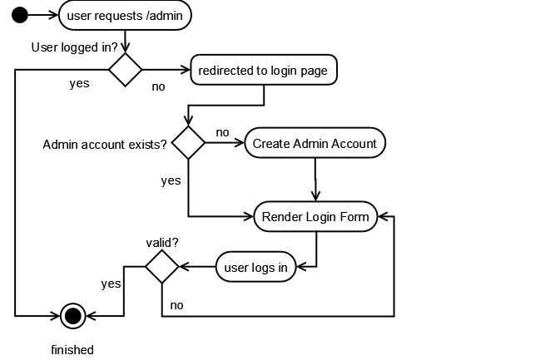
Figure 7.1 Workflow for creating the first administrator account
The first time a user installs Code Camp Server, no users will be present in the system. So when they request /admin and it redirects to /login, we can provide a better first-time install experience by allowing the user to create an admin account.
The login action checks to see if any users have been set up in the system. If not, then it prompts the user to create a new administrator account. When the user submits this form, it submits to the CreateAdminAccount action. Now of course we don't want random blokes to submit fake HTTP POSTS to this action, so we protect it by verifying that there are still no users in the system before proceeding.
With a general idea of what we want, we open up LoginController.cs and write the action shown in listing 7.1:
Cueballs in code and text
Listing 7.1 The CreateAdminAccount Action
public ActionResult CreateAdminAccount(string firstName, string lastName, string email, string password, string passwordConfirm)
{
if (GetNumberOfUsers() > 0) #1
{
throw new SecurityException(@"This action is only valid when
there are no registered users in the system.");
}

if (string.IsNullOrEmpty(email) |#2
|| string.IsNullOrEmpty(password)) |#2
{
TempData["error"] = "Email and Password are required.";
return RedirectToAction("index");
}

if (password != passwordConfirm) #3
{
TempData["error"] = "Passwords must match";
return RedirectToAction("index");
}

Person admin = new Person(firstName, lastName, ""); |#4
admin.PasswordSalt = _crypto.CreateSalt(); |#4
admin.Password = _crypto.HashPassword(password, |#4
admin.PasswordSalt); |#4
admin.IsAdministrator = true; |#4

_personRepository.Save(admin); |#4

return RedirectToAction("index");
}

That's a lot of code for one method. First it’s checking to verify that there are still no users in the system (1) (to prevent this action from being called once users have been defined). Then it’s validating the presence of the fields (2) and that the password and confirmation password match (3). Finally the admin account is created and saved to the database (4). In this code the authentication cookie is not being set, so it is assumed that the user would have to fill out the actual login form after this action was completed. (Please excuse our lack of attention to usability in this example).
How can we get this controller under control? (Sorry for the pun.) For starters we can identify that we have three calls to return RedirectToAction("index"). No matter what, the user will end up at the index view. We also have a section for validation, where we want to return an error message to the view. Finally, we have the section that creates and saves the Person object and marks the Person as an administrator.
If we were to extract most of this functionality into another class that has the distinct responsibility of creating an admin account, we could simplify this code. Verifying that the user count is still zero is not really a responsibility of this new create-an-admin class, and thus it should remain a part of the controller. The rest relates directly to creating an admin account, so we can extract this into a method on another class: CreateAdminAccountTask. The name of the class indicates its function exactly. The responsibility of any given class should be painfully obvious. If not, your class is probably either named inappropriately or is not fully decomposed into logical units. Listing 7.2 illustrates a refactoring to the code.
The Single Responsibility Principle
The guiding principle behind this refactoring is the SRP. Basically, SRP states that a class should have one and only one responsibility. Another way to look at it is that a class should only have one reason to change. If you find that a class has potential to be changed for nonrelated reasons, the class is probably doing too much. A common violation of SRP is mixing data access with business logic. For example, a Customer probably shouldn’t have a Save() method.
SRP is a core concept of good object-oriented design, and its application can help your code become more maintainable. SRP is sometimes referred to as Separation of Concerns (SoC). You can read more about SRP/SoC from Bob Martin’s excellent article on the subject:
http://www.objectmentor.com/resources/articles/srp.pdf
Listing 7.2 The updated CreateAdminAccount action
public class LoginController
{
/* snip */

ICreateAdminTask _createAdminTask; #A

/* snip */

public ActionResult CreateAdminAccount(string firstName,
string lastName, string email, string password,
string passwordConfirm)
{
if (GetNumberOfUsers() > 0)
{
throw new SecurityException(@"This action is only valid
when there are no registered users in the system.");
}

_createAdminTask.Execute(firstName, lastName, email, password,
passwordConfirm);

if (!_createAdminTask.Success)
{
TempData["error"] = _createAdminTask.ErrorMessage;
return RedirectToAction("index");
}

TempData["message"] =
"Your admin account was created successfully.";
return RedirectToAction("index", "home");
}
}

#A Injected via the constructor

Here we have introduced a new interface (defined in listing 7.3) which is responsible for creating the admin account. This interface encapsulates the validation and operation for our sequence of code. It provides a clear separation of responsibility and a mechanism for returning success/failure along with error messages. The implementation is left as an exercise for the reader.
Listing 7.3 The ICreateAdminTask interface
public interface ICreateAdminTask
{
void Execute(string firstName, string lastName, string email, string
password, string passwordConfirm);
string ErrorMessage { get; }
bool Success {get;}
}

We have cleaned up the controller and introduced a new, focused interface responsible for performing the task. Both controller and task class remain fully testable. It is important to keep your controllers small, and keep responsibilities clearly defined. This helps tame your controllers. When your controllers seem to be getting unwieldy, look for:
- Data access code that could be pushed into a repository.
- Model construction code that could be moved to a custom ModelBinder.
- Many repository calls that might be consolidated into a single application service.
- Complex or repetitive validation that could be done inside the domain entity (or a separate class, such as our ICreateAdminTask class in listing 7.3).
- Too many exit points. In listing 7.1 we noticed the duplication of the return RedirectToAction() calls. Removing duplication is good, but the removal also improved the readability of the code. Having too many exit points from any function is a design smell in general, and that clearly applies to controllers as well.
Now that you’ve seen how to tackle controller complexity, what about complex views? Surely views can be made more maintainable as well.
7.2 Whipping views into shape
When building HTML, your views can get complex. With view helpers, you can simplify your views and reduce duplication and complexity. For larger views, segmenting the view into partials can simplify the view, and provide more options for rendering with AJAX. Finally, Components can be created to completely encapsulate the data retrieval and rendering of a partial.
7.2.1 Using and creating view helpers
When you build your first link to an action with dynamic parameters, you'll notice the visual complexity of the code.

<a href='/sessions/view/<%= ViewData["id"] %>'>
<%= ViewData["name"] %>
</a>

Yuck. Mixing code blocks within strings is a sure way to give anyone a headache. This is both cumbersome to read and to write, so Microsoft gave us helper methods early on. Here is the same link, written using the Link Helpers:

<%= Html.ActionLink((string)ViewData["name"], "view", "sessions",
new { id = (int)ViewData["id"] }, null) %>

This is much easier to write, and has the added effect of adapting to changing routes, but it is still hard to tell exactly what each parameter means, so we prefer another format, using lambda expressions:

<%= Html.ActionLink<SessionsController>(c=>c.View((int)ViewData["id"]),
(string)ViewData["name"]) %>

This representation makes it a bit more obvious which controller and action are being used. Having type-safe lambda expressions also us with refactoring. Refactoring tools will detect lambda expressions and include them in refactoring changes. Don't underestimate the power of this.
ActionLink<T>
Microsoft decided against including the lambda expression syntax of ActionLink() in the framework. Microsoft did not feel comfortable supporting a method with known performance issues for high-volume sites. The technique has been refined over time and ought to be in ASP.NET MVC version 2. This helper method, and others, is available in the ASP.NET MVC Futures Assembly–Microsoft.Web.Mvc. This is available on CodePlex at http://codeplex.com/aspnet.
Microsoft ships a handful of view helpers for creating forms, HTML tags, and a few other things. There will be a number of opportunities for additional view helpers in your applications that are specific to your domain. If you were Amazon.com, you might create a helper method to create the product rating widget, like this:

<%= Html.ProductRatingWidget(product) %>

In Code Camp Server, let's say that we want to have speaker links formatted a specific way (where they link to the speaker profile and possibly have a mouse-over popup of a picture and bio).
To create the new view helper, we’ll create an extension method in a static class. The class’s namespace must be referenced using the <%@ Import Namespace=… %> directive at the top of the view or globally imported in the web.config file. Listing 7.4 shows a view helper for building speaker links. View helpers can extend HtmlHelper, UrlHelper, or others. In this example, we are extending ViewPage.
Listing 7.4 A view helper for building speaker links easily
public static class CodeCampServerHelpers
{
public static string SpeakerLink(this ViewPage page,
Speaker speaker)
{
string linkHtml = new HtmlHelper(page.ViewContext)
.ActionLink<SpeakerController>(
c => c.View(speaker.SpeakerKey), speaker.GetName());

return string.Format("<span class='speaker-link'>{0}</span>",
linkHtml);
}
}

This gives us a clean and easy way to represent links to speakers within any Code Camp Server view. It is used like this:

<%= this.SpeakerLink(speaker) %>

It may seem trivial, but the benefit is twofold: readability of your views, and the ability to change the visual representation in one place. The more concise view helper in this example has much less visual weight.
Another great example of a quick and easy view helper is generating script and CSS references. These aren’t hard to write by hand, but it’s nice to have the path calculated for you. Usage is simple, and listing 7.5 shows a full example:

<%= Html.Stylesheet("master.css") %>
<%= Html.ScriptInclude("jquery.js") %>

This will be rendered as:

<link type="text/css" rel="stylesheet" href="/content/css/site.css" />
<script type="text/javascript" src="/content/js/jquery.js"></script>
Listing 7.5 Implementations of CSS and Javascript view helpers
public static string Stylesheet(this HtmlHelper html, string cssFile)
{
string cssPath = cssFile.Contains("~") ? cssFile :
"~/content/css/" + cssFile;
string url = ResolveUrl(html, cssPath); /* defined below */
return string.Format(@"<link type=\"text/css\"
rel=\"stylesheet\" href=\"{0}\" />\n", url);
}

public static string ScriptInclude(this HtmlHelper html, string jsFile)
{
string jsPath = jsFile.Contains("~") ? jsFile :
"~/content/js/" + jsFile;
string url = ResolveUrl(html, jsPath); /* defined below */
return string.Format(@"<script type=\"text/javascript\"
src=\"{0}\" ></script>\n", url);
}

public static string ResolveUrl(this HtmlHelper html,
string relativeUrl)
{
if (relativeUrl == null)
return null;

if (! relativeUrl.StartsWith("~"))
return relativeUrl;

var basePath =
html.ViewContext.HttpContext.Request.ApplicationPath;
string url = basePath + relativeUrl.Substring(1);
return url.Replace("//", "/");
}

The Stylesheet() helper assumes that your CSS files are located in the /content/css directory, but you can specify a relative path such as ~/content/css/some/other/folder/style.css, and it will work as well. The ScriptInclude() helper does the same, but assumes your scripts are located in /content/js directory.
The possibilities for view helpers are endless. Most of the ones you will create will be specific to your application. Others will be applicable to many applications. When you are displaying date/time values, for instance, you might want them to be displayed relative to the current time. A label that says "Posted 2 days ago" rather than "Posted on 9/15/2009" is much friendlier to the user.
Rob Conery’s Law
When you have an “if” statement in the view, make a helper!
View helpers are good when the required markup is relatively limited. When the required HTML is more complex, view helpers generally become cumbersome and difficult to manage. To alleviate the pain of creating complex HTML within a C# code file, we can turn to using partials.
7.2.2 Creating partials
Often views have sections of relatively self-contained segments of HTML. You can tighten your views by separating these segments into partials. In the same way you break a large section of C# code into methods, you extract partials from a complex view to simplify it. With the WebFormViewEngine, these partials are called ViewUserControls, but ViewPage works just as well as a partial. Like view helpers, ViewUserControls help reduce the visual weight of a view. In addition, they help compartmentalize the output. This turns out to be a benefit in rendering partial HTML fragments during AJAX requests as well. We will see an example of this later in this section.
In Code Camp Server, there is a list of sponsors on the right side of every page. We can build a ViewUserControl to handle this segment of the page. ViewUserControls, by default, share ViewData with the parent view. You can pass in a specific value for the view user control’s strongly typed view data if you prefer. Listing 7.6 shows the sponsor list ViewUserControl.
Listing 7.6 A ViewUserControl for listing sponsors
<%@ Control Language="C#" Inherits="System.Web.Mvc.ViewUserControl" %>
<%@ Import Namespace="MvcContrib" %>

<ul class="sponsors">
<% foreach (var sponsorLevel in Enum.GetValues(typeof(SponsorLevel))) { %>
<li>
<h2><%= sponsorLevel %> Sponsors</h2>
<ul>
<% foreach (var sponsor in
ViewData.Get<IEnumerable<Sponsor>>(sponsorLevel.ToString())){ %>
<li><%= sponsor.Name %></li>
<% } %>
</ul>
</li>
<% } %>
</ul>
Sponsor levels are defined as:

public enum SponsorLevel
{
Platinum,
Gold,
Silver
}

The list loops over the three different levels of sponsors and outputs the sponsors in each one. Notice we are using an extension method on ViewDataDictionary from MvcContrib to provide us with friendly syntax for getting strongly typed objects out of the bag. See more examples of this in chapter 4.
Of course we need to load the data for this ViewUserControl in the controller; otherwise it won’t have any data to render! We have to ensure that the controller for this action preloads the sponsors whenever we want to render this user control. Such an action is shown in listing 7.7.
Listing 7.7 Preloading sponsors for the view component
public ActionResult Index()
{
Conference conference = GetConference();
Sponsor[] sponsors = GetSponsorsFor(conference);
ViewData.Add("conference", conference);

foreach (var level in Enum.GetNames(typeof(SponsorLevel)))
{
string sponsorLevel = level;
ViewData.Add(sponsorLevel, |#A
conference.Sponsors.Where( |#A
s => s.Level.ToString() == sponsorLevel)); |#A
}

return View();
}

#A Load the sponsors in ViewData

Our controller action loads up the data necessary to render the entire view. This includes any partials like our sponsor view user control. The Index.aspx view renders the partial:

<div class="sponsor-list">
<% Html.RenderPartial("_sponsors"); %>
</div>

The resulting page looks like figure 7.2.
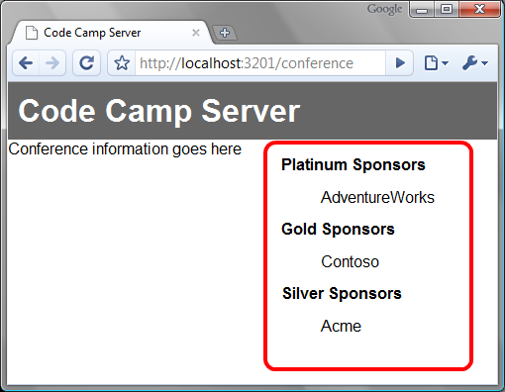
Figure 7.2 The sponsors are loaded into ViewData by the controller action; the partial displays it
In this example our user control shared view data with the main view. We could instead use a strongly typed ViewUserControl by passing the model directly into the RenderPartial method:

<%= Html.RenderPartial("_sponsors",
ViewData.Get<IEnumerable<Sponsor>>("Platinum")) %>

Using this technique the view user control will be constrained to the view data that you pass in to it (via the Model property). You also have to ensure that you declare the type of view data in the @Control directive, like so:

<%@ Control Language="C#"
Inherits="System.Web.Mvc.ViewUserControl<IEnumerable<Sponsor>>" %>

What’s with the underscore?
You may have noticed that we named the partial “_sponsors”. This name refers to the user control _sponsors.ascx. The underscore is a convention borrowed from Rails that allows you to quickly differentiate between full HTML views and partial ones. Also, because our partial templates have a different extension than normal views, view names can collide (i.e., sponsors.aspx vs. sponsors.ascx). Adopting the underscore convention addresses this problem, but otherwise has no semantic meaning in ASP.NET MVC.
You can probably imagine that if you have many partials and each needs its own specific view data, your controller actions can be encumbered by the loading of seemingly unrelated data. You'd be right. Imagine if every action for every controller in our application needed to load these sponsors and other data. This becomes serious duplication that we should notice right away. It also adds to the noise of the action method, clouding the responsibility. Figure 7.3 shows a 10-foot glance at a controller action whose meaning is being lost in surrounding noise.

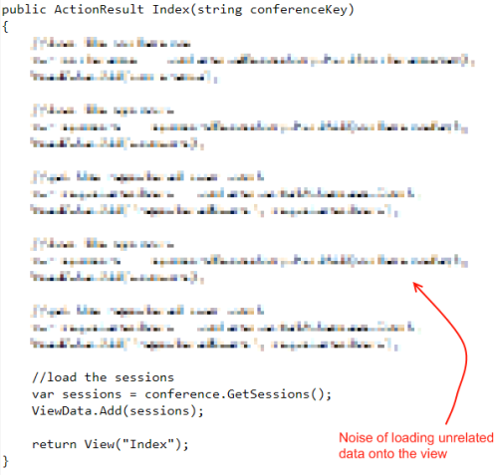
Figure 7.3 The purpose of the action is lost when loading all the required data for a view.
You’ll probably notice that this data needs to be loaded into view data for every action on this controller. We certainly shouldn’t copy and paste this code in each place, but even different, but similar-looking method calls can get repetitive. If the code truly runs for every action of the controller, we can move this common code to the OnActionExecuting event that we learned about in the last chapter. Listing 7.8 demonstrates this.
Listing 7.8 Handling common functionality for all actions of a controller
public void ConferenceController : Controller
{
/* snip */

protected override OnActionExecuting(
ActionExecutingContext context)
{
Conference conference = GetConference();
Sponsors[] sponsors = GetSponsorsFor(conference);
ViewData.Add(sponsors);
}
}

Now ViewData will contain the sponsors for the current conference for every action on this controller. You can also accomplish this in a base controller class, in order to have this code executed for every controller that inherits from it.
Another direction you might take is to allow the partial to be in control of loading its own data. This is helpful for scenarios when you want to package up a reusable view segment that can be used on many views. It is accomplished through a helper method called RenderAction in combination with partial views. These are sometimes referred to as components.
7.2.3 Creating components
Components are the result of packaging up a controller, an action, and a view segment all in one piece. It turns out components are supported by ASP.NET MVC by using an extension method on HtmlHelper called RenderAction. It takes as parameters the controller and action that you want to render. You can render any action on any controller, but you’ll probably want to use this in conjunction with an action that renders a partial view. In other words, the rendered view should be a user control, not a full page.
Note:
Html.RenderAction is located in the MVC Futures assembly, Microsoft.Web.Mvc.
With this approach, the controller will simulate another full request (this time with different route data), almost as if it was requested directly through a browser. The component will have its own entire request pipeline, load its own data, and pass it on to its own view. Since it is completely usable outside the containing view, these are easily packaged up and reused among many views. Listing 7.9 demonstrates rendering a partial view.
Set foreach (var level in AND string sponsorLevel = level; lines in red. Author says indent is wrong but he is unable to change in Word doc.
Listing 7.9 An action rendering a partial view for sponsors
public class SponsorsController : Controller
{
/* snip */

public ActionResult ListPartial(string conferenceKey)
{
var conference =
_conferenceRepository.GetConference(conferenceKey);
foreach (var level in
Enum.GetNames(typeof(SponsorLevel))) {
string sponsorLevel = level;
ViewData.Add(sponsorLevel,
conference.Sponsors.Where(
s => s.Level.ToString() == sponsorLevel));
}

return View("_sponsors");
}
}

In this action we get all of the sponsors for the conference, add them to ViewData, then render our partial. We named it ListPartial to be clear that this action renders a partial view. Note that we are using the same partial view that was outlined in listing 7.5. This partial view will now get rendered and inserted inside the parent view:

<% Html.RenderAction<SponsorsController>(x=>x.ListPartial(conferenceKey)); %>

If you aren't familiar with lambda expressions then take a couple of minutes to soak it in. Basically we are telling the method that we want it to call the ListPartial() action on the SponsorsController class. This is like passing a delegate to the method, but much cleaner to read (and write). We're also getting the current conference from the main view's ViewData, which is needed to execute the Index() action.
Lambda expressions aid in refactoring
Don’t underestimate the value of lambda expressions in your views. These are compiled along with the rest of your code, so if you rename an action, for example, this code will break at compile time. Contrast this with code in your ASPX that references classes and methods with strings. You won’t find those errors until runtime. Having strongly typed view data references also aids in refactoring. Using a tool like JetBrains ReSharper (http://www.jetbrains.com/resharper) will allow you to refactor code and have it reach out to all of the views that use it as well. Very powerful, indeed.
Partial actions can help you segment the loading and displaying of disparate data required to render a complete page. One caveat is that to have all this magic happen this technique simulates another web request from the beginning of the lifecycle. If you have deeply nested components you might notice performance hits. For this reason we suggest you avoid it. Make your controllers more focused and easier to develop and maintain.
This sounds like Rails Components
This method of repurposing the request with different route values was included in early version of Ruby on Rails called Components. In a subsequent version, Components were removed from the Rails Core. You could opt-in and continue to use them as a separate gem/plugin; however the Rails team didn’t condone their use. Why? Some would argue performance, but the main reason is that it turns the MVC pattern on its head. Instead of your controllers being in control, you’re relinquishing some of that control to the view. It’s good to learn from other communities and notice how a pattern can be abused. In ASP.NET MVC, RenderAction can definitely be abused, but can also be an elegant solution for complex views.
In listing 7.9, we showed an action that was specifically crafted for our partial use. Sometimes it is useful to reuse actions that already load the data we need. If we change the method signature we might be able to accommodate both. Listing 7.10 shows an action that serves both partial and full requests.
Cueball in code and text
Listing 7.10 A controller action that services partial views as well as full views
public ActionResult List(string conferenceKey, bool? partial) #1
{
var conference = _conferenceRepository.GetConference(conferenceKey);

foreach (var level in Enum.GetNames(typeof(SponsorLevel)))
{
string sponsorLevel = level;
ViewData.Add(sponsorLevel, conference.Sponsors.Where(
s => s.Level.ToString() == sponsorLevel));
}

string viewName = "list";
if (partial == true)
viewName = "_sponsors";

return View(viewName);
}

Here we declared an action parameter for an optional boolean parameter, partial (1). Because this parameter is nullable, existing calls to this action work (unless you use the lambda helpers, in which case you need to pass nulls in). If partial is true, then it renders a partial view; otherwise it renders the default view. Now we’ve reused our action to support partial requests as well! Sometimes this is appropriate, other times not. When you find code with more than one responsibility in the case of a partial result, you probably need a separate action.
Using these methods you can keep your controller actions and the associated views organized. One method we used was overriding the OnActionExecuting event to preload data. What if we needed this data to be used for actions in other controllers? For that matter, just about any code that we write in an OnActionExecuting handler could be reused in other controllers. To accomplish that reuse, we can leverage action filters.
7.3 Using action filters to load common data
Chapter 6 introduced you to action filters. We can leverage action filters to provide common logic that can be executed across many controllers. Listing 7.11 shows an action filter that loads sponsors into ViewData.
Listing 7.11 A custom action filter for preloading common data
public class RequireSponsorsAttribute : ActionFilterAttribute
{
private readonly IConferenceRepository _conferenceRepository;

public RequireSponsorsAttribute()
{
_conferenceRepository =
ServiceLocator.Resolve<IConferenceRepository>(); #A
}

public override void OnActionExecuting(
ActionExecutingContext filterContext)
{
Conference conf = GetConference(filterContext.RouteData); #B

if (conf == null) #C
return;

var controller = filterContext.Controller;

foreach(var level in
new [] { "Platinum", "Gold", "Silver" })
{
var sponsorLevel =
(SponsorLevel)Enum.Parse(typeof(SponsorLevel), level);

controller.ViewData.Add(level,
conf.Sponsors.Where(s => s.Level == sponsorLevel));
}
}

private Conference GetConference(RouteData routeData)
{
string conferenceKey = routeData.Values["conferenceKey"] as string;
if (conferenceKey == null)
return null;

return _conferenceRepository.GetConference(conferenceKey);
}
}

#A Cannot utilize constructor injection
#B Get conference from route value
#C Ensure conference exists

Usage is simple. You decorate an action method with the new attribute, and it will be executed when the action is invoked:

[RequireSponsors]
public ActionResult Index(string conferenceKey)
{
return View();
}
You can also apply the attribute at the class level, if you want the behavior to occur for all actions in the controller.
How is code in the action filter called?
It may seem strange that the behavior defined in the attribute is called when the action is invoked. At runtime the method is not called directly; it is passed to the ControllerActionInvoker, which reads the action filters that are present on the controller and action. This is a nice extension point in the framework, as you are allowed to substitute your own IActionInvoker if you want to customize the semantics.
During unit tests, you will be calling action methods directly. None of the behavior defined in the action filters will be executed. Thus, you should treat your tests as if the action filters were executed (for example, load any data into ViewData that would have been loaded by an action filter). For things like [Authorize] or [AcceptVerbs(HttpVerbs.POST)] you can easily test the existence of the attribute with reflection. Here is a class that can help you simplify the reflection code required to get attributes.
public static class ReflectionExtensions
{
public static TAttribute GetAttribute<TAttribute>(
this MemberInfo member) where TAttribute : Attribute
{
var attributes = member.GetCustomAttributes(typeof (TAttribute), true);
if (attributes != null && attributes.Length > 0)
return (TAttribute)attributes[0];
return null;
}

public static bool HasAttribute<TAttribute>(
this MemberInfo member) where TAttribute : Attribute
{
return member.GetAttribute<TAttribute>() != null;
}
}
Usage is simple:
type.GetMethod("Index").HasAttribute<AcceptVerbsAttribute>()…
As you can see, to create a custom action filter, you inherit from ActionFilterAttribute and override the methods for which you need to provide functionality. Unfortunately, the framework instantiates these attributes for us when the AppDomain starts, so we must rely on a Service Locator pattern to fetch dependencies. We could also choose to implement our own IActionInvoker if we wanted to integrate more deeply with an IoC container.
The use of action filters is expressive. They are also incredibly easy to reuse among other controllers in your application or even packaged in their own assembly to be used on multiple projects.
7.4 Organizing controllers into areas
Organizing controllers into hierarchies can help rein in complex sets of controllers by grouping them into logical areas. One way to accomplish this is through custom routing rules, as we saw in chapter 5. Managing this can become complex, and your route rules can become brittle.
How many controllers do you think you'd have if you were Amazon.com? What about Facebook? In any complex web application, it's easy to imagine having 50 controllers along with 50 folders for their respective views. Clearly this would be a mess.
We can borrow a feature from Castle MonoRail to solve this. In MonoRail there is a concept of areas. An area is like a namespace for your controllers. Within an area, everything must be unique. Additionally areas provide a directory for your controllers and views. This allows you to segment your controllers and views into logical pieces that make sense to your application. If you were building Dell.com, you’d probably want an area for shopping and an area for customer support. You might even want a separate area for forums. Each of these might have its own HomeController, and areas will allow this to happen.
As of writing, this feature has not made it into the ASP.NET MVC Framework, but we can add it ourselves without too much trouble through the extensibility points of ASP.NET MVC. We will leverage the WebFormViewEngine as our starting point, as all we want to do is change where it looks for views.
7.4.1 Capturing the area for a request
The first step is to add a required “area” route parameter to our route definitions. We won’t give it a default value. This will force your URLs to contain an area. Listing 7.12 shows the definition.
Listing 7.12 Adding area to the route definition
routes.MapRoute("AreaRoute",
"{area}/{controller}/{action}/{id}",
new { controller = "Home", action = "Index", id = "" }
);

Next we’ll create a custom view engine for locating views.
7.4.2 Creating a view engine with support for areas
By default the WebFormViewEngine looks for views in ~/views/controllername/viewname.aspx, etc. When a view isn’t found, the view engine returns a ViewEngineResult object that contains a list of the locations searched. This is why you see an informative error message when a view isn’t found. Figure 7.4 shows an example of this.
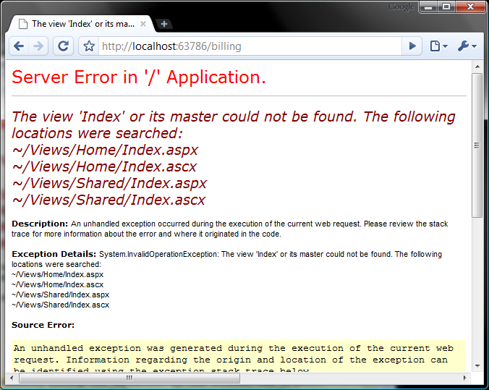
Figure 7.4 When a view isn’t found, a list of locations searched is displayed.
In our view engine, we will have to continue to provide this functionality. This means that although this seems like the simple task of telling the WebFormViewEngine to look somewhere else, we also have to override the methods that return the ViewEngineResult. Listing 7.13 outlines our custom view engine.
Author says indents are OK.
Listing 7.13 A custom view engine for handling areas
public class AreaWebFormsViewEngine : WebFormViewEngine
{
public AreaWebFormsViewEngine()
{
ViewLocationFormats = new[]
{
"~/views/{2}/{1}/{0}.aspx",
"~/views/{2}/{1}/{0}.ascx",
"~/views/Shared/{1}/{0}.aspx",
"~/views/Shared/{1}/{0}.ascx",
};

MasterLocationFormats = new[]
{
"~/views/{1}/{0}.master",
"~/views/Shared/{0}.master",
"~/views/{2}/{1}/{0}.master",
"~/views/{2}/Shared/{0}.master",
};
}

public override ViewEngineResult FindPartialView(
ControllerContext controllerContext,
string partialViewName, bool useCache)
{
//snip
}

public override ViewEngineResult FindView(
ControllerContext controllerContext,
string viewName, string masterName, bool useCache)
{
//snip
}
}

In our constructor, we redefine the ViewLocationFormats and MasterLocationFormats arrays to accommodate an extra parameter (area). The view locations use standard string formatting placeholders. The first placeholder, {0}, denotes the action name. The second placeholder, {1}, is the controller name and the final placeholder, {2}, is the area name (if specified). The formatting of these strings happens in the FindPartialView and FindView methods, so we must override these as well. Listing 7.14 shows this code.
Listing 7.14 FindPartialView and FindView methods for a custom view engine
public override ViewEngineResult FindPartialView(
ControllerContext controllerContext,
string partialViewName, bool useCache)
{
if(HasArea(controllerContext)) #A
{
string[] searchedLocations;

string viewPath = FindViewWithArea(controllerContext, |#B
partialViewName, |#B
ViewLocationFormats, |#B
out searchedLocations); |#B

if(viewPath == null)
return new ViewEngineResult(searchedLocations);

var view = CreatePartialView(controllerContext, viewPath);
return new ViewEngineResult(view, this);
}

return base.FindPartialView(controllerContext, partialViewName,
useCache);
}

public override ViewEngineResult FindView(
ControllerContext controllerContext,
string viewName, string masterName, bool useCache) #C
{
if (HasArea(controllerContext))
{
string[] searchedLoations;
string viewPath = FindViewWithArea(controllerContext, viewName,
ViewLocationFormats, out searchedLoations);
if(viewPath == null)
return new ViewEngineResult(searchedLoations);

string masterPath = "";
if(! string.IsNullOrEmpty(masterName))
masterPath = FindViewWithArea(controllerContext, |#D
masterName, |#D
MasterLocationFormats, |#D
out searchedLoations); |#D

var view = CreateView(controllerContext, viewPath, masterPath);
return new ViewEngineResult(view, this);
}

return base.FindView(controllerContext, viewName, masterName,
useCache);
}

#A Only handle routes with areas
#B Try and find view
#C FindView also handles master pages
#D Find master page

These methods are fairly similar; however the FindView method also has to deal with the concept of a master page. If the route data contains an area, we call the FindViewWithArea method. If this method doesn’t return a valid path, we return a ViewEngineResult that contains a list of searched locations. If the view was found, we call the CreateView method (provided by the base class) and return it. The HasArea and FindViewWithArea methods are defined in listing 7.15.
Listing 7.15 Helper methods for our custom view engine
private string FindViewWithArea(ControllerContext controllerContext,
string viewName, IEnumerable<string> locationFormats,
out string[] searchedLocations)
{
searchedLocations = new string[0]; #A
string controller =
controllerContext.RouteData.GetRequiredString("controller");
string area = controllerContext.RouteData.GetRequiredString("area");

var searched = new List<string>(); #B
foreach (var locationFormat in locationFormats)
{
string viewLocation = string.Format(locationFormat, |#C
viewName, controller, area); |#C
searched.Add(viewLocation);
if(FileExists(controllerContext, viewLocation))
{
return viewLocation;
}
}

searchedLocations = searched.ToArray(); #D
return null;
}

private bool HasArea(ControllerContext controllerContext)
{
return controllerContext.RouteData.Values.ContainsKey("area");
}

#A Default value for 'out' parameter
#B Track each location
#C Format each string
#D Return complete location list
7.4.3 Tying it all together
Because our controllers will now reside in a subfolder of the Controllers folder, we have to register the additional controller namespaces:

ControllerBuilder.Current.DefaultNamespaces.Add(
"AreasSample.Controllers.Billing");

This is required because the default ControllerBuilder does not want to reflect over the entire assembly looking for the controller when matching a route to a specific controller. By default, the controllers are searched only in the namespace YourApp.Controllers. You have to add a new line for each defined area in your application. Note that with these new namespaces added, it is possible to have multiple HomeController classes. We also have to replace the default view engine, like so:

ViewEngines.Engines.Clear();
ViewEngines.Engines.Add(new AreaWebFormsViewEngine());

These can be placed next to your route definitions in Application_Start.
Now it’s time to see it all working. In the Controllers folder, we create a new subfolder called Billing (the area name) and place a controller in it. We also create a similar Billing folder for our views. Figure 7.5 shows the Visual Studio solution structure.

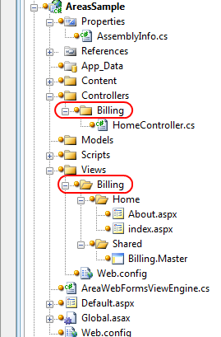
Figure 7.5 Organizing controllers and views into an area subfolder called Billing
Now we can run our project, navigate to http://localhost/billing/home/about and see it working as shown in figure 7.6.

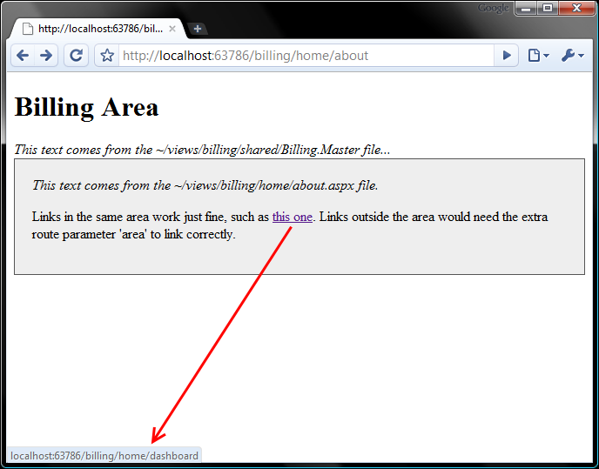
Figure 7.6 Seeing our finished result: a controller and action nested within a ‘Billing’ area.
7.5 Summary
In this chapter we covered a number of techniques to help your application adapt to complexity. We talked about the Single Responsibility Principle and how you can apply it to controllers to keep them small and focused. We talked about centralizing the loading of common view data into action filters. For views we learned that we can reduce clutter by creating view helpers. Finally we talked at length about how to create a custom view engine that supported controller hierarchies called areas. Each of these techniques can be applied to keep your applications complexity under control.
In the next chapter, we’ll take a look at the existing features of ASP.NET that we can still leverage in ASP.NET MVC.

