11
Exploring MonoRail and Ruby on Rails
This chapter covers:
- Castle MonoRail
- Castle ActiveRecord
- Castle Windsor
- Ruby on Rails
- ActionPack
Model-View-Controller as a pattern emerged about 20 years ago in the Smalltalk community. Since then, numerous representations of the MVC pattern for almost every visual technology and language have developed. Combined with object-oriented programming, the MVC pattern provides a powerful separation of concerns between view technologies and the logic to interpret and react to user input. The MVC pattern is certainly not new, nor is ASP.NET MVC the first MVC framework to exist on the ASP.NET platform.
Many alternative MVC frameworks position themselves as full-stack MVC frameworks, where everything from database to deployment to hosting is included in the framework. Full-stack frameworks can greatly reduce the amount of development time needed to create an application, as all components are designed to work together to create one seamless development experience.
In this chapter, we will examine MVC frameworks built for both .NET and other platforms. We will dive into MonoRail, which is a popular MVC framework built on .NET and is part of the larger Castle project. Next, we will explore another popular web framework, Ruby on Rails. Ruby on Rails is built on the dynamic language of Ruby, and uses the strong opinions of the framework’s developers to guide the end user down well-trodden paths. By the end of this chapter, you will be familiar with two major MVC frameworks used today and their primary features, benefits, and advantages.
11.1 MonoRail
MonoRail is a .NET MVC implementation inspired by the Ruby on Rails ActionPack component. MonoRail is part of a larger open source project, Castle. The Castle project includes several other enterprise application components, including an IoC container implementation in Windsor/MicroKernel, as well as an Active Record implementation. With the ActiveRecord piece, the Castle project provides a powerful full-stack web development framework.
As MonoRail has seen more releases and has been under active development for many years, it is natural that MonoRail provides a richer feature set than ASP.NET MVC. But because many components in Castle are not coupled strictly to MonoRail, many features of Castle and even MonoRail can be used in ASP.NET MVC. It is possible to develop a MonoRail and ASP.NET MVC application side-by-side in one project. But before we examine how to combine Castle features with ASP.NET MVC, let’s take a closer look at what MonoRail provides.
11.1.1 Feature overview
Before we look at more advanced features of MonoRail, let’s look at a baseline application that incorporates many of the same features as ASP.NET MVC. This example will use quite a few features from MonoRail, which we will cover in detail. First, let’s look at a simple controller that displays a list of people in listing 11.1:
Cueballs in code and text
Listing 11.1 A simple PeopleController using MonoRail
[Layout("default")] #1
public class PeopleController : SmartDispatcherController #2
{
public void List() #3
{
Person[] people = Person.FindAll();

PropertyBag["people"] = people; #4
}
}

We will skip all the configuration needed for MonoRail, as it is fairly similar to ASP.NET MVC configuration. In listing 11.1, we created the PeopleController by declaring a class and inheriting from SmartDispatcherController (2). SmartDispatcherController is similar in functionality to the base Controller class in ASP.NET MVC, and holds references to common HttpContext runtime components as well as other items needed for the view. Next, we declared a single action, List (3). Any public method becomes an action in a SmartDispatcherController, with automatic naming conventions tying URLs to actions. MonoRail also provides support for fine-grained control over the action name relative to the method name. At the top of the class, we tell MonoRail that we’re going to use the “default” layout with the Layout attribute (1). There will be a corresponding “Layout” view template in our project.
Inside the action method, we use the Person class to query the database to return all people. The Person class uses ActiveRecord, another Castle component that we’ll cover in the next section. Finally, we add an entry in the PropertyBag (4) with the people array returned from the database. PropertyBag is analogous to the ViewData property in ASP.NET MVC. When we want to pass data to the view, we use the PropertyBag. One important difference between actions in MonoRail and actions in ASP.NET MVC is that the Monorail actions return void, instead of an ActionResult object. In MonoRail all actions alter the state of the controller, and that state is interpreted by the dispatcher after all actions have been executed.
MonoRail, like ASP.NET MVC, supports multiple view engines. For our example, we will use the popular NVelocity view template framework. Listing 11.2 shows our simple table of people:
Cueballs in code and text. Indent is correct
Listing 11.2 NVelocity template for listing people
<h2>People</h2>

#foreach($person in $people) #1
#beforeall #2
<table class="datatable">
<thead>
<tr>
<th>Name</th>
<th>Email</th>
<th>Website</th>
<th>Comments</th>
</tr>
</thead>
<tbody>
#odd #3
<tr style="background-color: #eee">
#even #4
<tr>
#each #5
<td>$person.GetName()</td>
<td>$person.Contact.Email</td>
<td><a href="$person.Website">$person.Website</a></td>
<td>$person.Comment</td>
#after </tr>
#afterall
</tbody>
</table>
#end
In the view template, we provide only the snippet of template code to show the list of people. This template is part of a parent “default” layout, which we specified earlier in our controller with the Layout attribute. In the template, the #foreach section does the work. The #foreach section will loop over all the people in the $people identifier (1), which looks in the PropertyBag for the actual underlying object. The #beforeall section creates the initial table HTML elements, the header columns, and the start of the table body (2).
Next, we see two interesting sections: an #odd (3) and an #even (4) section. As would be expected, the #odd section is used before each odd-numbered section, and the #even is used before each even section. Next, we supply the individual table cells with data in the #each section (5). Each table cell uses the $person identifier, defined in the #foreach section. The $person is a Person object, so we can access the properties and methods as if we were working in C#. The result of this template is shown in figure 11.1.
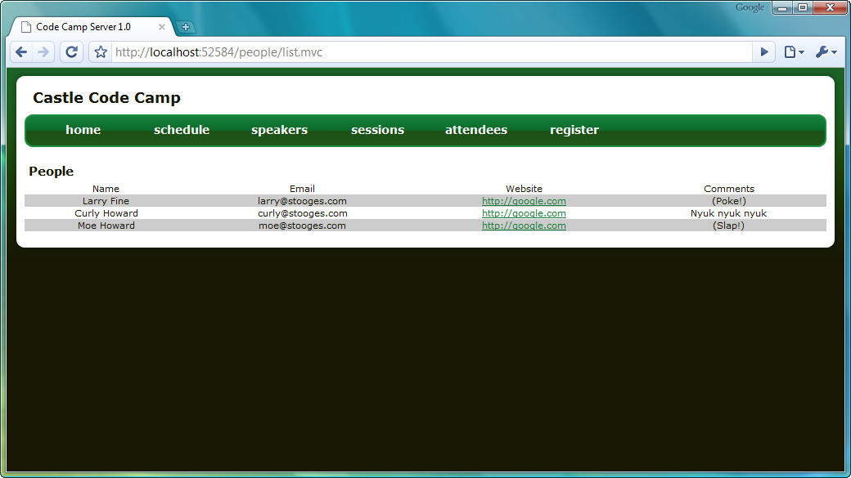
Figure 11.1 Displaying all people with the NVelocity templating engine
Because of the #odd and #even templates, we were able to apply specific row alternating styles in our table. Unlike other ASP.NET controls, we were able to work efficiently in HTML, putting the <tr> element only in the #odd and #even sections. The Layout attribute allowed us to put our entire common HTML in one template, shown in listing 11.3.
Listing 11.3 The common default template
<!DOCTYPE html PUBLIC "-//W3C//DTD XHTML 1.1//EN" "http://www.w3.org/TR/xhtml11/DTD/xhtml11.dtd">
<html>
<head>
<meta http-equiv="Content-Type"
content="text/html; charset=iso-8859-1" />
<title>Layout</title>
<link rel="stylesheet" href="$siteRoot/css/stylesheet.css" /> #A
<link rel="stylesheet" href="$siteRoot/css/themes/green.css" />
</head>
<body>
<div id="frame">
<div id="frame-header"></div>
<div id="content">
<div id="header">
<h1>Castle Code Camp</h1>
</div>
<div class="cleaner"></div>
<div id="navigationWrapper">
<div id="leftNavigationEndCap"></div>
<ul id="navigationMenu">
<li><a href="#">home</a></li>
<li><a href="#">schedule</a></li>
<li><a href="#">speakers</a></li>
<li><a href="#">sessions</a></li>
<li><a href="#">attendees</a></li>
<li><a href="#">register</a></li>
</ul>
<div id="rightNavigationEndCap"></div>
<div class="cleaner"></div>
<div id="contentWrapper">
$childContent #B
</div>
</div>
</div>
<div id="frame-footer"></div>
</div>
</body>
#A $siteRoot similar to “~” in ASP.NET
#B $childContent variable is a placeholder
Our custom content comes from the $childContent placeholder inside the <div> content element. All views needing to use this common layout will use the Layout attribute to specify the common default layout. Now that we have our first simple controller, action, and view under our belt, let’s explore some of the more interesting features of MonoRail.
Filters
In many MVC projects, we tend to see similar code appearing at the beginning or ending of many actions. Whether it’s authorization code, session checks, or repository calls, the code tends to clutter the actual work of the action. When this code is duplicated at the beginning of many actions, we can create a filter to house our code. Filters are special classes we can use to decorate our controller actions to ensure the filter is executed at a specific time during the request. We can tell MonoRail to execute the filter before, after, or both before and after the action executes.
In our application, we will create a filter that prevents nonadministrators from viewing the List action we created in the last section. First, we need to create a class that implements IFilter. IFilter has only one method, Perform, which returns a Boolean that tells MonoRail whether or not the action should continue executing. In Listing 11.4, our filter checks the role and redirects if the user does not belong to the correct role.
Cueballs in code and text
Listing 11.4 Authorizing users and performing redirections
public class AuthorizationFilter : IFilter
{
public bool Perform(ExecuteWhen exec, IEngineContext context,
IController controller, IControllerContext controllerContext)
{
if (context.CurrentUser.IsInRole("Administrator")) #1
{
return true;
}

context.Response.Redirect("home", "index"); #2
return false;
}
}
MonoRail will pass in any contextual information that the filter might need to perform its work, including when the filter is executing in the ExecuteWhen parameter, execution context information such as the Session, Response, and Request objects in the IEngineContext parameter, the executing IController, and the current IControllerContext. In our example, we check to see if the CurrentUser belongs to the Administrator role (1). If so, we return true and our action continues executing. If not, we redirect the user to the index action on the home controller (2), returning false so that the action does not continue to execute.
To use this filter on a controller, you’ll need to use MonoRail’s FilterAttribute to decorate any controller where we want this filter to execute. You can decorate both actions and controllers with a filter, depending on whether you want the filter to execute for every action in your controller, or only for specific actions. In listing 11.5, we decorate the controller with our filter using the ExecuteEnum.BeforeAction parameter, so that every action on this controller will have the AuthorizationFilter executed before it.
Cueball in code and text
Listing 11.5 Decorating our controller to prevent unauthorized execution
[Layout("default")]
[Filter(ExecuteWhen.BeforeAction, typeof(AuthorizationFilter))] #1
public class PeopleController : SmartDispatcherController
{
public void List()
{
Person[] people = Person.FindAll();

PropertyBag["people"] = people;
}
}

The Filter attribute allows us to tell MonoRail which filter to use, as well as when that filter should execute. In listing 11.5, we directed MonoRail to execute the AuthorizationFilter before each action (1).
There is still a slight problem with our filter: it gives zero feedback to the end user that anything was wrong! Unauthorized users are silently redirected back to the home page, whether or not intentionally accessing blocked actions. This can be very frustrating for an end user of the application, but easily remedied by use of the Flash, as we’ll see in the next section.
Flash
In the last section, we created an AuthorizationFilter that ensured that only authorized users were able to access certain controllers and actions. If the user did not belong to a certain role, we redirected them back to the home page. We did not give them any indication of what happened or why, which would lead to their considerable confusion and annoyance. To mitigate the user’s potential confusion, we can show them a short message at the top of the screen. In the Web Forms days, we would use Session to store these types of values. Because our error message needs to live until the next action is executed, we need to store the error message in a durable container.
Session presents a slight problem to developers for messages like these. What about subsequent actions? If our view looks into Session for an item, we need to make sure that we clear that value out, so that we don’t keep seeing error messages pop up well after they occurred. For messages that need to live only until the next action, we can use MonoRail’s Flash object. Flash is a dictionary-like object, much like Session, whose contents are durable only until the next action is executed. Flash contents don’t last beyond the next action, analogous to TempData in ASP.NET MVC. Both Flash and TempData are implemented using Session under the covers.
Flash is perfect for error messages, as we only want them displayed on the very next (or current) action executed. For our AuthorizationFilter, we want a message displayed after the user gets blocked from an action. In listing 11.6, we add an error message to Flash.
Listing 11.6 Adding an error message to Flash
public class AuthorizationFilter : IFilter
{
public bool Perform(ExecuteWhen exec, IEngineContext context,
IController controller, IControllerContext controllerContext)
{
if (context.CurrentUser.IsInRole("Administrator"))
{
return true;
}

context.Flash["error"] = |#A
"You are not authorized to view this page."; |#A
context.Response.Redirect("home", "index");
return false; #B
}
}
#A Put message in Flash
#B Cancel current request
After our message is in Flash, we check for that item in our templates. The ideal place for messages like these would be our default layout, as all other views use the default layout at this time. In listing 11.7, we modify our default layout to show the Flash error if it exists.
Listing 11.7 Displaying the Flash error message
<div id="contentWrapper">

#if ($Flash.error) #A
<div class="flash error">
$Flash.error
</div>
#end

$childContent

</div>
#A Display error message from Flash
Because we want the error message to display only when it actually exists, we wrap the entire Flash output in a #if statement. Now that we have a meaningful error message when the user attempts to navigate to an unauthorized action, our page will display useful information, as shown in figure 11.2.
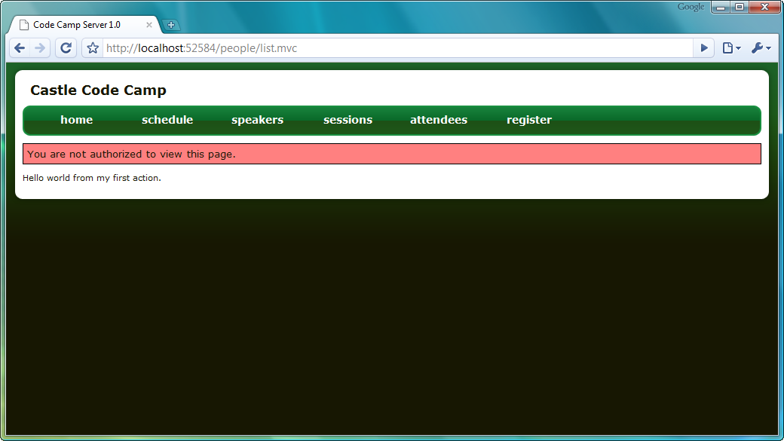
Figure 11.2 Error message displayed after an attempt to access an unauthorized action
After we refresh this page, the error message goes away. The contents of Flash live only until the next action is executed, and is purged after the action executes. In MonoRail, we have granular control over the Flash lifetime, so Flash messages can live on or get purged earlier if needed. But for simple items like error messages, the default Flash behavior provides nice behavior that Session will not.
Up to this point, our application has behaved quite nicely. But exceptions are a fact of life in .NET, and production-ready applications need to handle exceptions gracefully. By default, an ugly yellow error page shows in the event of an unhandled exception in ASP.NET. Although Web Forms allows for custom error pages to be defined in Web.Config, there isn’t much built-in control for more complex behavior. In the next section, we’ll look at unhandled exceptions and rescues.
Rescues
Exceptions and errors are realities in application development, but they don’t have to create an overtly negative user experience. Out of the box, Web Forms does not provide much to prevent a negative experience for unhandled exceptions. Even the greenest of ASP.NET developers becomes familiar with the “yellow screen of death,” the ugly default error page that ASP.NET displays in the event of an unhandled exception. Configuration allows us to create a custom error page, but any additional configuration is severely limited. ASP.NET allows custom error pages per HTTP status code, but this is not nearly enough to provide custom error pages, as all exceptions generate a 500 Internal Server Error status code. The custom error page is global to the site, and cannot be easily configured per request.
Because MonoRail is in complete control of the entire request, as well as executing the controller actions, MonoRail is in a much better position to provide finer grained control over exception pages. This control comes in the form of rescues. A rescue is simply an attribute applied to either the controller or action level, with the name of the view that should be displayed in the event of an exception. MonoRail also allows exception-specific rescues, where different exceptions route to different rescue views, as shown in listing 11.8.
Listing 11.8 Rescues defined per exception and action
[Layout("default")]
[Rescue("generalerror")] #A
[Rescue("specificerror", typeof(ApplicationException))] #B
public class ErrorController : SmartDispatcherController
{
public void Error1()
{
throw new Exception("Something wicked this way comes.");
}

public void Error2()
{
throw new ApplicationException(
"Something specifically wicked this way comes.");
}

[Rescue("actionerror")] #C
public void Error3()
{
throw new SystemException("System error.");
}
}
#A Rescue for all exceptions
#B Rescue for specific exception type
#C Rescue declared for specific action

Not only do we define type-specific rescues on the controller, we can effectively override the default rescue by providing rescues at the action level. After we have the rescues defined in our code, we need to create the views for each corresponding rescue. These rescue views reside in a special Rescues folder in the Views folder. Our simple rescue view for the generalerror rescue is shown in listing 11.9.
Cueball in code and text
Listing 11.9 Our default rescue view
<h2>Unexpected error happened</h2>

<p>
Please review the details below. If this error
continues, please contact your adminstrator.
</p>

<pre>
#set($exc = $context.LastException) #1
<strong>$exc.GetType().Name</strong>

Message:
$exc.Message
</pre>

The LastException property from the $context object contains the Exception object originally thrown in the action (1). We only show the exception type name, but all information on the Exception object is available to us, including stack trace and other custom data. Because our rescue view still uses the default layout defined at the controller level, we get stylized error pages, as shown in figure 11.3.
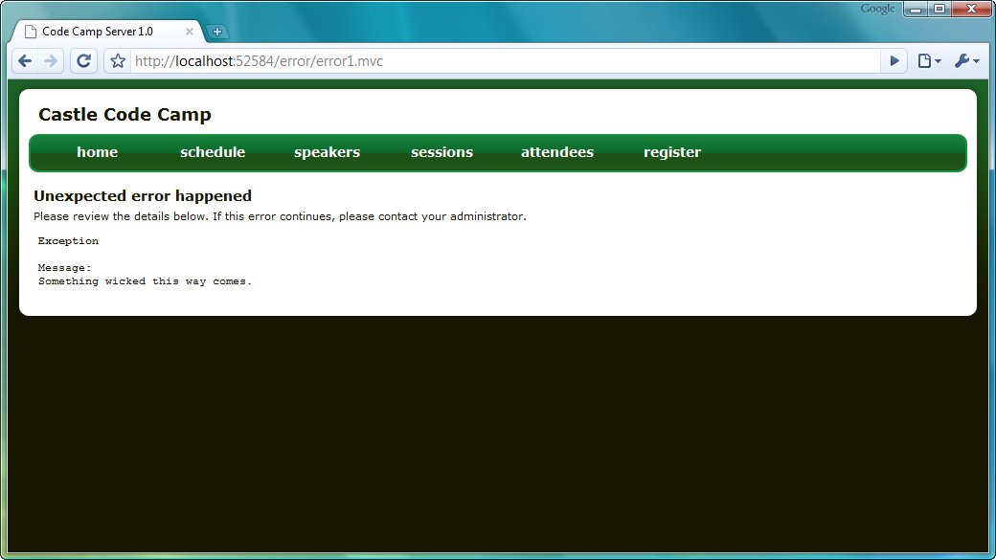
Figure 11.3 General error rescue matching site design
Even with rescues, an end user might see the “yellow screen of death.” Rescues do not preclude developers from creating a custom ASP.NET error page for their websites. The probability for this page being shown is much lower as most exceptions originate from actions.
Showing only static pages is not an interesting application. Data access and separation of concerns are necessary in any medium to large application. In the next section, we’ll tour some of the additional components of the Castle framework to see how Castle tackles these two areas.
11.1.2 ActiveRecord and Windsor
Besides MonoRail, the other two major components of the Castle framework are ActiveRecord and Windsor. As Castle aims to be a full-stack web framework, it supplies two other pieces to the web application puzzle besides the MVC component. ActiveRecord fills in the puzzle pieces for data access, by providing a full-featured Active Record pattern implementation. For managing dependencies and component lifetime, Castle supplies the Windsor container.
ActiveRecord
Databases and data access are nearly ubiquitous in web applications. But how should we expose the database to our web application? The .NET Framework exposed DataSets from the first release as a means of moving data to and from the database. Unfortunately, DataSets are quite clunky as their structure mirrors the physical structure of the database. Moreover, individual components were not easily disconnected from their source.
Because .NET is a fully object-oriented platform, many developers took the route of creating classes to represent their models in the application, while providing mapping layers to map data in and out of these custom classes. As anyone who has written mapping layers can attest, the task of creating a robust mapping layer is quite daunting. Most development frameworks mitigate the Object-Relational Mapping (ORM)) problem through open source libraries. .NET is no different in that regard, as several mature ORM frameworks are available today.
With the power of these ORM frameworks comes more responsibility on the developer’s side to understand how to configure and use these frameworks. For many classes of applications with a simple model, it is not necessary to completely separate the object model from the database mapping. The Active Record pattern is used in those applications to provide one-to-one mapping structures from the object model to the database. Additionally, the objects themselves contain all the mapping logic needed to both hydrate and persist.
In the Castle framework, an Active Record implementation, known as ActiveRecord, is available to developers. ActiveRecord is built on top of a proven ORM framework, NHibernate. Instead of configuration files, you decorate your ActiveRecord classes with attributes to describe the mapping. Typically, ActiveRecord is used in green-field development, where the database does not yet exist.
We still have to provide XML configuration for ActiveRecord, but this is only for configuration items such as the SQL dialect (NHibernate supports multiple databases, including Oracle and SQL Server) and connection string. After these configuration values are defined, we can start creating our ActiveRecord classes. Active Record pattern implementations are usually simplified by inheriting from a base class. In ActiveRecord’s case, the base class is ActiveRecordBase. This base class provides the Active Record functionality, such as persistence, searching, deletion, and retrieval; ActiveRecordMediator is a preferred method over ActiveRecordBase in many cases. Our first ActiveRecord class will be the Person object, used for both Speakers and Attendees in the Code Camp Server application. First, we need to create the Person class, as shown in listing 11.10.
Listing 11.10 Empty Person class tied to ActiveRecord
[ActiveRecord]
public class Person : ActiveRecordBase<Person>
{
}
For most configurations, that’s all need to describe the table mapping for an entity. By default, ActiveRecord will assume the same table name as the class name. This can be overridden by setting properties on the ActiveRecord attribute. In addition to the ActiveRecord attribute, the Person class inherits from the ActiveRecordBase<T> class, which provides strongly typed functions such as Create, Delete, Save, Find, and Update. But to use an ActiveRecord class, we’ll first need to define the primary key of the entity. This is as simple as creating a property and decorating the property with the PrimaryKeyAttribute, as shown in listing 11.11.
Cueball in code and text
Listing 11.11 Adding a primary key to our ActiveRecordPerson class
[ActiveRecord]
public class Person : ActiveRecordBase<Person>
{
[PrimaryKey(PrimaryKeyType.GuidComb)] #1
public virtual Guid Id { get; set; }

By applying the PrimaryKeyAttribute, we are directing ActiveRecord to use the Id property as the identity of this entity, for both persistence and determining transience. If a Person is created, but not yet saved, it is in a transient state and its Id will be the default value. We also supply an additional configuration setting, to use a special Guid generation algorithm optimized for database persistence in a clustered index (1). No additional configuration files or modeling diagrams need to be changed. The entire configuration for our database persistence for the Person class is entirely made up of these attributes. But a Person with only an Id is not interesting; let’s fill out some of the other Person attributes. In listing 11.12, we add the rest of our Person attributes, excluding the Contact:
Cueball in code and text
Listing 11.12 Filling out the other Person attributes
[ActiveRecord]
public class Person : ActiveRecordBase<Person>
{
[PrimaryKey(PrimaryKeyType.GuidComb)]
public virtual Guid Id { get; set; }

[Property] #1
public virtual string Website { get; set; }

[Property]
public virtual string Password { get; set; }

[Property]
public virtual string PasswordSalt { get; set; }

[Property]
public virtual bool IsAdministrator { get; set; }

[Property]
public virtual string Comment { get; set; }

Each new property we add to the ActiveRecord class is decorated with the PropertyAttribute (1). The PropertyAttribute, among other things, contains mapping options for cases where the property name does not match the database column name. For the most part, ActiveRecord attributes directly expose the underlying NHibernate configuration options, which are quite extensive. But for most scenarios, especially in new application development, there is little need to provide additional configuration.
We have one final piece of the puzzle for our Person entity: the Contact object. The Contact object does not have an identity of its own. The Contact at its heart is a group of related properties from the Person object. It is an example of a domain-driven design value object, as covered in chapter 2. When using ORMs like NHibernate and ActiveRecord, it is common to group a set of related properties into a mapping called a component, which can then have its own behavior. With ActiveRecord, these components are configured through the NestedAttribute, as seen in listing 11.13.
Listing 11.13 The nested Contact component configured on the Person class
[ActiveRecord]
public class Person : ActiveRecordBase<Person>
{
private Contact _contact = new Contact();

[Nested] #A
public virtual Contact Contact
{
get { return _contact; }
set { _contact = value; }
}
#A Group columns into a single type

The NestedAttribute tells ActiveRecord that this property is not defined by a single database column, but is instead composed of many database columns. With this in mind, the Contact class does not need as many attributes as the Person class, nor does it need to inherit from ActiveRecordBase, as seen in listing 11.14.
Listing 11.14 The configured Contact component
public class Contact : IEquatable<Contact>
{
private string _firstName = string.Empty;
private string _lastName = string.Empty;
private string _email = string.Empty;

[Property]
public virtual string FirstName
{
get { return _firstName; }
set { _firstName = value; }
}

[Property]
public virtual string LastName
{
get { return _lastName; }
set { _lastName = value; }
}

[Property]
public virtual string Email
{
get { return _email; }
set { _email = value; }
}
The Contact class merely needs to configure its individual properties. The IEquatable implementation is functionality for other domain behavior, and is not needed by Components.
We have looked at the basics of defining our ActiveRecord implementations, but should the querying and saving reside directly in our controller actions? Ideally, we would like to create individual service and repository classes that can house all these concerns. In the next section, we will take a closer look at Castle Windsor, which allows us to take advantage of SoC, the Dependency Inversion Principle, but keep the burden of locating and building objects off calling code.
Castle Windsor
In our controller actions, we are primarily concerned with handling input, handing off to services to process the request, and finally choosing a view for display based on the results of that operation. Although ActiveRecord provides true rapid application development, we do not always want to see queries, saving, and other logic directly inside our controller actions. If we do not take care to break out concerns into distinct classes, our controller actions will quickly resemble the SaveButton_Click or Page_Load events we have seen from Web Forms.
Instead, we can break out these concerns into individual classes. For example, instead of calling directly into our ActiveRecord class to retrieve all Person objects, we can create a simple abstraction on top of this concept in the form of an IPersonRepository, as shown in listing 11.15.
Listing 11.15 The IPersonRepository interface
public interface IPersonRepository
{
Person[] FindAll();
}
The implementation of IPersonRepository is quite simple. It uses the ActiveRecord FindAll method to return all Person objects in the database, as shown in listing 11.16. There is a good argument for also using ActiveRecordMediator in the repository if you prefer that your entities not be bound to ActiveRecord.
Listing 11.16 The PersonRepository implementation using ActiveRecord
public class PersonRepository : IPersonRepository
{
public Person[] FindAll()
{
return Person.FindAll(); #A
}
}
A. FindAll comes from ActiveRecordBase
This implementation is not that interesting until we consider the impact on our PeopleController, which needs to use the PersonRepository to find the list of people. But how should the PeopleController get its instance of IPersonRepository? Should it instantiate it itself, or use a Factory or Builder pattern? What happens if the implementation of IPersonRepository has dependencies of its own? All of these decisions are too much for the PeopleController to manage. Instead, we will assume that “something” gives the IPersonRepository implementation to our PeopleController. To make it clear that PeopleController depends on IPersonRepository, we will make this dependency required by the constructor, as shown in listing 11.17.
Listing 11.17 The PeopleController using the IPersonRepository
public class PeopleController : SmartDispatcherController
{
private readonly IPersonRepository _personRepository;

public PeopleController(IPersonRepository personRepository) #A
{
_personRepository = personRepository;
}

public void List()
{
Person[] people = _personRepository.FindAll();

PropertyBag ["people"] = people;
}

A. IPersonRepository is required

The interesting aspect of this implementation is that the PeopleController is no longer directly coupled to how the Person array is found. We could have used ADO.NET, LINQ to SQL or NHibernate. By separating the database concern from PeopleController, we have allowed each class to grow independently. As long the IPersonRepository contract is fulfilled, the PeopleController will function properly. But how did the IPersonRepository get there? Something had to know to create the correct implementation at runtime and wire the PeopleController up properly. That “something” is Castle Windsor, Castle’s IoC container.
Castle Windsor provides the wiring up of dependencies, as well as strong support for lifetime management and runtime configuration of components. But before we can take advantage of Windsor, we need to tell Windsor about the components in our application. We have several options for providing this configuration, including programmatically, XML configuration files, or even a Boo Domain Specific Language (DSL). For compile-time safety, we will go with the programmatic option. Our first step is to create a WindsorContainer, which will house all our component registration code, as shown in listing 11.18.
Listing 11.18 Our WebContainer with component registration
public class WebContainer : WindsorContainer
{
public WebContainer()
{
RegisterFacilities();
RegisterComponents();
}

private void RegisterComponents()
{
AddComponent("home.controller", typeof(HomeController)); #A
AddComponent("people.controller", typeof(PeopleController));
AddComponent("error.controller", typeof(ErrorController));
AddComponent("person.repository", typeof(IPersonRepository), typeof(PersonRepository));
}

protected void RegisterFacilities()
{
AddFacility("monorail", new MonoRailFacility());
}
}
#A Add named components
In the RegisterFacilities method, we register the MonoRailFacility, a Windsor facility designed especially for MonoRail integration. This facility ensures that controller lifetime is correct, and registers other components needed for managing controller dependencies. In the RegisterComponents method, we place all of our component registration code. To register each component, we use the AddComponent method. We register each controller, as well as the IPersonRepository interface and implementation.
At runtime, Windsor examines PeopleController and notes that it requires an IPersonRepository implementation. Because we also registered the IPersonRepository interface and PersonRepository implementation, Windsor knows to wire up the PersonRepository implementation to the PeopleController. Note that we never specified that PeopleController should get a PersonRepository in our component registration. Component registration is separate from dependency specification. It is up to each component to expose its required dependencies, which is simply through a constructor. In this fashion, the wiring up of dependencies is completely separate from the use of the dependency, as we saw in our PeopleController.
Finally, we need to reference Castle.MonoRail.WindsorIntegration.dll. Then create the container and instruct MonoRail to use Windsor to resolve controller instances. The most straightforward manner to do this is to modify our Global.asax implementation, as shown in listing 11.19.
Cueballs in code and text
Listing 11.19 Providing the WindsorContainer to MonoRail through Global.asax
public class Global : System.Web.HttpApplication, IContainerAccessor #1
{
private static IWindsorContainer _container;

protected void Application_Start(object sender, EventArgs e)
{
_container = new WebContainer();
}

protected void Application_End(object sender, EventArgs e)
{
_container.Dispose();
}

public IWindsorContainer Container #2
{
get { return _container; }
}
}
To expose our WebContainer implementation to MonoRail, we need to implement the IContainerAccessor interface (1). This interface has one member, the Container property (2). This Container property returns the private WebContainer instance, which is created and disposed at the Start and End application events. The final piece to configure is in the Web.config file, to tell MonoRail to use Windsor integration, as shown in listing 11.20.
Listing 11.20 Configuring MonoRail to use Windsor integration
<monorail useWindsorIntegration="true"> #1
<controllers>
<assembly>MonoRailExample</assembly>
</controllers>
<viewEngines viewPathRoot="Views">
<add type="Castle.MonoRail.Framework.Views.NVelocity.NVelocityViewEngine, Castle.MonoRail.Framework.Views.NVelocity"/>
</viewEngines>
</monorail>

With the useWindsorIntegration attribute value configured (1), MonoRailwill now use the IContainerAccessor to access the IWindsorContainer. All controller instantiation will go through our WebContainer.
Many of these MonoRail and Castle components and features can be taken advantage of directly inside ASP.NET MVC. In the next section, we will examine some of the key features of Castle and MonoRail that can enhance an ASP.NET MVC application.
11.1.3 MonoRail and Castle features available in ASP.NET MVC
During the first few preview releases of ASP.NET MVC, many components of MonoRail did not have had an equivalent counterpart in ASP.NET MVC. ASP.NET MVC has caught up in many areas, but some components are still missing. Because of the modular nature of ASP.NET MVC, however, quite a few features of MonoRail and Castle can be used directly in an ASP.NET MVC application.
In chapter 6, we learned how to integrate Castle Windsor as a ControllerFactory. All of the power of Castle Windsor is available by supplying the Windsor ControllerFactory implementation to ASP.NET MVC.
Additionally, all of the power of Castle ActiveRecord is available for use in ASP.NET MVC. Because no Castle component (Windsor, MonoRail and ActiveRecord) has a dependency on another, using ActiveRecord or Windsor in an ASP.NET MVC application will not force any dependency on MonoRail.
Besides the major Castle components, many of the components of MonoRailare available in ASP.NET MVC. These include the view engines, NVelocity and Brail. Originally part of MonoRail, both of these view engines have been adapted to execute against ASP.NET MVC, and are part of the open source MVCContrib project. Eventually, many other features of MonoRail will show up in ASP.NET MVC. For the missing features, it would be easier to look toward MonoRail for inspiration, rather than trying to adapt MonoRail components to run directly inside ASP.NET MVC. Often when we want to use existing features of MonoRail in an ASP.NET MVC application, it is easier to use MonoRail instead.
For inspiration, MonoRail relied heavily on another MVC framework, Ruby on Rails. In the next section, we’ll examine the core philosophy behind Rails and how this philosophy shaped the design of Rails.
11.2 Ruby on Rails
Ruby on Rails is perhaps the most popular MVC framework used today. Shortly after the 2004 release of the framework, the Rails community exploded to include numerous community websites, dozens of books, and many conferences held worldwide. Unlike many other MVC frameworks, Ruby on Rails is a harvested framework, one that was extracted from a real-world application: 37signals’ application Basecamp. Because Ruby on Rails is a harvested framework, all its features have been used in a production environment and all are needed. Any feature that goes well outside the existing design is probably not needed at all.
Ruby on Rails incorporates two central design philosophies, “convention over configuration” and the DRY (Don’t Repeat Yourself) principle. Ruby on Rails is built to directly support Agile Development and at its core is the Agile Manifesto. Unlike rapid application development (RAD) frameworks like Web Forms or VB6, Rails supports testability and SOC directly out of the box. Its design attempts to minimize duplication as much as possible, so that the common scenarios require as little code as necessary to function properly.
In this section, we will take a short tour through the major components and design philosophies of Ruby on Rails. Although this section is not meant to be an introduction to the Ruby language, you will recognize its constructs because you already familiar with the object-oriented paradigm.
11.2.1 Convention over configuration and “the Rails way”
The easiest way to explain the “convention over configuration” philosophy and the DRY principle is to see a simple example in action. First, we will start with defining the model. In our code camp domain, we have Person, Conference, Session, TimeSlot and Track entities. Of these, Person and Conference are the core pieces of our model. Without these, none of the other entities can exist. In an ASP.NET MVC application, creating these initial models can be quite a daunting task. We need to create the controller, the model class, a view, and some sort of mapping layer code. With NHibernate, this might mean the repository and a mapping file. In Rails, creating a model is accomplished through a generator.
But before we even think about our model, we need a Rails site to work against. After installing Ruby and Rails, we can create a Rails development site from the command line, as shown in listing 11.21.
Listing 11.21 Creating our Rails application from the command line
D:\Dev>rails codecampserver_onrails
create
create app/controllers
create app/helpers
create app/models
create app/views/layouts
create config/environments
create config/initializers
create db
create doc
create lib
create lib/tasks
create log
create public/images
create public/javascripts
create public/stylesheets
create script/performance
... more output
We removed the bulk of the output for brevity, but we can see that one command from the command line creates the entire skeleton for our new application. The rails command is far more powerful than the Visual Studio Add New Project command—it creates the full-stack environment for our new application:
- A home for our application in the “app” folder
- Environment configuration
- A home for the content of our application (JavaScript, images, CSS)
- A bevy of helpful Ruby scripts used throughout development
- Build scripts
- Migration scripts
- Tests
The initial starting point for a Rails application is light-years ahead of anything Visual Studio can give you to start with. Now that we have our Rails application created, it is time to generate our first model. In Visual Studio, we would normally accomplish this through the File>New dialog, and create a single class. In some cases, a wizard might pop up to give us more options. In Rails, we can use the scripts created for us in the previous step to generate exactly what we need. In listing 11.22, we use the resource generator to create a starting point for our Person model.
Listing 11.22 Using a generator to create the Person model
D:\Dev\codecampserver_onrails>ruby script\generate resource person
exists app/models/
exists app/controllers/
exists app/helpers/
create app/views/people
exists test/functional/
exists test/unit/
dependency model
exists app/models/
exists test/unit/
exists test/fixtures/
create app/models/person.rb
create test/unit/person_test.rb
create test/fixtures/people.yml
create db/migrate
create db/migrate/20081103024758_create_people.rb
create app/controllers/people_controller.rb
create test/functional/people_controller_test.rb
create app/helpers/people_helper.rb
route map.resources :people

The generator caused interesting things to happen. We can see that a person.rb file was created in the app\models folder, as well as a test file for that model. The generator also created a people folder in the views folder, correctly figuring out the plural for person. A controller/test pair, a helper, and finally a migration script were also generated. That is quite a few files for one command! The concepts of DRY and convention over configuration are strong influencers for this design, as the same files are almost always needed each time we create a new model. We are never forced to use these generators, but life can be much easier if we follow the conventions laid out.
One of the files created is the migrations file. In Rails, every database change is managed through a migration script. This migration script is not a SQL script, but rather an internal Domain Specific Language (DSL). That is, our migration script is written in Ruby. By using Ruby instead of SQL, we are able to shield ourselves from the different SQL dialects of the various SQL products supported by Ruby. In each migration script, we create both up and down scripts, so that our changes can be rolled back at any time. Rails manages the migrations through the clever use of timestamps and record keeping. Since the file was created with a timestamp, Rails can keep track of which scripts should be executed on any developer or production environment.
First, we will fill in the columns we need for our Person class, which included name attributes, password attributes, and other information. In listing 11.23, we see our basic Person table through the migration DSL.
Listing 11.23 The CreatePeople migration script
class CreatePeople < ActiveRecord::Migration #A
def self.up #B
create_table :people do |t| #C
t.string :first_name
t.string :last_name
t.string :email
t.string :website
t.string :password
t.string :password_salt
t.boolean :is_administrator
t.timestamps
end
end

def self.down #D
drop_table :people
end
end

#A Inherit from ActiveRecord::Migration
#B Used to upgrade a database
#C Create peopletable
#D Used to downgrade a database

We will not go too deeply into the Ruby language, but we can see in our example that we defined two class methods, up and down. In the up method, we call the create_table method to create a People table, with the initial columns. The ActiveRecord::Migration class contains many methods to manipulate the database, such as creating and dropping tables and columns. To run our migrations, we simply run the migration script through, as shown in listing 11.24.
Listing 11.24 Running the migration script
D:\Dev\codecampserver_onrails>rake db:migrate
(in D:/Dev/codecampserver_onrails)
== 20081103024758 CreatePeople: migrating =====================================
-- create_table(:people)
-> 0.2100s
== 20081103024758 CreatePeople: migrated (0.2100s) ============================
The rake db:migrate command executes the migration script to apply any new database changes to our local database. When we run this script again, no migration scripts execute because our database is up to date. In a team environment, we run the migration script on a regular basis on each of our development machines when we want to update our local database with the newest changes.
Now that we have created a table, we can play around with our model in the Ruby console. The Ruby console is a sandbox that lets us run Ruby code directly against our model. We can create a new Person in our application, as shown in listing 11.25.
Listing 11.25 Using the Ruby console to create a new Person
D:\Dev\codecampserver_onrails>ruby script\console
Loading development environment (Rails 2.1.2)
>> Person.create(:first_name => 'Larry', :last_name => 'Fine', :email => 'larry@stooges.com')
=> #<Person id: 1, first_name: "Larry", last_name: "Fine", email: "larry@stooges.com", website: nil, password: nil, password_salt: nil, is_administrator: nil, created_at: "2008-11-06 01:42:34", updated_at: "2008-11-06 01:42:34">
>>
The Person model class created by the generator earlier has quite a few helpful methods, similar to MonoRail’s ActiveRecordBase class. In listing 11.25, we call a class method to create a person, with the specified attributes for first name, last name, and email. We did not have to create a new Person object, and instead we passed a Hash of name-value pairs for the Person attributes and values. The create method creates a new Person and immediately saves it back to the database. If we want a transient Person, we can use the initializer instead, as shown in listing 11.26 below.
Listing 11.26 Using the initializer and the save method to create a new Person
>> curly = Person.new(:first_name => 'Curly', :last_name => 'Howard', :email => 'curly@stooges.com')
=> #<Person id: nil, first_name: "Curly", last_name: "Howard", email: "curly@stooges.com", website: nil, password: nil, password_salt: nil, is_administrator: nil, created_at: nil, updated_at: nil>
>> curly.save
=> true
>>
So far, nothing is much different than what we saw in the previous section on MonoRail. Rails provides a better total package, such as a build script, but these are items we can fairly easily put on top of our application. Where Rails truly shines is its embrace of the dynamic nature of Ruby combined with the mantras of convention over configuration and the DRY principle. We can see these two ideas in action if we open up our Person model, created earlier by the generator. Listing 11.27 below shows the entire Person implementation.
Listing 11.27 The entire, fully functional Person implementation
class Person < ActiveRecord::Base #A
end
#A Inherit from ActiveRecord::Base
That’s it! Rails defines the Person class and inherits it from the ActiveRecord::Base type, in just two lines. But in our previous examples, we saw a Person object with all sorts of attributes, such as first_name, is_adminstrator, and others. Where did these extra attributes come from? Since Ruby is a dynamic language, Rails adds these attributes to our class dynamically. Conventions cover the details, leaving much less code for us to write. In our MonoRail example, the Person class required dozens of lines of code, none of them interesting.
The base ActiveRecord type, ActiveRecord::Base, defines many helpful methods for searching, lifetime management, and everything else we would expect from a fully featured Active Record pattern implementation. But because Ruby is a dynamic language, the Rails developers took advantage of its nature to create powerful conventions to reduce the amount of code needed to get an application up and running. In the next section, we will go deeper into Active Record with a more complex model and more interesting querying scenarios.
11.2.2 Active Record
In the last section, we saw the power of convention over configuration and the DRY principle applied to the dynamic nature of Ruby. In this section, we will see how these two ideals shape Rails to support scenarios that, while difficult in a static language, are easy and intuitive in Ruby. Up to this point our model consists of exactly one class, Person. If we go back to our original CodeCampServer model, the relationships can get fairly complex, as shown in figure 11.4.
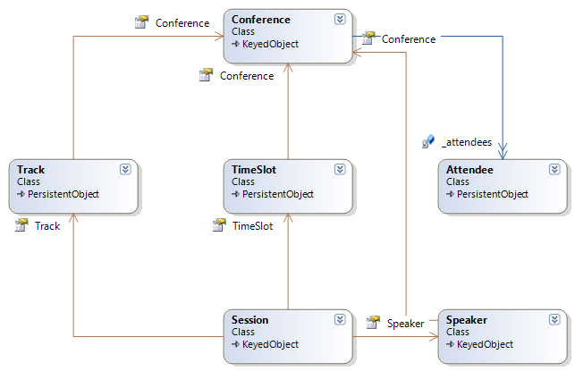
Figure 11.4 The CodeCampServer entities with relationships shown
It is not entirely clear from figure 11.4, which only shows explicit associations through properties and fields, but there are more relationships defined than are programmed for. For example, the Track entity has a Conference, but does a Conference not have many Tracks? That relationship must be traversed through a repository or through direct querying. The same problem can be seen with both Session and TimeSlot; we cannot navigate the web of relationships.
First, we will focus on the relationship between Conference and TimeSlot. A Conference has many TimeSlots, and each TimeSlot belongs to a Conference. When we create the table for TimeSlot in our migration script, we must include this relationship in the definition. Our Conference schema definition will be fairly straightforward, as shown in listing 11.28.
Listing 11.28 The Conference schema migration script
class CreateConferences < ActiveRecord::Migration
def self.up
create_table :conferences do |t|
t.string :key
t.string :name
t.date :start_date
t.date :end_date

t.timestamps
end
end

def self.down
drop_table :conferences
end
end
We added the name, key, and start and end dates for our Conference model. For our TimeSlot schema definition, we will need to add the foreign key for Conference because a TimeSlot belongs to a Conference. Listing 11.29 shows the TimeSlot definition, with the foreign key back to Conference.
Listing 11.29 TimeSlot schema migration script with foreign key for Conference
class CreateTimeSlots < ActiveRecord::Migration
def self.up
create_table :time_slots do |t|
t.string :purpose
t.datetime :start_time
t.datetime :end_time
t.integer :conference_id

t.timestamps
end
end

def self.down
drop_table :time_slots
end
end
To wire up the relationships between the two entities, adding this column will not be enough. Instead, we will need to add information to each model, describing the relationship for each endpoint. Looking back at our relationship diagram, we see that a Conference has many TimeSlots, and a TimeSlot belongs to a Conference. To add this relationship to our model, we need to change the Conference and TimeSlot, as shown in listing 11.30.
Listing 11.30 The Conference and TimeSlot models include the relationship
class Conference < ActiveRecord::Base
has_many :time_slots #A

end

class TimeSlot < ActiveRecord::Base
belongs_to :conference #B

end

#A “one” side of one-to-many
#B “many” side of one-to-many
Notice how easy it is to read the models and interpret the relationship between the two. A Conference has many TimeSlots, and this is represented by the has_many association in our model. On the other side of the relationship, a TimeSlot belongs to a Conference, so we see the belongs_to association to Conference. Because of the Rails convention, Rails knows to look for a column called conference_id on the TimeSlot table. We are not forced to use these conventions, and we can override the defaults as needed. In most cases, it is simpler to accept the conventions and move on to building the application.
Now, it would not be a Rails feature if it did not incorporate the dynamic nature of Ruby to provide rich support for this association. We merely described the relationship, but how do we develop against these new relationships? First, we need to create a new Conference and TimeSlot, as shown in listing 11.31.
Listing 11.31 Creating a Conference and TimeSlot
>> Conference.create(:key => "UCON", :name => "UberCon", :start_date => Date.new(2007, 10, 1), :end_date => Date.new(2007, 10, 3))
=> #<Conference id: 1, key: "UCON", name: "UberCon", start_date: "2007-10-01", end_date: "2007-10-03", created_at: "2008-11-09 23:09:22", updated_at: "2008-11-09 23:09:22">
>> TimeSlot.create(:purpose => "Morning", :start_time => DateTime.new(y=2007, m=10, d=2, h=9, min=0, s=0), :end_time => DateTime.new(y=2007, m=10, d=2, h=10, min=0, s=0))
=> #<TimeSlot id: 1, purpose: "Morning", start_time: "2007-10-02 09:00:00", end_time: "2007-10-02 10:00:00", conference_id: nil, created_at: "2008-11-09 23:29:14", updated_at: "2008-11-09 23:29:14">
In listing 11.31, we created a Conference and TimeSlot, but did not associate the two. To do so, we can grab the TimeSlot we just created and append it to the Conference’s TimeSlots, as shown in listing 11.32.
Listing 11.32 Appending the Morning TimeSlot to the UberCon Conference
>> @morning = TimeSlot.find(1)
=> #<TimeSlot id: 1, purpose: "Morning", start_time: "2007-10-02 09:00:00", end_time: "2007-10-02 10:00:00", conference_id: nil, created_at: "2008-11-09 23:29:14", updated_at: "2008-11-09 23:29:14">
>> Conference.find(1).time_slots << @morning
=> [#<TimeSlot id: 1, purpose: "Morning", start_time: "2007-10-02 09:00:00", end_time: "2007-10-02 10:00:00", conference_id: 1, created_at: "2008-11-09 23:29:14", updated_at: "2008-11-09 23:31:16">]
The append operator << lets us append the TimeSlot we created onto the Conference. The bidirectional association is maintained for us as well. We can inspect the “Morning” TimeSlot and see that the Conference was associated at that end of the relationship as well, as shown in listing 11.33.
Listing 11.33 Maintaining both ends of the relationship
>> @morning.conference
=> #<Conference id: 1, key: "UCON", name: "UberCon", start_date: "2007-10-01", end_date: "2007-10-03", created_at: "2008-11-09 23:09:22", updated_at: "2008-11-09 23:09:22">
ActiveRecord and Rails start to show their power in the ability to create smart, scoped searches. We might not know the specific TimeSlot ID for the “Early Morning” TimeSlot, but we can easily do a find for it, as shown in listing 11.34.
Listing 11.34 A scoped search for a specific TimeSlot
>> Conference.find(1).time_slots.find_by_purpose("Early Morning")
=> #<TimeSlot id: 3, purpose: "Early Morning", start_time: "2007-10-02 08:00:00", end_time: "2007-10-02 09:00:00", conference_id: 1, created_at: "2008-11-10 00:58:18", updated_at: "2008-11-10 00:58:30">
Instead of searching for all TimeSlots with a purpose of “Early Morning”, only the TimeSlots of the Conference with ID of “1” are returned. Listing 11.34 also showcases the dynamic nature of Ruby, as the find_by_purpose method did not exist on our original model. It was generated dynamically, and convention pointed to search by the purpose attribute. Convention combined with the dynamic nature of Ruby results in a powerful mechanism derived from succinct code. We merely set up the table schemas and described the relationship, and Rails and ActiveRecord did the rest. We only showcased one type of relationship, the “has many”, but several other types of relationships are supported, each with its own features added strictly to support scenarios for those types of relationships.
We set up a preliminary model for our CodeCampServer, but we have yet to display any HTML. In the next section, we will take a closer look at the Rails view/controller component, ActionPack.
11.2.3 ActionPack
In the previous section, we looked at the ActiveRecord component of Rails, and discovered how to create rich models with little code. These models are not very useful if no end user can interact with them. With Rails, this interaction is coordinated through ActionPack, which manages the request cycle and routing. A user types a URL or clicks a link to generate a request to Rails. Through routing configuration, ActionPack will direct the request to the correct action on the correct controller. After the action executes on the controller, the view generates the HTML that eventually travels back down to the client. In addition to the routing component, ActionPack includes a controller and view component, aptly named ActionController and ActionView.
Part of our resource generator in the previous section generated entries in the routing configuration and created a blank controller and view. This initial routing configuration, which we will not need to change, is shown in listing 11.35.
Listing 11.35 Routing configuration
ActionController::Routing::Routes.draw do |map|
map.resources :time_slots

map.resources :conferences

map.resources :people

map.connect ':controller/:action/:id' #A
map.connect ':controller/:action/:id.:format'
end

#A Default route similar to ASP.NET MVC
Because many requests will follow the same format, the first map.resources calls set up resource mappings for several default actions, such as new, create, show, and others. Like ASP.NET MVC, routes are defined in order of precedence, so the less specific rules are defined last. In our Rails CodeCampServer, we want to show a single Conference, and a table with all of its TimeSlots. We could additionally provide links for Sessions, Attendees, as well as actions for registering. In our simplified application, we will just look at the Conference and TimeSlot relationship.
For our simple Conference page, we first need to handle the request for a single Conference in an action on our ConferenceController. We need to grab the ID passed into the URL, and use ActiveRecord to find that Conference, as shown in listing 11.36.
Listing 11.36 Defining the show action to find a single Conference
class ConferencesController < ApplicationController #A
def show #B
@conference = Conference.find(params[:id])
end
end
#A Inherit from ApplicationController
#B An action method
The result of the find is put into a variable, which will be available for the view to use. For our view, which will look similar to the Web Form views in ASP.NET MVC, we will use embedded Ruby in HTML to create our final HTML delivered to the client. The view, whose name and location match the action name and controller name, is shown in listing 11.37.
Listing 11.37 The full Show Conference view
<!DOCTYPE html PUBLIC "-//W3C//DTD XHTML 1.1//EN" "http://www.w3.org/TR/xhtml11/DTD/xhtml11.dtd">
<html>
<head>
<meta http-equiv="Content-Type"
content="text/html; charset=iso-8859-1" />
<title>Layout</title>
<%= stylesheet_link_tag 'style-2column' %>
<%= stylesheet_link_tag 'master' %>
</head>
<body>
<div id="header">
<div id="logo">
<h1>Rails Code Camp</h1>
<p>Powered by
<a href="http://codecampserver.org">Code Camp Server</a>
</p>
</div>
<div id="menu">
<ul>
<li>Home</li>
<li>Schedule</li>
<li>Speakers</li>
<li>Attendees</li>
<li>Sponsors</li>
</ul>
</div>
</div>
<div id="page">
<div id="content">
<h1><%= @conference.name %></h1>
<h2>aka <%= @conference.key %></h2>
<p>
kicks off at <%= @conference.start_date %>
<br />
shuts it down at <%= @conference.end_date %>
</p>
<h3>Time Slots</h3>
<table>
<thead>
<tr>
<th>Purpose</th>
<th>Start Time</th>
<th>End Time</th>
</tr>
</thead>
<tbody>
<% for time_slot in @conference.time_slots %>
<tr>
<td><%= time_slot.purpose %></td>
<td><%= time_slot.start_time %></td>
<td><%= time_slot.end_time %></td>
</tr>
<% end %>
</tbody>
</table>

</div>

<div id="sidebar">
</div>
</div>
<div id="footer">
<!-- Footer -->
</div>
</body>
</html>
Embedded Ruby looks nearly identical to Web Forms, with the exception that we are using Ruby instead of C#. We use output embedding tags (<%= %>) to directly output strings, for the Conference name, key and dates. Without the equals, the tags become evaluation embedding tags, where we can put any Ruby code. In this case, we used evaluation embedding to create a for loop to loop over the Conference’s TimeSlots. The final rendering of this page is modified in listings 11.38 and 11.29 and can be seen by navigating to http://localhost:3000/conferences/show/1 and in figure 11.5.
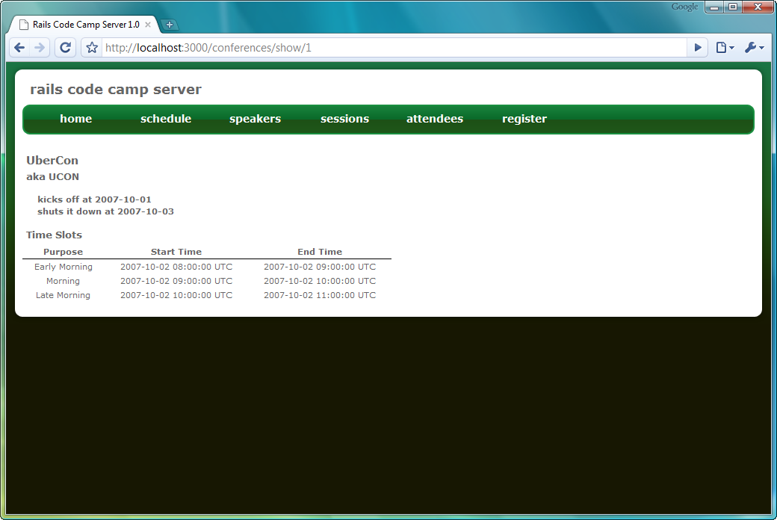
Figure 11.5 Our View Conference page
The rendering in figure 11.5 shows the time slots in the correct sort order. We did not sort them directly in the view, because TimeSlot order is a fundamental aspect of the relationship between a Conference and its TimeSlots. ActiveRecord lets us manipulate this ordering aspect, as shown in listing 11.38.
Listing 11.38 The new Conference to TimeSlot relationship incorporating order
class Conference < ActiveRecord::Base
has_many :time_slots, :order => "start_time ASC" #A

end
#A Include sort order in association
We supply a small SQL fragment describing the correct order of TimeSlots belonging to a Conference, which now corrects the order of TimeSlots we see in the Show Conference view. Much like ASP.NET MVC and MonoRail, ActionView allows us to combine common views into layouts. Because all pages show the same layout, we will create a view with a convention-based name, called application.html.erb. We could create controller-specific layouts as needed, but for our purposes, a site-wide layout is more than sufficient. Our application layout is shown in listing 11.39, which looks very similar to the Master Page in our ASP.NET MVC application. The main difference is the use of the Ruby yield keyword to denote child content.
Listing 11.39 The application layout
<!DOCTYPE html PUBLIC "-//W3C//DTD XHTML 1.1//EN" "http://www.w3.org/TR/xhtml11/DTD/xhtml11.dtd">
<html>
<head>
<meta http-equiv="Content-Type"
content="text/html; charset=iso-8859-1" />
<title>Rails Code Camp Server 1.0</title>
<%= stylesheet_link_tag 'themes/green' %>
<%= stylesheet_link_tag 'stylesheet' %>
</head>
<body>
<div id="frame">
<div id="frame-header"></div>
<div id="content">
<div id="header">
<h1>rails code camp server</h1>
</div>
<div class="cleaner"></div>
<div id="navigationWrapper">
<div id="leftNavigationEndCap"></div>
<ul id="navigationMenu">
<li><a href="#">home</a></li>
<li><a href="#">schedule</a></li>
<li><a href="#">speakers</a></li>
<li><a href="#">sessions</a></li>
<li><a href="#">attendees</a></li>
<li><a href="#">register</a></li>
</ul>
<div id="rightNavigationEndCap"></div>
<div class="cleaner"></div>
<div id="contentWrapper">
<%= yield %>
</div>
</div>
</div>
<div id="frame-footer"></div>
</div>
</body>
</html>
With the child content removed, our Show Conference view becomes small, and rather easy to understand without the entire page layout HTML getting in the way. The final Show Conference view is shown in listing 11.40.
Listing 11.40 The condensed Show Conference view
<div class="dataDoubleWideContainer mt10">
<h2><%= @conference.name %></h2>
<h3>aka <%= @conference.key %></h3>
<p>
kicks off at <%= @conference.start_date %>
<br />
shuts it down at <%= @conference.end_date %>
</p>
<h4>Time Slots</h4>
<table class="display">
<thead>
<tr>
<th>Purpose</th>
<th>Start Time</th>
<th>End Time</th>
</tr>
</thead>
<tbody>
<% for time_slot in @conference.time_slots %>
<tr>
<td><%= time_slot.purpose %></td>
<td><%= time_slot.start_time %></td>
<td><%= time_slot.end_time %></td>
</tr>
<% end %>
</tbody>
</table>
</div>
<div class="cleaner"></div>
In this section of Ruby on Rails, we barely scratched the surface of capabilities in each of the major areas of Rails. Because MonoRail was inspired by Rails, many of the features in MonoRail have their own counterpart in Rails, such as validation, partials, flash, filters, as well as other features not found in MonoRail. The combination of Ruby, convention over configuration, and the DRY principle combine to form a powerful full-stack framework.
Choosing an MVC framework
A quick, but rather useless recommendation is “it depends.” Each framework has its strengths and weaknesses, and often the platform decision is out of your hands. Additionally, you will have to consider other aspects such as deployment, support, your current team’s skills, and so on. If you are already on a team developing with ASP.NET, it will be a nontrivial undertaking to switch to Ruby on Rails.
MonoRail, with its integration with Windsor and ActiveRecord, provides a more complete solution than ASP.NET MVC. Because ASP.NET MVC is a Microsoft product, you will have access to a much wider community, even if MonoRail is more mature by many years. Some companies, for whatever reason, tend to discourage open source tooling, even when there is commercial support available for MonoRail.
The Ruby on Rails question will be more difficult. Rails is a complete ecosystem, and one that currently does not run on .NET. If you choose Rails, you will be switching programming languages, IDEs, hosting environments, and so on. The Rails community is huge, with bookstores dedicating large sections to books on the subject. If your IT shop is 100% Microsoft, the decision has already been made for you. Even in those situations, we encourage you to try out Rails on personal or pet projects, as Rails is built to get you up and going quickly.
11.3 Summary
MVC as a pattern extends back several decades, and has existed in the web space since nearly the beginning of the web. Since ASP.NET MVC leaned heavily on existing MVC frameworks, including MonoRail and Ruby on Rails, an examination of these frameworks is helpful for new ASP.NET MVC developers to understand the mistakes, challenges, and problems solved by preexisting communities and frameworks. These existing frameworks will continue to serve as bellwethers in MVC framework design, and many features will cross-pollinate among the different frameworks. For many features not yet incorporated into ASP.NET MVC, application developers can look to existing frameworks for clues on how to solve problems that most likely arose years before in other communities.
In some cases, another framework might be a better fit for a given situation. Because each MVC framework has different advantages and disadvantages, only through understanding which options are available can we make an informed decision on which framework to use. In this chapter, we reviewed two of the more widely used MVC frameworks, and gained a deeper understanding of the motivation behind each framework as well as their influence on ASP.NET MVC design.
In the next chapter, we will examine a collection of best practices harvested from CodeCampServer and other ASP.NET MVC applications in production today.

